

**-**

*Before initial operation*

*read these instructions*

*thoroughly, and retain*

*for*

*future reference.*

This manual is primarily intended to give operators instructions for YASNAC MX1 programming, opera- tion and maintenance.

This manual applies to the basic and optional features of YASNAC MX1. The optional features are marked with a dagger. For the specifications of your YASNAC MX1, refer to the machine tool builder’s manual.

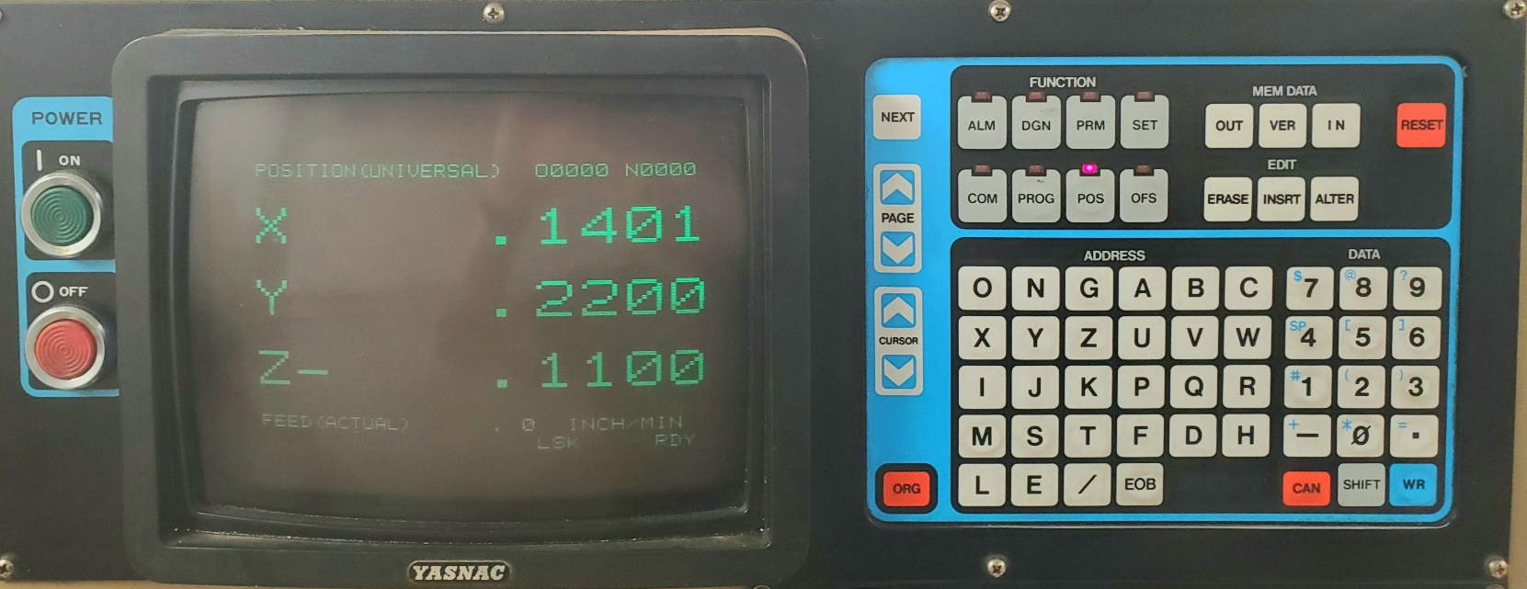581-273

YASNAC MX1 OPERATOR'S STATION

**PREFACE**

|  |  |
| --- | --- |
| Read this manual keeping in mind that the infor- mation contained here in does not cover every possible contingency to be met with the operation. The operations not described in this manual should not be attended with the control.  The functions and performance as NC machine are determined by a combination of machine and the NC control. For operation of your NC machine, the machine tool builder's manual shall take pri- ority over this manual. | Unless otherwise specified, the following rules apply to the description of programming exam -ples shown in this manual.   * Least Input Increment: 0.01 mm * Feed Function Selection: G94 (mm/min.) * Absolute Zero Point: * Reference Zero Point   (Return to reference zero by manual and auto-  matic return ):   * Dimensions: in MM |

|  |  |
| --- | --- |
| **TABLE OF CONTENTS** | |
| 1. **INTRODUCTION** *1* 2. **PROGRAMMING** *1*    1. Input Format *1*    2. Program Number and Sequence Number *6*    3. Coordinate Word *6*    4. Traverse and Feed Functions *9*    5. Spindle-Speed Function (S -Function) *13*    6. Tool Function (T-Function) *13*    7. Tool Compensation *14*    8. Miscellaneous Functions (M-Function] *15*    9. Preparatory Function (G-Function) *21*    10. User Message Display/ *83*    11. User Macro (G65 and G66) *84* 3. **PART PROGRAM TAPE CODING** *110*    1. Tape Code *110*    2. Programming *110*    3. NC Tape Punching *113*    4. NC Tape *113* 4. **NC OPERATOR'S STATION WITH CRT CHARACTER DISPLAY** *114*    1. Pushbuttons, Lamps and Keys *114*    2. Power On /Off Operation *119*    3. Display and Writing Operation *120*    4. Tape Input/Output Operations of NC DATA *132*    5. Loading Part Programs Into Memory *135*    6. Edit *138*    7. Data Input /Output Interface *140*    8. Tape Verifying *145* 5. **TAPE READER** *148*    1. Tape Reader Compartment *148*    2. Tape Reels *149* | 1. **MACHINE CONTROL STATION** *155*    1. Switching Units on the Control Station *155*    2. Operation Procedure *163* 2. **OPERATION PROCEDURE**    1. Inspection Before Turning on Power *173*    2. Turning on Power *173*    3. Manual Operation *173*    4. Preparation for Stored Leadscrew Error Compensation and Stored Stroke Limit' *173*    5. Preparation for Automatic Operation *173*    6. Operation in Tape and Memory Mode *175*    7. Manual Operation Interrupting Automatic Operation *175*    8. Automatic Operation in MDI Mode *175*    9. MDI Operation Interrupting Automatic Operation *176*    10. Preparation for Turning Off Power *1*76    11. Turning Off Power *176* 3. **MAINTENANCE** 178    1. Routine Inspection Schedule *1* 78    2. Battery Replacement *181*    3. Power Circuit Breaker and Fuses *182*    4. Thermal overload Relay of Servo Unit 184    5. Others *185*    6. Trouble Causes and Remedies *185*   **APPENDIX – 1 LIST OF SETTING NUMBERS** *187*  **APPENDIX – 2 LIST OF PARAMETER NUMBERS** *192*  **APPENDIX – 3 STORED LEADSCREW ERROR**  **COMPENSATION** *209*  **APPENDIX - 4 LIST OF STANDARD INPUT/**  **OUTPUTSIGNALS** *213*  **APPENDIX - 5 LIST OF ALARM CODES** *222*  **APPENDIX - 6 LIST OF ADDRESS CHARACTERS** *234* |

**INDEX**

**Subject Chapter Section Page**

1. Absolute Zero Point (G92), Programming of 2 2.9.31 79

Absolute /Incremental Programming (G90, G91) 2 2.9.30 79

Address and Function Characters 2 2.1.1 3

ADDRESS CHARACTERS, LIST OF APPENDIX 6 234

ADDRESS Keys 4 4.I.4 116

Address Search 4 4.3.10 130

Alarm Code Display 4 4.3.10 130

Alarm Codes and Remedies 8 8.6.2 185

ALARM CODES, LIST OF APPENDIX 5 222

Alarm Message Display by #8000 Command 2 2.10.1 83

Alarm Number of User Macro 2 2.11.10 105

Argument Designation 2 2.11.2 86

Automatic Acceleration and Deceleration 2 2.4.6 12

Automatic Centering Function (G36, G37) † 2 2.9.19 37

Automatic Coordinate System Setting † 6 6.2.2 164

AUTOMATIC OPERATION, PREPARATION FOR 7 7.5 173

Automatic Return to Reference Point (G28) † 2 2.9.14 34

Automatic Tool length Measurement † 6 6.2.3 164

Axis Control, 4Th 2 2.3.4 8

AXIS INTERLOCK Input 6 6.1.29 162

1. Battery 8 8.1.4 180

BATTERY REPLACEMENT. 8 8.2 181

Breakpoint Function 4 4.3.11 131

Buffer Storage † 2 2.1.55

1. Cable Connector Specifications 4 4.7.4 114

Canned Cycles (073, 074, G76, G77, G80 to G89, 098, G99) † 2 2.9.29 68

Cautions in Programming 3 3.2.3 112

Circle Cutting (G12, G13) † 22.9.9 28

Circuit Breaker for Servo Control 8 8.3.5 183

Circuit Breaker of Composite Control Power Supply Unit 8 8.3.1 182

Circular Interpolation (G02, G03) 2 2.9.4 24

Circular Path Mode On/Off on Tool Radius Compensation C

(M97 /M96) † 2 2.8.6 19

Command Data Display 4 4.3.2 121

Considerations and Remarks for User Macros 2 2.11.9 102

Constant Display 4 4.3.1 120

Control Commands 2 2.11.6 99

Control Panel 8 8.1.2 179

Coordinate Word 22.3.1 7

COORDINATE WORD 2 2.3 6

CRT Character Display 4 4.1.2 115

Current Position, Displaying and Resetting 44.3.4 124

CURSOR Keys 4 4.1.8 117

CYCLE START Push button and Lamp 66.1.2 155

1. DATA INPUT/OUTPUT INTERFACE, SUPPLEMET TO 4 4.7 140

Data Input/Output Interface to be used and Baud Rate, Setting of 4 4.7.2 140

DATA Keys 44.1.5 116

Decimal Point Programming 2 2.1.3 5

Display and Write of Local Variables and Common Variable 22.11.8 102

DISPLAY AND WRITING OPERATION 4 4.3 120

DISPLAY LOCK/MACHINE LOCK Switch 6 6.1.21 160

DRY RUN Switch 66.1.20 160

Dwell (004) 2 2.9.6 27

ii

**INDEX**

**Subject Chapter Section Page**

1. EDIT 4 4.6 138

EDIT Keys 4 4.1.10 117

EDIT LOCK Switch 6 6.1.28 162

Editing Operation, Summary of 4 4.8.4 146

EIA/ISO Auto-Recognition 3 3.1.2 110

EMERGENCY STOP Pushbutton 6 6.1.4 155

Exact Stop (G09, G61, G64) 2 2.9.7 27

Exercises of User Macro 2 2.11.11 105

EXTERNAL DECELERATION Input Signals † 26 6.1.30 162

1. F1-Digit Programmingt † 2 2.4.4 11

Feed Function Designation (G94, G95) † 1 2 2.9.32 80

FEED HOLD Pushbutton and Lamp 6 6.1.3 155

Feed Per Revolution† 2 2.4.5 12

Feedrate (F-Function) 2 2.4.2 1Q

Feedrate 1/10 2 2.4.3 11

FEEDRATE OVERRIDE CANCEL Switch 6 6.1.13 159

FEEDRATE OVERRIDE Switch 6 6.1.12 157

FUNCTION Keys 4 4.1.3 115

Fuse Blowing (Alarm No. 331, 332) 8 8.4.1 184

Fuse for Servo Control Power Unit 8 8.3.4 183

Fuses of Composite Control Power Supply Unit 8 8.3.2 182

Fuses of Power Input Unit 8 8.3.3 183

1. G Codes and Groups, List of 2 2.9.1 21

(GOO, G06) Positioning 2 2.9.2 23

(G01) Linear Interpolation 2 2.9.3 Z3

(G02, G03) Circular Interpolation 2 2.9.4 24

(G02, G03) † Helical Interpolation 2 2.9.5 26

(G04) Dwell 2 2.9.6 27

(G09, G61, G64) Exact Stop 2 2.9.7 27

(G10) Tool Offset Value Designation 2 2.9.8 28

(G12, G13) † Circle Cutting 2 2.9.9 28

(G17, G18, G19) Plane Designation 2 2.9.10 31

(G20, G21) † Inch/Metric Designation by G Code 2 2.9.11 31

(G22, G23) † Stored Stroke Limit 2 2.9.12 32

(G27) Reference Point Check 2 2.9.13 33

(G28) † Automatic Return to Reference Point 2 2.9.14 34

(G29) † Return from Reference Zero 2 2.9.15 35

(G30) † Reference Point Return 2 2.9.16 36

(G31) † Skip Function 2 2.9.17 36

(G33) † Thread cutting 2 2.9.18 37

(G36, G37)Automatic Centering Function 2 2.9.19 37

(G38) † Z - Axis Reference Surface Offset 2 2.9.20 39

(G40, G41, G 4 2 ) † Tool Radius Compensation C 2 2.9.21 39

(G43, G44, G49) † Tool Length Compensation 2 2.9.22 53

(G45 to G48) Tool Position Offset 22 2.9.23 55

(G50, G51) † Scaling Function 2 2.9.24 60

(G52 to G59)Nork Coordinate System Setting 2 2.9.25 62

(G60) † Unidirectional Approach 2 2.9.26 64

(G70, G71, G72) Hole Pattern Cycles 2 22.9.7 65

(G73, G74, G76, G80 to G89, G98, G99) † Canned Cycles 2 2.9.29 68

(G80, G81) † Output for External Motion 2 2.9.28 67

(G90/G9I) Absolute/Incremental Programming 2 2.9.30 79

(G 92) Programming of Absolute Zero Point 2 2.9.31 79

(G94, G95) † Feed Function Designation 2 2.9.32 80

(G100 through 102) High-Speed Cutting Feature 2 2.9.33 80

iii

**INDEX**

**Subject Chapter** **Section Page**

1. H- and D-function (H, D Codes) 2 2.7.3 14

HANDLE AXIS Select Switcht 6 6.l.6 156

HANDLE DiaI• (Manual Pulse Generator) 6 6.1.5 156

HANDLE Dials for Simultaneous Control of up to Three Axest 6 6.1.8 157

Helical Interpolation (G02, G03) † 2 2.9.5 26

High-Speed Cutting Feature (G100 through 0102) 2 2.9.33 80

Hole Pattern Cycles (G70, 071, G72) † 2 2.9.27 65

1. Inch/Metric Designation by G Code (G20, G21) † 2 2.9.11 31

Input Format 2 2.1.1 1

INPUT FORMAT 2 2.1 1

Input/Output Signals 8 8.6.3 185

InputlOutput Signals, Displaying On/Off of 4 4.3.13 132

INSPECTION BEFORE TURNING ON POWER 7 7.1 173

Interface, Type and Functions of 4 4.7.1 140

Internal Toggle Switches 4 4.3.8 130

INTRODUCTION 1 1

1. JOG FEEDRATE Switch 6 6.1.10 157

JOG Pushbuttons 6 6.1. 9 157

1. Label Skip Function 2 2.1.4 5

Least Input Increment and Least Output Increment 2 2.3.5 8

Linear interpolation (G01) 2 2.9.3 23

1. (MOO, M01, MO2, M30) M Codes for Stop 2 2.8.1 15

(M90 to M199) M Codes for Internal Processing 2 2.8.2 16

(M91/M90)T Program Interruption On/Off 2 2.8.3 16

(M93/M92)t Multi-Active Registers On/Off 2 2.8.4 16

(M951M94) Mirror Image On/Off 2 2.85 16

(M97/M96) † Circular Path Mode On 10ff on Tool Radius

Compensation C 2 2.8.6 19

(M98, M99) Subroutine Program 2 2.8.7 19

M Codes for Internal Processing (M90 to M199) 2 2.8.2 16

M Codes for Stop (MOO, M01, MO2, M30) 2 2.8.1 15

M Codes, Other 2 2.8.8 20

M-FUNCTION LOCK Switch (Auxiliary Function Lock) 6 6.1.23 160

MACHINE CONTROL STATION 6 155

Maintenance Call, Before 8 8.6.4 186

MAINTENANCE 8 178

MANUAL ABSOLUTE Switch 6 6.1.24 160

MANUAL OPERATION 7 7.2 173

MANUAL OPERATION INTERRUPTING AUTOMATIC OPERAION 7 7.7 175

MANUAL PULSE MULTIPLY Select Switch† 6 6.1.7 156

MANUAL REFERENCE POINT RETURN Switch† 6 6.1.15 159

Manual Return to Reference Point 6 6.2.1 163

Maximum Programmable Dimensions 2 2.3.6 9

Message Display by Control -Out and Control-In 2 2.10.2 83

MDI MODE, AUTOMATIC OPERATION IN 7 7.8 175

MDI OPERATION INTERRUPTING AUTOMATIC OPERATION 7 7.9 176

MEM DATA (Memory Data) Keys 4 4.1.11 117

MIRROR IMAGE AXIS SELECTOR Switch 6 6.1.25 160

Mirror Image On/Off (M951M94) 2 2.8.5 16

Miscellaneous Function (B-Function) †, 2Nd 2 2.8.9 20

MISCELLANEOUS FUNCTION (M-FUNCTION) 2 2.8 15

MODE SELECT Switches 6 6.1.1 155

iv

**INDEX**

**Subject Chapter** **Section Page**

M. Multi - Active Registers 1 2.1.6 5

Multi-Active Registers On/Off (Mo3/Mo2) 2 2.8.4 16

1. NC OPERATOR'S STATION WITH CRT CHARACTER DISPLAY 4 114

NC TAPE 3 3.4 113

NC Tape Check 3 3.3.3 113

NC Tape Keeping 3 3.4.2 113

NC Tape Punch 3 3.3.2 113

NC TAPE PUNCHING 3 3.3 113

NEXT Key 4 4.1.6 116

1. On-Line Diagnostics 8 8.6.1 185

Operation Commands 2 2.11.5 99

OPERATION PROCEDURE 6 6.2 163

OPERATION PROCEDURE 7 173

Operations using Data Input/Output Interface 4 4.7.5 144

Operation Time Display 4 4.3.9 130

Optional Block Skip ( /1 - /9) † 2 2.2.3 6

OPTIONAL BLOCK SKIP Switch 6 6.1.19 159

OPTIONAL STOP Switch 6 6.1.18 159

ORG (Origin) Key 4 4.1. 117

OTHERS 8 8.5 185

Output for External Motion (G80, G81) † 2 2.9.28 67

Overload (Ala rm No. 351, 352) 8 8.4.2 184

Overview of User Macro Body 2 2.11.3 87

1. PAGE Keys 4 4.1.7 117

Paper Tape Select 3 3.3.1 113

PARAMETER NUMBERS, LIST OF APPENDIX 2 192

Parameters, Displaying and Writing 4 4.3.7 128

Part Program, Adding 4 4.6.4 139

Part Program Block, Deleting 4 4.6.2 138

Part Program Block, Modifying 4 4.6.3 139

Part Program by MD1, Loading 4 4.5.3 137

Part Program Display 4 4.6.1 138

Part Program Form, General 3 3.2.2 112

PART PROGRAM TAPE CODING 3 110

Part Program Tape into Memory, Loading 4 4.5.1 135

Part Program Tape Verifying 4 4.8.3 145

Part Program to Paper Tape, Outputting 4 4.4.5 133

Part Program, Making Addition to 4 4.5.2 136

PART PROGRAMS INTO MEMORY, LOADING 4 4.5 135

Plane Designation (G17, G18 ,G19) 2 2.9.10 31

Playback Function 6 6.2.5 170

Positioning (GOO, G06) 2 2.9.2 23

POWER CIRCUITBREAKER AND FUSES 8 8.3 182

POWER ON/OFF OPERATION 4 4.2 119

Power On/Off Pushbuttons 4 4.1.1 115

PREPARATION FOR TURNING OFF POWER 7 7.10 176

PREPARATORY FUNCTION (G-FUNCTION 2 2.9 21

Process Sheet 3 3.2.1 110

Program Interruption On/Off (M91/M90) † 2 2.8.3 16

Program Number 2 2.2.1 6

PROGRAM NUMBER AND SEQUENCE NUMBER 2 2.2 6

PROGRAMMING 3 3.2 110

PROGRAMMING 2 1

V

**INDEX**

**Subject Chapter** **Section Page**

1. Program Restart 6 6.2.4 167

PUSHBUTTONS, LAMPS AND KEYS 4 4.1 114

1. Rapid Traverse Rate 2 2.4.1 9

RAPID TRAVERSE RATE OVERRIDE Switch 6 6.1.11 157

Reference Point Check (G27) † 2 2.9.13 33

REFERENCE POINT Lamps† 6 6.1.16 159

Reference Point Return (G30) † 2 2.9.16 36

Registration of User Macros 2 2.11.7 101

Registered Program Number, Display of 4 4.5.4 137

Remote Power On/Off Pushbuttons 4 4.2.3 120

RESET Key 4 4.1.12 118

Return from Reference Zero (G29) † 2 2.9.15 35

ROUTINE INSPECTION SCHEDULE 8 8.1 178

1. 52-Digit Programming 2 2.5.1 13

55-Digit Programming† 2 2.5.2 13

Scaling Function (G50, G51) † 2 2.9.24 60

Sequence Number 2 2.2.2 6

Servomotor and DC Motor for Spindle 8 8 .1.3 179

Setting and Parameter Tape Verifying 4 4.8.1 145

Setting Data and Parameter Data, Inputting 4 4.4.2 133

Setting Data and Parameter Data to Paper Tape. Outputting 4 4 .4.4 133

Setting Data. Displaying and Writing 4 4.3.6 127

SETTING NUMBERS, LIST OF APPENDIX 1 187

Setting of Baud Rate and Others of Serial Interface 4 4.7.3 141

Simultaneously Controllable Axes of Four-axis Control† 2 2.3.3 7

Simultaneously Controllable Axes of. Three-axis Control 2 2.3.2 7

SINGLE BLOCK Switch 6 6.1.17 159

Skip Function (G31) † 2 2.9.17 36

SPINDLE SPEED OVERRIDE Swltch† 6 6.1.14 159

SPINDLE-SPEED FUNCTION (S-FUNCTION) 2 2.5 I3

Splicing NC Tape 3 3.4.1 113

STANDARD INPUT/OUTPUT SIGNALS, LIST OF APPENDIX 4 213

START LOCK Input (or Switch) † 6 6.1.27 162

STORED LEADSCREW ERROR COMPENSATION APPENDIX 3 209

STORED LEADSCREW ERROR COMPENSATION AND

STORED STROKE LIMITt, PREPARATION FOR 7 7.4 173

Stored Stroke Limit (G22, G23) † 2 2.9.12 32

Subroutine Program (M98, M99) 2 2.8.7 19

SWITCHING UNITS ON THE CONTROL STATION 6 6.1 155

1. T2-Digit Programming 2 2.6.1 14

T4-Digit Programming† 2 2.6.2 14

Tape Feed Switch and System No. Switch 5 5.1.1 148

TAPE AND MEMORY MODE, OPERATION IN 7 7.6 175

Tape Code 3 3.1.1 110

TAPE CODE 3 3.1 110

TAPE FEED and SYSTEM No. Switches 4 4.1.13 118

TAPE INPUT /OUTPUT OPERATIONS OF NC DATA 4 4.4 132

Tape Reader 5 5.1.2 148

Tape Reader 8 .8.1.1 179

TAPE READER 5 148

TAPE READER COMPARTMENT 5 5.1 148

Tape Reels, Handling 8-inch 5. 5.2.2 149

Tape Reels, Handling 6-inch 5 .5.2.1 149

TAPE REELS† 5 5.2 149

vi

**INDEX**

**Subject Chapter** **Section Page**

1. Tape Tumble Box 5 5.1.3 148

TAPE VERIFYING 4 4.8 145

TC Error (Alarm No. 391, 392) 8 8.4.3 184

THERMAL OVERLOAD RELAY OF SERVO UNIT 8 5.4 181

Threadcutting(G33) † *2* *2.*9.18 37

TOOL COMPENSATION 2 2.7 14

Tool Compensation, Outline of - FUNCTION) 2 2.7.1 1413

TOOL FUNCTION ( T

Tool Length Compensation (G43, G44, G49) 2 2.9.22 53

TOOL LENGTH MEASUREMENT Push button and Lamp † 6 6.1.26 162

Tool Offset Data , Displaying and Writing 4 4.3.5 126

Tool Offset Memory 2 2.7.2 14

Tool Offset Value Designation (G 10) 2 2.9.8 28

Tool Offset Value Tape Verifying 4 4.8.2 145

Tool Offsets from Tape, Inputting **4** 4.4.1 132

Tool Offsets to Paper Tape, Outputting 4 4.4.3 133

Tool Position Offset (G45 to 048) ' 2 2.9.23 55

Tool Radius Compensation C (G40, G41, G42 ) t 2 2.9.21 .. 39

TRAVERSE AND FEED FUNCTIONS .................................. 2 2.4 9

TROUBLE CAUSES AND REMEDIES .................................... 8 8.6 185

TURNING OFF POWER 7 7.11 176

Turning off Power . 4 4.2.2 119

TURNING ON POWER 7 7.2 173

Turning on Power **4** 4.2.1 119

TV Check (Tape Vertical Parity Check ) . 3 3.2.4 113

1. Unidirectional Approach (060)† 2 2. 9. 26 64

USER MACRO (G65, G66) 2 2.11 84

User Macro Call Commands 2 2. **il.** 1 84

USER MESSAGE DISPLAY 2 2.10 83

1. Variables2 2.11.4 84
2. Work Coordinate System Setting (G52 to G59) † 2 2. 9. 25 62

Writing in Blocks and Displaying Contents by MDI 4 4.3.3 123

1. Z-AXIS FEED NEGLECT Switch 6 6.1.22 160

Z-Axis Reference Surface Offset (G38) † 2 2.9.20 39

vii

**INTRODUCTION**

|  |  |
| --- | --- |
| The YASNAC MX1 is a high-performance CNC for simultaneously controlling 3 or 4 axes of a machin- ing center, with emphasis placed on high -speed machining, unattended automatic operation, or feedback gauging control.  With the NC logic incorporating 16-bit micropro- cessors and various LSIs, the YASNAC MX1 in- corporates a compact design with a wide range of capabilities. The memory comprises permanent, semi-permanent and programmable software storage used in combination to utilize each one to maximum advantage.  The data input-output interface has been expanded in concept, and, in addition to conventional | interfaces such as FACIT and RS 232C, RS 422 is now available to accommodate requirements for new modes of operations such as high-speed, long-distance data transmission.  The YASNAC can incorporate a programmable machine interface, and the logic diagram can be edited easily from the NC operator's station. |

**2. PROGRMMING**

**2.1 INPUT FORMAT**

**2.1.1 INPUT FORMAT**

|  |  |
| --- | --- |
| A variable block format conforming to JIS#B 6313 is used for YASNAC MX1. | Table 2.1 shows the input format. Numerals following the address characters in Table 2.1 indicate the programmable number of digits. |



|  |  |
| --- | --- |
| Note:  A decimal point should be omitted in actual pro- gramming when you make a program including decimal points, refer to 2.1.3 DECIMAL POINT PROGRAMMING.  The leading zeros can be suppressed for all ad- dress codes. Plus signs need not be programmed, but all minus signs must be programmed.  ln the manual, EOB (end of block) code in a pro- gram example is represented by a semicolon (;). in actual programming, CR (E1A code) or LF/NL (ISO code) should be used instead of the semicolon (;). | * Metric input format   04 N4 G3 a+43 F5 S2 T2 M3 D(H)2 B3;   * Inch input format   04 N4 G3 a+34 F31 S2 T2 M3 D(H)2 B3  Notes:   * “a” represents X, Y, Z, I, J or K. * P. Q. R and L are omitted in the above format because they are used for various meanings   # Japanese Industrial Standard |

-1-

Table 2.1 Input Format

|  |  |  |  |  |  |  |  |
| --- | --- | --- | --- | --- | --- | --- | --- |
| No. | Address | | Metric output | | Inch input | | B: Basic  O: Optional |
| Metric input | Inch input | Metric input | Inch input |
| 1 | Program No. | | O4 | | O4 | | B |
| 2 | Sequence No. | | N4 | | N4 | | B |
| 3 | G function | | G3 | | G3 | | B |
| 4 | Coordinate Word | Linear axis | a + 43 | a + 34 | a + 53 | a + 34 | B |
| Rotary axis | b + 43 | b + 43 | b + 43 | b + 43 | O |
| 5 | Feed/min | | F40 | F31 | F50 | F31 | B |
| 6 | Feed/min 1/10 | | F41 | F32 | F51 | F32 | B |
| 7 | Feed/rev | | F22 | F13 . | F22 | F13 | O |
| 8 | Feed/rev 1/10 | | F23 | FI4 | F23 | F14 | O |
| 9 | S-function |  | S2 | | S2 | | B |
|  | S5 | | S5 | | O |
| 10 | T-function |  | T2 | | T2 | | B |
|  | T4 | | T4 | | O |
| 11 | M-function | | M3 | | M3 | | B |
| 12 | Tool Offset No. | | H2 or D2 | | H2 or D2 | | B |
| 13 | B-function | | B3 | | B3 | | O |
| 14 | Dwell | | P53 | | P53 | | B |
| 15 | Program No. designation | | P4 | | P4 | | B |
| 16 | Sequence No. designation | | P4 | | P4 | | B |
| 17 | No. of repetitions | | L8 | | L8 | | B |

**-2-**

**2.1.2 ADDRESS AND FUNCTION CHARACTERS**

Address characters and their meanings are shown

in Table 2.2.

Table 2.2 Address Characters

|  |  |  |
| --- | --- | --- |
| Address  Characters | Meanings | Basic  Optional |
| A | Additional rotary axis parallel to X -axis | O |
| B | Additional rotary axis parallel to Y-axis | O |
| C | Additional rotary axis parallel to Z-axis | O |
| D | Tool radius offset number | B, O |
| E | User macro character | O |
| F | Feedrate | B |
| G | Preparatory function | B, O |
| H | Tool length offset number | B |
| I | X-coordinate of arc center Radius for circle cutting | B, O |
|  | Y - coordinate of arc center  Cutting depth for circle cutting | B ,O |
| K | Z-coordinate arc center | B |
| L | Number of repetitions | B, O |
| M | Miscellaneous functions | B |
| N | Sequence number | B |
| 0 | Program number | B |
| P | Dwell time, Program No. and sequence No.  designation in subprogram | B, O |
| Q | Depth of cut, shift of canned cycle s | O |
| R | Point R for canned cycles  Radius designation of a circular arc | O, B |
| S | Spindle-speed function | B |
| T | Tool function |  |
| U | Additional linear axis parallel to X-axis | O |
| V | Additional linear axis parallel to Y-axis | O |
| W | Additional linear axis parallel to Z-axis | O |
| X | X-coordinate | B |
| Y | Y-coordinate | B |
| Z | Z-coordinate | B |

-3-

2.1.2 ADDRESS AND FUNCTION CHARACTERS (CONT'D)

Table 2, 3 Function Characters

|  |  |  |  |
| --- | --- | --- | --- |
| EIA Code | ISO Code | Meanings | Remarks |
| Blank | Nul | Error in significant data area in EIA Disregarded in ISO |  |
| BS | BS | Disregarded |  |
| Tab | HT | Disregarded |  |
| CR | LF/NL | End of Block (E013) |  |
|  | CR | Disregarded |  |
| SP | SP | Space |  |
| ER | % | Rewind stop |  |
| UC |  | Upper shift |  |
| LC |  | Lower shift |  |
| 2-4-5 bits | ( | Control out (Comment start) | ETA: |
|  |  |  |
| 2-4-7 bits | ) | Control in (Comment end) | Special code |
| + | + | Disregarded, User macro operator |
| - | - | Minus sig n, User macro operator |  |
| 0 to 9 • | 0 to 9 | Numerals |  |
| a to z | A to Z | Address characters, User macro operator |  |
| / | / | Optional block skip |  |
| Del | DEL | Disregarded (Including All Mark) |  |
| . | . | Decimal point |  |
| Parameter setting | # | Sharp (Variable) | EIA: Special code |
| * | * | Asterisk (Multiplication operator) |
| = | = | Equal mark |
| [ | [ | Left bracket |
| ] | ] | Right bracket |
| : | : | User macro comment |
| $ | $ | User macro comment |
| @ | @ | User macro comment |
| ? | ? | User macro comment |

Notes:

1. . Characters other than the above cause error in significant data area.
2. . Information between Control Out and Control In is ignored as insignificant data.
3. . Tape code (EIA or ISO) can be switched by setting.

- 4 -

**2.1.3 DECIMAL POINT PROGRAMMING**

Numerals containing a decimal point may be used as the dimensional data of addresses related to coordinates (distance), time and speed.

Decimal points can be used in the following address words.

Coordinate words: X, Y, Z, I, J, K, A, B, C ,

U, V, W, Q, R

Time word: P

Feed rate word : F

EXAMPLE

|  |  |  |
| --- | --- | --- |
|  | [mm] | [inch] |
| X15 | X15.000 mm | or X15 .0000 inches |
| Y20.5 | Y20.500 mm | or Y20.5000 inches |
| (G94)F25.6 | F25.0 mm/min  (for F4.0) | or F25.6 inches/min (for F3.1) |
| G95F.2 | F0.20 mm /rev  (for F2.2) | or F0.200 inches/rev  (for F1.3) |
| G04P1. | Dwell 1.000 sec |  |

Normally, when data without a decimal point is inputted, the control regards"1" as 0.001 mm (or 0.0001 inches, or 0.001 deg), but with a parameter setting, the control may be made to regard "1 " as 1 mm (or 1 inch or 1 deg.). Refer to parameter #6019D6).

**2.1.4 LABEL SKIP FUNCTION**

In the cases named below, the label skip function becomes effective, and LSK is displayed on the CRT.

* When the power supply is turned on.
* When the RESET key is pushed.

While the label skip function is effective, all data on the punched tape up to the first EOB code are neglected. When LSK is displayed on the CRT in the MEM (memory) or EDIT (editing) mode, it indicates the presence of a pointer at the leading end of the part program.

-5-

**2.1.5 BUFFER REGISTER**

. During normal operation, one block of data is read in advance and compensation computing is made for the follow-on operation.

In the tool radius compensation C± mode, two blocks of data or up to 4 blocks of data are read in advance and compensation computing re quired for the next operation is executed. One block can contain up to 128 characters including **EOB.**

**2.1.6 MULTI-ACTIVE REGISTERS+**

For the portion of part programs sandwiched in between M93 and M92, up to 5 blocks of data are read in advance.

|  |  |
| --- | --- |
| M code | Meaning |
| M92 * | Multi-active register off |
| M93 | Multi-active register on |

Note: When power is applied or the control is reset, the control is in the state of M code marked with.*

Inter-block stoppage can be eliminated when the program is so made that the automatic operation time of advance reading of 5 blocks is longer than processing time of advance reading of next 5 blocks of data.

NOTE:

Advance reading is not made for every 5 blocks but is always ready to be made up **to** 5 blocks in M93 mode.

-5-

# 2.2 PROGRAM NUMBER AND SEQUENCE NUMBER

**2.2.1 PROGRAM NUMBER**

Program numbers may be prefixed to programs for the purpose of program identification.

Up to 4 digits maybe written after an address character "0" as program numbers. Up to 99 Program numbers can be registered in the control, and up to 199 or 999 can be registered employing an option.

One program begins with a program number, and ends with MO2, M30 or M99. MO2 and M30 are placed at the ends of main programs, and M99 is placed at the end so f subprograms.



ER (or % at ISO code) is punched on the tape at the top and end of the program.

NOTES:

* The blocks for optional block skip such as /MO2; , /M30; , /M99; are not regarded as ends of programs.
* To make the reading of MO2, M30, and M99 in effective as a program end, and to make the succeeding ER (EIA) or % (ISO) as a sign of program ends is possible with a parameter change. ( #6021D0)

2 .2 .2 **SEQUENCE NUMBER**

Integers consisting of up to 4 digits may be written following an address character N as sequence numbers.

Sequence numbers are reference numbers for blocks, and do not have any influence on the meaning and sequence of machining processes. Therefore, they may be sequential, non-sequential, and duplicated numbers, and also not using any sequence number is also possible. Generally, sequential numbers are convenient as sequence numbers.When searching for sequence numbers, be sure to search or specify program numbers before hand.

NOTES:

* When 5 or more digits are written as a sequence number, only the digits up to the 4th from the trailing end are effective.
* When two or more blocks have the same sequence number, only one is retrieved and read, and no more searching is performed.
* Blocks without sequence numbers can also be searched for with respect to the address data contained in the blocks.

**2. 2.3 OPTIONAL BLOCK SKIP (/ 1 - /9)**†

Those blocks in which "/n” (n = 1 - 9 ) is included are neglected between /n and the end of that block, when the external optional block skip switch for that number "n" is on.

EXAMPLE

/2 N1234 G01 X100 /3 Y200;

When the switch for /2 is on, the entire block is neglected, and when the switch for /3 is on, this block is read as if

N 1234 G01 X100;

With "1", "1" may be omitted.

NOTES:

* The optional block skipping process is executed while the blocks are read in to the buffer resister. If the blocks have been read, sub sequent switching on is ineffective to skip the blocks.
* While reading or punching out programs, this function is ineffective.
* The optional block skip /2 - /9 is an option function.

**2.3 COORDINATE WORD**

Generally, commands for movements in axis directions and commands for setting coordinate systems are called coordinate words, and coordinate words consist of address characters for desired axes and numerals representing dimensions of directions.

|  |  |  |  |  |  |  |  |  |  |  |  |  |  |  |  |  |
| --- | --- | --- | --- | --- | --- | --- | --- | --- | --- | --- | --- | --- | --- | --- | --- | --- |
| **2.3.1 COORDINATE WORD**  **Table 2.4**   |  |  |  | | --- | --- | --- | | Addre | ss | Description | | Main axes | X, Y, Z | Position or distance in X, Y or Z coordinate direction. | | 4Th Axist | A, B, C  or  U, V, W | These coordinate words are treated as commands in the directions of the 4th axes.  A, B and C are used for rotary motion , and U, V and W are used for parallel motion. | | Circular interpolation aux. data | Q | Circular arc increment in circle cutting (G12, G13) | | R | Generally , radius values of circles. | | I, .J, K | Generally, distances from start point to arc center (in X, Y and Z components). | |

**2.3.2 SIMULTANEOUS CONTROLLABLE AXES**

**OF THREE-AXIS CONTROL**

Table 2.3.2 shows simultaneously controllable axes.

Table 2.5

|  |  |
| --- | --- |
|  | Simultaneously controllable axes |
| Positioning G00 | X, Y and Z axes |
| Linear interpolation GO1 | X, Y and Z axes |
| Circular inter- polation G02, G03 | Two axes: XY, YZ or ZX  (see Note.) |
| Circle cutting† 012, 013 | Two axes: X and Y |
| Helical interpola- tion† G02, G03 ' | Circle in XY-plane and linear feed in Z - axis direction. Refer to 2.9.5 HELICAL INTERPOLATION. |
| Manual control | Simultaneous control of X, Y and Z |

Note:

Circular arc plane is determined according to the currently effective G codes for plane designation.

(017 to 019)

For details, refer to 2.9.4 CIRCULAR INTERPOLATION (002, G03).

**2.3.3 SIMULTANEOUSLY CONTROLLABLE AXES**

**OF FOUR-AXIS CONTROL**†

Table 2.3.3 shows simultaneously controllable axes.,

Table 2.6

|  |  |
| --- | --- |
|  | Simultaneously controllable axes |
| Positioning GOO | X, Y, 'Z, and a(1) axes |
| Linear interpola- tion GO1 | al  X , Y , Z , and a(1) axes |
| Circular inter- polation G02, G03 | Two axes, (2),(3) XY; YZ, ZX,  Xa(1), Ya(1), Za(1) |
| Circular cutting† G12, G13 | Two axes: X and Y |
| Helical interpola- tion† G02, G03  • | Three axes: circle in XY- plane and linear feed in 2 - axis direction.' Refer to  2.9.5 HELICAL INTERPO - LATION, |
| Manual control | One axis, X, Y, Z, or a(1). |

(1 )The a axis represents any one of axes A, B, C , U , V or W , selected as the 4th axis.

1. Circular arc plane is determined according to the currently effective G codes for plane designation (G17 to 019). For details, refer to 2.9.4 CIRCULAR INTERPOLATION (G02, 003)
2. For circular interpolation axis a, any one of linear axes U, V, and W should be designated.

-7-

|  |  |  |  |  |  |  |  |  |  |  |  |  |
| --- | --- | --- | --- | --- | --- | --- | --- | --- | --- | --- | --- | --- |
| **2.3.4 4TH AXIS CONTROL**†  An additional 4th axis can be incorporated. In this manual, the 4th axis is referred to as a-axis, and represents any of the 6 axes, A, B, C, U, V and W.     |  |  | | --- | --- | | 2.3.4.1 ROTARY AXIS (A, B OR C AXIS ) |  | | The rotary axis is defined as follows.   |  |  | | --- | --- | | Rotary axis | Definition | | A axis | Rotary axis parallel to' X-axis | | B axis | Rotary axis parallel to Y-axis | | C axis | Rotary axis parallel to Z-axis |   Table 2.7  Note: In this manual, any one of the three axes, A, B and C , is referred to as b-axis. | Fig. 2.1 4Th Axis in Right - hand Coordinate System |   Table 2. 9 |

The unit of output increment and input increment for b-axis is "deg ." instead of "mm" used with linear axes. For the other respects, the treatments are the same as those in mm. (Metric

system)

Even when inch system is selected by parameter, the values for the b-axis remains " deg." unit. The control does not convert b-axis coordinate commands. However, feed rate command F is converted. (Refer to 2.9.3 LINEAR INTERPOLATION)

2.3.4.2 LINEAR AXIS (U, V OR W AXIS) The linear axes are defined as follows.

Table 2.8

|  |  |
| --- | --- |
| Linear axis | Definition |
| U--axis | Linear axis parallel to X-axis |
| V-axis | Linear axis parallel to Y-axis |
| W-axis | Linear axis parallel to Z-axis |

Note: In this manual, linear axes either U , V or W are indicated by c -axis.

The unit output increment and input increment for c-axis is the same as the other linear axes, X, Y and Z. No discrimination is necessary.

When inch system is selected by parameter, input values must be in inches for c-axis .

|  |  |  |
| --- | --- | --- |
|  | Rota ry ax is (b) | Linear axis (c) |
| Least output increment | 0.001 deg./ pulse | 0.001 mm/ pulse |
| Least input increment | 0.01/0.001 deg. | 0.01/0.001  mm |
| Maximum pro- grammable value | ±8388.607 | ±8388.607 mm |
| Rapid traverse  rate | deg. /min | deg. /min |
| Cutting feedrate | deg. /min | deg. /min |
| Manual feedrate | deg ./min | deg. /min |

**2.3.5 LEAST INPUT INCREMENT AND LEAST OUTPUT INCREMENT**

2.3.5.1 LEAST INPUT INCREMENT

-The minimum input units that can be commanded

by punched tape or MDI are shown in Table 2.10

Table 2.10 Least Input Increment

(#6006D5 = "0.")

|  |  |  |
| --- | --- | --- |
|  | Linear Axis | Rotary Axist |
| Metric input | 0.001 mm | 0.001 deg |
| Inch input | 0.0001 in | 0.001 deg |

Least input increment times ten can be set by setting parameter #6006D5 at "1."

Input Increment x 10

(#6006D5 = "1.")

|  |  |  |
| --- | --- | --- |
|  | Linear Axis | Rota ry Axist |
| Metric input | 0.001 mm | 0.001 deg |
| Inc h inp ut | 0.001 in. | 0..001 deg |

Metric input and inch input can be selected by setting #6001D0.

- 8 -

Notes:

* Selection of metric system or inch system is made by setting (#6001D0). Selection of x 1 or x 10 is made by parameter setting (#6006D5).

Tool offset value must always be written in 0.001 mm (or 0.0001 inch, or 0.001 degt.), and offset is possible in these units.

In 0.01 mm increment system, the following operation must be made in the unit of 0.01 mm.

* Programming for operation in TAPE mode.
* Write operation in MDI mode.
* Programming for operation in MEMORY mode+.
* Program editing operation in EDT modet.

NOTES:

If NC tape programmed by 0.001 mm is fed into or stored in an equipment set by 0.01 mm increment, the machine will move ten times the intended dimensions.

If the increment system is switched when the contents of NC tape are stored in memory, the machine will move by ten times or one tenth of the commanded dimensions.

When the stored program is punched out on the tape+, the stored figures are punched out "as stored" regardless of switching of the increment system.

2.3.5.2 LEAST OUTPUT INCREMENT

Least output increment is the minimum unit of tool motion. Selection of metric or inch output is made by parameter (#6007D3) setting.

Table 2.11 Least output Increment

|  |  |  |
| --- | --- | --- |
|  | Linear axis | Rotary axist |
| Metric output | 0.001 mm | 0.001 deg |
| Inch output | 0.0001 in. | 0.001 deg |

**2. 3.6 MAXIMUM PROGRAMMABLE DIMENSIONS**

Maximum programmable dimensions of move command are shown below.

Table 2.12 Maximum Programmable Dimensions

|  |  |  |  |
| --- | --- | --- | --- |
|  |  | Linear axis | Rotary axist |
| Metric output | Metric input | ±8388.607 mm | ±8388.607 deg |
| Inch input | ±330.2601 in. | ±8388.607 deg |
| Inch  output | Metric input | ±21307.062 mm | ±8388.607 deg |
| Inch input | ±838.8607 in. | ±8388.607 deg |

9

In incremental programming, input values must not exceed the maximum programmable value.

In absolute programming, move amount of each axis must not exceed the maximum programmable value.

Note: The machine may not function properly if a move command over the maximum programmable value is given. The above maximum programmable values also apply to distance command addresses I, J, K, R, Q in addition to move command addresses X, Y, Z, a.

The accumulative value must not exceed the maximum accumulative values shown below.

Table 2.13 Maximum Accumulative Values

|  |  |  |
| --- | --- | --- |
|  | Linear axis | Rotary axist |
| Metric input | ± 99999.999 mm | ± 99999.999 deg |
| Inch input | ± 9999.9999 in. | ± 99999.999 deg |

Listed input values do not depend on metric/ inch output system.

**2.4 TRAVERSE AND FEED FUNCTIONS**

**2.4.1 RAPID TRAVERSE RATE**

2.4.1.1 RAPID TRAVERSE RATE

The rapid traverse motion is used for the motion for the Positioning (G00) and for the motion for the Manual Rapid Traverse (RAPID). The traverse rates differ among the axes since they are dependent on the machine specification and are determined by the machine tool builders. The rapid traverse rates determined by the machine are set by parameters in advance for individual axes. When the tool is moved in rapid traverse in two or three axial directions simultaneously, motions in the se axial directions are independent each other, and the end points are reached at different times among these motions. Therefore, motion paths are normally not straight.

For override rapid traverse rates, Fo, 25%, 50% and 100% of the basic rapid traverse rates, are available. Fo is a constant feed rate set by a parameter (#6231).

2.4.1.2 SETTING **RANGE OF RAPID** TRAVERSE RATE

For each axis, rapid traverse rates can be set at some suitable multiple of 7.5 mm /min (or deg min).

The maximum programmable rapid traverse rate is 24,000 mm/min. However, respective machine tools have their own optimum rapid traverse rates. Refer to the manual provided by the machine tool builder.

2.4.2 FEED RATE (F FUNCTION)

With five digits following an address character F, tool feedrates per minute (mm /min) are program med.

The programmable range of feedrates is as follows.

Table 2.14

|  |  |  |  |
| --- | --- | --- | --- |
|  |  | Format | Feedrate (Feed/min) range |
| Metric output' | Metric input | F40 | F 1 . - F8100. mm /min |
| Inch input | F3I | F0.1 - F313.0 in. /min |
| Inch  output | Metric input | F50 | [F1. --F20574. mm](http://f1.--f20574.mm/) /min |
| Inch input | F31 | F0.1 - 810.0 in. /min |

The maximum feed rate is subject to the performance of the servo system and the machine system. When the maximum feedrate set by the servo or machine system is below the maximum programmable feedrate given above, the former is set by a parameter (#6228), and whenever feed rates above the set maximum limit are commanded, the feedrate is clamped at the set maximum value.

F commands for linear and circular interpolations involving motions in simultaneously controlled two axial directions specify feedrates in the direction tangential to the motion path.

EXAMPLE G91 (incremental)

001 X 4000 Y 3000 F 500;

With this command,

1. = 500 = j3 00 2 + 400 2

(aim /min) X component

_________ Y. component

1. 0 3 X . . . . y . . . . I . - - F 2 0 0 ;

With this command,

F = 2 0 0 4 0 ( 2 + F Y 2

(mm /min)

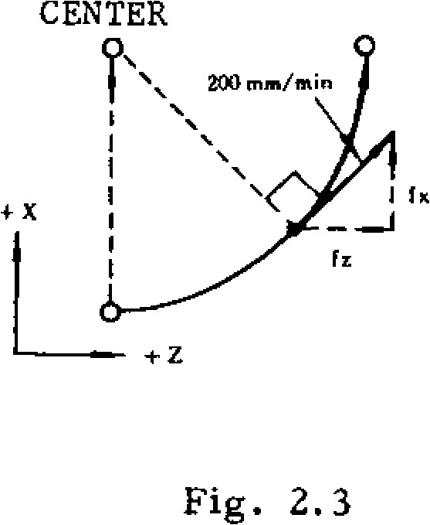

**Fig. 2.3**

**200**

**min/min**

F commands for linear interpolations involving motions in simultaneously controlled three axial directions specify feedrates also in the direction tangential to the motion path.

EXAMPLE

With G O l X . - • Y . . . Z . . . F 4 0 0

F = 4 0 0 = i f X 2 + f Y 2 + f Z 2

(mm /min)

+Y

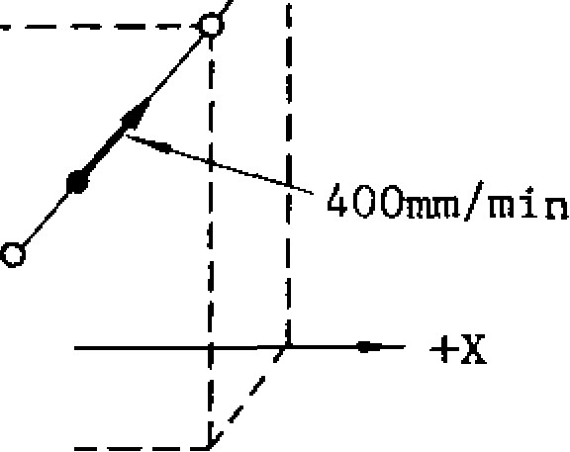

END POINT

START

POINT

+z

Fig. 2.4

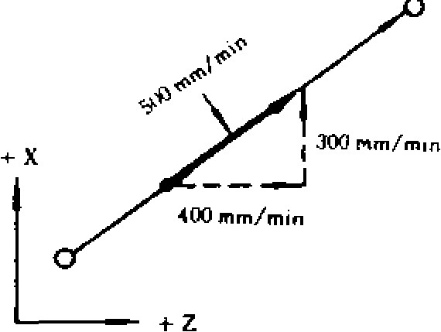

F (mm/min) = JfX 2 + fY 2 + fZ 2 + fet2

Fig. 2.2

F commands for linear interpolations involving motions in simultaneously controlled four axial directions specify feedrates also in the direction tangential to the motion path.

NOTES:

* If FO is programmed, it is regarded as a data error. (alarm code "030)
* Do not program F commands with minus numerals, otherwise correct operation is not guaranteed.

EXAMPLE

F-250 ; ............. wrong

2.4.3 FEEDRATE 1/10

The feedrate programmed by F commands can be converted to 1/10-th value with a parameter setting as follows.

* When parameter #6020 Do or Dl is set to "1," the feedrates range becomes as shown below.

Table 2.15

|  |  |  |  |
| --- | --- | --- | --- |
| **----------------____________._** | | **Format** | **Feedrate (Feed/min) range** |
| **Metric o utput** | **Metric input.** | **F41** | **FI.0- F8100.0 mm /min** |
| **Inch irtput** | **F32** | **F0.01- F313.00 in. /min** |
| **Inch o utput** | **Metric input** | **F51** | **F1.0- F20574.0 mm/min** |
| **inch input** | **F32** | **F0.01 - F810.00 in. /min** |

* When parameter #6020 DO or D1 is set to "0," the feedrate range returns to normal.

**2.4.4 F1 - DIGIT PROGRAMMING ±**

1. Specification of a value 1 to 9 that follows F selects the corresponding preset feedrate.
2. Set the feedrate of each of Fl to F9 to the setting number shown in Table 2.16(a).
3. By operating the manual pulse generator when Fl -DIGIT switch is **on,** the feed rate of Fl digit command currently pecified maybe increased or decreased. Set the increment or decrement value per pulse (Fl-digit multiply) to the parameters listed in Table 2.16(b).

As a result of this operation, the contents of the setting number of the Fl-digit feedrate are changed.

1. Upper Limit of Feedrate

Set the maximum feedrate of Fl-digit designation to the following parameter. If a value greater than the usual maximum cutting rate (the contents of #6228) is set, it is governed by the contents of #6228.

Table 2.16(a)

|  |  |
| --- | --- |
| **F command** | **Se tting N o. fo r F l - d i g i t s p e e d** |
| **Fl** | **#6561** |
| **F2** | **#6562** |
| **F3** | **#6563** |
| **F4** | **#6564** |
| **F5** | **#6565** |
| **F6** | **#6566** |
| **F7** | #6567 |
| **F8** | **#6568** |
| **F9** | **#6569** |

**Setting "1" = 0.1 mm /min**

Table 2.16(b)

|  |  |
| --- | --- |
| **F command** | **Parameter No. for • Fl- dig it m ultiply** |
| **Fl** | **#6141** |
| **F2** | **#6142** |
| **F3** | **#6143** |
| **F4** | **#6144** |
| **F5** | **#6145** |
| **F6** | **#6146** |
| **F7** | **#6147** |
| **F8** | **#6148** |
| **F9** | **#6149** |

**Setting "1" = 0. 1 mm /min /pulse**

Table 2.16(c)

**Parameter No. Meanin g**

|  |  |
| --- | --- |
| **#6226** | **Max speed of Fl to F4** |
| **#6227** | **Max speed of F5 to F9** |
| **NOTES:** |  |

1. **. When this feature is in stalled, the specitying 1 to 9 mm /m in by the usual F f u nc ti o n is no t a l lo w e d, Spe c ify ing 1 0 mm /min or m o re is a llo w e d usually. .**
2. **. If FO is specified, error "030"** w i l l b e c a us e d.
3. **.** W h e n DR Y RU N s wi t ch i s o n, t he r a te o f d r y

r u n i s a s s u m e d .

**d .** F o r Fl - di g it s pe c if i ca ti o n, th e fee d r at e ov e r -

r i d e M a t u r e i s i n v a l i d .

*c.* T h e f e e d r a t e s t o r e d i n m e m o r y i s r e t a i n e d a f t e r t h e p o w e r i s t u r n e d o f

**2. /I. 5 FEED PER REVOLUTION+.**

When a spindle pulse generator is installed, the feed rate per revolution function can be used, and a new G code wilthe used for this function. Before 1 . function for feed rate per revolution is give n, G code of F group shown below must be designated. When the power supply is switched on, G94 is in effect.

|  |  |
| --- | --- |
| G code of group | t h e n e x t F c o d e i s g i v e n . H o w e v e r , w h e n G 9 4 / Function G95 are switched over, F code must be designated |
| G94 | Feed per minute  (mm/min) desig nati on |
| G95- | After the designation of G95, the feedrateF e e d per revolution -of revolu tion can be given by 4 d igits (mm/rev) designation |

Since F code is modal, the code is effective until

again.

tool

per spindle following F. The command range of the F code is as follows.

Table 2.17

|  |  |  |  |
| --- | --- | --- | --- |
|  |  | Format | Feedrate (Feedirnin)rarige |
| Metric output | Metric input | F22 | F0.01 - F99.99 mm /rev |
| Inch input | F13 | F0.001 -F3.936 in. /rev |
| Inch output | Metric input | F22 | F0.01 -F99.99 mm /rev |
| Inch input | F13 | **F0.001 -**F3.936 in. /rev |

Table 2.18

|  |  |  |  |
| --- | --- | --- | --- |
|  | | Format | Feedrate (Feed /rrrin ) range |
| Metric output | Metric input | F23 | F0.001 - F99.999 mm /rev |
| Inch input | F14 | F0.0001 - F3.9366 in. /rev |
| 1 h  output | Metric input | FZ3 | F0.001 - F99.999 mm/rev |
| Inch i nput | F14 | F 0.0001 - *F* 3.9366 in. /rev |

1/10 of minimum unit of F code programmable range can be programmed by setting the contents of param- eter 16 02 00 2However, the programming of feedrate is restrict, 17 , to 1 . See Tabl 2 .18 . e d by the spindle speed ( S ) as shown below .

|  |
| --- |
| S Lc . F e e d r a t e u p p e r l i m i t v a l u e o r c l a m p v a l u e  (rnm /rev o r in . /re v ) (rp m ) (mm /min) |

99 99

FEEDRATE UPPER LIMIT VALUE

F OR CLAMP VALUE

(mm/

rev)

s rpm

F ig . 2 .4 Re s tric tio n o f F e e d ra te (F ) and Spind le Spe ed (5 )

**2.11.6 AUTOMATIC ACCELERATION AND DECELERATION**

Acceleration and deceleration for rapid traverse and cutting feed are automatically performed.

2.4.6.1 ACCELERATION AND DECELERATION OF RAPID TRAVERSE AND MANUAL FEED

In the following operation, the pattern of au tomatic acceleration and deceleration is linear. Positioning (G00)

* Manual rapid traverse (RAPID)
* Manual continuous feeding (JOG)
* Manual HANDLE feeding (HANDLE)

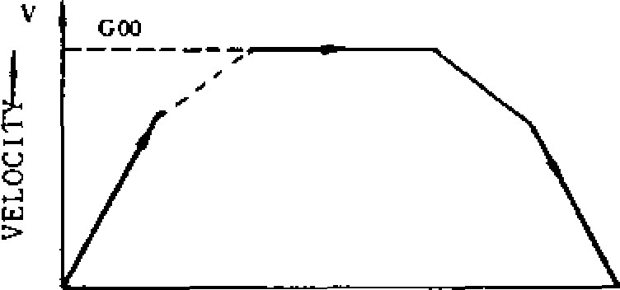

T I M E -

Fig. 2.5

Rapid traverse rate and acceleration /deceleration c o n sta n t o f ra p id tra v e rse ra te c a n b e se t b y parame ter. (#62 80 to #6301)

2. 4.6. 2 ACCELERATION /DECELERATION OF

FEEDRATE

•Automatic acceleration and de Ce lera tion of fe ed motion (G01 - G03) are in the exponential mode.

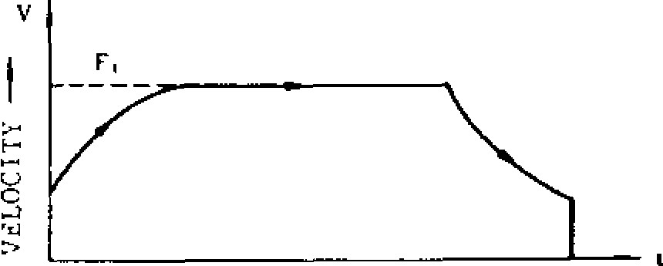

TIME

Fig . 2 .6 Expon entia l ac cele ration deceleration

Feedrate time constants are set at 4 msec inter v a ls an d feedrate bias is se t a t 2k pp s intervals by para meters. (#6092 , #6093 )

Note:

|  |
| --- |
| - 12 - |

T h e a u t o m a t i c acceleration/deceleration parameters are set to the o p t i m u m v a l u e s f o r t h e r e s p e c t i v e m a c h i n e s . D o n o t c h an g e t h e s e t t i n g u n l e s s t h i s i s r e q u i r e d f o r s p e c i a l p u r p o s e s .

**2.5 SPINDLE-SPEED FUNCTION (5-FUNCTION) 2.5.1 S 2-DIGIT PROGRAMMING**

**The spindle speed is specified by two digits fol lowing the address S (S00 to 599).**

**For each S code and its corresponding spindle speed (rpm), refer to the machine tool builder's manual.**

**When a move command and an S code are issued in a block, whether the S command is executed together with the move command or after the completion of tool move depends on the machine tool builder. Refer to the machine tool builder's manual.**

EXAMPLE

GOO 511 M03 ;

• S c o m m a n d

Spindle CW 511: Effective

X...

GO1 Z..- F... •

I

GOO X... Y... Z• • • MO5 ; • . • Spindle stop

; 511: Effective

X... Y• • - 2- — } M 0 3

GO1 Z... F.—

S22 ; X... Y... 522: Effective

NOTE: The two-digit BCD output is sent to the machine when S and two-digit command is issued.

**2. 5.2 S 5-DIGIT PROGRAMMI** NGt

**2. 5. 2.1 S 5-digit Programming**

**With five digits written after an address character S ( S El QC] EJ ) , spindle speeds in rpm are directly commanded.**

**The programmed speeds become , effective upon the inputting of an S-command-completion-inputsignal (SFIN).**

**When an S command is programmed in the same block with M03 (spindle forward run) or M04 (spindle reverse run), the execution of the next block starts only after the spindle speed reaches to the level specified by the S command, in most cases. However, for exact behavior of the ma chine tool under consideration, refer to the ma chine tool builder's manual.**

EXAMPLE

S 1000 MO3 ;

1000 rpm

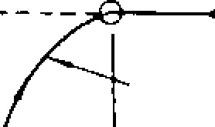At ".T.11, SPINN.F. SPFFP

• 4'.14:1'

**1----•------ corTLETI** ON OF

11 COMMAND

START OF

**The S commands are modal, and when it is pro grammed once, it remains effective until another command is programmed. Even when the spindle is stopped by a M05, the S command remains effective. Therefore, when the spindle starts again with an M03 (or M04), the spindle runs at the speed specified by the S command.**

**When the spindle speed is to be changed by a new S command after it is started with an M03 or M04, attention must be paid to the selected spindle speed range.**

**NOTES:**

**The lower limit of programmable S commands (SO and other S commands for near 0 values) is determined by the spindle motor of the machine tool. Refer to • the machine tool builder's manual. Do not program minus values as S commands.**

• **When the control is equipped with the S 5-digit command function, spindle speed overriding i s pos sible . Tha t is , ov err ide sp eeds be t ween 50 and 120% of the commanded spindle speed can be obtained at intervals of 10%.**

# 2.6 TOOL FUNCTION (T-FUNCTION)

**2.6.1 T 2-DIGIT PROGRAMMING**

**Two digits, following the address T, specify the tool number. Leading zeros may be omitted.**

**T** ❑❑

**Tool number**

**The figures used for the designation of tool num ber are determined by the machine. Refer to the machine tool builder's manual.**

**When a move command and a T code are issued**

simultaneously ,

* **the two commands are executed simultaneously, or**
* **the T command is executed upon completion of the execution of the move command,**

**depending on the design of the machine.**

**For this, refer to the machine builder's manual.**

**T codes are modal, and therefore, once they are given, they remain effective until another T command is given.**

|  |
| --- |
| THE BLOCK **Fig. 2.7 - .13 -** |

**T code commands are generally for making automatic tool changers (ATC) to select the tool number to be used next. Therefore, they can be given without regard to the G, H or D codes which are for offsetting for the length or radius of the tool currently in use.**

2 . 6 . 2 T **4 - DIGIT + PROGRAMMING**

Four digits following the address T specifies the tool number.

T ❑ ❑ ❑ ❑

______ Tool number

* Leading zeros may be omitted.
* This tool code is the same as the T 2-digit codes, except for the increased number of digits.

# 2.7 TOOL COMPENSATION

**2.7.1 OUTLINE OF TOOL COMPENSATION**

The tool compensation function is in the following three modes.

Tool length compensation

This function is for compensating for differences in tool length, and is effective in the Z axis direction. Specified length compensation becomes effective from the block in which G43 or G44 is programmed together with an H code. It is cancelled with H00 or G49.

Tool position offset (for simple compensation for tool radius)

This function is for compensating for errors in machined dimensions to be introduced by the radius of tools. It is effective in the X, Y , and Z ( 4th" ) axis directions. It is effective only for the block in which G45 - G48 is programmed together.

Tool radius compensation C + (for compensating for tool radius effects with complicated machining contours)

This function is for compensating for the tool radius effect with any given machining contours . It is effective in X -Y, Y-Z, and Z-X planes.

It becomes effective from the moment G41, or G42 is commanded together with a D code, and is cancelled by G40.

N O T E : For details of these compensations functions, -refer to 2.9 PREPARATORY FUNCTION (G-FUNCTION).

**2. 7. 2 T OOL OFF SET M EMOR Y**

For the three groups of offsets, all the necessary o ff se t v a lu e s mu s t b e s to r e d i n m e mo ry b e fo re hand.

Up to 99 offset values can be stored in the tool offset memory_

[ - O f f s e t v a l u e sto ra g e : 9 9 ma x .

The setting range of offset values is as follows.

|  |  |
| --- | --- |
|  | Linear axis |
| Metric input | 0 - .± 999.999 mm |
| Inch input | 0 - ± 99.9999 inch |

Rotary axis1

0- ±. 999.999 deg

0 - ± 999.999 deg

Listed input values do not depend on metric/input output system.

For the procedures of storing values into memory, refer to 4.3.5 WRITING OF TOOL OFFSET VALUE.

**2.7.3 H AND D FUNCTION (H ,D CODES)**

Two digits, following the address **H** or D, specify tool offset numbers.

H Q ❑ o r D

Tool offset number

The tool offset numbers 01 through 99 directly correspond to the 99 offset -value memory numbers. That is, when certain numbers are designated , the corresponding offset values stored in the offset memories will be used to offset the tools.

Tool offset numbers 00 (H00 or D00) have differ end meanings depending on the respective offset functions. For details , refer to the descriptions on the respective G functions.

H - and D-codes must be used properly according to their functions.

|  |  |
| --- | --- |
|  | Function |
|  | Tool length offset |
|  | Tool position offset, Tool radius compensation |

Code

H code

D code

The tool offset numbers 01 through 99 can be used freely in combination with the both H arid D codes.

|  |  |  |  |  |  |  |  |  |  |  |  |  |  |  |  |  |  |  |  |  |  |  |  |  |  |  |  |  |  |  |  |  |  |  |  |
| --- | --- | --- | --- | --- | --- | --- | --- | --- | --- | --- | --- | --- | --- | --- | --- | --- | --- | --- | --- | --- | --- | --- | --- | --- | --- | --- | --- | --- | --- | --- | --- | --- | --- | --- | --- |
| |  |  | | --- | --- | | However, for programming case, it is recommended to divide the numbers in to H code part and | H cod es: H0 1 to H30  D cod es: D3 1 to D99 |   D cod e part.  Table 2.19   |  |  |  |  | | --- | --- | --- | --- | | Offset method | G code | H or D code | Offset value memory | | Tool length offset | G43  G44  G49 |  | |  |  | | --- | --- | | No. | Offset value | | 01 |  | | 02 |  | | 03 |  | | 04 |  | |  |  | | 96 |  | | 97 |  | | 98 |  | | 99 |  | | | Tool position offset | G45  G46  G47  G48 | **D u El** | | Tool dia. compensa-  tion C  (Intersection computing system) | G40  G41  G42 | |

**2.8 MISCELLANEOUS FUNCTIONS (M-FUNCTION)**

The miscellaneous function is specified with the address M and three digits. The function of each M code (MOO to M89) is determined .by the machine, except for several M codes. Refer to the machine tool builder's manual for the function of M codes except for the following M codes concern ed with the control.

**2.8.1 M CODES FOR STOP (MOO, M01, MO2, M30)**

MOO (Program Stop)

This code, when given in automatic operation mode, stops the automatic operation after the commands in the block containing MOO have been completed and MOO R signal is fed. The program may be continued by pressing the CYCLE START button.

• MO1 (Optional Stop)

M O1 performs the same function as program stop MOO whenever the OPTIONAL STOP switch is on. When the OPTIONAL STOP switch is off, the MOI code is disregarded.

MO2 (End-of-Program)

A10. 1 k used at the end of program. Whorl given

**UttItllat it' 01'101%114M Motic• ,** this code stops

th e automa tic opera tion after the co mmand s in the block containing MO2 have been completed. Although the control is reset in most cases , the details are determined by the machine. Refer to the machine tool builder's manual..

M30 (End-of-Tape)

M30 is given at the end of tape. When given in automatic operation mode, this code stops the automatic operation after the commands in the block containing M30 have been completed. In a d d i t i o n , i n m o s t c a s e s , t h e c o n t r o l i s r e s e t a n d re win d s th e ta p e (o r me mo ry ) . S in c e th e d e t a i l s a r e d e t e r m i n e d b y t h e m a c h i n e , r e f e r to the machine tool builder's manual.

NOTES:

When MOO, M01, MO2 or M30 is gi ven, it prev e n ts t h e c o n t ro l fr o m re a d i n g a h e a d th e n e x t

b lo c k o f in fo rma tio n . T he sin g le d e c o d e d s i g n a l

is fe d in a dd itio n to the 2 - dig it BCD o u tp u t fo r

M codes.

Whether MOO, M01, MO2 or M30 executes spin dle stop, coolant off or some other executions, refer to the machine tool builder's manual.

Whether the control is automatically reset or re win d s th e ta p e (o r me m o ry ), i s d e te rm in e d by the following state.

1. Input signal of the control "EOP" **(internal** re se t in p u t) is wire d fo r 'O N " o r n o t .
2. **Input signal of the control** "RWD" (rewind in put) is wired for "ON" or not.

Refer to the machine tool **builder's manual.**

**2. 8.2 M CODES FOR INTERNAL PROCESSING (M90 TO M199)**

M90 through M199 are used only for internal pro c e s s i n g . E v e n w h e n t h e y a r e p r o g ra m m e d , n o ex ternal outp ut signal (BCD and decoded outp ut) is sen t.

M9 0 1 : Program interrupt off

M 9 1 t : Program interrupt on

M 92±: Multi-active register off

M93±: Multi-active register on

M94: Mirror image off

M95: Mirror image on

M96±: Tool radius compensation C: circular path mode

M97t: Tool radius compensation C: intersection computing mode

M98: Subroutine program call

M99: Subroutine program end M100 to 199: Used for enhanced codes

**2.8.3 PROGRAM INTERRUPTION ON /OFF (M90, M91) 1**

The following M codes are used for the program interruption function .

Program interrupt function OFF

Meaning

M code

M90

|  |  |
| --- | --- |
| M91 | Program interrupt function ON |

Note: When power is applied or the control is re set, the control is in the state of M code marked with -1 .

M91 P

During the time from this command to an M90 c o m m a n d , w h e n e v e r a p r o g r a m i n t e r r u p t i o n s i g n a l i s r e c e i v e d , t h e p r o g r a m u n d e r e x e c u tion is interrupted (if the mach ine is in motion, it is stopped afte r dece lera tion), an d the a ju mp is made to the program the number of which is w ritte n a f te r th e P.

• M90

With this command, the program interrupt function is cancelled.

Mirror image OFF

Mirror image ON

2 . 8 . **4 MULTI-ACTIVE REGISTERS ON /OFF**

**(M93, M92)±**

Multi-active register off

M code

M92

Meaning

|  |  |
| --- | --- |
| M93 | Multi-active register on |

Note: When power is applied or the control is re se t, the control is in the state of M code marked with.

M93:

During the time from this command to M92, the control assumes the 5 blocks -advance-reading mode . Namely , up to 5 blocks of data are read in advance for the following operation.

Inter-block stoppage can be eliminated when the program is so made that the operation time of advance reading of 5 blocks is longer than p ro c e ssin g t ime o f a d v a nc e re a d in g o f n e x t 5 blocks of data.

• M92:

This command cancels 5 blocks-advance-reading mode.

NOTE: In tool radius compensation C mode , the blocks without move command can be contained(up tc two blocks). Under this condition , 7 blocks, including the two blocks, may be read in advance.

**2. 8. 5 MIRROR IMAGE -ON/OFF (M 95, M 94)**

Note: When power is applied or the control is reset, the control is

Meaning

M code

M94

M 95 in the state of M code marked withl.

With these code s, mirror image operation can be started and stopped at any desired po int in the program. These commands must always be made on a single block.

M94 and M95 are modal. When the power supply is turned on , M94 (OFF) is in effect.

The axis on which mirror image is to be effect ed is specified by setting #6000D0 to D3 (or mirror imag e a xis d esigna tion switch .) F or t h i s p r o c e d u r e , r e fe r t o **6.1.25 MIRROR IMAGE** AXIS SELECT SWITCH.

* **When M95 is given, the subsequent blocks will control the machine in mirror -image fashion, that is, movements in the specified coordinate direction will be reversed.**

**Y** 1

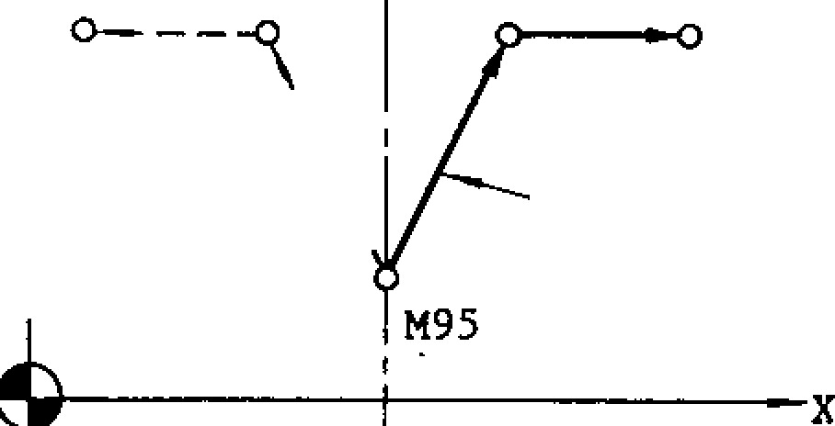

**■**

**---**

**'**

**1.**

**-**

**\**

**\**

**PROGRAMMED**

**COMMAND**

**X AXIS MIRROR**

**IMAGE ON**

**Fig. 2.8**

**With both the absolute and increment move commands, the same mirror image effect will be obtained. The block including M95 command constitutes the mirror point.**

**When M94 is given, mirror image effect will be cancelled on the subsequent blocks. Mirror image operation must be started and cancelled at the same position.**

**NOTES:**

* **When G28 or G29 is used to change tools or for ending machining processes, make sure to cancel the mirror image effect by means of M94. If mirror image effect is not cancelled when G28 or G29 is given, an error "058" is shown,**

**The mirror image effect is not effective on the offset movement resulting from the tool length offset function.**

**Do not switch the designation of mirror image axis during operations under M95 (ON) mode.**

**Displayed current position by POS key in mirror image fashion indicates the actual motion of tool. Displayed data by COM key show programmed commands.**

* **Program must be made so that mirror image operation starts and stops at the same position. If the start position and the stop position are not the same, movements of the machine after cancelling mirror image will be shifted by the difference between both positions.**

**When the operation is reset, it will be in M94 mode.**

2.8.5 MIRROR IMAGE.ON/OFF (M95, M9 14) (CONT'D)

EXAMPLE

X AXIS MIRROR IMAGE ON

PROGRAMMED COMMAND

100

40

|  |  |  |
| --- | --- | --- |
|  |  |  |
|  |  |  |

**L._ _ ALI\**

-

80

\

-120 -40

-20

STAR 2 0 4 0 60 120 POIN1

PATH BY

CORRECT PATH

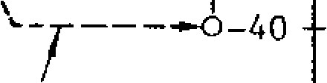

ERRONEOUS CANCELLING

N O 1 G 9 2 X0 YO ;

NO2 M 9 5 ;Mi rro r i mage on.

N O 3 G 9 0 G O 1 X 4 0 0 0 Y 4 0 0 0 F 3 0 0 ' ;

N04 X12000 ;

N05 Y10000 ;

N06 x4000 ;

N07 Y4000

___ I f " M 9 4 ; " i s p r o g r a m m e d h e r e ,

NO8 X0 YO

the tool moves on the dotted line.

;

N09 M94 ; Correct mirror image off N10 X2000 Y-4000 ;

N11 x6000

Fig. 2.9

**2.8.6 CIRCULAR PATH MODE ON/OF F ON TOOL RADIUS COMPENSATION C (M97, M96) 1**

M code Meaning

•

M96 Tool radius compensation circular path on.

M97 Tool radius compensation circular path off.

(Execution of intersection point)

Note: When power is applied or the control is reset, the control is in the state of M code marked with,

* **In the G41 or G42 cutter radius compensation mode, when M96 is given, the tool moves along a circular path around a corner with an angle of 1800 or larger. In the M97 mode, the** tool does not move along a circular path at the corner, but moves along two intersecting straight lines intersecting at a calculated intersecting point shifted from the programmed contour by the tool radius.

M96 MODE M97 MODE

CIRCULAR

PATH INTERSECTION

PROGRAMMED

CONTOUR

Fig. 2.10

M96 and M97 are modal. When the power is turned on, M96 takes effect.

* M96 and M97 are effective on the following move command blocks.

**G01 X • • . Y... F ;** Effective **from** the corner of

**(G01) X• • • Y.• •** M96 ; **these 2 blocks**

**GO1 X••• Y••. F••• ; Effective from**

**M96 (or M97) ; the corner of**

**these 2 blocks**

**(G01) x... y... ;**

**2. 8. 7 SU B R OU T IN E PR OGR A M (M 98, M 99)**

With this function, call of subroutine programs which have been numbered and stored in advance is made and executed as many times as desired.

* The following M codes are used for this function.

**Table** 2.26

M code Meaning

M98 Call of subroutine program

**M99** Subroutine program end

* Call **of subroutine program (M98)**

M98 P.• L•.

With this command, call of the subroutine program with the number specified after P is made and is executed number of times specified after L. When no L code is programmed, the sub - routine is executed once.

Subroutine programs can be nested up to 4 times.

Format of subroutine program (M99)

Subroutine programs are written in the following format, and are stored in the part program memory in advance.

0 • • • — Program No.

M99 ; Subroutine

program end.

Automatic return command from subroutine pro gram

M99 ;

At the end of subroutine programs, M99 is written in a block of its own. **When M99 is commanded in the subroutine** program which has been called by M98, the execution of the main program is automatically restarted at the block immediately following the M98 block.

|  |
| --- |
| 2.8.7 SUBROUTINE PROGRAM (M98, M99) (CONT 1D)  EXAMPLE  Call of subroutine programan d execution of it are made in the sequence shown below .  Main program Subroutine program        0100  ;    N001 GOO    N002 M98 P200 L3 ;    N003    -    • •    N004 M98 P200 ;    N005            E  0200    ;    N001    -    -    N002    •    -    N050    M99    ; |

Special use of M99

M99 P. • •

With this command, the main program does not return to the block following the M98 block after executing the subroutine program, but returns to the block with a sequence No. specified by the P code.

NOTES:

If the program number specified by the P code is not found, this is regarded as an error "0 4 1 . "

While a subroutine program is repeated L times, the number of remaining repetitions may be displayed. For details, refer to 4.3 DISPLAY AND WRITING OPERATION.

This function is usable when subroutine programs are stored in the part program memory. The main program can either be commanded from NC tape or the part program memory.

When the nesting of subroutine programs is attempted more than 4 times, an error state is caused.

Commanding M99; in main program will return the execution of the program to the head of the main program and control endless operation.

2.8.8 OTHER M CODES

For using M codes, other than those mentioned above, refer to the machine tool builder's manual.

**C1)**

0

Table 2.2 0 Typical Examples of

M codes for Machine

M code

M03

M04

M05

M08

M09

Meanings

Remarks

Spindle forward

running

Spindle reverse

running

M03 and M04 are

not

s witch able.

M 0 5 (s t o p ) m u s t

be intermediated.

Spindle stop

Coolant on

Coolant off

When these M codes are given in a block together with move command, whether the M commands are executed simultaneously or after completion of move command, are determined by the type of machine. Refer to the machine tool builder's manual.

2.8.9 2ND MISCELLANEOUS FUNCT ION (B-FUNCTION)t

B -function and T 4 -digitt commands cannot be used simultaneously.

Three digits following the address B givein table positions.

The actual index positions corresponding to the respective **B** codes depend on the machine tool builder. For this, refer to the specifications of the machine tool builder. When a B-function is given together with a move command in one block,

* the B command is executed simultaneously with the move command, or
* B command is executed after the execution of the move command,

depending on the design of the machine tool. For this refer to the specifications of the machine tool builder.

B codes are modal. When one B code is given, it remains effective until another B-command is given.

NOTES:

* **B** function standard interface is in 3-digit BCD output.
* With MDI operation on NC panel, "B" is used to specify address for **B** codes. Therefore, when the control has B-function, the 4th axis control cannot be added.

# 2.9 PREPARATORY FUNCTION (G-FUNCTION)

**2. 9. 1 L I ST OF G C OD ES A N D GR OU PS**

An address character G and up to 3 digits following it specify the operation of the block.

Ordinary G codes are either non-modal G codes marked with * or modal G codes belonging to groups 01 through 15. Those G codes belonging to the division 13 are included in the basic specifications.

The G codes belonging to groups 01 through 15 are modal, remaining effective when once commanded until other G codes in the same group will be commanded.

The G codes in the * group are non-modal, and are effective only for the block in which they are commanded.

The G codes belonging to groups 01 through 15 may be programmed twice or more in the same block. However, when different G codes in the same group are programmed, the last appearing G code only is effective.

The G codes belonging to the * group can not be programmed twice or more in a block. They must be programmed only once in a block of its own.

* When a G code belonging to the 01 group is commanded during a canned cycle (673, G74, 676, G77 and G81 through 689), the canned cycle is cancelled and these codes in the group 09 becomes G80.

When the RESET key is depressed during the execution of a tool compensation C (G41, or 642) or a canned cycle, they become respectively G40 or G80 which cancels the programmed commands.

* G43, G44, 649 and G45 through G48 belonging to the * group can be programmed together with the following G codes in the 01 group in the same block.

|  |  |
| --- | --- |
|  | Combination G code |
| G43, G44, 649 | GOO, G01, G60 |
| G45 - G48 | GOO, G01, G02, G03, G60 |

* The transition state of the following G codes can be changed by setting of parameters.

The G codes belonging to the following groups can be specified as to the state immediately after the application of supply power. (#6005D0 - D4)

|  |  |  |
| --- | --- | --- |
| Group | Initial state | Parameter |
| 01 | G00 or 001 | #6005D2 |
| 03 | G90 or G91 | #6005D0 |
| 05 | G94 or G95 | #6005D1 |
| 08 | G43, G44 or G49 | #6005D3, D4 |

* G codes in the 01 group may selectively be changed to G00 or kept unchanged after resetting. (#6005D6)
* During the execution of G92, Display may selectively be made. (#6005D5).

**2.9.1 LIST OF C CODES AND GROUPS (CONTI D)**

Table 2.21 List o f G cod es

|  |  |  |  |  |
| --- | --- | --- | --- | --- |
| code | | Groupi | Function | B: Basic 0 : Optional |
|  |  | 01 | Positioning | B |
| a-1111 | Linear interpolation |  |
| 002 | Circular interpolation CW, Helical interpola- tion CW | B, 0 |
| G03 | Circular interpolation CCW, Helical interpola- tion CCW | B , ❑ |
| 004 |  | * | Dwell |  |
| G06 | Positioning in error detect off mode | B |
| G09 | Exact stop |  |
| G 10  G12  G13 | Tool offset value and work coordinate, Shift - value modification | B, 0 |
| Circle cutting CW |  |
| Circle cutting CCW | 0 |
| G 171 |  | 02 | XY plane designation | B |
| G18 | ZX plan e desi gnat ion | B |
| G19 | Y Z plan e desi gnat ion | B |
| G20 |  | 06 | Inch input designation | ❑ |
| 021 | Metric input designation | 0 |
| G221 |  | 04 | Stored stroke limit ON | 0 |
| G23 | Stored stroke limit OFF | 0 |
| G27 |  | * | Reference point check | 0 |
| 028 | Automatic return to reference point |  |
| 029 | Return from reference  point | 0 |
| 030 | Return to 2nd, 3rd, 4th reference point |  |
| G31 | Skip function | 0 |
| G33 |  | 01 | Thread cutting | 0 |
| G 36 |  |  | Automatic centering | 0 |
| G37 | Automatic centering | 0 |
| G 38 | Z-ax is reference sur face offset | 0 |
| G 4 0 1 |  | 07 | Tool radius compensation cancel |  |
| G41 | Tool radius compensation, left | ❑ |
| 042 | Tool radius compensation, right | 0 |
| G43 |  | 08 | Tool length compensation , plus direction | B |
| 044  _ _ , , , | Tool length compensation, minus direction | B |
| G49 | Tool length compensation, cancel | B |
| 045 |  |  | Tool position offset, extension | B |
| 046 | Tool position offset, retraction | B |
| 047 | Tool position offset, double extension | B |
| G48 | Tool position offset, double retraction | B |
| 050-1 6-51— | l | c ,  '' | Scaling OFF | 0 |
| Scaling ON | 0 |
| 052 |  | 12 | Return to base coordinate system | 0 |
| 053 |  | * | Temporary shift to machine coordinate system | o |

|  |  |  |  |  |
| --- | --- | --- | --- | --- |
| U , c o o t , | Group | | Funct ion | B : B a s n 7 -  0: Option al  ❑ |
| G54 | 1 | 2 | Shift to work coordinate system 1 |
| G55 | Shift to work coordinate system 2  0 |  |
| G56 — | Shift to work coordinate system 3 | 0 |
| G57 | Shift to work coordinate system 4 | 0 |
| G58 | Shift to work coordinate system 5 | 0 |
| G59 | Shift to work coordinate system 6 | ❑ |
| 060 |  | 01 | Unidirectional approach | ❑ |
| G61 |  | 13 | Ex act stop mode | B |
| --6-61 | Ex act stop mode cancel | B |
| G65 |  | * | Non-modal call of user macro | 0 |
| G66 |  | 14 | Modal call of user macro | 0 |
| — 1  G67 | ' Modal call of user macro cancel | 0 |
| 070 |  | * | Bolt hole circle | 0 |
| G71 | Arc | ❑ |
| G72 | Line -at -angle | ❑ |
| G73 |  | 09 | Canned cycle 10 | ❑ |
| G74 | Canned cycle 11 |  |
| G76 | C an n ed cy cl e 1 2 |  |
| G77 | r Canned cycle 13 | 0 |
| CT8-0-1 | Canned cycle cancel | ❑ |
| G8I | Canned cycle 1, Output for external motion | 0 |
| G82 | C an n ed cy cl e 2 | 0 |
| G83 | Canned cycle 3 | 0 |
| G84 |  | 09 | Canned cycle 4 | 0 |
| G85 | Canned cycle 5 | 0 |
| R-6— | Canned cycle 6 | 0 |
| G87 | Canned cycle 7 | ❑ |
| G88 | Canned cycle 8 | 0 |
| G89 | Canned cycle 9 | 0 |
| 1  G90 |  | 03 | Absolute command designation | B |
| G91 | Incremental command designation | B |
| G92 |  | * | Programming of absolute zero point | B |
| ■  G94 |  | 05 | Feed per minute  (nun /min) designation | o |
| 095 | Feed per revolution (mm/rev .) designation | ❑ |
| ■  G98 |  | 10 | Return to initial point for canned cycles | 0 |
| G99 | Return to point R for canned cycles | ❑ |
| G1001  0101 | 1 | 6 | , High-speed cutting cancel | 0 |
| High-speed cutting in sequential processing mode ON | 0 |
| 0102 | High-speed cutting in  processing mode ON | ❑ |

G

Notes:

* 1. The G codes in the * group are non -modal. and are effective only for the block in which they are commanded. They can not be programmed twice or more in a block. They must be programmed only once in a block of its own.
  2. The codes marked with **lir** is automatically selected at power on or reset .

- 22 -

**2.9.2 POSITIONING (COO, G06)**

GOO X • • • Y... Z • • . ;

( wh e re a = A , B, C, U, V, o r W)

With this command, the tool is sent to the speci fied position in rap id traverse mo tions a long the 3 axe s (4 axe s + ) simultaneou sly. If any of the coordinate positions is not specified, the machine does not move along that coordinate axis.

T he ra p id trav e rse ra te fo r th e respe c tiv e ax e s a re inh ere nt to th e ma ch in e to ol. Refe r to the machine tool builder's manual.

Motions in the respective axis directions are independent each other, and therefore, the resultant tool path is not necessarily straight. When programming tool position in g commands, take care to avoid the possibility of tool and workpiece interference.

EXAMPLE G01 X4000 Y4000 Z4000 ;

Y

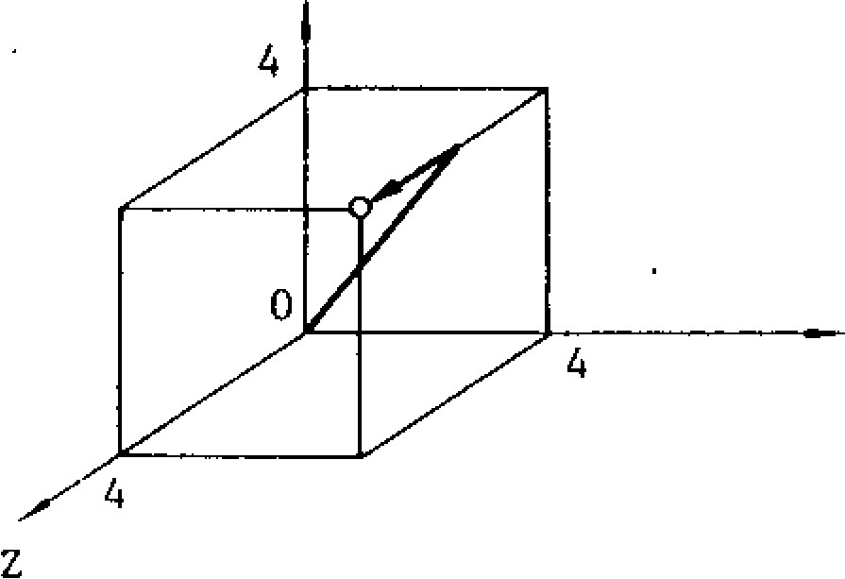

Rapid traverse rate

X axis: 8 m /min Y a x is: 8 m/ min

Z axis: 4 m /min

F i g . 2 . 1 1

G00 is a modal G code belonging to the 01 group.

Error detect OFF positioning (G06

G06 X • • • Y- - • Z... (at. • •) ;

With this command, the same positioning motions are initiated as with a GOO command, with the following exceptions.

After the completion of the positioning motion with G06 block, the program advances to the next block in the ERROR DETECT OFF mode (Note). Therefore. the tool path at the corner is rounded.

G06 is a non modal G code belonging to the * group. and therefore. it is effective only in it is programmed.

NOTE

G00 commands position the tool in the ERROR DETECTION mode , which means that the program advances to the next block only after the servo lag pulses are decreased below the permissible level, and this is detected by the control. With this command, therefore the corner of the workpiece is machined sharp.

•

With the ERROR DETECT OFF mode commanded by G06, the program advances to the next block immediately after the completion of pulse distri bution.

**2.9.3 LINEAR INTERPOLATION** (G01)

GO1 X... y... Z... (a±. -•) F... where a = A , B , C , U , V , o r W

With this command, the tool is moved simultaneously in the three (fourt) axial directions result in g in a linear motion . When a certain axis is missing in the command , the tool does not move in the axial direction of that axis. Feedrate is specified by an F code the feed rate in the component axial directions are so control led that the resultant feedrate becomes the specified feedrate.

, F = / F x 2 + F y 2 + F z 2 + **F a 2**

(where Fx, Fy• .. are feedrate in the X, Y. - directions.)

The end point can be programmed either in ab solute coordinates or in incremental values with G 9 0 o r G9 1 respectively. (Refer to 2.9.3 1

Absolute /Incremental Programming (G90, G91))

If no F code is given in the block containing the G01 or in preceding blocks, the block constitutes an error "030."

EXAMPLE

G01 X4000 Y4000 Z4000 F100;

Y

cp;:onal axis arritary axis (A,

100 mm/min

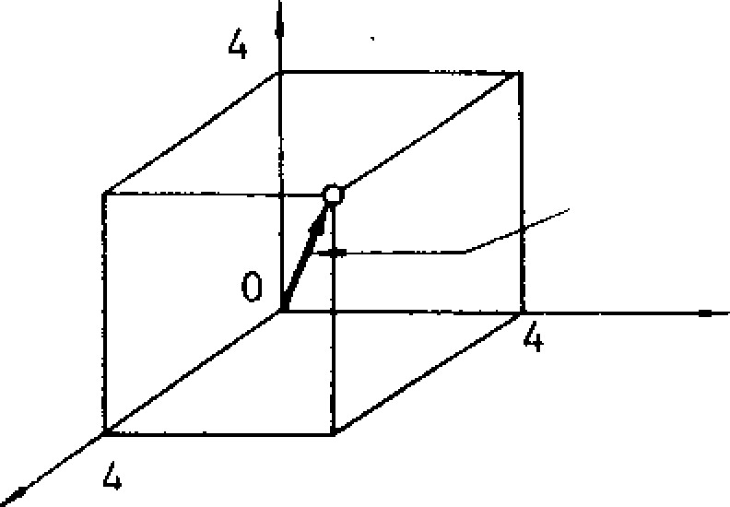

RESULTANT

FEEDRATE

(TANGENTIAL FEEDRATE)

X

Fig. 2.12

13 or C) , for the same F code, the feedrates in the basic three axis directions (X, Y and Z), and the rotary axis feedrate are as indicated.

- 23 -

2.9.3 **LINEAR INTERPOLATION (G01) (CONT'D)**

Table 2.22

|  |  |  |  |  |
| --- | --- | --- | --- | --- |
|  | F-function |  | In minimum F command unit | |
| Feedrate in basic three axes | Feed rate of rotary axes |
| Metric output | Metric input | F40 | 1 mm/min | I deg/min |
| Inch input | F31 | 0.1 in | 2.54 deg/min. |
| Inch output | Metric input | F50 | 1 mm /min | 0.3937 deg /min |
| In c h in p u t | F31 | 0.1 in. /min | 1 deg /min |

Note: Feed rate of linear 4th as the same as that of basic three axes.

**2.9.4 CIRCULAR INTERPOLATION (G02, G03)**

|  |  |
| --- | --- |
| With the following commands, the tool is control - | ZX, or YZ p lane; at a tangential speed specified |
| led along the specified circular paths on the XY , | by the F code . |

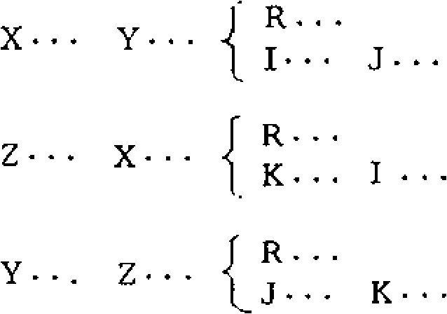{ G02

XY plane G17 G 0 3 { }F.- -

G oo 2 1

ZX plane G18 F- - -

G3 - If

Y2 plane G19 G 0 2 1, F...

,G031 j.

The moving direction of the tool along the circle is as follows.

G2: Clockwise

G3: Counter-clockwise

Y x z

G02 GO'\3:

X Z Y

GO;

\

\

G02

G02

G03

\

XY plane ZX plane YZ plane

(G17) (G18) (G19)

F ig . 2 .1 3

When circular interpolation (G02, G03) is to be programmed, usually, the plane of interpolation should be specified in advance with G17, G18 or G19.

G17 : XY plane or X4 plane t

G18: ZX plane or Z4 plane t

G19: YZ plane or Y4 plane t

In addition to the plane of circular interpolation, these G codes specify planes for tool radius corn-

EXAMPLE

G17 G90 003 X1500 Y4000 1-3000 J-1000 F150 ;

1. Absolute command with (G90)

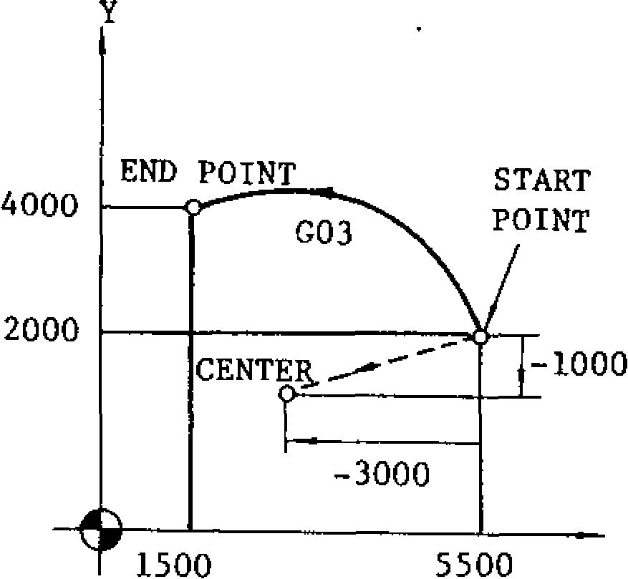

START

POINT

Instead of the coordinates I, J, and K of the center of the circle, the radius can be directly specified with an R command. This is called circular interpolation with radius R designation mode.

G17 G02 X . . . Y . . . R * . . . F . . .

pensation (041, 042). If no selection is made to the contrary, XY plane (G17) is selected automatically immediately after the switching of the power supply.

The end point of the circular arc may be specified by G9 0 o r 091 respectively in absolute or incremental values. However, the center of the circle is always programmed in incremental values from the start point, irrespective of G90 or 091.

G17 G91 003 X-4000 Y2000 1-3000 J-1000 F150 ;

1. Incremental command

Y

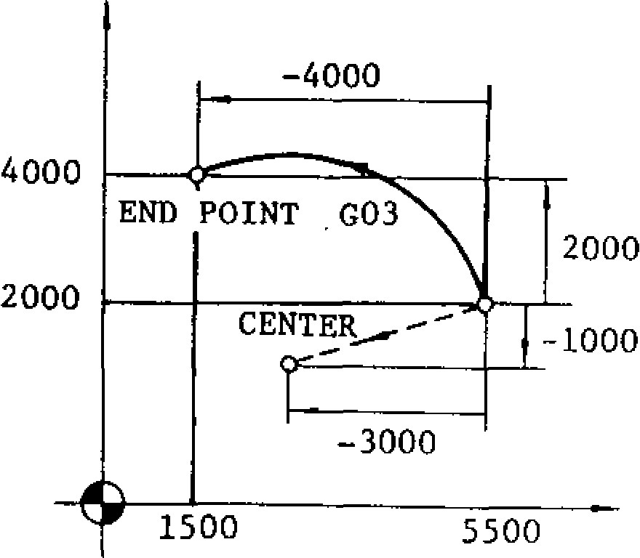

**Fig. 2.14**

|  |
| --- |
| **Fig. 2.15**    **180**  **°**    **OR BELOW** |

**In this case, when R > 0,** a circular arc with the center angle less than 180°, andwhen R < 0, a circular arc with the center angle larger than 180° are specified.

**2.9.4 CIRCULAR INTERPOLATION (G02, G03) (CONT'D)**

G17 G02 (G03) I . . . J • • • F . . . L n

With this command, complete circular interpolations are repeated n times. Without an L designation, the interpolation is executed only once.

G02

X a plane G17 G03 X- • a. GO2 Z• - Z a plane G18 '{.003

Yet. plane G19 J GO2 Y. a.

LGO3

NOTE:

• G17 G02 X...

{ • J • • - 1 F . - .

Where address characters for the 4th axis is missing as in the above command, the XY plane is automatically selected. Circular interpolation can not be performed on the axes including When a linear 4th axis option is used, circular interpolation is possible in the X or , Za , and Y a planes in addition to the XY, YX, and ZY planes (where a . = U, V, or W)

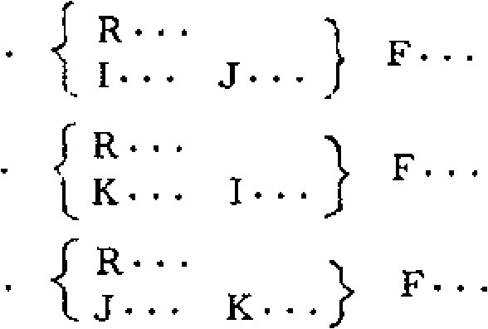

F.

F.

K.

-

•} F...

The end point is represented by "°."

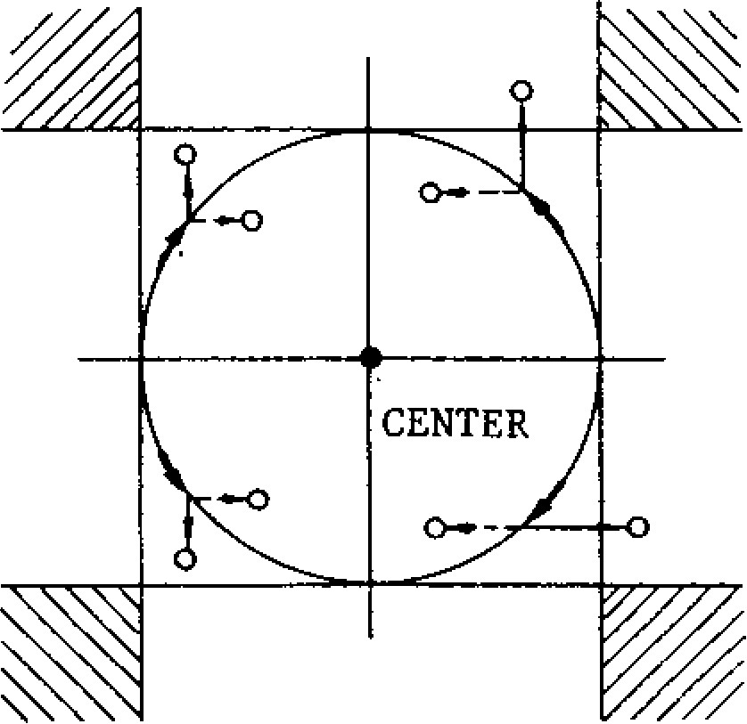

rotary 4th axis.

Circular paths covering two or more quadrants can be programmed in a single block. A complete closed circle can also be programmed.

EXAMPLE

G00 XO Y0 ;

G02 X0 Y0 1 1 0 0 0 J O F 1 0 0 ;

complete circle

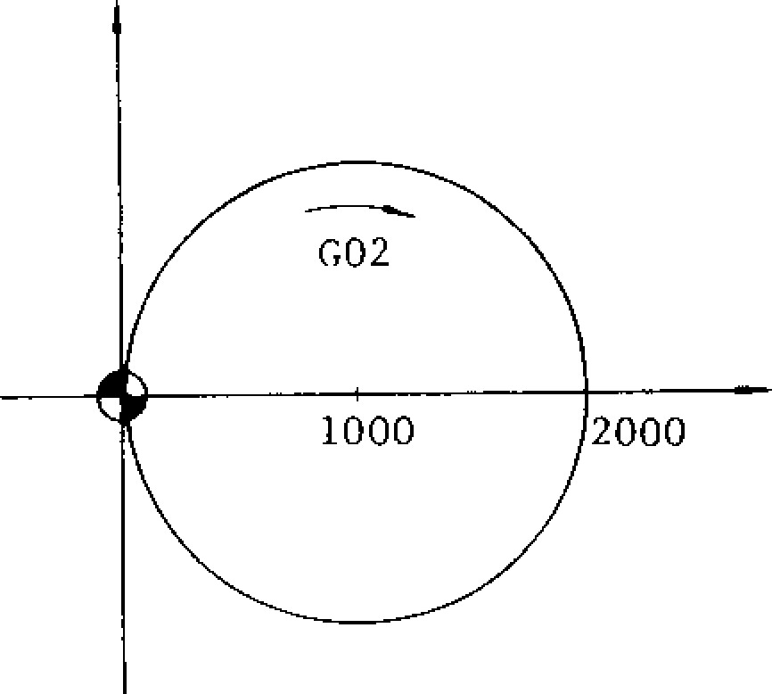

Fig . 2 .16

When the coordinate values of the end point of a circular path is not exactly on the correct circular path due to calculation errors, etc., correction is made as shown below. Points 0 are commanded as end point. ( S e e th e figure below.)

F ig . 2 .1 7

When the end point is programmed in the hatched areas shown above, no alarm state is created, but the tool will keep on rotating. Especially when tool compensation is applied, coordinate values of the point and the center must be programmed accurately .

2.9.5 **HELICAL INTERPOLATION (G02, G03) ±**

A circular interpolation on a certain plane, and a linear interpolation along an axis not included in that plane can be executed in synchronization, and this combined interpolation is called helical interpolation.

- Command format

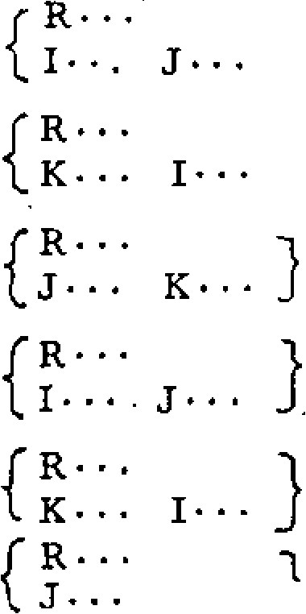

K• • •

( a ) For X Y plane G17 **1 0 0 2** X• • . Y...

003i

**0021**

( b ) For ZX plane G18 **1003i**

Z . . . X .

**f 0021**

( c ) For YZ plane G19 **1003..)** Y. • • Z. • • ( d ) For x a plane G17 **1003002** X.. • a • • •

1. For Z a plane G18 **_10021** Z • • • a •

1G03

1. For **Ya plane** G19 f 0021 y• • • a • • •

G03

**Where a is one** of the **linear 4th axes U, V, or W. if no 4th axis is p rog ramm ed in (d), (e), and (0, they are regarded as equal to (a), (b) and (c).**

EXAMPLE

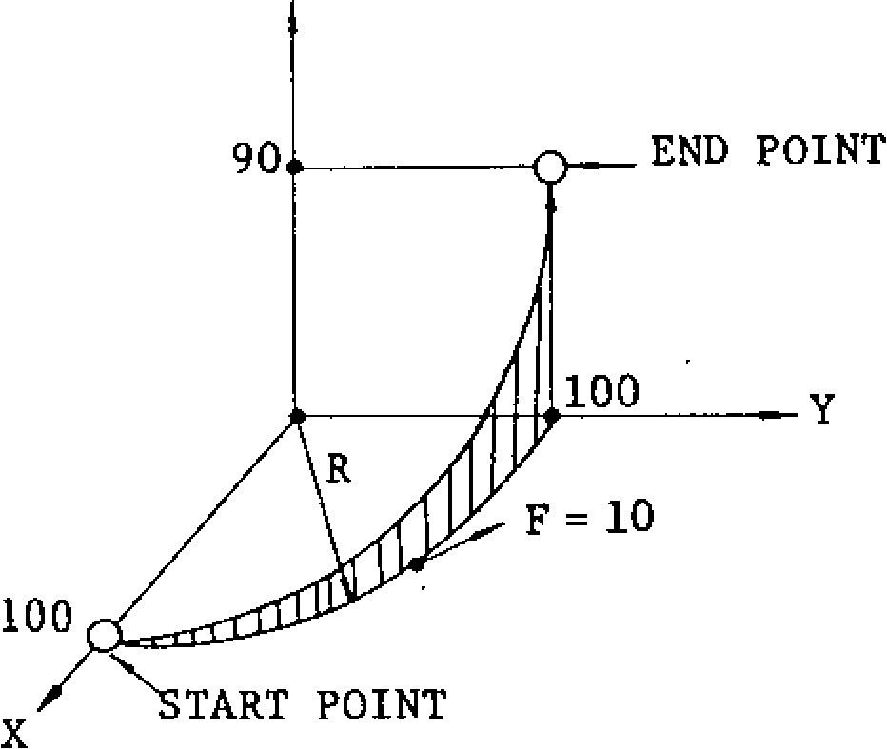

Z (et) • F. y()... F•

x (a) • . . F.

Z• • • F

Y • . . F .

X• • • F

**2.9.6 DWELL (0 0 4 )**

**GO4 171••-**

This command interrupts feed for the length of time designated by the address P. Dwell is programmed as an independent block.

The maximum length of time which can be designated with address P is as follows.

|  |  |
| --- | --- |
| Format | Dwell time (P programmable range) |
| P53 | 0 - 99999.999 sec |

The value does not depend on metric/inch input or metric/inch output.

EXAMPLE

G04 P2500 ;

G17 G03 XO Y100 . R100 . Z90 . F10 . ;

Fig. 2.18

NOTES:

The circular arc should be within 360°.

As long as above note (a) is satisfied, the start and end points can be taken at any time.

The feedrate F means the tangential speed on the plane of circular interpolation. Therefore, the speed (F') in the direction of linear interpolation is as follows.

F' = F x (Length covered **by linear** interpolation)

(Length of circular path)

Tool radius compensation C± can be applied only to the circular path on the plane of cir cular interpolation.

Dwell time : 2 .5 se c.

Two types **of dwell** can be selected by parameter: Dwell when the specified value in the command block before the dwell block is identified by lag p u l s e s o f servo, or dwell on completion of pulse distribution.

**2.9.7 EXACT STOP (G09, 061, G64)**

Exact stop (G09)

When a block containing G09 is executed, the program advances to the next **block** after completing a block in the Error Detect On mode (Note a). This function is used when sharp corners are desired. G09 is non -modal, and is effective only in the block in which it is contained.

2.9.7 EXACT STOP (G09, G61, G64) (CONT’D)

Exact stop mode (G61)

When once G61 is commanded, all the following blocks will be completed in the Error Detect On mode before proceeding to the next block.

Exact stop mode cancel (G64)

This G command is for cancelling the effect of G6I.

NOTES:

In the Error Detect On mode, the program proceeds to the next block only after the number o f servo delay pulses is found to have decrea sed below a permissible limit following the complete distribution of circular interpolation command pulses.

In the G09 and G61. off modes, the. program proceeds to the next block immediately after the complete distribution of the pulses of ordinary linear and circular interpolations, and therefore, because of the servo delay, tool paths are rounded at the corner. This mode is called "Error Detect Off" mode .

For rapid traverse, the Error Detect On and Off modes are controlled only by G00 and G06, and not by the above G codes.

2.9 .8 TOOL OFFSET VALUE DESIGNATION (G10 )

With a G10 command, correction of tool offset values and work coordinate system can be made as follows.

Designation of tool offset value (G10)

Normally, tool offset values are written in by MDI. O n t h e o t h e r h a n d , with a program G10 P. • . R• • • ; , ( w h e r e P = t o o l o f f s e t n u m b e r

and R = tool offset value) , any programmed offset values can be replaced by a designated value.

When G10 is commanded in the G90 mode, R is regarded as an absolute value. When G10 is commanded in the G91 mode, R is regarded as an incremental valu e.

Changing work coordinate systemt

Corresponding to G54 through G59, separate work coordinate systems are setup as setting data in advance.

G10 Q2 Pn X . . . Y . - . Z . . . c t . —

(where Q2 is used to discriminate from tool

off set value designation ,oid a mean:•,- to set a work coordinate system . Pn (n=1 to 6) ti corresponds to the work coordinate system n to be setup.)

1. o r P l - • • G 5 4 F o r P 2 . . .
2. 5 5 Fo r P6 .• • G 5 9

corresponds.

With the above command, data of any desired work coordinate system can be changed.

2.9.9. CIRCLE CUTTING (C12, c13) t

This is a canned cycle includes a complete series of movements for machining a circle in a single block. It includes the following functions.

• Format

G12 (G13) i . . . D . . . F . . .

Y-AXIS

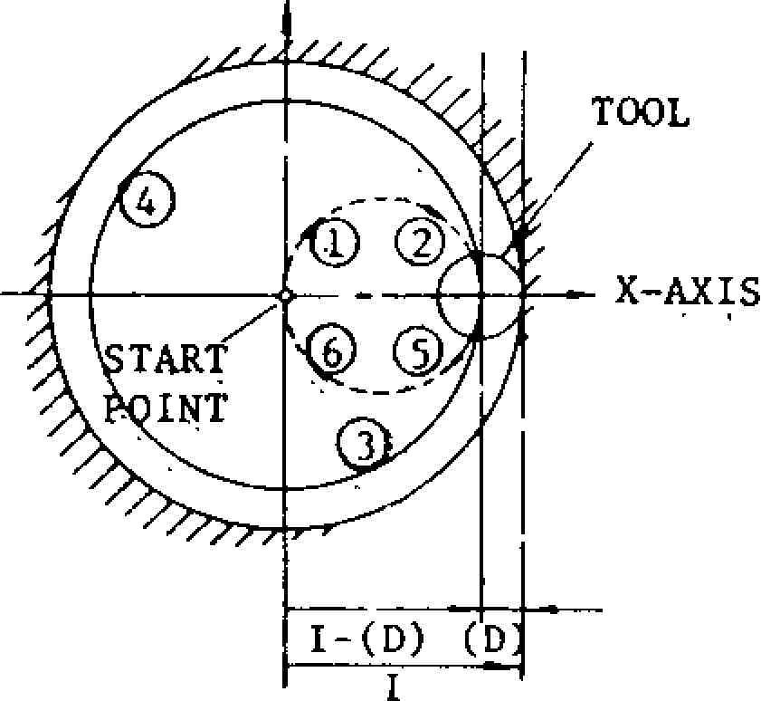

F ig . 2 .1 9

Designation of rapid traverse section R

G12 (G13) I• - • R..• D. - • F- - -

With this command, a circular bore is machined as shown below. Numerals following an address character R specifies rapid traverse sections.

Y

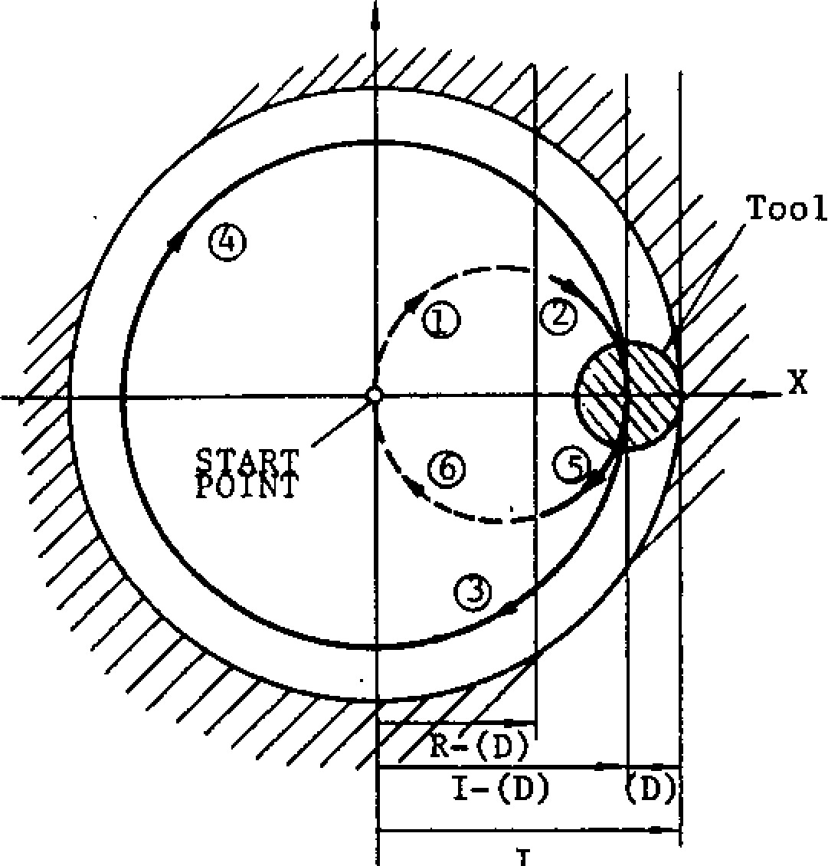G12: Clockwise

(CW)

G13: Counter clockwise

(CCW)

Radius of finished circle (incremental value with sign)

R: Rapid traverse section (incremental value with sign)

13: Tool radius compensation No. F: Cutting feed rate

Fig. 2. 20

• Automatic calculation of rapid traverse section G 1 2 ( G 1 3 ) I - . . J . . . D . • • F . . .

With this command, when depth of cut (incremental) is designated by numerals following an address character J in place of R, the tool rapid traverse section within which the tool can move at rapid traverse rate without making

Tool path - C D - 0 - - G12: 0 _ ()- -0--

G13: 0

(D) represents a set value of tool radius compensation.

• Commanding repeated circle designation

G12(G13) D . . . L . . . F . . . ;

With this command, the circular bore surface can be executed L times.

Commanding spiral circle Q, K

G12 (G13) I . . . D - • . K . . . Q . . . F . . . ;

contact with the stock is calculated automatically.

J is programmed without a plus or minus sign. With this command, the tool is moved along a

spiral before finally finishing a circular hole,

Y**-AXIS**as shown below. For the sake of simplification,

the diagram shows as if the tool has a zero radius (D = 0). Q (radius increment) must be programmed without sign.

Y

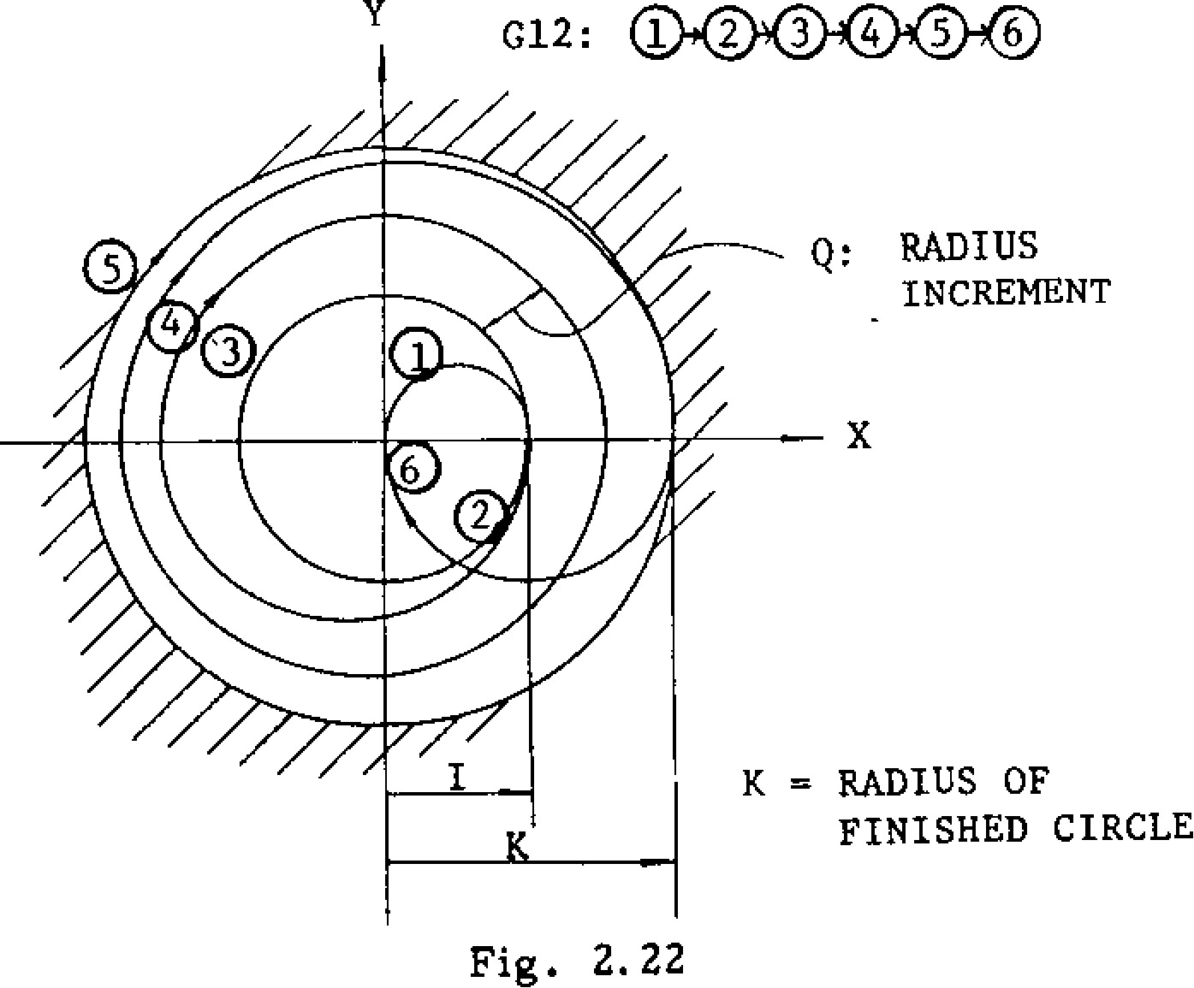

0

0 0 0 0

0

:

RADIUS

INCREMENT

K = RADIUS OF

FINISHED CIRCLE

G12:

Fig. 2.22

NOTES:

Tool rapid traverse section can be **set at •i** **(n = 0,** 1, 2 ... 10) pitch for a returning semicircle of circle bore.

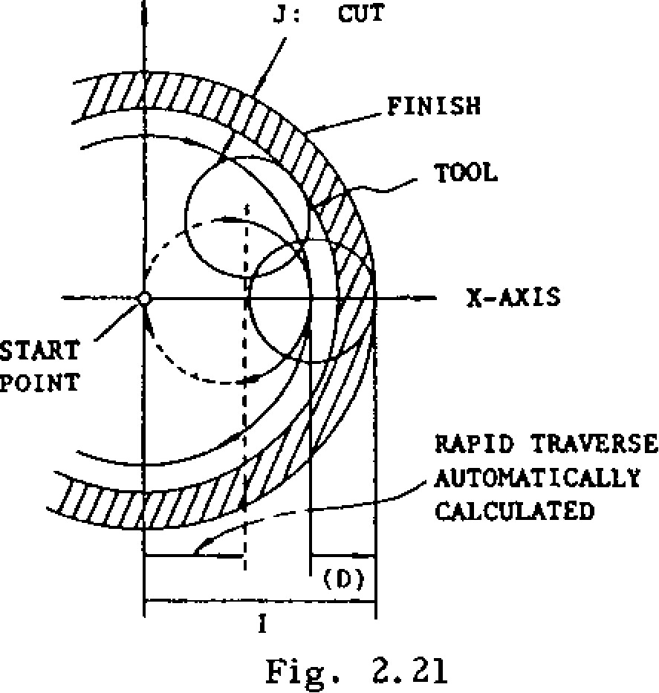

***.1***

**:**

**CUT**

**FINISH**

**TOOL**

**X**

**-**

**AXIS**

**START**

**POINT**

**RAP ID TRAVERSE**

**AUTOMATICALLY**

**CALCULATED**

1

Fig. 2.21

**2.9.9 CIRCLE CUTTING (G12, G13)t (CONT 1 D)**

Y

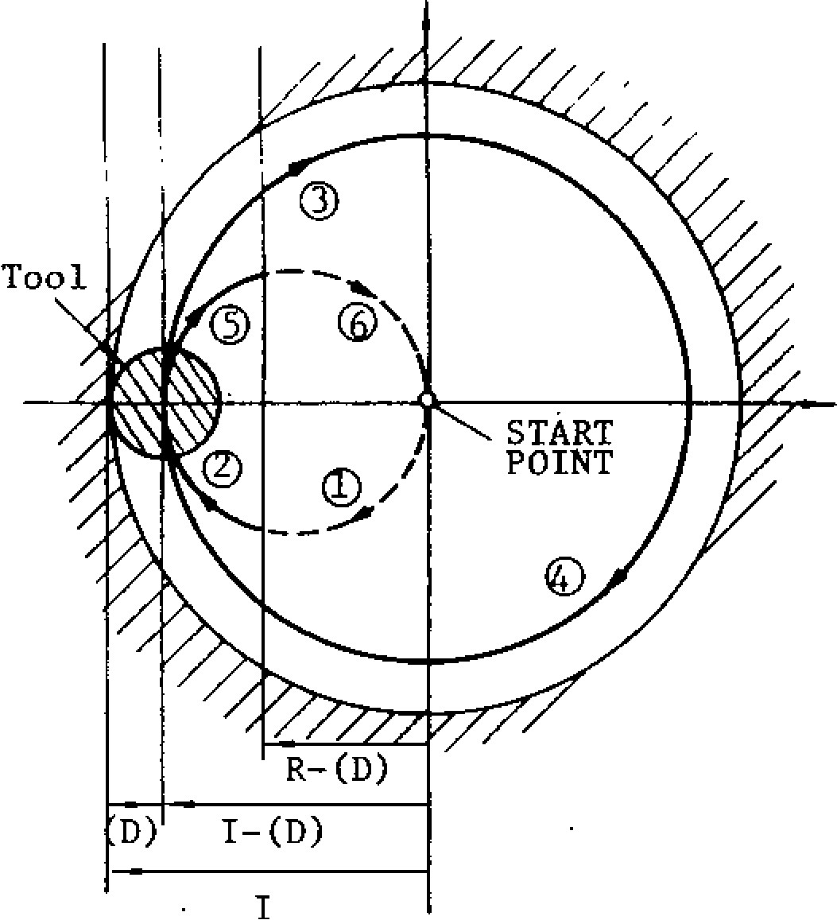

1. ig . 2 .2 3

Combined designation of rapid traverse sec tion, repeated circle and spiral circle.

Rapid traverse section, repeated circle desig na tion and spiral circle can be commanded in combination as shown below.

1. 1 2 ( 0 1 3 ) I . . . R . . . ( o r J . . • ) K . . - Q . . . L•- - F...

NOTES:

Circle cutting is possible only on the XY plane.

The tool speed in the rapid traverse section is set by parameter 66225.

With a circle cutting command (G12, G13), the tool is offset for its radius compensation with out the use of G41 or G42 (tool radius compen sa tio n ) . Wh e n u sin g Cl? o r G I3 , c a n c e l to o l radius compensation with G40.

In the explanation above, only motions in the + direction of X-axis is considered. With proper use of signs for I, K and D codes, motions in the - direction of X-axis (symmetrical with respect to Y-axis) can be commanded. In Fig. 2 .2 3 , s ig n s o f I, R a n d ( D) a re min u s. Ho w ever, cutting in the Y-axis direction is impossible.

I, J, K, R, Q and L codes in circle cutting com mand are effective only in the block containing them.

The radiu s I of finished circle and the ra pid traverse section R are subject to the following r e s t r i c t i o n . W h e n v a l u e s n o t i n c o n f o r m i t y with th e re striction are prog ra mme d, this is re g a rd e d a s a n e rro r .

1 R - d l < I I - d j

Tool path

G12: **4)**

G13:

(D) represents a set value of tool radius compensation.

G 1 2 : C l o c k w i s e ( C W )

G 1 3 : C o u n t e r c l o c k w i s e ( C C W )

I: Ra d iu s o f fin ish e d c irc le

(incremental value with sign)

R: Rapid traverse section

(incremental value with sign)

D: Tool radiu s co mpensa tio n value

If R-d and 1-d have different signs, this is a lso re g a rd e d a s a n e rro r.

When programming G12(G13), always specify a to ol radius compensation number D. If thiE is not specified, the tool moves without radius compensation.

EXAMPLE

• G00 Z-4 000 ;

G12 15000 R4000 **DIO** F300 D10 = 10.0 mm

GOO Z4000 ;

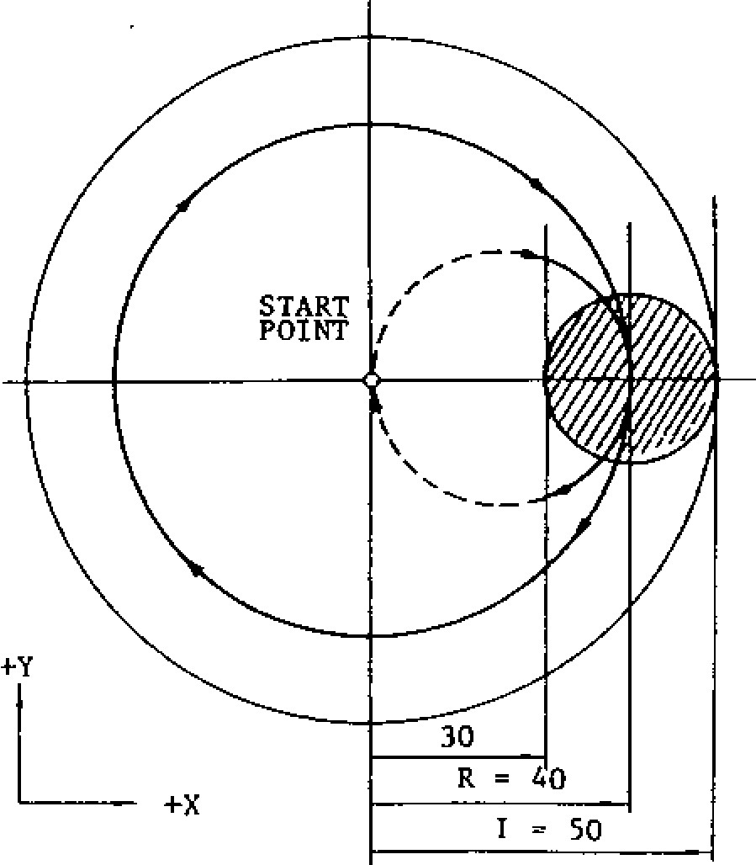(a)

Fig. 2. 24

**. GOO Z-4000;**

**013 1-5000 3700 D15 F300; D15 = -8.0 mm**

**GOO 24000;**

**8.0** TOOL RADIUS

7.0 DEPTH OF CUT

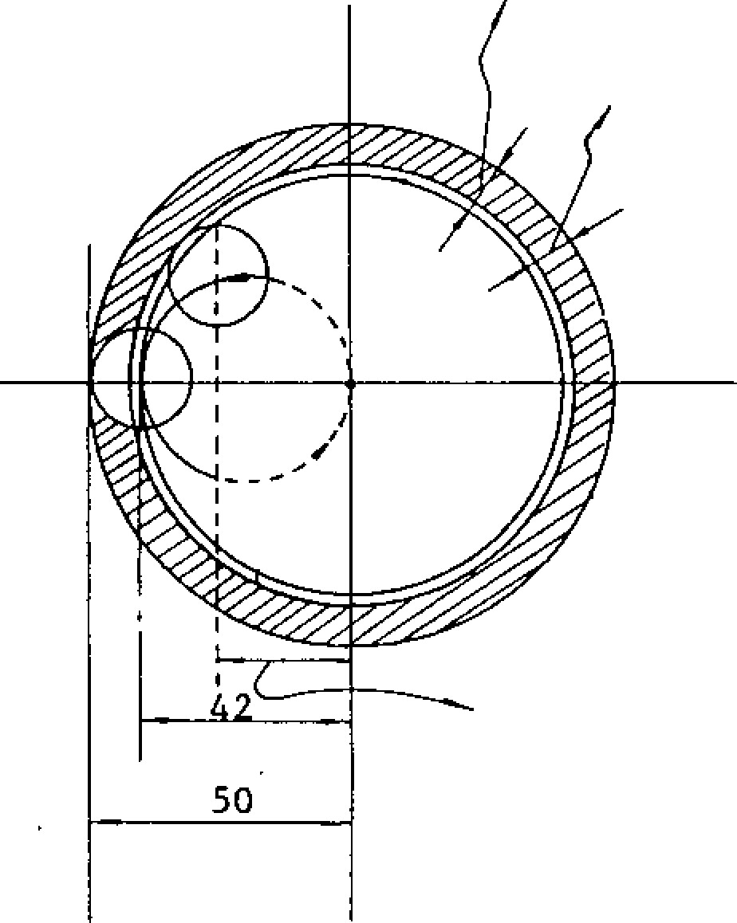

AUTOMATICALLY COMPUTED RAPID TRAVERSE SECTION

Fig. 2.25

**2.9.10 PLANE DESIGNATION (Gil, C18, G19)**

T h e p la n e fo r ma k in g c irc u la r in te rp o la tio n a n d tool radius compensation is designated by G codes 017/018/G19.

G 1 7 : X Y p l a n e

G 1 8 : Z X p l a n e

G 1 9 : Y Z p l a n e

When the 4th axist is selected, the following planes a re ne wly adde d.

G17: XY plane or Xet p lane

018: ZX plane or Zo. plane

G19: YZ plan e or Yet p lane ct means U, V o r W axis.

The move command in each axis can be program med regardless of the plane designation by G17/ 018/019.

For example, if

G17 Z• is designated, motion is on Z axis.

The plane for making tool radius compensation by command G41 or G42 is univocally determined by G17, G18 or 019: It is not possible to designate compensation plane including the fourth axis.

**The XY plane (017) is selected when the power is turned on.**

**2.9.11 INCH/METRIC DESIGNATION BY G CODE**

**(G20, G21)1-**

Unit of input data are **selectively specified by** the following G co d es between metric and inch.

|  |  |
| --- | --- |
|  | Input unit |
|  | Inch |
|  | Metric |

G code

G20

G21

T he se G co de s a re p ro gramme d at the le ad in g e nd of a b lock o f its o wn . If one these G cod es are commanded, the units of all the following motions a re c h a n g e d a fte r wa rd s. subsequent programs

* tool offset values
* part o f se tting para me ters
* part of manual movements displays

NOTES:

* When G20 or G21 is commanded, the setting of in c h / me tric se le c tio n is c h a n g e d . T h e re fo re , the state of G20/G21 at the time of power ap plication depends on the setting by parameter #6001 DO.

EXAMPLE

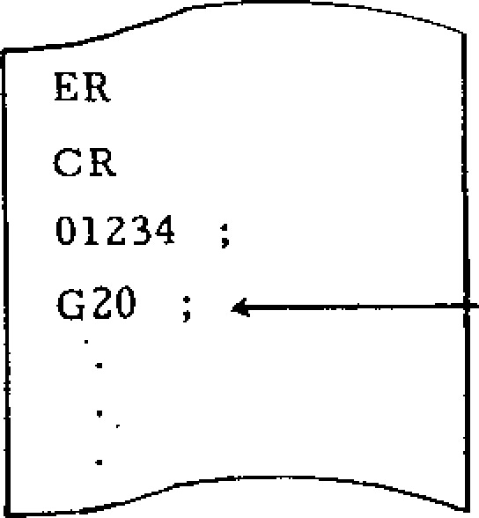Inch input designation

When G20/G21 selection is commanded in the program, take the following procedure before hand.

1. When work coordinate system (G54 to 059) is used, return it to base coordinate system.
2. Cancel all tool compensation command. (041 to G48)

**2. 9.11 INCH /METRIC DESIGNATION BY G CODE**

**(G20, G21) t (CONT'D)**

Take the following procedure after the command of G20/G21 selection.

1. Program absolute zero point for all axes before move command.
2. in principle, make the display reset opera tion when current position display (exter na l) is used.

The tool offset values are processed different ly in the G20 mode and the G21 mode. G20/G21 must be commanded after modifying the tool offset values.

|  |  |  |
| --- | --- | --- |
| Stored off  set values | Processing in G20 (Inch) | Processing in G21 (Metric) |
| **15000 _______ w 1.5000** | | 15.000 mm |

**2. 9. 12 ST OR ED STR OK E LIM IT (G22, G23) +**

This fun ction is for checking th e current tool p o s i t i o n d u r i n g m a n u a l o r a u t o m a t i c o p e r a t i o n fo r en try into the p rohib ited area specified by parame ters or by G22. If th e too l en ters a p ro h ib ited area , mac hine ope ra tion is sto pp ed an d an erro r sign is displayed.

1st prohibited area

The area outside the area specified by a para m e t e r i s a p r o h i b i t e d a r e a . G e n e r a l l y , t h i s c a n be used as a substitu te o f o vertravel checkin g fu n c tio n . Up p e r l imi t p o in t A a n d lo we r l imi t

point 13 are specified by parameters.

1S; PROHIBITED AREA

A (Xa, Ya, Za)

Z

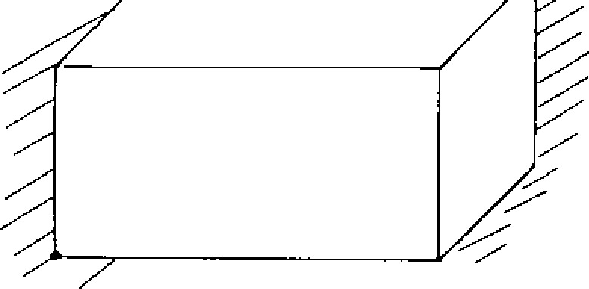

Z."7/.

■;■

7

2nd prohibited area

The boundary of the 2 nd pro hibited a rea i.s s p e c i f i e d b y a parameter setting or by G22. The inside or the outside of the boundary can selectively be made a prohibited area by means of parameter setting.

G22 X... Y... Z--• I.-. ,I• • K- ••

1. point D point

Upper limit Lower limit

With this command, the checking of the 2nd p roh ib ited a rea is sta rted , an d with G2 3 ;, th e check func tion is cleared .

2ND PROHIBITED AREA C (X, Y, Z)

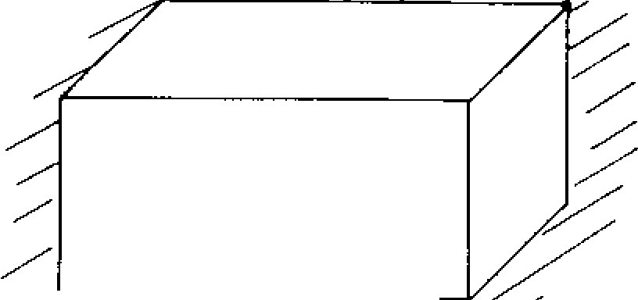

1. (I, J, K)

Where 2nd prohibited area is outside.

C (X, Y, Z )

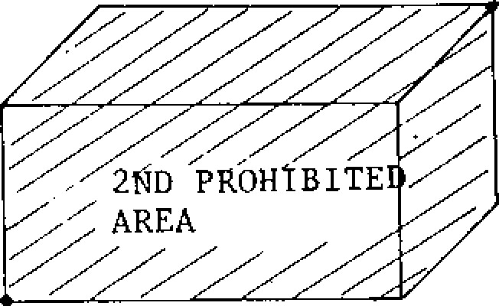

Where 2nd prohibited area is inside. F ig . 2 .2 7

B (Xb, Yb, Zb) Fig. 2.26

Y



* **The parameter numbers and the setting numbers of these prohibited areas are as follows.**

**Table 2.23**

|  |  |  |  |  |  |
| --- | --- | --- | --- | --- | --- |
|  |  | X | Y | .Z | Division |
| 1st prohib- ited area | A **point** | **#6600** | #6601 | #6602 | Parameter |
|  |  |  |  |
|  | B point | #6606 | #6607 | #6608 |  |
| 2nd prohib- ited a rea | C point | #6510 | #6511 | #6512 | Setting |
| D point | #6513 | #6514 | #6515 |

* The parameters for specifying the inside and the outside of the 2nd prohibited area are as follows.

#6007D0 Meaning

|  |  |
| --- | --- |
|  | Inside prohibition |
|  | Outside prohibition |
|  |  |

* The 2nd prohibited area checking function can also be turned on and off with the following se ttin g nu mber.

#6001D1 Meaning

|  |  |
| --- | --- |
|  | 2nd prohibited area |
|  | check; on |
|  |  |
|  | The 1st and the 2nd prohibited area can be |

2nd prohibited area check; off

NOTES:

* specified overlapping each other.
* Boundary lines are included in the prohibited areas.

All the prohibited areas become effective after a manual return to reference point or a return to re ference point b y G28 afte r turnin g on of th e po wer supply.

**If the tool is in the prohibited area at the time when the prohibited area becomes effective, this is immediately regarded as an error. In this case, turn off the 2nd prohibited area** by the setting of the setting number, and either rewrite 1he data or move the tool out of the prohibited area manually.

**If** an alarm state is created by the entry of the **tool into the prohibited** area, the tool can move **only** in the retu rning direction.

No stored stroke limit can be set to the 4th axis.

The stored stroke limit check ing function may selectively be used or disused during a machine lo ck ope ratio n by the settin g of the setting #6001D5.

**2. 9.13 REFERENCE POINT CHECK (G27) t**

T h i s f u n c t io n i s f o r c h e c k i n g t h e c o r r e c t re t u r n o f th e too l to th e refe re nc e p o in t a fte r p erforming a cycle of operation in accordance with a program w h i c h s t a r t s a t t h e r e f e r e n c e p o i n t a n d e n d s a t

th e re ference poin t.

G 2 7 X • • • y . . . Z . . • ( at ) ;

With this command, the tool moves towards the specified position along the three axes (4 axes t) simu ltane ously but independen tly , and afte r the arriva l at the spec ified point, the point is check e d fo r th e c o n fo r mi ty t o t h e r e f e r e n c e p o i n t . If a n y o f th e a x e s is o m it te d in th e c o m m a n d , th e t o o l d o e s n o t m o v e i n t h a t a x i s a n d n o c h e c k i s

made in that axis.

If the point is in conformity with the reference p o i n t , the r e f e r e n c e p o i n t r e t u r n l a m p l i g h t s . If the tool is correctly in the reference point in all the axes, automatic operation is performed fu rther, but if th e tool is not in the refe rence p o in t e ve n in on e a xis, th is is reg arde d a s a n error (alarm 241 - 244 display), and the auto m a t i c o p e r a t i o n i s i n t e r r u p t e d . ( C y c l e s t a r t **lamp goes off.)**

**If G27 is commanded in the tool offset mode, the tool return point is also offset. Cancel the tool offset mode when commanding** G27.

**2.9.13 REFERENCE POINT CHECK (G2 7) t (CONT'D)** R e f e r e n c e p o i n t a s m e a n t h e r e i s a f i x e d p o i n t

re lative to the machine to wh ich the tool returnsb y t h e m a n u a l re f e r e n c e p o i n t r e t u rn m o t i o n o r by G2 8 automa tic refe rence poin t re turn mo tion . Refer to 6.1.15 MANUAL REFERENCE POINT RETURN SWITCH.' The mirror image function can be applied to the G27 command. To avoid non -confo rmity e rro rs, clea r th e mirror imag e mo de with M94 (Mirror image off) before commanding G27.

**2.9.14 AUTOMATIC RETURN TO REFERENCE P O I N T** (G28)t

G28 X... Y . . . Z . . . ( a t . . . ) ;

With this command, the tool is sent back to the re fe re n c e p o in t. T h e to o l mo v e s to wa rd s th e specified points in rapid traverse, and automati - ca lly stops at the reference poin t.

•

The tool moves simultaneously in up to 3 axes (4 axe s+). Ho wev er, th e tool will not move in the direction of the axis for which a coordinate in struction is omitted.

EXAMPLE

G28 X... Y... Z...

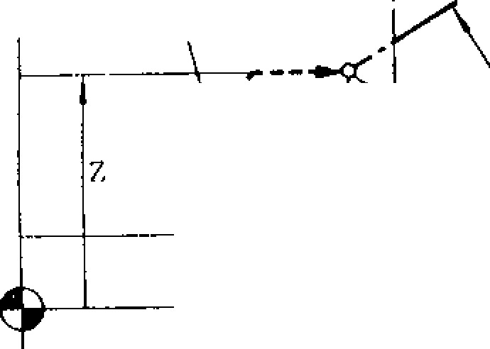

Z

*REFERENCE ZERO POINT

Z AXIS

DECELERATION LS

RETURN TO REFERENCE

ZERO

INTERIM

POSITIONING POINT

Y AXIS DECELERATION LS

Y

POSITIONING

START

POINT

Fig . 2.28

"Return to reference point" involves the same series of motions as the manual return to refer ence point.

NOTES:

* If G28 is commanded in the tool radius compensa tion mo de (G41 , G42) or in a canne d cyc le, th is is re g a rd e d a s a n in p u t e rro r "0 2 4 ."
* If G28 is commanded in the Mirror Image mode

(M95) , this constitutes an input error "058."

The tool position offset command is not cancel led by G28. Make it a point to cancel it before commanding G28. If C28 is given in the tool position offset mode , the tool motion by the suc ceeding prog ram becomes as de scrib ed be l o w . C a r e s h o u l d b e t a k e n .

1. When the succeeding program is made in the incremental mode:

Tool moves•by the amount of incremental value from the reference point. The tool offset is not effective.

1. When the succeeding program is made in the absolute mode:

Tool moves to the position which is speci fied by absolute value and tool offset value.

1. When G29 is given immediately after the G28:

By G29 command, the tool moves to the off se t interim position ing point an d the suc c e e d in g m o t io n is ma d e a c c o rd in g to t h e item A and B.

When returning the tool to the reference point fo r th e first time afte r turn ing on the po wer s u p p l y , p a y a t t e n t i o n t o t h e t o o l p o s i t i o n . Refer to 6.2.1 MANUAL RETURN TO REFER ENCE POINT".

R e t u r n t o r e f e r e n c e p o i n t i n r a p i d t r a v e r s e

In addition to the above " Automatic Return to

R e fe re n c e Po in t, " " Ra p id T ra v e rse Re tu rn to Reference Point" function may be incorporated in th e con trol. With this fu nction, the motion se quence is as follows.

After positioning at an interim positioning point B , t h e t o o l d i r e c t l y m o v e s t o t h e r e f e r e n c e p o in t in ra pid trav erse. Th e re tu rn ing time is sh o rte r th a n th a t with th e o rd in a ry re tu rn to reference in which deceleration LSs are used in all the axes.

With the "Rapid Traverse Return to Reference Point," point B may not necessarily be within th e refe re nc e p oin t retu rn po ssib le a rea .

T h e ra p id tra v e rse re tu rn to re fe re n c e p o in t

becomes possible only after the tool has been returned once to the reference point in all the axes by manual operation or by G28, following th e tu rn in g o n o f th e p o w e r su p p ly .

Rapid traverse return to reference point is ef fe ctive on ly with G28 . Ma n ua l re tu rn mo tio ns are not changed by it.

Where a 4th axis is used, when no command is given for the 4th axis in a G28 command, and w h e n th e to o l h a s b e e n re tu rn e d to th e re fe r e n c e p o in t in th e X, Y , a n d Z a x e s, th e to o l moves to the reference point in the rapid trav e r s e r e t u r n m o d e . I f a c o m m a n d f o r t h e 4 t h a x is is in c lu de d in th e co mma nd , th e to o l re t u r n s t o t h e r e f e r e n c e p o i n t i n t h e o r d i n a r y r e t u r n mo d e , u n le s s th e r e t u r n mo t io n s in a ll

the 4 axes have been completed.

**2. 9. 15 R ET UR N FR OM R EF ER EN C E Z ER O (G29)t**

**This code is used to return the tool to its original position after return to reference zero by autom atic retur n to refere nce zero, along the sam e path.**

**G28 Y• .• Z... ; Point A 4- B C**

**(Reference zero point)**

**Point B**

**G 29 Y ... Z.. • ; Point C B D**

**Point D**

**40' C(REFERENCE ZERO POINT)**

**I1 "------ RETURN TO REFERENCE ZERO**

**,,............1 B**

**D cr"" / / '' _.POINT \ INTERIM POSITIONING**

d

**A**

**Figl 2.29**

**When G29 is programmed, it is not necessary to consider the distance between point B and** C **in the program. Particularly when an incremental instruction is used, this is effective for return ing tool to the original position, after returning to reference zero.**

1. **o v e m e n t o f C B a n d o f B D i s m a d e a t r a p id traverse rate simultaneously along three axes (simultaneously four axes') by G29. However, in an axis for which a coordinate instruction was omitted, the tool will not move.**

**If G28 is programmed a number of times, the fi nal coordinates of point B which the last G28 creates is effective for the move** of G29.

**EXAMPLE 1 (In the case of absolute inp ut)**

**Interim point**

**N21 G90 coordinates**

**X Y**

1. **2 2 G 2 8 2 1 0 0 0 Y 2 0 0 0 ; — • ( 0 , 2 0 0 0 , 1 0 0 0 )**

**N23 : 028 X3000 ; (3000, 2000, 1000)**

**I**

**N24 G29 X-4000 Y-5000 ;I**

L**Equal to**

|  |
| --- |
|  |
| **GOO X3000 Y2000 ;.g-**  **GOO X-4000 Y-5000 ;** |

**t h e t w o =**

**blocks**

**EXAMPLE 2**

|  |  |  |  |
| --- | --- | --- | --- |
| **N31** | **G91** |  |  |
| **N32** | **G28** | **Z•••** |  |
| **N33** | **G28** | **X2000 Y4000** |  |
| **N34** | **M06** |  |  |
| **N35** | **G29** | **X4000 Y-4000** | **;** |

**\* (REFERENCE ZERO)**

**+**

**Y**

+

x

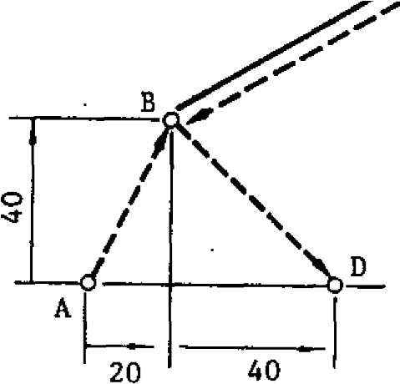

**Fig . 2.30**

**NOTES:**

**An input error "024" occurs if G29 is programmed in tool radius compensation mode (041, G42) or during canned cycle mode (G73, G74, G76, G77, 081 to 089).**

**An input error "059" occurs if 029 is given without execution of G28 after the control is turned on.**

**In principle, cancel tool offset before program ming G28 or G29. If they are programmed when of fset is also effe ctive ,** i n t e r i m p o s i t i o n i n g p o i n t B wi l l **also be offset, and the tool** p as ses **point B'.**

**C**

**(REFERENCE ZERO POINT)**

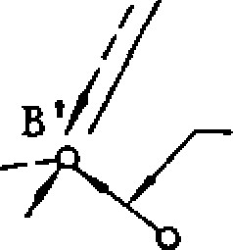

B

**OFFSET AMOUNT**

**(INTERIM POSITIONING** d **POINT)**

AT

**Fig. 2.31**

**2.9.15 RETURN FROM REFERENCE ZERO (629)t**

**ICONT ID)**

An i n p u t e r ro r "058" o c c u r s if G2 9 is g iv e n d u r ing mirror image (M95).

T he fo llo wing co mma nd o r o p eration must n o t he taken because interim positioning point B of G28 does not meet with that of G29.

1. The following operations are made between 628 and G29 commands.
   * S e tu p o f a b so lu te ze ro (G 9 2 , OR G k e y ) • Machine lock
   * Manual operation at Manual Absolute Off
2. G28 and G29 are commanded in the blocks following the block containing M94 which cancels mirror image at the different point from the starting point of mirror image.
3. G28 and G29 are commanded after manual operation at Manual Absolute Off.

**2.9.16 2ND, 3RD A N D 4 T H R E F E R E N C E P O I N T RETURN (G30) t**

6 3 0 P n X . . . Y • • - Z - - - ( c i t - . . )

( w h e r e P n = P 2 , P 3 , P4 )

With this command, the tool first moves to an int e r i m p o s i t i o n i n g p o i n t , a n d th e n , m o v e s to th e 2 n d , 3 rd o r 4 th re fe re n c e p o in t .

|  |  |  |
| --- | --- | --- |
| P2: | 2nd reference point | When P is omitted, |
| P3: | 3rd reference point | the tool moves to |
| P4: | 4th reference point | point.  the 2nd reference |

**2.9.17 SKIP FUNC TION (G31)t** G31 X... Y... Z... **F...**

With this command, a special linear interpok.tion is commanded. During the interpolation movement u n de r the co mma nd o f th is p ro gra m, wh en ev e r a skip signal is inputted, the interpolation is inter rup ted immed iate ly, and the progra m advance s to the next block. From the moment that a.skip sig n a l is in p u tte d to th e ti me th e c o n tro l sta rt t o p r o c e s s t h e s i g n a l , d e l a y t i m e i s l e s s t h a n 0 . 5 m sec. 6 3 1 i s n o n - m o d a l .

EXAMPLE

N100 G90 G31 X100.0 Y50.0 ;

N200 601 X80.0 Y15.0 ;

SKIP SIGNAL INPUTTED HEREIS

(100, 50)

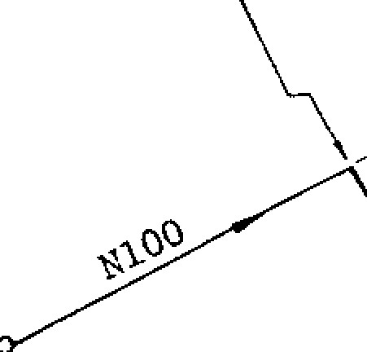

(50

, 20)

____

X

--,....- ACTUAL MOTION

YPATH

MOTION WITHOUT

SKIP SIGNAL

(80, 15)

If any axis of the coordinate instruction is omit te d in the co mmand , the to ol re ma ins motionle ss in the directio n of that axis.

E ach re ference po int is spec ified by the pa ra m eters (#6612 to #6629) before hand.

EXAMPLE

G 3 0 P 3 X 3 0 Y 5 0 ; The tool returns to the

3rd reference poin t

moving in the X and Y directions.

NOTES:

• T h r e e i t e m s e x c e p t t h e l a s t o n e i n N O T E S o f

2 . 9 . 1 4 AUT OM A T IC R E T U R N T O R E FE R E NC E

POINT (G28)t apply to G30 in the same manner.

- W h e n 6 2 9 i s c o m m a n d e d a f t e r G 3 0 , t h e t o o l m o v e s t o t h e d e s i g n a t e d p o i n t b y 6 2 9 b y w a y

o f in t e ri m po s it io ni ng po in t d e s ign a te d by 6 3 0. However the interim positioning point is renew ed on the ax is de signa ted b y G30.

F ig . 2 .3 2

When G31 block is executed without a skip signal b e i n g i n p u tt e d , th e m a c h i n e s to p s a t th e e n d o f the block, and the alarm code "087" is displayed.

Feedrate of the tool is set for GM blocks selec tively by one of the following two methods as specified by parameter #6019D4.

To be specified by F similar to ordinary pro grams.

T o b e s et in a dv an ce by pa ra me ter #6 23 2 .

When a skip sig nal is inputted, the coord inate values at the moment are automatically stored as parame ter data .

**#6552 • • • storing X coordinate value**

**#6553 • • - storing Y coordinate value**

**#6554 • - • storing Z coordinate value**

**#6555 • • •** storing 4th coordinate value

**These data can be treated as coordinate data in user macros.**

**When a skip signal is not given in spite the execution of G31 by setting (#6004D0), the program moves on to the next block automatically.**

**2.9.18 THREADCUTTINC (G33)t**

**Provided that the machine is equipped with a spindle pulse generator generating referenc e pulses, and a synchronous feed function (G95), screw threads can be cut with this function.**

**G33 Z. • • F• • •**

**With this command, threadcutting is made in the Z direction at a lead of F.**

|  |  |
| --- | --- |
| **Metric**  **Inch** | Range of lead |
| **0.01** - 99.99 mm |
| 0.001 - 3.936 inches |

However, lead is subject to the following restriction from the spindle speed.

**F(mm/rev) x S(rpm) r 24000(mm/min) or** a clamp value

**NOTES:**

G33 may be programmed with two or more axes simultaneously as for example in G33YyZzFf In this case, the tool moves along the axis for w h i c h t h e l o n g e s t d i s t a n c e i s s p e c i f i e d a t t h e lead specified by **F.** **G33 is a G code in the 01 group.**

During a threadcutting operation, feedhold and mode change are impossible. Feedrate override is also ineffective, and the feedrate is locked at 100%.

G33 can only be commanded in the G95 (min/rev) mode. If it is commanded in the G94 (mm/min) mode, it causes an alarm.

G33 can not be programmed in the tool radius compensation C mode. If it is commanded, it causes an alarm.

Threadcutting command can not include 4 axes. If 4 axes are included in a threadcutting command, an alarm is caused.

**2.9.19 AUTOMATIC CENTERING FUNCTION**

**(G36, G37)Th**

**With this** function, the spindle is aligned withthe center line of the machined bore, with a touch sensor.

**Lead range is shown below.**

a b

D

2

where b = distance between G37 start point to contact point.

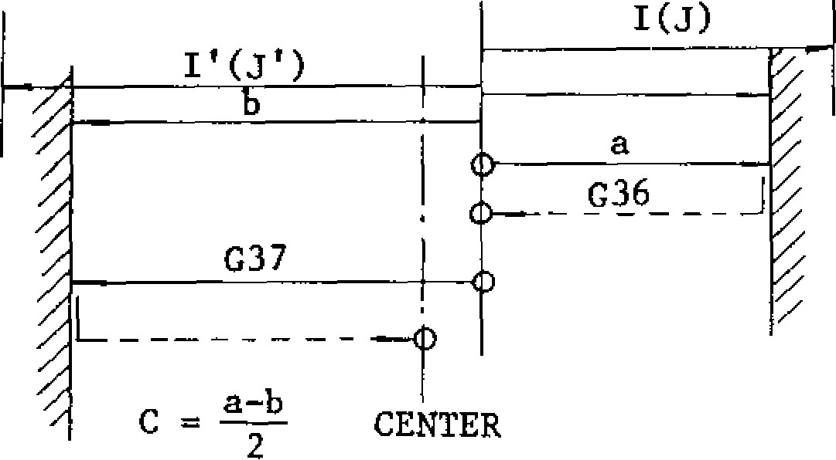WORKPIECE

**(I, 3, I', =** In c rem ental value ) **Fig. 2.33**

NOTES:

**When no contact signal is obtained during the movement through the** specified incremental distances **I (or 3)** and I' (or J'), this constitutes an error.

When I and J are progi-ammed together in a block of G36 or G37, this constitutes and error.

* **When** G36 or G3Tis commanded in the tool radius compensation C mode or in a canned cycle, this command is treated as an error "cia4,11
* **G36 I• • • (or 3. • .) F• • • ;**

**With this command, the spindle moves in the X (or Y) direction at speed F until the touch sensor makes contact with the workpiece** and gives **a contact signal. The distance "a" from the start point to the contact point is stored with the function of G37. Then, the spindle returns to the start point in rapid traverse.**

**G37 I'• .•(or.r • • • ) F• • • ;**

**With this command, the spindle moves in the X (or Y ) direction at speed F until the touch sensor makes** contact with the workpiece and gives a contact signal. Then, the spindle returns to the start point in rapid traverse.

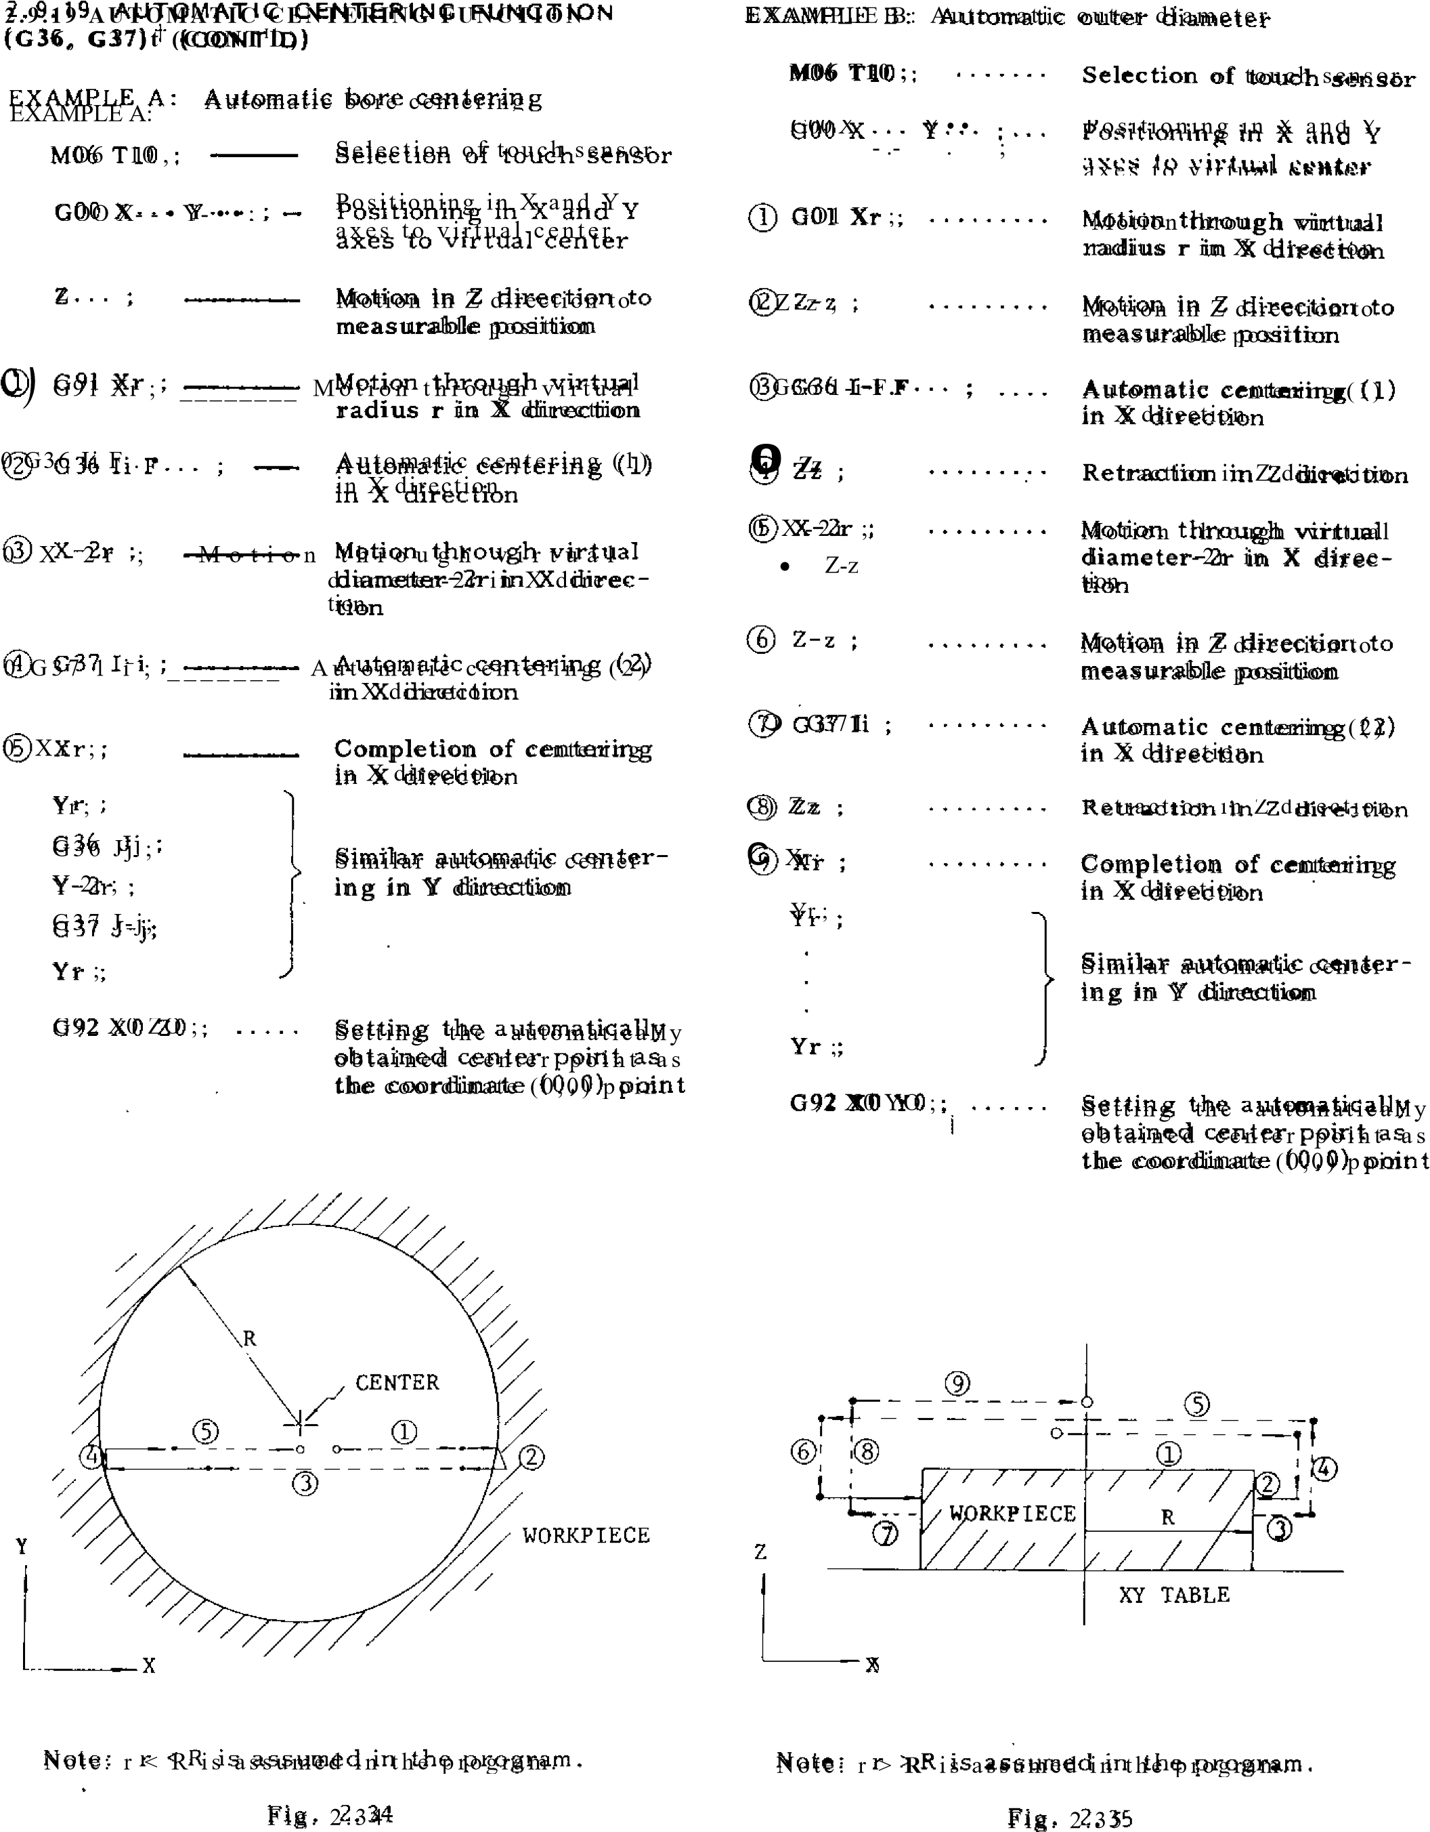

**2.9.20 Z-AXIS REFERENCE SURFACE OFFSET**

**(G313)t**

With this function, the tool is offset in the Z direction automatically for obtaining accurate dimension relative to a reference surface, with a touch sensor.

G38 K... F• • •

With this command, the spindle moves in the Z direction at a speed F, and stops when the touch sensor gives out a contact signal. Then, d = k g is calculated, and the spindle returns through g - d in rapid traverse, where k is a value specified by K and g is the distance from the start point to the contact point.

START

POINT

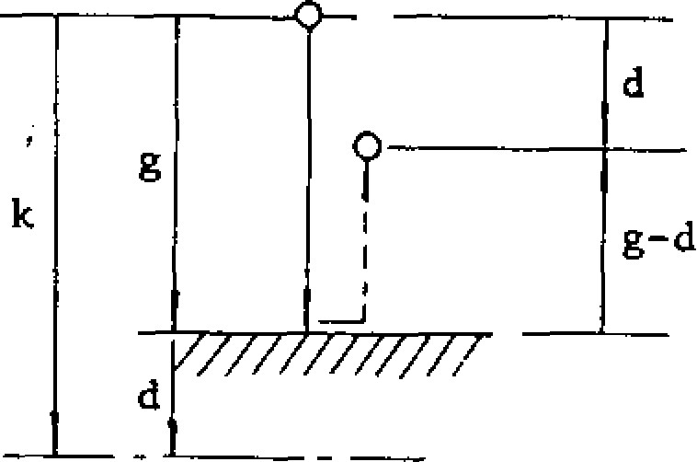

k: INCREMENTAL DISTANCE

Fig . 2.36

NOTES:

* If no contact signal is received during the travel through the specified incremental distance k, an error "087" is caused.
* When G38 is commanded in the tool compensation C mode, or in a canned cycle, this is regarded as an error "024."

EXAMPLE

|  |  |
| --- | --- |
| M06 T11 ;  Q G91 GOO ;   G38 K-1( F• | Selection of touch sensor Approach to the measur- ing point in Z direction  Z r - frence surface  compensation |

Zz ; _________~~_______~~__ Return to the offset position in the Z direction

G92 ZO ; ________ Setting of Z coordinate origin at this point

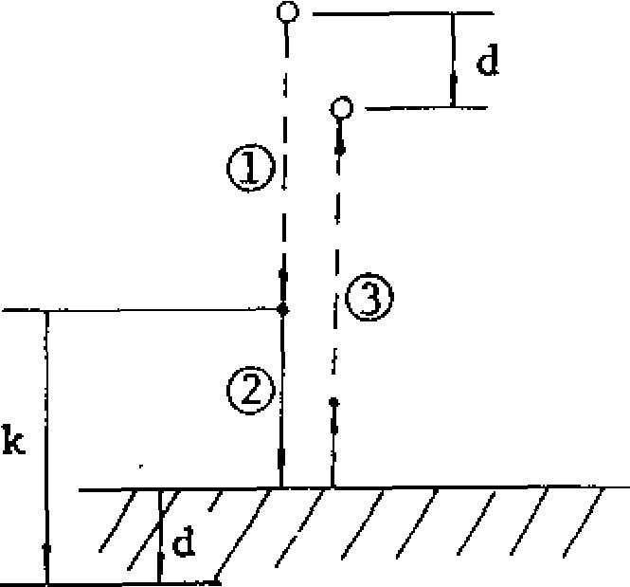

WORKPIECE

Fig . 2.37

**2,9.21 TOOL RADIUS COMPENSATION C**

**(G40, G41, C42)t**

It is possible to specify the radius of the tool and to cause automatic tool path offset by this value. Store the offset value (tool radius value) in the offset value memory in advance by MDI, and program the tool offset number correspond to the tool radius value by a D code in the program.

1. Designation of compensation direction and of D code

Tool radius compensation C is programmed with G41, G42 and is cancelled by G40. G41 and G42 indicate the directions of tool offset with respect to the direction of movement.

G code of tool radius compensation C

|  |  |  |
| --- | --- | --- |
| G code | Group | Meaning |
| G40 | 07 | C an c el l at i o n o f t o o l rad i u s compensation C |
| G41 | 07 | Tool radius compensation  C, left |
| G42 | 07 | Tool radius compensation C, right |

Note: When the power is turned on, G40 is effective.

Note that the directions of compensation (right, left) indicated above are reversed when the sign of the tool radius value in the offset memory designated by a D code is negative. Make sure to designate a D code in the block containing G41, G42 or in a preceding block. If DOO is commanded, tool radius

will be regarded as "0."

|  |
| --- |
| **2. 9.21 T OOL R ADIU S C OM PEN SAT ION C (G40, G41, G42)i . (C ONT ID )** |

EXAMPLE A

G41 (LEFT)

( a ) G 1 7 G O 1 F . . .

TOOL



G 4 1 ( G 4 2 ) D . . - X

PROGRAMMI

G42 (RIGHT)

Fig. 2.38

Switching between G41 and G42 can be made in th e c o mp e n sa tio n mo d e . De ta il s w ill b e given in item 5 below.

2. Desig natio n of co mpensa ting plane

T he plan e in which to o l ra d iu s c o mp en sation is ma d e is designated by G17, G18, G19. They are G codes of 02 group. The XY plane

(G17) is in effect at the time power is turned on.

G codes for designation of planes

|  |  |  |
| --- | --- | --- |
| G code | Group | Meaning |
| G17 | 02 | XY plane |
| G18 | 02 | ZX plane |
| G19 | 02 | YZ plane |

N o te : W h e n th e p o we r is t u rn e d o n , G1 7 is effective.

Make sure to de signa te a G cod e fo r pla ne d e sign a tio n in the sa me blo ck as th a t o f G4 I, G 4 2 o r i n a p r e c e d i n g b l o c k . P l a n e d e s i g nation cannot be made in a compensation mode. It is not possible to apply tool radius compen sa tio n in a p lan e inc lud in g th e fo u rth a x is'.

3 . Metho d o f e n try in to co mp en sa tio n mo de

When G41(G42) is programmed, the tool moves to a n o ff se t p o sitio n with th e d i sta n c e e q u a l t o t h e ra d i u s . T h e o ff se t p o si t io n i s o n th e norma l line a t the start point o f th e blo ck immediately after G41(G42). If no coordinate in struc tion is programmed in the b lock o f 041(042), m o v e m e n t i s m a d e b y t h e o f fs e t va lue on ly. Be cause G4 1(G42) acco mpanies a movement, it is necessary to program GOO o r G O1 fo r a G c o d e in g ro u p A. An in p u t

error (ala rm code "026) occu rs if a G code X• ;

TOOL, G40

Y

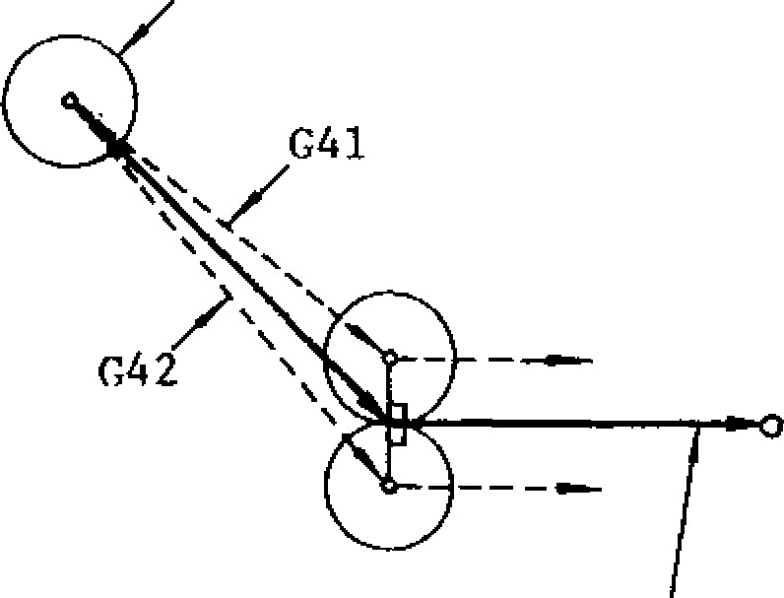

PROGRAMMED

**PATH**

**_____________**

**X**

(

b) G

17

-

001

F. •

**-**

**G 4 1 ( G 4 2 ) D . . . X . . . Y • • •**

GO2 -. y...

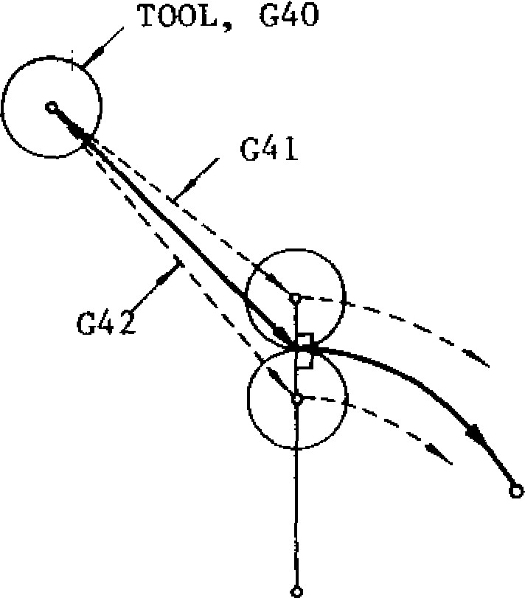

CENTER

Fig. 2.39

other than GOO, GOI is programmed.

**EXAMPLE B**

**(c ) G17 G O1 F•• - ( d ) G 1 7 G 0 1 F . . .**

**G41(G42) D• • • ; G41(G42) D...**

**X- - • Y • • • ; G 0 2 X . . . y . . . j . . .**

**G02 X• • • Y• • • J- - •**

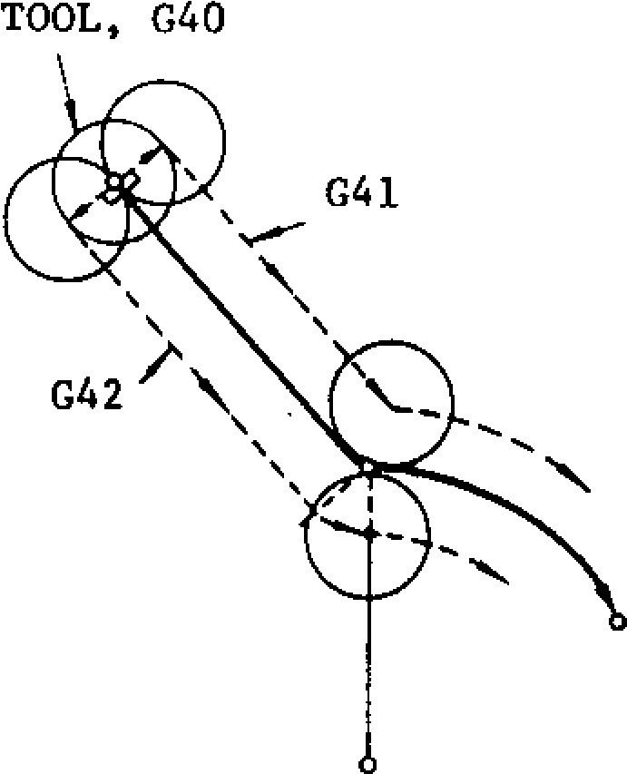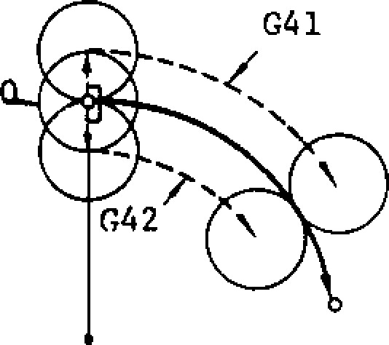**TOOL, C4**

**CENTER**

**CENTER**

**Fig . 2.40**

**Pay attention to the fact that offset is made on the normal line to the program line deter m ined by the block after G41 (G 42) at the start point in all of the examples (a) to (d) above. When the movement on the compen sation plane is not programmed in the block after G41(G42), the next one block is read ahead and the compensation start with the b l oc k . The b lo ck s w i tho u t mo ve c o m ma nd can be programmed continuously up to two. Input error occurs if move commands on the compensation plane are not programmed in more than three blocks.**

**When compensation entry is programmed in the G00 mode, positioning movement is made ind ependent ly. by each ax is to the offs et point. Take care not to make the tool inter fere with the workpiece.**

**4. Movement in compensation mode**

**When after the tool radius compensation is programmed by G41, G42, the tool moves along the off set p ath un til the instru ction G 40 i s given.**

**As calculation** of the path is automatically **m a d e b y t h e c o n t r o l , d e s i g n a t e o n l y t h e shape of the workpiece in the program. The tool path is controlled as follows depending on the angle between blocks.**

1. **Inside corner (180° or less):**

**Intersection computing type**

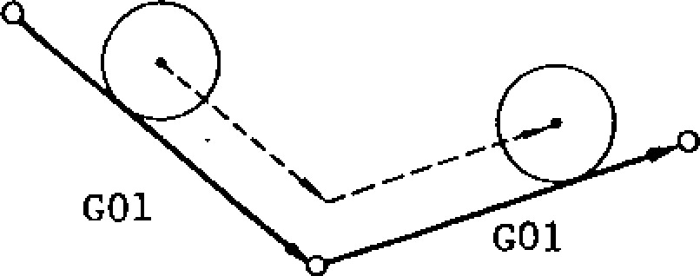

**Fig. 2.41**

2.9 .21 T OOL R ADIUS C OM PE NSAT ION C

( G 4 0 , G 4 1 , G 4 2 ) t ( C O N T ' D )

1. Ou tsid e c orne r (o ve r 1 8 0 °):

Circular path type (in the c ase o f M96)

■ ARCCIRCULAR

**4$**



GO1

G01



Fig, 2.42

In this case, movement of circular path is included in the former block. Code M97 can be used to machine the outside c o rn er by th e in te rse ction co mp uta tion , d e p e n d i n g o n t h e w o r k . R e f e r t o 2 . 8 . 6 C IR C UL AR PATH MODE ON /OFF ON T OOL R A D IU S C O M P E N S A T IO N C ( M 9 7 , M 9 6 ) f o r details.

M96 • Tool radius compensation circular p a th ON

C. Movement in GOO mode

The instruction GOO positions tools independ ently along each axis toward the final offset position. Care should be taken on the cutter path.

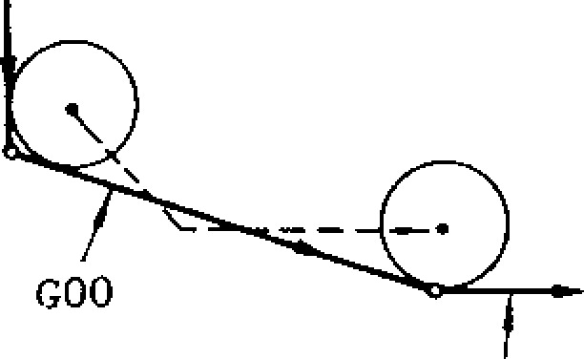

GOO OR

GO1

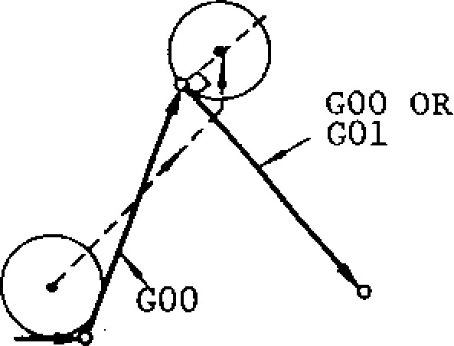

(In M96 mode) F ig . 2 .4 3

M97 • - • Tool r a d i u s c o m p e n s a t i o n c i r c u l a r path OFF (execution of intersection computation)

Normally, M96 is used for this operation, ho weve r, when the re is a possibility of an "overcut" in cutting special shapes with the M96, M97 should be used.

**D . Shape r equiri ng care**

**Do not program a wedge shape having an accute angle.**

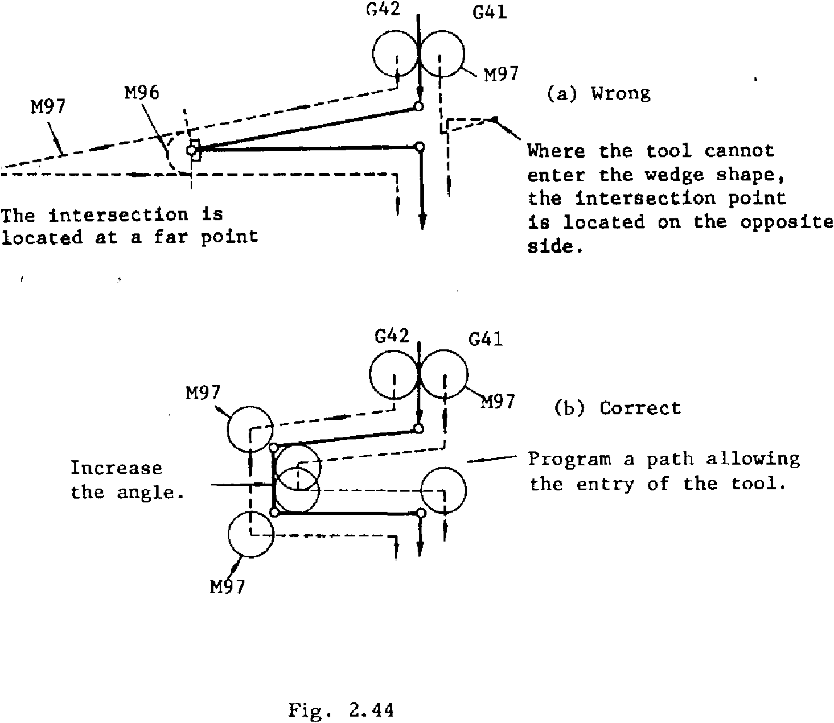

**G42**

**G41**

**---**

**Program a path allowing**

**the entry of the tool.**

**Increase**

**the angle.**

**G42**

**M97**

**M96**

**The intersection is**

**located at a far point**

**G41**

**1197**

**(**

**a) Wrong**

**1**

**Where the tool cannot**

**enter the wedge shape,**

**the intersection point**

**is located on the opposite**

**side.**

**97**

**b) Correct**

**(**

**M97**

**M97**

**Fig.**

**2.44**

**5. Command involving no movement in compen sation mode**

**The control normally reads in advance two blocks during tool radius compensation mode and computes the tool path. If either .of these blocks give no coordinate instructions such as G04 (dwell), the control reads the block further ahead and makes computing.**

**T h e b l o c k s w i t h n o c o o r d i n a te i n s t r uc t i o n s c a n b e p r o c e s s e d c o n t i n u o u s l y u p t o t w o blocks. When coordinate instructions are mi s si ng i n thre e or more bloc ks, tool ra di us compensation becomes impossible and accurate t o o l p a t h c a n n o t b e o b t a i n e d . T h e r e f o r e , i n a program where G41 or G42 is used, ensure that, after them, three or more blocks without movement command plane will not follow.**

**2. 9. 21 TOOL RADIUS COMPENSATION C**

**(G 410, Gil** , G112) 1 (CONT 1D)

EXAMPLE

G 1 7 G O 1 G 4 1 X . • • Y . . . D . • . F • • •

G 0 4 P 1 0 0 0 ; Blo cks without move ment

in comp ensa tion pl ane. ( W h e n t h e s e b l o c k s a r e w i t h i n two, machining is made smoothly.)

X...

y...

;

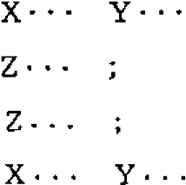

X- - • Y- .-

G4 0 X. - . Y• • •

If n o m o v e m e n t i n s t r u c t i o n i s p ro g r a m m e d i n t h re e o r m o re c o n t i n u o u s b l o c k s fo r re t ra c t i n g

t h r e e c o n t i n u o u s b l o c k s , o f f s e t i n t h e b l o c k i n t h e t h i rd a x i s o r t h e l i k e , a n d o ff s e t t i n g o n

i m m e d i a t e b e fo r e t h e m i s m a d e o n t h e n o r m a l t h e n o r m a l l i n e i s n o t s a t i s f a c t o r y , a d u m m y

l i n e a t t h e e n d p o i n t . Wh e re m o v e m e n t i n t h e b l o c k c a n b e i n s e r t e d b y I , J o r K .

c o m p e n s a t i o n p l a n e c a n n o t b e p ro g r a m m e d i n

EXAMPLE

N001 G17 GO1 G41 X. - • Y... D••- F. • .

|  |  |  |
| --- | --- | --- |
| N012 | Z... | Z axis |
| N019 | Z-•• | 3 blocks o r a b o v e |

NO11 I-.. J.-- Dummy block

N002

X..

-

Y...

XY plane

NO10

X••.

V...

I

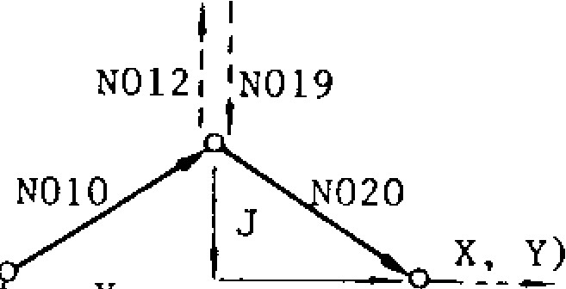

1  1 --------

I NO20 X Y.-. ;

XY plane

NO29 X--• Y..-

NO30 G40 X••• ; Fig. 2.45

The dummy block is not programmed for actual movement but it only provides data required for tool radius compensation computation. In the example indicated above, an instruction that is the same as the first block (NO20) of restarted movement of the XY plane after movement of Z axis is programmed as a dummy by I and J. I, J and K are used as the addresses of this dummy instruction, and they correspond to X, Y, Z axes respectively. Suitably use them in accordance with the plane designation.

EXAMPLE

N050 GO1 X••• Y.•.

Dummy for X axis

command Programmed in

J: Dummy for Y axis incremental command values

K: Dummy for Z axis command

If X... Y• • - of ***N***O20 is in absolute values in the above example, give an instruction by converting into incremental values.

Note: Make a dummy block as follows if the object of the dummy block is circular interpolation.

CENTER N052I I N059 .-1

~~N050 GO1 I(b) J(~~

~~-~~

~~a) ;~~

~~-~~

~~Dummy block~~

N052 Z • •

-

N053 Z•

-

•

N059 Z...

I

. Z axis

N 0 6 0 G0 3 X . . . Y. . . 1 ( a ) J ( b )

-

C

i r c u l a r

interpolation

1

1

a

NO60

NO51: DUMMY BLOCK

(

LINEAR

)

N050

Y

X



N061 GO1 X••. Y...

Fig. 2.46

This is, insert a linear dummy block that gives 6 the tangential direction at the start point of the circular interpolation program block as shown above. Exercise care with the sign of the dummy block data depending on the shape of the circle. The tool stops at point A by the dummy block in preparation for the next circular command.

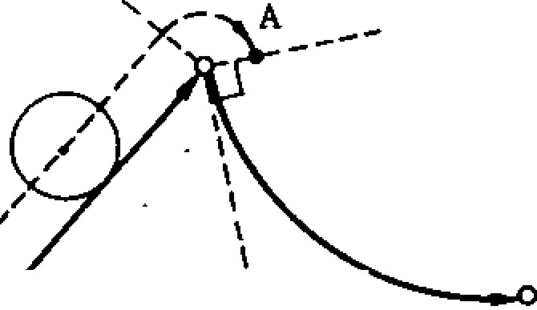

_

o

CENTER

Y

N051

DUMMY BLOCK

X

Fig. 2.47

. Switching between G41 and G42 in compensation mode

In this compensation mode, direct switching between G41 and G42 is possible without making cancellation with G40.

EXAMPLE

N10 G17 GO1 F• • •

N11 G41(G42) D• • •

N20 GO1 X... Y...

[N21 G42(G41) X• • • y••• ; ___ Block of

switching

N22 X...

**2. 9. 21 TOOL RADIUS COMPENSATION C**

**(G4I3, Gill, G4I2) (CONT(D)**

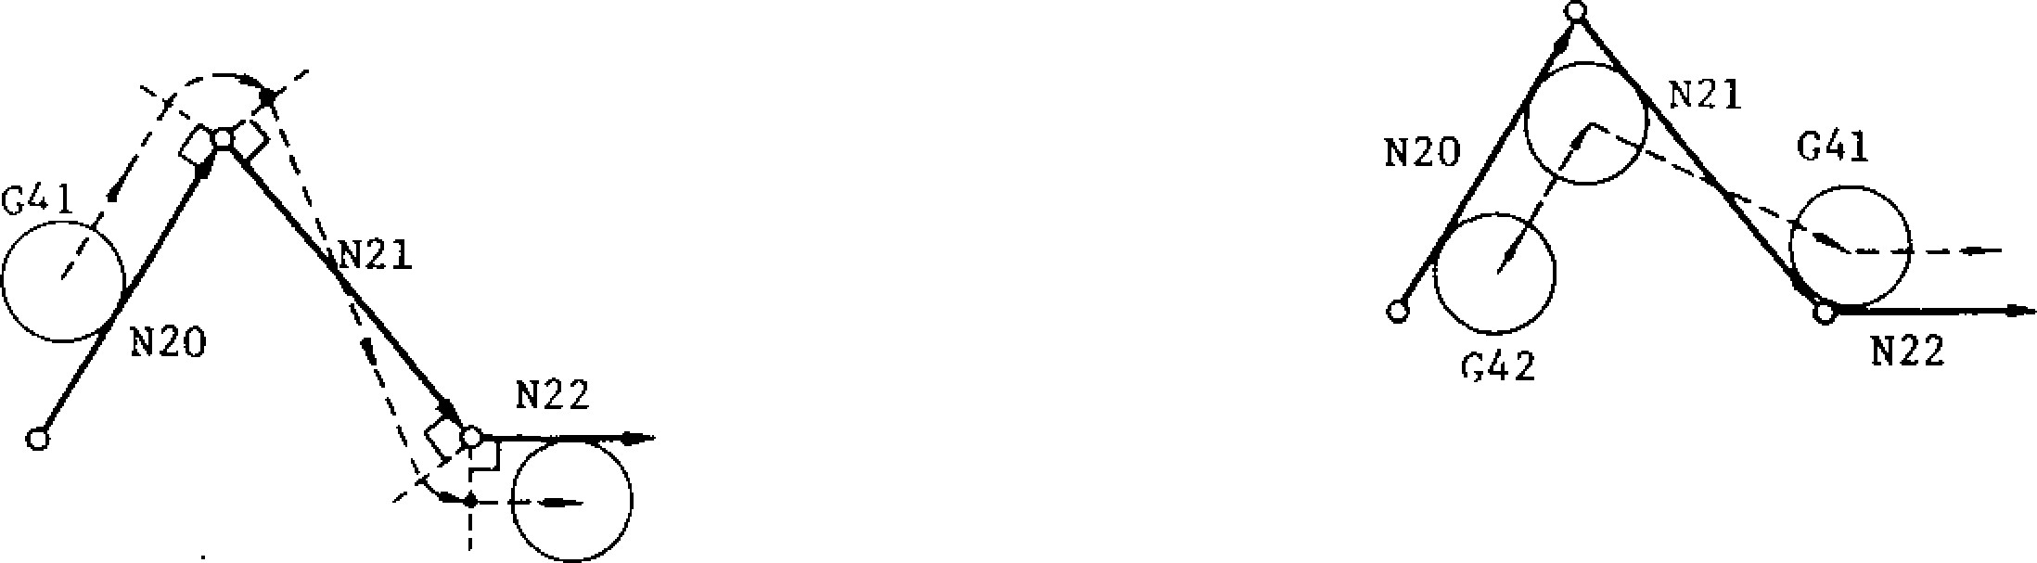

G42 (b) G42 4- G41

( a ) G 4 1 4 - G 4 2

(M96 mode )

F ig . 2 .4 8

Note: The movement identical to what is shown above is also obtained when block N21 is split into two blocks as follows.

G 4 2 ( G 4 1 ) ;

X

-

Y

-

-

•

1. Change of tool radius value in compensation BLOCK READ AFTER mode CHANGE OF TOOL

RADIUS VALUE

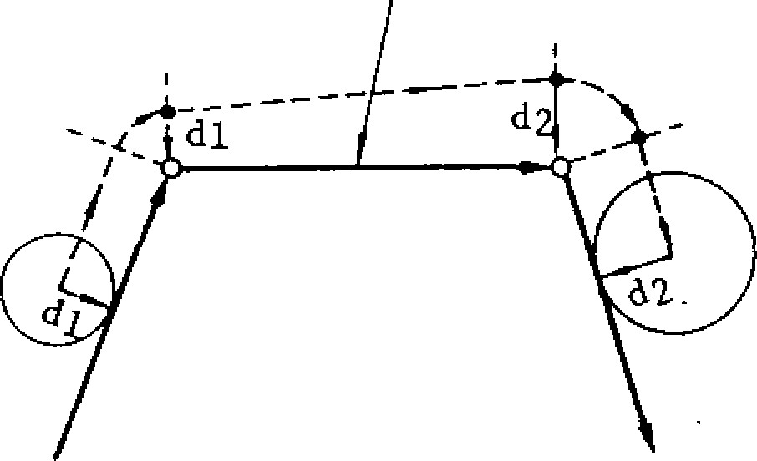New D code commanded in the compensation mode is effective in the block next to the commanded block.

1. Method of cancellation of compensation

G40 is the command for cancelling tool radius compensation C and for positioning or feeding the tool to just programmed end point.

In this case, the tool moves to a point on the normal line at the end point of the block im mediately before the block containing G40.

F ig . 2 .4 9

T

herefore, no portion will be left unmachined even when a cancellation with sharp angle is programmed. Because G40 accompanies can celling movement, program it in the GOO or GO1 mode like G41, G42. An input error "027" occurs if group A other than GOO, G02 is used.

EXAMPLE A

(a) G41 (G42)

GO1 X- .. F...

G40 X... Y...

1 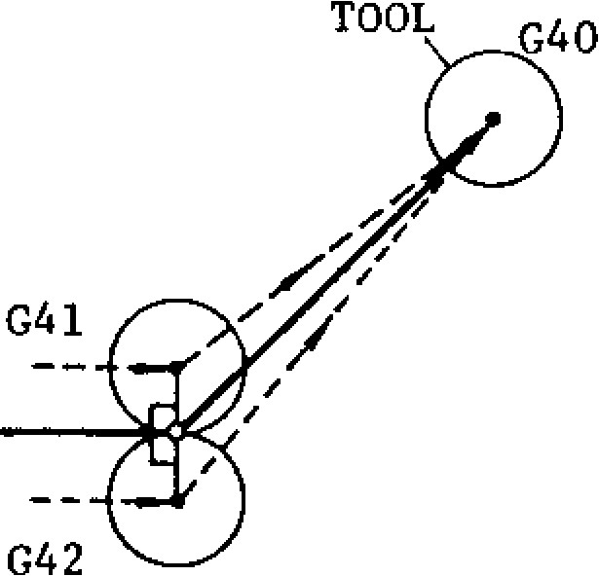

EXAMPLE B

1. G41 (G42)

G02 x... Y... I . . . J . . .

GO1 X• • . Y• - .

G40

G40

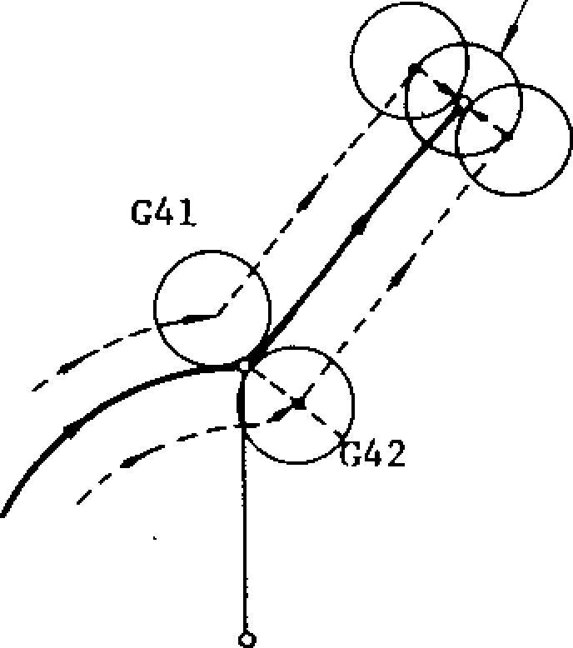

CENTER

(b) G41 (G42)

G 0 2 X . . . Y . . . I . . . J . . .

G O 1 G 4 0 X . • Y • . •

TOOL G40

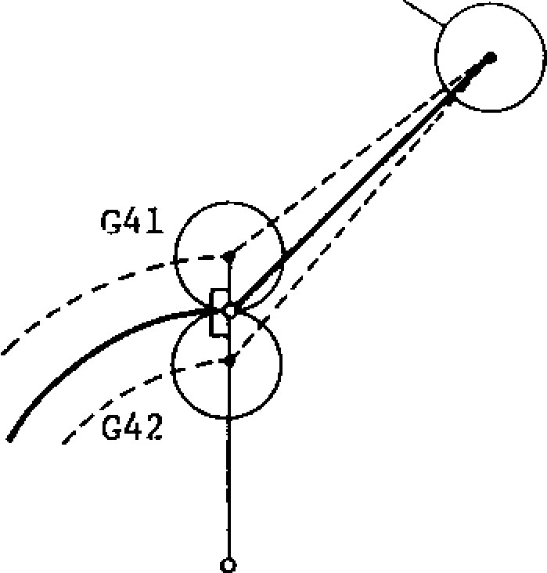

CENTER

Fig. 2.50

1. G41 (G42)

G02 X... Y... I . . . J . . .

GO1 G40 ;

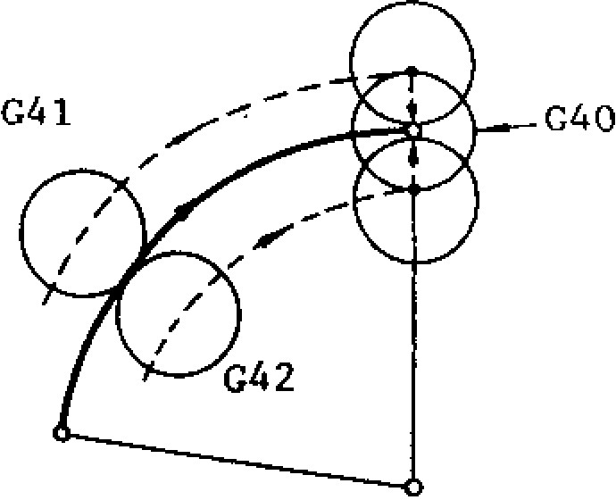

CENTER

Fig. 2.51

In a ll c a se s (a) th rou gh (d ) d e sc rib ed a bo v e, the offset position on the normal line at the end the tool reaches the programmed end point via point of the block immediately before G40.

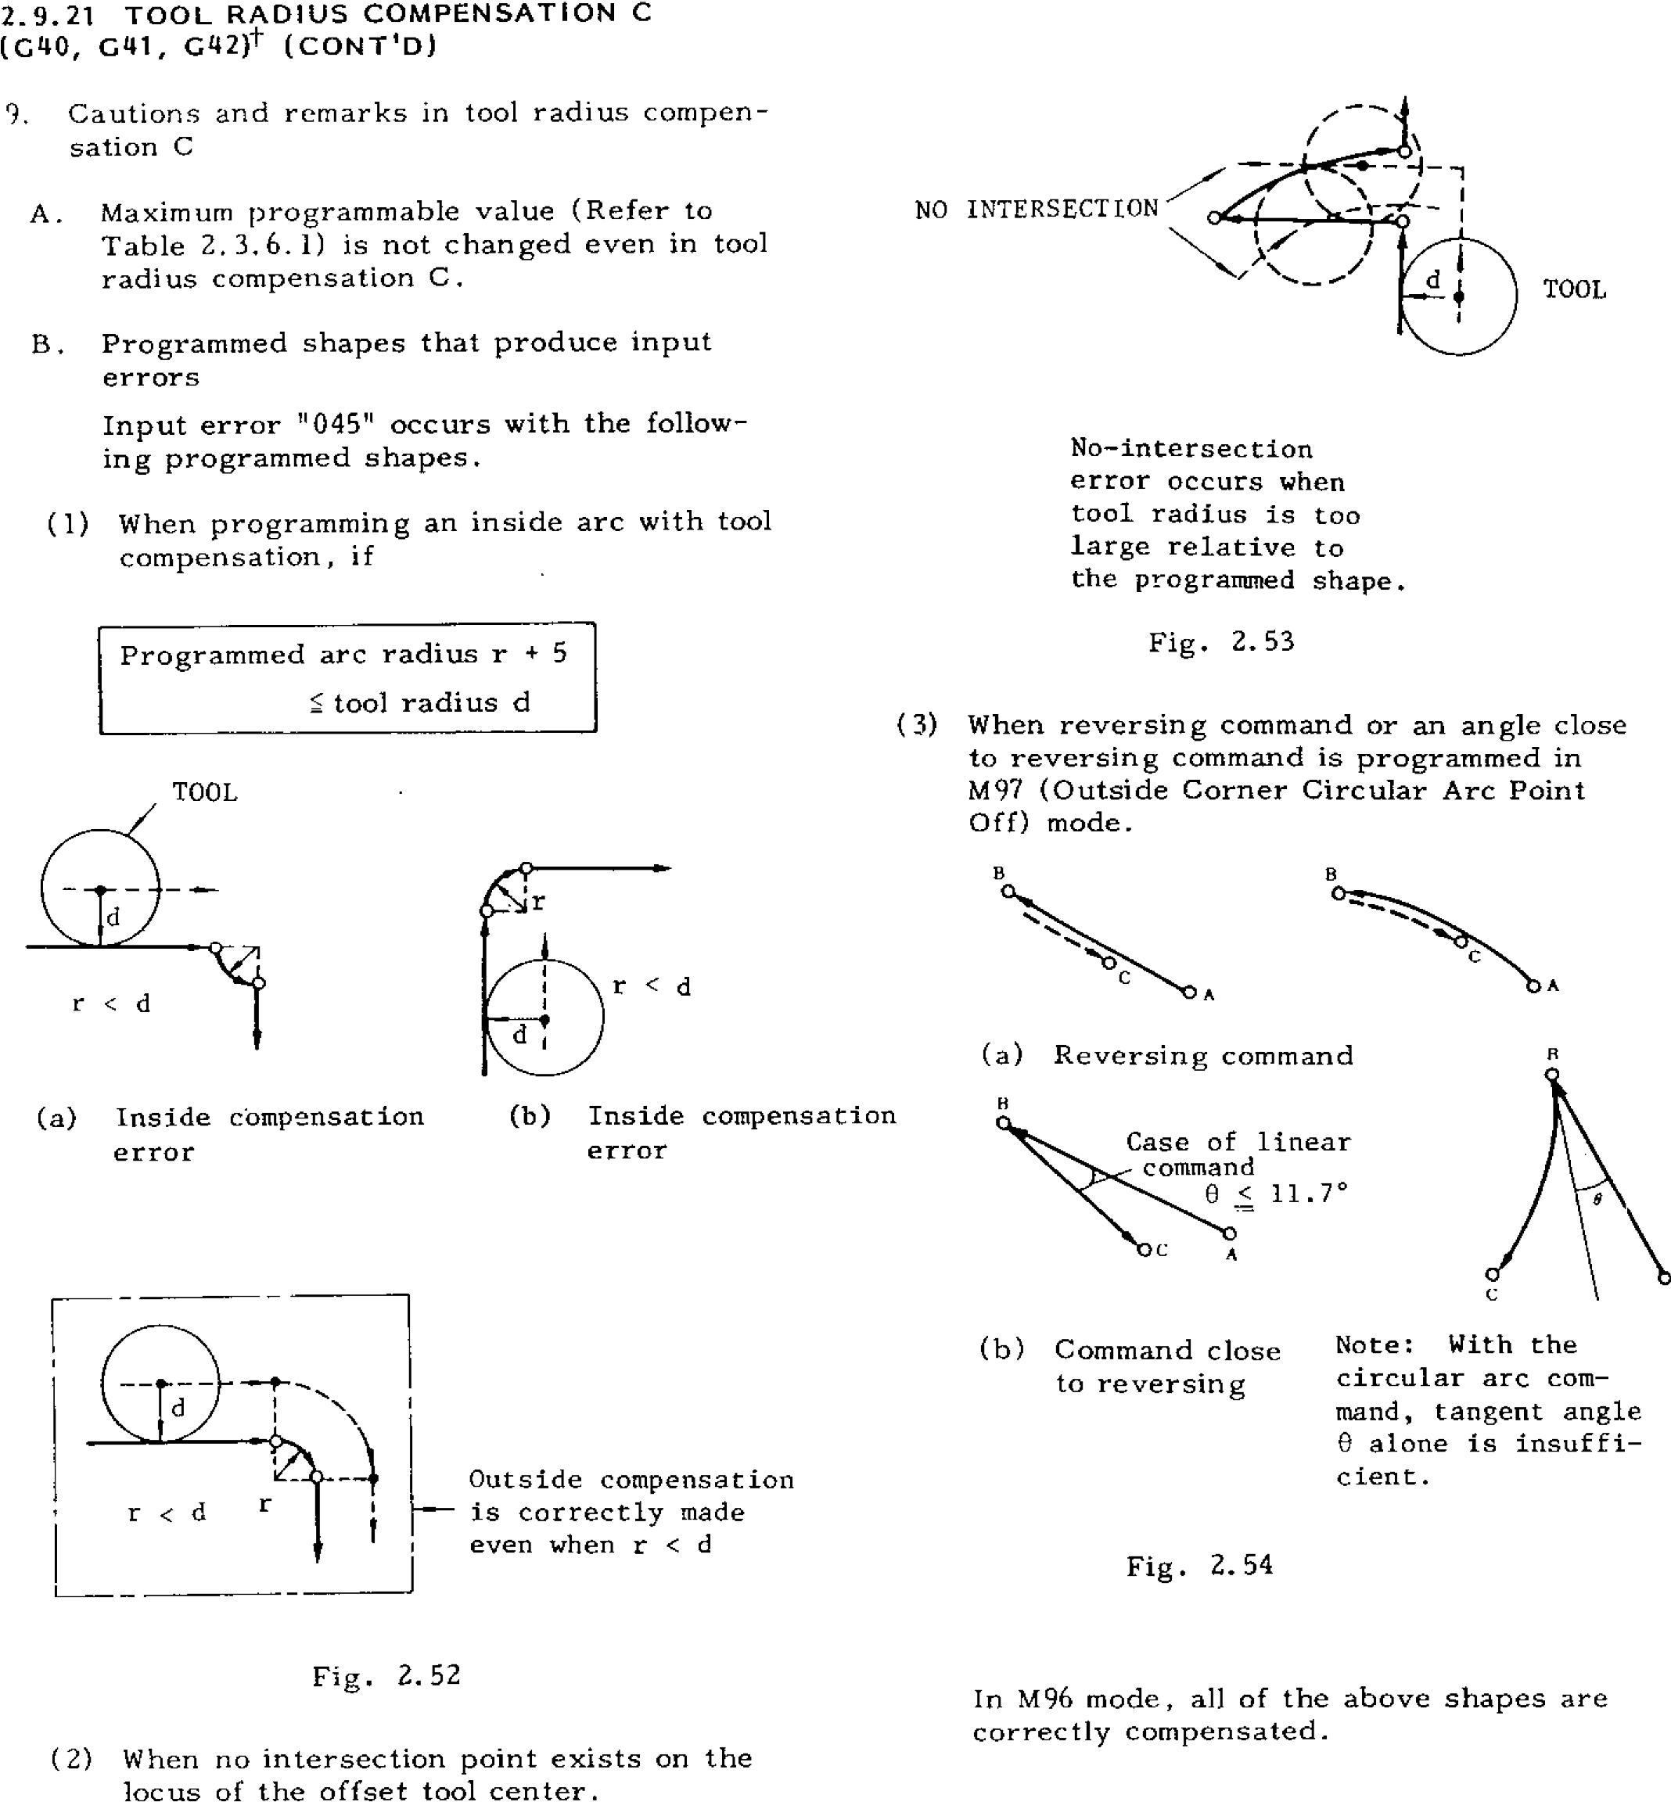

TOOL

9

. Cautions and remarks in tool radius compen

-

sation C

NO INTERSECTION

A.

Maximum programmable value (Refer to

Table 2.3.6.1) is not changed even in tool

radius compensation C.

B.

Programmed shapes that produce input

errors

error

error

(

b) Command close

to reversing

Note: With the

circular arc com

-

mand, tangent angle

alone is insuffi

8

-

cient.

TOOL RADIUS COMPENSATION C

2.9.21

(

)

G40, G41, G42)t (CONT'D

Input error "045" occurs with the follow

-

ing programmed shapes.

(1)

When programming an inside arc with tool

compensation, if

P ro g ra m me d a rc ra d iu s r +5

tool radius d

Outside compensation

---

is correctly made

even when r < d

Fig. 2.52

(2)

When no intersection point exists on the

locus

of

the offset tool center.

No

-

intersection

error

occurs when

tool radius is too

large relative to

the programmed shape.

Fig. 2.53

(3)

When reversing command or an angle close

to reversing command is programmed in

M97 (Outside Corner Circular Arc Point

Off) mode.

A

a) Reversing command

(

Case of linear

command

11.7°

<

Fig. 2.54

In M96 mode, all of the above shapes are

correctly compensated.

TOOL

a) Inside compensation

(

(

b) Inside compensation

**C. Input errors occur when the following G codes are programmed in the compensa-**

|  |  |
| --- | --- |
|  | **Prohibited G codes** |
| **G codes producing input errors** | **G12, G13 (G17 to G19)**  **G28, G29**  **G73, G74, G76, G77**  **G81 to G89**  **G92** |

**\* If a "reset operation" is performed in the compensation mode, compensation is can-**

**t i o n**

**m**

**o**  **d**

**e** 0A/N .



**r**

**M97**

**/ M96**

**. COMPENSATION PLANE /i**

**r**

**Fig. 2.55**

**celled and G40 remains.**

1. **Tool radius compensation C is applied to the movement path offset by tool length offset and tool position offset. However, in principle, avoid applying compensation C to the path using tool position offset for compensation of tool radius.'**
2. **When programming G41, G42 and G40, GOO or 001 and an F code should be program med in the same block or in a preceding block.**

**COMPLETING POSITION**

**OF PULSE DISTRIBUTION OUT OF THE**

**COMPENSATION PLANE.**

1. **Input error "046" occurs when circular interpolation is programmed out of the plane designated by G17, G18 or 019.**
2. **Offset position may be temporarily modified by programming a dummy block using ad '. dresses I, J, K.**
3. **An input error occurs if a G code, G17 to G19 of plane designation for changing the compensation plane is programmed during compensation.**
4. **Progra m circl e cut ting (G 12, 013) , and canned cyc les ( G73 , G74, G76, 077, G80 to 089) in the tool radius compensation cancel mode. Circle cutting and helical cutting incorporate tool radius compensating functions in themselves. Input error "024" occurs when they are programmed in the compensation mode.**
5. **Tool radius compensation C is also possible on circular interpolation by radius R designation.**
6. **Subprogram (M98, M99) can be programmed in the compensation mode.**
7. **Compensation is applied to the projection to the compensation plane designated by G17, G18 or G19 when simultaneous movement along three axes (four axest) is pro grammed in compensation mode.**

**(042)**

**N100 001 X..• Y...**

**N101** **I.• • • •**

**N102**  **X• .•**

**N102**

**DUMMY BLOCK USING I, J CODES: N101**

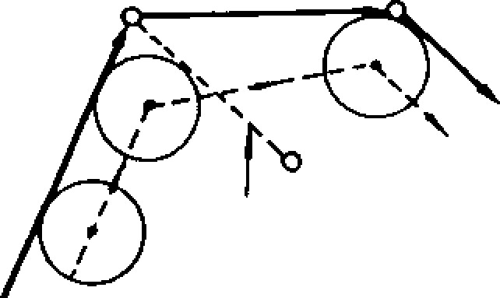

**N100**

X

**Fig. 2.56**

2 . 9 . 2 1 T O O L R A D I U S C O M P EN S A T I O N C

(G40, (CONTID)

|  |  |  |  |
| --- | --- | --- | --- |
| (G41)  GO1  N200 X ..• | | Y... |  |
| N201  N2Q2 | I . . .  MOO | J...  ; |
|  |
| NZO3 | X• • • | Y... |
|  |

1. Ad va nc e rea ding of b loc ks is proh ibited when MOO, MO1 (MO2, M30) commands are given, and compensation is usually inter rup ted. Con tinua tion of correct co mpen sa tio n is sec ured b y p rog ra mmin g I, 3 , K in a dummy block immediately before MOO, MO1 to avoid interruption.

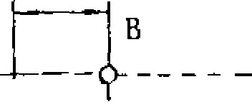L____ A? 1 , . . . . -

----;-. MOVEMENT

,-• NOF TOOL. I

\ I I

Command movement data N203 using I, J

1. Up to 99 radius values can be stored in the offset memory in total for the tool radius compensation, together with the values for o t h e r c o m p e n s a t i o n . M a k e d e s i g n a t i o n b y a D code. The maximum programmable value of tool radius compensation is i'999.999 mm

(or ±99. 9999 inch) .

1. Overcut occurs if compensation is program me d on a ste p less th an th e to ol ra d iu s in M9 6 mo d e . Ke e p th is in m in d . Alth o u g h unde rsize cut occurs with the G97 mode, it is better than overcut with the M96 mode.

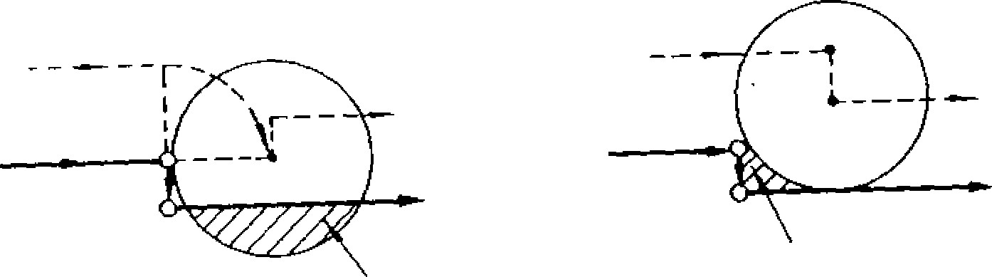

OVERCUT UNDERSIZE

CUT

(a) M96 mode (b) M97 mode

Fig. 2.57

1. Even in M9 6 mo d e , th e to o l mo v e s d ire c tly toward point B without making circular path, if both AX and AY are smaller than a fixed v a l u e a s s h o w n b e l o w . T h e f i x e d v a l u e i n this case i s t h e v a l u e s e t b y p a r a m e t e r

(#6230).

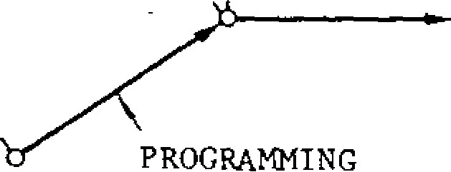

AX <

Y y : Se t value of parameter #6230

)C

F ig . 2 .5 8

1. Intervention of MD1 operation in compensation mode

MDI operation can not be intervened in compensation mode.

1. Intervention to active buffer in compensation mode

The data given below can be programmed in the compensation mode of G41 or G42 with procedures identical to those of MDI operation, after turning on the SINGLE BLOCK switch to suspend the block, and then, se lecting the RAPID or JOG mode.

|  |
| --- |
| Programmable data: F , M , S . T a n d B t c o d e s  Programmable block:  In addition to the block of instructions of the active bu ffer just execu ted |

When the CYCLE START button is pushed in th e RAPID o r JOG mod e a fte r p rog ra mming , the instructions are immediately executed and signals such as BCD output are sent out. Automatic operation can be resumed when CYCLE START is made after returning to the original automatic operation mode.

N o t e : I n t h e o p e r a t i o n d e s c r i b e d i n t h e s e items, the following M codes cannot be written. MOO, M01, MOZ, M30, M90 to M199

|  |
| --- |
| EXAMPLE A  +X    **START POINT**  **Inside cutting**  **Z- Outside cutting**  **G42**  C41 |

0 G91 GO ! A -2 50 0 w I nc re me nt a l ; Z a xis

F150 ; **lowering**

®G 17 (G01) F300 ; XY plane designation, feed command

0G41 D21 ; — T o o l r a d i u s c o m p e n s a t i o n

start command with tool offset No. 21

(DY 14 000 ; Offs e t to a point on the

**normal** line of s ta rt point **of this block .**

OX3000 Y4000 ;

OGO2 X10000 15000 ;

7 G01 X3000 Y-4000 ;

O u t e r C u t t i n g

Y-10000 ;

e

X-4000 ;

R designation circular

10 GO3 X-8000 R5000 ; arc

11GO1 X-7000 ;

0 J - 2 0 0 0 ; — D u m m y b l o c k ( f o r m o d i -

fying offset position)

(13 22500 Z axis Two blo

elevation without move-

ment on **the**

MO1 ; — O p t i o n a l de s igna te d

|  |  |
| --- | --- |
| G42 (G01) X13000  Y9000 F2000 ;  **Z -2500** P150 ; —  Y-4000 F300 X-  6000 ;  Y3000 ;  G02 X8000 14000 ; | stop _ plane  Switching of direction of c ompe ns a tion( le ft + right )  Z axis lowe ring  I n n e r C u t t i n g |

GO1 Y-3000 ;

X-6000 ;

Y3000 ;

Offse t to a point on the norma l line of e nd point of this block

Z2500 ; Z axis elevation

G40 (G01) X-6000 Compe nsation cance l

Y-12000 F2000 ; command

The same effect is obtained even when the commands in parentheses a re n o t ma d e . T h e y a re e n te re d fo r e a s e o f u n d e rst a n d i n g .

Fig . 2 .59

- 51 -

2.9.21 TOOL RADIUS COMPENSATION C

(G40, G41, G42)t (CONT'D)

EXAMPLE B

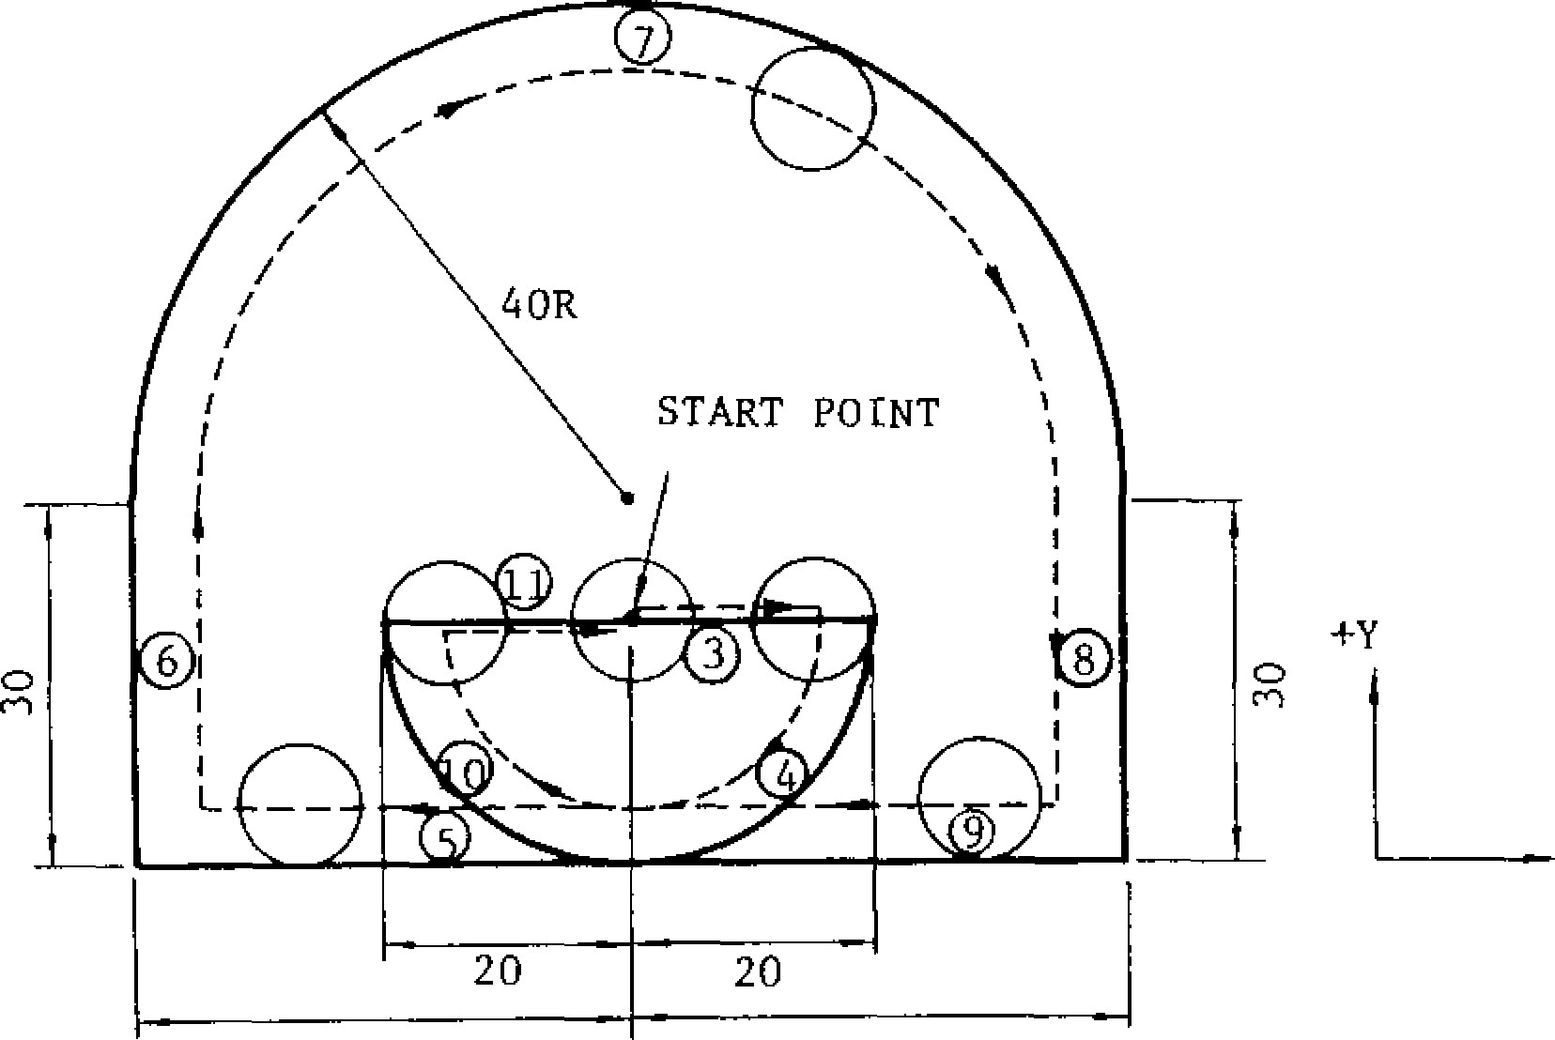

START POINT

40 40

(G40)

0 G91 GO1 Z-2500 F150 ;

G17 F300 ;

0 0 G42 D20 X2000 ;

0 0

G02 X-2000 Y-2000 1-2000 ;

0 0

G01 X-4000 ;

0 0

Y3000 ;

0 G02 X8000 14000 ;

0

GO1 Y-3000 ;

X-4000 ;

G02 X-2000 Y2000 J2000 ;

G40 G01 X2000

Z2500 ;

W ith th e in n e r c u t tin g in E XA M PL E A, th e d o u b le cutting allowance at the cutting start and cutting end v a r i e s w i t h t h e t o o l r a d i u s . A n i n n e r c u t t i n g c a s e with zero double cutting allowance regardless of the cutter radius is shown in EXAMPLE B.

Fig . 2 .60

**!2.9.22 TOOL LENGTH COMPENSATION**

**(GU, G44, G49)**

The tool length compensation function is for addin g o r su b tra c tin g th e sto re d to o l o ffse t v a lu e s t o t h e Z - a x i s c o o rd in a t e i n s t ru c ti o n v a lu e s f o r th e p u rp o se o f c o mp e n sa tin g fo r th e d e v ia tio n s

in tool length.

* G cod es for tool length co mpensa tion ( G 0 1 ) Z . . . ; G43(G44) H...

|  |  |  |
| --- | --- | --- |
| G code | Group | Meaning |
| G43 | 08 | (+) direction |
| G44 | 08 | (-) direction |

* G43 and G44 are modal functions, remaining effective when once commanded until cancellation by G49.

G49 cancels tool length comp ensation effects.

H00 also cancels tool length compensation effects.

The tool length compensation function is pro grammed in the following format.

A. (G01)

6 4 3 ( 0 4 4 ) Z . . . H • • • ;

With this command, the tool moves towards t h e Z c o o r d i n a t e p o s i t i o n w h i c h i s the sum of (or difference between) the H v a l u e a n d t h e Z v a l u e . As t h e r e s u l t , t h e to o l po int is d isp la ce d fro m the sp ec ifie d Z-coordinate position by the distance spec ified by the H code.

G49

08

.

cancel

With this command, the tool is shifted by th e distance spec ified by th e G cod e.

Q. G 4 3 ( G 4 4 ) Z • • . H . •

**H. • • ;** ( 2 )

With the command (2), the tool is shifted b y th e d if fe re n c e b e t we e n th e p re v io u s

tool offset value and the new tool offset value.

When G43, G44 and G49 are to be commanded, the accompanying 01 group G codes must be GOO, GO1 or G60. When 002 or G03 is used, th is is re g a rd e d a s a n e rro r.

Direction of shift

The direction of tool shift is determined by the sign of to o l o ffset va lu e a s p ro g ra mme d in the H cod e and by the G co de u sed.

|  |  |  |
| --- | --- | --- |
|  | Sign of tool offset value | |
|  |  |
| G43 | Plus direction | Minus direction |
| G44 | Minus direction | Plus direction |
|  |  |  |

|  |  |  |  |  |  |  |
| --- | --- | --- | --- | --- | --- | --- |
| 2.9.22 TOOL LENGTH COMPENSATION (G43, G44, G49) (CONT'D)  EXAMPLE   |  |  |  | | --- | --- | --- | | H10 | • | Offset v alue: -3 .0 | | Hll | - | Offset value: 4.0 |   CRT display including offset value |

(Z direction only)

|  |  |  |  |
| --- | --- | --- | --- |
| N101  N102  N103  N104 | G92  G90  G43  GO1 | ZO ;  GOO X1.0 Y2.0 ;  Z-20. H10 ;  Z-30. F1000 ; | 0.000  0.000  -23.000  -33.000 |
| N105 | GOO | ZO HOO ; | 0.000 |
| N201 | G00 | X-2.0 Y-2.0 ; |  |
| N202 | G44 | Z-30. H11 ; | - 34.000 |
| N203 | GO1 | Z-40. F1000 ; | -44.000 |
| N204 | GOO | ZO H00 ; | 0.000 |

NOTES:

• When the tool offset value is changed by the MDI fu n c tio n wh ile p rogra ms in th e o ffset mode is in execution, the change is effective from the block containing D code.

The tool position offset function or the tool radius compensation function is effective on the tool which is already offset by the tool length compensation function.

G43, G44 and G49 can be programmed in can n e d c y c le s. If th e y a re p ro g ra m m e d , th is is r e g a r d e d a s a n i n p u t e r ro r .

ACTUAL

T O O L

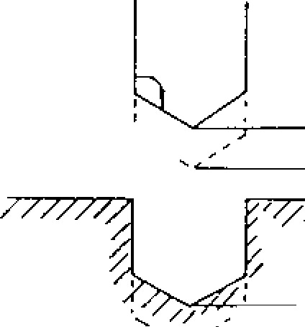

PROGRAMMED

-

L;1

TOOL POSITION

POSITION

− 2 0 .0 0 0

− 2 3 .0 0 0

-30.000 -33.000

ACTUAL

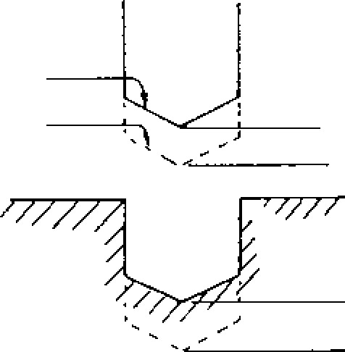

TOOL

POSITION

−

30.000

−

34,000

−

40.000

−

40,000

PROGRAM

TOOL POSITION

When a G92 co mmand inv olving the Z axis is given during the execution of a program in the tool length compensation mode, the tool length c o mpe nsa tion is c an ce le d. In p rin cip le , wh en G 9 2 is to b e p ro g ra m m e d , th e e x i s tin g to o l length compensation mode should first be can celed.

During the automatic execution of a program in the tool length compensation mode, the number of the effective tool compensation memory (H c o d e n u m b e r) c a n b e d i sp l a y e d . F o r t h i s , r e fer to **4.** 3. 2 DISPLAY OF COMMAND DATA.

L.9.23 TOOL POST - I - 10N OFFSET (C45 TO G48)

Tool position offset A is fo r ex tending or reduc ing the movement value designated in the program b y th e v a lu e s in th e to o l o ffse t me mo ry , a n d is m a in ly u se d fo r to o l ra d iu s c o m p e n sa ti o n fo r sq ua re pa tte rn s. T he re fo re , th is fun c tion is no t

re q u ire d with c o n tro ls e q u ip p e d with G4 0 , G4 1 , G42 (tool radius compensation C).

1. G code s of too l position offse t

|  |  |  |
| --- | --- | --- |
| G, code | Group | Meaning |
| G45 | * | Extension |
| G46 | * | Reduction |
| G47 | * | Expansion by double |
| G48 | * | Reduction by double |

G45 to G48 extend and reduce the movement value programmed in the block, in the direc tion of movement by the tool offset value.

EXAMPILE

G91

|  |  |  |  |  |
| --- | --- | --- | --- | --- |
| 0  0 | 600  601        G00 | G46  G47 Y...  G47 X.  G47 Y.  G47 X... G46 X... | Y...  (D01)  (D01)  (D01)  (D01) Y... | DO1 ; F...  ;  ;  ;  (D01) |

Exte nsion or reduction is made only in the b loc k in wh ich G45 to 648 are p ro g ra mme d and movements in other blocks are unaffect e d . T h e r e f o r e , t o r e s t o r e e x t e n d e d o r r e duced values to the original program values, an exten sion or reduction in the oppo site direction must be programmed eventually.

1. Make program command by incremental de signation (691) for the sake of making the above operation clear. When the command is given by absolute designation (G90), exten sion and reduction are made along the direc tion of movement to the movement value from the end point of the preceding block, to the c o m m a n d t a r g e t p o i n t . T h a t i s , e x t e n s i o n and reduc tion are made to the incre men tal move ment a mount. The programming may become complicated.
2. When programming G45 to G48, designate the tool offset number by a D code simultaneously with ax is de signa tion. Becau se I) code s are m o d a l , t h e y m a y b e o m i tt e d i f t h e s a m e D c o d e is u se d . S t o r e th e to o l r a d iu s v a l u e i n

the tool offset value memory.

Reduction

Extension by double Extension by double Extension by double

Extension by double

Reduction

X

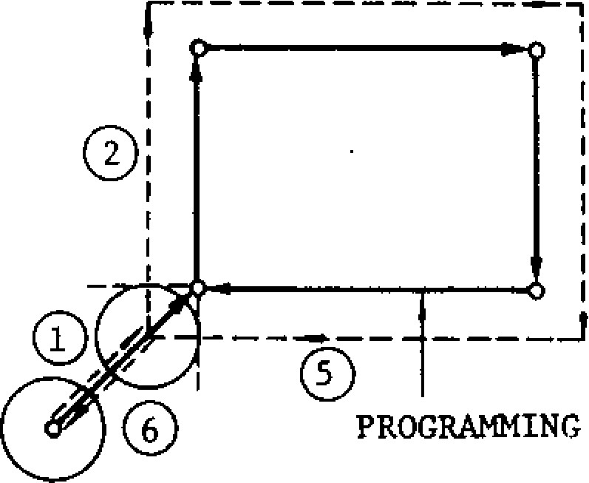

Fig . 2.61

**2.9.23 TOOL POSITION OFFSET (G145 TO CLIO**

**(CONT'D)**

G4 6 X1 0 0 0 D1 0 ; D10 = 2000

|  |  |
| --- | --- |
| 5 . E x t e n s i o n a n d r e d u c t io n  Extension or reduction is determined by the sign of the tool offset value designated by a D code in addition to the G code. | 1000 (COMMAND)  0--2000 |

|  |  |  |
| --- | --- | --- |
|  | Sign of tool offset value | |
| Positive | Negative |
| G45 | Extension | Reduction |
| G46 | Reduction | Extension |
| G47 | Extension **by** double | Reduction by double |
| G48 | Reduction by double | Extension by double |

END POINT START POINT

(TOOL MOVEMENT)

Fig. 2.64

7. The above applies to X and Y axes, but G45 to G48 may also be programmed to Z axis in the same manner.

|  |  |  |
| --- | --- | --- |
| N o te : In g e n e ra l, to o l o ffse t v a lu e sh o u ld be "positive."  6 . Va lu e s o f e x te n sio n a n d re d u c tio n  A. Pro g ra mme d inc re me n ta l mo v e v alue s a re extended or reduced by the designated tool o ff se t v a l u e s o r b y t w i c e t h e i r v a l u e s .  G 9 1 G 0 0 G 4 7 X 6 0 0 0 D 1 0 ; D 1 0 = 2 0 0 0  6000 (COMMAND) 4000 (EXTENSION BY DOUBLE)  9 ____________  0- _ | 8. | A p p l i c a t i o n t o c i r c u l a r i n t e r p o l a t i o n  If I, J, K are programmed in the block with G45 to G48, extension or reduction is made respectively in the same directions as X. Y, Z . T h e re fo re , to o l ra d iu s c o mp e n sa tio n is possible with 1/4 circ le, 314 o r fu ll c irc le.  G91  G 4 5 G 0 2 X 5 0 0 0 Y 5 0 0 0 1 5 0 0 0 D 1 0 ;  D10 = 2000  MOVEMENT OF |

|  |  |
| --- | --- |
| b ov e , bu t t he di s ta n ce i s m e a s u red fro m t he o f f s e t s t a r t p o i n t .  Wi t h an in s t ruc t ion s a me a s th a t d e sc ri be d above: | EXTENSION OF I:  2000  Fig. 2.65  In p ra ctice , co rre ct rad ius compen sat ion o f c i r c u l a r a r c i s m a d e i f a n o f fs e t is a p p l ie d in the preced ing b lock. |

10000

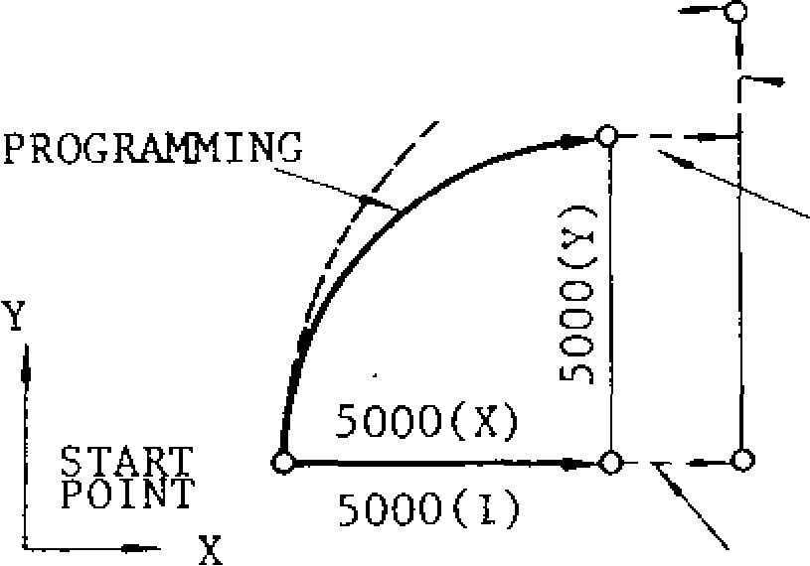

TOOL

START END — EXTENSION OF Y:

POINT POINT 2000

(TOOL MOVEMENT) EXTENSION OF X:

F i g . 2 .6 2 2000

B . W h e r e e x t e n s i o n o r r e d u c t i o n i s a p p l i e d t o a n ax i s in th e p re ce di ng bl o ck and th e st a rt point has already been offset, the total move m e n t v a l u e i s i d e n t i c a l t o t h a t d e s c r i b e d a -

6000 (COMMAND) 4000 (EXTENSION BY DOUBLE)

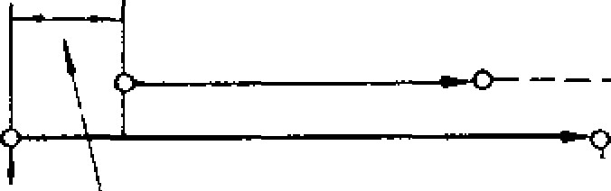

10000



G91 GOl F•••

G 4 6 X . • . Y . . . D 1 0 ;

START END POINT G45 Y...

POINT (TOOL MOVEMENT)

|  |  |  |
| --- | --- | --- |
| G45 GO2 X- | y- .- | - • |

|  |  |
| --- | --- |
| Fig. 2.63  N o t e : W h e r e t h e t o o l o f f s e t v a l u e i s l a r g e r t h an t h e p ro g ra m me d move m e nt v a lu e , t h e d i re c t i o n o f m o v e m e n t m a y b e r e v e r s e d w h e n e x t e n s i o n o r r e d u c t i o n is applied. | GO1 X- |

O f f s e t v a l u e b y p r e c e d i n g b l o c k

- 56 -



TOOL. MOVEMENT , 1 1 1 1

I I A I

(X, Y)

CENTER

PROGRAMMING



START POINT

N o te : W h e n it i s n e c e s sa r y to p ro g ra m 1 /2 circle, assemble them using 1/4 circle.

Fig. 2.66

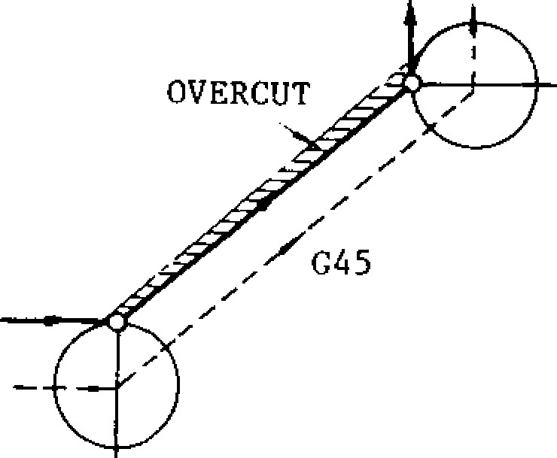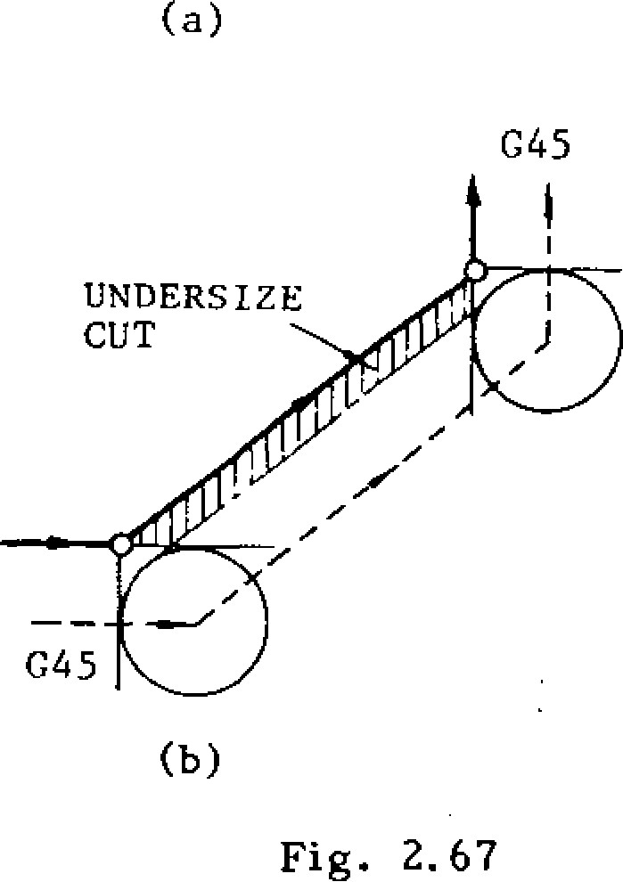

G45

(

b

)

Fig. 2.67

(

a

)

UNDERSIZE

CUT

1. When programming G45 to G48, the G code of 01 group can be given together in the same b l o c k . A n i n p u t e r r o r o c c u r s i f i n s t r u c t io n is given with other G codes.
2. When only movement by offset in the incre mental designation (G91) is required, pro gram "0" as the axis movement instruction.

G 9 1 G O 1 G 4 5 X O Y 0 D I O F . . . ;

Movement is made in the positive direction along both X and Y axis by the offset value with D10. ,

G 9 1 G 0 0 G 4 6 X O D 1 1 ;

Movement is made in the negative direction along X axis by the off set value with D11.

It is meaningless to give a sign to "0." NOTES:

W h e n G 4 5 t o G 4 8 a re p ro g r a m me d a s th e si m u l t a n e o u s m o v e m e n t i n s t r u c t i o n a l o n g t w o a x e s , e x t e n s i o n o r r e d u c t i o n i s m a d e i n t h e t w o a x e s . O v e r c u t o r u n d e r s i z e c u t w i l l o c c u r i f t h i s i s applied to cutting. Keep this in mind. (Fig.2.9.23.7)

Even when the offset value is changed **by MDI ,** t h e o ff se t i n s tr u c ti o n p r e v io u s ly p ro g r a m me d will not be affected. It becomes operable when G45 to G48 are programmed thereafter.

This tool position offset can be applied in ad dition to the tool length offset .

Mirror image can be applied to tool position off se t. T h a t is , it is p o ss ib le to p e rfo r m sy mme t rical cutting with this offset applied.

Tool position offset is independent of G codes (G17/G18/G19) of plane designation.

G45 to G48 can not be programmed in the can n e d cy c le s mo de . An inpu t erro r will oc cu r if this is programmed.

If G92 is p rogra mmed in th e offset mo de, p ro g ra mmin g o f a b so lu te ze ro p o in t is ma d e a fte r the offset value is canceled from the designated a x e s . In p r i n c i p l e , p r o g r a m G 9 2 a f t e r r e t u r n in g the offset value to the orig inal value by p ro g ra m m in g e x te n si o n o r • re d u c ti o n i n th e opposite direction.

Du ring a uto matic op era tio n , th e o ffse t d istan ce in each ax is fro m the p rogrammed end poin t by to o l po sition o ffset ca n b e display ed Re fe r to 4.3.2.3 DISPLAY OF TOOL OFFSET STATE: COMMAND (OFFSET).

**2.9.23 TOOL POSITION OFFSET (GL15 TO G 148)**

**(CONTID)**

EXAMPLE **A**

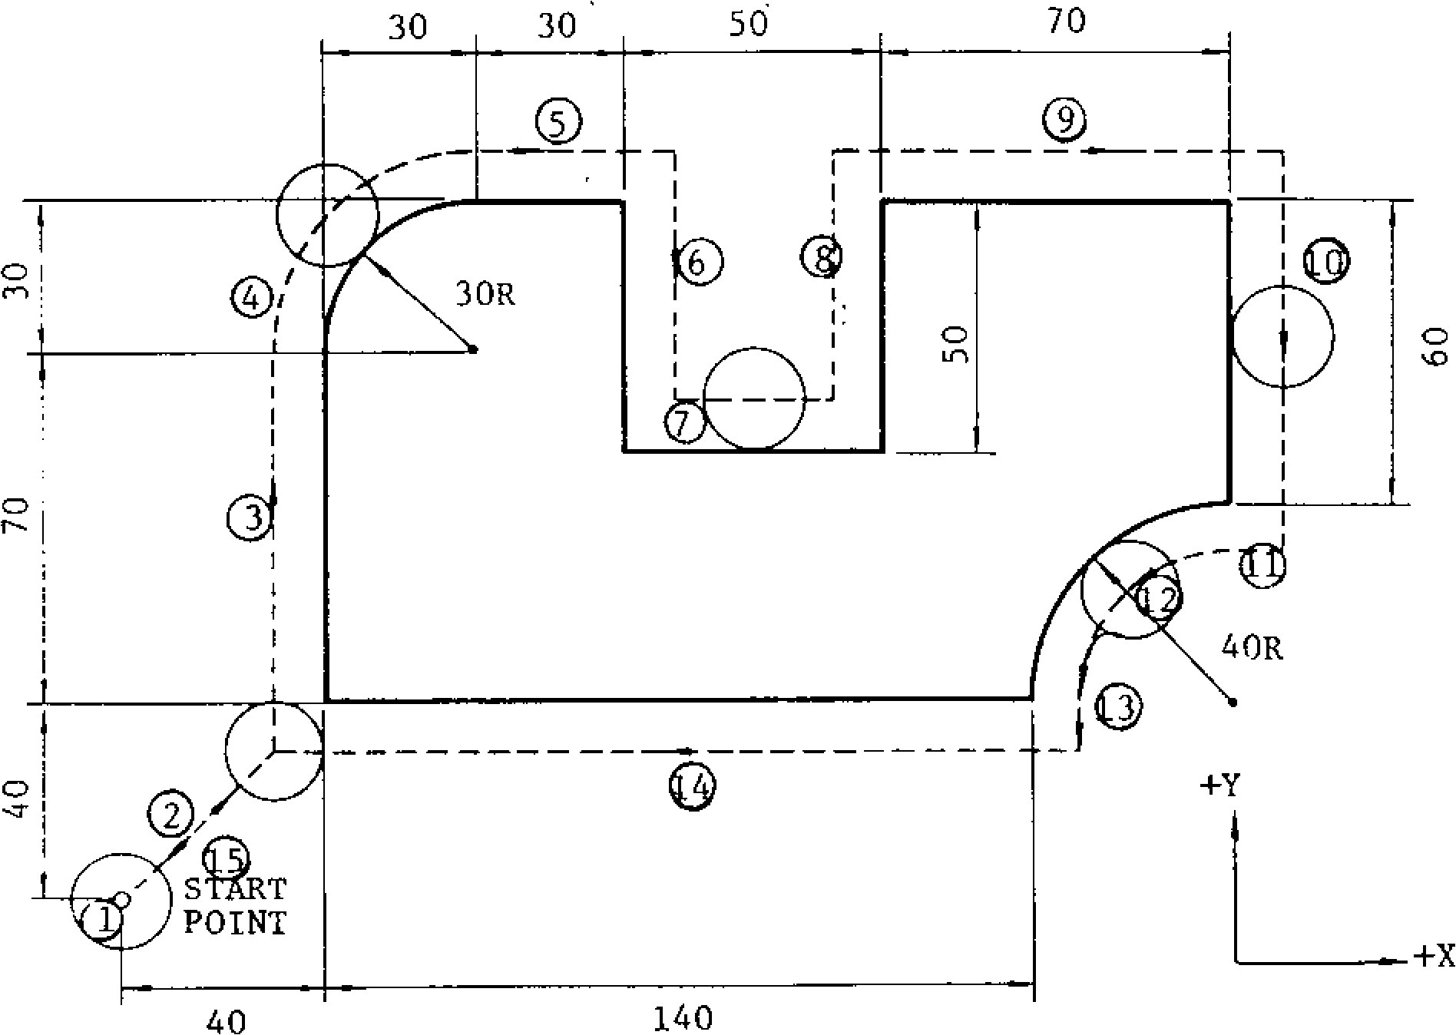

|  |  |  |  |  |  |  |
| --- | --- | --- | --- | --- | --- | --- |
| G91  G45  G45 | GO1 Z-2500  G46 X4000  G45 Y7000  G02 X3000 | | FI50  Y4000  ,  Y 3000  ;  ; | D10  13000 | F300 | |
| ; |  |
| GOI | X3000  Y - 5000 |
|  | G48 | X5000 | ; |  |  |  |
|  |  | Y5000 | ; |  |  |  |
|  | G47 | X7000 | ; |  |  |  |
|  | G47 | Y-6000 | ; |  |  |  |
|  | G46 | X0 ; |  |  |  |  |
| G46 | G03 | X-4000 | Y-4000 | J-4000 | | ; |
| G46 | GO1 | YO ; |  |  | |  |
|  | G47 | X-14000 ; | |  | |  |
|  | G46 | X-4000 Y-4000 | |  | |  |



Fig. 2.68

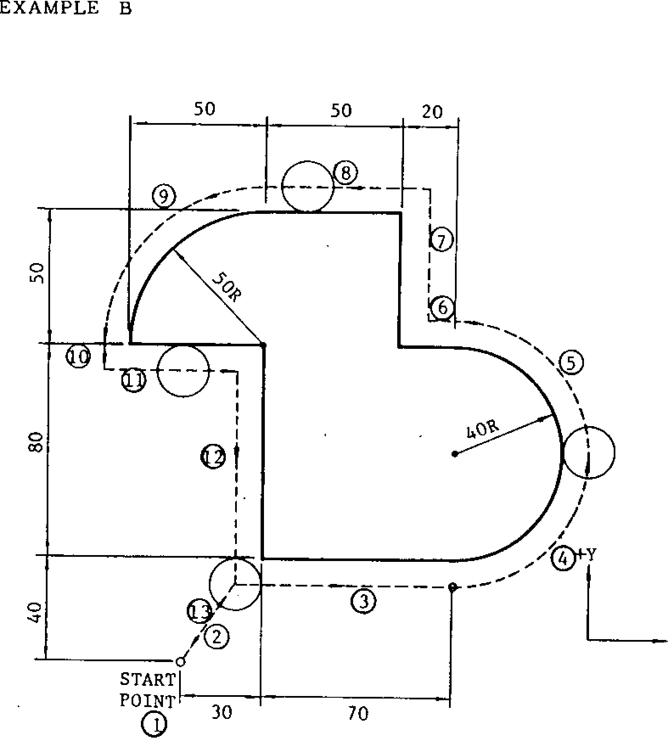

**EXAMPLE B**

**50**

**50**

**20**

----

0

----

**POINT**

**__**

❍

**30**

**70**

❍ **G 9 1 G O 1 F 3 0 0 ; 0 G 46**

**X 3000 Y4000 D15 ;**

* **G 4 5 X 7 0 0 0**
* **G 4 5 G 0 3 X 4 0 0 0 Y 4 0 0 0 J 4 0 0 0 ;**
* **G 4 5 G 0 3 X - 4 0 0 0 Y 4 0 0 0 1 - 4 0 0 0 ;**

**0 G 4 6 G O 1 X - 2 0 0 0 ;**

**0 Y5000**

* **G 4 5 X - 5 0 0 0 ;**
* **G 4 5 G 0 3 X - 5 0 0 0 Y - 5 0 0 0 J - 5 0 0 0 ;**
* **- G 4 6 G 0 1 Y O ;**
* **X 5 0 0 0 ;**
* **Y - 8 0 0 0**

**0 G 4 6 X - 3 0 0 0 Y - 4 0 0 0 ;**

**Fig. 2.69**

2.9 .24 SC AL ING **F U N CT I ON ( C 5 0 , G 5 1 ) 4.**

Wi t h th i s fun ct io n, wo rkp ie c e c on to u rs p rog ra m m e d b y p a rt p ro g ra m s c a n b e e n l a rg e d o r re d u c e d at any desired scale .

PROGRAMMED CONTOUR

SCALED CONTOUR

(I, .7) SCALING CENTER

t i .

Y

X Fig. 2.70

The following G codes are used for this function. Example

|  |  |  |
| --- | --- | --- |
| G code | Group | Meaning |
| G50 1 | 15 | Scaling OFF |
| 051 | 15 | Scaling ON |

Note: When power is applied or the control is r e s e t , t h e c o n t ro l i s i n t h e s t a t e o f G c o d e m a rk e d wi t h l .

G51 J.•• K••• P.•-

With this command, the program is executed on a n e n a l r g e d o r r e d u c e d s c a l e w i t h t h e s c a l e

ratio specified by P, and the center of scaling s p e c i fi e d b y 1 , J , a n d K .

* G5 0 ; c o m m a n d c a n c e l s t h e s c a l i n g m o d e .
* The enlarging and reducing scales can be se lected within the following range.

' Enl arg ing and reducing range 0.000001 -99.999999

When no scale ratio is specified in the program, the ratio set by parameter #6500 becomes effec tive as the scale ratio.

Co mmand unit fo r P is : 1 = 0.000001. When P command includes decimal number, num b e r s a f t e r d e c i m a l p o i n t a r e r e g a r d e d a s s i x digi t numb e rs .

Example

|  |  |
| --- | --- |
| P0. 999999 | 0.999999 time |
| P2.0 | 2 times |
| P2 | 0.000002 time |

When P (designating multiplication) is omitted, multiplication is determined by setting #6500 and #6501.

#6500

Multiplication

#6501

Where setting #6500 3, #6501 ,• 100

Multiplication = 1030 - 0.03 times

Multiplication should not exceed the enlarging a n d re d u c i n g ra n g e .

When I, J, or K is programmed in the G51 com m and, sc aling func tions on the ax is des ignated:

I• • • X - a x i s , J - • • Y - a x i s , K • • • Z - a x i s . Scaling will work only on the axis selected by I, J, or K.

Example

G51 1100 JO P08

With this command, scaling will work on X - and Y- axi s and not on Z -axi s.

Where the work coordinate system is specified,' , J, and K in the G51 block designates the distance between coordinate system zero point and scaling c ente r.

N1 G92 XO YO •

Example N 2 G O O G 9 0 X200 Y 1 0 0 ; N3 G5 1 1 2 0 0 J 2 0 0 ;

400—

SCALING

X CENTER

200—

|  |  |
| --- | --- |
|  | N2 |
|  |  |

1 1 1 I i I 1 I i x

200 400 600 800

G92 G54 NI G54

N 2 G 0 0 G 9 0 X 2 0 0 Y 1 0 0 ;

4 0 0 W o r k 4 N3 G5 1 1 2 0 0 J 2 0 0 ;

200

N2



200

400

600

I

I

!

I

1

1

200

400

600

800



Coordinate

400

System

Shift Amount

(200

,

100)

-

SCALING

200

X

CENTER

Fig . 2. 71

NOTES:

Scaling is turned on when approaching for usual machining and off after retraction on co mplet ion o f app ro aching. Tu rning o ff and on scaling during machining will not form the correct contour.

Scaling is executed on the two axes on machin ing plane. If scaling is executed on a single axis, an alarm occurs at circular command because scaling cannot work according to circular command.

* Block commands G51 I • • • J••• K P ; and G50 ; should be programmed independently. If X, Y and Z commands coincide in the same block, an alarm will occur.
* When the scale ratio of one or more is programmed, the resultant command value should not exceed the maximum.
* ' Scale ratio 0 cannot be commanded. If commanded, an alarm will occur.

Scaling is not effective on compensation value. Canned cycles cannot be executed with scaling commanded on Z-axis. If scaling is commanded on Z-axis during canned cycle execution, an alarm will occur.

When operation is reset (reset pushbutton, MO2, M30 command), scaling is turned off.

Display of command and position will show the values of command and position after scaling is finished.

The following Gcodes cannot be commanded during scaling. If commanded, an alarm will occur.

G28, G29, G30, G31, G36, G37, 038, G53, G92 Scaling (051) command cannot be given during tool radius compensation C.

|  |  |  |  |  |  |  |  |  |  |  |
| --- | --- | --- | --- | --- | --- | --- | --- | --- | --- | --- |
| EXAMPLE  Reduction by half in respect with the point (40, 30) specified as the center.    N100 G92 XO YO ZO ;  G51  N101 140. J30, P 0.5 Center of 1/2 scaled contour (40, 30) *N* 102 090 GOO X10. Y20. ;  N103 GO1 Y50. F1000 ;  N104 002 X50. 120.  Scaling range N105 GO1 X90.  N106 Y10,  N107 X50. ; N108 XO Y35.   |  |  |  |  |  | | --- | --- | --- | --- | --- | | lO | N109 | G50 ; |  | Scaling cancel | |  | N110 | GOO XO YO |  |  |     ORIGINAL  /CONTOUR    0  30  1    Fig. 2. 72    10    40    50    90    50    1  /2 SCALED  CONTOUR    20  1    x  Y |

Alarm codes for scaling are listed below.

**2.9.25 WORK COORDINATE SYSTEM SETTING**

**(G52** to **G59) I .**

Six types of work coordinate systems correspond in g to six G c o d e s, G5 4 th ro u g h G5 9 , a re a v a il able for selective use.

• There are three types of coordinate systems as follows.

A. Basic coord inate system

T h is is th e b a sic c o o rd in a te sy s te m to b e se t u p b y G9 2, by th e ORIG IN k e y , o r b y the automatic coordinate system setting func t i o n . W h e n t h e p o w e r s u p p l y i s t u r n e d o n , until any of these actions will be made, the tool position at the time of turning on is treated as the temporary coordinate origin point.

B . W o r k c o o r d i n a t e s y s t e m

• The setting number for setting the shift amounts for G codes from G54 to G59 are as follows.

When any of the G codes G54 through G59 is commanded, a coordinate system with the origin shifted by the amount set by the setting numbers corresponding to that G code is setup. The coordinate systems setup

by th e se G c o d e s a re re fe rre d to a s wc rk coo rdina te sy ste ms, and when once a work coordinate system is set up, the tool will be con trolled to it. Since there are six G code s for work coordinate systems, up to six work coo rdina te sy ste ms c an be used.

C . M a c h i n e c o o r d i n a t e s y s t e m

|  |  |  |  |  |  |  |  |  |  |  |  |  |  |  |  |  |  |  |  |  |  |  |  |  |  |  |  |  |  |  |  |  |  |  |  |  |  |  |  |  |  |  |
| --- | --- | --- | --- | --- | --- | --- | --- | --- | --- | --- | --- | --- | --- | --- | --- | --- | --- | --- | --- | --- | --- | --- | --- | --- | --- | --- | --- | --- | --- | --- | --- | --- | --- | --- | --- | --- | --- | --- | --- | --- | --- | --- |
| |  |  |  |  |  |  | | --- | --- | --- | --- | --- | --- | | G code | Coordinate system | X | Y | Z | a | | G54 | Work coordinate system 1 | #6516 | #6517 | #6518 | #6519 | | G55 | Work coordinate system 2 | #6522 | #6523 | #6524 | #6525 | | G56 | Work coordinate system 3 | #6528 | $6529 | #6530 | #6531 | | G57 | Work coordinate system 4 | #6534 | #6535 | #6536 | #6537 | | G58 | Work coordinate system 5 | #6540 | #6541 | #6542 | #6543 | | G59 | Work coordinate system 6 | #6546 | #6547 | #6548 | #6549 | |

T h is is a c oo rd ina te sy ste m wh ich is fix ed to the mach ine, and is set u p when the tool i s r e t u r n e d to t h e r e f e r e n c e p o i n t . T h i s coordinate system has its (0, 0, 0) point at th e re ference poin t.

Setting up work coordinate systems (G54 to G59)

G54 (G55, G56, G57, G58 or G59);

When this command is once given, from that time on, the tool will be controlled on the work coordinate system specified by it.

Returning to basic coordinate system (G52) G52 ;

With this command, the currently effective work coordinate system is cancelled, and the basic coordinate system becomes effective again (Fig . 2 .9 .2 5 .1 )

Temporary shift to positions on machine coordi nate system

(G90) G53 G00 X . . . Y • • - Z . • •

With this command, the tool is shifted to the position (X, Y, Z) on the machine coordinate system only in this block. G53 is a non -modal G code.

EXAMPLE

N1 G90 X100 Y200

N2 G54;

N 3 X100 Y300

N 4 X300 Y200

N5 G52 ;

N6 XO YO ;

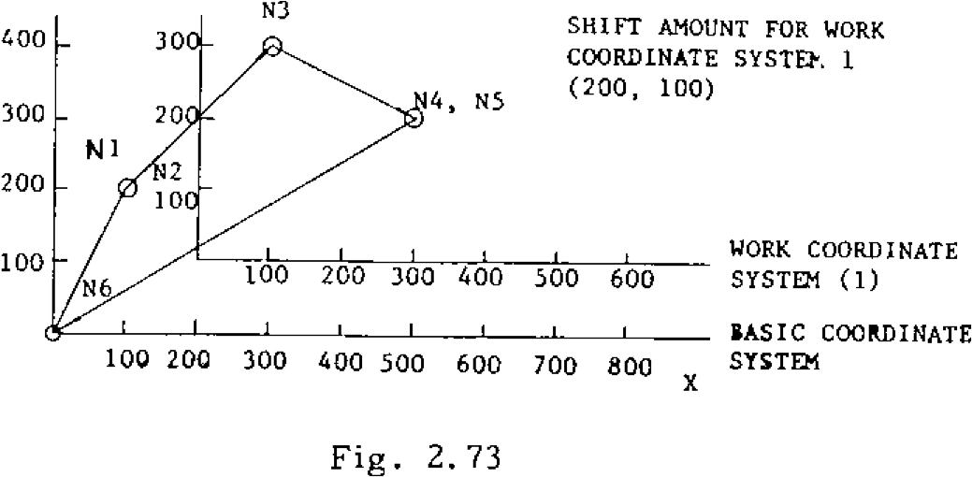

BASIC COORDINATE

SYSTEM

SHIFT AMOUNT FOR WORK

COORDINATE SYSTE'. 1

(200

,

100)

WORK COORDINATE

100

1

1

30 200

_________________________

300 400 5(

I

)0 600

N3

Fig .

2.73

|  |
| --- |
| **EXAMPLE (Reference program)**  **WORK COORDINATE SYSTEM**  **MACHINE COORDINATE N 1 G92 X 200 Y100 ;** YM **SYSTEM**  Y  **0**  G53    **X**  **W**    **G53**      **x**  **0**    **N 3 G 5 4 G 9 0 X 1 0 0 Y 2 0 0 ;**  **N 4 G53 X 300 Y100 ;**  **N5 X300 YO ;**  **N6 G52 ;**  **N7 XO Y0 ;**  ABSOLUTE **ZERO**  **Fig.** 2.74  **MACHINE**    **800**    **700**    **600**  **500**      **400**  **300**    **200**      **100**  N7    SHIFT AMOUNT OF WORK  COORDINATE SYSTEM 1  (300  ,  300)    **WORK**    **00**  **400 500 600 700 800**  SYSTEM  **COORDINATE 1**    **300**    **400**    500    600    700    800    900    **I**            **I**      **500**    **600**    700    800    **900**    **1000**    **1100**    **I**    **I**    **I**    **100 200 300 400**    **200**    **COORDINATE**    **BASIC**  **COORDINATE**  **SYSTEM**    **SYSTEM**    Fig. 2. 75 |

**NOTES:**

**The shift amounts for work coordinate systems can be specified by programs with G10 com mands, in addition to the MDI writing. For details, refer to 2.9.8 TOOL OFFSET VALUE DESIGNATION (G10).**

* **Work coordinate systems set up by G54 through G59 are canceled by the G52 command, and the basic coordinate system becomes effective again.**
* **When once a work coordinate system has been set up by any of the commands G54 through G59, the selected shift amount s can not be changed even when they are rewritten.**

**The rewritten shift amounts will become** effective when a new work coordinate system corn mand.is executed.

G53 commands should only be given under the fo llo wing c onditions. If th ese cond ition s are n o t sa tisfie d , th e co mma n ds a re reg arde d as errors.

1. **) The mi rror imag e func tion is not u sed.**
2. **) No canned cycle is in** use and no tool compen sation C is in use .
3. **)** If a 01 group G code is used, it is **GOO, GO1 or** G60 **and** nothing else.

2. 9.25 WORK COORDINATE SYST EM SETTING (G 52 t o G59 ) I . (C ON T ID )

If a 053 co mm and i s ex ecuted with the machin e l o c k f u n c t i o n o n , t h e c u r r e n t v a l u e d i s p l a y e d ch anges s equenti ally un til the co mmand value corresponding to the machine lock function off state will be d isplayed. If the ma chine lock function is switched on and off during the ex ecution of G53 blocks, correct positioning can no t be achieve d.

However, when a complete G53 block is execut ed with the machine lock function off, correct p o sitio n i n g is a c h ie v e d a s p ro g ra mme d , e v e n

when the mach ine lock func tion is switche d on and off before tha t b lock.

G53 commands should be given in the G90 mode. If they are given in the G91 mode, the command va lues a re regarded as G90 mod e values.

When work coordinate systems are to be changed with any of the G54 through 059 commands, the p ro g ra m sh o u ld b e so writ te n th a t a n e w c o o r dinate system will be set up in the G90 mode and the basic coordinate system will be reset in the G90 mode.

If a G53 command is given while the tool length compensation or tool position offset function is o n , t h e t o o t o f f s e t v a l u e i s d e l e t e d t e m p o rarily. Generally, when giving a G53 command, the tool length compensation and tool position offset commands should be canceled in advance.

When any of the commands G54 through G59 is given while the tool length compensation or tool position offset command is on, the compen s a t i o n r e m a i n s e f f e c t i v e . G e n e r a l l y , w h e n a n y of the commands G54 through G59 is to be given, t h e to o l le n g th c o m p e n sa t i o n o r to o l p o si ti o n offset command should be canceled in advance.

G43 ZO H01 ; COM Z100

G54

G 90 Z1000 ; COM Z1100

Z 1300 in incremental shift

G54 shift: Z 300 O ffse t: H0 1 = 1 0 0

If G92 is g iven du ring execu tion on the work coordinate system set up by G54 through G59, G54 through G59 or the basic coordinate sys te m is sh ifte d so th a t the c urren t po sition is to b e a sh ifte d po sition b y G9 2 , G92 sho u ld no t be used in G54 to 0 59 mod es in gene ral .

2 . 9 . 2 6 U N I D IR E C T I O N A L A P P R O A C H ( G 6 3 ) t

Th is fun ction is e ffectiv e to posi tion th e tool at high accuracy.

G60 X—. • • • Z ...

With th is com mand, the tool mov es and stops at t h e s p e c i fie d p o si ti o n . If th e to o l a p p ro a c h e s th e stop po sition in th e d ire c tio n spe c ified by th e pa ra meter (#60 14), it ove rtrave ls the sto p position by the amount specified by parameters (#6062 - #6065) once, and then returns to the specified position to stop.

- — — D I R E C T I O N S E T B Y

PARAMETER OVER-

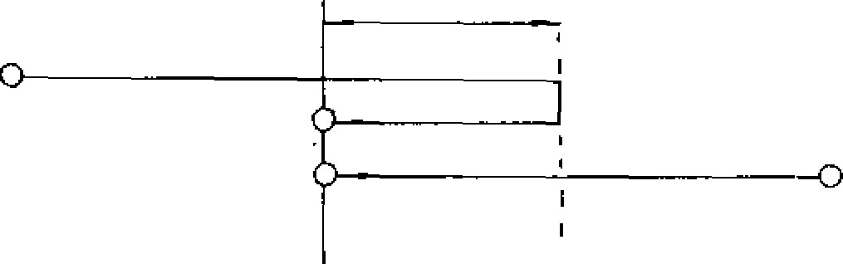TRAVEL

STOP

POSITION

Fig . 2 .76

**2. 9. 27 HOLE PATTERN CYC LESS (070, 071, G72)±**

**With this function, when a radius and a center angle are specified, the corresponding rectan gular coordinate positions are computed automatically and the tool is brought to the required positions. This function is used in conjunction with one of the canned cycles G81 through G89, G73, 074, G76 and G77. With this function, the bolt hole cycle, the arc cycle, and the line at angle cycle are programmed. The tool moves to the position specified by a radius and an angle in rapid traverse (G00).**

**Bolt hole cycle (070)**

**G70 X• •. Y • • 1• • • J• • • L•• • ;**

**With this command, the tool is positioned successively at equally spaced L points on a cir cle with the center at X, Y and the radius of I, starting at a point located on a line forming J degree with the X axis. , In the command, X,Y: Coordinates of the bolt hole cycle, de -** **fined either in G90 or 091 mode.**

1. **is the radius of the bolt hole circle, pro grammed in a positive number and programmed with an accuracy of the least input increment.**
2. **is the angular position of the first hole, programmed in degrees with an accuracy of 0.001 degree. COW direction is regarded positive.**

**L is the number of division of the circumference**

**For the counter-clockwise sequence, positive numbers are programmed, and vice versa.**

**EXAMPLE**

**2**

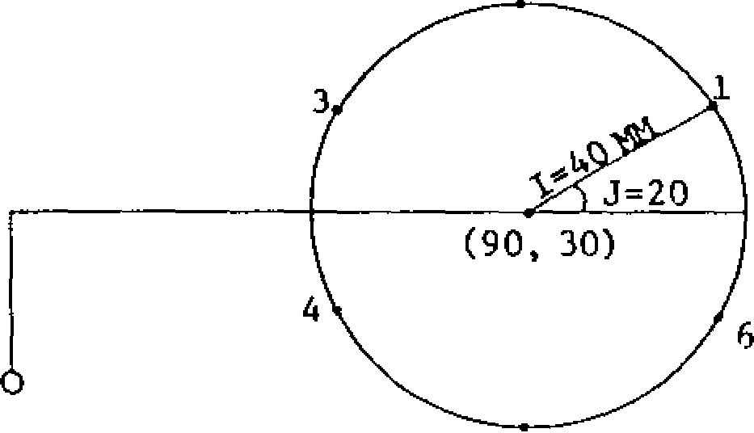**END POINT**

**5 Arc cycle (071)**

**With this function, when the following command is given, the tool is successively positioned to L points located on a circular arc with the center located at X, Y and with the radius of I, at a center angle of K degrees, starting from the point lying on a line intersecting the X axis at J degrees.**

**G71 X... Y••• I•.• J... K... L•.•**

**X, Y: Coordinates of the arc center, defind either in G90 or G91 mode**

|  |  |
| --- | --- |
|  | **Radius of the arc programmed with an accuracy of the least programmable increment, and in positive numbers** |
| **J:** | **Angular position of the first hole, programmed in 0.001 degrees. Positive values are used to command counterclockwise direction.** |
| **K:** | **Angular spacing in degrees with an accuracy of 0.001 degrees. Positive values are used to command counter-clockwise direction.** |
| **L:** | **Number of holes, to be set in positive numbers.** |

**EXAMPLE**

**G 8 1 G9 8 G 90 Z -5 0 . R -20 . F20 LO ;**

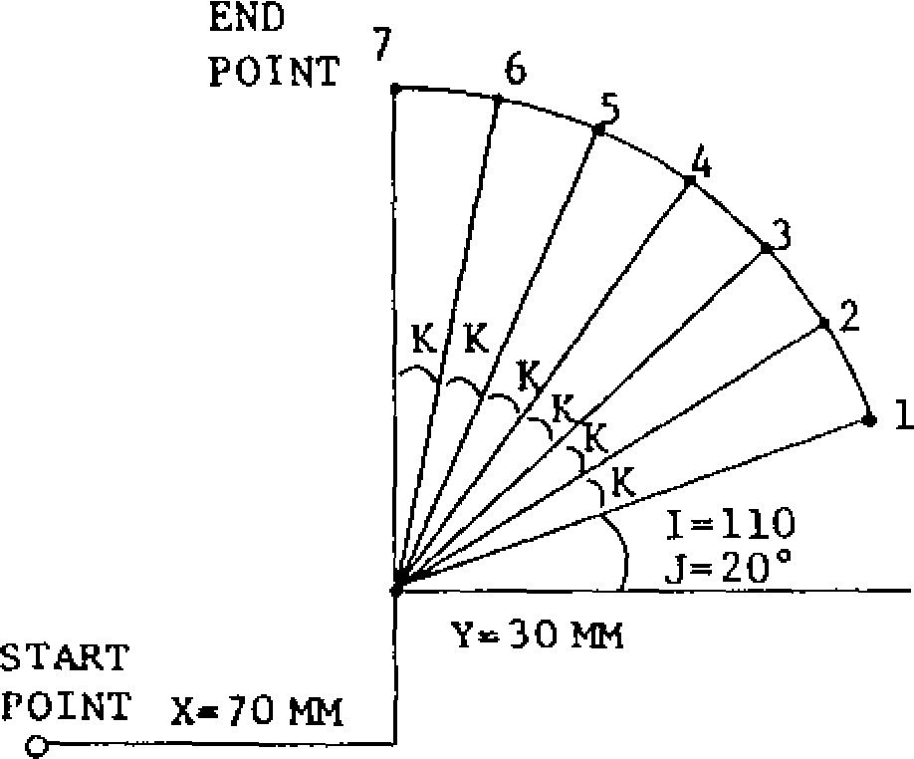

START

POINT X=70

**G71 X70. Y30. 1110. 320. K15. 2 L 7 ;**

**G80 GOO X0 YO ;**

**G 8 1 G 98 G 90 Z -5 0 . R- 20. F2 0 LO ;**

**G 7 0 X 9 0 Y 3 0 1 4 0 . J 2 0 . L 6 ; 0 8 0 G 0 0 X 0 Y 0 ;**

**Fig. 2.77**

**Fig. 2.78**

**2.9.27 HOLE PATTERN CYCLESS (G70, G71, C72) -**

**(CONTI O)**

Line at angle cycle (G72)

When the following command is given, the tool is positioned successively at L points lying on a Tine forming J degrees with the X axis, with a uniform interval of 1, starting at X, Y.

G72 X• - • Y **I... J • - • L• • •** Coordinates of the starting point, either

X, Y: in G90 or G91 mode

|  |  |
| --- | --- |
| J:  L: | In te rva l is p rog ram med in deg ree s, a t an accuracy of the least input incre ment. When i is negative, the holes will be located on the line in the nega tive direction.  Angles programmed with an accuracy of  0.001 degrees.  Positive values are used for CCWdirection.  Number of holes programmed in positive numbers. |

**•**

EXAMPLES

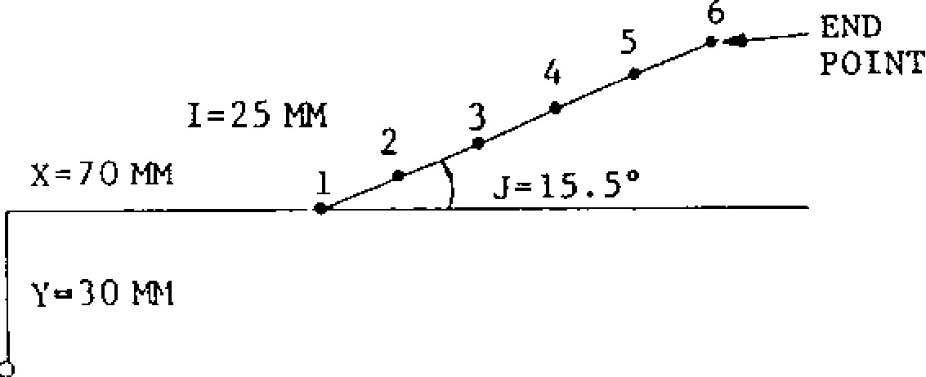

G 8 1 G 9 8 G 9 0 2 - 5 0 . R - 2 0 . F 2 0 . L O ;

072 X70 Y 3 0 . 1 2 5 . J 1 5 . 5 L 6 ;

G80 GOO X0 Y0 ;

Fig. 2.79 NOTES:

When the hole pattern cycles are to be program m ed with G70 , G71 o r G72, in p rin ciple, a can n e d c y c l e G 7 3 , G 7 4 , G 7 6 , G 7 7 , G 8 1 t o 0 8 9 should be programmed with L = 0 in the preced ing block. Since L = 0, the canned cycle is not executed, but its mode becomes effective.

070, G71 or G72 may be programmed in the same block with a canned cycle G code.

H o w e v e r G 7 3 a n d G8 3 w h i c h i n v o l v e I, J , a n d K can not be programmed with G70, G71 or G72 i n t h e s a m e b l o c k . W h e n G 7 3 o r 0 8 3 i s t o b e

u s e d , e i t h e r Q i s t o b e u s e d o r I , . 1 , a n d K

s hould be p rogram med in the preceding block .

The machimng control of 0,70, 071 or *07 2 ends* w i t h t h e d ri l l i n g o f t h e l a s t h o l e , a n d t o m o v e the tool to the next position, the 090 (absolute) m ode i s mo re conve nient than th e G91 (in c re mental) mode, because the latter involves com plicated calculations.

Immediately after the completion of the machinin g p roce s s a s co mm anded by G70 , G71 o r G72 , the canned cycle is still effective, and care must be taken in p rog ra mming the sub sequen t block . M a k e i t a p o i n t t o c a n c e l t h e c a n n e d c y c l e b y

G80.

* If G70, G71 or G72 command is given in the tool radius compensaion mode (G41 or G42), the ALARM code will be displayed.
* G7 0 , G7 1 a n d G7 2 a re n o n - m o d a l G c o d e s .
* Give G70, G71 or G72 command in a canned cy cle mode only. If they are given without pro gramming any canned cycle, the ALARM code will be displayed.

**2.9.28 OUTPUT FOR EXTERNAL MOTION**

**(G80, C81)\***

**G81 X• • • Y • • • L• • • ; The L number specifies the number of repeated**

**With this command, the control outputs external positioning motions. G81 is a modal G code, and motion signals to the machine after each position- remains effective until cancellation with 080. ing. G81 may be used either for this purpose or as a**

**canned** cycle command code, depending on the setting of the parameter #6018D0.

**EXAMPLE**

**G81 ;**

**GOO X10. Y20 ;**

**091 X10 ;**

.. **External motion function , on**

|  |
| --- |
| **X10. ;**  **X10. ;**  **Y10, ;**  **X10. ;**  **X10. ; X10. ;**  **G80. ;** |
|
|

**External motion signal, output**

**.. Ex ter nal mo tio n func tion, o ff**

**Fig. 2.80**

**2.9.29 CANNED CYCLES (73, G74, G76, G77, G80 TO G89, G98, G99)t**

Canned cycles (G73, G74, G76, G77, G80 to G89,

G98, G99) are simplified programs that contain Specific movements over a number of blocks in one block. 14 types of cycles are available, and G80 code is commanded for cancelling them.

|  |  |  |  |  |
| --- | --- | --- | --- | --- |
| G code | Plunging | At hole bottom | Retraction | Application |
| G73 | Wood pecker  feed | _ | R a p i d t ra v e r s e | High speed deep hole drilling |
| G74 | Feed | Spindle forward  r u n n i n g a ft e r dwell | Spindle reversing after feed | Rev e rse tapping |
| G76 | Feed | Spindle index- ing 4- shift | R a p i d t r a v e r s e - shift, spindle  start | Boring |
| G77 | Spindle index- ing 4 - shift -4 rapid traverse  --1.- shift -4- spindle  start 4. feed | Dwell | Rapid traverse 4- spindle indexing **4 -** shift 4 - rapid t rav erse -,  shift, spindle  start | Back boring |
| G80 |  | - | - | Cancel |
| G81 | Feed | - | Rap id t rav erse | Drilling |
| G82 | Feed | Dwell | Rap id t rav erse | Spot, facing |
| G83 | Wood pecker feed | T | Rap id t rav erse | Deep hole drilling |
| G84 | Feed | Spindle revers- ing after dwell | Spindle forward  r u n n i n g a ft e r  feed | T apping |
| G85 | Feed | - | Feed | Boring |
| G86 | Feed | Spindle stop | R a p i d t r a v e r s e -+ Spindle start | Boring |
| G87 | Feed | Spindle stop | Manual retraction 4- Spindle start | Boring |
| G88 | Feed | Spindle stop after dwell | Manual retraction -3- Spindle start | Boring |
| G89 | Feed | Dwell | Feed | Boring |

T able 2.24

|  |
| --- |
| • Command format:    G code of canned cycle    G•  -    •    Xi  -  • • •    y±...    R...    P... Q... L    F•••    Cutting feedrate  Number of repeats    Drilling pitch for G73, G83  Shift amount of G76, 077    Dwell at hole bottom  R p o i n t c o o rd i n a t e c o m m a n d Z point coordinate command  Drilling position X, Y coordinate command |



INITIAL POSITION

START

POINT (Di 1 ED

R POSITION

Z POSITION

(HOLE BOTTOM)

Fig. 2.81

Operations t h r o u g h 0 a r e e x e c u t e d i n one cycle with the commands shown above.

Positioning the drilling position (X,Y)

Rapid traverse to R point

Drilling to Z point

Return to R point or to initial point

Nu m b e r o f re pe a t s i s sp e ci fi e d by th e ad d re s s L . Whe re L i s no t gi ve n , nu m be r o f rep e at s

i s re g a rd e d a s "1 . "

If 0 is given for L, only positioning to (X, Y) i s made. Sh ift di rec tion of shi ft o f G76, 077 c a n b e m a d e a t t h e i n t e n d e d a n g l e s p e c i f i e d b y t h e p a r a m e t e r . ( # 6 0 1 9 0 0 ) Z a x i s r e t u r n i n g p o s i t i o n a t t h e e n d o f c a n n e d cycle can be designated by the following G code.

|  |  |
| --- | --- |
| G code | Meaning |
| G98 | 1 Initial level return |
| G99 | I R position level return |

Note: When power is applied o r t he con tro l is r e s e t , t h e c o n t r o l i s i n t h e s t a t e o f G c o d e marked with 1.

Where parameter #6019D0 is set to 0, the shift d i re c t i o n i s m a d e i n t h e s p e c i fi e d d i re c t i o n . Th e di re ction i s set a s li sted belo w.

|  |  |  |
| --- | --- | --- |
| Bit  Directio | D2 | Di |
| X( +) | 0 | 0 |
| X(-) | 0 | 1 |
| Y(+) | 1 | 0 |
| Y(-) | 1 | 1 |

Where parameter #601900 is set to 1, the shift d ir e c ti o n i s m a d e a t t h e i n t e n d e d a n g l e . T h e

shifting angle is set by setting #6506 (1 = 0.001 deg).

**2.9.29 CANNED CYCLES (73, G74, G76, G77**

**G8 0 T O C 89, G98, G99) (C ON T 'D )**

Table 2. 25 Canned C ycle

With G99 (return to R) With G98 (return to initial point)

G13

|  |  |  |
| --- | --- | --- |
| (Fixed pitch)  High speed deep hole drilling | Q... L... F... (:)  (x, Y)    G73 X... Y... Z... R... I...  Setting data(#1,2I0 | ( ; ) ( X, Y) **INITIAL**  **POINT**  R  **1**  **1_**  Setting data  ... K... L... **F... ;**  **INITIAL**      **fPOINT** |
| G73  (Variable)  High speed deep hole drilling | **1**    I-J  I-2J  (X, Y)  I: Initial value  I J: Reducing value  K: Final value  I-2J K Setting data (06211)  z K 1 z  6: Setting data | |
|  |  | |

G73 X... Y... Z... R...

G74 X... Y... Z... R... P...

(:) (X, 1)

Reverse 1 SPINDLE tapping 1/REVERSE

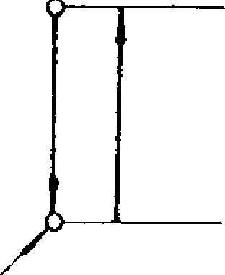

(:)X, Y) INITIAL -- —7—

F-POINT I ISPINDLE

REVERSE R

V

G74

SPINDLE FORWARD

AFTER DWELL

SPINDLE FORWARD AFTER DWELL

Table 2. 25 Canned Cycle (continued)

|  |  |  |  |  |  |  |  |
| --- | --- | --- | --- | --- | --- | --- | --- |
| **,,,.......„....„..„,_** | **With G99 (return to R)** | | **With G98 (return** to **initial point)** | | | | |
| **G76 Boring** | **Y... Z... G76 X...**  **(X, Y)**  **._,._.....?**  **/START**  4 : „  **H 1**  **,P!**.**1**/**1/f**  **#6210 x DWELL**  **SPINDLE** | **L...**  **ISPINDLE**  **Q...**  1: | **F... ;**  **aIs-1.43(c.::—**  **#6210**  **DWELL**  **SPINDLE**  **INDEXING**  **STOP** | | **SPINDLE**  **START**  **INITIAL**  i----  ,  **POINT**  **I I** | | |
| **SHIFT**  **SPEED**  **4 M**6**223** | **E.-4**  1**;11**/**1**  **x m**  , | | **c=04!)----Z**  **1 SHIFT**  **/SPEED**  **#6223** |
| **INDEXING STO** | **Q** | |
| **G77**  **Back boring** | **G77 X...Y... Z... R... Q... L...**  **NOT USED** | | **F...**  **SPINDLE**  **ORIENTATION** | **;**  **(X, Y)-.___**1 **INITIAL**  **POINT**  **-- SHIFT1-**  **DWELL** | | | |
| **I**  **I**  **I** | **,F 1 r-i-.**  **li**    **I** | |  |
| **START SPINDLE** |
| 4 | |
| **G80** | **G80 ;**  **C a n c e l** | |  | | | | |
| **G81 Drilling** | **G81 X...Y... Z.. R... L... .**  **(X Y)**  **---i.**  **1 I**  **,** i  **I**  **i**  **Z** | | **. ;** | **1:::)** | | | |
| **I** | | I **POINT**  **I I** | |
|  | |
|  | |

**2.9.29 CANNED CYCLES (73, G74, G76, G77**

**G80 TO G89, G98, G99)t (CONT'D)**

Table 2.25 Canned Cycle (continued)

|  |  |  |  |
| --- | --- | --- | --- |
| With G99 (return to R) | | **With** G98 **(return to initial** point) - | |
| G82 G8  Spot facing | 2 X... Y... Z... R... P.  **R**  DWELL (P) | .. L. | (x, Y) INITIAL  -1 1 POINT  T  R  1  1  DWELL (P) |
| G83 X..  G83 (Fixed p i t c h )  Deep hole drilling  5: **Set** | . Y... Z... R... Q... L.  **(X, y)**    **ting data** (#6213) | • • •  INITIAL  POINT  6: Setting data | |
| G83 G83 X.  (Variable pitch)  Deep hole drilling  K  6: | .. Y... Z... R... I... J.  I: Initial value  J: Reducing valueFinal value  K: /Tr f  ;    6    1    **11**    1  II      Setting data (#6213) | .  INITIAL  POINT      6    6      K...    L...    F...    X,  (    Y)          I        **I**    **f t**    **I**    **1**  **-**  **J**      1    1    i    1          Setting data | |

* 7a -

|  |  |  |
| --- | --- | --- |
|  | **With 099 (return to R)** | **With 098** (return to initial point) |
|  |  |  |

Table 2. 25 Canned Cycle (continued)

)

( : ) (

X, Y

**SPINDLE**

**FORWARD**

**SPINDLE REVERSE**

**AFTER DWELL**

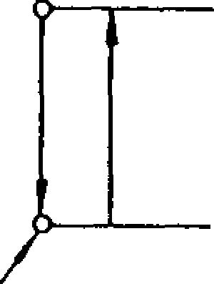

Q

.

)

X, Y

(

INITIAL

?

______

POINT

I

/

SPINDLE

FORWARD

**SPINDLE REVERSE**

**AFTER DWELL**

**Tapping**

**)**

**X, Y**

**(**

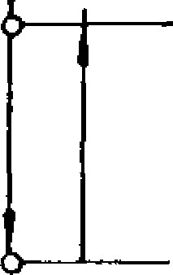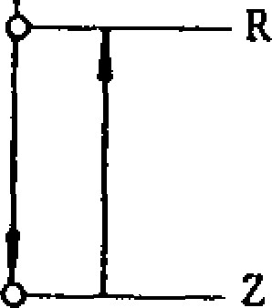

Boring

**i**

**f**

**SPINDLE STOP**

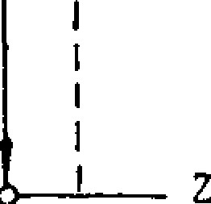

**SPINDLE**

**START**

R

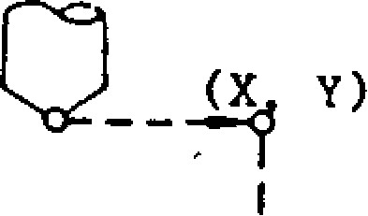

SPINDLE

START

(

)

X, Y

—

j

__

INITIAL

POINT

1



**SPINDLE STOP**

**G84**

**G84 X...**

Y... Z... 41

.

L...

F... ;

**C85**

**085**

**X... Y... Z... R... L...**

F... ;

( : )

(

X,

Y)

INITIAL

POINT

**C86**

**G86**

X... Y... Z...

**R... L...**

• • ;

**Boring**

* 73 -

2.9.29 CANNED CYCLES (73, G74, G76, C77,

G80 TO C89, G98, G99)1- (CONT'D)

T a b l e 2 . 2 5 C a n n e d C y c l e ( c o n t i n u e d )

|  |  |  |
| --- | --- | --- |
|  | With G99 (return to R) With G98 (return to initial point) | |
| G87 Boring | G87 X... Y... Z... R... Q.. L... F.. - ;  SPINDLE  START  (X, Y) (X, Y) t o **- 9 i** INITIAL  START I POINT  R  MANUAL  I--"--RETRACTION  z ______ Z  I/ l/  SPINDLE STOP SPINDLE STOP | |
| G88 Boring | G88 X... Y... Z... R... P... L  CI (X,. Y)  I  I SPINDLE  I  ,..---"RETRACTION  MANUAL  R  Z  SPINDLE STthi:  AFTER DWELL (P) | ... F... SPINDLE  START  ( X , Y )  .- ___ 9 INITIAL  I /  1 POINT  RETRACTION z  /iL  SPINDLE STOP  AFTER DWELL (P) |
| G89  Boring | G89 X..- Y... Z... R... P...    R  DWELL (P) | L... F... ;  C D ( X , Y ) INITIAL  **9 ____** POINT  R  DWELL (P) |

EXAMPLE

1. . G 9 8 G 9 0 G 8 1 X . . . Y . . . Z - 7 0 0 0 R - 4 0 0 0 F . . .

•• Return to initial point, absolute

1. . G 9 9 G 9 1 G 8 1 X . - . Y . . . Z - 7 0 0 0 R - 4 0 0 0 F . - -

• R e t u r n t o R p o i n t , i n c r e m e n t a l

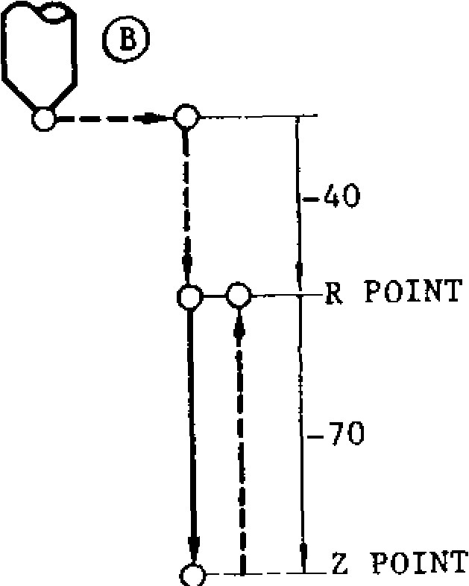(31_ **--a-Ce 10—**INITIAL

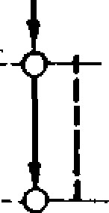

i

POINT

1

1

1!

I

1

1

I

I

R POINT

1

POINT

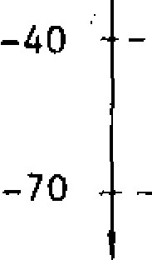

-

Z

Fig . 2.82

|  |  |  |  |  |  |  |  |  |  |  |  |  |  |  |  |  |  |  |  |  |  |  |  |  |
| --- | --- | --- | --- | --- | --- | --- | --- | --- | --- | --- | --- | --- | --- | --- | --- | --- | --- | --- | --- | --- | --- | --- | --- | --- |
|  | |  |  |  | | --- | --- | --- | | Absolute position | | Remarks | |  |  | | Z = | R = |  | | -5000 | -2000 | Cann ed cy cle sta rt | | -5000 | -3000 | C h a n g e i n X, R | | -8000 | -3000 | Change in Z | | -9000 - | -5000 | Chang e in R, Z | | Tool moves to Z = 0 | | Canned cycle cancel | |

1. . N 1 G 9 2 X 0 Y O Z O ;

N 2 G 9 8 a22 G 8 1 X 1 0 0 0 Y 1 0 0 0 Z - 5 0 0 0 R - 2 0 0 0 F 1 0 0 ;

N 3 G 9 1 X 2 0 0 0 R - 3 0 0 0 ;

N 4 Z -5000 ;

N 5 G 9 9 Z - 4 0 0 0 R - 5 0 0 0 ; N6 G80 GOO Z5000 ;

Newly programmed addresses only are changed N o t e : S i n c e a d d r e s s P . Q , I, J a n d K a r e including the case where switching is made from modal in canned cycle mode, if once G9 0 t o G9 1 s u ch a s N2 -1 - N3 in di c at e d in th e commanded, they are effective until a b o v e c a s e . A s f o r t h e n o n - p r o g r a m m e d a d - the canned cycle is cancelled. dresses, the positions programmed in the earlier blocks are maintained.

**2 . 9 . 2 9 C A N N E D C Y C L E S ( 7 3 , G 7 4 , G 7 6 , G 7 7**

**G80 TO G89, G98, G993 1-**

Variable pitch command (G73, G83) Initial value

Command is R e d u c i n g v a l u e i n 2 n d

In the deep hole drilling cycles of G73 and G83, and subsequent plunges given without

variable drilling pitch can be programmed with signs

addresses I„ I, K instead of address Q for pro - K: Final value gramming a constant drilling pitch.

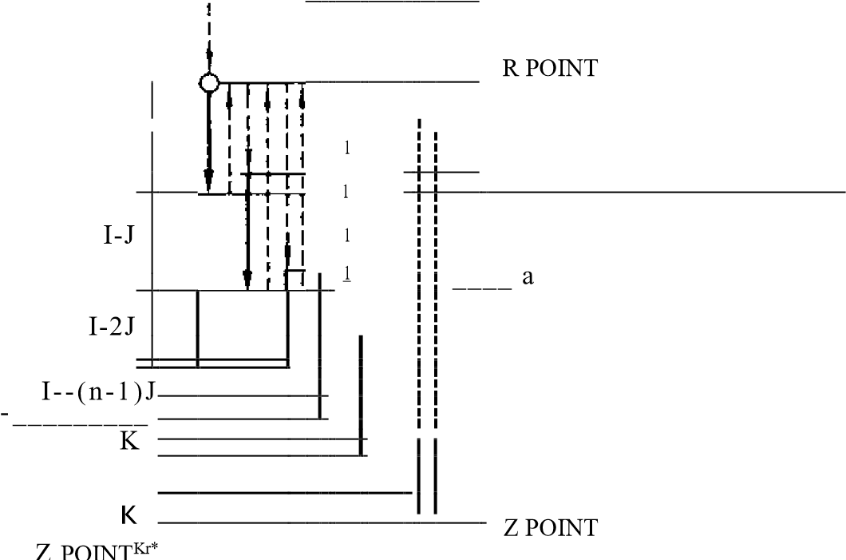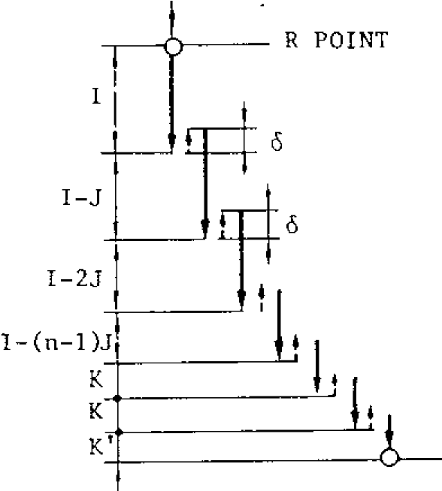

K ' : F i n a l p l u n g e t o Z p o i n t

K' K

(a) With G73 (b) With G83

Fig. 2.83

|  |  |  |
| --- | --- | --- |
| Drilling pitch |  |  |
| 1st plunge | 10 mm | 11000 |
| 2nd plunge | 9 mm |  |
| 3rd plunge | 8 mm |  |
| 4th plunge | 7 mm |  |
| 5th plunge | 6 mm |  |
| 6th plunge | 5 mm |  |
| 7th plunge | 4 mm | K400 |
| 8th plunge | 4 mm |  |
| 9th plunge | 2 mm | K' |
| Total | 5 5 . 0 0 m m c Z - 5 5 0 0 | |

The value of 15 is given by setting (#6211 for G73, #6213 for G83).

NOTES:

* Q, I, J, K are modal during canned cycle modes and are effective until the canned cycle is can c e l le d. Spe c i fy th e m wi tho ut s ig n s.
* Variable pitch can also be programmed by ad d r e s s Q i n s t e a d o f I. Fu r t h e r m o r e , wh e n i n structions Q, I „T, K are given simult aneously, drilling cycle is executed with variable drilling pitch with Q as the initial value.

Qo must be commanded in the block including modal G code before programming variable pitch w i t h I, J , a n d K .

EXAMPLE

G 9 1 G 7 3 X • • • Y • • • T - 3 0 0 0 Z - 5 5 0 0 I 1 0 0 0 - • -

J 100 K 400 F . .. ,

**NOTES:**

**When the canned cycles are executed by turn ing on the SINGLE BLOCK switch, a temporary stop is made in an intermediate position, and the FEED HOLD lamp lights up.**

**( 1 ) A f t e r p o s i t i o n i n g t o ( X , Y ) p o i n t**

**( 2 ) A f t e r p o s i t i o n i n g t o R . p o i n t**

**( 3 ) After termination of each cycle, if L command has been given.**

**The single block stop after the completion of canned cycles is as usual, and the FEED HOLD lamp does not light up.**

**Be sure to designate R point and Z point by programming R and Z before entering the can ned cycle mode. R point and Z point are clear ed when canned cycles are cancelled.**

**When executing canned cycles with the address data changed, the block requires any of the following address commands. The canned cycles will not be executed otherwise.**

**X, Y, Z, 4, R**

* **W he n M, 5, T or Bt co de i s giv en i n the ca n ned cycle, M, 5, T signals are sent at the first positioning in the block. In general, M, S, T**

**should be commanded in their own block.**

* **An input error occurs when any of the followi ng G co de s a re progra mme d in the ca nne d cycle mode.**

**G codes of * group except for G04 G70, G71, and G72**

**G co de s o f 07 gro up (G41 , G 42)**

**When programming G92, G27, G28 etc., make sure to cancel the canned cycles in advance. Cancellation is made when a G code of 01 group is programmed.**

**An independent block of dwell (G04) can be programmed in the middle of the canned cycle mode. Dwell is executed properly.**

**An input error occurs when canned cycles are programmed in the tool radius compensation C mode (041, 042).**

**Star t o f s pi ndle for war d or reve rs e (M03 or M04) should be executed by automatic opera tion commands before entering canned cycles. Do not enter into canned cycles after manually switching the spindle between forward and re verse.**

**Execution of subprogram (M98) in canned cycle mo de . I n a ca nne d cy cl e mo de , M98 P .. - L ... ; can be programmed to call up subprogram and the c a nne d cy cl e i s co ntinue d i n the s ubpr o gram. The address P (program No. of the first block of subprogram) with M98 command de stroys temporary the contents of address P for designation of dwell time, but after the jumping to subprogram, it resumes the contents.**

**Note:**

**Programming consideration of M98 in the canned cycle mode is the same as those of other than ca nne d cy cle modes . (e.g . Re s tri ction o f ex ecution to no more than four levels, M98** c o m m a n d **from punched tape and the like.)**

**Address L for designation of repetition number o f s ubpr og r am s i s no nmoda l . B ut de s c ri be d below is a special case that the address L is retained temporarily.**

**EXAMPLE**

**0 9 1 G 8 1 X1 0 0 0 R -2 0 0 0 Z - 3 0 0 0 F 1 0 0 ;**

**L3 ; .• . The canned cycle is not executed because X, Y, Z, 4 or R is not designated in this block. The L3 is retained.**

**X2000 ; • • • The canned cycle G81 is executed 3 times using the** r e t a i n e d L 3 . A f t e r t h e e x e c u t i o n , t h e L 3 i s **erased.**

**As mentioned above, address L in** c a n n e d c y c l e is retained until actually executed.

Chang ing o f R point and Z po int

When R is commanded instead of Z during the execution of canned cycle in G91 mode, Z be comes incremental value from the new R point. Ca re shou ld be taken .

G92 X0 YO ZO

G 9 1 X • . . Y . . . R • 5 . 0 .

|  |  |
| --- | --- |
| R point | Z point |
| -5.0 | -10.0 |
| -7.0 | -12.0 |
| -7.0 | -10.0 |
| -4.0 | -15.0 |

**Z--10.0F ;**

**X•-- R-7.0 ;**

**X.— Z-3.0 ;**

**R-4.0Z-11.0 ;**

**2.9.29**  **CANNED CYCLES (73, G7 1 1, G76, G77,**

**G8 0 T O G89, G98, G9 9) (C ON T 'D )**

EXAMPLE

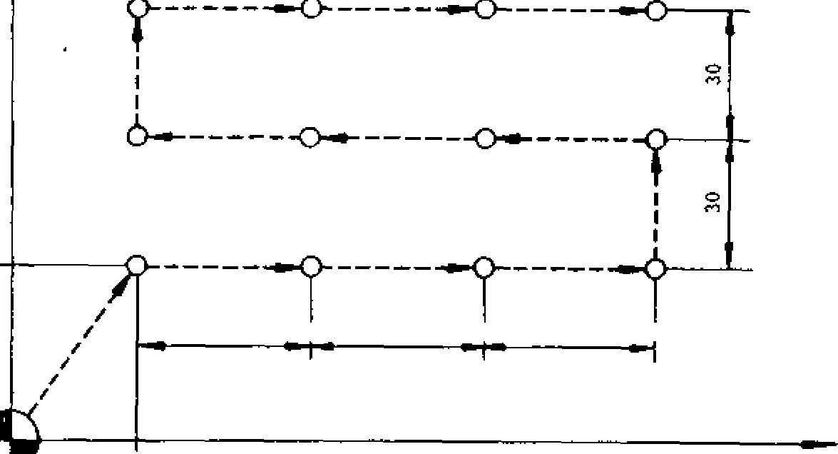

**Y**

**40**

**40**

**40**

**-**

**40**



30

START POINT

Fig. 2.84

N1 0 G9 2 X0 Y O Z O ;

N 11 G90 G98 ; Return to initial point, Absolute

N 1 2 G 8 1 X 3 0 0 0 Y 4 0 0 0 R -2 0 0 0 Z - 3 0 0 0 F 2 0 0 ; - D r i l l i n g c y c l e

N13 M98 P100 ; J ump to subpro gram

N14 GOO X0 YO ;

N15 TO5 ; Tapper selection

N16 M06 ; Tool change

N i ? G 8 4 X 3 0 0 0 Y 4 0 0 0 R - 2 0 0 0 Z - 3 0 0 0 F 2 0 0 0 ; - Tapping cycle

|  |  |
| --- | --- |
| N18 M98 P400 ;  N19 GOO X0 Y0 ;  0400 | J ump to subpro gram (Not e) |
| N1 0 0 G9 1 X4 0 0 0 L 3 ; N101 Y3000 :  N102 X-4000 L3  N103 Y 3000 ;  N104 X4000 L3 | Subprogram for drilling position pattern. |

N105 090 080 ;

N106 M99 ;

- 78 --

**2. 9. 30 ABSOLUTE/INCREMENTAL PROGRA MM INC (090, 091)**

**These G codes are for designating whether the movement data following the axis address are in absolute value or incremental value.**

• **G 9 0 • • Absolute designation**

**In the block including G90 and in the subsequent blocks, the movement data which follow addresses X, Y, 1, at are regarded as abso lute values.**

**G 9 0 G O O X . . . y . . . Z . • • ;**

**- • • Absolute designation**

• **0 9 1 • • Incremental designation**

In **the block including G91 and in the subsequent blocks, said data area is regarded as incremental values.**

**G 9 1 0 0 1 X . • • Y . . . Z • - • ;**

• **• • Incremental designation**

+Y

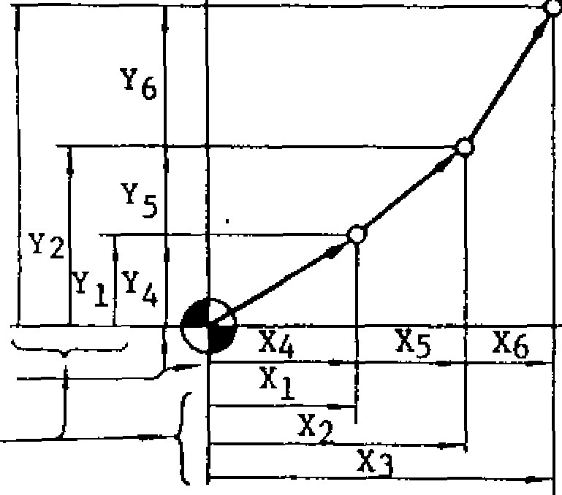Y3 091: Incremental

|  |  |
| --- | --- |
| Parameter( #6005D0)  "0" | **Initial state**  **G90** |
|  | **091** |

**2. 9. 31 PROGRAMMING OF ABSOLUTE ZERO POINT (G92)**

**It is necessary to program the absolute zero point before programming movement command. When an absolute zero point is programmed, one absolute coordinate system is determined, and all absolute movement commands programmed thereafter will move the tool on the programmed coordinate.**

**G92 X... y... Z... (at...)**

**With this command, the current position of the tool is programmed in the control as absolute coord inate poin t ( X ,** Y, Z , at ). That i s, **pr o gram the distance (with sign) from the desired absolute coordinate zero position (0, 0, 0, Ot) to the current position. In other words, G92 command is for designating** the position of the "absolute zero **point."**

EXAMPLE

G9 2 X5 0 0 0 0 Y3 0 0 0 0 Z 4 0 00 0 ;

|  |
| --- |
| +x  090; Ab solut e    +z  **Fig. 2.85 Fig. 2.86** |

+Y

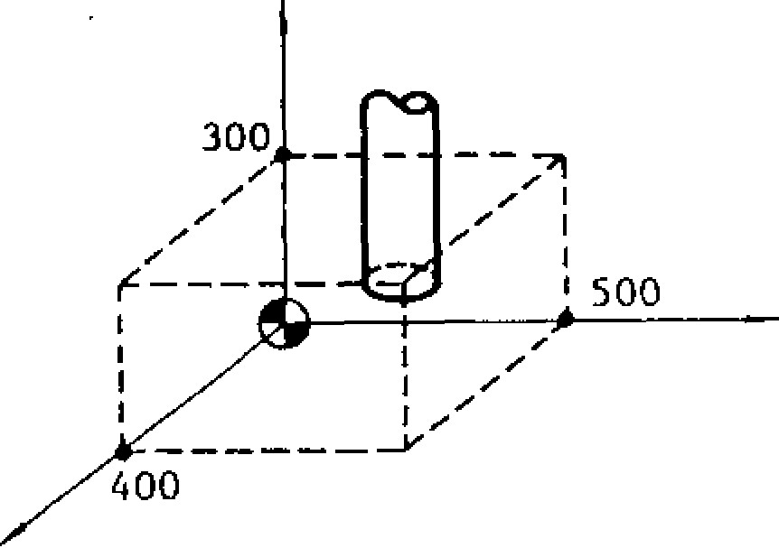

* . 0 9 0 , 0 9 1 a r e m o d a l G c o d e s o f 0 3 g ro u p .
* **If both G90 and 091 are programmed in the same block, the G code which was programmed** last is valid.•

NOTE:

* The **initial state of these G codes when the power is turned on can be designated by parameter**

**#6005Do.**

* **G92 is a G code of non-modal group which is** valid only in **the programmed block.** It **is not possible to program other G codes, F, M, 5 ,** T, 131 - codes in the same block.

NOTES:

* In **principle, program G92 in -the state where all tool offset modes are cancelled.**
* **When the power is turned on, the current posi tion of the tool is set as absolute zero point (0, 0,0,0t). Make sure to reprogram absolute co ordinate by G92 before executing the automa tic operation.**

2 . 9 . 3 1 P R O G RA M M I N G O F A B S O L UT E Z E R O

P O I N T ( G 9 2 ) ( C O N T ' D )

T h e p r o g r a m m e d a b s o l u t e z e r o p o i n t i s n o t a f f e c t e d b y r e s e t o p e r a t i o n . P e r f o r m a n y o f t h e fo l l o w i n g o p e rat i o n s f o r re set ting the absolu te zero point.

1. . U s e O R G k e y ( s e e 4 . 1 . 9 ) .
2. . W r i t e 0 9 2 X O Y0 Z O c i 0 ; i n M D I m o d e , a n d t h e n e x e c u t e .
3. . T u r n t h e p o w e r o f f a n d o n a g a i n .

2. 9. 32 FEED FUNCT ION DESIGNAT ION (G94, G95) '

These G codes are for selecting whether to desig nat e the feed i n mm / mi n . o r in mm/ rev. p rio r to p r o g r a m m i n g t h e F c o d e f o r f e e d , i n t h e c a s e

w h e r e t h e co n t ro l i s eq u i p p e d w i t h f e ed p e r r ev o l u t i o n ' f u n c t i o n .

W h e n G 9 4 ; i s p r o g r a m m e d , t h e F c o d e p r o g r a m m e d t h e r e a f t e r i s e x e c u t e d i n m m / m i n , ( o r i n c h / m i n . t , d e g / r n i n . t ) .

W h e n G 9 5 ; i s p r o g r a m m e d , t h e F c o d e p r o g r a m m e d t h e r e a f t e r i s e x e c u t e d i n m m / r e v . o r i n c h / r e v . ( d e g / r e v . ' ) .

G 9 4 , G 9 5 a r e m o d a l G c o d e s o f F g r o u p , a n d G 9 4 i s s e l e c t e d w h e n t h e p o w e r i s t u r n e d o n .

W h e n s w i t c h i n g b e t w e e n G 9 4 a n d G 9 5 i s m a d e , t h e p r e v i o u s l y p r o g r a m m e d F c o d e i s c a n c e l l e d. Th e re fo re, a n e w F c od e mu s t b e p rog ra m med.

2 . 9 . 3 3 H I G H -S P E E D C U T T I N G F E A T U R E

(G10 0 T HROUGH G102 ) t

2 . 9 . 3 3 . 1 High Speed C u t t i n g in Sequential Processing Mode (G101)

G101 ;

G100;

E v e r y t i m e t h e a b o v e i s s p e c i f i e d , t h e d a t a p r o c e s s i n g a n d d a t a r e g i s t r a t i o n o f t h i s d i v i s i o n a r e p e r f o r m e d . T h e a u t o m a t i c o p e r a t i o n i s f o l l o w e d by t h e r e g i s t e re d d a t a . T h e a b o v e c o m m a n d m a y b e

u s e d r e p e a t e d l y i n o n e p a r t p r o g r a m . H o w e v e r , t h e n u m b e r o f b l o c k s i n a p r o g r a m b e t w e e n G 1 0 1 ; a n d G 1 0 0 ; i s l i m i t e d a s s h o w n i n t h e t a b l e b e l o w . T h e p a r t p r o g r a m m e m o r y c a p a c i t y i s a l s o l i m i t e d t o 1 / 2 a s s h o wn i n t h e s a m e t a b l e .

|  |  |  |  |
| --- | --- | --- | --- |
| No. | Part. Pro- gram Capacity in Usual Operation | High-Speed Cutting Function ON | |
| Part Program  Memory  Capacity | No. of Allowable Blocks .:or  High-Speed  Cutting |
| 1 | 40 m | 20 m | 480 blocks |
| 2 | 80 m | 40 m | 672 blocks |
| 3 | 150 m | 90 m | 1504 blocks |
| 4 | 320 m | 150 m | 4064 blocks |

**2.9.33.1 High-Speed Cutting** in Memory Processing **Mode (G102)** G102 p...

RE GISTRAT ION NO. O F

HIGH SPEED CUTTING

G100 ; PROGRAM

I i i t h i s f e a t u r e , a d i v i s i o n i n a p a r t p r o g r a m i s

d e s i g n a t e d b y a G c o d e a n d t h e d a t a p r o c e s s i n g o f t h e d e s i g n a t e d d i v i s i o n i s p e r f o r m e d b e f o r e e n t e r i n g t h e a u t o m a t i c o p e r a t i o n m o d e . T h i s

f e a t u r e , t h e r e f o r e , e l i m i n a t e s t h e i n t e r b l o c k

s toppage ti me d u e t o co mp en s at i o n c al cu l at i o n ,

p r o v i d i n g a u u n i n t e r r u p t e d m a c h i n i n g o p e r a t i o n

i f s h o r t - d i s t a n c e b l o c k s a r e c o n s e c u t i v e l y s p e c i f i e d . T h i s f e a t u r e i s o f t w o t y p e s : ' ' s e q u e n t i a l p ro ces s i n g mo d e" an d " m emo ry p ro c es s i n g mo d e , " w h i ch m a y be se lect ed by s peci fying one o f the

c o d e s s h o w n b e l o w :

I i i g h Sp e ed Cu t t i n g G co d es

|  |  |
| --- | --- |
| G code | Meaning |
| G100 | High-speed cutting cancel |
| G 101 | High-speed cutting in sequential processing mode ON |
| G 102 | High-speed cutting in memory processing mode ON |

B y t h e a b o v e c o m m a n d , d a t a p r o c e s s i n g a n d d a t a r e g i s t r a t i o n a r e f i r s t p e r f o r m e d t h e n t h e a u t o m a t i c o p e r a t i o n i s p e r fo rm e d u s i n g t h e re g i s t e r e d d a t a . T h e r e a f t e r , w h e n t h e s a m e c o m m a n d given, the automatic operation is immediately per f o r m e d u s i n g t h e r e g i s t e re d d a t a . In a d d r e s s P . d e s i g n a t e t h e re g i s t r a t i o n n u m b e r o f t h e p ro g ra m to be registered in memory processing mode. The r e g i s t ra t i o n n u m b e r i s o f a m a x i m u m o f 4 d i g i t s

(PO th rough P9999 ). When P d esign ation is omi t t e d, P00 00 i s a s su m ed . Thi s P de s ig n at io n a ll o ws t h e re gi s t ra ti on o f a ma xim u m o f 20 hi gh -s pe ed cut ting p rog ra ms .

N o t e : T h e ' r e g i s t r a t i o n n u m b e r " b y P d e s i g n a t i o n h a s n o r e l a t i o n s h i p w i t h t h e " p r o g r a m n u m b e r " b y ❑ d e s i g n a t i o n . H e n c e , t h e r e g i s t r a t i o n n u mb e r i s no t sub j ec t ed t o t he ad d re s s s e a rch o p e r a t i o n . T h e c o n t e n t s o f t h e p r o g r a m w h i c h w a s d a t a -p ro c e s s e d a n d re g i s t e re d c a n n o t b e d i s p l a y e d o n t h e C R T s c r e e n _ T h e n u m b e r o f

b l o c k s i n o n e p a r t p r o g r a m b e t w e e n G 1 0 2 ; a n d G100 and the limits to the part program memory c apacity a re as sho wn in Tabl e 2.9 .32.2.

The total number of blocks in the maximum of 20 r e g i s t e re d h i g h - s p e e d c u t t i n g p ro g ra m s s h o u l d

not exceed the value allowed in Table 2.9. -:;3.2.

**2.9.33.2 Restrictions on High-Speed Cutting Feature**

1. When the high-speed cutting feature is made valid by parameter setting, the part program memory capacity is decreased to about 1/2 (see

Table 7.1.1 and

1. The program between G101 (or G102); and G100 ; should follow the restrictions shown below:
2. The addresses that can be specified are as

follows:

**0, !(slash),** N, G, X, Y, Z, I, J, K, R, D, H, M, L, F

**The 4th-axis address cannot be.specified.**

1. **The** G codes that can be specified are as

follows:

GOO, G01, G02, G03, G09, G40 through G42, G43, G44, G45 through 04S, G49, G90, G91

If any G code other than above is specified, program error "142" will be caused.

1. The M code that can be specified are as

follows:

M90 through M99

**If** any M . code other than above is specified, pro gram error "142" will be caused.

**Considerations and Remarks**

(1 ) Do n o t e n te r th e h ig h -sp e e d c u tt in g mo d e

(G101 or G102) with the tool radius compensation C mode being on. Cancel (by G40) the compen sation C mode. Otherwise, program error "024" will be caused. With the high-speed cutting mode being on, the compensation **C** mode can be entered . Ho wever, **be fore ca ncel ing the hig h -s pee d cutting by G100 ; command, cancel the compen sation C by G40 command. Otherwise, program error "024"** will be caused.

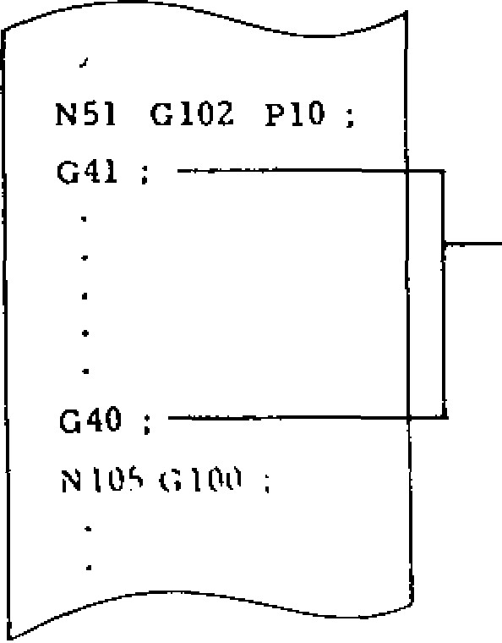**TOOL RADIUS**

**COMPENSATION C FUNCTIONS CORRECTLY.**

1. **The tool length** compensation and tool position offset features are not affected by G 100 through G102 commands and therefore always valid.
2. The execution of 0102 P• • . ; **command, thereafter, needs the use** of the data processed and registered inthe first execution, so that the following points should be taken into account:
3. The tool offset amount to be used should be

th e sa me a s **t ha t us e d i n t he** first e x e c u tio n . T o c h a n g e th e to o l o f fse t a m o u n t, re se t th e registered data and execu te the command again for the first time (see 7.4, (7)).

1. If there is a single coordinate command of absolute value in a program of memory processing mode, the absolute coordinate value immediately before G102 P..• ; command must be in the same position as that used in the first execution. Otherwise, the correct position cannot be obtain ed as specified by the absolute command in the program.

(3) Specifying a subprogram (M98) is as follows: as follows:

**N100 0102 P2 ;**

**M98**

**P10**

**L10 ;**

**N102**

G100 ;



**010**

**;**

-

**M99;**

**020**

**;**

**N1 G102 P3 ;**

**N105 0100 ;**

**M99 ;**

**a.**

b.

**M98 P20**

**L5 ;**

**(4)**

**G101 ;**

G101 P... ;



G100 ;

**These** commands should be specified independently.

**( 5 )** The blocks between G101 (or G102 P) ; and G100 ; are handled as a **single** block with **regard t o t he s i ng l e bl o c k s wi tc h . T ha t i s , the s i ng l e block stop feature is disabled between these com mands.**

**( 6 ) D u r i n g** the data processing and registration o f th e h ig h -spe ed cu tting p ro g ra m, th e d isp la y

on the CRT screen is as shown below. The func tion keys are automatically put in the COM dis play mode, displaying the screen shown below. At this time, the **NC operator's** station keys except for RESET are disabled.

**2. 9. 33. 2 Restrictions on High-Speed Cutting**

**Feature (Cont'd)**

See NOTE.

C

OMMAND (REG)

*01234 N0018

PROGRAM

REG

REG

RDY

_____

1

N o t e : D u r i n g d a t a p r o c e s s i n g a n d r e g i s t r a t i o n , * is displayed to the left of the program number. With G101 ; command, * is erased after the com pletion of registration, upon which the automatic ope ra tion mode i s ente red. Wi th G102 P ; com m a nd , * re m ai n s d i s pl ay ed a ft e r t he c o mp le t ion o f regi st rat ion until the reg ist ered p rog ram is e ra sed .

When a re set op eration is pe rfo rm ed, the da ta b e i n g r e g i s t e r e d i s e r a s e d a n d t h e r e s e t s t a t e i s p r o v i d e d . If F E E D H O L D b u t t o n i s d e p r e s s e d o r a m o d e s w i t c h i n g o p e r a t i o n i s p e r f o r m e d , t h e d a t a b e i n g r e g i s t e r e d i s e r a s e d a n d t h e

lab el skip sta te i s p rovid ed.

( 7 ) T h e p r o c e s s e d a n d r e g i s t e r e d p r o g r a m d a t a i s e rased by any o f the follo wing ope ration s:

1. NEXT key on NC operator's station was

pressed.

1. Address search was performed in MEM or EDIT mode.
2. Some edit operation was performed either on t h e s t o r e d p a r t p r o g r a m o r o n t h e h i g h - s p e e d cutting p rogram.

N o t e : T o c h a n g e t h e t o o l o f f s e t a m o u n t a f t e r

d a t a p r o ce s s i n g an d re gi s t ra t io n, de p re s s NE XT

k e y t o e r a s e t h e r e g i s t e r e d p r o g r a m d a t a . I n

t h e c a s e o f t h e h i g h -s p e e d c u t t i n g (G1 0 1 ) i n

s e q u e n t i a l p r o c e s s i n g m o de , h o we v e r , t h e d a t a processing and registration are performed each time, eliminating the need for depressing NEXT key.

( 8 ) T h e fol lo win g p a ra met e r s e tt in g ma y in v al i date the high -speed cutting feature temporarily. W h e n t h i s fe a t u r e i s i n v a l i d a t e d , t h e p a rt p ro gram memory may be used to its full capacity.

Parameter

Number

#6008

D7 = 1 • • • Disables high-speed cutting function

D7 = 0 • • • Enables high -speed cutting function

Ho weve r, to change the pa rt p rog ram m emo ry capacity, key in 0 - 9 9 9 9 ERASE (by EDIT, PROG) for both changes of D7 from 0 to 1 and f r o m 1 t o 0 . H e n c e , i n e i t h e r c h a n g e , a l l t h e p a rt p ro g ra m s a re e ra s e d . If G I0 1 o r G1 0 2 i s

specified when #6008 D7 = "1," error "147" will be cau sed.

( 9 ) The following s e t t i n g m a y p ro v i d e the m o d e in which only data registration is performed:

Setting

Number

#6004

D5 = **1 • • •** The high-speed cutting is executed normally.

D5 = 0 • • • The high -speed cutting is not e x e c u t e d fo r G1 0 1 ; c o m m a n d b u t

the usual automatic operation is p e rfo rm ed . Fo r G1 02 P - - • ; command, only data registration is p e rfo rm e d d u ri n g t h e u s u a l a u t o matic operation.

This setting may be used for the checking of programs as follows:

1. . S e t # 6 0 0 4 D 5 t o 0 .
2. . Select low-speed feed by FEEDRATE OVERRIDE or DRY RUN switch.
3. . Cycle-start the program to be tested includ. -

i n g G 1 0 2 P ; t h r o u g h G 1 0 0 ; c o m m a n d s . T h e u s u a l a u t o m a t i c o p e ra t i o n i s p e r f o r m e d , s o th a t

v i su a ll y c he ck th e t oo l p at h . In so m e c a s e s , the p rog ra m m ay be sing le -block - stopped fo r c h e c k u p s . U p o n t e r m i n a t i o n o f t h e o p e r a t i o n , t h e p ro c e s s e d d a t a u p t o G 1 0 0 ; c o m m a n d h a v e be en regi ste red in th e ma chine .

1. . S e t # 6 0 0 4 D 5 t o 1 .
2. . S e t t h e f e e d r a t e t o t h e o r i g i n a l v a l u e .
3. . C y c l e - s t a r t t h e s a m e p r o g r a m . G 1 0 2 P ;

through G100 ; are immediately executed using t h e re g i s t e re d d a t a .

**2.10 USER MESSAGE DISPLAY**

**2.10.1 ALARM MESSAGE DISPLAY BY #8000 COMMAND**

**The user can display any alarm message on the CRT screen. By specifying the following command in the part program, 3-digit alarm number n and the alarm message (less than 32 characters) may be designated:**

**#8000 = n ((alarm message> );**

**The alarm number should be 3 digits and the one that is not used by the control. For the alarm message, alphanumeric characters may be used. When this #8000 command is executed, the alarm message is displayed and "ALM" flashes at the bottom of the CRT screen.**

**Fig. 2.87 Sample Display of**

|  |
| --- |
|  |
| **ALARM 00010 N0107**  **USERS MESSAGE 123: USER ALARM**  **ALM** |

**Alarm Message by #8000 Command Note: If a command with a wrong alarm message is specified, a format error will be caused.**

**2.10.2 MESSAGE DISPLAY BY CONTROL -OUT**

**AND CONTROL-IN**

1. **Programming and Display by Control-Out and**

**Control-1n**

**The user can program any message between the information enclosed with control-in and controlout in the part program in order to display the message on the CRT screen. The enclosed in- formation is assumed to be insignificant.**

1. **How to Edit Control-Out And Control-In**

**The control-in and control-out part may be edited by the usual edit operation.**

1. **Depress El key and 'SHIFT( key, and char-**

**acter "(" may be entered.** 1-1

1. **Depress key and** !SHIFT' **key, and char- acter ")" may be entered.**

**Program**

**Example**

**TEST PROGRAM**

**(**

**)**

**G81 X100 Y100**

**Z**

**-**

**50**

**R**

**-**

**25**

**L3 ;**

**(**

**DRILL**

**END)**

**Message Display by**

**Control**

**-**

**out and Control**

**-**

**in**



**PROGRAM (MEM)**

**01234**

**N**

**0018**

**(**

**TEST PROGRAM**

**)**

**G81 X100 Y100**

**Z**

**-**

**50**

**R**

**-**

**25**

**L3 ;**

**(**

**DRILL END**

**)**

**Notes:**

1. **The characters which are indicated in the thick-lettered keys shown below may be enclosed in control-out and control-in.**
2. **The number of characters that may be enc l os ed i n co n t ro l -o u t a nd c o nt ro l -i n l es s t h a n**

**32.**

1. **Nesting of the control-out and control-in is not allowed.**

DATA

6

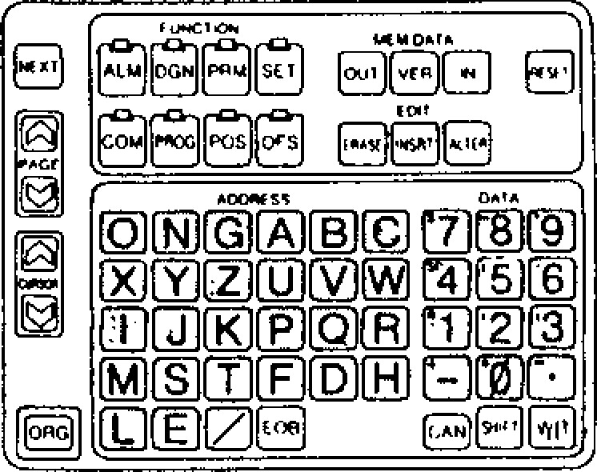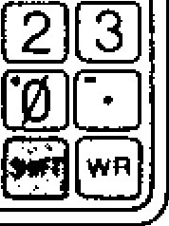

**Fig. 2.88**

r4-1

**Characters Enclosed in Control-Out and Control-In (Thick-**

**Lettered Keys)**

**- 83 -**

**2.11 USER MACRO (G65 AND G66)** 2.11.1 USER MACRO CALL COMMANDS

S p ec ia l p rog ra ms written b y th e ma ch in e b u ilde r or user by the use of a group of instructions are r e g i s t e r e d i n t h e p a r t p r o g r a m m e m o r y . T h e s e programs can be called by the use of G65 or G66 command to execute them.

These specia l programs are referred to as the u ser ma cro bo dy , wh ic h c a n b e written an d sto red in the sa me format as a subp rogra m.

Main Program User Macro Body

P9001

G65

(

Argument

Designation)



❑

9 0 1

;

/

—

Variable

Operation Command

Control Command

M99 ;

Main Program

Subprogram

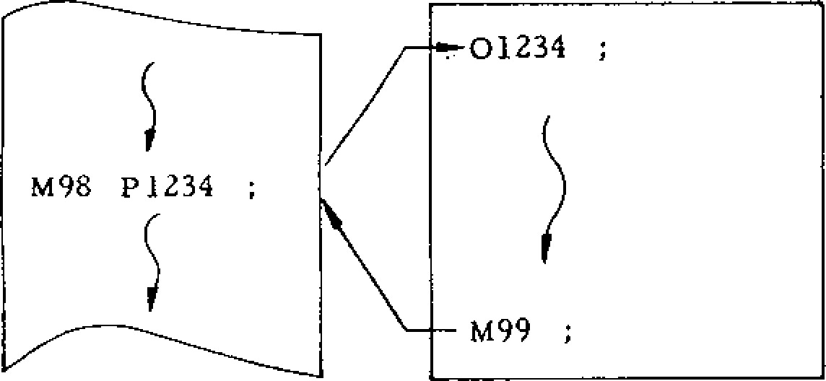

However, unlike a subprogram, a user macro allows:

( 1 ) U s e o f v a r i a b l e s .

( 2 ) Computation between variable or between constants.

( 3 ) Use of con tro l commands such as conditional branch.

These fea tures enable the u ser mac ro body to provide a generalized program that requires complicated c o m p u t a t i o n s and d e c i s i o n s .

The "argument designation" in calling a user m a c r o b o d y f ro m t h e ma i n p r o g ra m ma k e s i t possible to a s s i g n the real nu mbers to the vari a b l e s i n th e b o d y . T h is e n a b le s th is u se r ma c r o to ru n a s a se rie s o f sp e cific p ro g ra m th a t p ro vide tool movements.

In this manual, the user macro body is sometimes

r e f e r r e d t o a s " m a c r o p r o g r a m " o r , s i m p l y ,

"macro."

|  |  |  |  |
| --- | --- | --- | --- |
| No. | Type of Call | Code | Remarks |
| **—**    **rq rel**    **Tr tr,** | Simple call  Modal call  Call by arbitrary  G code  Call by M code  Call by T code | G65  G66 Gxx  Mxx  Txxxx | G67: For cancel.  4 digits max. |

A user macro body may be called in the following five manners:

**(1) Simple Call (G65)**

G 6 5 P . - . L — • ( a r g u m e n t d e s i g n a t i o n ) ;

The mac ro p rogra m whose progra m number was sp e c ifie d b y P is c a lle d a n d is e x e c u te d L time s . T he de fa u lt va lue o f L is 1 . Wh en th e d esign ation o f a n a r g u m e n t t o t h e u s e r m a c r o i s d e s i r e d , sp ec ify it in (argu men t de sig na tion ). "Argu men t d e sign a tio n " is the assign me nt of re a l n u mb ers to the "local variables" used in the user m a c r o . F o r details, see 1 . 3 AR G UM E NT DE S IG N AT IO N .

(2) **Modal Call (C66 and G67)**

G 6 6 P . . . L • - • (a rg u m e n t d e s ig n a ti o n ) ;

This command provides the mode to call the macro p r o g r a m o f t h e p r o g r a m n u m b e r s p e c i f ie d b y P . Each time a move command is executed, the speC ified macro is run L times.

G67 ;

This command cancels the modal call mode.

**(3) Macro Call by Arbitary G Code**

Gxx (argu ment designation) ;

This provides the command which is equivalent to G 6 5 P . . - ( a r g u m e n t d e s i g n a t i o n ) ; . F o r G x x , t e n se ts o f G c od es of GOl th ro ug h G1 99 ex ce pt for those designated by NC maker may be set for the parameter. The macro program numbers which correspond to these G codes are as follows:

**#6120 • • • Sets G code which calls the macro of program number** ❑**9010.**

**#6121 • • • Sets G code which calls the macro of program number 09011.**

**Parameter No.**

**#6134**

**0 • • • T code designation is handled as a T code.**

**#6129 • • • Sets G code which calls the macro of program number 09019.**

**NOTE: Macro call by arbitrary G code permits only single nesting. Namely, the macro which was called by the macro call using arbitrary G code or the macro call with M code or T code does not permit another macro call by arbitrary G code.**

**(4) Macro Call by M Code**

**C• • • X• • • Y• •• Mxx ;**

**This command may call macros. In this case, the macro is executed after the execution of the move command in the same block. MF and M codes are not transmitted. For Mxx, four sets of M codes of except for MOO, M01, MO2, M30,M90 through M99 may be set for the parameter.**

**#6130 • - • Sets M code which calls the macro of program number 09001.**

**#6131 • • • Sets M code which calls the macro of program number 09002.**

**#6132 • • • Sets M code•which calls the macro of program number 09003.**

**#6133 • - • Sets M code which calls the macro of program number 09004.**

**NOTE THAT THE MACRO CALL BY M CODE DOES NOT PERMIT ARGUMENT DESIGNATION.**

**When these M codes are specified in the macros called by the macro call using arbitrary G code or by the macro call using M code or T code, the macro call is not executed but is handled as a usual M code.**

1. **Macro Call by T Code**

**All the T code commands provide a macro call command.**

**G• • • X • • • Y• • • Txxxx**

**With this command, the macro of program number 09000 is executed after the move command in the same block is executed:**

**Transmission of •T code and TF signal is not performed. Whether a T code is to be used as a macro call command may be specified by the following parzuneter:**

**I • • • T code designation is handled as a macro call command to call the macro of program number 09000.**

**When a T code is specified as a macro call command, the value designated by T "xxxx" (up to decimal 4 digits) becomes the argument of common variable #149. NOTE THAT THE ARGUMENT**

**DESIGNATION OTHER THAN THIS IS NOT**

**PERMITTED. When a T code is designated in the macro called by the macro call by arbitrary G code or by the macro call by M code or ,T code, the macro call is not executed but is handled as a usual T code.**

1. **Multiple Call**
2. **G65 Simple Call And G66 Modal Call**

**As a subprogram is called from another subprogram, a user macro may be called from another user macro. Quadruple nesting is permitted for simple call and modal call combined. Multiple call is disabled for the macro call by arbitrary G code, or M code or T code.**

1. **Multiple Call by G66 Modal Call**

**In modal call, each time a move command is executed, the designated macro is run. This is also valid for the move command in the macro called by multiple call. The macros are sequentially executed from the one designated latest.**

**Sample Program**

GOO

**Main Program**

**Macro**

Si

**Macro**

G

66

**P9400 ;**

**GOO X10.,**

**G66 P9500**

**GOO ZZO. ;**

**G67 ;**

G67 ;

Z30.

09400

;

GOO

X40.

GOO Y50.

M99

09500

;

GOO

x60.

GOO Y70.

M99 ;

**The above sample program is executed in the following order:**

2.11.2 **ARGUMENT DESIGNATION**

A r g u m e n t is th e r e a l v a lu e to b e a s sig n e d to a v a riab le u se d in the use r ma c ro bo dy . Arg u me n t

d e s i g n a t i o n , t h e r e f o r e , i s t h e a c t o f a s s i g n i n g

rea l va lues to v ariab les. Argu men t designation is

of type I and type Ii, which can be selected as re -

quired.

**(1) Argument Designation I**

Argu men t may be desig nated in any ad dress ex c e p t f o r G , **L, N,** 0 , a n d P . T h e r e l a t i o n s h i p s

between the argument designation addresses and th e variable s are as sho wn belo w.

|  |  |
| --- | --- |
| Address of Argument Designation I | Variable in  User Macro Body |
| A | #1 |
| B | #2 |
| C | #3 |
| D | #7 |
| E | #8 |
| F | #9 |
| H | #11 |
| 1 | #4 |
| J | #5 |
| K | #6 |
| M | #13  #17 |
| R | #18 |
| S | #19 |
| T | #20 |
| U | #21 |
| V | #22 |
| w | #23 |
| X | #24  #25  #26 |

For the address in which no argument need be designated, the command may be omitted.

Sample Program #1 #2 #24 #26

1' t

G 6 5 P 9 1 0 0 L 3 A 3 0 B 6 0 X 3 4 . 8 2 5 0 . 2 ;

Argument Designation

Part

**(2) Argument Designation II**

A , B , a n d C a r g u m e n t s a n d 1 0 s e t s o f I , J , a n d K a r g u m e n t s m a y b e d e s i g n a t e d . I , J , a n d K

m u st b e d e si g n a te d in t h i s o rd e r. T h e re la t io n sh ip s b e twe en the a rgu me n t d esign ation a dd ress -

es and the va riab les a re as sho wn be lo w.

Address of Variables in

Argument Designation 11 User Macro Body

|  |  |
| --- | --- |
| A | #1 |
| B | #2 |
| C | #3  #4 |
| J1 | #5 |
| K1 | #6 |
| 12 | #7 |
| J2 | #8 |
| K2 | #9 |
| 13 | #10 |
| J3 | #13 |
| K3 | #12 |
| 14 | #13 |
| J4 | #14 |
| K4 | #15 |
| 15 | #16 |
| J5 | #17 |
| K5 | #18 |
| 16 | #19 |
| J6 | #20 |
| K6 | #21 |
| 17 | #22 |
| J7 | #23 |
| K7 | #24 |
| **18** | #25 |
| J8 | #26 |
| K8 | #27 |
| 19 | #28 |
| J9 | #29 |
| Kg | #30 |
| 110 | #31 |
| J10 | #32 |
| K | #33 |

The suffixes 1 th rough 10 to I, J, an d K are de t e r m i n e d b y t h e o r d e r o f t h e d e s i g n a t e d I , J , and K combinations.

For the a d d re ss in wh ic h n o a rg u me n t n e e d be designated, the command may be omitted.

Sample Program

#4 #5 #6 #7 #9 t + $ +

G 6 5 P 9 0 0 5 A . • • B . . . C . . . I . . . J . - - K - • • 1 . . . K . . . ;

Argument Designation Part

1. **Position of Decimal Point Argument**

An a rg u men t may g e ne rally b e d e sign a te d with a sign and dec ima l poin t. For the designation with out decimal point, the position of decimal point is as sho wn o n th e nex t page.

|  |  |  |
| --- | --- | --- |
| Address in Argument Designation | Metric Input | Inch Input |
| A, C | 3 (2) | 3 (2) |
| B (Without B 3-digit option) | 3 (2) | 3 (2) |
| B (With B 3-digit option) | 0 | 0 |
| D, H | 0 | 0 |
| E, F (In G94 mode) | 0 (1) | 1 (2) |
| E, F (In G95 mode) | 2 (3) | 3 (4) |
| I, J, K | 3 **(2)** | **4 (3)** |
| **M, S, T** | **0** | **0** |
| **Q, R** | **3 (2)** | **4 (3)** |
| **U, V, W** | **3 (2)** | **4 (3)** |
| **X,** Y, Z | 3 (2) | **4 (3)** |

**The value shows** the position of decimal point as **counted from the least** significant digit. **The value in parentheses indicates the number of digits that follows decimal point at the time of parameter #6020D0 = 1, D2 = 1 for addresses E and F, and parameter #6006D5 = 1 for the other addresses.**

1. **Considerations in Argument Designation**
2. **Argument designation** types I and II may be used concurrently. If the same variable has been designated duplicately, the last one is validated.
3. For both types I and IL, addresses I, J, and K should be designated in this order. The other addresses may be designated in any order.
4. In the argument designation part, negative sign and decimal point may be used regardless of the address.
5. In G65 and G66 **blocks, G65 and G66 should always be specified before each argument** designation. T h is h o ld s tru e w ith th e macro call by

**G code.**

**2.11.3 OVERVIEW OF USER MACRO BODY**

A user macro body is programmed using the combination of the following commands.

**(1) Variables**

1. **Local variable (#1 through #33)**
2. **Common variable (#100 through #509)**
3. **System variable (#1000 through #5104)**

**(2) Operation Commands**

1. Arithmetical operations (+, *, 1, • • • )
2. Functional operations (SIN, COS, ROUND,...)

**(3) Control Commands**

1. **Branch** command (IF <qualification> GO TO n)
2. Repeat command (WHILE <qualification> DO m)

**Using these commands, a program which requires complicated operations and conditional judgements may be written in the general format. Hence, the feature of user macro is to enable the programming of the wide range of NC functions from a simple machining cycle which is rather a subprogram to a special, complicated** canned cycle, and the storing of **these** cycles in the machine. Described below are details of the commands mentioned above.

**2.11. 4 VARIABLES**

Instead of directly assigning a value to an address in a user macro body, the address may be designated by a variable. When this variable is called during execution, the corresponding value is fetched from the variable area to provide the address value.

There are three types of variables: local variable, common variable, and system variable. Each is identifiable by a variable number.

To the local variables, real numbers can be assigned using the argument designation part of macro call command by G65 or G66.

**(1) Local Variables (#1 through #33)** A local variable is the one that is used for each macro locally, That is, when the local variable is used, the variable area(#1 through #33) is independently allocated for each macro c all, certain values are stored by argument designation, and the results of operations in macro are retained.

**2.11.4 VARIABLES (CONT ID)**

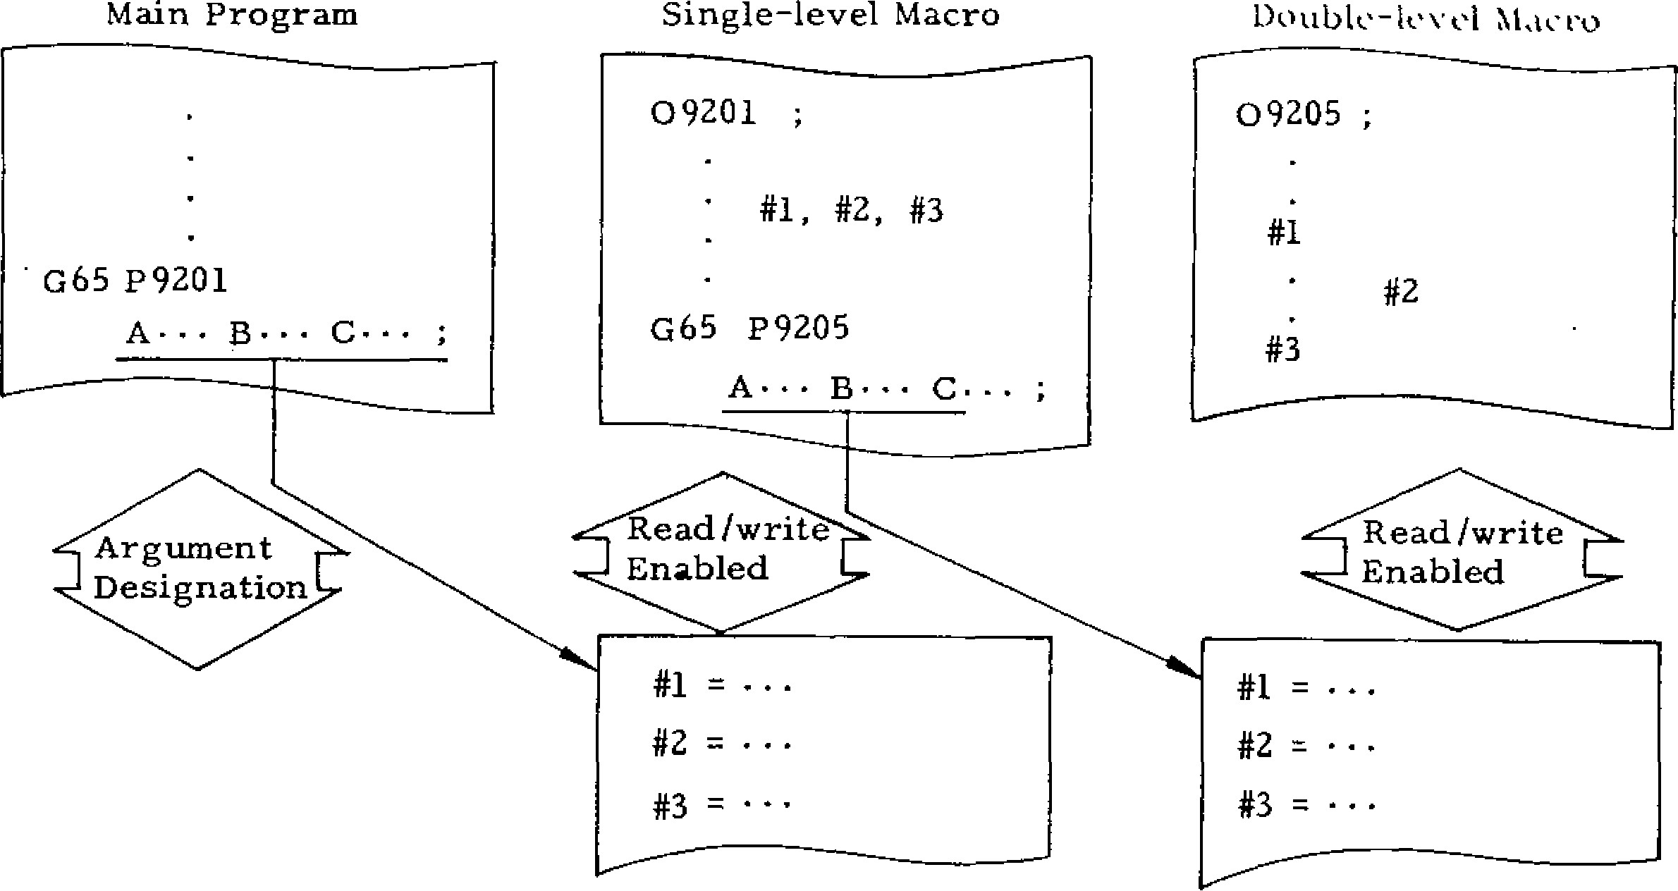

Main Program

Single

-

level Macro

09201

;

#1, #2, #3

G65 P9205

Double

-

lt•vel Macro

09205

;

#1

#2

Local variable **area** Local variable area for single-level macro for **duplicate-level macro**

|  |  |
| --- | --- |
| Hence, the variables #1, #2, #3, - • • of the sa me ma cro a ssu me d iffe ren t values ea ch time it is ca lle d . Ea ch lo ca l v a ria b le is reset fo r e ac h macro call and is registered by argument desig n a t io n . T h e v a ri a b l e n o t d e s ig n a t e d b e c o m e s " b l a n k . " E a c h l o c a l v a r ia b l e i s s e t t o " b l a n k " at the time of power -on and rese t ope ration s.  (2) **Common Variables (#100 through #149, #500 through #509)**  A c o m mo n v a ria b le ma y b e sh a re d b y a l l ma c ro s and thro ugh a ll macros o f a ll nesting levels. Tha t | 1. #100 through #149: These common variables are cle ared a t the time of p owe r -on and reset **operations and are set** to "blank." **They are** not cleared by reset operation in some controls **if parameter** #6008 D1 is set to "1." 2. **#500** through #509: These common variables are not cleared at **the time of** power-on and reset operations.   T he co mmo n va ria b le s a re av a ilab le to the u s e r w i t h o u t r e s t r i c t i o n s . T h e y c a n n o t b e d e s ig n a t e d b y a rg u me n ts. In d i re c tl y , h o we v e r , they can be designated as follows: |

is, th e c o m mo n v a ria b le e n a b le s a ma c ro to re fe r #100 = #109008 ; to th e re su lts o b ta ine d b y an o th er mac ro. G65 P9008 A•I• ;

Common Variable Area

|  |  |
| --- | --- |
| #100 | #500 |
| #149 | #509 |

|  |  |
| --- | --- |
| **OK**  OK **OK** OK  Single-nest D o u b le -n e st T ri p p le - n e st Q u a d r u p le -  Macro Macro Macro nest Macro | A system variable is the one whose use is unique to th e syste m. There are follo wing type s o f sy s tem variables:  A. Interface input signals . .. #1000 through |
| Common variables are divided into the following | #1015, #1032t |
| two types depending on clear conditions: | B. In te rfa ce ou tp u t sig na ls ... #1 10 0 th ro ug h |

Argument Designation of #1

(3) **System Variables**

#1115, #1132t

1. Tool offset amount and work coordinatesystem shift amount ... #2001 through #2099, #2500 through #2806
2. Alarm mess age display ... # 3 0 0 0
3. Clock ... #3001, #3002
4. Single-block stop and auxiliary-function completion wait control ... #3003
5. Feed-hold,feedrate-override, and exactstop control ... #3004
6. RS232C data output ... #3100 (print out feature).

1. Modal information ... #4001 through #4120

J. Position information ... #5001 through #5014

Note: The interface input and output signals of (A) and (B) may not be installed. Follow the specifications of the machine tool builder.

The following paragraphs describe the details of the variables mentioned above.

A. Interface Input Signals (#1000 Through

#1015, #1032)fi

a, When one of system variables #1000 through #1015 is specified to the right-hand of an operational expression, the on/off state of each of user-macro-dedicated 16-point input signals is read. The relationships between the input signals and the system variables are as shown below.

|  |  |  |  |  |  |  |  |  |  |  |
| --- | --- | --- | --- | --- | --- | --- | --- | --- | --- | --- |
| #1007 | #1006 | | #1005 | #1004 | | #1003 | #1002 | #1001 | | #1000 |
| U17  27 | U16  26 | | U15 25 | U14 24 | | U13 23 | U12 22 | U11 21 | | UN  20. |
| 111015  - | 111014 | | 111013111012 . |  | |  | 111011111010 | #1009 | | #1008 |
| UI15 215 | U114 214 | | U113  213 | U112 212 | | U111  211 | 13110 210 | U119  2.3 | | U118 28 |
| Variable Value | | | Input Signal | | | |
| 1 | | | Contact Closed | | | |
| 0 | | | Contact Open | | | |

YASNAC

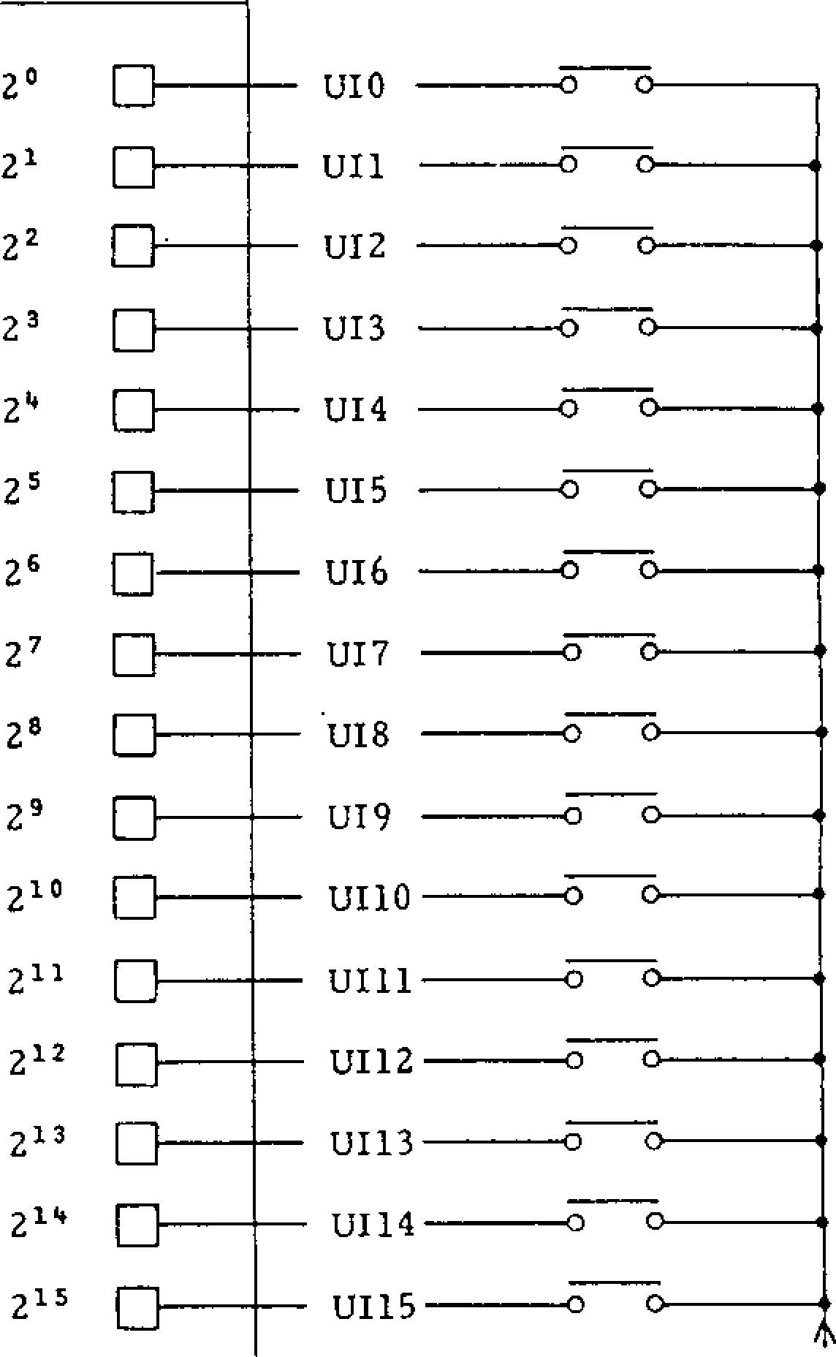

2

0

214

215

❑

21

❑

D.

2

3

24

❑

25

❑

2

7

2

8

2

9

210

211

2

"

D

213

❑

U13

_______

0

UI4

UI5

________

U16

U17

.

UI8

U19

UI10

UIll

UI12

--

o

UI13

________

U114

UI15

----

0

UI0

UI1

Each read variable is 1. 0 or 0.0 when the associated contact is "closed" or "open" respectively, regardless of the unit system of the machine.

b. Whe n system variable #1032 is designated,

the input signals (U10 through UI15) that consist of 16 points (16 bits) are collectively read as a decimal positive value.

1 5

#1032 = E # L1000 + i]* 2i

i =0

Sample Program

IF #1015 EQ 0] GO TO 100 ;

Bit 2 1 5 (UI15) is read and, if it is "0," a branch is made to sequence number N100.

#130 = #1032 AND 255

Bits 20 through 27 (UV) through UI7) are collectively read to be stored in common variable #130 as a decimal positive value.

Note: System variables #1000 through #1032 cannot be placed to the left-hand of operational expressions.

2.11.LI VARIABLES (CONT'D)

B. Interface Output Signals (#1100 Through

#1115, #1132)1-

a . Wh e n o n e o f sy ste m v a ria b le s # 1 1 0 0 th ro u g h #1115 is specified to the left-hand of an operationa l e x p re ssio n , a n o n o r o ff s ig n a l c a n b e se n t to e a c h o f u s e r - m a c r o - d e d i c a t e d 1 6 - p o i n t o u t p u t s i g n a l s . T h e r e l a t i o n s h i p s b e t w e e n t h e o u t p u t

s i g n a l s a n d t h e s y s t e m v a r i a b l e s a r e a s s h o w n

below:

|  |  |  |  |  |  |  |  |
| --- | --- | --- | --- | --- | --- | --- | --- |
| #1107 | #1106 | #1105 | #1104 | #1103 | #1102 | #1101 | #1100, |
| LT07  2 7 | U06  26 | U05  25 | U04  2" | 1103  23 | UO2  22 | U01  21 | U00  20 |
| #1115 | #1 1 14 | #1113 | #1112 | #1 1 1 1 | #1110 | #1109 | #1108 |
| U15  215 | U14  211* | U13  213 | U12 212 | Ul 1 211 | 1110  210 | U09  29 | U08 26 |

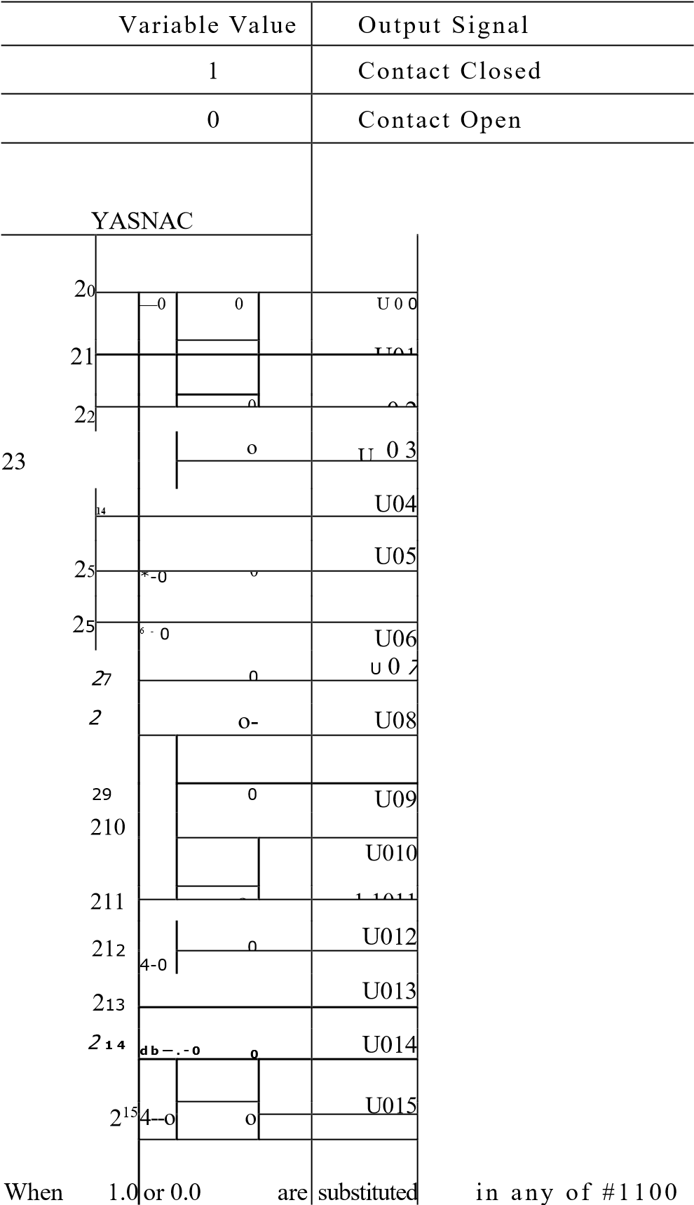

through #1115, the associated output contact is ou tput in the "clo sed" or "open "sta te.

b. When system variable #1132 is specified, the

o u t p u t s i g n a l s ( U 0 0 t h r o u g h U 0 1 5 ) t h a t c o n s i s t of 16 points (16 bits) are collectively output.

At this time, the dec imal positive va lue su bstituted i n # 1 1 3 2 i s o u t p u t in t h e f o r m o f b i n a r y 1 6 - b i t

value.

15

#1132 = Z it [1100 + * 21

= 0

1. With system variables #1100 through #1132,

th e v a lu e se n t la st i s re ta in e d . He n c e , wh e n o n e of them is written to the right -hand of an opera tional expre ssion , its v alue is read.

1. C o n s i d e r a t i o n s

Wh en an y v alue s o the r tha n 1 .0 o r 0 .0 are sub s t it u t e d in to o n e o f # 1 1 0 0 th r o u g h # 1 1 1 5 , th e values are handled as follows:

"Blank" is assumed to be "0."

Value s o ther than "bla nk" and 0 are assume d to be "1."

Sample Program

#1107 = #10 ; (#10 = 1.5)

T h e o u tp u t sig n a l o f b it 2 7 (U0 7 ) is o u tp u t

in the conta ct (close d) state.

#1132 = (#1132 AND 240) OR (#8 AND 15;)

The output signal of bits 2 4 through 2 7 (UC)4 th ro u g h U0 7 ) a re o u tp u t w ith o u t c h a n g e a n d th e c o n te n ts o f lo c a l v a ria b le # 8 a re o u tp u t t o t h e o u t p u t s i g n a l s o f b i t s 2 0 t h r o u g h 2 3

(U00 through UO3).

(Decimal 240) = 11110000,

(Decimal 15) = 00001111)

C . T o o l O f f s e t A m o u n t A n d W o r k C o o r d i n a t e

System Shift Amount (#2001 Through #2099, #2500

Through #2086)

1. When one of system variables #2001 through #2099 is specified to the right -hand of an operational expression, the tool offset amount can be read.

|  |
| --- |
| - 90 - |

1. When one of system variables #2500 through #2806 is specified to the right -hand of an operat i o n a l e x p re ss io n , t h e wo rk c o o r d i n a te sy st e m

shift amount (and the external work coordinate sy ste m co rrection a moun t) can b e read .

1. The rela tionsh ips between the tool offset numbers and the system variables are as shown below:

(4) When one of the above system variabl es is specified to the left-hand of an operational expre ssion , its value can be c hanged.

|  |  |
| --- | --- |
| System Variable    #2001  #2002  #2098  #2099 | Tool Offset No. |
| 01  02  98  99 |

System Work Coordinate

Variable System Shift Amount Spindle

External work coordinate

#2500 system correction amount

#2501 G54 X

#2506 G59

#2600 External work coordinate

#2601 system correction amount

G54

Y

Sample Programs

1. . # 1 1 6 = # 2 0 1 6 ;

The contents of tool offset number 16 are substituted for common variable #116.

1. . # 2 5 0 6 = # 4 ;

The work coordinate system shift amount of G 5 9 X - a x i s i s e r a s e d a n d t h e c o n te n t s o f local variable #4 are set.

**D. Alarm** Message Display (#3000)

When a condition to be alarmed occurs in a user macro program, system variable #3000 may be specified to put the machine in the alarm state. #3000 = n (<alarm meassage>);

Using this command, specify the alarm message ( l e s s t h a n 3 2 c h a ra c t e r s ) e n c l o s e d b y 3 - d ig i t

alarm nu mber n and control -in and con trol -out. The alarm. number should be three digits and be th e one that is not used by the mach ine.

When this #3000 command is executed, "ALM" or "A/B" is displayed on the bottom of CRT screen regardless of the mode and function. Its message can be seen by the following opera tion:

a. Pre ss ALM func tion key.

|  |
| --- |
| #2606 G59  #2700 External work coordinate  #2701 system correction amount G54  #2706 G 59    #2800 External work coordinate  #2801 system correction amount G54  #2806 G59 sample display |

The alarm number and message are displayed on the botto m of CRT screen .

ALARM

09100

N

0054

USERS MESSAGE

550:

MACRO ERROR: DATA OVERFLOW

"ALM"

Me

ssage display area and

**2 . 1 1 . 4 V A R I A B L E S ( C ON T I D )**

b. When RES ET ke y is pre ssed after remo val of the cause of alarm, the message display and the alarm state can be clea red.

Same Program

#3000 = 550 (MACRO ERROR: DATA OVERFLOW)

E. Clock (#3001, #3002)

When system variable #3001 or #3002 for clock is specified, the clock can be read.

|  |  |  |  |  |
| --- | --- | --- | --- | --- |
| System Variable | ,., e iTyp • e | Unit | At  Power-On | Count Condition |
| #3001 | Clock 1 | 1 ms | Reset to "0" | Always |
| #3002 | Clock 2 | 1 s | Same as power-off time | When STL signal is on |

T o p re se t th e c lo c k , su b sti tu te th e v a lu e with this system variable put at the left -hand of the expression.

Sample Program

#3001 = 0 ; • • - The clock is preset to value "0."

Restrictions

1. . T h e a c c u r a c y o f c l o c k 1 i s 8 m s . W h e n 4294968000 cosec has been reached, an overflow o c c u rs, se ttin g th e c lo c k to "0 ."
2. . T h e a c c u r a c y o f c l o c k 2 i s 8 m s . W h e n

429496800 sec has been reached, an overflow oc c u r s , s e t t i n g th e c l o c k to " 0 . "

Sample Progra m

________ Argument designation Main Programof variable #1 F. Sing le B lock Stop and Auxili a ry Func tion Completion Wait Control (#3003) When the value listed in the following table is substituted in system variable #3003, the single block switch can be disable d or the next block may be entered without waiting for the checking of the finish signal (FIN) of the auxiliary func tion (MST).

|  |  |  |  |
| --- | --- | --- | --- |
| #3003 | Single  Block Switch | PIN Signal |  |
| 0 | Valid | Waited |  |
| 1 | Invalid | Waited |  |
| 2 | Valid | Not waited |  |
| 3 | Invalid | Not waited |  |

When the finish signal is not waited for, the distribution end signal (DEN) is not transmitted. In this case, the FIN is waited for in the block w i t h th e c h e c k sk ip c le a re d . H e n c e , wh e n th e FIN is not waited for, be careful not to specify th e nex t aux ilia ry fu nction. _

G . F e e d - H o l d , F e e d ra te -Q v e r ri d e , A n d Ex a c t

-Stop Control (#3004)

When the value listed in the following table is substituted in system variable #3004, feed hold, fe ed ra te o ve rride , a nd exa c t stop c an be mad e valid or invalid.

|  |
| --- |
| 065 P9351 AS ;• • Macro to wait for  5 seconds    Mac ro Prog ra m  00351 ;  #3002 = 0 ;  WHILE #3002 TE #1,1 DOI. ; END 1 ;  MOO ; |

|  |  |  |  |
| --- | --- | --- | --- |
| #3004 | Feed Hold | Feedrate Override | Exact StoF |
| 0 | Valid | Valid | Valid |
| I | Invalid | Valid | Valid |
| 2 | Valid | Invalid | Valid |
| 3 | Invalid | Invalid | Valid |
| 4 | Valid | Valid | Invalid |
| 5 | Invalid | Valid | Invalid |
| 6 | Valid | Invalid | Invalid |
| 7 | Invalid | Invalid | Invalid |

Sample Program

Tapping Cycle (for Incremental Command)

Main Program

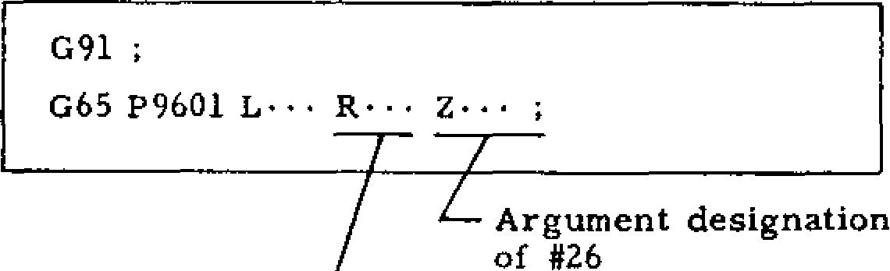

Argument designation

of #26

Argument designation of #18

**;**

**09601**

**#3003 = 1 ;**

**Single**

block switch

invalidated

GOO 2#18 ;

#3004

-

7

_

GO1 Z#26 ;

M05 ;

M04 ;

**#3004 =**

0

;

GOO Z

-

#18

M05 ;

MO3 ;

#3003 = 0 ;

M99 ;

{

Feed hold invalidated

Feedrate override invalidated

Exact stop invalidated

Macro Program

H. RS232 C Data Outpu t (#3100 )

When system variable #3100 is specified, messages and NC internal data can **be** outputted to external e q u i p m e n t v i a R S 2 3 2 C d a t a i n p u t / o u t p u t i n t e r fa c e . If th e e x te rn a l e q u ip me n t is a p r in te r, the abci ve in fo rmation is p rint ed.

a. Output of Messages

#3100 = KMessage>)

W h e n t h i s c o m m a n d i s s p e c i f i e d , t h e m e s s a g e enclosed by control-in and control-out is outputted. via R S232C in te rface .

Each output message is followed by CR/LF

( Ca rria g e Re tu rn / Lin e F e e d ). He n c e , wh e n

#3100 = ( ) is specified, only CR/L F is outputted, which is useful in tabula tin g the punched data .

1. **Output of Data**

**#3100 = <variable >**

**When this command is specified, the value of** the local variable, common variable, or system

variable at the right-hand is outputted vis RS232C interface as the signed decimal 8 -digit data.

1. The above output is performed when system

v a ri a b l e # 3 1 0 0 i s e x e c u t e d i n t h e m a c ro p ro g ra m . I t i s r e q u i r e d , t h e r e f o r e , t o p r e v i o u s l y a t t a c h t h e e x t e r n a l e q u i p m e n t s u c h a s a p r i n t e r v i a R S2 3 2 C i n t e r fa c e a n d p re s e t t h e p a r a m e t e rs th a t

use the interface.

Sample Program

# 3 10 0 = ( ); • • - Carria ge return /line fe ed #3100 = (TOOL OFFSET 01 AND 02):

#3100 = #2501 ; • •• = 10.000 mm

#3100 = #2502 ; • • = -35.524 mm

#3100 = );

Printout Data

- T w o s p a c e s p r e c e d e s i g n e d d e c i m a l

TOOL OFFSET 01 AND 02

u u 1 0 . 0 0 0 u t i

-

35.524



1. Modal Information (#4001 Through #4120)

W h e n o n e o f sy st e m v a ria b l e s # 4 0 0 1 th ro u g h #4120 is specified, the modal commands that are s p e c i f i e d u p t o t h e i m m e d i a t e l y p r e c e d i n g b l o c k

c an be kno wn . These modal co mmands are some times called the current values of modal informa tion commands.

|  |  |
| --- | --- |
| System Variable | Modal Information |
| #4001 | G code (group 01) |
| #4021 | G code (group 21) |
| **#4102** | B **code** |
| #4107 | D code |
| #4109 | F c o d e |
| #4111 | H code |
| #4113 | M code |
| **#4114** | Seque nce nu mbe r |
| **#4115** | Prog ra m nu mber |
| #4119 | **S code** |
| #4120 | T code |

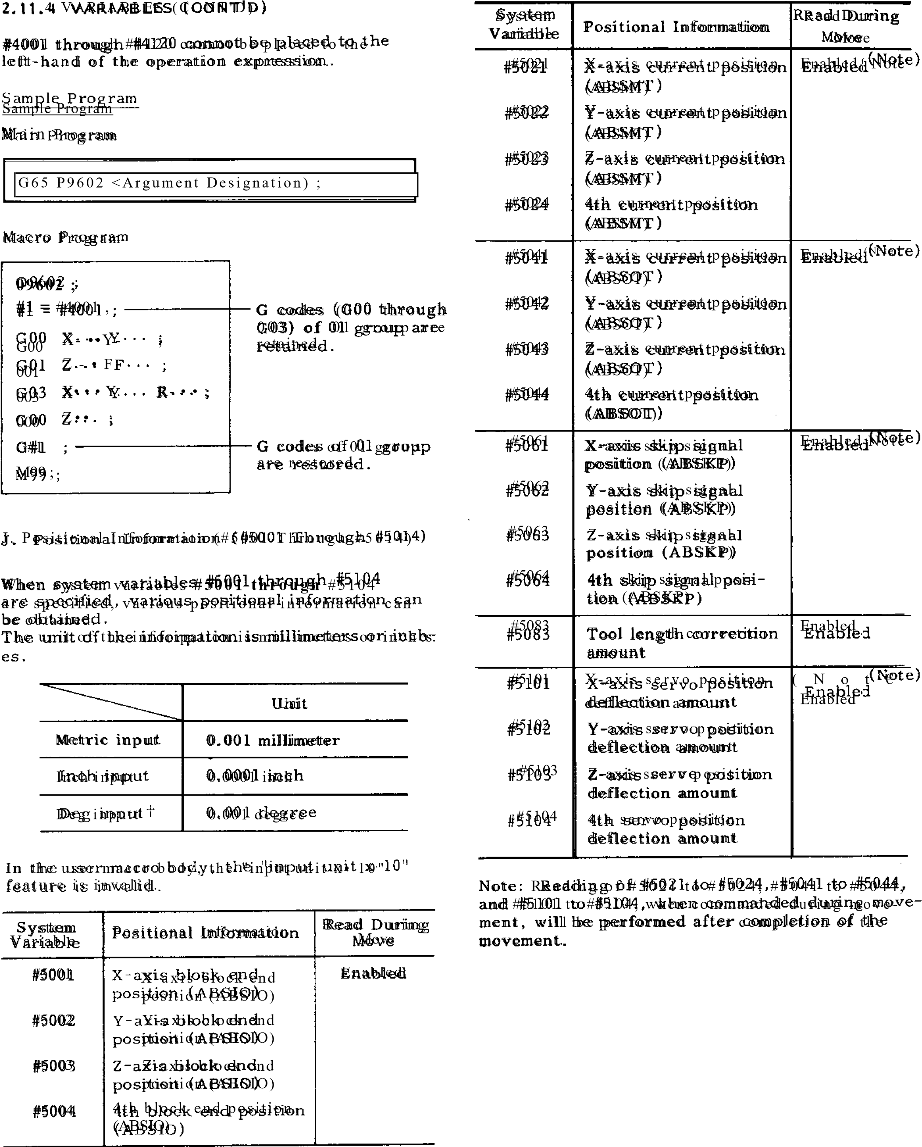

|  |  |  |  |  |
| --- | --- | --- | --- | --- |
| Mnemonic | ABSIO | ABSMT | ABSOT | ABSKP |
| Meaning | End pasition of  block im-position  mediately before. | Command current  (same as POS.  MACHINEVERSAL display) .display). | Command  current  position  (same as  POS.UNI- | Position at which skip signal did not go on in G31 block. |
| Coordi- nate system | Work  coordi- nate system | Machine coordi- nate system | Work co- ordinate system | Work coordinate system |
| Tool position, Tool  Tool  radius  compen-  sation  Amount | l e n g t h ,  Not included |  | Included | Included |

Notes:

1. When the skip signal is not turned on in G31 block, the skip signal position is at the end of G31 block.

Z. The "input unit x 10" feature is valid up to the macro call block (the argument designation part by G65 or G66) but is invalid in the user macro body.

3. System variables #5001 through #5104 may not be placed to the left-hand of operational expression.

Sample Program

The tool is positioned to the specified location

(X, Y, 2) on machine coordinate system, performs the specified M feature, and returns to the start point.

Main Program

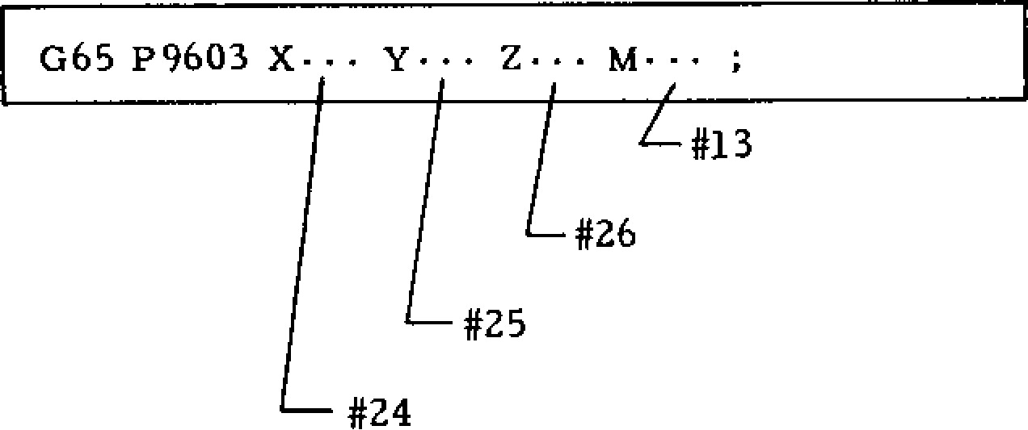

Macro Program

09603 ;

#1 = #5001 ;

#2 = #5002 ;

#3 = #5003 ;

G91 ;

GOO X [#24-#5021] Y [#25-#5022];

GOO z [#26-#5023] ;

M#13;

GOO Z#3 ;

GOO X#1 Y#2 ;

M99 ;

|  |  |
| --- | --- |
| Variable NO. | Meaning |
| #1 to #33 | Local variables. |
| #100 to | Common variables (reset to"blank" at |
| #149 | power-off). |
| #500 to | Common variables (retained at power- |
| #509 | off). |
| #1000 to | Interface input signals (each signal |
| #1015 | for each bit).  15 |
| #1032 | Interface input signal (E # [1000 + ii  i=0 2i) |
| #1100 to | Interface output signals (each signal |
| #1115 | for each bit).  15 |
| #1132 | Interface output signal (E #[1100 + i=0 * 21). |
| #2001 to | Tool offset amount. |
| #2099  #2500 to | Work coordinate system shift amount, |
| #2806 | external work coordinate system correction amount. |
| #3000. | Alarm message display. |
| #3001 | Clock 1 (in units of 1 ms). |
| #3002 | Clock 2 (in units of 1 s). |
| #3003 | Single block stop, auxiliary function complete wait control. |
| #3004 | Feed-hold, feedrate-override, and exact-stop control. |
| #3100 | R S 2 3 2 C data output (print out feature). |
| #4001 to | Current value of modal information |
| #4120 | command. |

List of Variables

**2. 11. 4 VARIABLES (CONT I D)**

|  |  |
| --- | --- |
| Variable No. | Meaning |
| #5001 to #5004  #5021 to #5024  #5041 to #5044  #5061 to  #5064  #5083 #5101 to  #5104 | End position of immediately preceding block (for e ach ax is).  Current position of machine coordinate system (for each axis).  Current position of POS. UNIVERSAL (for ea ch ax is).  Position at which G31 skip signal is tu rn e d o n (fo r e a c h a x is).  Valid tool length compensation amount. Servo position deflection amount (for each axis) |

K . Va ria b le Re p re n ta tio n

Each variable is represented in a variable number that follows #.

a . Ho w to d e sign a te a numb e r d ire ctly:

# i ( i = 1 , 2 , 3 , 4 , •• •)

Sample #10

#130

#2000

b. How to designate an expression as a variable number: #[(expression)]

Sample # [#1001

# [#500 + 1]

*#* [#20/2]

In the following description, variable #i may be replaced with variable #[<expression >].

L . Va ria b le Re fe re n c e

a. The value that follows an address may be rep laced by a variable.

When < address> #i or <address> -#i is specified, the value of the variable or its negative value (complement , more exactly) is made the specified va lue of the addre ss.

Sample #30 = 1. 0 ;

#101 = 100. ;

#102 = 200. ;

#103 = 300. ; #140 = 250. ; G#30 X#101 Y#102 Z-#I03 F#140 ;

The above specification is equivalent to the specification below:

G O l X 1 0 0 X 2 0 0 Z - 3 0 0 F - 2 5 0 ;

Notes:

( 1 ) Ad d r e s s 1 , 0 , a n d N m a y n o t re fe r to variables.

(3 ) Wh en a va ria ble is use d a s a dd ress d ata , the values below the least significant digit are rounded .

Sample

( i ) W h e n # 1 = 4 5 . 2 3 4 6 X#1 - • • = X45.235 mm (for mm input)

( i i ) . W h e n # 2 = 3 5 0 . 8 5

F#2 - • • F351 (mm/min)

( i i i ) W h e n # 3 = 5 . 3 7 6 7 2 G04

P#3 ••• =G04 P5.377 (sec) ( i v ) W h e n # 4 = 2 . 7 2 3 6

*M#4* - • M03

G#4 • • • G03

( 4 ) V a l u e f o r e a c h a d d r e s s s h o u l d n o t e x c e e d the maximum programmable value.

(5 ) Th e va lue that follows a n address may be rep laced with (expre ssion> .

(6) The c onstan t with out dec imal po int en .alose d in brackets [ ] is assumed to have a decimal point at its end .

M. Und efined Varia ble

The value of an undefined variable is assumed to be "blank." An undefined variable occurs in the following situations:

1. The local variable for which argument desig-

nat ion wa s not pe rformed in mac ro call co mmand .

1. Common variables #100 through #149 at the

time of power-on and reset operations.

1. The local variables and common variables

for which the values were not written from MDI panel.

Sample

( 2 ) A v a a variabl Sample

Designation and function of <blank> is classified in the fo llo wing two versions A and B. Th e con trol is se t for eith er version. Versions A and B cannot be changed.

|  |  |  |  |
| --- | --- | --- | --- |
|  | | Version A | Version B |
| I | Concept of "#0" | . No concept- ion of #0.  . Command- ing #0 causes alarm. | . #0 defined as variable s of <blank> . Command-  ing #0 at the left-hand side of the equation. |
| 2 | Variable <blank> is commanded in the replacement equation. | . Where #2 is <blank> , command  #3=#2; means #3=0. | . Where #2 is <blank> cornmand #3=#2; means #3= <blank>. |
| 3 | Variable <blank> is commanded in th e p a rt p ro - gram. | . Where #2 is <blank> , command 600 x #2; is equiva- lent to corn- mand  600 x 0; | . Where #2  is <blank>  command 600 x #2; is equivalent  to 600; (Adress is  Ignored.) |
| 4 | Variable <blank> is co mmanded i n t h e c o n d i - tion of EQ and NE. | . Where #2 is <blank>,  #3 is 0  0 C o n d i t i o n "IF #3 EQ #2" is established 0 C o n d i t i o n "IF #3 NE #2" is not estab- lished. | . Where #2 is <blank> #3 is  0  0 Condition "IF #3 EQ #2" is not established.  a) Condition "IF #3 EQ #2 is established. |
| 5 | Others  . | #341 #0+#0j  #3=#2 * #0;  #3=#0 t #0;  In these corn#3=#0/#0;  mands, #3=0,  #3=5*#0;  #3=2-#0; means #3=2 #3=51#0; causes alarm.  Blank in the replacement described above is treated as "0."  . Condition IF#3 GE#2 is established when #2 and #3 are <blank> , or #2 **is 0** and #3 is <blank> .  . Condition IF #3LT #2 is not established when #2 and #3 are <blank> , or #2 is <blank> , and #3=0. | |

**2.11.5 OPERATION COMMANDS**

V a rio u s o p e ra tio n s c a n b e p e rfo r me d b e t we e n

v a r ia b le s a n d b e t we e n v a ri a b le s a n d c o n s ta n t s.

T h e o p e r a t i o n e x p r e s s io n i s r e p r e s e n t e d i n t h e

form of #i = <expression> , in which <expression> is a general arithmetic operational expression pro duced by combining variables and constants with o p e r a t o r s a n d f u n c t i o n s . T h e • a v a i la b l e o p e a r a tio ns an d fu n ction s a re as follo ws. In ste ad of #j and #k, con stan ts may be used.

1. **Variable Definition and Replacement**

# 1 = # j • • • d e fin itio n , re p la c e me n t. =

#t + #1c.1

1. **Ad d - Ty p e Op e ra tio n s**

#i = #j + #k Sum.

#i = #j - #k • • • Difference.

#1 = #j OR #k • - • Logical sum (for each of

32 bits).

#1. = #j XOR #k • • • Exclusive logical sum (for each of 32 bits).

1. **M u l t i p l y - T y p e O p e r a t i o n s**

#i = #5 * #k • • • Product.

#i = #j / #k - • • Quotient. = #j AND #k • • • Logical product (for each of 32 bits).

N o t e : I n O R , X O R , o r A N D o p e r a t i o n , t h e v a ria b le v a lu e (o r c o n sta n t) is c o n v e rte d i n t o

t h e b i n a ry 3 2 -b it e q u iv a le n t a n d th e o p e ra tio n i s p e r fo rm e d o n e a c h b i t .

**(4) F unc ti o ns** #i = SIN DijSin e (in deg rees).

#i = COS rifj - • • Cosine (in degrees). #i = TAN [#j] • - • Tangen t (in deg rees). t f i = A T A N [ # j / # k ] A r c t a n g e n t ( i n d e g r e e s ) .

= S QRT [ #j] • • - Squa re root. ffi = ABS • • • Ab so lu te v a lu e .

BIN Et • • • Convert from BCD.

# i - B C D [ # j i • . . C o n v e r t i n t o B C D . #i = ROUND [ifj] • • • Produce integer by rounding, #i = FIX [#j T ru n c a te th e fra c t io n s.

= FUP [ Raise the fractions to a unit .

1. **) Co m b in a tio n s o f Op er a tio n s**

The above operations and functions may be used in combinations. A functional operation is per formed first. Then, a multiply -type operation is performed. An add -type ope ratio n is p erformed last.

Sample # 1 = # j + # k * S IN [ # 2 . 1

0

0

1. **) Ch a n g e o f Op era t io n a l Ord e r b y**

Priority may be given to an operation by enclos in g it in brack ets E 3 . Up to quintu ple (five hold) nesting of brackets is permitted including those of functional operations.

Sample #1 = SIN [ [[#j+ #k] * CZ, + itrn] #n]

1. **) Considerations for Operational Commands**
2. The constant without decimal point used in <expression> is assumed to have a decimal point at its end .



1. When used in conditional expression IF or WHILE, function ROUND truncates the fractions.
2. When used in address data, function ROUND r o u n d s t h e p a r t b e l o w t h e l e a s t s i g n i f i c a n t digit.

Sample (a)

#10 = 12.3758

When the least significant digit of address

X is 0.001 mm, the following command G00 X [ ROUND [ #10 ]]; means

G00 X12.376 ; because 8 of 12.3758 is rounded.

This command is also equivalent to

G00 X#10 ;

Usually, ROUND is not used as mentioned above; it is used as shown below:

Sample (b)

When ROUND is used as follows, the program re tu rns to the start poin t correctly:

(I) #10 = 12.3758 ; START #10 #11.,„

C2) #11 = 13.1236 ; POINT

( G 9 1 G 0 0 X # 1 0 RETRACTION

0 G 0 1 X # 1 1 F . . • ;

® G00 X- [ROUND [4110] + ROUND [#11]] ;

CD

before This is because the data of #10 and #11 in a n d 0 b l o c k s a r e s u b s ta n t i a l l y r o u n d e d being executed. I f 0 b l o c k i s

0 G O O X - [ # 1 0 + # 1 1 ; then, the movement is made by the following amount:

X- [ #10 + #11] = X - [12.3758 + 13.1236]

= X - [25.4994]

= X - [25.499]

On the other hand, block movement of

**a f T i S**

**X#10 X#11 =** X 1 2 .3 7 6 + X1 3.12 4

= X25.500

H e n c e , t h e p ro g ra m o f j i s n o t c o rr e c t.

**( 8) Operational Errors**

The data format and the operational errors in the user macros are as follows:

1. Data Format

The numeric data I -1.ndled in user macros are **of** the floating point format.

M * 2E

wh e re , M is sig n + da ta 52 -bit bina ry , E is sign + data 10-bit binary.

1. O p e r a t i o n a l E r r o r s

Each time an ope ration is p erformed , the fo llo w in g error is ca used a nd is a ccu mulated. Th e nu m ber of significant digits is 15 to 16, which com pen sates the erro r su ffic ien tly.

**2. 1 1. 6 C ON TR OL C OM M AN D S** provide a simple branch command as shown below:

**The commands which control the flow of microprogram are of the following two types:**

1. **Branch Command ... IF [<conditional expression)] GO TO n ;**
2. **Repeat Command ... WHITE [<conditional expression>] DO m ;**

**(1) Branch Command**

**A. IF [< conditional expression>] GO TO n ;**

**If < conditional expression>of this command is established, a branch is made to the block of sequence number n within the same program. When a variable or an expression is used for n, the branch destination may be changed. If the condition is not satisfied, the program proceeds to the next block.**

**—**

**IF [( Conditional)] GO TO n;**

**expression**

**(**

**Next Block**

**)**

**n**

**• • •**

■

.

-------

Unestablished

Established

IF

[<conditional **expression >] may be omitted to**

U

.c

—

GO TO n;

Nn• • •

c ca

MI a)

Q.

.,

E *u)*

,-------- ------____

**Conditional expressions are EQ, NE, GT, LT, GE, and LE. They are represented as** follo ws:

|  |  |  |  |  |
| --- | --- | --- | --- | --- |
| **Conditional Expression** | | | **Meaning** | |
| **#i** | **EQ** | **#j** | **(#i =** | **#j)** |
| **#i** | **NE** | **#j** | **(#i** | **#j)** |
| **#i** | **GT** | **#j** | **(#1 >** | **#j)** |
| **#i** | **LT** | **#j** | **(#i <** | **#j)** |
| **#i** | **GE** | **#j** | **(#i** | **#j)** |
| **#i** | **LE** | **#j** | **(#i 5** | **#j)** |

A **constant and <expression> may be used to #i and** # 6 . A v a r i a b l e **and <expression> may be** use d for n.

Notes:

**1. The sequence number of the** d e s t i n a t i o n **of the branch by a branch command must be located at the head of that block. Otherwise, the** d a t a prior **to the sequence number is** ignored as shown below:

Branc h Destination **Sequence No.**

(

**< • • • ; G 0 1 X 1 0 . N 3 5 Z 2 5 . F 3 0 0 ; • • •**

Executed **with this data ignored.** *■ _______________________ I* **2.** The reverse branch on the program takes *i _____* longer execution time than the forward branch.

**(2) Repeat Command**

A. WHILE E< conditional expression)] DO m;

(m = 1, 2 and 3)

END m ;

While <conditional expression> is satisfied, the blocks between DO m and END m are repeated. When it is un satisfie d, the proc essin g b ranches to the block next to END m.

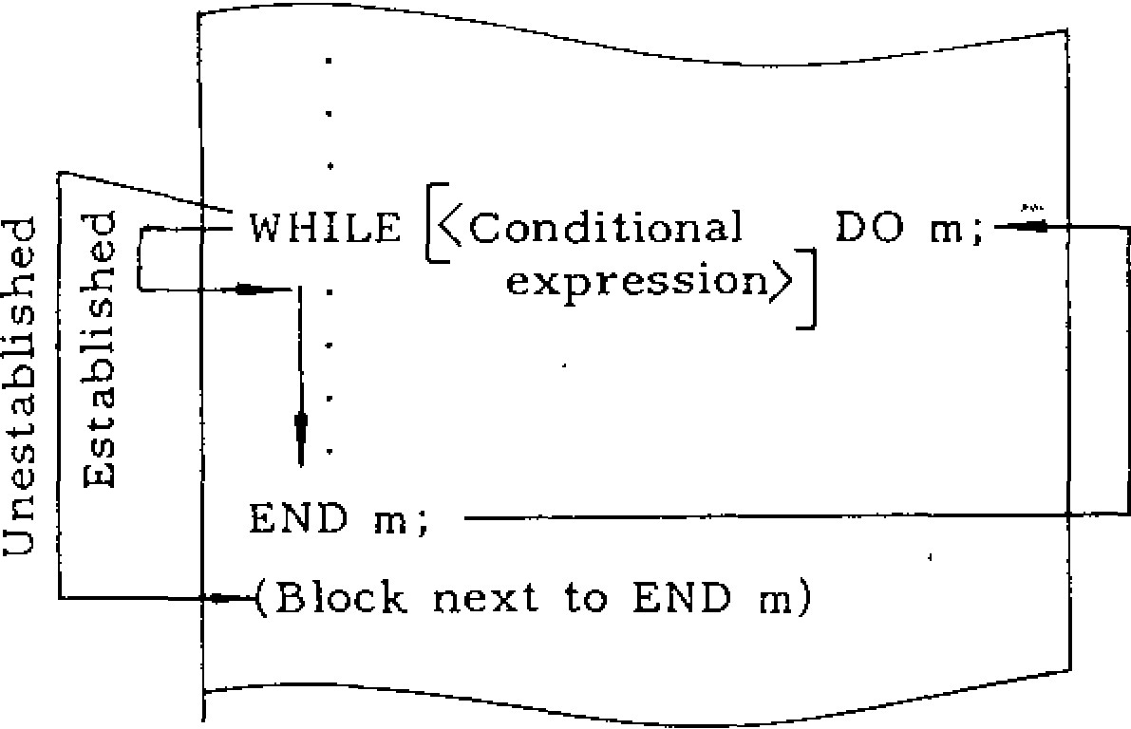

Unestablished

-

0

___

WHILE [<Conditional

DO m;

expression)]

END m;

(

Block next to

END m)

(1)

•

***n***

When the specification is made omitting WHILE

[<conditional expression)] , the blocks between DO m and END m are repeated infinitely. Gen erally, this is used in the format shown below.

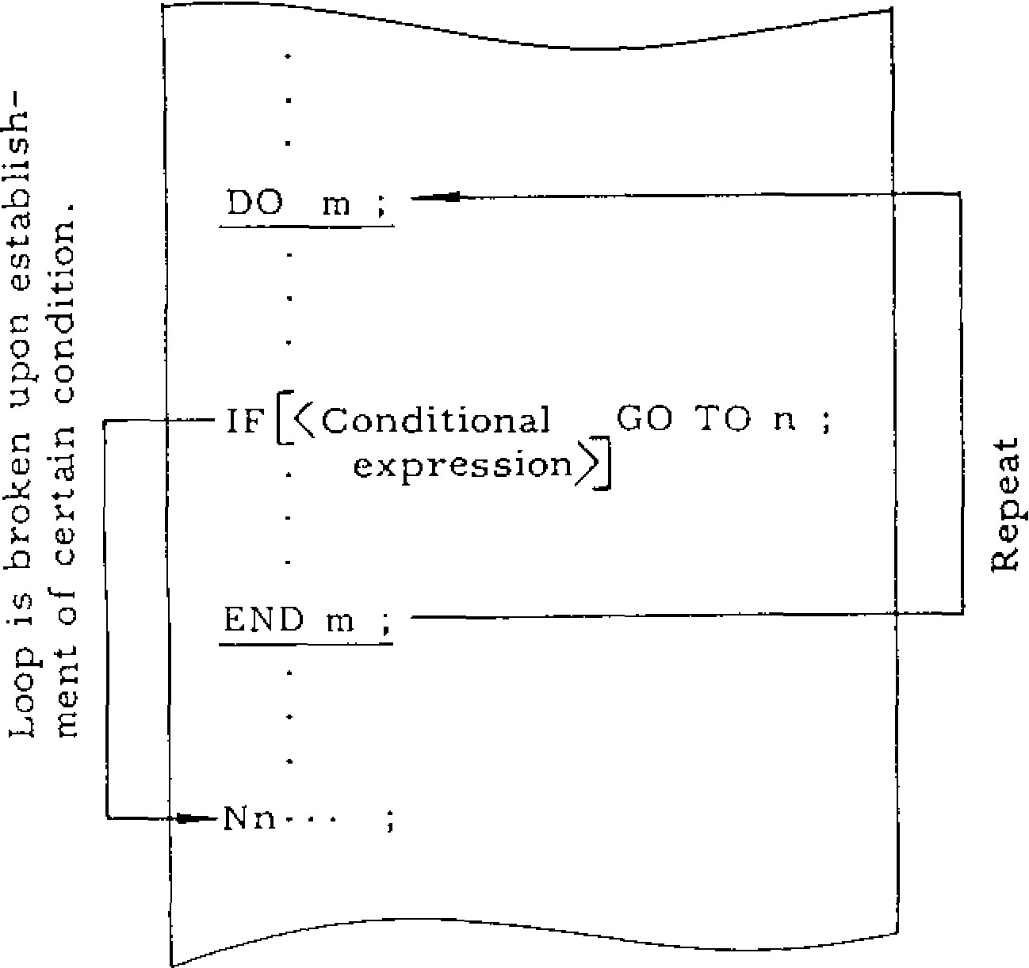

DO m ,

IF [<Conditional GO TO n ;

. expression)]

END m ,

cC

CL

establish

-

Notes:

DO m should be specified before END m.

1. m of DO m and END m should have the same v a lu e . Ho we v e r, o n ly 1 , 2 , o r 3 ma y b e sp e c ifi ed in m. DO 1 -;:a__

The va lue o f m, 1, 2, o r 3 is called the identification nu mber, which is use d by

DO and END to call each END I ____ other.

DO 2

END 2 —

1. The same identification number may be used repeatedly except where repeat ranges ove:rlap.
2. GO TO n enables to get out of DO loop but it does not enable to get into DO loop as shown below:

**DO I ;** -0 — GOTO 100 ;

-

o

CO

DO 1 ;

GOTO 100 ;

N100 ; 1=1 END 1

END 1 ;

;

1. **TiiSti** DO-loop nesting is permitted for each

micro **piaoiram.**

G65• ••ABC ;

DO 1 ;

DO

2

;

DO 3 ;

G65..• XYZ ;

END 3 ;

END 2 ;

END 1 ;

DO 1

;

DO 2

;

DO 3

;

END 3 ;

END 2 ;

END 1 ;

--- Enabled Enabled

1. T h e c od in gs sh o wn b elo w ca u se a n e rro r:

7

( i ) D O 1 ;

The return destination

DO 1; 7 of END 1 is unknown.

END 1 ,

( i i ) DO 1 ;

One END 1 is missing. END 1 ;

7

END 1

7

1. DO 1 ; ____ DO 1 ;

Overlap of DO ranges is not D O 2 ; 7 permitted.

DO 2 ; Rewrite as END 2 ;

END 1 ;i shown right.

E N D 1 : —

END 2 ;

1. DO 1 ;

DO 2;

DO 3 ;

DO 1 ;

Quadru ple n esting. Max. nexting permitted is triple.

END 1

END 3 ; END' 2 ;

END 1 ;

1. DO 1 ;

,

;

GO

TO

N7000

Do loop may not be entered from

END 1outside.

**2.11.7 REGISTRATION OF USER MACROS**

1. **How To Make Registration of User Macros**

The reg istra tion an d ed it of user macro bodies (macro programs) are p e rfo r me d in the same manner as usual part programs and subprograms. Hence, there is no program size restriction that applies to the user macro body only. Part pro grams, subprograms, and macro programs may be stored together in the part program memory to its full capacity.

1. **Classification of Program Numbers**

The program numbers are classified into the following:

|  |  |
| --- | --- |
| Program No. | Classification |
| 01 to 07999 | These programs may be registered, erased, or edited without restrictions. |
| 08000 to | When D4 of #6004 is set to 1, the |
| 08999 | registration, erase, and edit of programs are disabled. |
| 0 9000 to | When 07 of #6021 is set to 1, the |
| 09999 | registration, erase, and edit of programs are disabled. |

-101 --

**2. 11. 8 DISPLAY AND WRITE OF LOCAL VARIA BLES AND COMMON VARIABLE**

Local variables (#1 through #33) and common var iables (#100 through #149, #500 through #509) can be displayed and written by the following operations:

**( 1 ) D i s p l ay Op er at i o n s**

A, Display of Variab les

1. Press SET function key. Mode select

may b e prov ided any where. position

|  |
| --- |
| CUSOR  4 |

1. Key-in the variable number and press

(2) **Write Operations**

A. Write of Va lues to Variables

1. Press SET function key. Mode select position

may b e prov ided any where.

1. K e y - in t h e v a r ia b le n u mb e r t o th e w ri tt e n .

|  |
| --- |
| CURSOR |

|  |
| --- |
| CURSOR |

Press key or key. 1 -low-

e v e r, # n e e d n o t b e k e y e d -in . T h e k e y e d -in variable number is specified and the cursor is positioned to it.

c . K e y - i n t h e v a l u e t o b e w r i t t e n . P r e s s W R k e y . T h e k e y e d - i n v a l u e i s s t o r e d a s t h e d a t a of the variable number with the cursor positioned.

k e y o r C U R S O R k e y . H o w e v e r , # n e e d n o t b e k e y e d T in . T e n se t s o f v a r ia b l e n u mb e r s in c l u d in g the sp ec ifie d va ria b le nu mb er an d the ir da ta a r e d i s p l a y e d . T h e d a t a a r e d i s p l a y e d i n t h e sig n e d 8 -d ig i t in te g e r p a rt a n d th e 8 -d ig it f ra c tion pa rt.

Macro nesting level

(0: Macro not in execution)

|  |  |
| --- | --- |
| SETTING MACRO 01234 N0035 | |
| — | ..---LEVEL  #0100 -12345678. 12345678  #0101 0. 00000001  #0102 3. 00000000 |
| # | 0109 |
| R | DY |
|  |  |

1

Sa mple Di splay o f Co mmon Va ri able s

PAGE

c. Press k e y o r P A G E k e y , a n d t h e

d i s p l a y m a y b e s c r o l l e d u p o r d o w n .

B . R e m a r k s

1. Common variables may always be displayed

fo r revi ew.

1. For local variables, those of the macro cur-

r e n t l y e x e c u t e d a r e d i s p l a y e d . C o n s e q u e n t l y , when a macro of a nesting level is in execution, th e loc a l va ria b le s o f the ma c ro s o f the oth er n e stin g le v e ls c a n n o t b e se e n . T h e lo c a l v a ria bles after completion of execution are all rest to

"blank."

|  |  |  |
| --- | --- | --- |
| CURSOR  4 | |  |
|  | PAGE  4, | |

1. . P r e s s k e y o r C U R S O R k e y o r

t key to move the cursor.

PAGE k e y o r

1. . Re p e a t o p e ra tio n s in c . a n d d . to write th e va lues to the de sired variab les.

B. Remarks

1. . C o m m o n v a r i a b l e s c a n a l w a y s b e c h a n g e d .
2. . L o c a l v a ri a b le s ma y n o t b e w r it te n a t a n y

t i m e o t h e r t h a n w h e n a m a c r o i s i n e x e c u t i o n . Any a tte mpt to do so is inva lida ted. Ho wev er, re writing of loca l va riables during macro execu tio n **m ay** c a u se a n u n e x p e c te d fa i lu re . Be fo re attempting the rewriting, stop the machine oper a tion b y sing le sto p fun ctio n an d c he ck to se e if it is safe to rewrite variables.

c . The written local variables and common variables #100 through #149 are reset to "blank" by the re set operation o r th e power -on ope ratio n.

**2. 11. 9 CONSIDERATIONS AND REMARKS FOR USER MACROS**

**(1) Summary of Restrictions**

A . Av a ila b le Va ria b le s

#1 through #33 • - • Local variables.

#100 through #149] ___ Common variables.

#500 through #509

System variables

- 102 -

1. Constant Values Usable in <Expression>

±(8 digits above decimal point). (7 digits below decimal points).

Sample Maximum value ±99999999.9999999 Minimum value ±0.0000001

1. Operational Accuracy

Decimal 15 digits significant.

1. M a c r o C a l l M a x i m u m Nesting Level Quadruple (four-hold).
2. Maximum Nesting Level of Repeat Command Triple (thread-hold) for each macro.
3. Repeat C o m m a n d (DO) Identifier m m = 1, 2, and 3.
4. Maximum Nesting Level of Brackets Quintuple (five -hold).

**(2) Differences Between User Macro and Subprogram**

1. User macros G65 and G66 allow argument designation but the subprogram (M98) does not.
2. T h e u s e r m a c r o directly branches to the user macro body without executing any command that was specified in G65 or G66 block and has no rela tionship with the macro . With the sub pro gra m, however, a branch is performed after the execution of the command (if any) other than P and **L** in M98 block.
3. The maximum nesting level of user macro is quadruple including G65 and G66 calls. That of subprograms is also quadruple but separately.
4. If user macros _are specified via **the** MDI during automatic operation, the maximum nesting level is restricted to quadruple. With subprograms, up to four levels of nesting are per mitted in tape mode or memory mode, or separately in **MDI** mode.

|  |  |
| --- | --- |
| B. Available Variable Values | **(3) Relationship with MDI Operation** |
| Maximum value • 4-10-'-308 | **A. MDI** writing permits the macro call and the |
| Minimum value • 4 - 10 - "B | execution of the called macro. |

1. **MDI** writing does not permit or execute macro body commands such as operational commands and control commands.
2. When a macro program being executed is stopped by the single block stop function, any MDI writing command not related to the macro may be specified and executed.
3. **Relationship** with **Address Search**

The address search function is not permitted to search for the sequence numbers in the user macro body.

1. **Relationship with Single Block Switch**
2. The operational command and control command blocks do not single-block stop if the single block switch is turned on. This switch is enabled for the other macro program blocks.
3. However, when setting number #60041)1 = 1, the single block switch is enabled for the opera tional command and control command.
4. System variable #3003 (for the control of single block stop, see 1.5.3.6) and setting #6004 D l mentioned above operate as shown below:

|  |  |  |  |
| --- | --- | --- | --- |
| Setting #6004 |  | System Vari- able #3003 | When Single Bock Switch is on |
| D 1 = 0 |  | = 1 or 3 | None of operational command, control command, and general command stop. |
| D 1 = 0 | ' | = 0 or 2 | Operational command and control command do not stop. General command stops. |
| D1 = 1 |  | = 1 or 3 | None of operational command, control command, and general command stop. |
| **DI = 1** |  | **= 0** or 2 | All of operational command, control command, and general command stop. |

(6 ) Relationship with Operational Block•Skip

T h e s l a s h " i " c h a r a c t e r u s e d i n t h e r ig h t - h a n d o f a n o p e ra t i o n a l expression or i n b ra c k e t s

i s a s s u m e d t o be the operator for quotient. It does not mean the optional skip.

(I) Setting and Parameter of Program Number

Classification

A. Disab ling of Progra m Registra tion , Era se, And Edit

The following setting is permitted to protect the reg iste red u ser mac ros a nd subprog ra ms from in advertent d estru ction :

Setting Number

#6004

D4 = 1 - • - The programs of program numbers #8000 through #8999 are disabled for registra tio n , e ra se , a n d e d it.

D4 = '0 - • • Registration, erase, and edit are enabled.

Parameter

Number

#6021

D7 = 1 • - • The programs of program numbers #9000 through #9999 are disabled for registra tio n , e ra se , a n d e d it.

D7 = 0 • • • Registration, erase, and edit are enabled.

(8) Effects of Reset Operation

1. A reset operation resets all local variables (#1 through # 3 3 ) and part o f c o mmo n v a ria b le s (#100 through #149) to "blank."
2. A r e s e t o p e r a t i o n r e s e t s t h e u s e r - m a c r o multiple call state and the multiple DO loop state, m a k i n g t h e p r o g r a m p o i n t e r r e t u r n t o t h e p r o gram head.

(9 ) Special Codes Usable in User Macro Body

A. T he sp ec ial co de s liste d b e lo w may be u sed in the user macro body:

ElA Code ISO Cock

Code Use 16 5 413 2 _ 1

1 1 13 *2*1

SP For comment 111311:111101111° For alarmessagm e °111

ii

comment I I I I I

1111E0111 IBIS ° •

+ Add **1311111111111313°** ° **••**

**_**: DivideFor comSubtra mect nt **limminn**arame er**us.** **13111111111131**11132111°11212**31**1**•** . •**■** •**•**

# Variable • desi •nation, **12110 •**

** Multiply **EI1"S.1111013181 •**

. Equal •

~~[~~ Bracket (open **minomoun!11121311x12121g\*** ]For coclose) etmm ent 111111113811M• **.•**•

$ **1111F2ininumnp•11118111011111 Ing1** **I**

- 1 eci-ntai al 111111114111114

Notes:

1. For the hole pattern o f EIA code of the cha r a c t e r a t t a c h e d w i t h a n a s t e r i s k , t h e p a t t e r n s h o w n a b o v e i s s t a n d a r d . H o w e v e r , o t h e r p a t terns may be specified by using the following parameters:

#6110

#6111

#6112

#6113

#6114

#6115

Re a d the de sired ho le pa tte rn in the b ina ry value, convert it into the decimal equivalent, a n d s e t i t t o t h e p a r a m e t e r . F o r e x a m p l e , the hole pattern shown below is set as "152" :

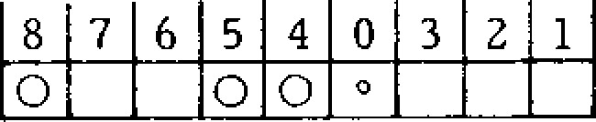

When the va lue of the para me ter is "0," the hole pattern listed in the above table is pro -- vided.

**2. When the codes shown below are output from the NC unit for punch-out or other purposes, the upper code (UC) or lower code (LC) is output immediately before.**

1. **Cod es p reced ed by UC • • • #, +, $ , ?.**
2. **Code preceded by LC • • • @.**
3. **Codes preceded by UC only at parameter**

**designation ... ( ,) , *, '•**

**2. 11. 10 ALARM NUMBER OF USER MACROS**

**Shown below are the user-macro-associated alarms and their causes.**

1. **MACRO ERROR (CONSTANT)**

**The number of constants is in excess of the specified range.**

1. **MACRO ERROR**

**There are too many G67 cancel codes.**

1. **MACRO ERROR (FORMAT)** 
   1. **format other than expression has an error.**
2. **MACRO ERROR (UNDEFIN #NO)**

**The value not defined as a variable number is designated.**

1. **MACRO ERROR (#NO NOT LEFT)**

**The variable of assignment statement is the one that is disabled for assignment.**

1. **MACRO ERROR (** [ ] **5 LIMIT)**

**The bracket nesting level is in excess of the upper limit (5).**

1. **MACRO ERROR (MOVE G66 - M99)** 
   1. **move command is specified in the macro end command M99 called by G66.**
2. **MACRO ERROR (5)**

**The macro call nesting level is in excess of the upper limit (4).**

1. **114 MACR~~O ER~~ROR (DO FORMAT)**

**- 105 -**

**DO and END are not paired.**

1. **MACRO ERROR ([** 3 **UNMATCH)**

**The format of <expression> has an error.**

1. **MACRO ERROR (DO - END NO.)**

**DO m is not in the range of 1 < m < 3.**

**117**

**118 MACRO ERROR (GO TO *N)***

**GO TO n is not in the range of 0 < n <**

**9999.**

**2. 11. 11 EXERC I SES OF USER M ACR O**

**( 1) C an n ed -C ycl e G82**

**T (Teacher): We have discussed many complicated rules you have to understand to write user macros. Now, let's create some user macros as exercises. Let's take G82 Spot Facing Cycle of canned cycles for ex ample, because it is a simple opertion.**

**S (Student): Where shall we start?**

**T: An example of usual G82 command takes the following format:**

**(P1)**

**G91 ; (• • • Incremental Designation)**

**G82 X100. Y50. R -80. Z -40. P3.0 F250 ;**

**This command is divided into the following and executed within the NC unit:**

(P2)+z

I

x,



M

0

---

9

1

|  |
| --- |
| **G91 ;**  **0 000 X100. Y50 ;**  **C) G00 X-80. ;**  **0 0 0 1 Z - 4 0 F 2 5 0 ; 0 G0 4 P 3. ; (Dwell)**  **®G00 Z-((-80) + (-40)) ;** |

**DWELL**

**2.11.11 EXERCISES OF USER MACRO {CONT I ())**

First, these moving distances may all be conve rted into variable s.

1. : T h e y a r e l o c a l v a r i a b l e s # 1 t h r o u g h # 3 3 , aren't they? But which type of local variable?
2. : T y p e 1 fo r s ma ll n u mb e r o f v a ria b le s . T h is type allows the use of X, Y, and Z and there f o r e m a k e s th e a r g u me n t d e si g n a t io n e a s ie r to u n d e rsta n d .

5 : O K. Wh e n ty p e I i s u se d , we h a v e th e f o l lo w ing variables:

|  |  |  |
| --- | --- | --- |
| X100. Y50. R-80. | Z-40. | F250 |
| #24 #25 #18 | #26 | 7  #9 |

(P3)'

Address P of dwell time cannot be used for arg umen t de signa tion , can it?

T : N o . U s e s o m e o t h e r a d d r e s s . T h e n , w r i t e th e address U instead o f P.

P3.0 U3.0 (P3')

#21

Using these variables, rewrite the former pro gra m (P2 ).

5: OK.

(P4)

|  |
| --- |
| G91 ;  c) GOO X#24 Y#25 ;  CD GOO Z#18 ;   G O 1 Z # 2 6 F # 9 ;  0 G04 P#21 ;  (D GOO Z- [#18 + #261; |

#24, #25

#18 a

#26

DWELL T -IME

Is this all right?

#20

T: Sorry , it isn 't right. You have forg otten to sp e c ify so me th in g in 0 , h a v n 't y o u ?

5: Oh, I should have specified "ROUND."

(P5)

e GOO Z- [ROUND [#18] + ROUND [#26]];

Is this good? Program number "09082" of the user macro is a rb itra ry .

T : Y e s . W r i t e a s f o l l o w s a f t e r t h e a b o v e , a n dwe have a complete user macro body.

® M99;

5: T h a t 's e a sy .

T : T h e n , u s i n g G 6 5 , c r e a t e t h i s m a c r o c a l l a n d

the user macro body in the complete formats.

S: Let me try it.

The macro call command is as follows:

(136)

G91 ;

G65 P9082 X100. Y50. R-80. Z-40. U3.0 F250. ;

The user macro body is as follows:

(P7)

09082 ;

GOO X#24 Y#25 ;

**GOO Z#18 ;**

GO1 2#26 F#9 ;

GO4 p#21 ;

GOO Z- [ROUND E#18] + ROUND [#2611 M99 ;

T : T h a t lo o k s O K.

**********

|  |
| --- |
| - 106 - |

I think something is wrong. With this pro g r a m , I h a v e t o s p e c i f y p o i n t s R a n d Z every time!

|  |  |
| --- | --- |
| T: | T ha t's tru e . With a u su a l c a nn ed c yc -e , whe n points R and Z have been specified once, th eir values are retained . |
| S: | Do you have any trick to overcome thi.s in covenience? |
| T: | I do. In such a case, common variables help. Using common variables, write the macro to d e sig n a te th e p o s itio n o f p o in ts R **and** Z. U and F may also be used for the same purpose. |

S : I'v e g o t it ! N o w, I d iv id e th e m a c r o b o d y into two parts as follows:

(118)

0 9000 ;

#100 = #18 ;

#101 = #26 ;

#102 = #21 ;

#103 = #9 ;

M99 ;

(P9)

0 9082 ;

000 X#24 Y#25 ;

000 Z#100 ;

001 Z#101 F103 ;

G04 P#102

G01 Z- [ROUND E#100] + ROUND [#101]] ;

M99 ;

and I write macro call as follows:

(P10)

G91 ;

G65 P9000 R-80. Z-40. U3.0 F250. ;

G65 P9082 X100. Y50. ;

G65 P9082 X• • • Y• • • ;

T: Very good.

**********

1. **: Wait a minutes This canned cycle always re turns** to the initial point.
2. : I a lso o v e rlo o k e d i t. A p ro g ra m wo u ld b e useless if it is disabled for the designation of the initial point return (G98) and point-- R re tu rn ( G9 9 ). T o so lv e th i s p ro b le m , use the system variable called "current value of modal information command" to know which s ta te , G9 8 o r G9 9 , i s p ro v id e d , a n d c h a n g e

th e spec ification of the too l re turn destina tion.

5: **G98 and G99** belong to group "10." **So,** I have to use system variable # 4010. Is it right?

T: Yes. Then, using "IF - • • GO T O • • • " co m - mand, change the specification of the tool re turn destination.

T h e r e i s o n e m o r e p o i n t t o b e i m p r o v e d . Write th e prog ra m so that the g roup "01 " G codes before execution may be retained after th e e x e c u tio n o f th is ma c ro . Gro u p "0 1 " G codes include G00 through G03.

1. : I t l o o k s d i f f i c u l t - • • What would you say to the following program?
2. : W e l l d o n e ! (P11)

1

**Macro Call Program**

G91 G99;

G65 **P9000 R-80. Z-40. U3.0 F250; G65 P9082 X100. Y50.;**

**G65 P9082 X...Y... ;**

**G98;**

**G65 P9082 X...Y... ;**

User Macro Body (P12)

|  |
| --- |
| **09000;**  **#100 = #18;**  **#101 = #26;**  **#102 = #21;**  **#103 = #9;**  **#104 = 0**  **09082;**  **#104 = #104 4 1**  #1 = #4001; ... GO to G3  #2 -= **#4010; ... G98/G99** **G00 X#24 Y#25;**  **IF[ #104 NE1] GO TO 1;**  **IFI #2 EQ99] GO TO 2;**  **GOO Z#100;**  **Ni 001 Z#101 F#103;**  **G04 P #102;**  **IFI #2 EQ 981 GO TO 2;**  **GOO 7-[ #101] GO TO 3;**  **N2 GOO Z-I ROUND [ #100] + ROUND [ #10111;**  **N3 G#1; ... Restore G Code** M99; |

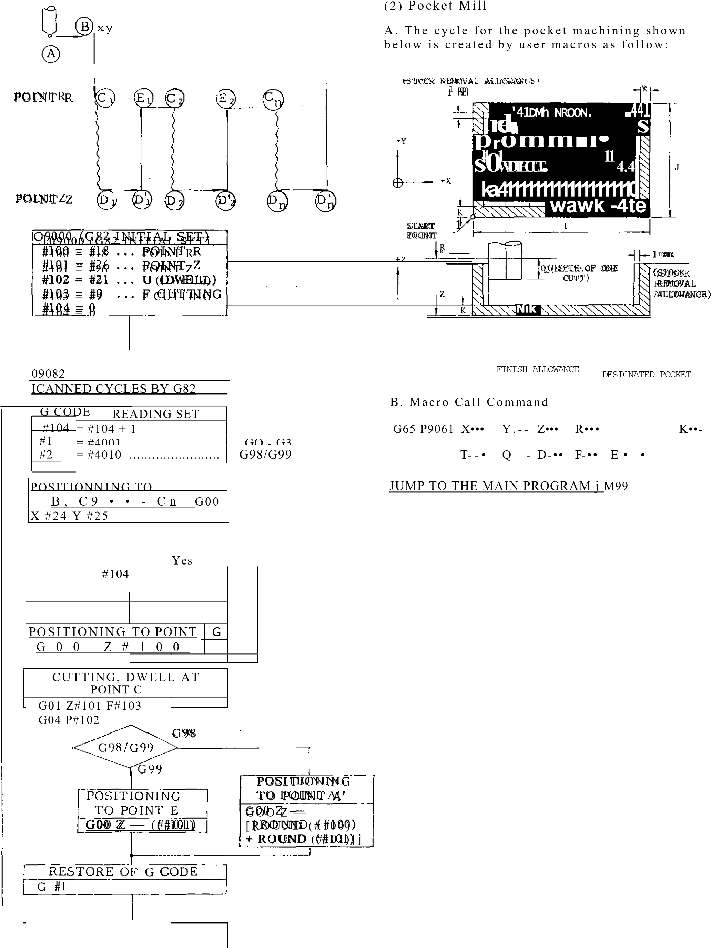

wh e re ,

X, Y: The absolute coordinate values of the start point (the lower left position of the pocket).

Z: The absolute position of the bottom of the pocket.

R: The absolu te po sition o f rap id traverse tool return.

1, J: X - a x is a nd Y-ax is len g th s o f th e p oc ke t (unsigned).

K: Finish allowance (left-over allowance. un-

sig n e d ). De fa u lt v a lu e is 0 .

T: Cut width rate (designated in %).

Cut width = tool radius x

T/100

Q: Z-ax is c ut de pth for e ach time

(unsigned).

D: Tool offset number.

F: Feed rate on XY pl ane.

E: Feed rate at Z-axis cut.

(Tool is fed 4 times as fast

as E up to the point 1 mm to

the preceding cut bottom.)

- 108 -

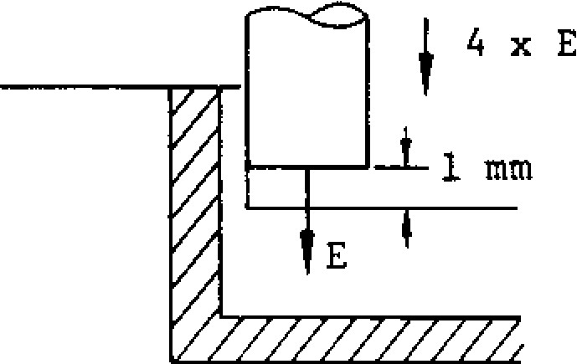

The stock removal allowance (1 mm) inside the finish allowance is all cut by a single operation in the final process as shown below. Then, the tool returns to the start point, completing the cycle.

**~~re=,~~111111,** LEFT-OVER

CONVEX **ott—Reil**

START POINT

STOCK REMOVAL ALLOWANCE

( 1 mm WIDE)

C. User Macro Body

09061 ;

#10 = # [2000 + #7]; • • • Tool radius

#11 = #6 + 1.0 + #10 ;

#12 = #5 - 2 * #11 ;

#13 = 2 * #10 * #20/100 ; • • • Cut width

#14 = FUP [#12/#13] ; • X-axis cut count:-1

#27 = #24 + #11 ; • • • X, Y coordinates of m

#28 = #25 + #11 ; • • • machining start point

#29 = #26 + #6 ; • • • Z-axis coordinates of cut bottom

#30 = #24 + #4 - #11 ;

#15 = #4003 ; • • - Read of G90/G91

G90 ; • • • Absolute command

G00 X#27 Y#28 ;

GOO 2#18 ;

#32 = #18 ; •• • #32 Cut bottom in execution

DO 1;

#32 = #32 - #17 ;

IF [#32 GT#29] GO TO 1 ;

#32 = #29 ;

N1 GO1 Z#32 F#8 ;

GO1 X#30 F#9 ;

#33 = 1 ;

WHILE [#33 LE#14] DO 2 , _______

IF [#33 EQ#14]G0 TO 2 ;

GO1 Y [#28 + #33 * #13] F#9 ;

______ a cut

GO TO 3 ;

loop

N2 GO1 Y [#25 + #5 -#11] ;

N 3 IF [#33 AND 1 EQ GOTO 4 ;

GO1 X#27 ;

GO TO 5;

N4 GO1 X#30 ;

N5 #33 = #33 + 1 ;

END 2 , ____________________________

GOO Z#18 ; IF [#32 LE#29] GO TO 6 ;

G00 X#27 Y#28 ;

GOI Z [#32 + 1.0] F [4 * #81 END 1 ;

N6 #11 = #11 - 1.0 ;

#27 = #27 - 1.0 ;

;

-

#11

#28 = #28 - 1.0 ; Stock

#30 = #30 + 1.0 removal

#31 = #25 + #5

GOO X #27 Y #28 ; cycle

GO1 Z#32 F#8 ;

GO1 X#30 F#9 ; Y #31 ;

X#27 ;

Y#28 ;

G00 Z#18 ; ______________

GOO X#24 Y#25 ; • • • Return to start point

G#15 ; • • • Restore of G90/G91

M99 ;

|  |
| --- |
| **3. PART PROGRAM TAPE CODING** |

**3.1 TAPE CODE**

**3. 1. 1 T A PE C OD E**

With this control, both the EIA and the ISO codes c a n b e u se d .

EIA code: EIA R5-244-A IS O c o d e : IS O 8 4

Table 3.1.1 shows the EIA and ISO punched tape formats.

Before starting programming any machining ope ration s, d ec isio n mu st be ma de a s to th e c od e to be u sed.

**3. 1. 2 EI A / I SO A U T O - SEL EC T**

B e fo re sta rt in g to u se p a rt p ro g ra m ta p e s, th e control must be switched to the same code as the tapes, inaccordance with the procedure for writ ing-setting under 4.3.6 DISPLAY AND WRITING OF SETTING DATA.

When "1" is set with se tting #6001 D6, the con t rol i s a u t o m a t i c a l l y a d a p t e d t o t h e c o d e u s e d fo r t h e p a r t p r o g r a m t a p e . T h e c o n t r o l r e c o g n i z e s t h e

code used when it reads the first EOB code in the label skip mode, and all the subsequent data will be read automatically in that code.

When "0" is set with #6 001D6, the control will not discriminate the code used automatically, and will read all tapes in the code specified by the setting with #6 0 0 0 D7 - That is:

When "0" is set with #6000D7 EIA code

When "1" is set with #6000D7 - ISO code

If the code setting of the control and the coth of th e tan e are differen t, alarm code 015 will be displayed.

N O T E : F o r p u n c h i n g t a p e s , t h e c o d e must be selected by the setting of #6000D7.

**3.2 PROORAMMI NG**

**3. 2.1 PROCESS SHEET**

Pro g ra ms are first d rafted on proc ess sh ee ts.

P r o c e s s s h e e t s s h o u l d b e e a s y t o r e a d a n d to make corrections, and should preferably be c.e sig n e d a n d p re p a re d by th e u se r in c o n fo rmity with the specifications of the NC.

LABEL

PROGRAM NO.

______

I

FOR

EOB

[0

N

x

Y

7

R

Q

L

Q

1

H/D

S

**M**

F ig . 3 .1 E x a m p l e o f Pro c e ss S h e e t

**Table 3.1 Tape Code**

**EIA CODE ISO* 1 rt • ArAr11 ,101** ISO CODE

2 **111**

**EN**8 **f l0MN 6 EMI tin.**  ❑**0**  3 **0a 111111111111111= 0** ■ **M D 0**  6 ©o**00 0** ■

■EME**IN**.1.0NCIOIll **MN** 0 ■**. IIII**0 ■**0** 0**IN**0111111111M=2 0 IMO 0 MONO 0110 0 ■

EMI**N** •1 0 . 0■**0** **.**'  **o**0 ■ 0.1**oN**  **86oMMISMINIMollo o**  11111111011111.11■**01.0 0**111**M**  O O **o AI** ■**M0**  . .

**IMMEM0**

**0 0**  **0E1109 111/ 0 0 0**  **mo 0m o o**  **0 Mom** **o**■ **ba**  **A B NAOMME.**  **MO OMAN°**

■

**No 0 0 am om.. 00E0.00. 0 0**  **D00 IMIIII dIMIIII c D*F*c** ■**0**  **(DM0o m 0 MINm** ■

**MID 0 0 E f** 0 0.

**Ago** ■

**Mc) ollo 0 .** ■ **I m o m m m s m .**

**M**

**M EMOM**■**M 00 .MIM 0 1 0M0O0**   **1111**11■**MoMM01M**°**0**  **M**■**IIE** ■ **a IMI0 MMIIIMM=MIMMM.h =11.1110 0011o o**■ **M.**■ **10il.°1100 00**   **0Cli 0 M IN0O I**■ **I °**❑ **M**

**MOMMOMM**11 **0M M0 00 OME**■**M0 oOOMMIMMEM I0 0NM 0MO 0ED** ■**li 00 0 0 0**

**° =111.**

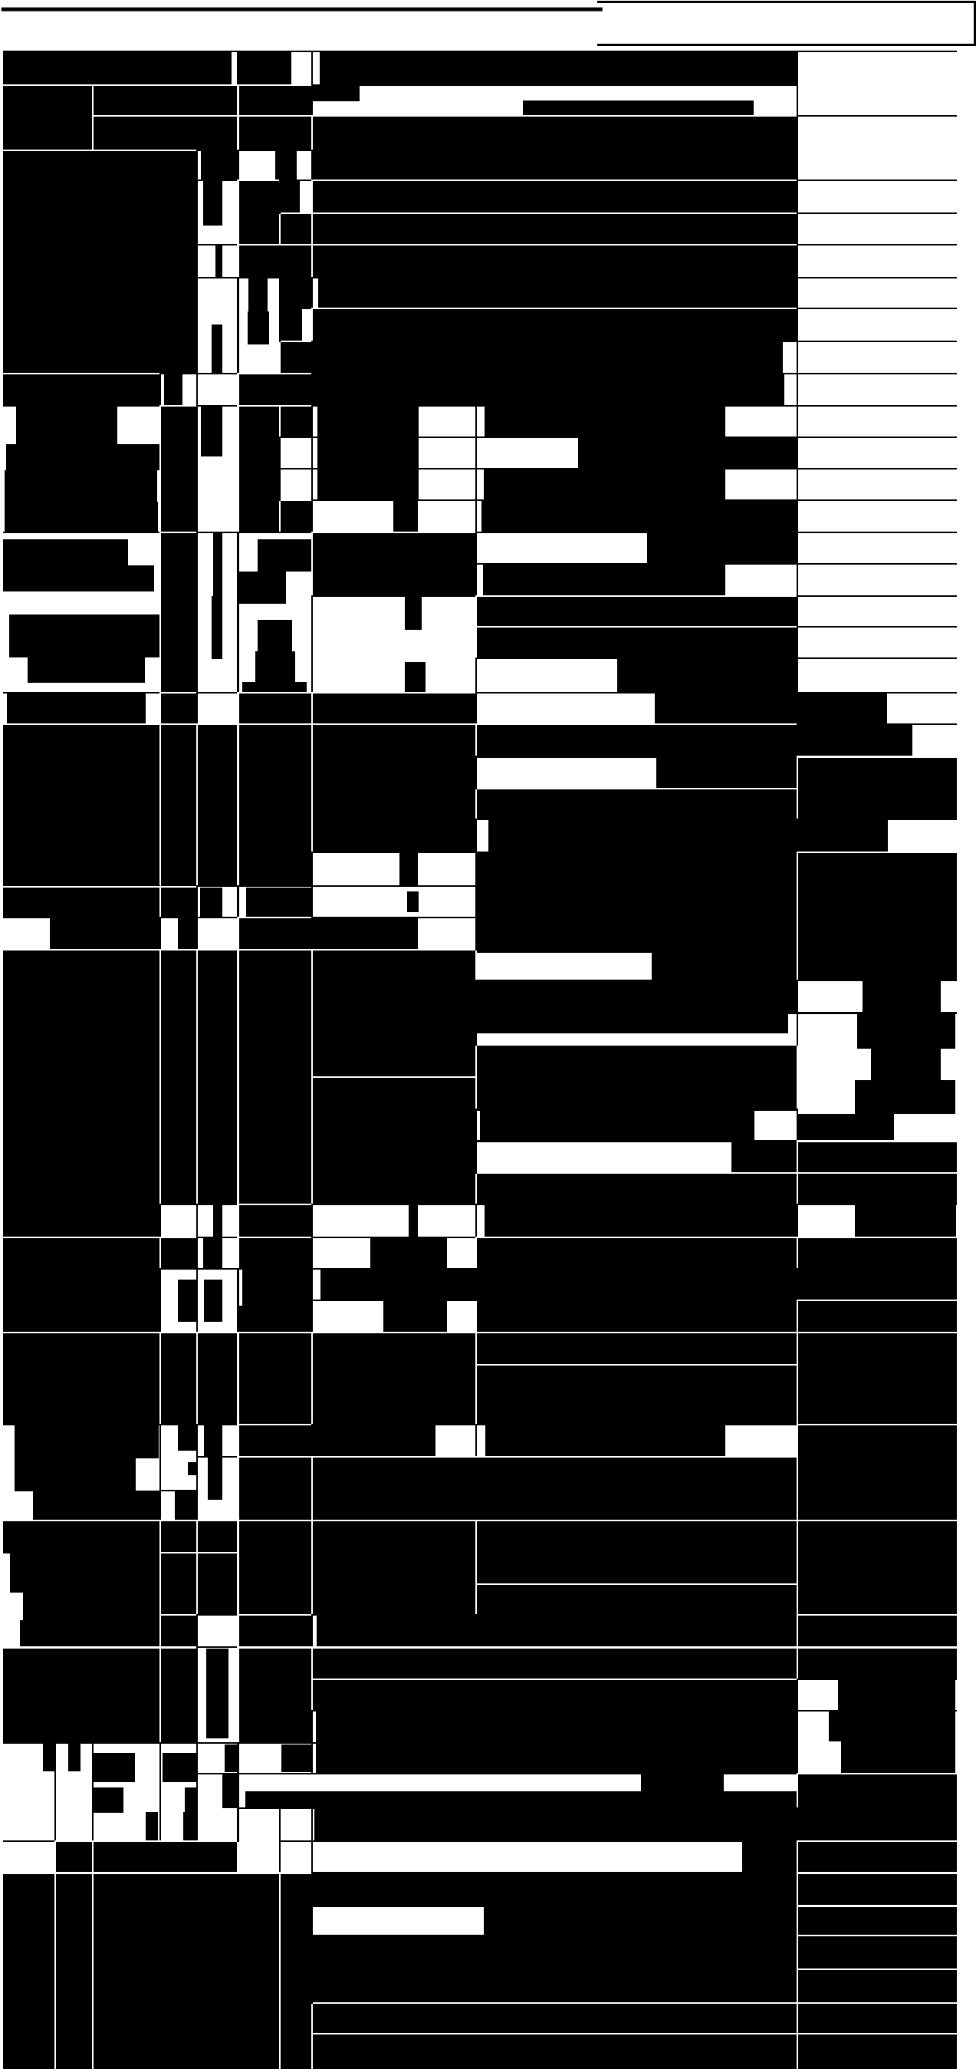**M**■■**O °MO° E**.0■**MOMEM0.**.1**M01CIIIII M10**0**O110** ■**MM0** 0 000**0M**■■■ **M quE =1P**  **II.= Q**s**P** **MMI01.0MO0 ° . 110**■ **1110110II011 011100010 ° .1O**■**0M1000**■ **M00**

**0=2.111**

**IMMIIIM011011**

■**MO**■**MM=**III **OMMO0**° **0 MD0 0**11 **v** oo1 w **V** ■**DEE**000**M=** 0000**° 0**  **011**

**M**

IM 0■ IIIII■**IIMMI MINIM 0**■**El 0**000 **0 MN 0**

**uEEmll Mm0E m0o 00 0 0** ❑**°M** ■**O**O1■**BBlanSTa y bk** NUL**IIMMIMMII** **0 MMM 0OM °M 1.**  **00 MIS ° MEI. . o .Il0**

**u s**  **0. No . z 0**■**00**

■

**0 INIMMINNIM=1MGSP omois**

**ME0MN 0 E 0. m0**❑ **0. 0°mEl Mom 0m0111116 EMCR11ICICIC 1111==I % LF/NL 00 M 0 IN** ■**I0MEM Ma** ■**M 0 00** ■ **MEIN00**

**III 0 °**

**Illo o o o Lc** ■

■**MI**■**M0111IIIE**■**11M11**   **M M**■**MINI1111=** **)**■**MIIIMINIIIIIMMM0 1111111111111111:1 0 III 0 MCMIN 0I=**  **° MR 0a MN oNlo 0 0** o f

**IIM0 0 0 EMI**  **E**  **M litmoMo0**  ■0 **. II**0 MII■ a o/100 1111110M M . o o C 1MMINIIIIIVIIIoo 0 **0**0 **0 0**  o 0o. o0

■**o 111M**■0

• 000 0 0 00 0 **Del DEL 0 0 0 0 0**

0 0 See0 0 Note0 20 # 0 0 0 **All Mark 0NO 0 M0** **0 0** 011 **II II MINI**

**- •** ■**a** ■

**M -**  **\* BIM**■ **c r:_. 111111•_**

**EMIR** ■**$@1111111=1115111111111111M6111 -[ 1111Maillainial111111111111EIN1111111(-2, Nr1111** **MI**

**A ll** ■ **-i‘**

**LCIMEISION511111111111111111111 ME 0** ■

Notes:

1. For characters from # to ?, EIA codes h ave no t been a g r e e d u p o n . I n t h e

present system, for the time being, the above provisional codes are used.

1. EIA code of character # can be designated by the parameter #6017.

|  |  |  |  |  |  |  |
| --- | --- | --- | --- | --- | --- | --- |
| **3. 2. 2 GEN ER AL PA R T PROGR A M F OR M**  Part programs are generally written on tapes in the following formats.   |  |  |  | | --- | --- | --- | | L A B E L I E R C R 0 PROGRAM No  (ISO code) | part program | M30 CR ER | | 11,AR71n, % LF /N L 0 ~~PROGRAM No~~  **A** | part program | M30 LF/NL O |   (EIA code)  **! - EOB** code, or"end of block" code or MO2  --EOR code, or "re wind sto p" code |

Fig . 3.2

To facilitate classification and handling of tapes, any identifying labels may be written at the lead ing end of all part program tapes. Since all data a p pe aring b e fo re th e first EOB c o de are sk ip pe d b y t h e N C r e a d i n g t h e s e t a p e s u s i n g t h e l a b e l skip function, even addresses and function codes n o t spe c ified may b e writte n h ere , an d a lso o u t of -parity cod es may be written .

The EOR (rewind stop) code following the label is the stopping point of rewinding motion which is initiated by a rewind command .

When programs on a part program tape is trans f e r re d in to t h e me mo ry , t h e d a t a b e t we e n th e firs t EO B c o d e , fo llo w ing la b e l sk ip p in g , a n d th e nex t earliest EOR code is transferre d. T h e re fo re , th e E O R c o d e a t th e e n d sh o u ld n o t

be omitted.

3 . 2 . 3 **C A U T I ON S I N P R OG R A M M I N G**

One block ends with an EOB code.

The EOB code is CR in EIA, and LF/NL in ISO. However, in the example programs in this man u a l , " : " i s u s e d t o r e p r e s e n t E O B c o d e s t o make recognition easy.

One part program ends with a block containing MO2 (end of program) or M30 (end of tape).

Wh en an MO2 o r M3 0 c od e is re ad , th e NC re sets itself or rewind the tape (or the memory), depen ding on th e design of the machine under c o n tro l. F o r th is, re fe r to th e ma n u a l p re p a re d by the machine tool builder.

D o n o t u s e a n y c h a r a c t e r s o t h e r t h a n t h e a d d r e s s c h a ra c t e r s a n d t h e f u n c t i o n c o d e c h a r acters specified in 2.1.2 ADDRE SS AND FUNCTION CHARACTERS.

When the tape vertical parity check (TV check) f u n c t i o n i s t o b e u s e d , th e n u m b e r o f c h a r a c t e r s i n e a c h b lo c k mu st b e m a d e e v e n w it h a n S P (space ) code .

D i s r e g a r d c o d e s s u c h a s B S , T a b , S P , U C , LC, and Del should be avoided in the sign.11 - c a n t d a ta a re a , if u n n e c e ssa ry .

The maximum number of characters that can be w r i t t e n i n a b l o c k i s 1 2 8 , n o t c o u n t in g d i s re g a rd c h a ra c te rs su c h a s De l.

N 12 G O O X4000 z200000 SP

1 - 2 0 c h a r a c t e r s e v e n

1. Evening up number of characters for TV c h e c k (o d d is tre a te d a s e rro r)

N 0058 G03 X.. . Z. M . . F . . . ;

L 128 charac ters max./block



1. Maximum number of effective characters th at ca n be written in a blo ck

F ig . 3 .3

**3.2.4 TV CHECK (TAPE VERTICAL RARITY**

**CHECK)**

**W hen th e tape s are to be checked for v ertica l parity, programs must be so made that each block (including EOB) contains even number of charac ters. Normally, SP codes are used to make the number of characters even.**

**The TV check function is turned on and off by the setting function. While the TV check func tion is on, all blocks containing odd number of characters are regarded as errors.**

**Setting No.: #6000D6 = 0** • **TV check off**

**#6000D6 = 1 •** • **• TV check on**

**3.3 PART PROGRAM TAPE PUNCHING**

**3.3.1 PAPER TAPE SELECT**

**For part program tapes, eight -channel paper tapes for computers conforming to JIS C6243 (width:**

**25.4 ±0.08 mm, thickness: 0.108 mm) are used.**

**The color should be black or gray. Tapes with high transparency tend to cause read ing errors, and should not be used.**

**3.3.2 NC TAPE PUNCH**

**Part programs written on process sheets are punched in EIA or ISO codes in paper tape with a tape puncher.**

**A part program tape should be provided with a proper length of feed hole part at the leading and the trailing ends. For a tape reader using 6" reels, the feed hole length should be at least 70 cm, and for a tape reader using 8" reels, it should be at least 1 m.**

**3.3.3 N C T A P E C H E C K**

**Punched part program tapes can be checked by . an NC with the following functions. Machine lock**

* **M function lock**
* **D ry run**
* **Sin gle b lock operat ion**

**3.4 PART PROGRAM TAPE HANDLING**

**3.4.1 SPLING NC TAPE**

**To join part program tapes, the two ends should be placed end to end without overlapping and without a space, and a proper length of splice t a p e s h o u l d b e p a s t e d o n o n e s i d e . ( a p p r o x .**

**0.08 mm in thickness) Splice tapes are available in the fully perforated tyke and in the type with which only the feed holes are punched, but** t h e f o r m e r **is more convenient. After splicing, the tape should be checked for correct alignment of the feed holes before use. Do not use rigid in dustrial adhesive, and do not make the joint too thick, as these conditions are conductive to jamming troubles.**

**NC TAPE**

**0 0 0 0 0 0 0 0 0 0 0 0**

**0 0 0 0 0 0 0 0 0 0 0 0**

**0 0 0 0 0 0 0 0 0 0 0 0** 0 0 0 0 0 0 **0 0 0 0 0 0 0 0 0 0 0 0** 000



**0 0 0 0 0 0 0 0 0 0 0 0**

**0 0 0 0 0 0 0 0 0 . 6 0**

**0 0 0 0 0 0 0 0 0 0 0 00 0 0 0 0 0 0 0 0 0 0 0 'Example**

|  |  |
| --- | --- |
|  |  |
| **A P PROX .** |
| **30 MK** |

 **0 0 0 0 0 0 0 0 0 0 0 0 NBC SPLICE TAPE**

**SPLICE 8-CHANNEL**

**TAPE FULLY PERFORATED**

**`SILVER**

**Fig. 3.4 Splicing Part Program Tape**

**3.4.2 KEEPING NC TAPE**

**Part program tapes should be stored in** a c l e a n a re a , **free of contaminants and humidity. Do** n o t hand le pa rt p rogra m tapes wearing glov es con taminated with oil or cutting fluid.

G e n e r a l l y , p r o p e r l y m a i n t a i n e d p a r t p r o g r a m tapes can last at least 300 cycles, with one cycle consisting of one reading and one rewinding pass.

**- 113 -**

1. **NC OPERATOR'S STATION WITH CRT CHARACTER DISPLAY** 
   1. **PUSHBUTTONS, LAMPS AND KEYS**

Fig. 4.1 shows an overall view of NC operator's p a n e l with CRT d i sp la y. T h e n a me s a n d fu n c tions of operator devices are as follows.

F ig . 4 .1 S tan da rd NC Ope rato r's. S tation with CRT Ch arac ter Disp la y

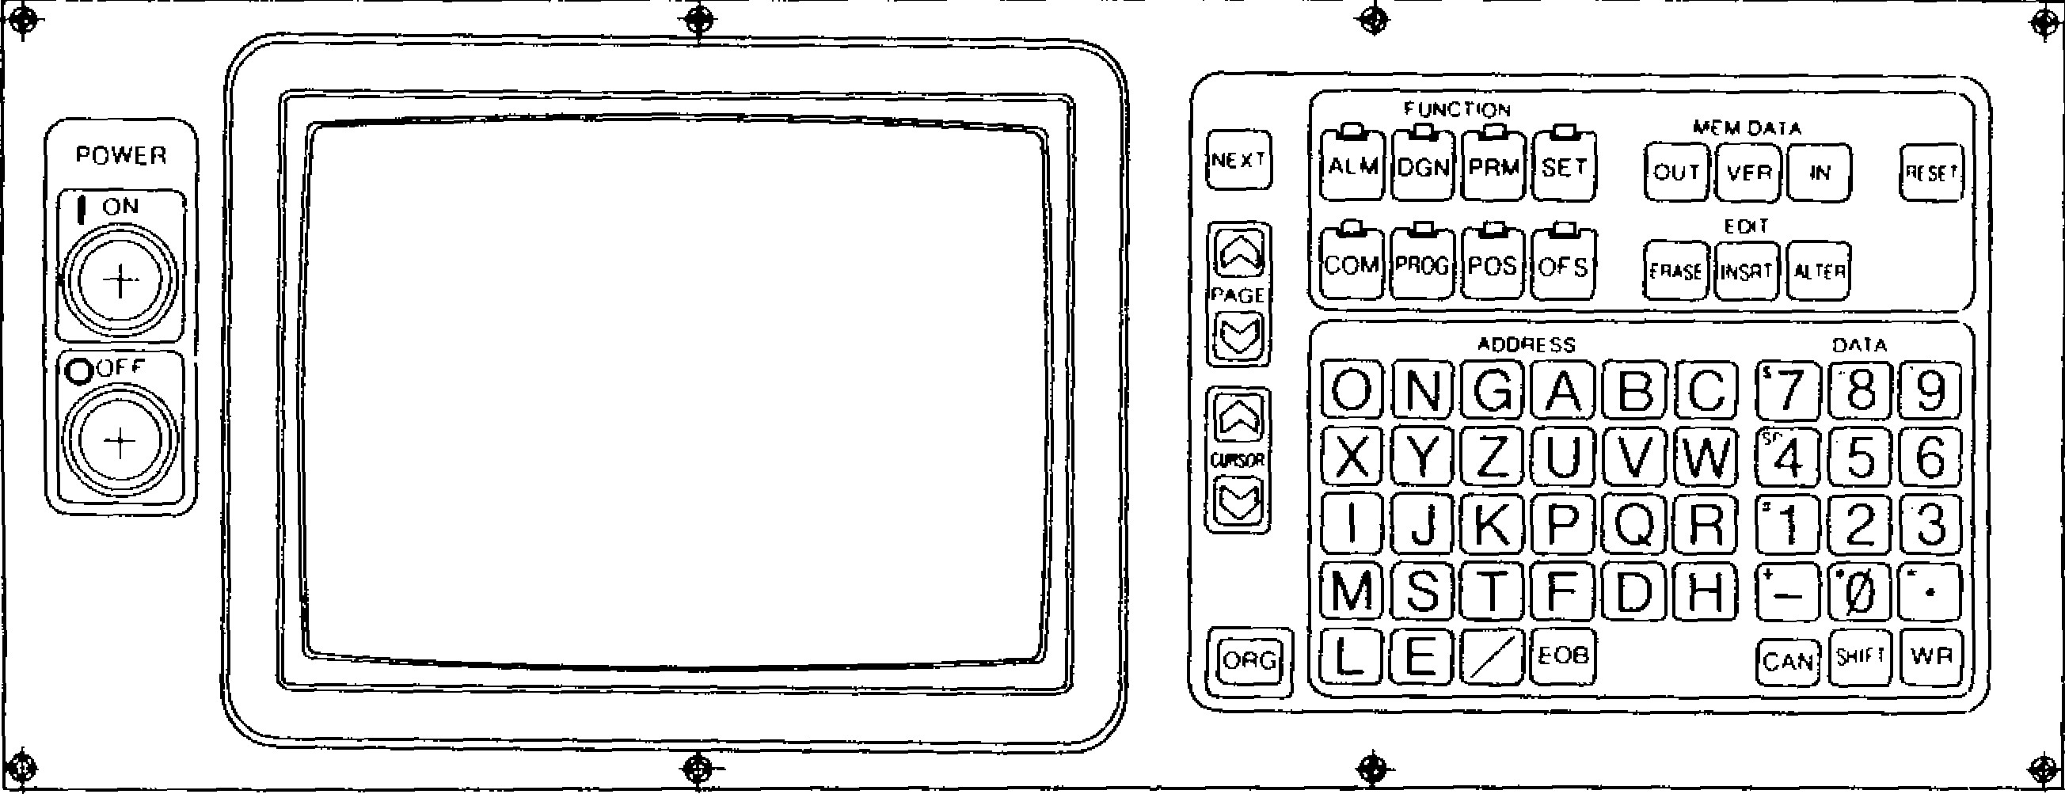

Om PROG

rira"

-

•

**P OS**

DATA

ADDRESS

J

1

P

)

'11

)

(

K

rv

i

*0

'

S

)

{

**E**

IL]

**CAN**

**(**

**)**

SNIT

[

Ti

4

E LAC

noN

**ALM DON PRtA SET**

MEM DATA

VER371;11

101.11{

_______

*II*

EDIT

EITTSPTI

LBJ

[

c

)

r7)

[8

1

(

vi

z

(

)

U

)

(

vj

*wi*

*t*

s

1

}

4

(51

161

44

-

[

NEXT

T

o

PAGE

s

-

POWER

°

0

Fr

L

**4.1.1 POWER ON /OFF PUSHBUTTONS**

**POWER ON pushbutton**

**To turn on the power for the control: Depress the pushbutton first to turn on the control power and depress it again to turn on the servo power. Push this button to recover the servo power after an emergency stop.**

• **POWER OFF pushbutton**

**To turn off the power for the control: Depress it to turn off both the servo and control powers.**

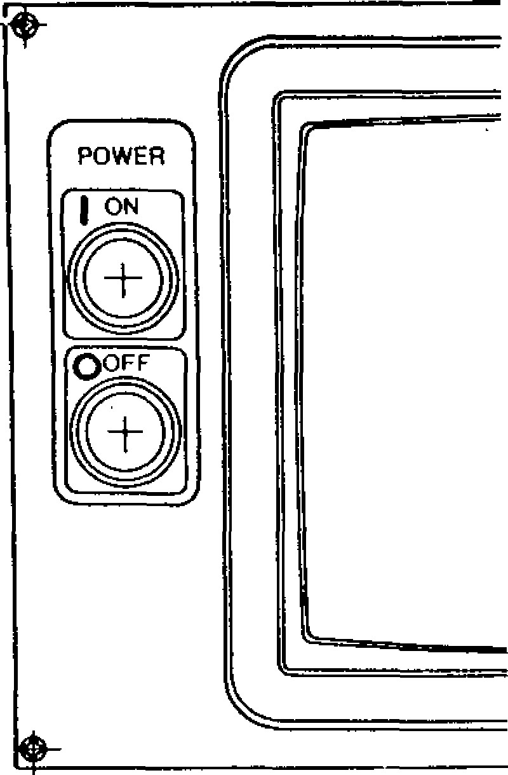

**Fig. 4.2**

**4.1.2 CRT CHARACTER DISPLAY**

**According to each operation, this display indi cates the alpha-numerical data in a regular size (1x1)and, triple -size (3x3) of the regular size.**

**B r a u n t u b e s i z e : 9 i n c h e s**

**Maximum number of characters:**

**32 characters x 16 lines =**

**512 characters (at regular size)**

**Indicating characters: N u merals -** [0 **through [91 , U ,** E.]

**Alphabetic characters -** L@ **through 2**

**Special code - (E0 B), !II (sla sh ), etc.**

**32**

**CHARACTERS**

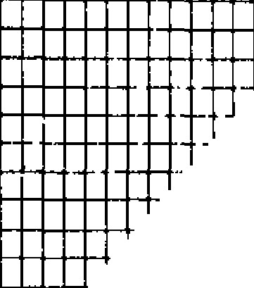

**Fig. 4.3 Braun Tube**

**4.1.3 FUNCTION SELECT KEYS**

**The key selects one of eight functions for the operation of the display and MD1. Pushing a key makes it effective and light up.**

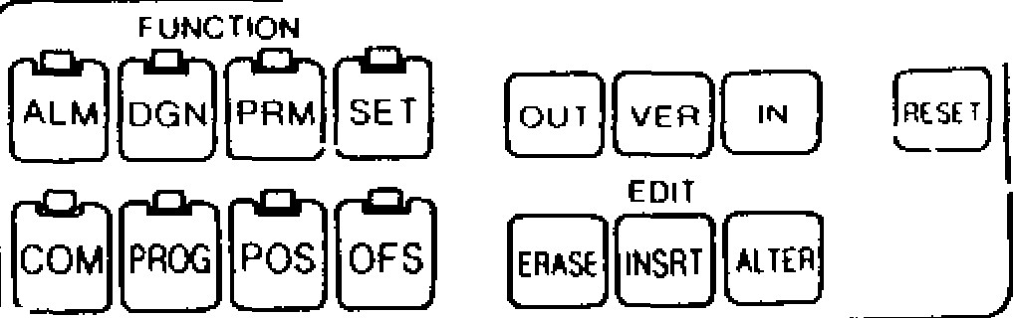

**met.4**

**DATA**

**NEXT**

I i

**7**

**-**

**S**

**-**

**M7:7) r**

**-**

**F1 nA**

**-**

**1**

**(7"ln r**

**raTT**

**ADDRESS**

**DMA**

•

**Fig. 4.4**

**IALM I**

**(**

**Alarm )**

**key:**

**PAGE**

**Select this key for display of alarm and status c o de s. Th e f un ct i on b eco m e s e ff ec t iv e wh en the power is turned on or an alarm occurs.**

[ DC N I (Dia g n o sis ) k e y :

Select this key for display of input/output signal status.

IPRM j (Parameter) key:

Select this key for display or writing -in of parame ters.

!SET] ( S e t t i n g ) k e y :

Select this key for display or writing -in of se ttin g data.

~COMj (Command) key:

Select this key for display or writing -in (MDI) of the command data for automatic operation. 1PROGI (Prog ram) key :

Select this key for display or writing -in of a p a rt p ro g ra m.

[FOS] (Position) key:

Select this key for display of various current positions.

0'5] ( O f f s e t ) k e y :

Select this key for display or writing -in of tool offset values.

**4.1.4 ADDRESS KEYS**

T h e se k e y s a re to d e s ig na te a n a d d re ss c h a ra c te r when writing in va rious data . N o te : S p e c ia l c h a ra c te rs

"A GEI'LL -3! lleolipHoGirosirFsj [ERASERI.NSFITJIALTE1

ADDRESS DATA

CURSOR x N (6z) [[uA 1 [Bv) [wC)] r4i57 F61 r9)(6[3] iii [j] K P A I [2) IM Is] T F ID) H r0:

[(1

10

(ORG) F [/1 Ecei SHIRT)

g (Slash) key: For an optional block skip

command.

[EDS] (EOB) key: For the block end command. On the CRT display, ";" is displayed instead of

"EOB."

Fig. 4.5 T h e s e k e y s c o n s i s t o f 1 5 k e y s in to ta l, su c h a s 1-01

**4.1.5 DATA KEYS**

-

116

-

through 1E, D (minus) D [C.K1W1

.51-11.F. T1

1 WR1

, and can be used for writing -in of such all numeral values as tool offset value setting data, parameter data, and so on, in addition to command value.

For input of numerical data

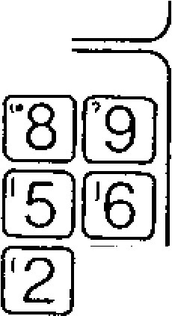

**DATA**

t

3

]

C

)

(

L

\

M

[

•

0]

n

)

[

CAN

SHIFT

WR)

Note:

____

to

?

9

key

E

(

minus)

key

[

17

)

isP4

El (decimal point) key: For input of decimal poit ICANj (cancellation) key:

For cancellation of the numeric value or address d a t a e r ro n e o u s l y k e y e d . lw R I (write) key:

Fo r s t o ring ad dre ss d a ta b y a dd ress k ey s a nd da ta key s in to bu ffer sto rage .

[SHIFT' (shift) key:

De S H I F T k e y a f t e r d e p r e s s i n g 0 t o

L9 j, E or fl key makes the display turn into to 171 , 111 **BE** which are written on the u p p e r le f t c o r n e r o t h e k e y s . T h e s e s p e c i a l c h a r a c t e r s a r e u s e d i n u s e r m a c r o .

Fig . 4 .6

**4.1.6 NEXT KEY**

The NEXT key is used for special purpose and expanding function in display or writing data.

Writing of optional in EDIT mode.

* For other special purpose and expanding func tion.

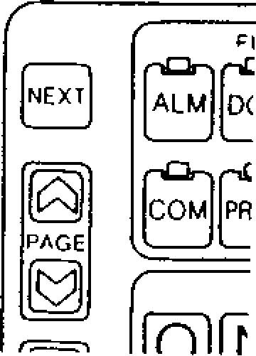

F ig . 4 .7

|  |  |
| --- | --- |
| 4.1.7 PAGE KEYS | **4 . 1 . 9 O R G ( O R I G I N ) K E Y S** |
| The PAGE key is used for display the next page | The ORG **key is used to** set the current position |
| or the previous page when CRT display is re | **of** the machine tool as the origin of the reference |
| garded as page. | coordinate system. |
| For example, when a bundle of tool offset values | The origin setting can be made for each axis. |
| are displayed by OFS key, this key is pushed to | The reference coordinate system means the coor- |
| display the next bundle of tool offset values, | dinate system which is set by G92 command or |
| which just looks like opening the pages of a book. | the automatic coordinate system setting. |
| D e p r e s s i n g key displays the next page. | ORG key is used for the following operation. Reset of current position (UNIVERSAL, EXTER- |
| Depressing PAGE key displays the previous page. • Reset of tool offset values Keeping the PAGE key depressed makes the page step automatically forward or backward.  **4.1.8 CURSOR KEYS**  The CURSOR control key is used to move the cursor. For example, when a page of parameter data are displayed by PRM key.  • Depressing CURSOR key moves the cursor forward. | NAL)  • Reset of operation time  **4. 1.10 EDIT K EYS**  These keys are for editing a stored part program.  ERASE key: Used for erasure of data in storage.  Used for insertion of data in memory. INSRT key:  ALTER key: Used for alteration of data in memory. |

* Depressing CURSOR

forward. key moves the cursor

|  |  |  |  |
| --- | --- | --- | --- |
| • Keeping the cursor control key depressed makes the cursor move automatically forward or backward. | SET | **MEM DATA**  **OUT VER [ IN**  **EDIT** | **RESET** |

(ERASE) **INSATI ALTER**

Fig . 4.9

**4 . 1 . 1 1 M EM D A T A (M E M O R Y D A T A ) K E Y S**

TAPE KEYs are to start the tape operation except in the automatic operation mode. They are effective only in the EDT mode.

-

117

-



[

ORG

]

to

OOC

I

Fig. 4.8

OUT key

This key is to start outputting various data in memory through data I/O interface.

IN key

This key is to start storing various data into memory through tape reader or data I/0 interface.

* VER key

This key is to start verifying between memory data and punched tape data.

4.1.12 RES ET KEY

T h is k e y re se ts th e c o n tro l.

**JA** J

IRE SE T)

**TA [ ___**

**IT**

**[ALTER**

**DATA IFC717-Vil**

Fig. 4.10

Operations to be executed by this RESET key are:

Move command cancel

Buffer register clear

* Alarm code release if the cause is eliminated
* Tool offset cancel
* Auxiliary function cancel • Label skip function ON

Memory pointer rewind

Sequence number reset

RST signal transmission

G code of A group

Refer to 2.9.1 LIST OF G CODES AND GROUPS. The following will not be affected by operating the RESET key.

Current position values of each axis.

- F commands

* S. T and B commands
* Tool offset values, setting data, parameter data

NOTE: Depressing the RESET key or the re mote reset pushbutton is defined as "Reset op eration" in this manual.

118

-

These switches are mounted above the tape re a d e r.

4.1.13 TAPE FEED AND SYSTEM NO. SWITCHES

* TAPE FEED switch

This is a switch to wind and rewind the tape manua lly. Setting the switch to F (forward) c a uses the tap e to fee d . T o re wind the tap e . s e t t h e s w i t c h t o R ( r e v e r s e ) . T h i s s w i t c h is effective, either manually or automatically.

Fig. 4.11

•

SYSTEM NO. switch

ki ,Y

,

TEM

PARAMETER

1

2

LOAD

3

***4***

TEST 101

E

0

TAPE

FEED

■

0

■

0

0

0



Set the switch at "0 11 during the usual operatio n . F u n c tio n s o f its e a ch se t tin g a re a s

follows.

"0": SYST EM

For usual operation. Writing parameters Is p re v e n te d .

"1": PARAMETER

To write parameters. At this position, the Cycle Sta rt is p revented.

" 3 " : L O A D

To store the maintenance tape into the control.

" 4 " : T E S T ( 0 )

The usual operation is similar to case of 110" SYSTEM. Self-diagnostics of the memory con te n ts a n d c h e c k in g o f re fe re n c e ze ro re tu rn position are omitted.

|  |  |
| --- | --- |
| **4.2 POWER ON/OFF OPERATION**  **Li. 2.1 TURNING ON POWER**  **Check the machine before turning on power, re ferring to the machine tool builder's manual for details. Operations after completion of preinspec tions are as follows.**  • **Depress the POWER ON pushbutton to turn on the control power. The internal timer will be read in about two seconds. Then the servo power is ready for turning on, which is shown by alarm code "310."** | **1 4.2.2 TURNING OFF POWER**  **Depressing the POWER OFF pushbutton causes both the servo and control powers to be turned off simultaneously. However, for more stable operation, use the following procedure.**  **First depress the EMERGENCY STOP push button to cut off the servo power. The NRD (NC READY) signal is interrupted, which usually results in turning the machine power, too.**  • **Depress the. POWER OFF pushbutton to cut off the control power.** |
| **Depress the POWER ON pushbutton again to turn on** the servo **power. The NRD (NC READ Y) signal is sent out when the NC power is normally supplied.** | **EMERGENCY**  **STOP**  **POWER OFF** |
| **When the NRD signal turns on the machine power, and the MRD (MACHINE READY) signal returns back to the control, the READY lamp will be lit.** | **CONTROL POWER**  **CONTROL READY** |

**SERVO POWER**

|  |  |
| --- | --- |
|  |  |
| **READY LAMP** |
|  |

**POWER ON I POWER ON CONTROL POWER**

**Fig. 4.13 Sequence of Turning off Operation**

**NRD (NC READY)**

**MACHINE POWER**

**MRD (MACHINE READY)**

**READY LAMP**

**ALARM CODE**

**BLANK**

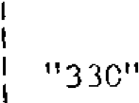

**NRD (NC READY)**

**NRD (NC READY)**

**MACHINE POWER**

**SERVO POWER**

**APPROX.**

**2 SECONDS**

**MRD (MACHINE READY)**

**ALARM CODE "310" '2801 BLANK**

**Fig . 4 .12 Sequ ence o f Turn ing on Op eration**

4.2.3 **REMOTE POWER ON /OFF PUSHBUTTONS** **4.3 DISPLAY AND WRITING OPERATION**

Connect the power ON/OFF pushbuttons to EON, 4.3.1 CONSTANT DISPLAYEOF and COM terminals on the control panel as shown below. Then the remote turning ON/OFF The following display is made on both the top o p eration c an b e ma de 'e x a ctly th e sa me as with and bottom on the displayed picture of CRT, the POWER ON/OFF pushbuttons. irrespective of the FUNCTION key currently

selected.

***rASNAC*** MACHINE Function message •

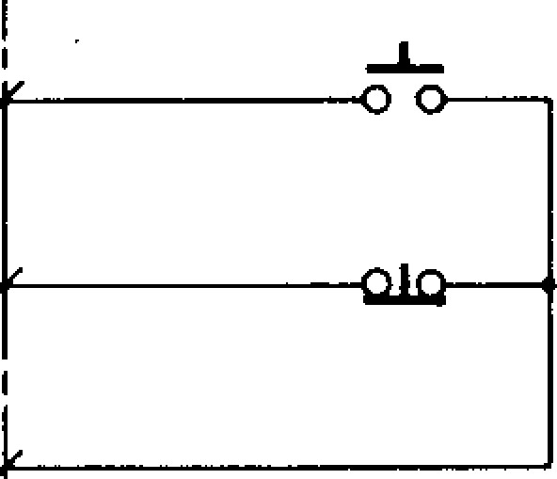Anyone of the following eight function messages corresponding to the function key is displayed at the top of CRT display.

REMOTE

EON OFF BUTTON ALARM PROGRAM

(TU01-24) DIAGNOSIS POSITION

REMOTE PARAMETER OFFSET

EOF SETTING

ON BUTTON

(TU01-25) COMMAND

COM

(TU01-26)

F ig . 4 .1 4 Co n n e c tio n s o f Re mo te

ON /OFF Pushbuttons

FUNCTION MESSAGE [ ALARM

COMMAND

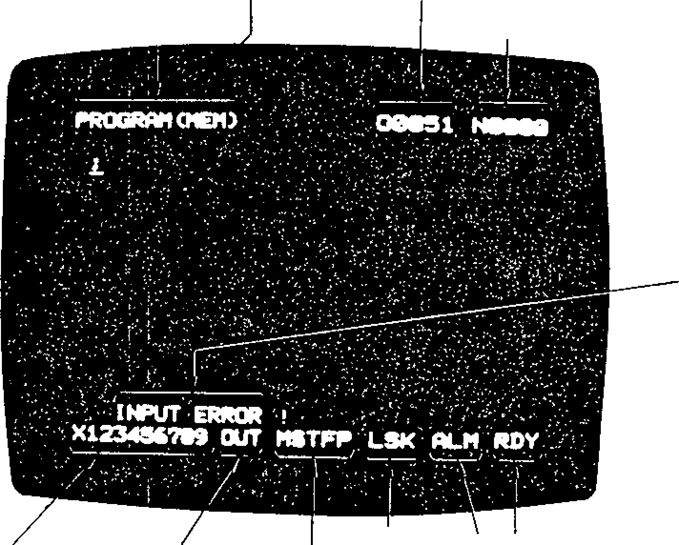

DIAGNOSIS

PROGRAM [MDI

]

PROGRAM NUMBER

SEOUENCE NUMBER

LIGHT ERROR

ALARM DISPLAY

BUFFER

LABEL

SKIP

DISPLAY

BUF

LSK

MST

-

FW DWELL, FEED

DISPLAY ( FLICKERING)

M,

S , T, F AND P

I_

DWELL

READY STATE DISPLAYED

WHEN SYSTEM IS READY

RDY

KEY INC IN DATA

I/O

OR

EDITING

DISPLAY

)

(

FLICKERING

IN

VER

OUT

AS

ALT

ALARM DISPLAY

ALARM OR BATTERY FAILURE IS

DISPLAYED (FLICKERING)

f ALM]

A /B

BAT

Fig. 4.15

-

120

-

Program No.

0 and 4 digits of program No. under execution is constantly displayed at the top of CRT dis play irrespectively of function key.

Sequence No.

N and 4 digits of program No. under execution is constantly displayed at the top of CRT dis play irrespectively of function key.

Display of keying data

Up to 10 characters of keyed in data can be displayed at one time. The data is processed by using ERASE key, INSRT key, ALTER key, etc.

• Display of I/O and editing (flickering)

The following messages are flickerlingly displayed during loading of punched tape, address search or edition.

|  |  |
| --- | --- |
| "IN" | loading tape |
| "VER" | verifying tape |
| "OUT" | p u n c h in g ta p e out searching address |
| "ALT" | altering data in EDIT mode |
| "INS" | insearting data in EDIT mode |
| "ERS" | erasing data in EDIT mode |

Display of MST-FIN signal waiting, dwelling and feeding waiting FIN signal of M command waiting FIN signal of S command waiting FIN signal of T command

feeding

|  |  |
| --- | --- |
|  | "R" is displayed at rapid traverse |
| - • •  "DWELL" - | loading tape dwelling |

M, S, T, F and P are displayed independently each other.

Display of the state of buffer full and label skip

"BUF" displayed at completion of advanced reading

"LS K" • displayed at label skip on

Display of alarm (flickering)

Alarm continues to be displayed flickeringly until the cause is removed and reset operation is made.

"ALM" • - • indicates alarm state occuring

"BAT" indicates battery alarm occuring

"A /B" • in d ic a te s b o th o f a la rm a n d battery alarm occuring

Display of ready state

"RDY" • • ind icates the syste m is normal and the control is operable

Display of light errors (flickering)

T h e messages shown below indicate light er rors which occur in keying or searching op eration. Differing from the alarm codes, t h e s e e rro r me ssag es are c le a re d by d e pressin g s o m e k e y . ( G e n e r a l l y C A N key)

"INPUT ERROR!" • • • Format error of keyed -in data

"ALREADY IN • • • The same number of part program has been stored already.

"EDIT LOCK ON!" Editing operation is made

* •with Edit Lock on.
* P a r t p r o g r a m to b e st o r e d is beyond memory capacity.

"MEMORY OVER!" • •

* •

"PROGRAM OVER!" Registered number of part program is beyond 99 (basic) or 199 (option).

"NOT FOUND!" • Desired data has not been

located.

"BREAK POINT!" • • • Break point occurs

4.3.2 **D I SPL A Y OF C OMMA N D D A TA**

1. Depress COM key.

Anyone of the following th re e d ig i ts a p p e a rs.

* 1. Command data (COMMAND)
  2. Repetition number of su bprogram

**(SUB PROC.** NESTING)

* 1. State of tool offset (COMMAND 1OFFSETi)

1. The a bove d isplay

|  |  |  |
| --- | --- | --- |
| PAGE  4- | or | PAGE |

steps forward or key

back ward by depressing one by one.

- 121 -

4.3.2.1 COMMAND DATA DISPLAY

T h e d isp la y sh o ws th e blo c k d a ta o f u n d e r e x e c u tion or just before execution in which compensation c a lc u la tio n s h a v e b e e n c o mp le te d . T h e c o n d itio ns of the data to be displayed is as follows.

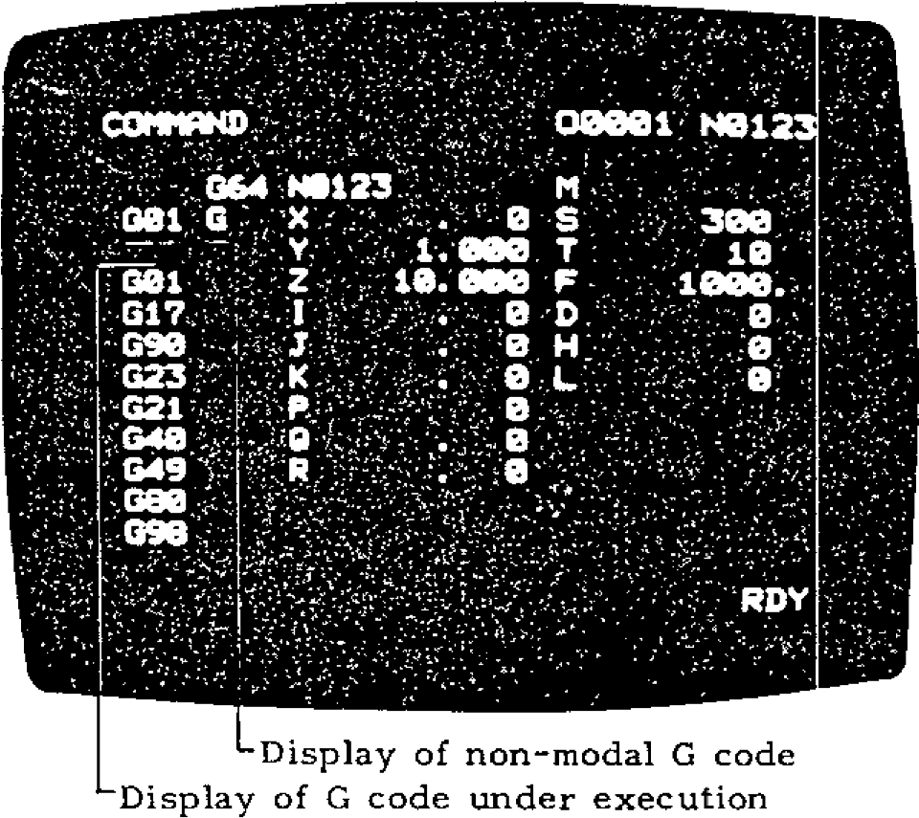

Display of non

-

modal G code

Display of G code under execution

1. The data shows the contents of the active register during an automatic operation or a feed hold.
2. While the control is stopped at a block end, th e c on te n ts of th e b uffer reg iste r a re d is played. If the b uffer reg ister b lank (BUF is not displayed), the contents of the just exe cu ted b lock a re displaye d.
3. In the MDI operation, the current block data a re d isp la ye d a fte r c yc le is in d ic a te d.

4,3.2.2 DISPLAY OF REMAINING MUNBER OF

REPETITIONS OF SUBPROGRAM

(SUB PROG. NESTING)

The remaining number of repetitions of a sub pro gra m is displayed .

Subprogram

Main

Program 1st level 2nd level 3rd level

|  |  |  |  |  |  |  |  |
| --- | --- | --- | --- | --- | --- | --- | --- |
| |  | | --- | | 0001 - ;  P1000 L3 M98  N070 M30 ; | | |  | | --- | | 01000 ;  P2000 L5 M98 ;  N150 M99 ; | | |  | | --- | | 02000 ;  P3000 L10 M98 ;  N260 M99 ; | | |  | | --- | | 0 3000 ;  Executing block  N340 M99 ; | |

The subprog ra m has executed th e 3rd leve l twice and entered in to the exe cution o f 3rd time of the 3rd level.

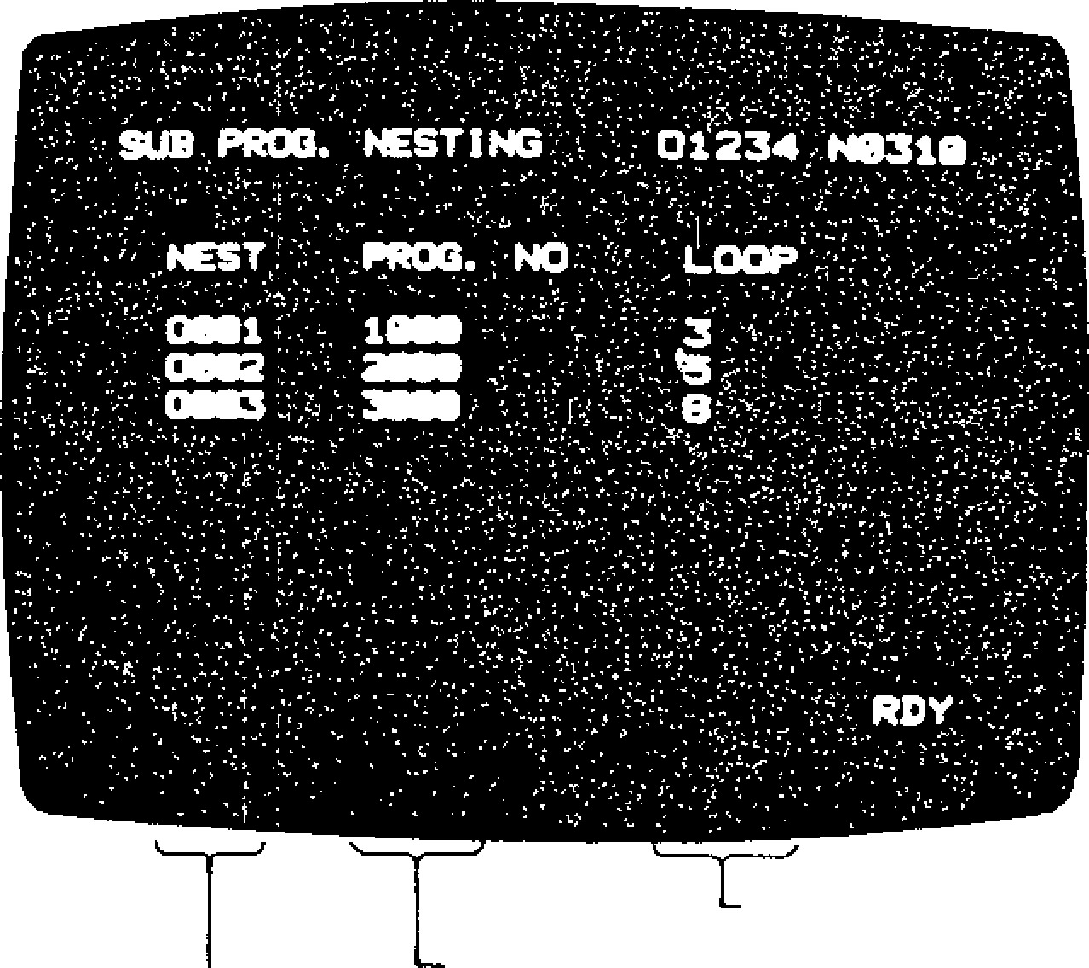Remaining number of repetitions Sequence number of subprogram start

—Subprogram level (up to 4)

Fig. 4.16 Example of SUB FROG. NESTING

- 122 -

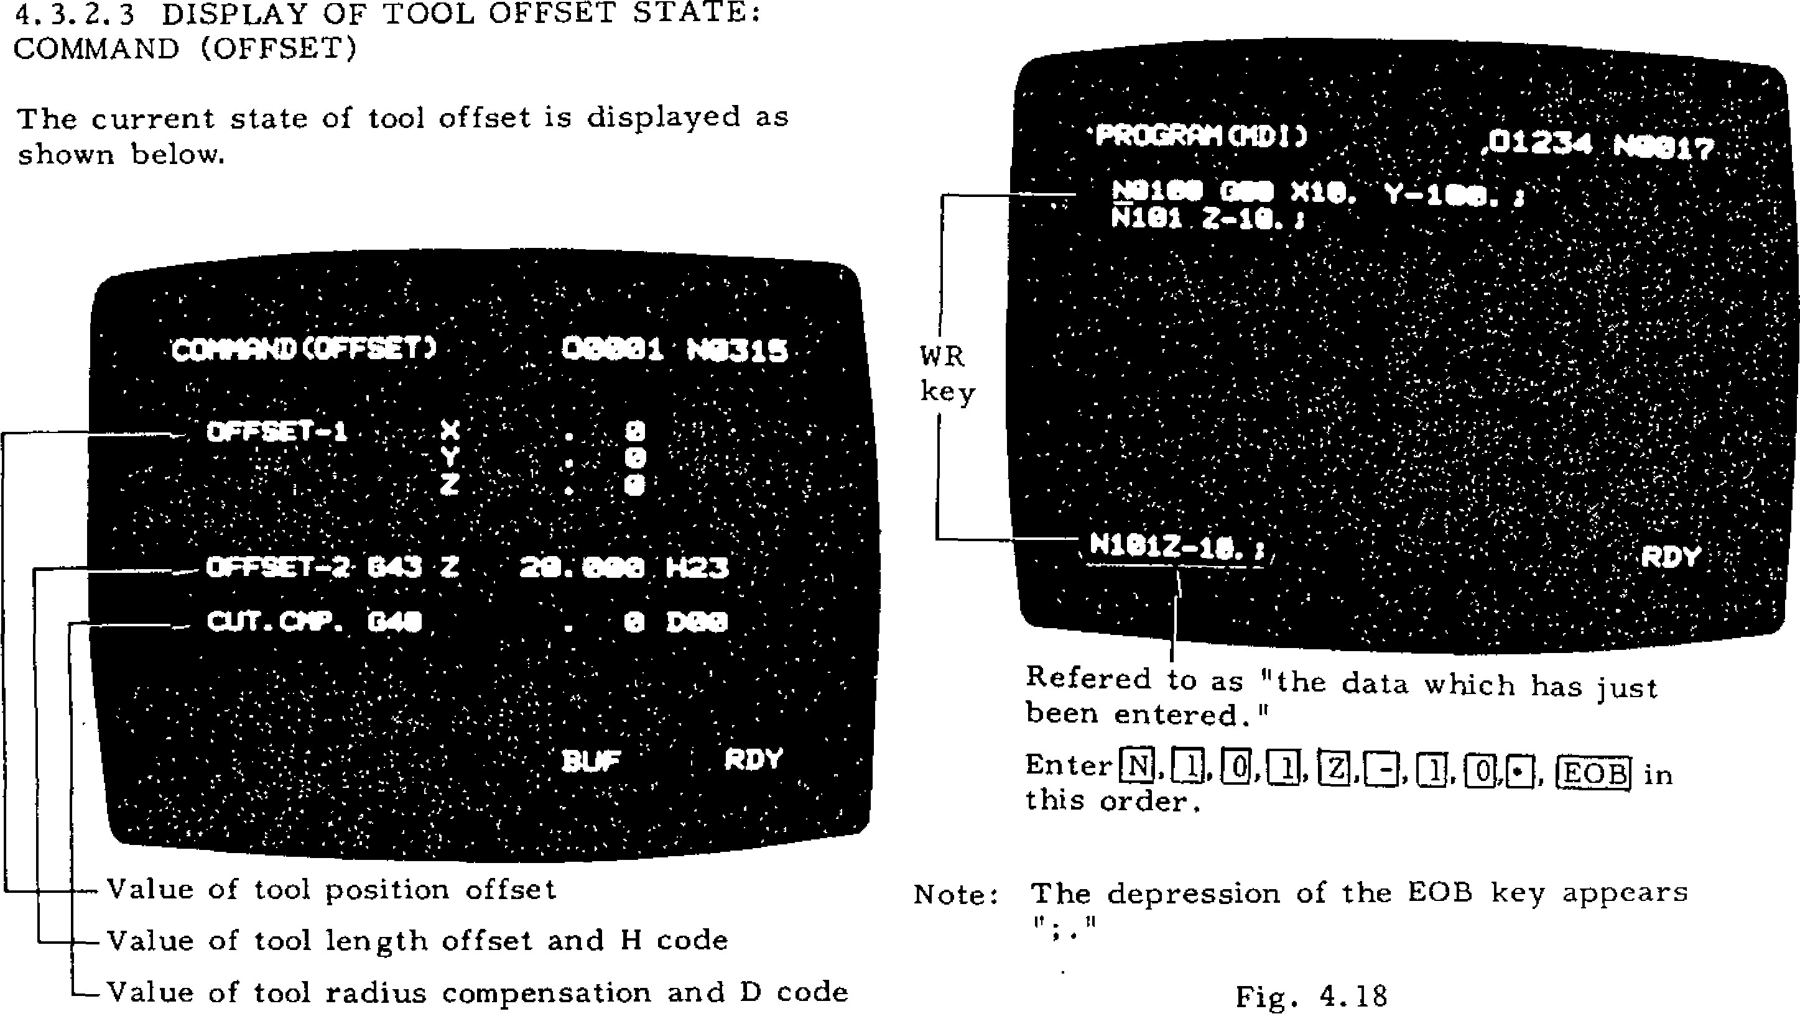

0

**13**

Enter

this order.

EOBJ

[

0

in

4.3.2.3

DISPLAY OF TOOL OFFSET STATE:

COMMAND (OFFSET)

The current state of tool offset is displayed as

shown below.

Refered to as "the

data which has just

been entered."

[1

,0, Eli

__

Value of tool position offset

_

Value of tool length offset and

H

code

—

Value of tool radius compensation and D code

Note: The depression of the

EOB key appears

i

f

.

11

Fig. 4.18

NOT E: Fun ction COM is exc lusiv ely u sed for display. Data cannot be written under function COM. Select function FROG. to write block data.

Fig . 4 .17 Exa mp le of display of tool offset state

**4. 3.3 WRITING IN BLOCKS AND DISPLAYIN G CONTENTS BY MD1**

In M DI, EDIT , and MEM m odes , it is pos sible to write data into blocks by MDI and perform oper ation. (MEM mode permits displaying only.) The following operations are possible when function PROG. is selected.

1. In MDI mode

A . W ritin g a n d d isp la y in g d a ta

D a t a e n t e r e d t h r o u g h t h e k e y b o a r d w i l l appear on the bottom line of the CRT screen fro m le ft to rig h t. Up to 1 0 c ha rac te rs ma y be entered at a time.

Depre ss the WR key , th en the da ta move s to the middle of the CRT and the bottom bocome:-: blank.

--

123

-

In **MDI** mode, data of up to 10 lines may be collected on the CRT screen.

B. Editing MDI data CURSOR

T CURSOR'h e + I , ERASE,

'

INSRT, and ALTER keys permit editing multi-block data written in. Address (word) pointed to by the cursor will be edited. The 1CURSOi1

a n d keysR move the cursor forward and backward.

ERAS E key: When this key has been depre ssed, the whole word designated is era sed.

I N S R T k e y : T h i s k e y i n s e r t s t h e d a t a wh i ch ha s ju st be e n en tere d to th e loc a tion which is next to the word the cursor points to.

ALTER key: This key replaces the word which the cursor points to by the data w h i c h h a s ju st b e e n e n tere d .

W R k e y : T h is k e y a p p e nd s th e d a ta wh ic h

h a s ju st b e e n e n te re d a t th e e n d o f th e

p ro g ra m d isp la y e d . In MD I m o d e , i t i s

p o s s i b l e t o e d i t o n l y t h e c u r r e n t p a g e . Note : Editing is possible in M DI mod e and EDIT mode.

4.3.3 WRITING IN BLOCKS AND DISPLAYING C ONT ENT S B Y M DI (C ONT ' D)

1. . Op e ra t i o n i n M D I m o d e
2. e p r e s s t h e C y c l e S t a r t b u t t o n t o l e t t h e p ro g ra m o f b l o c k s d i s p l a y e d o n t h e C R T t o

run au toma tica lly.

At t he en d o f o pe ra ti on , th e mu lt i -bl oc k p ro g r a m d i s p l a y e d i s c l e a r e d f r o m t h e C R T .

1. . I n E D I T m o d e

See 4.6 EDITING OPERATION OF PART PROGRAMS.

Program s writt en by M DI c an be execut ed r e p e a t e d l y b y M 9 9 .

1. . I n M E M m o d e
   1. h i s m o d e p e r m i t s t o d i s p l a y t h e p r o g r a m

wh i ch i s ru nn ing by me m ory op e ra ti on . T he

c u r s o r p o i n t s t o t h e t o p o f t h e b l o c k wh i c h

# i s c u r re n t l y b e i n g e x e c u t e d , a n d i t m o v e s t o

t h e n e x t b l o c k a s e x e c u t i o n p r o c e e d s .

* 1. p t o 1 0 l i n e s m a y b e d i s p l a y e d a t a t i m e . W h e n e x e c u t i o n o f t h e n i n t h h a s b e e n c o m p l e t e d , t h e n e x t p a g e a p p e a r s w i t h t h e t e n t h l i n e o f t h e l a s t s c re e n a p p e a r i n g a t t h e

top.

1. D e p r e s s the POS k e y . A n y o f t h e follo wing s c reen s will : appea r.

1. Current position display -universal (POSITION LUNIVERSAL1 )
2. Current position display -external (POSITION 1jEXTERNAL] )
3. Current position display-increment ':POSITION . INCREMENT] )
4. C u r r e n t p o s i t i o n d i s p l a y - a l l ( P O S I T I O N )
5. Servo positioning error display (POSI -

T ION t ERR OR ] ) 2. Depress the 4,

_.1

PAGE o r p A G E I k e y , a n d o n e

s c re e n wi l l c h a n g e t o t h e n e x t .

N O T E : M o d e E i s p o s s i b l e o n l y wh e n t h e s y s t e m

N o . s w i t c h i s s e t a t " 4 . "

4 . 3. 4 .1 C UR RE NT POSIT ION D ISPL AY (UNIVERSAL):

POSITION (UNIVERSAL)

The current tool position which is the sum of the parameters of move commands will be displayed. D e p e n d i n g o n t h e v a l u e o f p a r a m e t e r # 6 0 0 5 0 5 (G92 display preset), either of the following will a p p e a r.

When parameter #6005D5 = 1 (Position in the r e f e re n c e c o o rd i n a t e s y s t e m )

1. 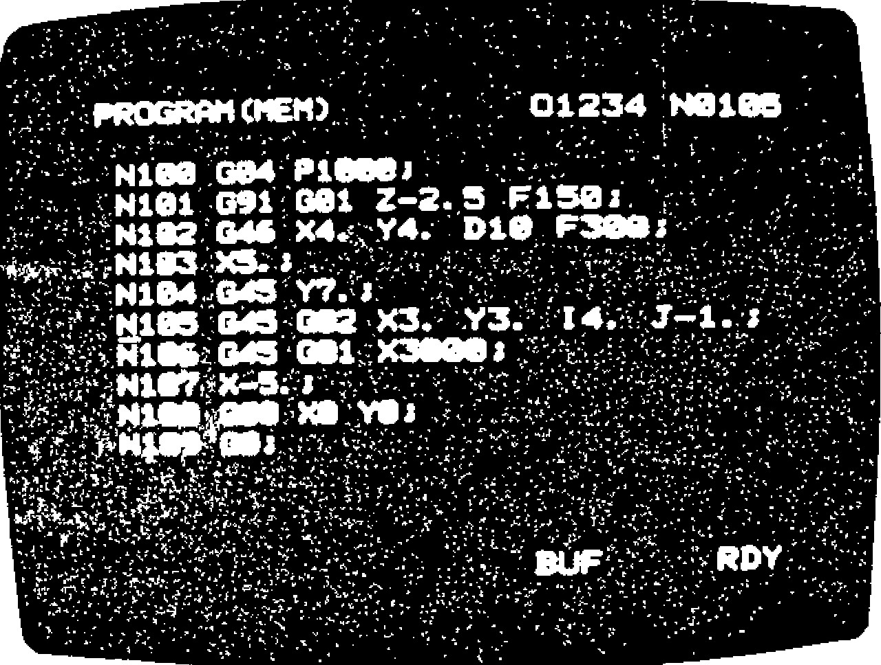The tool position displayed is based on the
   1. o o rd i n a t e s y s t e m s e t u p w i t h G9 2 .
2. T o r e s e t t h i s s c r e e n , d e p re s s t h e OR G k e y after designating an axis with the ADDRESS k e y . T h e c u r r e n t p o s i t i o n w i l l b e r e s e t t o "O." This is possible only during a mz ,.nual o p e r a t i o n m o d e ( R A P I D , J O G , S T E P , o r H A N D L E ) . T h e d e p r e s s i o n o f t h e O R C k e y

i s i n e f f e c t i v e d u r i n g n o r m a l o p e r a t i o n a n d

i n t h e "b u f fe r fu l l " s t a t e .

1. Th e coo rdin ate sy ste m which is e mployed fo r this screen is called the "reference coordinate s y s t e m . " A wo rk c o o rd i n a t e s y s t e m (o p t i o n ) w i l l b e s e t u p i n re fe re n c e t o t h e re fe re n c e
   1. o o rd i n a t e s y s t e m .

F i g . 4 . 1 9

4 . 3 . 4 D I S P L A Y I N G A N D R E S E T T I N G C U R R E N T

POSITION

It i s p o s s ib le to o b se rv e th e cu rre nt p o si t io n is d n y m o d e . O p e r a t e a s f o l l o w s .

- 124 --

T h e d a ta d is p l a y e d in t h is mo d e a re t h e sa m e

a s th e y a re u n c h a n g e d .

**Fig. 4. 20**

Current Position Display

Universal)

(

-

Example

as

those displayed on the "3

-

axis/4

-

axis exter

-

nal position display" (option). You may con

-

sider that the coordinate data of POSITION

(

EXTERNAL) are transmitted to the outside

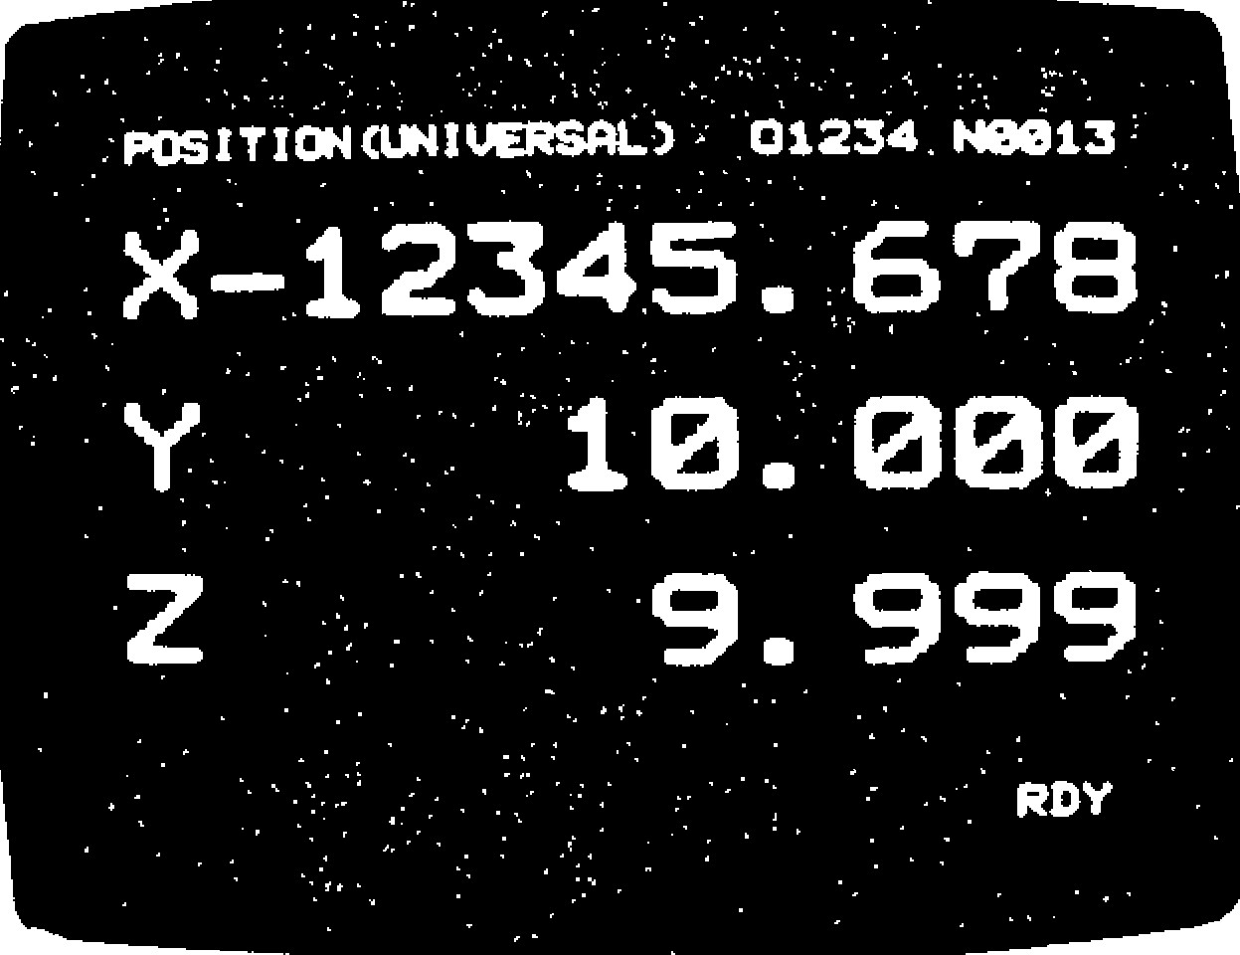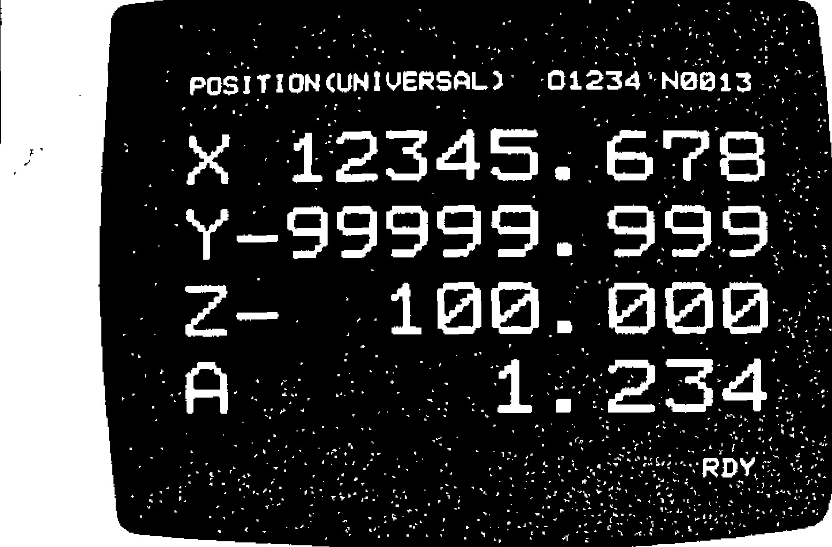

**POS I T I ON (UN I VERSAL 7 • 0**

**N0013**

•

•:

• When parameter #6005D5 = 0 (Position obtained by simple summation)

I. G92, even if issu ed,does not affec t the d is play. Move commands will be summed and displayed.

2 . T o reset th is sc ree n, d ep re ss th e ORG k ey after designating an axis with the ADDRESS key. The current position along the desig nated axis will be reset to "0." This is possible in any modes and even during operation.

4.3.4.2 CURRENT POSITION DISPLAY (EXTERNAL) : POSITION (EXTERNAL)

Move commands will be summed and displayed.

G92, if issued,. does not affect the display. • To reset this screen,.depress the ORG key after designating an axis with the ADDRESS key. The current position along the designated axis will be reset to "0." This is possible in any modes and even during operation.

These displaying and resetting operations are the same as with the case of POSITION(UNIVERSAL) #6005D5 = 0 (Position obtained by simple summation). **B**ut the resetting operation is effective only to the displayed screen since there are independent position registers.

Fig . 4 .21. Curren t Position Displa y

(External) -Example (with 4-axis control)

4.3.4.3 CURRENT POSITION DISPLAY (IN CREMENT) : POSITION '[INCREMENT}

Displayed in this mode are:

In automatic mode, distance to the end point of the block at every moment

In manual mode, distance to the position where manual operation is to start.

The increment display in manual mode will be c a nc elled in au to ma tic mo d e. (F ig. 4.3 .4 .3)

4.3.4.4 CURRENT POSITION DISPLAY (ALL): POSITION

* All positio n data will be displayed .
* < M AC H IN E] c o o rd in a te s in d ic a te th e c u rre n t position in the coord inate syste m whose o rigin i s t h e r e f e r e n c e p o i n t s e t u p b y r e s e t t i n g . Data for "stored stroke limitt" and "pitch error co mpensation t" func tions a re de fined in this coordinate system . (Fig . 4 .3 .4 .4 )

- 125 -

4. 3. 4. 4 CURRENT POSITION DISPLAY (ALL) :

POSITION (CONT'D)

Fig. 4.22 Current Position Display

(

Increment)

-

Example

Fig. 4.23 Current Position Display

(

All)

-

Example

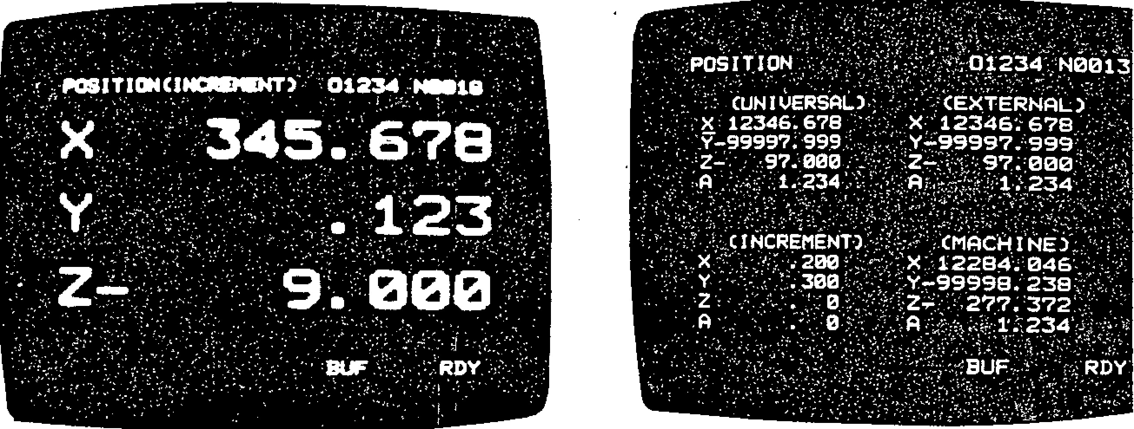

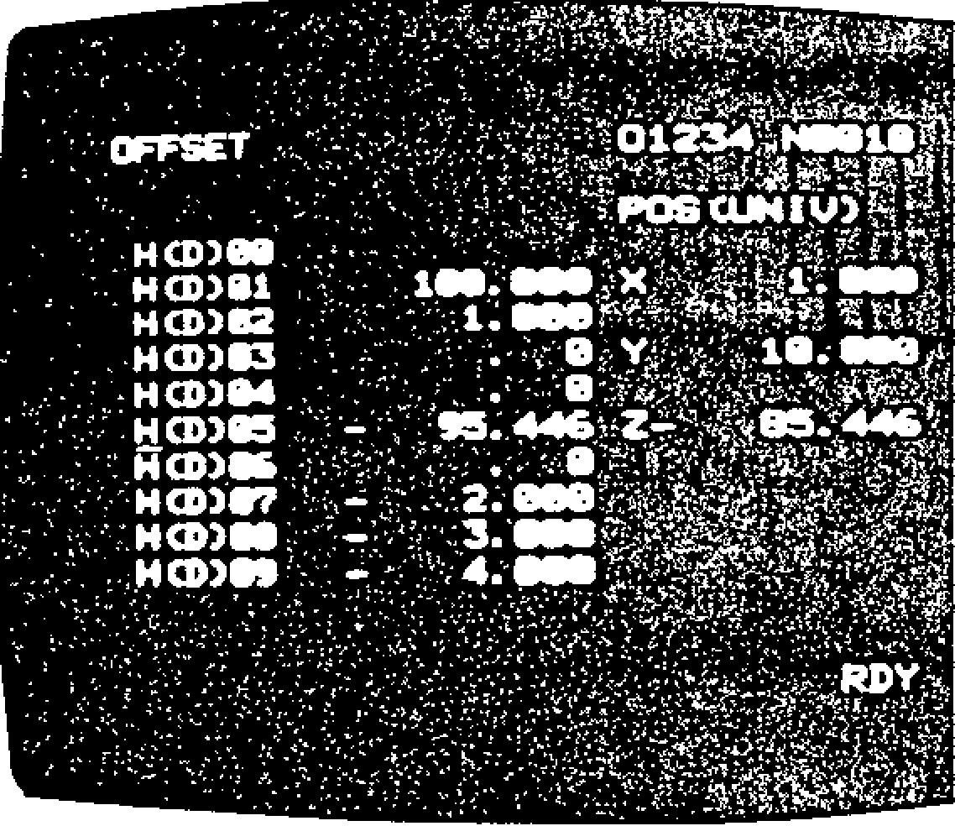4.3.4.5 SERVO POSIT IONING ERROR DISPL AY: ERROR PULSE

* This screen appears only when the system No. switch is set at "4." This mode will be normal ly u se d d u rin g m a i n t e n a n c e .
* Servo positioning error means the difference between the command position and the current tool position. Error will be displayed in units of pulse.

4 . 3 . 5 D I S P L A Y I N G A N D W R I T I N G T O O L O F F S E T

DATA

Tool offset data are stored in the memory of the c o n t r o l . T h e s e d a t a m a y b e d i s p l a y e d a n d r e -

written in any modes and even during automatic operation.

• D i s p l a y i n g tool o f f s e t d a t a .

Fig . 4.24

1 . S e l e c t t h e O F S f u n c t i o n k e y . 3 . D e p r e s s t h e

1 C U R S O R ] o r i key to CURSOR 2 . E n t e r n u m e r a l s , l i k e 1 a n d 0 , t h e n d e p r e s s

move to a smaller or larger tool offset number.

the CURSOR or C U R S O R k e y . T h e n t e n I f y o u m o v e t h e c u r s o r b e y o n d t h e f i r s t o r

l a s t t o o l o f fse t n u m b e r d i sp la y e d in t h e c u r -

pairs of tool offset number and tool offset, re n t sc re e n , th e n e ig h b o rin g te n se ts o f to o l including the designated pair, will be dis - offset number and tool offset will appear auto played and the cursor positioned at the matically. designated tool offset number.

-

126

-

1. The preceding or following page may be dis-

PAGE

played by depressing the IPAfG E key. The cursor will be positioned at the first tool offset number displayed at this time.

1. Tool offset will be displayed in units of 0.001 mm (or (0.0001") and up to 999.999 mm (or 99.9999") .

A. Binary mode

Setting numbers #6000-#6004 are associated w i t h s e t t i n g d a t a o f b i n a r y m o d e , t h a t i s , 8 - b i t i n f o r m a t i o n ( D 7 - D 0 ) . E a c h b i t i n dicates the on/o ff state of the assoc iated fun ction . The decima l value of e ach line is given at the rightmost column.

• Wr itin g to o l o f fse t d a ta

To rewrite a tool offset data, specify an incre m e n t wh ic h is to a d d a r ith me tic a lly to a to o l offset held in memory.

1. Position the cursor at the tool offset number whose offset d ata is to be c hanged.
2. Enter the increment which is to be added to th e too l o ffset. '
3. Depress the WR key. Then the specified in crement will be added to the old tool offset.

NOTES:

* A new tool offset itself may be input instead of a n i n c r e m e n t . F o r t h i s p u r p o s e , d e p r e s s t h e 'ORG key first. The tool offset number pointed b y t h e c u r so r w i l l b e r e se t t o " 0 . " T h e n e n t e r

a new tool offset.

Tool offset data held in the memory of the con tro l a re p re se rv e d e v e n a fte r p o we r i s tu rn e d off.

* It is possible to rewrite tool offset, data in any modes, even during au tomatic ope ratio n.
* Tool offsets modified during automatic opera tion become effective when the system starts to re ad c o mman ds fo r a n e w b loc k. T he o ld tool offsets remain effective for the current block and the blocks whose data are already r e a d i n t h e b u f f e r f o r a d v a n c e r e a d i n g .

**4.3.6 DISPLAYING AND WRITING SETTING DATA**

In th is s y s te m , v a r y i n g s e t t in g d a ta a re h e ld i n the internal memory and permit to specify mirror i m a g e a x e s , T V c h e c k o n / o f f, e tc . F o r d e ta i ls , see Appendix 1, LIST OF SETTING NUMBERS.

It is possible to disp lay and write se tting data at any time even during automatic operation.

1 , T y p e s o f s e t t i n g

Setting is made in binary mode or decimal mode.

DECIMAL VALUE

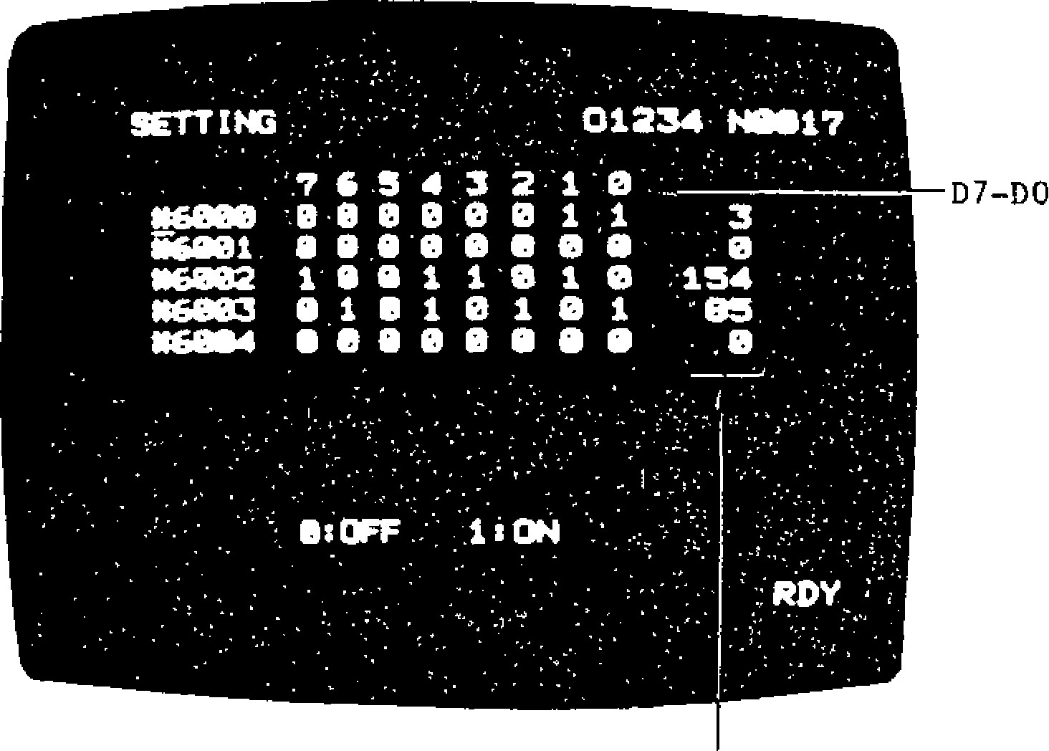

**NO/17 '**

**01234**

**.**

**.**

**' ' . 7 G 3 4 3 2 1**

**.**

**0**

**-**

***\*60913***

**-**

**0**

**1**

**•0 0 0 '8 0 1 ;**

**• 3**

**1 0**

**.**

**0 0**

**0**

**I I 0 0**

0

**# 1 6 0 0 2 1 e 1 1**

**-**

**6**

**1 0 ; 1 3 4 •**

**-**

**0 6 9 0 3 9 1**

**9 5**

**I 1 0 1 0 1 "**

**1 1 1 6 8 1 1 4 1 1 0 0 0 8 9**

**• •**

**•**

**• . 8 .**

D7

-

D0

Fig. 4.25 Setting (Deciaml model) -Example

B. Decimal mode

Setting numbers of #6200-#6219 and #6500-

#6599 are associated **with** setting d a t a o f decimal mode.

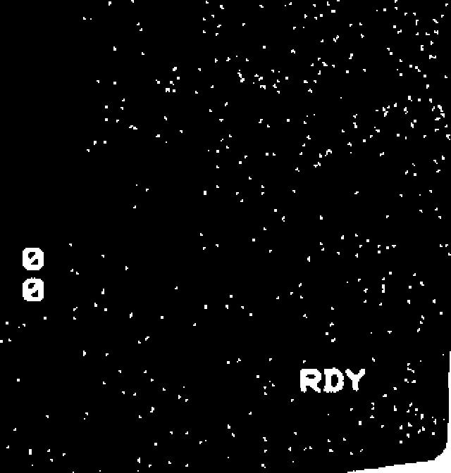

**:**

**SETTING**

**. „**

**$16210 ,**

**#6211**

**#6212 .**

**#6213**

**#6214**

•

**#6215**

**#6216 •**

**#6217**

•

**#62113**

•

**#6219**

**1000**

**.•**

**500**

0

**'**

**. •**

**2000**

•

**10000**

**• •**

**20000**

**10000**

**. 20000**

**0017.**

**H**

**61234**

|  |
| --- |
| - 127 - |

Fig . 4 .26 Se tting (Dec imal mode) -Ex amp le

**4.3.6 DISPLAYING AND WRITING SETTING DATA (CONT'D)**

2 . D i s p l a y i n g s e t t i n g d a t a

Enter a 'setting number then depress the

CURSOR

___ [ - C U R S O R k e y . ( " # " n e e d n o t b e

en tered.) Up to 10 group s o f se tting nu mber and data will be displayed at a time.

• De p re ss the CURS OR k eys to c ha ng e a se t t i n g n u m b e r a n d t h e P A G E k e y s t o c h a n g e

a screen .

3 . W r i t i n g s e t t i n g d a t a

A. In b inary mo de

( 1 ) D e s i g n a t e a d e s i r e d s e t t i n g n u m b e r .

( 2 ) D e p r e s s t h e I N S R T k e y . T h e c u r s o r

moves to the bit data from a setting numb e r . D e s i g n a t e t h e d a t a o f D 7 .

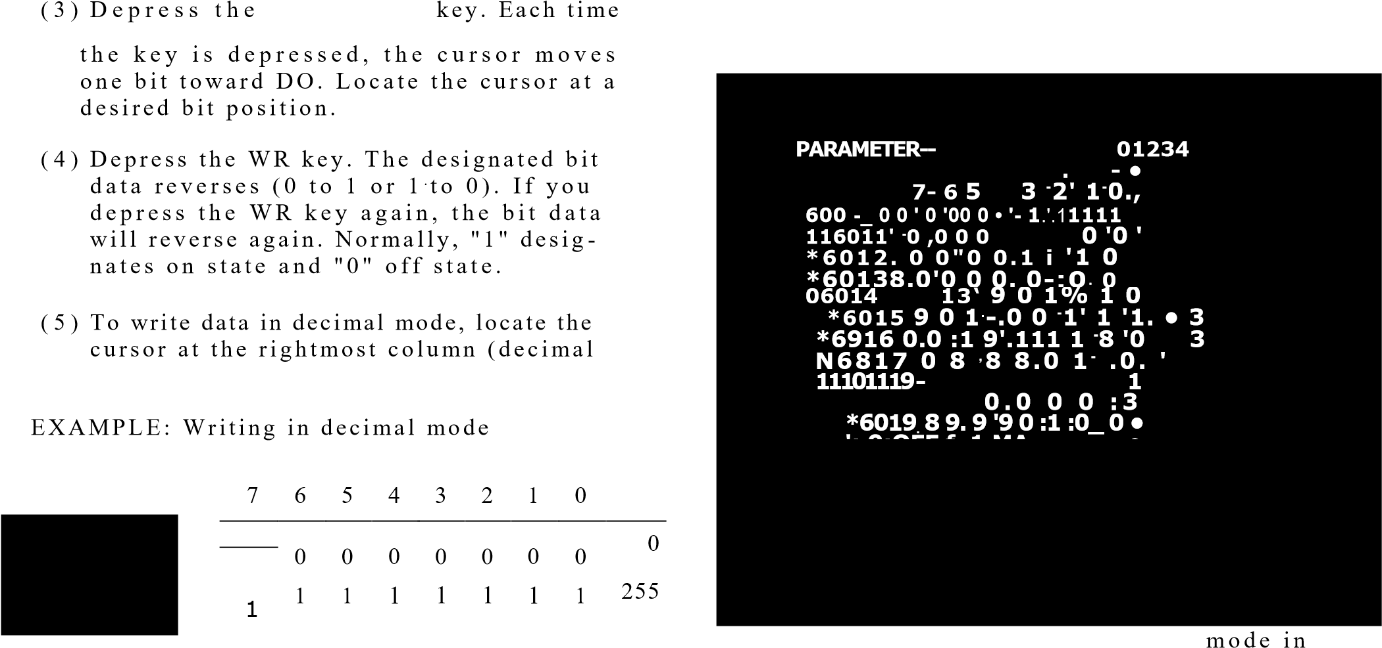CU 134SOR

data).

Entered data

( 6 ) Repeat steps (2) through (5) to write desired sired data. If you keep the or

C U R S O R k e y d e p re sse d , t h e c u r so r w il l move column by column in the screen auto matically.

( 7 ) When data has been written, depress the INSRT key. Normally, this sequence of operations begins and ends both with the dep ression of the INS RT key .

B . In d e c i ma l mo d e

1. Designate a desired setting number.
2. Enter a data and depress the WR key. The data will be assigned to the setting number which the cursor po ints to.

(3 ) Depress the 'CURS() t

WAGEI

' CURSOR' ' L ____

or

P A G E 1 k e y to ch an ge a se ttin g n u mb e r

or the scree n.

**4 . 3 . 7 D I S P L A Y I N G A N D W R I T I N G P A R A M E T E R S**

In th is sy ste m, vary ing para me ters are stored in the memory and they determine operating condi t i o n s s u c h a s t a p e c o d e a n d fe e d ra te . F o r d e ta ils, se e Append ix 2 , LIST OF PARAMET ER NUMBERS . The p ara meters may be displayed at any time even during automatic operation.

1. . K i n d s o f p a r a m e t e r s

Parameters are displayed either in decimal

binary mode .

F i g . 4 . 2 7 P a r a m e t e r s ( i n b i n a r y

mode) -Example

Parameter numbers #6005-#6045 are assigned to binary mode . Those of #6 050 and ua a re assigned to decimal mode.

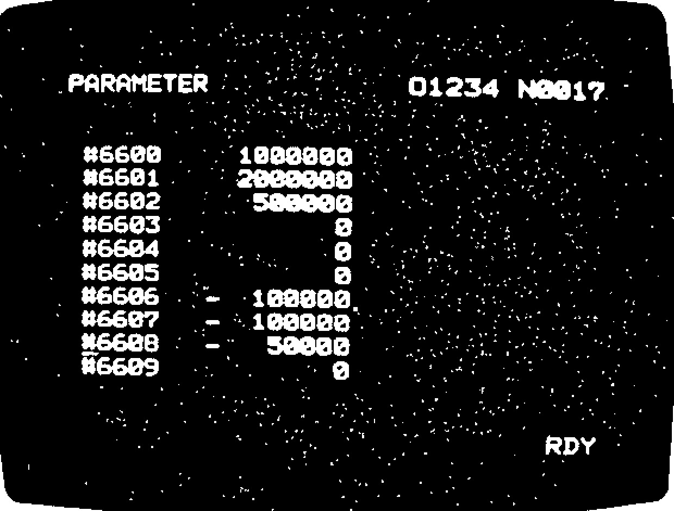

Fig. 4.28 Parameters (in decimal mode) -Example

1. . D i s p l a y i n g p a r a m e t e r s

Operation is the same as in displaying setting data except that PRM should be depressed in stead o f S ET. See 4 :3.6 DIS PLAYING AND WRITING SETTING DATA.

1. . W r i t i n g p a r a m e t e r s

T h e p a r a me te r v a lu e s a re p r e s e t a c c o r d i n g to the performance of the machine and pur p o se s. T h e re fo re , y o u sh o u ld c o n su lt th e machine tool builder if you want to change parame ter settings.

The parameters are protected with a system N o . s witc h p ro v id e d o n th e ta p e re a d e r so that they should not be destroyed by wrong ope ratio n. No rma lly syste m No . 0 is se lect e d a n d , a t th is time , th e p a ra me te rs c a n n o t

be re written by any operation.

A T he op era tion of writin g p a ra me te rs is the sa me as o f writing setting data but the p a ra me te rs a re p rotec ted . S ee 4.3 .6 DIS -

PLAYING AND WRITING SETTING DATA.

13. Parameters cannot be rewritten unless the sy ste m No. switch **is set** at "1 ."

-

129

-

After rewriting pa ra meters, be sure to re se t the sy ste m No, switch a t "0."

C . If the following parameters have been chin ged, b e s u r e t o t u r n o f f p o w e r t h e n t u r n i t o n a g a in . O th e r w is e th e sy st e m mi g h t fa il t o

ope rate properly.

#6009

#6010 #6023 #6032

#6086 to #6091 #6094 to #6099 #6068 to #6071 #6322 to #6337 #6642 to #6645 #8000 **to** #8511 After reading in parameter tape

**4.3.8 INTERNAL TOGGLE SWITCHES**

The following switches may be easily turned on and off on the NC operator's station even when they canno t be opera ted o n the mach ine c ontro l sta tion. Se tting nu mbers and their c onten ts a re as follows.

"1" = On, "0" = Off

7 6 5 4 3 2 1 0

#6001 L L

>Edit lock

__ Manual absolute

>Z-axis common cancel

6

5

4

3

2

1

0

#6002

0

Display

S

pla

t

y

ar

l

t

oc

lo

k

ck

---

>

Optional block skip

**--**

**>**

**Dry run**

**—**

**>**

**Optional stop**

**Machine lock**

**)**

**Auxiliary function lock**

0

1

1

L

Sin gle

block

**4.3.8 INTERNAL TOGGLE SWITCHES (CONT'D)**

I f t h e m a c h i n e c o n t r o l s t a t i o n i s p r o v i d e d w i t h the switches chat turn on and off the above func tio ns, th e sta te o f a switc h o n the mac h in e 's co n trol station is ORed with that of the NC operator's panel to determine the state finally.

|  |  |  |
| --- | --- | --- |
| Se tting data | Machine's switch | Result on/off |
| "0" = OFF | OFF | OFF |
| "0" = OFF | ON | ON |
| "1" ON | OFF | ON |
| **"1" =** ON | ON | ON |

T h e f u n c t i o n s o f t h e i n t e r n a l t o g g l e s w i t c h e s

work only when parameter #600603 = 1 (internal toggle switch function on). If it is off, only the s witc h e s o f th e ma c h in e c o n tro l s ta tio n wo rk .

**4 . 3 . 9 O P E R A T I O N T I M E D I S P L A Y**

The system counts the duration of automatic op era tion and it may b e displayed . This func tion permits the display of the time it has been taken for a piece of work or the total operational time of the system.

1. . P r o c e d u r e o f d is p l a y

Depress the ALM key, then select a screen

o f r u n n i n g t i m e w i t h t h e P A G E k e y a s

4,

shown below.

Three kinds of operation time will be dis p la y e d in h o u rs, min u te s, a n d se c o n d s.

Top: Tota l ope ratin g time a fter POWER ON

Middle: Total operating time of CYCLE START

Bottom: Total operating time of FEED

1. . R e s e t t i n g d i s p l a y

Each time of operational time may be reset independently by the following procedure. When operating times are displayed:

* + 1. . " 1 " " O R G " POWER ON timahe top

will be reset.

* + 1. . " 2 " " O R G " CYCLE START time in

the middle will be reset.

* + 1. . " 3 " " O R G " FEED timea the btom

will be reset

-

130

-

The timers of operation time preserve data unless th e y a re re se t, e v e n a fte r p o we r is tu rn e d o ff.

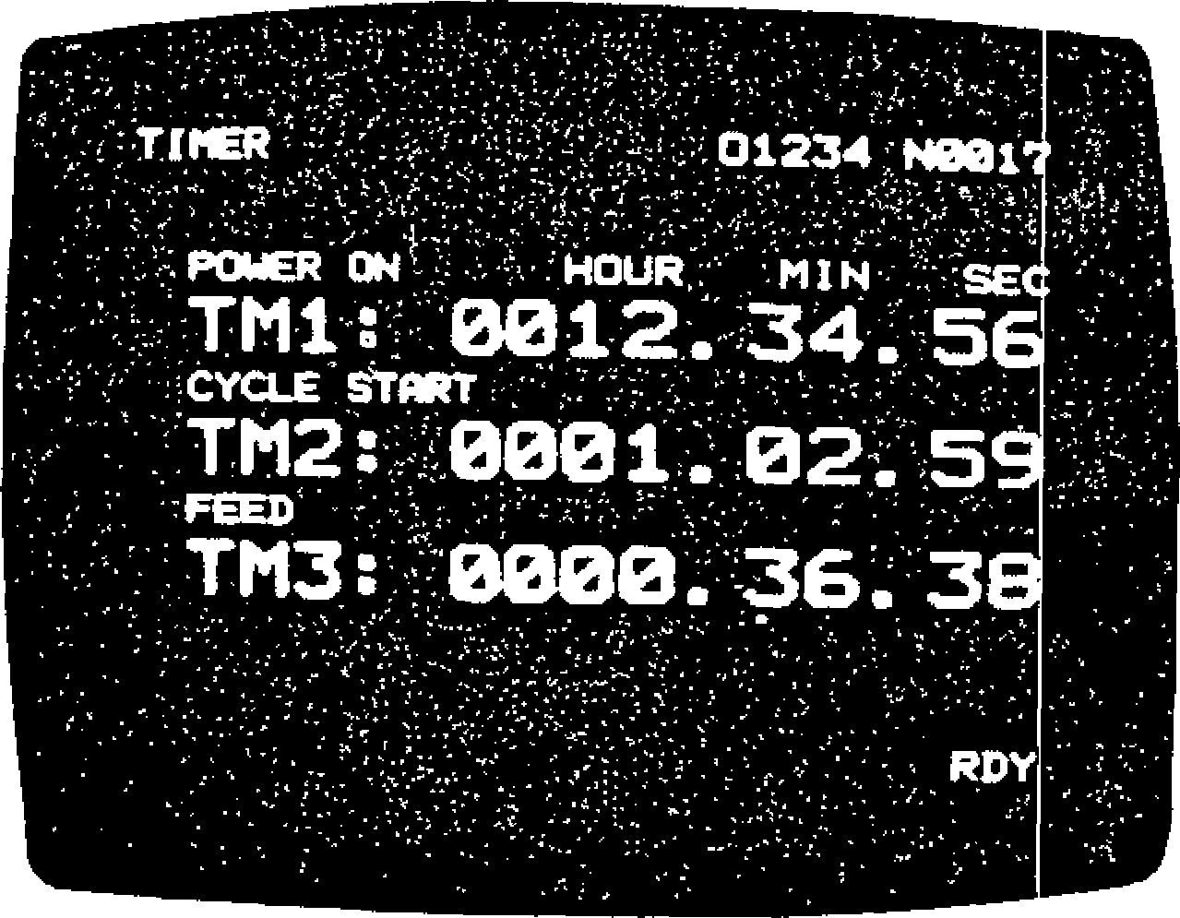

Fig . 4.29

**4.3 .10 ADD RE SS SE ARCH**

S e a r c h c o n t i n u e s u n t i l a d a t a ( c h a ra c t e r s t r i n g ) h e l d o n t a p e o r in t h e me m o r y w h i c h c o in c id e s w i t h t h e d a t a ( c h a r a c t e r s t r i n g ) e n t e re d t h r o u g h t h e N C o p e r a t o r ' s p a n e l i s f o u n d . T h e c o n t e n t s

o f ta pe will be se a rc he d in T APE mo d e a nd th o se of the part program memory in MEM or EDIT mode.

1 . Op e ra tio n

A. Selec t T APE, MEM, or EDIT mode.

B . D e p r e s s t h e P R O G f u n c t i o n k e y .

1. Depress the RESET key. "LSK" appears and the pointer returns to the top of the program number in MEM mode.
2. E n te r th e d a ta (strin g o f n o t mo re th a n 1 0 c h arac ters h ea de d b y ad dre ss) to be se arch ed.
3. D e p r e s s t h e C U R S O R I S e a r c hk e y .

4, ____ s t a r t s . " A S " b l i n k s d u r i n g s e a r c h .

2. End of search

A . " AS " d isa p p e a rs wh e n se a rc h is c o mp le te d .

1. In TAPE mode, the tape pointer points to the character that immediately follows the da ta fou nd and the tape sto ps.

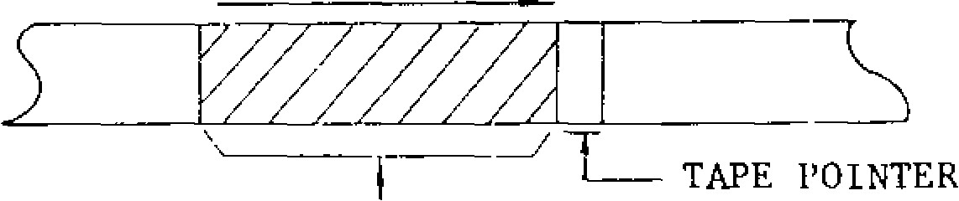

DATA FOUND

1. In MEM or EDIT mode, the pointer of the part **1 1.3.11 BREAKPOINT FUNCTION**program memory points to the top of the data

fou nd (po inted by the cu rso r). In all cases, It is possible to suspen d ope ratio n at the end o f only search will be performed a b l o c k b y d e s i g n a t i n g a s e q u e n c e n u m b e r i n but neither BUF display nor advance read ing se t fun ction . Loca tion is **6200 and 6201.**

|  |  |  |
| --- | --- | --- |
| will be performed. | |  |
| **1.** | | **If the** cu rren t seq ue nc e n u mbe r is fou nd to be equal to a sequence number designated as setting data during automatic operation, op eration will **stop after** execution of **the block like in** single block operation.  The designated sequence number is called a **breakpoint and up to two** breakpoints may be **designated.**  **Setting numbers are as follows for designating breakpoints.** |
| 1- MEMORY POINTER  *I*  DATA FOUND  B. "AS" disappears and "NOT FOUND!" appears **on the CRT if the desired data is not found. This message will disappear when you depress a key (CAN normally) of the control station.**  3 . R e m a r k s | **2.**  **3.** |

Do not omit leading zeros of the search data. Setting Setting data

The data itself which has been entered through the number keyboard will be compared with those on the tape

or in the part program memory. #6200 **II IA In 4** Break point 1

When searching a program number catalog ed, #6201  Break point 2 leading zeros may be omitted. [-4.0

Commands encountered during search will "0" means that no breakbe ignored even if they are modal commands. point is designated.

-

131

-

On Cycle Start after search, the data of a block S e q u e n c e n u m b e r **( o f u p t o** 4

which the pointer points to will be read in and digits) withou t ad dress N.

executed. (Leading zeros may be omitted.)

4 . Se arch of prog ra m numb e r 4 . " B R E AK P O IN T ! " a p p e a rs 'b li n k i n g wh e n o p - e r a t i o n h a s s t o p p e d a t a b r e a k p o i n t . T o The address search function also permits to search a re start, d epress the CYCLE ST ART bu tton . part program out of those stored in the memory.

**NOTE:** If the breakpoint function is not used, set

1. **Select MEM or EDIT mode.** the contents of #6200 and #6201 to "0."
2. Depress the PROG function key.

**4.3.12 A L A R M C OD E D I SP L A Y C.** Depress the RESET key.

If a n a larm sta tus ha s h ap p en ed , ALM" or "A/B"

1. En te r the p rog ra m nu mb er (o n b attery a la rm) .b lin ks on the b o tto m line of

"OODE ID." CURSOR , key. the screen regardless of working mode and function. If this happen s, the de taile d in formation of 4

1. Depress the th e ala rm status ma y be displayed by the follo w -

ing operation. The designated program number will be sea rched.

The resu lt o f sea rch is a s d e scribed in 2. In MEM mode, you may depress the CYCLE START button 1 . D e p r e s s t h e A L M k e y .

immediately after completion of search to start

automatic operation from the beginning of the Then up to four pairs of alarm code and mes program. sage will be displayed, with more serious one

on a higher line.

o p e r a t e **t h e** P A G E **k e y .**

NOTE: The alarm screen will appear during an

a la r m sta te and, th e re fo re , it is n o t n e e d e d to

4.**3.12 DISPLAYING ALARM CODE (CONT'D)**

Depress

the DON

function

key, and

the state

of

every

input/out

put

signal

will be

displayed

on

the

CRT.

X

1.000

X

2.000

X

-

10.089

Note:

Either H or D may

be used for address.

Label

H01

H02

D03

0

0

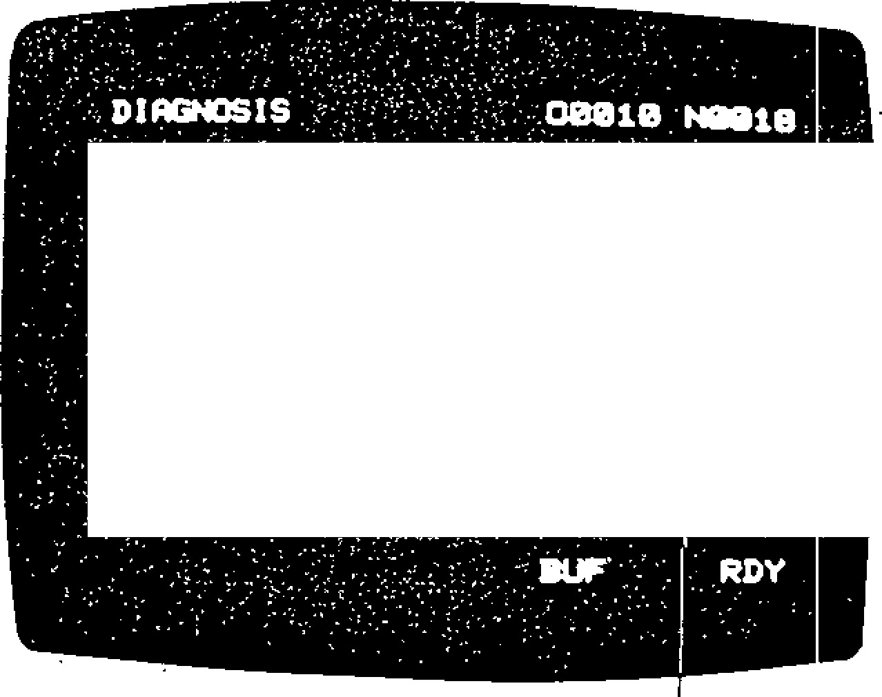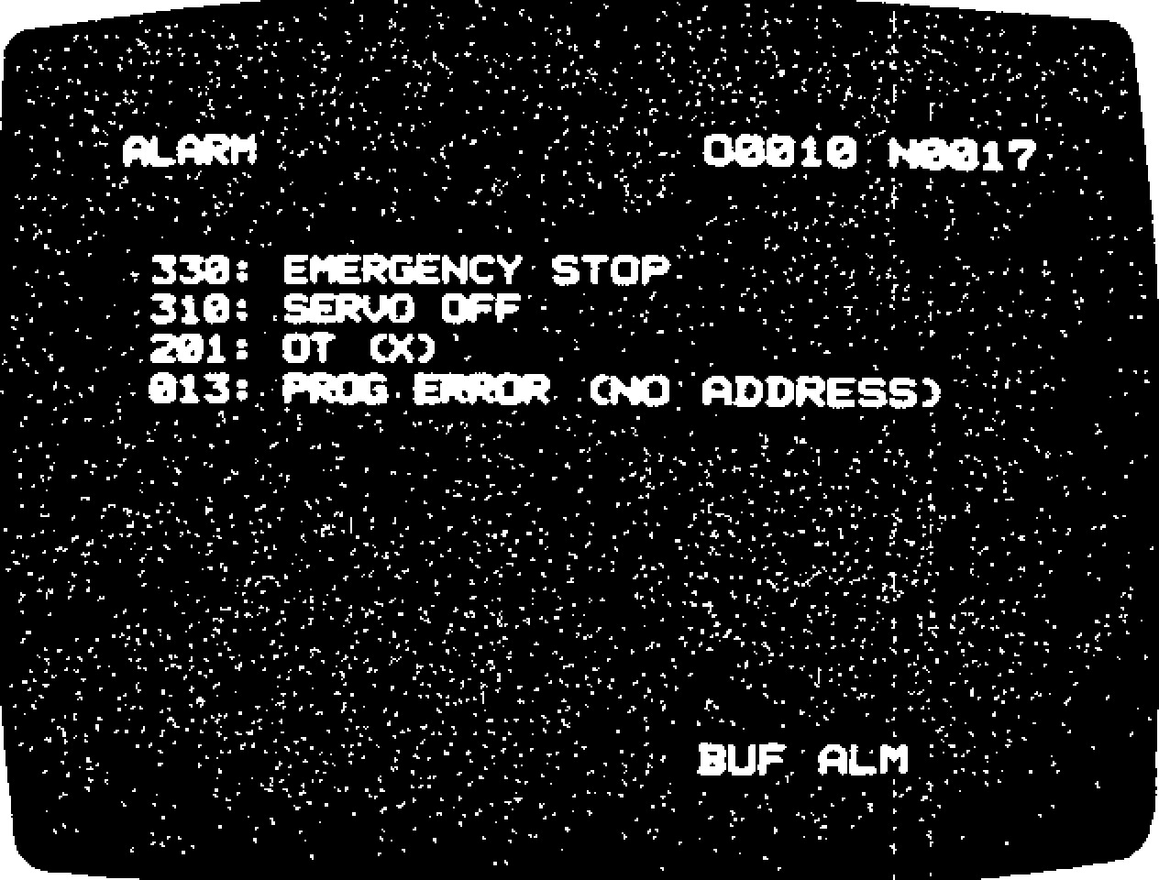

**338:**

**EMERGENCY' STOFF**

**-**

**.**

**.**

•

**310:**

**• SERVO OFF"**

**:**

**•**

•

**0 1 :**

**2**

**O T C C ) ' .**

**013:**

**:**

**PROG• ERROR,**

**''ADDRES**

**-**

**7.**

**•**

**4**

**-**

**8**

**,**

**4**

**1.**

**'3;2**

**111000 0**

**■**

**B 0. 8**

**1**

**.**

**;8 0**

**- -**

**011881**

**• 0 B • WO •0, 0 8 • : • 08 •**

**:4 1 802 1**

**AB • •**

**-**

**8**

**0 AS 4 . .4 0 •**

**1**

**$1883 0**

**.**

**0**

**0 1..1 .0'0 0 , '18**

**8 1**

**0 1 8 0 4**

**I I 0 • 8 . 1 •**

**.**

**\*1085.. 1**

**-**

**1**

**0**

**.**

**,**

**.1**

**0.**

**. O 1**

-

01006

**0**

**11**

**.**

**1**

**'111•1 O.' ,**

**16**

**.**

**•**

**.011111817 08**

**.**

**01**

**8130**

**1**

**,**

**,**

**111800**

**-**

**0**

**1 AI 1 B 1' O. O**

**54**

**-**

**•**

**01809**

**.**

**1**

**.8 IP**

**-**

**0**

**-**

**20:**

.

**(**

**PEN 1 r CLOSE**

_

F i g . 4 . 3 0 A l a r m C o d e s a n d M e s s a g e Di splayed -Examp le

T o r e s e t t h e a l a r m s t a t u s a n d s c r e e n , re m o v e t h e c a u s e o f a l a r m t h e n d e p r e s s t h e R E S E T k e y .

Fo r t h e d e t a i l o f a l a r m c o d e s , s e e Ap p e n d i x 5 , LIST OF' ALARM CODES.

LI. 3.13 **DISPLAYING ON /OFF INPUT /OUTPUT**

**SIGNALS**

Hexadecimal notation

F i g . 4 . 3 1 S t a t e o f I / O S i g n a l s

Di splayed -Examp e

4.4 . 1 I N P U T T I N G T O O L O F F S E T S F R O M T A P E

T h o u g h t o o l o f f s e t s a r e i n p u t t e d b y M D I o p e r a t i o n n o r m a l l y , t h e y m a y a l s o b e e n t e re d b y m e a n s of paper tape.

1 . T h e t a p e fo r m a t o f t o o l o f f s e t s i s a s f o l l o w s .

T h i s i s p o s s i b l e a t a n y t i m e e v e n d u r ing auto mat ic ope ration.

Fo r m o re d e t a i l o f t h i s o p e ra t i o n , s e e 8 . 6 . 3 D IA G N O ST IC S O F IN P UT / O UT P UT S IG N AL S.

T h e s t a i t : o f t h e i n p u t / o u t p u t s i g n a l i s a l s o g iv e n in th e h ex ad ec i m al n ot a ti on at th e ri gh t m o s t c ol u mn fo r t he e a se o f m a in te na n ce wo rk .

**4.4 TAPE INPUT/OUTPUT OPERATIONS OF NC DATA** *2.* T h e i n p u t o p e r a t i o n i s a s f o l l o w s .

Su c h NC d a t a a s t o o l o ff s e t s , s e t t i n g d a t a , a n d A . S e l e c t E D I T m o d e .

p a r a m e t e r d a t a m a y b e r e a d f r o m a n d w r i t t e n B . D e p r e s s t h e R E S E T k e y . o n t o t a p e . A t a p e re a d e r w i l l wo rk t o re a d d a t a f r o m t a p e . T o w r i t e d a t a o n t o t a p e , a d a t a i n - C . D e p r e s s t h e O F S k e y . p u t / o u t p u t i n t e r f a c e ( o p t i o n ) i s n e e d e d .

D . Set the tool offset data tape onto the tape H e r e we a s s u m e t h a t t h i s o p t i o n i s i n c o rp o r a t e d . r e a d e r.

S e e 4 . 7 . 2 I / 0 D E V I C E S A N D B A U D E . D e p r e s s t h e I N k e y .

R A T E S E T T I N G f o r h o w t o s e t t h e t y p e o f

i n p u t / o u t p u t d e v i c e ( s e t t i n g # 6 0 0 3 ) a n d b a u d T h e t a p e r e a d e r s t a r t s t o r e a d t h e t a p e . r a t e (p a r a m e t e r # 6 0 2 6 ). " IN" b l i nk s on t he CR T wh i le th e d at a a re

read.

F . T h e t ap e rea d e r st op s wh en it ha s re ad "% " ( o r E R ) . " I N " d i s a p p e a r s f r o m t h e C R T . N o w t h e t o o l o f f s e t d a t a h a v e b e e n r e a d into memory.

-- 132 -

**4 . 4. 2 I N PU T T I N G SE T T I N G D A T A A N D PA R A M ET ER D A TA**

T ho ug h se tting d a ta a nd p ara mete r da ta a re in putted by MDI operation normally, they may also b e e n te re d b y me an s o f p a pe r tap e . S ettin g d a ta and parameter data may be inputted from a single tape.

OUT key.

The paper tape punch punches the tool



**Label %**

**#6000 X128**

**#6001 X 5**

**#6002 X 0**

2

. The tape format is the same as that describ

-

ed in 4.4.1 INPUTTING TOOL OFFSETS

FROM TAPE.

**1**

**OUTPUTTING SETTING DATA AND**

**1.4.4**

**PARAMETER DATA TO PAPER TAPE**

**1**

**.**

The

**output operation is as follows.**

**Notes:**

**1.**

**"%' is used in**

**the ISO code and**

**"ER" in the EIA**

**code.**

**2.**

**"N" is used in**

**the EIA code**

**instead of "#."**

offset data onto paper tape and stops auto matically when all contents of the tool off set memory have been outputted.

G . To suspend the operation, depress the RESET key.

|  |
| --- |
| I. The tape format is as follo ws. D e p r e s s t h e |

At this time, the ou tput operation canno t b e re su med . Restart fro m th e be g in ning .

2. The inp lut operation is as follows.

1. Select EDIT mode.
2. Depre ss the RES ET k ey.
3. Deprss the PRM key.
4. Set the setting/parameter data tape onto th e tap e rea der. E. Depress IN key.

T h e ta p e re a d e r sta r ts to re a d th e ta p e .

"IN" blinks on the CRT while the data are read.

F. The tape reader stops when it has read "%" (o r "ER"). "IN" disappears fro m th e CRT. N o w th e se ttin g/pa ra me te r d ata ha ve b ee n r e a d i n t o m e m o r y .

T u rn o n p o we r a g a in **because the control is in the HOLT state (key inoperative) at completion of** inpu t.

**4. 4.3 OUT PUT TIN G TOOL OF FSET S T O PA PER TAPE**

The tool offset data set in the system may be ou tputte d to paper tape .

I. T h e o u tp u t o p e ra tio n is a s fo llo w s.

-

133

-

1. Select EDIT mode.
2. Depre ss the RES ET k ey.

Depre ss the OFS key.

U. C h e c k t h a t th e p u n c h i s r e a d y f o r o p e r a tion.

1. . S e l e c t E D I T m o d e .
2. . D e p r e s s t h e R E S E T k e y .
3. . Depre ss the PRM key .
4. . Check that the punch is ready for opera tion.
5. . D e p r e s s t h e O U T k e y .

The pape r tape punch punche s the setting / parame ter data onto paper tape continuous ly

1. . To suspend the operation, depress the RESET key.

At th is time, th e o utpu t op e ra tio n c an no t b e re su me d . Re sta rt f ro m th e b e g in n in g .

2 . T h e ta p e fo r ma t is th e sa me a s th a t d e sc rib e d in 4.4.2 INPUTT ING SETT ING DAT A AND PARAMETER DATA.

**4 . 5 O U T P U T T I N G P A R T P R O G R A M T O P A P E R T A P E**

**(1) The part program of the des ignated program number is punched out by the following operations:**

1. **Connect the external equipment such as the tape puncher to the** NC via the data in p u t/o u tp u t **interface.**
2. **Make the external equipment relay for operation.**
3. **Po wer on th e NC.**

. 5 OUTPUTTING A PART PROGRAM TO PAPER TAPE (CONT'D)

1. . S e l e c t t h e E D I T m o d e .
2. . D e p r e s s t h e P R O G f u n c t i o n k e y .
3. . Check to see if the external equipment is ready.

g• D e p r e s s t h e R E S E T k e y .

1. Depre ss "0" key and key in prog ram nu mber.
2. D e p re ss th e OUT key.

The part program of the keyed -in program number is outputted to the external equip m e n t . I f i t i s a t a p e p u n c h e r , t a p e p u n c h is pe rfo rme d . Wh en th e ou tpu t o f th e pa rt p ro g ra m is c o m p l e t e d , th e ta p e p u n c h e r

stops automatically. During the output of da ta, "OUT" is flashing.

1 To ci tscon tanu e t h e p h Out operation, depress the R k ey . i l o w c v et - , the discontinued operation cannot be resumed. Go back to f. and repeat the operations all over again.

NOTE: When RESET, OUT are operated without key ing in th e prog ra m number, th e part pro gra m of the curre ntly disp layed progra m number is ou tputte d.

( 2 ) P u n c h o u t o f a l l p a r t p r o g r a m s

All registered p art pro gra ms may be ou tput te d to the e xterna l equ ip ment by the above o p e ra tio n s e x c e p t t h a t 0 - 9 9 9 9 ma st b e keyed in the opera tion of h . All part progra ms stored in the memo ry a re o u tp u tted (p un ch ed o u t, e tc .) co nsec u tive ly.

NOTE: The contents of program number 00000

are outputted only when #6231D3 = 1.

OUT KEY

|  |  |  |  |  |
| --- | --- | --- | --- | --- |
| —3 rr.r..1 |  |  |  | J 1..1 |
| FEED HOLES | FEED HOLES |
| _ |  |  | ;7 | - |
| 1; HO1X - TOOL OFFSET DATA |  |  |
|  | (SETTING AND/OR PARAMETER DATA) |  |  |  |
| _ | %:01234:G92X0— PART PROGRAM |  | M30;% | __ ____ |
|  |  |  |

._....___._

Note:

3 Feel. = 360 characters 7

OUT 1KEY (TO PUNCH OUT ALL PART PROGRAMS)

DEPRESS THE CAN

KEY, AND THE PAPER

DEPRESS THE CAN KEY, AND THE PAPER

3

FEET

FEE) HOLES

1

FEET

3

FEET

'

FEED HOLES

FEET

----

SPACE "SP" CODE

PUNCHED

%;0100;

MO2;

SP

0200

;

M30;

SP

0500

M30;1

TAPE PUNCH IMMEDIATELY BEGINS TO TAPE PUNCH STOPS TO PUNCH SPROCKET PUNCH SIGNIFICANT DATA WHICH PERFORATION.

BEGIN WITH "1;..."

F ig . 4 .3 2 Da ta a n d P ro g ra m F o rma ts o n Pa p e r T a pe

**4.5 LOADING PART PROGRAMS INTO MEMORY**

**LI. 5.1 LOADING PART PROGRAM TAPE INTO MEMORY**

(1) Loading a part program which has a pro gram number.

1. . S e l e c t E D I T m o d e .
2. . D e p r e s s t h e P R O G k e y .
3. . Load the NC tape to the tape reader or an

equivalent external device.

......... % 0 1 2 3 4 : G 9 2 : X 0 Y 0 _ _ _ _ _ _ _ _ _ _ _ _ _ _ _ _ M 30: %

PROGRAM NI.TMBER HOLD HERE

1. . D e p r e s s t h e R E S E T k e y .
2. . Depre ss the IN key.

Then the system starts to read the tape and en lists the pro gra m nu mber punched on the ta pe as th e first re co rd . T he sy ste m ch ec ks for duplicator of program number as in 1. Operation ends with error if the designated p rog ra m nu mb er is no t fou n d on th e tap e .

W h e n th e ta p e r e a d e r h a s re a d " M O2 ;, " "M03 ;," or "M99 ; ," it stops and "IN" dis a p pe ars fro m the CRT . No w the pa rt p ro gram has been stored in memory.

(2 ) Load ing a part prog ram which has no p ro gram number.

1. Select EDIT mode.
2. D e p r e s s t h e P R O G k e y s .
3. Load the NC tape to the tape reader or an equivalent external device.

..... $: N1G 92X 0 ________________ M 02; % .....

The tape stops at this lo catio n when load ing is completed.

1. D e p r e s s t h e R E S E T k e y .
2. Depress the address 0 key then enter the pro gra m nu mber.
3. D e p r e s s t h e I N k e y .

T h e s y s t e m s t a r t s to read t h e t a p e . If t h e keyed-in program number coincides with the registered program number, "ALREADY IN b lin k s o n th e CR1' screen. lf this happens, delete the p rogra m number, then re peat step s a . t h r o u g h f . w h i l e t h e t a p e i s b e i n g r e a d , "IN" blinks on the CRT.

g . W h e n t h e t a p e r e a d e r h a s r e a d " M O 2 ; , " "M03 ; ," or "M99 ;," it stops and "IN" dis a p p e a r s fr o m th e C R T . No w th e p a r t p r o gra m has b een stored in me mory.

NOTES:

1. Program number "00000" is always in the r e g i s t e r e d s t a t e , s o i t c a n n o t b e e r a s e d . This program number should not be used in general.
2. T h e ta p e wh ic h h a s n o p ro g ra m n u mb e r ma y b e s t o r e d a s d e s c r i b e d b e f o r e . H o w e v e r , w r i te a p ro g ra m n u m b e r t o t h e h e a d o f th e ta pe , in p rin c ip le . T he op e ra tio n o f "Ox xx x

IN" described befo re cause s only prog ra m n u mb e r re g istra tio n . It d o e s not cause th e s to r in g o f in fo r ma ti o n o f "0 0 0 0 0 " in to t h e p a r t p r o g ra m m e m o r y . O n l y t h e p r o g r a m nu mber on tape is stored in to the me mory . A ssu me th a t a ta p e h a v in g n o p ro g ra m n u m ber is sto red an d the n all p art progra ms are p u n c h e d o u t b y d e p r e s s i n g " 0 , " " - , " " 9 , " "9," "9," "9," a n d " O U T " keys. S i n c e t h i s

tape contains programs with no program num b e r , t h e c o r r e c t r e s t o r i n g o f a l l p a r t p r o g ra m s m a y n o t b e p e r fo rm e d b y d e p r e s sin g " 0 , " " -, " "9, " "9 , " "9 , " "9 , " and " IN " k eys .

1. Co n seq ue ntly, whe n a ta pe ha v in g no pro g ra m n u mb e r h a s b e e n sto re d , write th e program number to the head of part program by the EDIT opera tion .

EXAMPLE:

N1 G 9 2 X O Z O ;

When this is in the first block, position the cursor to N and key in as follows (in EDIT and PROG modes):

O x x x x ; Ni ALT E R

(3 ) S to rin g a p rog ra m with prog ra m nu mb ers changed I

T o re giste r a p ro g ra m with a p ro g ra m nu m ber different from the one punched on tape, perform the following operations:

1. . S e l e c t t h e E D I T m o d e .
2. . D e p r e s s t h e P R O G k e y .

|  |
| --- |
| - 135 - |

1. . Set the NC tape to the tape reader or the external equivalent equipment.

S

"4 , I .! N. 0)" ../.•

••• 4 ,a G92:

PROGRAM NUMBER HOLD HERE

|  |  |
| --- | --- |
| 4. 5.1 **LOADING PART PROGRAM TAPE INTO** | The ta pe rea der stops each time it has read |
| **MEMORY (CONT'D)** | "MO2 ;," "M30 ;," or "M99 ;." |

1 . De p re ss th e IN k e y a g a in .

The tape reader resumes to read the tape. R e p e a t th is o p e ra t io n u n til a ll p ro g ra ms arc loaded.

1. . D e p r e s s t h e R E S E T k e y .
2. . K e y i n " 0 " a n d P R O G R A M N U M B E R .
3. . D e p r e s s t h e I N k e y .

T h e p r o g ra m n u m b e r e n te re d fr o m th e k e y is reg iste red in preference to the p rogra m n u mb e r p u n c h e d o n th e ta p e . At th is ti me , the program number on the tape is written

t o t h e p a rt p ro g ra m me mo ry s i mp ly a s a label.

MO2 ;, M30 ; or M99 ; is read and the stor ing operation is completed.

NOTE:

1 . If a p ro g ra m i s s to r e d w i th a c h a n g e d p r o g ra m n u mb e r a s d e sc r ib e d a b o v e , th e p ro g ra m n u mb e r p u n c h e d o n th e ta p e is st o re d in the part program memory without change. Consequently, to avoid the confusion in the la ter ha nd ling , re plac e th e prog ra m n u mbe r in the part program memory with changed pro gra m nu mber by the EDIT o peration.

( 4 ) L o a d i n g p a r t p r o g r a m s f r o m a t a p e

1. . S e l e c t E D I T m o d e .
2. . D e p r e s s t h e P R O G k e y .
3. . Load the NC tape to the tape reader or an

equivalent external device.

%.0 M 0 ? : 0 2 0 0 . M 3 0 . 0 3 0 0 . M 9 4 . *% - -*

The tape stops The tape stops to travel here. to travel here.

The tape stops to travel here.

1. . D e p r e s s t h e R E S E T k e y .
2. . D e p r e s s t h e I N k e y .

-

136

-

T h e n t h e s y s t e m s t a r t s t o r e a d t h e t a p e

a n d e n l i s t s t h e p r o g r a m n u m b e r p u n c h e d o n t h e t a p e a s t h e f i r s t r e c o r d . T h e s y s tem checks for duplication of program num b e r a s d e sc r ib e d in (2 ).

1. **Storing a program with program numbers changed**

When "0" key is depressed and program number is keyed in before depressing IN key as described in (4) above, the keyed in pro gram number is registered in preference to the program number punched on the NC tape.

1. Loading programs continuously

Programs existing on a tape as shown in (4) may be loaded continuously without inter r u p t i o n . F o r t h i s p u rp o se , d e p r e s s " 0 , " "," "9," "9," "9," and "9" before the first depression of the IN key. The tape reader stops at the position of "%."

**11.5.2 MAKING ADDITION TO A PART PROGRAM**

Perform the following operation to add data to a p a rt prog ra m wh ich is already loaded.

* 1. Select EDIT mode.
  2. Depress the PROG key
  3. Depress the 0 key then enter the part pro-

gram number and depress the key. CURSORT The system searches the designated program.

* 1. Load the tape of adding data to the tape: reader.

- • - %; Adding data M30 ; % - - •

* 1. Depress the RESET key.
  2. Depress the NEXT and IN keys in this order.

The data will be read from the tape into the memory.

N OT E: Yo u c a n n o t a d d d a ta to a p ro g ra m fro m t h e m i d d l e o f i t . I f necessary, delete t h e l a s t

part o f the prog ram by e diting opera tion and perform this adding .

**4.5.3 L OA D I N G PA R T PR O G R A M S B Y M D I**

P a r t p r o g r a ms ma y b e l o a d e d n o t th r o u g h th e tape reader but by MDI operation. Perform the following.

1. . S e l e c t E D I T m o d e .
2. . D e p r e s s t h e P R O G k e y
3. . D e p r e s s t h e R E S E T k e y .
4. Depress the 0 key then enter the part pro gra m nu mber a nd dep ress the WR key .

The design ated progra m nu mber will be reg -

iste re d . If th is n u mb e r a lre a d y e x ists ,

"ALRE ADY IN" b lin ks an d , in th is ca se , it is required to delete the registered program number.

1. W r it e th e p a rt p ro g ra m b y o p e ra t in g th e a d d r e s s k e y a n d t h e d a t a k e y . A s s h o w n in the fig ure be lo w, the keyed in data is

displayed on the b otto m lin e from left to

r ig h t s e q u e n ti a l ly . T h e m a x i m u m n u mb e r

o f c h arac ters tha t ca n be written at a time is 32. Within this limit, data may be keyed in over multiple words or blocks. However, when the 1 0th c harac ter is keyed in, the

n o r m a l d is p l a y sh o wn t o t h e r ig h t o f th e line is blanked.

1. D e p r e s s t h e I N S R T k e y .

The keyed in data is stored in the part pro gram memory.

1. Repeat the operations of e. and f. above to write the part program. The program edit operation is enabled by the use of ERASE, INSRT, and ALTER keys during this pro gram storing operation.

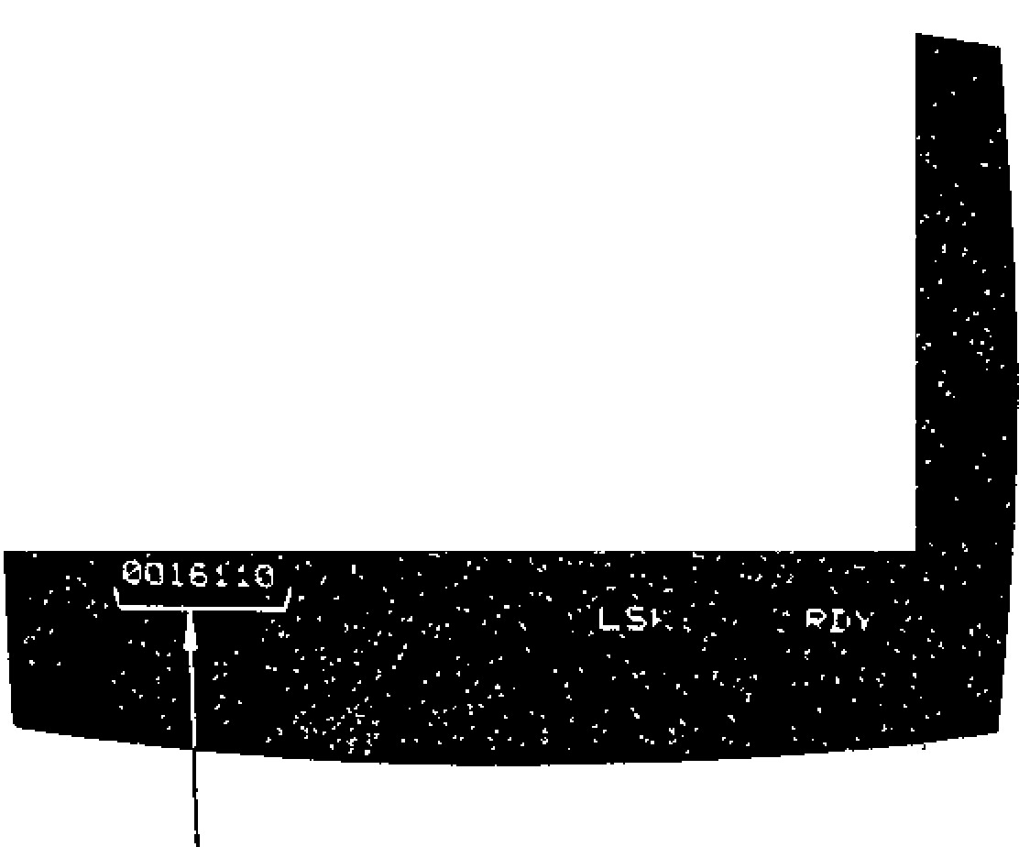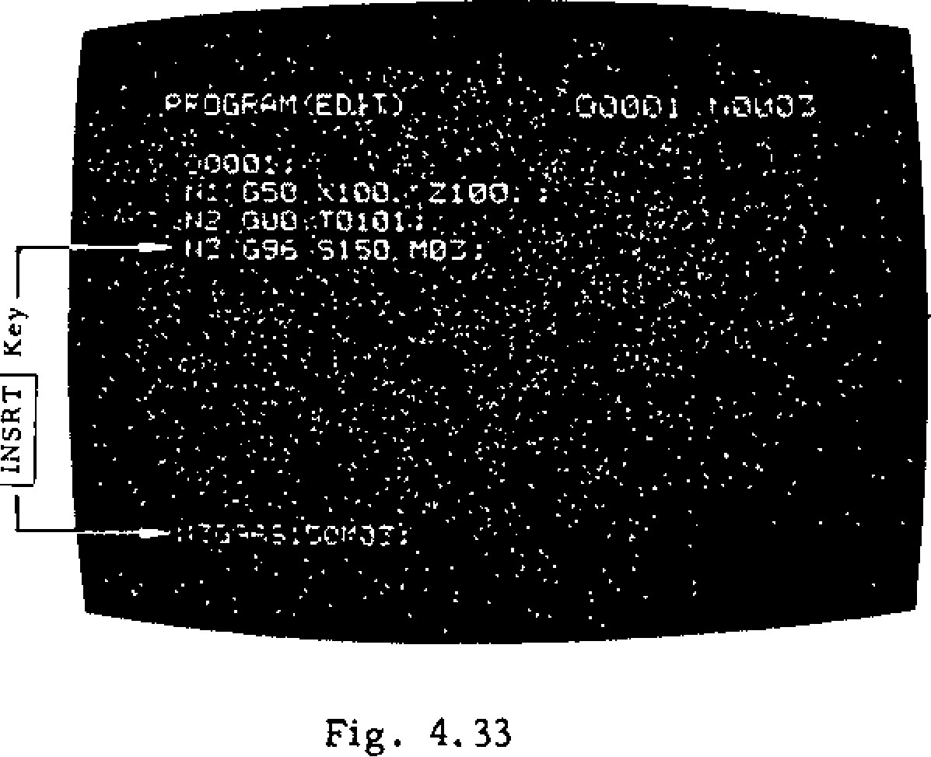

1. Key in MO2 : . M30 ; , or M99 ; and depress INS RT k e y. Th is co mp lete s th e sto rin g o f

th e part progra m. .0000- • .000- ;

•••

050. zloo: tr2 :096 5150.1"!03:

-

137

-

Fig. 4.33

**4.5.4 DISPLAY OF REGISTERED PROGRAM NUMBER**

This screen displays all registered program num b e rs a n d th e n u mb e r o f re ma in in g c h a ra c te rs in th e part progra m me mory.

( 1 ) T h e n u m b e r o f p r o g ra m n u mb e rs th a t c a n be registere d depend s on op tions.

Table 4.3.9.1

Max. Number Program No.

No. of Programs T y p e Table

1. 99 Basic 01 to 02
2. 199 Option 1 01 to 04
3. 999 Option 2 01 to 19

( 2 ) A ll p ro g ra m n u mb e rs a lre a d y re g is te re d a re

d i s p l a y e d . B y d e p r e s s i n gREMAINING NUMBER OF CHARACTERS I N P ART PROGRAM MEMORY PAGE .4, or

PAGE key , th e page sho wn b elow may be

obtained.The remaining number of characters in part p rog ra m me mory is d isp la y ed in th e lo wer le ft corner of the screen .

Fig . 4 .34

PPoGPAri NO. T.:4EIA.•

. . .

N o te : T h is s c r e e n d is p l a y s o n ly t h e re g i s te r:,(1‘4621eloo.too..r.pozo,o. 003 c7 e d p r o g ra m n u m b e r s . A p r o g r a m n u m b e r i s 'cowl; oolol 0020.1: 0om1.,a3112[2. 00'202 00302,, , ,00401 r e g is te re d b y d e p re ss in g t h e P R O G f u n c t io n • ,cictoz32'0o0rt,3 c.lo103-002n.T. 00303 040403

key in EDIT mode.0.3004 '00104. 001'0 -1 003E14 00404

0 0 0 0 5 . • 0 0 1 0 5 0 0 2 0 5 0 0 3 0 5 0 0 4 0 5 f

* + - * . 0 0 0 0 6 ' 0 0 1 0 6 0 0 2 0 G 0 0 3 0 6 0 0 4 0 6 ,
      * 00007 13010'7. 0020•. 00607 ••• • •

: 0 0 0 e c o i o o 0 0 2 0 8 0 0 3 0 8

0..000090 . 00109- 04209, 00309

* + - * . 0010, 10110'000210' 00310•

.• . •

**4,6 EDIT**

;,,,AN1 BLOCK

**4. 6. 1 PA R T PR OGR AM DI SPL A Y** wo rd will be d elet ed.

S t o re d p ro g ra m c o n t e n t s c a n b e d i s p l a y e d , a n d

c h e c k e d b y t h e o p e r a t o r . Before Deletion

Part Program

1. . S e l e c t , t h e E D I T m o d e .
2. . D e p r e s s t h e R E S E T a n d P R O G k e y s . P a r t

p r o g r a m s c a n b e d e l e t e d u s i n g P R O G k e y s in the

|  |  |  |  |
| --- | --- | --- | --- |
| |  | | --- | | a n d d e p re s s t h e | | |  | | --- | | CURSOR  4, | |

key.

E DIT mod e.

Deletion of Words

M o v e the CURSOR to the word to be deleted and d e p r e s s t h e E R A S E k e y . T h e C U R S OR - i n d i c a t e d

3 . I n p u t t h e p r o g r a m n u m b e r w i t h A DDR E S S 0

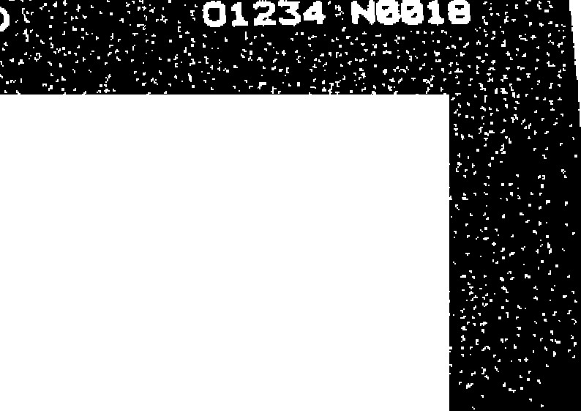

**ROGRAI1,(ED**

**'**

**•**

**FI**

**-**

**00**

**092 X0 Y0 '' 2201000**

**I4002**

**T10.**

**ries;**

**•**

**N003 S1600 P103:**

**14304**

**G90 Z4000 ,**

**:.:140**

**05**

**G91 G01**

**.**

**Z**

**-**

**2500**

**F150 ;**

**.w006.;646 X41300 Y4000' D15 ;F400:**

**MOT :645 'MOM**

**•••**

**HOW .1345 002**

**,**

**-**

**,X3**

**0130**

**:**

**'**

**.**

**.**

**Y4P0**

**0**

**;'.11400 ' J**

**--**

**1000**

**; •**

Operation in the MEM mode

Se a rc h ing c an he pe rfo rm e d in th e M EM m od e . Ho we v e r, p a g e a n d c u rs o r c a n n o t b e m o v e d b y

PAGE and C UR SOR k e y s .

T h e s p e c i f i e d p r o g r a m n u m b e r w i l l b e s e a r c h e d a n d t h e d a t a o f 1 0 l i n e s f r o m t h e b e g i n i n g o f p r o g ra m wi l l b e d i s p l a y e d o n t h e C R T . I f t h e p r o g r a m n u m b e r i s n o t f o u n d b y s e a r c h i n g , " N O T F O U N D " w i l l f l i c k e r . T h e d i s p l a y

w i l l b e r e s e t b y d e p r e s s i n g t h e C A N k e y . Fig . 4.35

Op e ra t i o n o f PA GE a n d C U R S OR k e y

] • P a g e k e y s [ t i a n d L i ] r e s p e c t i v e l y a d v a n c e s a n d r e t u r n s b y o n e p a g e .

2 . C U R S O R k e y s N a n d [ ± ] r e s p e c t i v e l y m o v e s

t h e C U R S O R a f t e r a n d b e f o r e a w o r d .

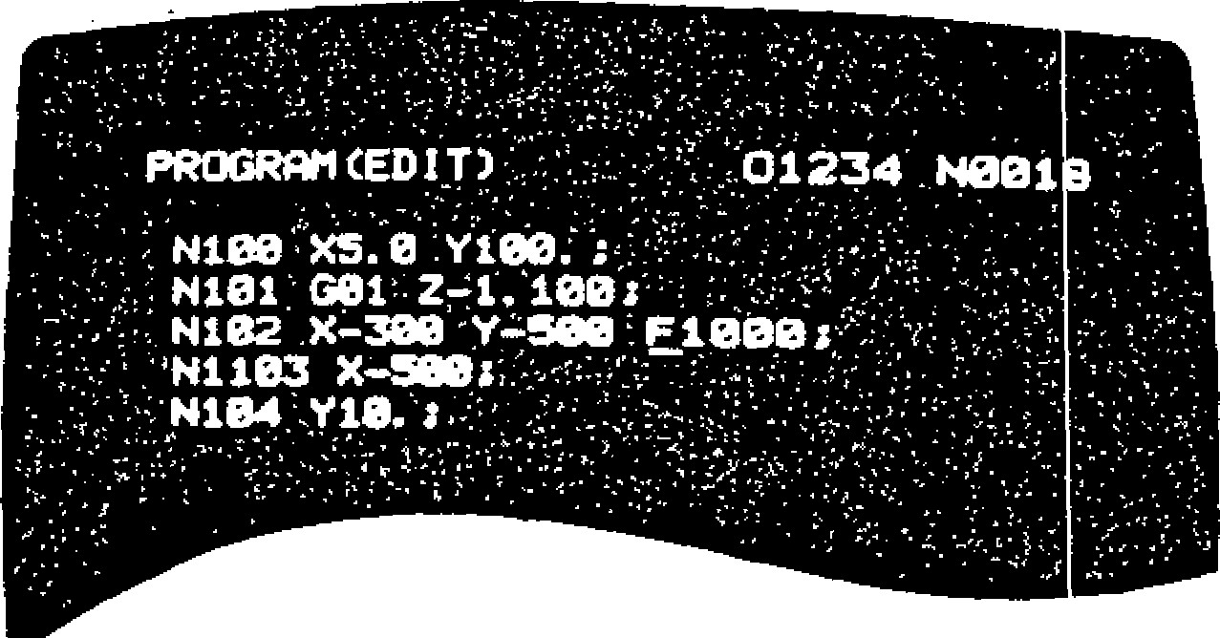

After Deletion

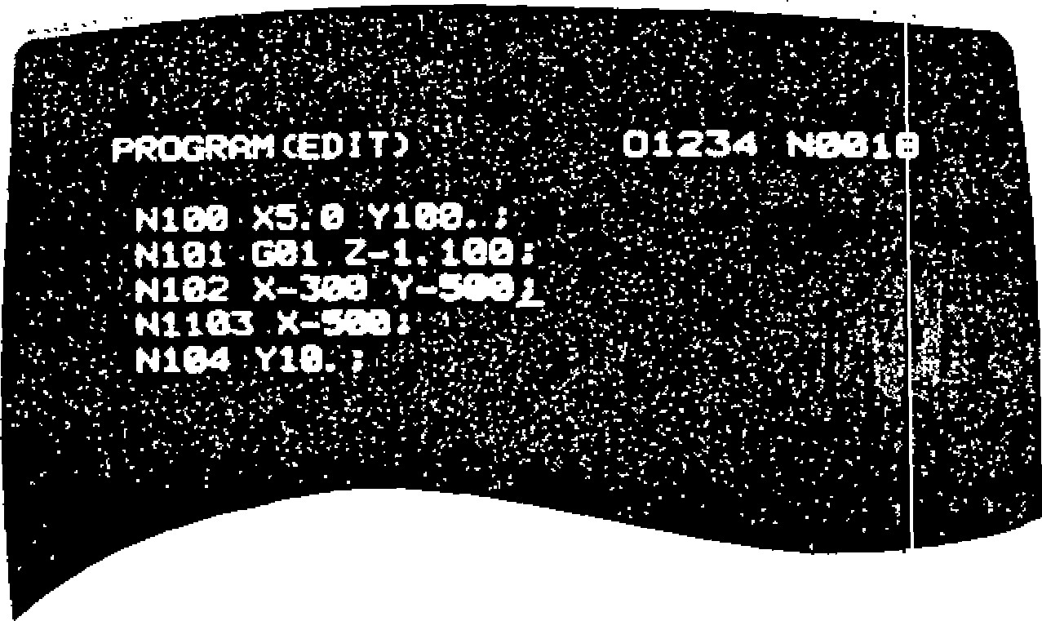

F i g . 4 . 3 6

Deletion of Program No.

E n t e r t h e p r o g r a m N o . w i t h a d d r e s s ❑ a n d d e p re s s th e E R A S E k e y . The specified p r o g r a m

No. and its part prog ram will be dele ted.

Deletion of All the program numbers

In p u t 0 - , 9 , 9 , 9 , 9 a n d d e p r e s s t h e E R A S E k e y . A l l t h e registered program numbers will b e d e le te d . P ro g ra m No . "0 " is re g iste re d n e w ly in the form of EOB.

**4. 6. 3 M OD IF YI N G PAR T PR OGR A M B L OC K**

Program modification is made using PROG key in th e EDIT mode.

Word Modification

Specify the word to be altered with the CURSOR k e y i n t h e n e w w o r d , a n d d e p r e s s t h e A L T E R

indicated word.

Before Modification

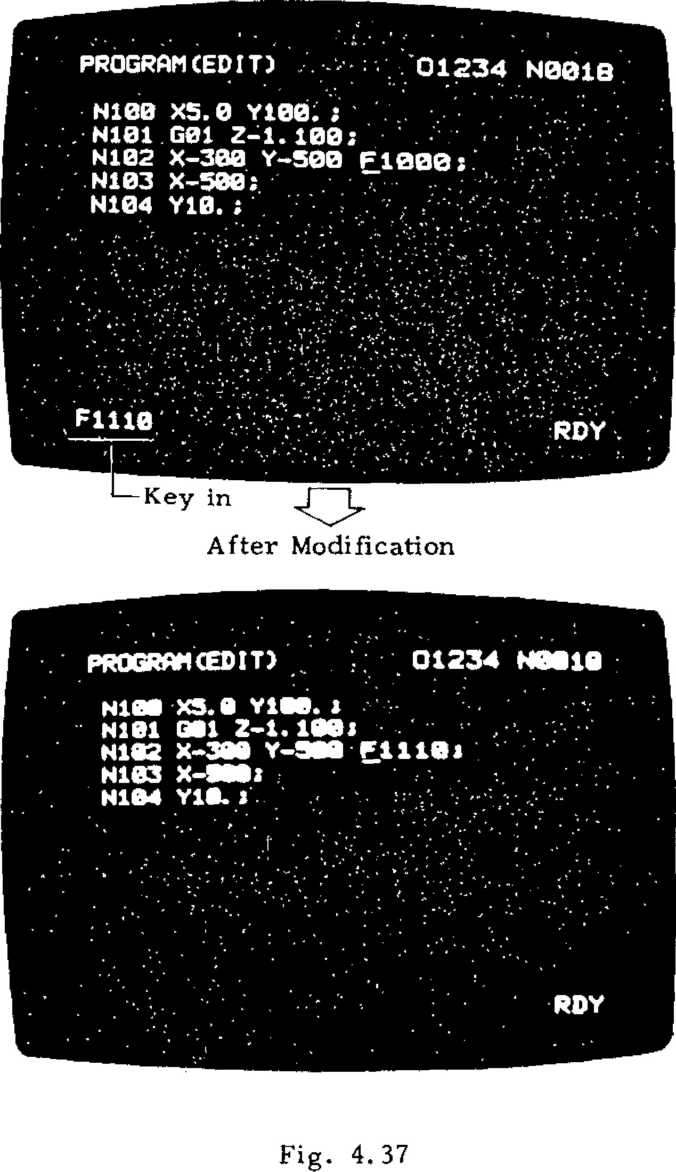

**PROGRAM (EDIT)**

**N100 X5.0**

**ne**

**e:**

**....•**

**N101 . G01 .Z1. 100: •**

**•**

**• N102 X**

**-**

**380**

**, Y**

**-**

**500**

**F**

**1000**

**N103 X**

**-**

**;.**

**500**

**.**

**N104 Y10. ;**

Key in

After Modification

Fig. 4.37

**PROGRAM OM T**

**N181111(5. Y Y181._**

**N101**

***Mil***

**Z**

**-**

**. 100 / •**

**1**

**N152 X**

**-**

**388**

**Y**

**-**

**388**

**• F 1 18**

***a***

**•**

**H103 X**

***41118***

**:**

**•**

**•**

**.**

**H184 Y10. . '**

k e y . T h e n e w w o r d will replace the CURSORWords less than 32 characters can replace one word specified.

**4 . 6 . 4 A D D I N G PA R T PR OG R A M ( I N S R T K E Y )**

Programs will be inserted using PROG key in the EDIT mode.

In sertion o f words

S p e c i f y t h e w o r d b e f o r e t h e w o r d t o b e a d d e d using CURSOR, key in the data to be added, and d e p re ss th e INS RT k e y . T h e n e w d a ta w ill b e in serte d immedia tely after the wo rd specified by the CURSOR.

Before Insertion

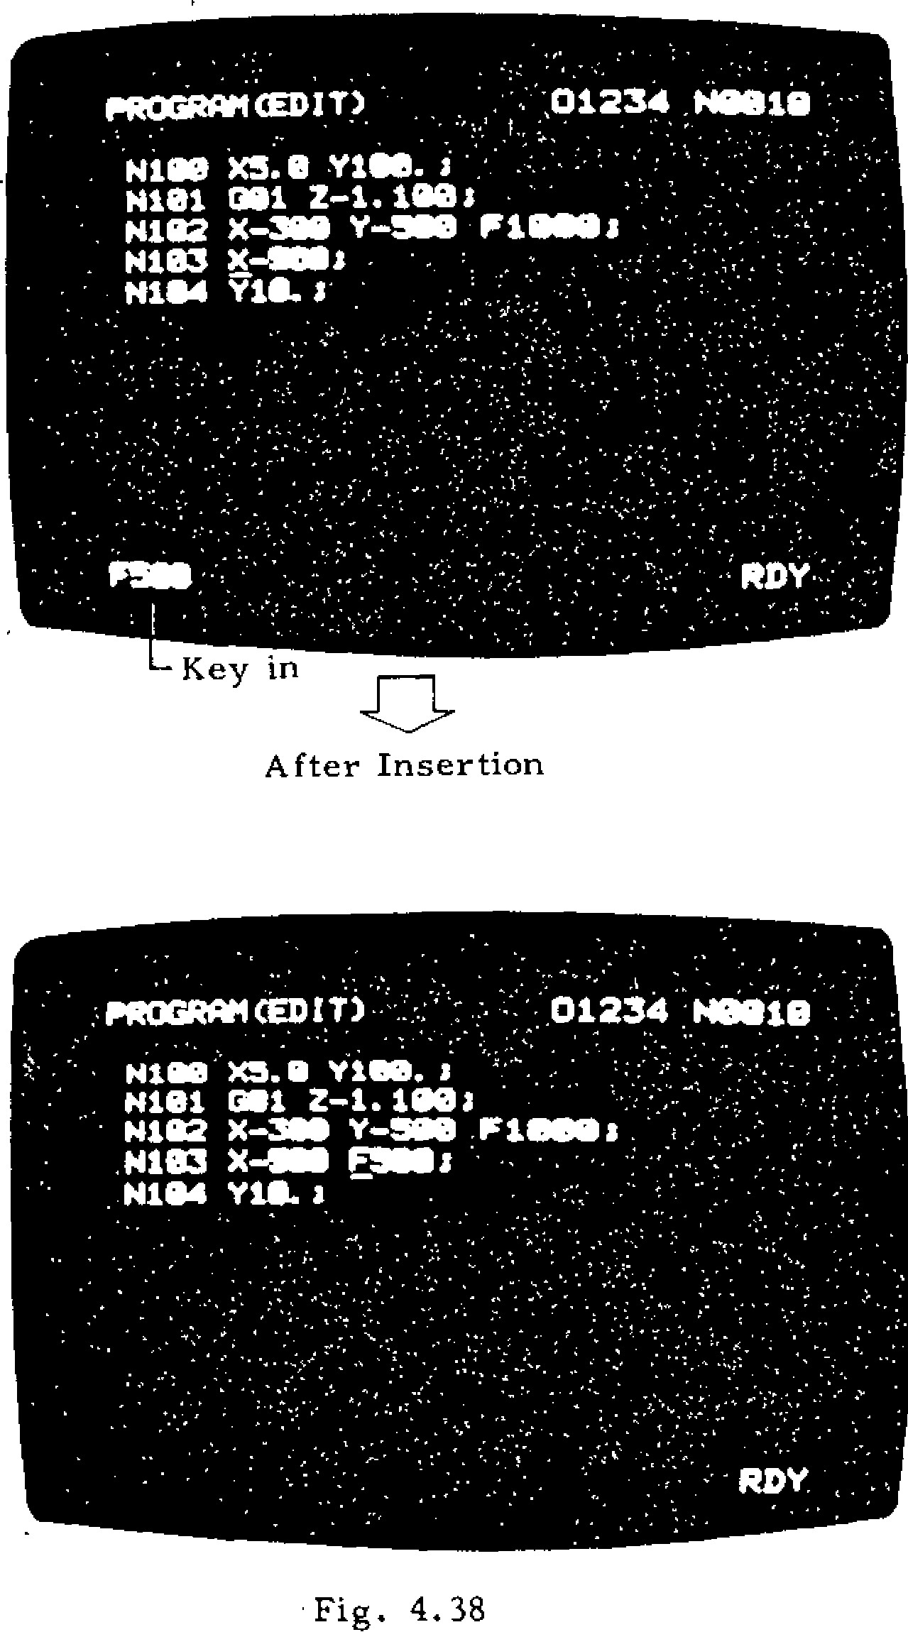

After Insertion

Fig. 4.38

After insertion, CURSOR indicates the last word keyed in words less than 32 charac ters can b e in se rte d a s o n e g ro u p .

-139 -

|  |  |
| --- | --- |
| **4.7 SUPPLEMENT TO DATA INPUT / OUTPUT** | Part Programs. |
| **INTERFACE** | Tool Offset Amount.  Se tting Data and Pa rameters. |

The ex terna l equipme nt hav ing th e designated i n p u t / o u t p u t i n t e r f a c e m a y b e a t t a c h e d t o t h e NC to input/output the following NC information:

**4 . 7 . 1 T Y P E S A N D F U N C T I O N S OF I N T ER F A C E**

Table 4.1

|  |  |  |  |  |
| --- | --- | --- | --- | --- |
|  | 1 | 2 | 3 | 4 |
| Name of interface | FACIT4070 Interface | Current Loop Interface(20mA) | RS232C Interface | RS422 Interface |
| Type of interface | Parallel-Voltage  Interface | Serial .Current  Interface | Serial-Voltage  Interface | Serial -Balanced  Interface |
| Data transmission speed | 70 charis | Parameter Input: #6026 setting Output: #6028 | | Input: #6027 Output: #6029 |
| Connector (Note) | MR-20MR | | DB-25S | DB-37S |
| Max cable length | 5 m | 50 rn | 15 in | 100 in |
| External equipment | FACIT4070 or equipment having equiva- lent interface | ASR-33 or equipment having current  loop (20 mA)  in | Equipment having RS232C interface | Equipment  having RS422 interface |
| Functions | - Output the NC data to the ex- ternal equipment (for punching out NC ta p e ) | | * Storing NC data into NC memory or collating them . * Outputting NC data to external equipment (punch out)   • Automatic operation in the Tape mode | |

N o t e : T h e t y p e s of the connector on the NC side. For the mating connectors t o this connector, use the following : MR- 20F , **DB-25P, DB-37P**

|  |  |  |
| --- | --- | --- |
| IDVCEI | IDVCEO | D a t a I n p u t I n t e r - |
| (#6003, D1) | (#6003, DO) | face to be used |
| 0 | 0 | PTR Interface ;Note) |
| 0 | 1 | RS232C Interface |
| 1 | 0 | RS422 Interface |

**4. 7. 2 SET T I N G OF D AT A I N PU T / OUT PU T INTERFACE TO BE USED**

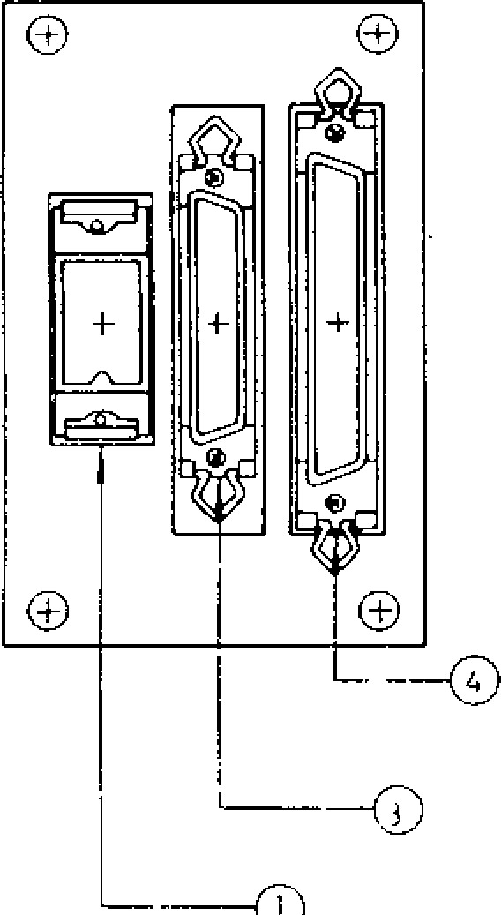

RS232C INTERFACE

(013

-

25

S

)

FACIT4070 INTERFACE

CURRENT LOOP (20 mA )

I NTER FACE (MR

-

20

MR

)

T o u se da ta inp u t/ou tpu t in te rfa ce , it is n ec e s sa ry to set which in terfac e is to be u se d . Mak e this setting as follows:

(1 ) S ettin g o f Da ta Inp u t In te rfa ce to Be Use d

Note: PTR interface is for the standard tz.pe Fig. 4.39 Data I/O Interface Receptacles r e a d e r . Us u a lly , t h i s in te rf a c e is s e t . in Control Cabinet

**(2) Setting of Data Output Interface to Be Used**

|  |  |  |
| --- | --- | --- |
| **ODVCE1 (#6003, D5)** | **ODVCEO**  **(#6003, D4)** | **Name of Interface** |
| **0** | **0** | **FACIT4070 Interface** |
| **0** | **1** | **Current Loop Interface RS232C Interface** |
| **1** | **0** | **RS422 Interface** |

**4.7.3 SETTING OF BAUD RATE AND OTHERS OF SERIAL INTERFACE**

**To use serial interface (current loop, RS232C, or RS422), it is necessary to set the baud rate, stop bit length, and control code transmission specification to parameters.**

1. **Set ting o f s top b it length**

|  |  |  |
| --- | --- | --- |
| **Input and Output in**  **Common** | **#6026D 4** | **= 1: Stop** bit as **2 bits**  **= 0: Stop bit as**  **1 bit** |
| **Input** | **#6026D4** |
| **Output** | **#6028D4** |

1. **Setting of control code** transmission designa-

tion

**Input and**

**Output in Common** #6026D5 **= 1: Does not send out**

**Input #6026D 5 = 0:control code**

**Sends out control**

**Output #6028D 5 code**

**(1) Current Loop or RS232C Interface**

**As shown below, the data is set for input and output combined or separately.**

**#6028 D6**

**0 • • • Data is set for input and output combined. 1 • • • Data is set for input and output separately.**

**a. Setting of Baud rate**

|  |  |  |  |  |  |
| --- | --- | --- | --- | --- | --- |
| **Input and Output in Common** | | **#6026D3** | **#6026D2** | **#6026D1** | **#6026D0** |
|  | **Input** | **#6026D3** | **#6026D2** | **#6026D1** | **#6026D0** |
| **Output** | **#6028D3** | **#6028D2** | **#6028D1** | **#6028D0** |
| Baud Rate | **50** | **0** | **0** | **0** | **0 •** |
| **100** | **0** | **0** | **.0** | **1** |
| **110** | **0** | **0** | **1** | **0** |
| **150** | **0** | **0** | **1** | **1** |
| **200** | **0** | **1** | **0** | **0** |
| **300** | **0** | **1** | **0** | **1** |
| **600** | **0** | **1** | **1** | **0** |
| **1200** | **0** | **1** | **1** | **1** |
| **2400** | **1** | **0** | **0** | **0** |
| **. 4800** | **1** | **0** | **0** | **1** |
| **9600** | **1 -** | **0** | **1** | **0** |

**(2) RS 422 Interface**

**As shown below, the data is set for input and output combined or separately.**

**#6029 D6**

**0 • • • Data is set for input and output combined. 1 • • • Data is set for input and output separately.**

**a. Set ting Bau d Rate**

|  |  |  |  |  |  |
| --- | --- | --- | --- | --- | --- |
| **Input and**  **Output in**  **C o m m o n** | | **#6027D3** | **#6027D2** | **#6027D1** | **#6027D0** |
| **Input** | | **#6027D3** | **#6027D2** | **#6027D1** | **#6027D0** |
| **Output** | | **#6029D3** | **#6029D2** | **#6029D1** | **#6029D0** |
| Baud Rate | **50** | **0** | **0** | **0** | **0** |
| **100** | **0** | **0** | **0** | **1** |
| **110** | **0** | **0** | **1** | **0** |
| **150** | **0** | **0** | **1** | **1** |
| **200** | **0** | **1** | **0** | **0** |
| **300** | **0** | **1** | **0** | **1** |
| **600** | **0** | **1** | **1** | **0** |
| **1200** | **0** | **1** | **1** | **1** |
| **2400** | **1** | **0** | **0** | **0** |
| **4800** | **1** | **0** | **0** | **1** |
| **9600** | **1** | **0** | **1** | **0** |

4.7.3 SETTING OF BAUD RATE AND OTHERS OF SERIAL INTERFACE (CONT'D)

1. . S et t ing S t op B i t

|  |  |
| --- | --- |
|  | #6027D4 |
|  | #6027D4 |
|  | #6029D4 |

Input and

Output in Common 1: Stop bit as 2 bits

Input  0: Stop bit as 1 bit

Output

1. Setting Control Code Sending

|  |  |  |
| --- | --- | --- |
| Input and Output in  Common | #6027D 5 | = 1: Does not send control code  = 0: Sends control code |
| Input | #6027D5 |
| Output | .#6029D5 |

Notes:

I. Some controls do not allow the switching between the setting types by #6028D6 but are fixed to the type in which data is set for input and output combined.

1. Set the baud rate and stop bit length according to the specifications of the input/output equipment to be used.
2. The start and stop signals to be send from the NC to the input/output equipment after pressing IN, VER, or OUT key are called "control codes." If the specifications of the input/output equipment do not allow the acceptance of the control codes, set the parameter for control code transmission designation to "1" (not send). In this case, it is necessary to press IN, VER, or OUT key on the NC side then start/stop the input/output equipment manually.
3. 7.4 CABLE CONNECTOR SPECIFICAT IONS

The specifications of the cable connectors for data input/output interface are as shown in Tables 4.7.10 through 4.7.14. These specifications depend on the external equipment to be used and are therefore listed in this publication for referenCe purpose only. Refer to the manual of the external equipment.

Table 4.2 FAC1T4070 interlace Connecting C.ible

|  |  |  |  |  |  |  |  |
| --- | --- | --- | --- | --- | --- | --- | --- |
| NC (MR-20F) | | | Connections | | | x tueir)nni, it .11A | |
| Symbol | Signal  Name | r:14 z |  | | | Pin No. | Symbol |
| PR | PUNCH READY | 1 |  |  |  | 12 | PR |
| 0 |  | 0 |
| TL | TAP LOWS | 2 |  |  |  | 21 | TL |
| 0 |  | 0 |
| ERR1 | ERROR | 3 |  |  |  | 20 | ERR1 |
| 0 |  | C) |
|  | Not Used | 4 |  |  |  |  |  |
| +6 V | FACIT / ASR. Auto- selection | 5 |  |  |  | 24 | +6 V |
| 0 | . | 0 |
|  | Not Used | 6 |  |  |  |  |  |
|  | Not Used | 7 |  |  |  |  |  |
| 0V | GROUND | 8 |  |  |  |  |  |
| 0 V | GROUND | 9 |  |  |  | 10 | SD |
|  |  |  |
| 0 V | GROUND | 10 |  |  |  | 25 | 0 V |
|  |  |  |
| CH1 | PUNCH  DATA 1 | 11 |  |  |  | 1 | CH1 |
| 0 |  | 0 |
| CH2 | PUNCH DATA 2 | 12 |  |  |  | 2 | CH 2 |
| 0 |  | 0 |
| CH3 | PUNCH DATA 3 | 13 |  |  |  | 3 | CH3 |
| 0 |  | 0 |
| CH4 | PUNCH DATA 4 | 14 |  |  |  | 4 | CH4 |
| 0 |  | 0 |
| CH5 | PUNCH DATA 5 | 15 |  |  |  | 5 | CL5 |
| 0 |  | 0 |
| CH6 | PUNCH DATA 6 | 16 |  |  |  | 6 | CE:6 |
| 0 |  | 0 |
| CH7 | PUNCH DATA 7 | 17 |  |  |  | 7 | CI-C7 |
| 0 | - | 0 |
|  | CP DATA 8H 8 | 18 |  |  |  | 8 | CH8 |
| 0 |  | 0 |
| CH9 | FEED HOLD | 19 | 0 |  |  | 9 | CH9 |
|  |  | 0 |
| PI | PUNCH  INSTRUC- TION | " |  |  |  | " | PI |
| 0 |  | 0 |

-

-Note

Note: The pin numbers at the time the external equipment is FACIT 4070 and its plug-in connector

is DB-25R

Table 4.3 Current Loop (20 mA) Table 4.5 RS232C Interface Interface Connection Cable Connecting Cable (B)

|  |  |  |  |  |  |  |  |
| --- | --- | --- | --- | --- | --- | --- | --- |
| **NC (MR-20F)**  **-** | | | | **Connections**  **E x t e r n a l** | | **Equipment** | |
| **Symbol** | **Signal**    *N***ame** | | **Pin No.** | **Pin No.** | **Symbol** |
|  |  | **- 1** | |  |  |  |  |
|  | **Not Used** | **i** | |  |  |  |  |
|  |  | **- 4** | |  |  |  |  |
| +6 V | **FACIT/ ASR. Auto- selection** | | **5** |  |  |  |  |
| **TTY2** | **Current loop** ( - ) | | **6** |  |  |  |  |
| **0** | **0** |
|  | **T T Y 1**  **Current** | | **7** |  |  |  |  |
| **0** | **0** |
| **0 V** | **loop (+)**  **GROUND** | | **8** |  |  |  |  |
|  |  | | 9 |  |  |  |  |
|  | **r** | |  |  |  |  |  |
|  | **Not Used** | | **20** |  |  |  |  |

|  |  |  |  |  |  |  |
| --- | --- | --- | --- | --- | --- | --- |
| NC (DB - 25P) | | | Connections E x t e r n a l | | **ent** | |
| Symbol | Signal 1 Name  ~ | Z | **Pulps** No, | ymbol |
| FG | Frame    grounding' | 1 | 0 | |  | FG |
| 0 1 | |
| SD | Sending data | 2 |  | |  | SD |
| RD | ei Recving data | 3 |  | |  | RD |
| RS | Request sending | **4** | **0 _ _ c i l** | |  | **RS** |
| CS | Capable of sending | 5 | 0_ -0 | |  |  |
|  | Not used | 6 |  | -  0 |  | DR |
| SG | Signal grounding | 7 | 0 | 0 |  | SG |
|  |
|  |  | - 8 |  |  |  |  |
|  |  | r |  |  |  | ER (OR 10 ALAR1 |
|  | N o t u s e |  |  | |  |  |

L

**(Note 2) Notes:**

1. **The type of connector and pin number are different with external equipment.**
2. **When the current loop interface is used, short-circuit pin No. 4 (signal RS) and pin No. 5 (signal CS) of plug connector DB-25P for RS232C. Then connect the plug to the NC receptacle DB-255.**

Table 4.4 RS232C Interface

Connecting Cable (A)

|  |  |  |  |  |  |  |
| --- | --- | --- | --- | --- | --- | --- |
| **NC (DB-25P)** | | | **Connections** | | **External**  **Equipment** | |
| **Symbol** | **Signal**  **Name** | **Pin No.** | **Pin No.** | **S y m b o l** |
| **FG** | **Frame grounding** | **1** |  | |  | **FG** |
|  | |
| **SD** | **Sending data** | **2** | **d • •a**c **t a** | |  | **SD** |
| **RD** | **Receiving** | **3** | **01 4111** | |  | **RD** |
| **RS** | Request sending | **4** | 00-_-.\:(-3 | | ) | **RS** |
| **CS** | **Capable of sending** | **5** |  |  |  | **CS** |
|  | **Not used** | **6** |  | **- 0** |  | **DR** |
| **SG** | **Signal**  **grounding** | **7** |  | **,** |  | **SG** |
| **0** | **0** |
|  |  | **8** |  |  |  | **IC) BUSY** |
|  | **1** | **/**  **25** | **- 0** | |  | **ER (OR**  **IO**  **ALARM)** |
|  | **Not used** |  |  | |  |  |

**Note: When the external equipment does not control the CS (Capable** of **Sending) signal given to NC, short-circuit pins RS and CS on both ends of the cable as shown in Table** 4.7.13 .

**4.7.4 CABLE CONNECTOR SPECIFICATIONS**

**(CONT'D)**

**Table 4.6 RS422** Interface Connection Cable

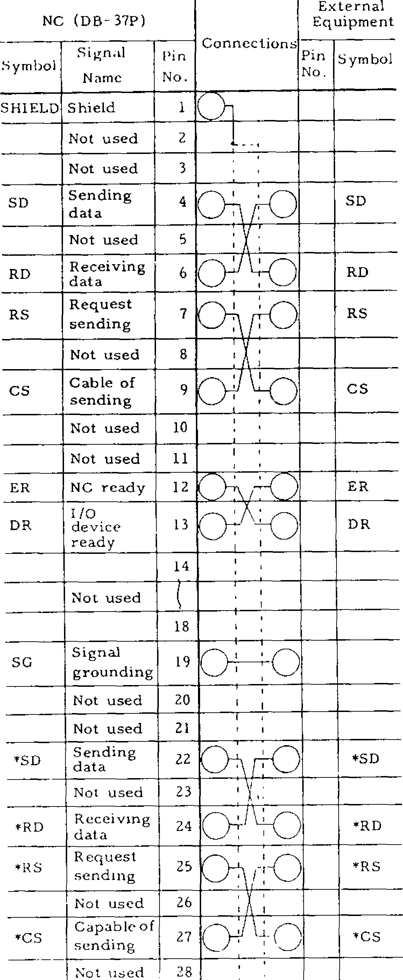

ternal

uipment

Ex

Eq

(

DB

-

371')

NC

Pin

No.

Symbol

Symbol

Connections

Signal

Pin

Name

No.

Shield

SHIELD

lc>

3

Not used

2

5

Not used

SD

RD

RS

CS

4

SD

ER

DR

25

Request

sending

28

Not used

RD

RS

CS

Not used

8

Not used

10

1

/0

device

ready

**12**

ER

13

DR

14

Not used

18

Signal

grounding

Not used

20

Not used

21

'To

SG

*SD

Receiving

24

data

co

*RD

*RD

Not used

26

Capable of

sending

*RS

*RS

*

C

S

*27*

*

CS

19

22

Sending

data

Not used

23

*SD

|  |  |  |  |  |  |
| --- | --- | --- | --- | --- | --- |
|  | Not used | 29 |  |  |  |
| *ER | NC ready | 30 |  |  | *ER |
| *DR | 1/0 device ready | 31 | . . **0 i : •** |  | **\*D R** |
|  | Not used | 32 | i., _.1 |  |  |
|  |  | 37 |  |  |  |

Table 4.7 RS232 C Interface

Connection Cable (B)

|  |  |  |  |  |  |  |
| --- | --- | --- | --- | --- | --- | --- |
| **NC (DB-25P**  **,** | | | **Connections**  **N o .** | | **External Equipment** | |
| **Symbol** | **Signal**  **Name** | **Pin No.** | **Pin** | **Symbol** |
| **FG** |  |  | **10** | **--CD1** |  | **FG** |
|  |
| **SD** | **Sending data** | **2** | **• •** | |  | **SD** |
| **RD** | **Receiving data** | **3** | **0 •** | |  | **RD** |
| **RS** | **Request sending** | **4** | **0.,** | **, . . 0** |  | **RS** |
| **CS** | **Capable of sending** | **5** | **0_ ...0** | |  | **CS** |
|  | **Not used** | **6** |  | -0 |  | DR |
| **SG** | **Signal grounding** | **7** |  | 0 |  | **SG** |
| 0 |
|  |  | **8** |  |  |  |  |
|  | **Not used** |  |  |  |  | **ER**  (0 Et IC  **ALARM** |
|  |  | **25** |  | |  |  |

**4.7.5 OPERATIONS USING DATA INPUT/OUTPUT INTERFACE**

The use of data input/output interface allcws the following **operations** and runs:

1. The input/output operations of tool offset a m o u n ts , s e t ti n g d a ta , a n d p a ra me te r d a ta a n d th e o utpu t o pe ration s (pun c h ou t) o f p art p ro grams. For details, see 4.4 TAPE INPUT/OUTPUT OPERATIONS OF NC DATA.
2. The storing of part programs **into** memory.

For details, see 4.5 LOADING PART PROGRAMS

INTO MEMORY

1. Tape-verification of part programs, tool offs e t a m o u n t , s e t t i n g d a t a , a n d p a r a m e t e r d a t a . For details, see 4.8 TAPE VERIFYING.
2. A u t o m a t i c r u n i n t a p e m o d e .

T h e c o n t r o l m a y b e a u t o m a t i c a l l y r u n i n t a p e

mode not v ia the tape reader on the mach ine bu t

v ia the da ta inp ut/ou tp u t in terfa ce . Fo r d eta ils, see 7.6 OPERATION IN TAPE AND MEMORY MODE.

**4.8 TAPE VERIFYING**

The punched tape of the data shown below may be compared to the contents of the NC internal memory to check if they ma tch.

Part program

Tool offset data

Se tting data and para meter

T he pu nc he d tap e is e n tere d throu gh the NC ta p e re a d e r o r th e d a ta in p u t/o u tp u t in te rfa c e (o p tio n ). F o r th e me th o d s o f se ttin g th e in p u t/ o u t p u t e q u ip m e n t (se t ti n g # 6 0 0 3 ) a n d th e b a u d

ra te (p a ra me te rs #6 02 6 th rou gh # 60 2 9), re fe r to 4 .9 D AT A IN P UT /O UT PUT INT E RF A C E. T h e

following description is made assuming that this option is installed.

**4 . 8. 1 SET T I N G A N D PA R A M ET ER T A P E V ER I F Y -**

**ING**

1. . S e l e c t " 1 " o f s y s t e m N o . s w i t c h .
2. . S e t th e M OD E S E LE CT sw itc h to th e E D IT .
3. . D e p r e s s P R M f u n c t i o n k e y .
4. . D e p r e s s R E S E T k e y .
5. . L o a d t h e N C t a p e v i a t a p e r e a d e r .

. Depress VER key .

T a p e s t a r t s , a n d t h e c o n t e n t s o f t a p e a n d

the contentns of setting /parameter are veri fied . "VER" is flicke rlin gly displayed .

If d isag re e men t with the ta pe da ta is de tec t ed, "INPUT ERROR" is flickeringly displayed.

7. Afte r co mpletion of verifying with out d is agreement, tape reader stops and "VER" disappea rs.

**11.13.2 TOOL OFFSET VALUE TAPE VERIFYING**1. Set the MODE S ELECT switch to the EDIT .

1. . D e p r e s s O F S f u n c t io n k e y .
2. . D e p r e s s R E S E T k e y .
3. . L o a d t h e s o u rc e t a p e v i a t a p e r e a d e r .
4. Depress VER key

T a p e s t a r t s , a n d t h e c o n t e n t s o f t a p e a n d the contents of tool offset values are verifi- e d . If d i s a g r e e m e n t wi t h t h e t a p e d a t a i s d e t e c t e d . ' IN P UT E R R OR " i s f l i c k e ri n g l y

di splay ed.

1. After completion of verifying without dis agreement, tape reade r stops a nd "VER" disappears.

**4.8.3 V E R I F Y I N G PA R T PR O G R A M T A P E**

(1 ) Ve rify in g a p a rt p ro g ra m t a p e h a v i n g p ro gram number

1. . S e l e c t t h e E D I T m o d e .
2. . D e p r e s s t h e P R O G f u n c t i o n k e y .
3. . Set the part program tape to the tape reader.
4. . D e p r e s s t h e R E S E T k e y .
5. . D e p r e s s t h e V E R k e y .

T h e t a p e i s s t a r t e d t o c o m p a r e t h e c o n te nts of the pa rt p rogra m me mory to the c o n te n ts o f th e p a rt p ro g r a m ta p e . D u r in g t h i s o p e r a t i o n , " V E R " k e e p s f l a s h i n g . I f a mismatch is found, "INPUT ERROR" is displayed flashing.

When a match is found and this operation is c o m p l e t e d , t h e t a p e r e a d e r s t o p s , u p o n

which "VER" display is erased.

N o t e : B y t h e o p e r a t i o n o f " R E S E T , V E R , " t h e v e ri f y i n g fe a t u re v e ri f i e s t h e d a t a f r o m the tape head to % code.

( 2 ) V e r i f y i n g a p a r t p r o g r a m t a p e h a v i n g n o

program number

1. . S e l e c t t h e E D I T m o d e .
2. . D e p r e s s t h e P R O G f u n c t i o n k e y .
3. . S e t t h e p a r t p r o g r a m t o t h e t a p e r e a d e r .
4. . D e p r e s s t h e R E S E T k e y .
5. . Dep re ss the "0 " key and key in p rog ra m n u m b e r.
6. . D e p r e s s V E R k e y .

T h e t a p e s t a r t s t o c o m p a r e **the co n -** **tents** o f th e p a rt p ro g ra m m e mo ry to th e c o n -

t e n t s o f t h e p a r t p r o g r a m t a p e . D u r i n g th is o peration, "VER" keeps flashing . If a mismatch is found,. "INPUT: ERROR" is displayed flash ing. When a ma tch is foun d and this operation is completed, the tape reader sto p s, u p o n wh ic h " V E R" d isp la y is e ra se d . If the k eyed in progra m nu mber is no t foun d in the memory, "NOT FOUND!" is displayed fla sh in g . In this c a se , d ep ress th e C AN k e y a n d sta rt wi th th e o p e ra tio n o f d .

***4 .*** 8 . 3 **VERIFYING PART PROGRAM TAPE (C ONT'D)**

NOTES:

1 T h e o p e r a t i o n s f o r v e r i fi c a t i o n w i t h a p ro - g r a m n u m b e r d i f f e r e n t f r o m t h e p r o g r a m n u m b e r p u n c h e d o n t h e t a p e a r e t h e s a m e a s t h o s e o f ( 2 ) a b o v e . T h e k e y e d - i n p r o g r a m n u m b e r

i s p roc es sed in p referen ce to the punc hed pro gra m nu mber.

2. Verification by the operation of "Oxxxx VER T' re g a rd s th e p u n c h e d in fo r ma tio n a s th e in fo rma tion on the key ed -in progra m number. H e n c e , w h e n v e r i f y in g a t a p e c o n ta i n i n g p ro g ra m n u mb e rs, n o p ro g ra m n u mb e r sh o u ld be keyed in.

(3) Verifying a tape containing multiple part programs

Mu ltip le pa rt p ro g ra ms pu n ch ed in a sin gle tape are continuously verified by the follow ing operations:

1. Select the Enur mode.
2. Depress the PROG t :unci ion key.
3. Se t the part pro gra m ta pe to the tape re ad er.
4. D e p r e s s t h e R E S E T k e y .
5. D e p r e s s t h e V E R k e y .

When MO2, M30, or M99 is read, the tape rea der does not stop but a ll the part p ro g ra ms are co n tinu ou sly v e rifie d up to % code. When the verification is completed, the tape reader stops at the position of % code.

- 146 -

**4.8. 11 SUMMARY OF EDITING OPERATION**

|  |  |  |  |  |  |  |  |  |  |  |  |  |  |
| --- | --- | --- | --- | --- | --- | --- | --- | --- | --- | --- | --- | --- | --- |
|  |  | | | | | **Edit Lock** | System No. **switch** | **Moue** Mod**e** | | **tion** | **Procedure** | | |
| Parameter I | **Storing from NC operator's panel** k e y b o a r d | | | | |  | **I** |  | | **PRM** | **Parameter** numbe r -0- I CURSOR I | | |
| **Data 4- I WR J** | | |
| S t a r i n g f r o m t a p e ( N o t e 4 ) ( N a t e 6) | | | | |  | **I** | **EDIT** | | **RESET 4- IN** | | |
| Punch ou t (Not e 3) | | | | |  |  | **I RESET I + [OUT]** | | |
| Matchi ng wit h tape (N ote 4) | | | | |  |  | **I RESET' . I VER I** | | |
| 1    Sumas | Storing from NC operator's panes k e y b o a r d | | | | |  |  |  | | **SET** | Settin g numb er --.• [CURSOR I | | |
| D**ata 4-** | | |
| **Storing from tape** | | | | |  | **I** | **EDIT** | | **( RESET] 4- IN** | | |
| **Punc h o ut** | | | | |  |  | **I RESET' + I O U T** | | |
| **Matching with tape** | | | | |  |  | **[RESET' " IVERI** | | |
| **Offset** | **Storing from NC operator's panel keyboard** | | | | |  |  |  | |  | **Offset number + [CURSOR I** | | |
| **Data -0' Erin** | | |
| **Storing from tape** | | | | |  |  | **EDIT** | | **I RESETI + 133** | | |
| **Punch out** | | | | |  |  | **OFS ____**  **[RESET I OUT** | | |
| **Matching with tape** | | | | |  |  | **[RESET] " [ VER 1** | | |
| **C le a r o f a ll o ffs e ts** | | | | |  |  |  | | ❑ **" -9999** -fr IORG] | | |
| Storing from NC operator's panel k e y b o a r d | | | | | **OFF** |  | EDIT | | **PROD** | ❑ + P r o g r a m n u m b e r I WR | | |
| **Repeat of edit opeation "addition o f a ddre ss d a ta** | | |
| I Part program | Storing from  tape | | One part program | | Tape with number  o | **OFF** |  |  |  | |
| **I RESET]** | **" [ IN.** | |
|  |  | |
| T a a w i t h o u t p n u m b e r O | **OFF** |  | **'RESET'** | **4- [0 I + Program** | |
| **number** | **" f I N** | |
| A l l p a r t p r o g r a m s o n t a p e | | | **OFF** |  | **RESET]** | **-0- 0 -0- -9999 " 'IN** | |
| Addition to registered part program | | | **OFF** |  |  |  | |
| **I RESET [** | **+ [ NEXT I 4 IN I** | |
|  |  | |
| Punch **out** | | D e s i g n a t e d p a r t p r o g r a m | | |  |  | **I RESET]** | **4 0 +** Program | |
| **number** | **+ LOUT1** | |
| **All part programs** | | |  |  | **[RESET** | **4- 0 "** -9999 y [OUT' | |
| Match- ing  with tape | | O n e p a r t  r  progam | | T a p e w i t h n u m b e r  0 |  |  | **[RESET 1** | **-0- 1 VER I** | |
| T a p e w i t h o u t number 0 (Note 1) |  |  | [RESET i + **MI** Program | | |
| number VER | | |
| A l l p a r t p r o g r a m s o n t a p e | | |  |  | I RESET I -fr I VER] | | |
| Edit | | Modify of address data | | | OFF |  | I C U R S O R ' ( S e t t o a d d r e s s d a t a t o | | |
| be modified) -fr A d d re ss da t a | | |
| -'• I ALTER i | | |
| Add of address data | | | OFF |  | C U R S O R 1 ( S e t t o a d d r e s s d a t a | | |
| **just before addition) + Ad-** | | |
| **dress data -0- I INSRT 1** | | |
| D e l e t e o f o n e a d d r e s s d a t a | | | OFF |  | **C U R S OR ] (Se t to a d dr e s s da t a t o** | | |
| **be deleted) " I ERASE 1** | | |
| Delete of one block  (Note 5) | | | OFF |  | **CURSOR 1 (Set to address data at** | | |
| **he a d o f bloc k to be dele te d) '** | | |
| **1 EOB1 4- I ERASE I** | | |
| A d d r e s s s e a r c h  **I_** | | | | |  |  | **EDIT TAPEM E** | | **PROG** | **Address da ta to be searc he d "** | | |
| **!CURSOR'** | | |
| Clear | | | **D e s ig na te d pa r t pr o gr am** | | **OFF** |  | **EDIT**  • | | **O -F- Program number to be** | | |
| **searched " I ERASE 1** | | |
| **All part programs on tape** | | OFF | **El** -'1'1'1`1 -, 1.210'0,1.: I | | |
| Notes: | | | | | | | | |  |  | | | |
| 1.  2.  3. | | | Storing of a part program having a program number different from program number 0  on tape is pertormed by the same operation as for "tape without program number 0."  Within the limit of 32 characters, addition of multiple address data and the change to one address data are permitted.  Setting is punched out at the same time. | | | | | | 4.  5.  6. | If the tape contains setting information, it is also stored and matched at the same t i m e .  When the cursor to the address data in the middle of a block and EOB and ERASE keys are depressed, the data following the cursor position is deleted.  When data has been stored from a param - | | | |
|  | | | - 147 - | | | | | | | eter tape, turn the power on and off. | | | |

**5. TAPE READER**

|  |  |
| --- | --- |
| **5.1 TAPE READER COMPARTMENT**  **5, 1 . 1 TAPE FEED SWITCH AND SYSTEM NO. SWITCH**  These switches are located above the tape reader and are accessible when the tape reader door is opened.  TAPE FEED switch  T h i s is a s p r in g re tu r n ty p e s w it c h f o r ma n ually feeding the tape forward and backward : When the switch lever is pushed to the F (for w a rd ) d i re c t io n , t h e t a p e m o v e s f o r w a rd , o r f r o m r i g h t t o l e f t , a n d w h e n i t i s p u s h e d t o t h e R ( r e v e r s e ) d i re c t i o n , t h e t a p e m o v e s i n t h e r e v e r se d i r e c t i o n . H o w e v e r , d u r i n g a n automatic or manual operation cycle, and while th e ta p e g u id e is p u sh e d u p , th is s witc h is i n e ff e c ti v e . T h e t a p e f e e d e r i s s to p p e d wh e n the control reads % code. | sc ra tc h e s o n th e g la ss win d o w a re lia b le to c a u se re a d in g e rro rs , it sh o u ld b e c le a n e d periodic ally , and handled with c are. Refer to 8.1 R OUT IN E INSPE CT IO N SC H ED U LE .  Loca ted in th e cen ter is the tape feed sprock et, for eng aging the feed ho les o f th e part pro gra m ta pe.  Tape Guide  F o r f e e d i n g a t a p e t h r o u g h t h e t a p e r e a d e r , p u s h u p t h e t a p e g u i d e re l e a s e m a g n e t u n d e r th e re a d in g h e a d to ra ise th e ta p e g u id e , p a ss th e tap e o ve r the re a ding h ea d , an d th en , p ush down the tape guide gently. While the tape guide is lifte d , c yc le sta rt in the T APE mo d e c an n .Dt be m a d e , a n d th e T AP E F E ED s witc h is in e ffe c tiv e . The sprocke t is freed from the fe ed ho les so that the tape can be pulled freely in both di rections. |

Fig. 5.1 LIGHT SOURCE

TAPE



0

SYSTEM

I

PARAMETER

CHECK

2

3

LOAD

4

TEST

(01

5

TESTIfl

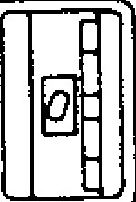

TAPE

FEED

❑

F

H

GUIDE

TAPE

BEADING

PEAR AND

TAPE

FEEDER

SYSTEM NO. SWITCH

TAPE GUIDE

SYSTEM No. Switch  **_______________________________________________________ 'FORWARD** RELEASING MAGNET

Normally, this switch is not to be manipulated b y th e u se r . D u r in g o rd in a r y N C o p e ra tio n s , th e s witc h sh o u ld b e in th e 0 p o sit io n . F o r w r i t i n g p a r a m e t e r s , i t s h o u l d b e s e t a t " 1 . " For details, refer to 4.1.13 TAPE FEED AND SYSTEM NO. SWITCHES.

5.1.2 TAPE READER

Light Source

A s t h e l i g h t s o u r c e , a n d L E D i s u s e d . I t r e quires no maintenance except for daily cleaning.

Tape Reading Head an d Tape Feeder

In th e ta p e re a d in g h e a d , p h o to tra n si sto rs a re b u ilt in u n d e r a g la ss win d o w . S in c e d u st a n d

F R O N T R E V E R S E

F ig . 5 .2

I

00

0000000

0000

**0**

**000000000000**

**0000000000000**

**000000000**

**00**

**0**

**0**

**0000000000000**

**00**

**000000**

**0**

**0**

**000000 0000 00 0**

**00000000**

**0**

**000**

**000 000 00 0000**

**000**

**0000000000000**



5 . 1 . 3 **T A P E T U M B L E B OX**

The tape tumble box is installed under the tape rea der.

To facilitate tape removal from the tumble box, a piece of braided nylon tape is laid in the tumble box covering its entire interior space. As the part program tape is piled up on the nylon tape as it is dropped into the tumble box, the entire part program tape comes out of the tumble box when the ny lon tape is pulled u p.

W h e n th e t wo s c r e ws a t t h e b o t to m o f th e ta p e tu mb le bo x a re u n sc re wed , th e lo wer part of the box opens to permit tape removal downward.

Clean the interior of the tape tumble box period ically, in accordance with 8.1 ROUTINE INSPEC TION SCHEDULE.

NOTE:

The unit type housing is not provided with this tape tumble box.

**5.2 TAPE REELS t**

1. **2.1 TA PE REEL S**

One of the following two types of tape readers designed for use with tape reels are available as options.

|  |  |  |  |
| --- | --- | --- | --- |
|  | Tape reel | Reel dia. | Note |
| A | 6" reel | 6" | For 80 m part program tape |
| B | 8" reel | 8" | For 180 m part p r o g r a m t a p e |

Note: These tape lengths are for 0.108 mm thick tape. POLYESTER **TAPE**

**5 . 2 . 2 H A N D L I N G 6 - I N C H T A P E R E E L S**

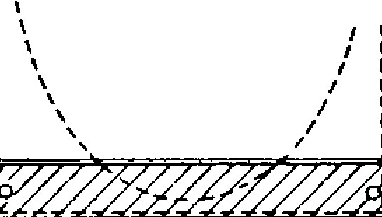

FA,

$

►

**4**

When the tape is no t in use, and when mounting and dismounting the tape, be sure to arrest the tension arms by the tension arm rest. While the tension arms are in the arrested positions, the reel motor is switched off, and the reels are free.

Mount the tape as follows.

* 1. Pull the reel lock pawl on the right reel spin dle to the horizontal position, and dismount the reel from the spindle.
  2. Insert the trailing end of the punched part program tape into the slit in the hub of the righ t re el, an d wind th e ta p e on th e ree l.

TAPE OUTLET Fig.

5.2. Tape tumble box

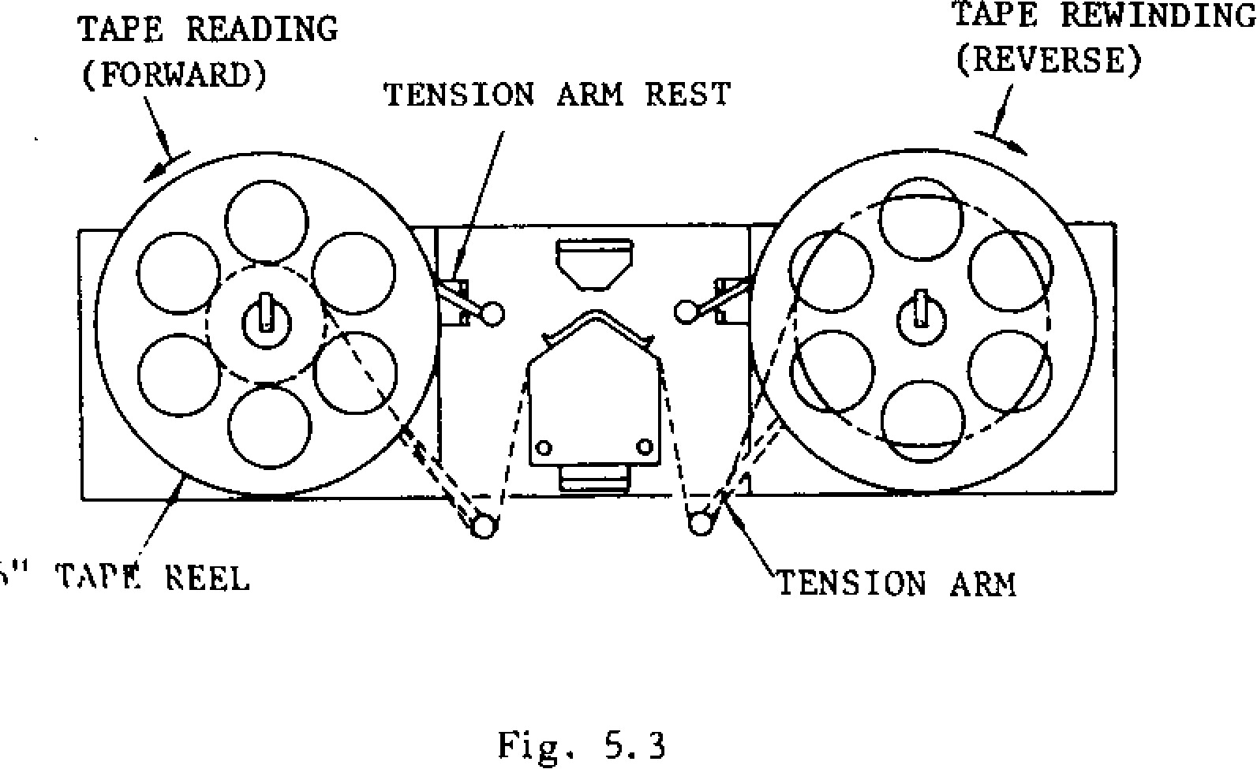



"

TAPP': REEL

ENSION ARM

TAPE READING

(

FORWARD

)

TENSION ARM REST

TAPE REWINDING

REVERSE

)

(

Fig. 5.3

**5 . 2 . 1 T A P E R E E L S ( C O N T ' D )**

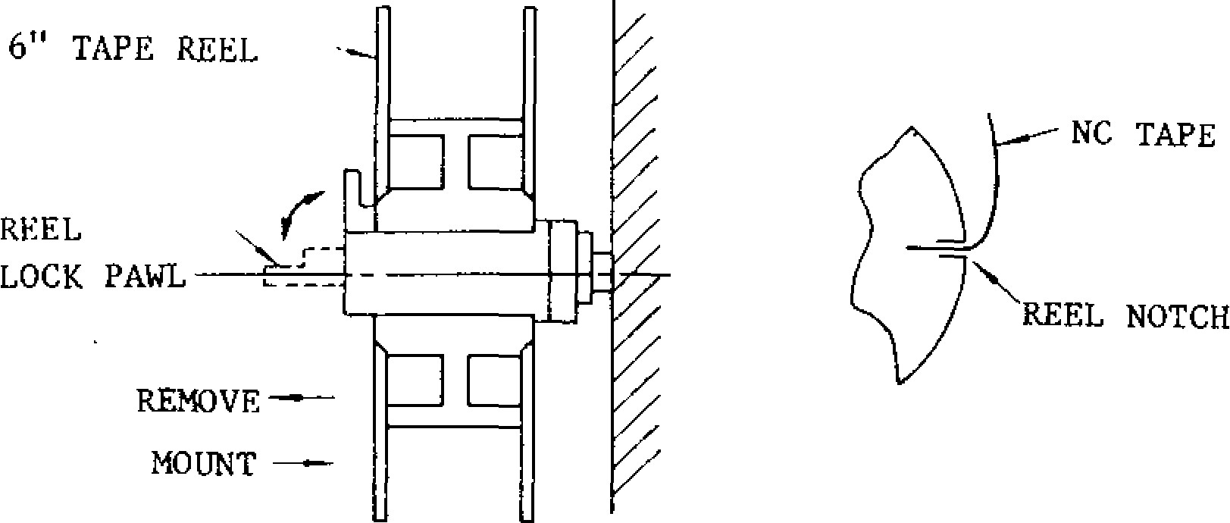

F ig . 5 .4

1. Mount a reel with a tape wound on it on the right reel shaft, align the reel lock slot with t h e r e e l lo c k p a w l , a n d p u sh t h e l o c k p a wl to the vertical position to lock the reel to the shaft.
2. Pull the tape approximately 1 m out of the re el, an d pa ss it th ro ug h th e tap e rea de r.
3. Wind the free end of the tape on the left reel i n t h e sa m e w a y a s 1 th ro u g h 3 , a n d m o u n t the reel on the left reel shaft. At this time, w i n d th e ta p e a t l e a st 3 t u r n s t o e l i m in a te any possibility of slipring loose.
4. Holding the reel with hand to prevent slackening o f t h e t a p e , f r e e t h e t e n s i o n a r m f r o m t h e t e n s i o n a r m r e s t , a n d l o w e r i t g e n t l y . T h e b ro k e n lin e s in F ig . 5 .2 .2 .1 sh o w th e correctly se t tape.

No w, the tape can be moved and wound smooth ly i n e ith e r d ir e c ti o n s in t h e a u t o ma ti c o p e ra ti o n

mode or by the manipulation of the TAPE FEED switch.

NOTES:

When dismounting the tape reel, observe the following two points.

( 1 ) Ho l d t h e re e l t o b e re m o v e d b y h a n d , a n d l e t t h e t e n s i o n a r m b e a r re s t e d b y t h e te nsion arm rest.

( 2 ) Push up the tape guide of the tape reading head befo rehand.

• S ta rt o p e ra tio n o n ly a fte r ma k in g su re th a t

the reel lock pawl is engaged in the lock slot in the reel.

**5 . 2 . 3 H A N D L I N G 8 - I N C H T A P E R E E L S**

Wh en th e tap e is n o t in u se, an d wh en mou nting a n d d ismo u n tin g th e ta p e , b e su re to s witc h o ff t h e p o we r su p p ly s w it c h . In th is c o n d it io n , th e reel motor is switched off, and the reels are free. Names and the functions of members are as follows.

Power supply switch

When this switch is turned on, the tape reels are ready to opera te.

Guide rollers

They guide the tape in rewinding and in forward feeding.

* Tension a rm

In conjunction with the guide rollers, the ten s i on a rm s gi ve p ro p e r t en s io n to the ta pe a nd eliminate slack.

* T e n s i o n a r m s t o p p e r

While no tape is mounted on the tape reader, th e ten sio n a rms rest o n th ese stop pe rs.

* 8 " ta p e re e l

In a tape reel 8" in diameter, a part program tape approximately 180 m in length can be wound.

* R e e l h u b

|  |
| --- |
| **- 150 -** |

The reel hubs are mounted on the reel spindle, and serves to receive and a rrest tape reels on them.

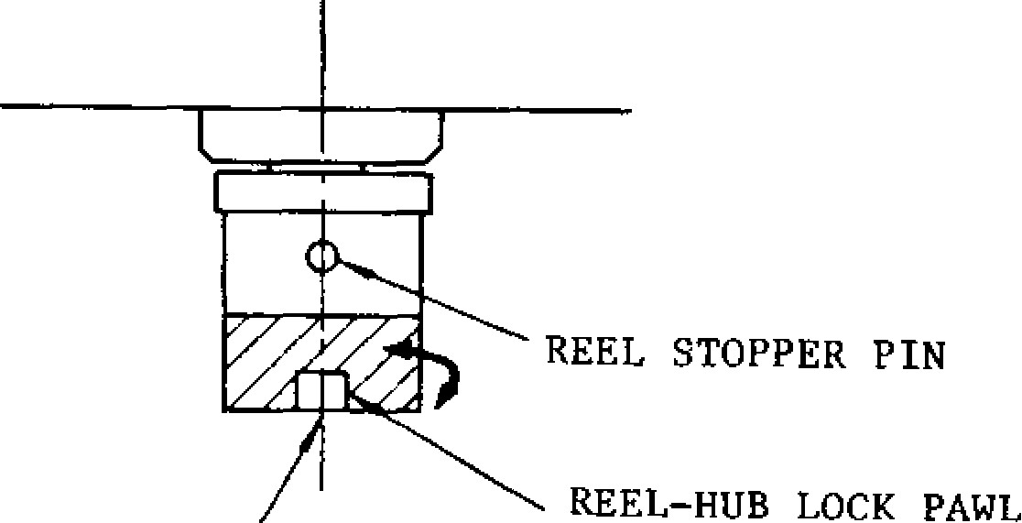

REEL STOPPER PIN

REEL

-

HUB LOCK PAWL

REEL SPINDLE

Fig. 5.6

* Tape threading graphic plate

This plate shows the tape threading route graphically.

Threa d th e part pro gra m tape as follows.

1. . H o l d in g th e r ig h t re e l w ith o n e h a n d , tu rn th e re el hub un til th e pawl is aligned with th e ree l g ro ov e , an d d ismo u nt th e o utside reel flange, the tape bobbin, and the inside reel flange from the tape hub.
2. . In se rt the tra iling en d o f th e pa rt p ro g ra m tape in the slit in the tape bobbin, and wind th e tap e o n it. (Whe n a ta p e bo bb in witho ut a s l it i s u s e d , fa st e n t h e t a p e e n d t o th e bobb in with adh esive tape.)

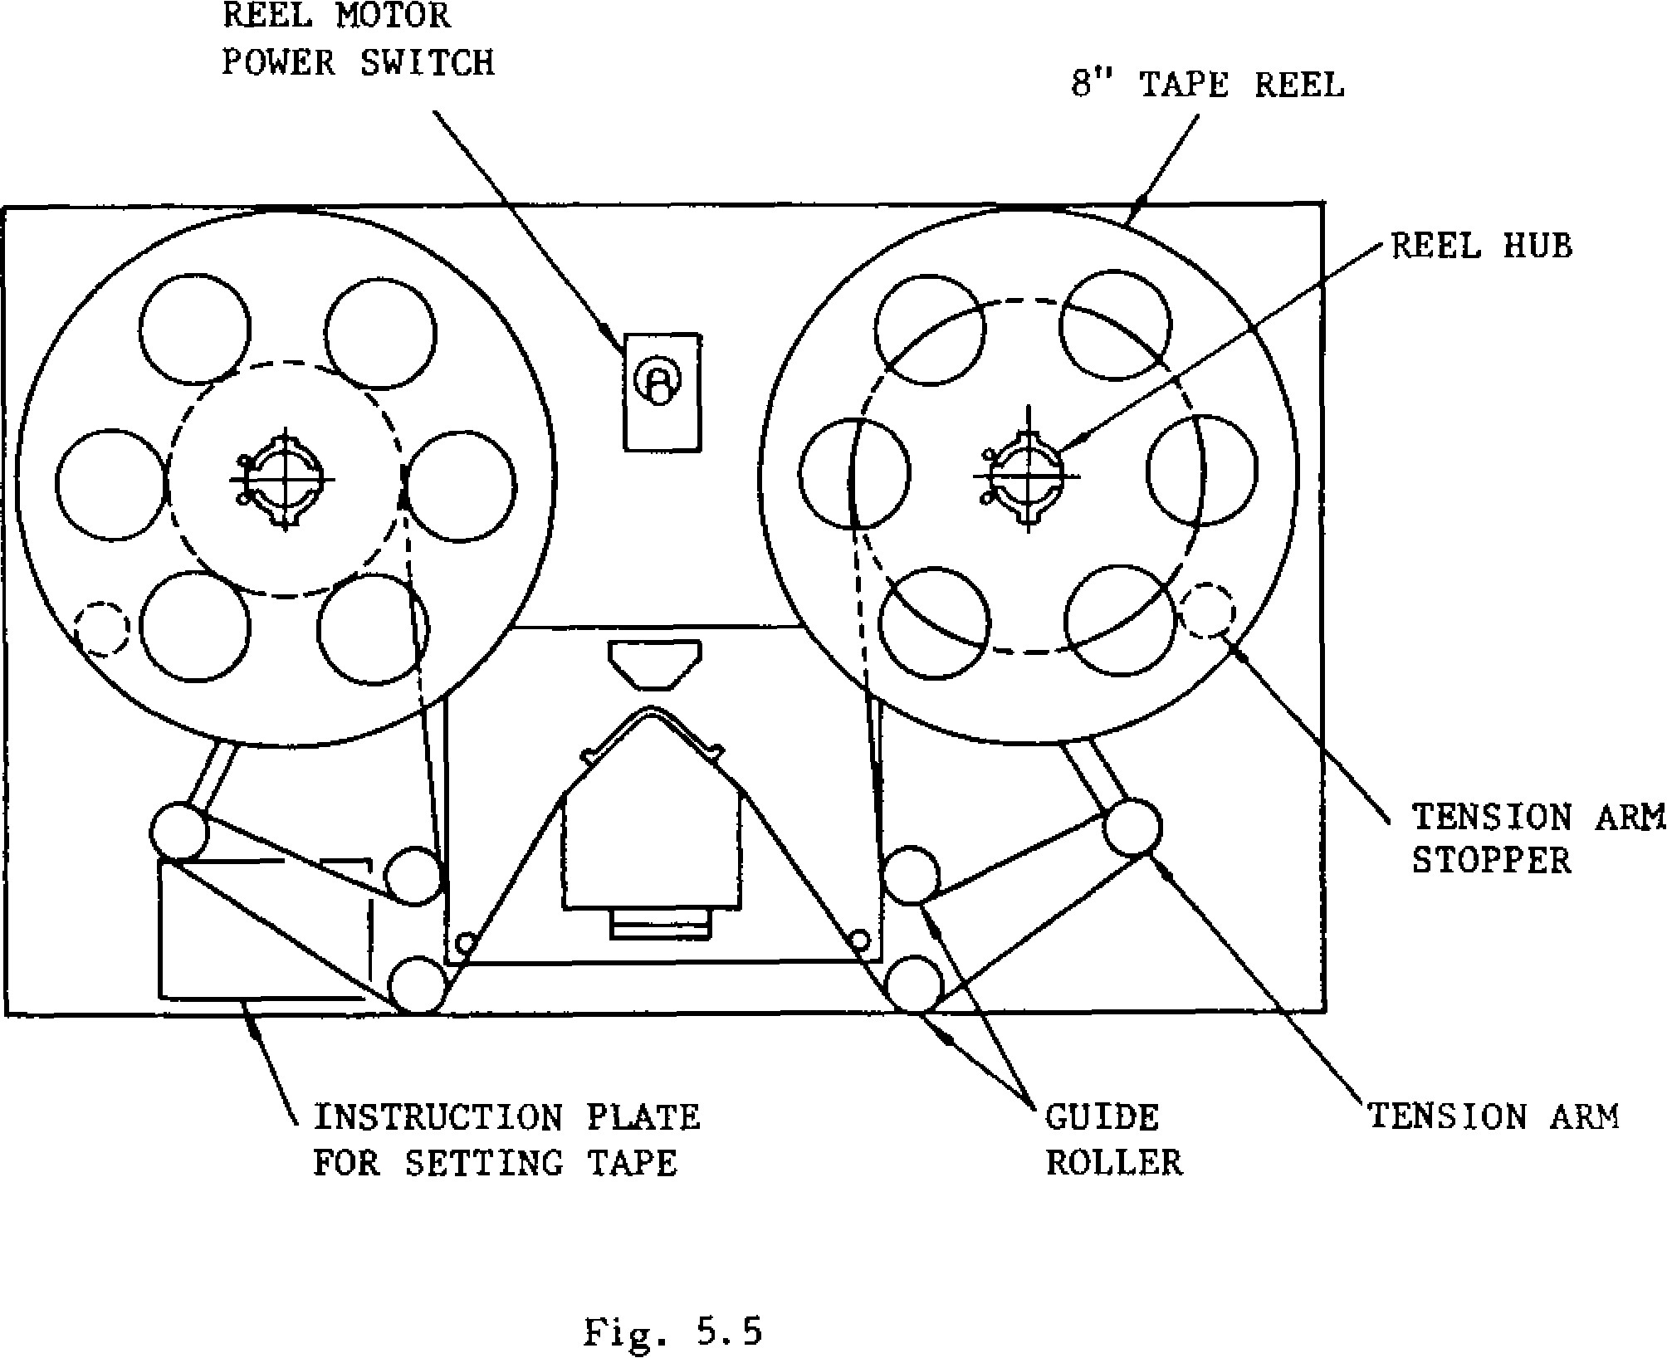

REEL

MOTOR

POWER SWITCH

8

" TAPE REEL

INSTRUCTION PLATE

FOR SETTING TAPE

GUIDE

ROLLER

TENSION ARM

STOPPER

Fig. 5. 5

1. . Turn the reel hub until the lock pawl is align e d w i t h t h e s t o p p i n . ( S e e F i g . 5 . 2 . 3 . 2 )
2. . Mount the inside reel flange on the reel hub, a lig n in g th e g ro o v e in th e fla n g e with th e lock pawl on the reel hub.
3. . Mount the reel bobbin with a part program tape wound on it on the inside reel flange.
4. . Mount the outside reel flange , a ligning th e n o tc h in the fla ng e with th e loc k p a wl, an d turn the lock pawl until it is brought between the two notches on the inside reel flange.
5. . Unwind the part .program tape approximately

1. 5 m.

1. . Thread the tape through the right guide ro llers and the tension a rm to the tap e re a d e r.
2. . Wind the leading end of the tape on the left ree l in th e sa me wa y as 1 th rough 6. In t h i s c a s e , w i n d t h e t a p e 2 t o 3 t u rn s o n th e tap e bobb in and make sure that the tape does not slip loose when pulled.

5.2.3 **HANDL I NG 8 -i NCH T APE REEL S (CONT' D)**

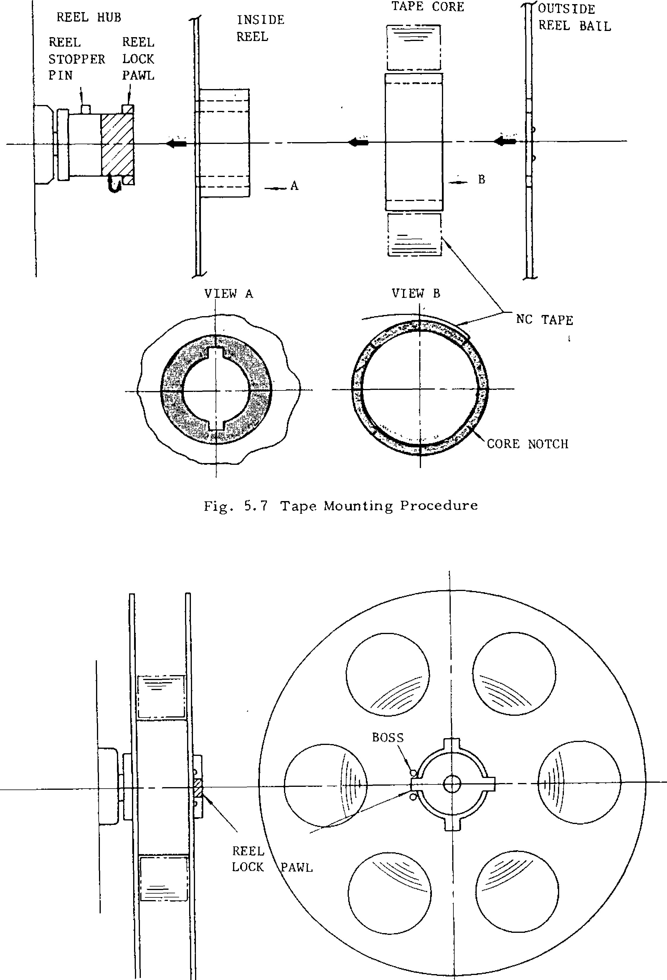

BOSS

REEL

LOCK •AWL

REEL HUB

REEL

REEL

STOPPER LOCK

PIN

PAWL

INSIDE

REEL

-

A

OUTSIDE

REEL BAIL

...

-

/

VIEW A

Fig.

5.

7

Tape Mounting Procedure

F i g . 5 . 8 M o u n t e d T a p e R e e l w i t h T a p e

- 15Z -

1 0 . Th rea d the ta pe th roug h th e left g u id e roll - NOTES:

e rs a n d th e te n sio n a r m, a s sh o wn in th e tape threading graphic plate.

• Wh ile the part prog ram ta pe is no t in use, keep

1 1 . T u r n t h e t w o r e e l s b y h a n d a n d b r i n g t h e t e n si o n a r ms t o a m id d le p o si t io n b e t w e e n

the guide rollers and the tension arm stopper. N o w , t h e t a p e r e e l s a n d t h e p a r t p r o g r a m t a p e h a v e b e e n p r o p e r l y m o u n t e d a s s h o w n

in F ig . 5 .2 .3 .1 .

1 2 . T u r n t h e p o w e r s u p p l y s w i t c h o n . The tension arms may move momentarily, but b e c o me sta b le so o n . No w, th e ta p e c a n b e driven smoothly in both directions in the automatic operation mode and by the mani pulation of the TAPE FEED switch.

th e po wer supply switch turn ed off.

− Before dismounting the loaded tape reels, be sure to do the following.

( 1 ) T u r n o f f t h e p o w e r s u p p l y s w i t c h .

( 2 ) Release the tape from the tension arms.

( 3) Push up the tape guide a w a y from the tape re a d e r.

• While the power supply switch is on, do not **turn the** tape reels by hand , etc .

**5 . 2 . 3 H A N D L I N G 8 - I N C H T A P E R E E L S (C O N T ' D )**

|  |  |  |
| --- | --- | --- |
| MODE SELECT | OP-  OP- TIONAL  SINGLE TIONAL BLOCK DRY | DIS- Z-AXIS  PLAY OFF NE- FUNCTION |

|  |  |  |
| --- | --- | --- |
| EDT | MANUAL MIRROR IMAGE OVERRIDE  ABSOLUTE AXIS CANCEL  X  (q)1  1  OFF C)  OFF OFF | START EDIT  LOCK-:' LOCK+ OFF OFF |

CYCLE FEED BLOCK STOP SKIP RUN LOCK MACHINE GLECT LOCK

START HOLD TAPE (q) LOCK ©

0 0 MEM MDI HANDLEtSTEP

JOG OFF OFF OFF OFF OFF OFF

PID

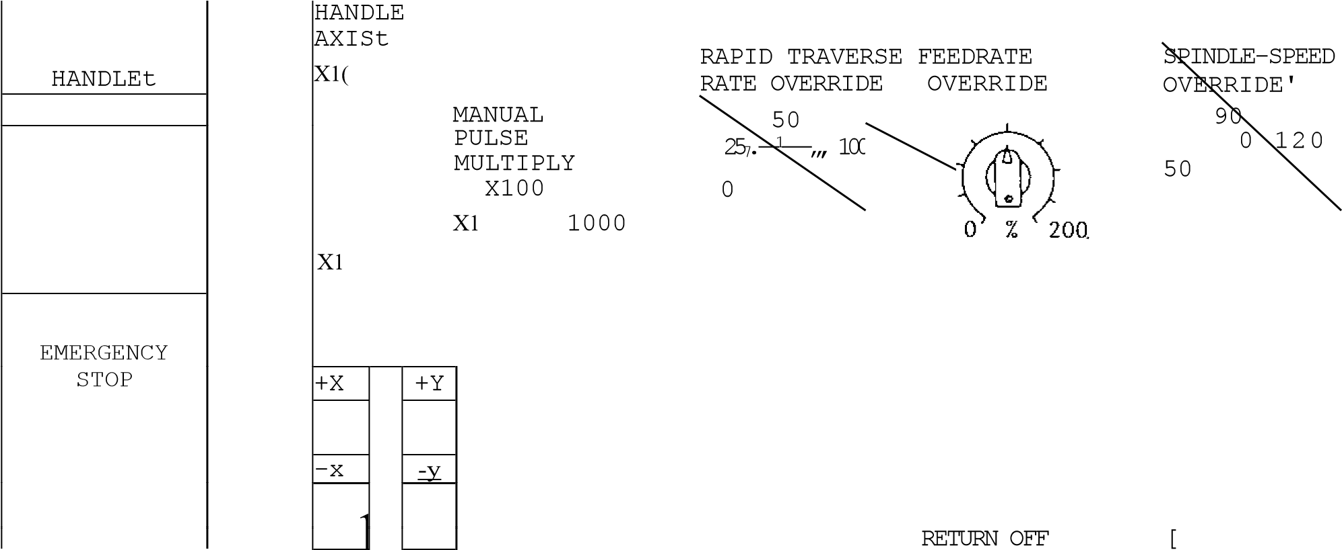X10,000

X100,000

REFERENCE POINTt TOOL LENGTH JOG FEEDRATE

+Z +ict X yz MEASUREMENTt

I) 0 CI 0

" r i ' MEASURE- WRITE & iii REFERENCE POINT aMENT RETRACT it 107



Fig. 6.1 Machine Control Station

1. **MACHINE CONTROL STATION** 
   1. **SWITCHING UNITS ON THE CONTROL STATION**

Fig. 6.1.0 shows the layout of switching units on the control station. For details, refer to the ma chine tool builder's manual.

**6.1.1 MODE SELECT SWITCH**

T h is switc h g iv es th e o pera to r a ch o ic e a mon g the following eight modes of operation (RAPID, JOG, STEP, HANDLE, TAPE, MDI, MEM, EDT). RAPID, JOG, an d HANDLE mode s are called manua l operation mode, and TAPE, MDI, and MEM, automatic-operation mode in this manual.

RAPID: Allows the tool to traverse rapid ly or return to reference zero by manual operation.

JOG: Allows the tool to feed continuously by m a n u a l o p e ra tio n . F e e d ra te is se t b y J O G FEEDRATE switch.

STEP: Allows the tool to feed manually by step each time JOG push button is depressed.

HANDLEt: Allows the tool to feed by operating th e manual pulse gene ratort.

TAPE: Automatically controls the system from NC tape.

M D I: Al lo ws th e o p e ra to r to in se rt u p to 1 0 blocks of data through the DATA keyboard and control the system automatically with the data.

MEM: Automatically controls the system with the stored part program.

EDT: Stores the part program into memory and ed it the pa rt p rogra m.

**CYCLESTART HOLDFEED** TAPE

0 MEM MDI HANDLESTEP t

fl EDT JOG



RAPID

**6.1.2 CYCLE START PUSHBUTTON AND LAMP**

D e p r e s s t h i s p u s h b u t t o n t o s t a r t t h e s y s t e m i n th e automa tic opera tion mode (TAPE, MDI a nd MEM). The CYCLE START indicating lamp lights when auto matic ope ration starts. Depress it aga in

to start the o peration a fter te mpora ry stop by operating FEED HOLD pushbutton or MODE SE LECT switch.

**6.1.3 FEED HOLD PUSHBUTTON AND LAMP**

When the FEED HOLD pushbutton is depressed during automatic operation, the feedrate is de creased immediately and machine motion is stop p e d. Fe ed ho ld is no t ac tiv e d u ring ta pp ing b y G84, ho wever, it fu nctio ns durin g positio ning b e fo re ta p p in g . De p re ssin g th e F E ED H O LD pushbutton during dwell by G04 works on com pletion of the curren t block .

I f i t i s d e p r e s s e d w h i l e M - , 5 - , T o r B t - f u n c tio n with ou t mo ve c o mma n d is b e in g ex ec u te d, the FEED HOLD lamp will light, but these func tions will be continued until finished. On com pletion of the function, the lamp goes off and ma c h in e op era tio n is sto p pe d. Dep ress the CY CLE START pushbutton to resume the operation after temporary stop by op erating FEED HOLD p u sh b u tto n .

FEED HOLD lamp is automatically illuminatcdwhen the machine stops temporarily during canned cy cles if SINGLE BLOCK switch is set on.

**6.1.4 EMERGENCY STOP PUSHBUTTON**

D e p r e s s t h i s p u s h b u t to n t o i m m e d i a t e l y s to p a l l m a c h i n e m o v e m e n t i n a n e m e r g e n c y . T h e s e r v o

po wer is tu rned o ff and the ma chine is stopped i m m e d i a t e l y b y d y n a m i c b r a k e . T h e N C A L A R M lamp lights and alarm code"330"and"310"are displayed

To recove r the system fro m an e mergency stop after the cause has been removed, take the fol lowing procedure.

1. Turn the EMERGENCY STOP pushbutton clockwise to release the locking.
2. Depress the RESET key. Alarm code "330" is deleted from page.
3. T u r n o n th e s e r v o p o w e r a g a i n b y d e p r e s s i n g P O W E R O N p u s h b u t t o n . N C A L A R M LAMP is extinguished and READY lamp lights up.

Fig. 6.2

EMERGENCY STOP

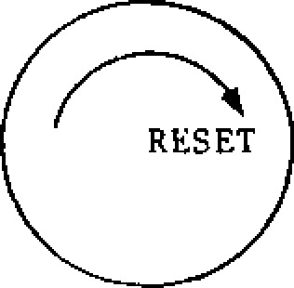 Fig. 6.3

- 155 -

|  |  |
| --- | --- |
| **6.1.5 HANDLE DIAL± (MANUAL**  **PULSE GENERATOR)**  The dial is used as a manual pulse generator to feed the tool manually with the MODE SELECT switch set to the HANDLE. HANDLE op eration is effective for an axis. Procedure of HANDLE operation is as follows:   1. • Set the MODE SELECT switch to the HANDLE. 2. Select the axis to be operated with HANDLE AXIS select switch. 3. Set the move amount per graduation of the dial by setting MANUAL PULSE MULTIPLY switch. 4. R o t a t e t h e d i a l t o m o v e t h e s e l e c t e d a x i s .   Turning it clockwise causes the axis to move in the plus direction. The axis moves in the minu s direction b y tu rning it coun terclock wise. | **6.1.6 HANDLE AXIS SELECT SWITCHt**  This switch is used to select an axis to be op.n -- a t e d . F o r o p e r a t i o n o f t h e s w i t c h , s e e 6 . 1 . 5 Handle Dial +.  **6.1.7 MANUAL PULSE MULTIPLY SELECT**  **SWITCHt**  This switch is used to:  . S e le c t th e v a lu e fro m T a b le 6 .1 . c o rre sp o n d ing to a single graduation of the HANDLE dial in the HANDLE mode.  • Selec t the mov e a mount (1 step) fro m Table 6.2 corresponding to each depression of JOG push butto n in the ST EP mode. |
| HANDLE HANDLE **AXIS** | **MANUAL** |

**PULSE MULTIPLY** X100

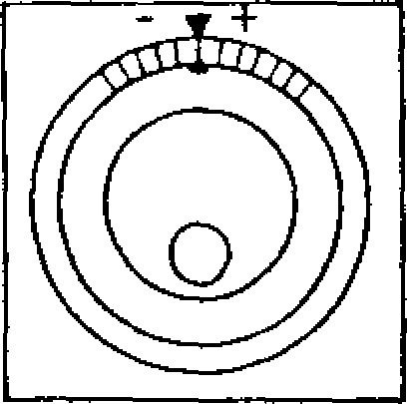

X10 X1000

**X**

xl X10000

X100000

F ig . 6 .4

Table 6.1 Selection of Move Amount in the HANDLE Modet

|  |  |  |  |
| --- | --- | --- | --- |
|  | Metric | Inch | Rotating Angle+ |
| x 1 | 0.001 mm/ graduation | 0.0001 inch/ graduation | 0.001 deg/ graduation |
|  | 0.01 mm/ | 0.001 inch/ | 0.01 deg / |
| x 10 | graduation | graduation | graduation |
| x 10Q x 1000 x 10000 x 100000 | 0.1 mm/ graduation | 0.01 inch/ graduation | 0.1 deg / graduation |

Table 6.2 Selection of Move Amount in the STEP Mode

|  |  |  |  |
| --- | --- | --- | --- |
|  | Metric | Inch | Rotating Anglet |
| x 1 | 0.001 mm /step | 0.0001 inch/step | 0.001 deg /step |
| x 10 | 0.01 mm /step | 0.001 inch/step | 0.01 deg /step |
| x 100 | 0.1 mm /step | 0.01 inch/step | 0 .1 d e g /ste p |
| x 1000 | 1.0 mm /step | 0.1 inch/step | 1.0 deg /ste |
| x 10000 | 10.0 mm /step | 1.0 inch/step | 10.0 deg/step |
| x 100000 | 100.0 mm /step | 10.0 inch/step | 100.0 deg/step |

**6. 1.8 HANDLE DIALS FOR SIMULTANEOUS CONTROL OF UP TO THREE AXES +**

When a manual pulse generator is connected for each axis, the tool can be manually moved along selected three of the four axes (X, Y, Z and a) simultaneously.

1. The tool move distance per graduation of the HANDLE dial for the manual pulse generator is determined by the MANUAL PULSE MULT IP L Y s w it c h (T a b l e 6 .1 .7 .1 ). T h is s w it c h is effective on all the three axes.
2. **Set the mode select switch to HANDLE, and turn the HANDLE dials for the desired axes in the positive or negative direction.**

JOG

nl+x +Y +2

-x -Y -Z -4

F ig . 6 .6

**6.1.10 JOG F EED R A T E SW I T CH**

The JOG FEEDRATE switch is used to select the **jog feedrate in the JOG mode. Up to 32 steps** of **feedrate can be specified. Jog feedrate depends on the machine tool. For definite values, refer to the machine tool builder's manual. See Table 6.1.10. The JOG feedrate can be preset by parameters #6233 to 6264.**

F ig . 6 .5

RAPID TRAVERSE

JOG FEEDRATE

RATE OVERRIDE

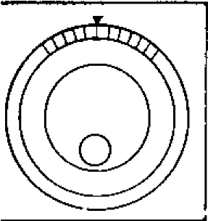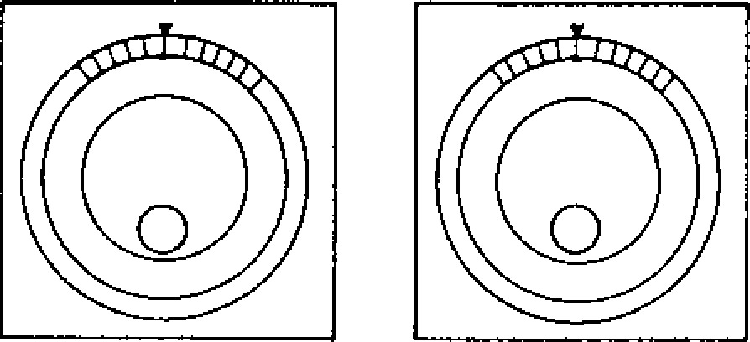

X

-

AXTS

xl

Z

-

AXIS



X10000

X100000

Y

-

AXIS

**MANUAL •**

**PULSE MULTIPLY**

X100

X

1

0

it‘

X

1

000

IsT

**6. 1. 9 JOG PU SH B UT T ONS**

This pushbutton is used to feed the tool manually.

W i th a n y o f p u sh b u tt o n s + X , - X , + Y , - Y , + Z , o r -Z (+a , **-(1)±** h e ld in th e RAPID mo d e , th e ax is can be move d rap idly until the b utton is released.

T h e s e p u sh b u t to n s mo v e t h e to o l a t th e s p e e d set by JOG FEEDRATE switch in the JOG mode.

• Eac h time the pu shbutto n is depre ssed in the **STEP** mode, the tool is moved by the value per step set by MANUAL PULSE MULTIPLY select switch. Maximu m fe edrate per step is de ter7 mined by parameter # "6222."

N OT E: J O G p u sh b u tto n s **work on all axes.**

**6. 1. 11 R A PI D T RA VER SE R A T E OVER R ID E SWITCH**

T h i s s w i t c h i s u s e d t o a d j u s t t h e t r a v e r s e r a t e by FO, 25, 50 and 100%. 100% Rate is the rapid t r a v e r s e r a te s e t b y p a r a m e t e r # 6 2 8 0 t o 6 2 8 3 .

T h e s w i t c h i s e f f e c t i v e b o t h i n a u t o m a t i c operation including G00 command and in manual opera t i o n **(RAPID mode). FO** i s s e t b y p a r a m e t e r

#6231.

**6 . 1 . 1 2 F E E D R A T E O V ER R I D E S W I T C H**

In th e a u to ma t ic o p e ra t io n m o d e ( T A PE , M E M , M D I) , t h i s s wi tc h is u se d to a d ju st t h e f e e d ra te by 10% from 0 to 200% of the programmed feedrate specified with an F function at whatever position t h e s w i t c h m a y b e s e t . F e e d d u r i n g t a p p i n g b y G74 an d G3 3 **follows F command.** Wh ere OVERRIDE CANCEL switch is set on, the tool will be moved at the p rogra mmed feedra te by **V** code reg ardle ss o f switch setting .

FEEDRATE OVERRIDE SWITCH (CONT I())

T a b l e 6 . 3 J o g F e e d r a t e

|  |  |  |  |  |  |
| --- | --- | --- | --- | --- | --- |
| Step | Parameter No. | mm /min | Step | Parameter No. | mm /min |
| 0 | #6233 | 0 | 16 | #6249 | 100 |
| 1 | #6234 | 1 | 17 | 46250 | 120 |
| 2 | #6235 | 2 | 18 | #6251 | 150 |
| 3 | #6236 | 4 | 19 | #6252 | 200 |
| 4 | #6237 | 6 | 20 | #6253 | 250 |
| 5 | #6238 | 8 | 21 | #6254 | 300 |
| 6 | #6239 | 10 | 22 | #6255 | 400 |
| 7 | #6240 | 12 | 23 | #6256 | 500 |
| 8 | #6241 | 15 | 24 | #6257 | 600 |
| 9 | #6242 | 20 | 25 | #6258 | 800 |
| 10 | #6243 | 25 | 26 | #6259 | 1000 |
| 11 | #6244 | 30 | 27 | #6260 | 1200 |
| 12 | #6245 | 40 | 28 | #6261 | 1500 |
| 13 | #6246 | 50 | 29 | #6262 | 2000 |
| 14 | #6247 | 60 | 30 | #6263 | 2500 |
| 15 | #6248 | 80 | 31 | #6264 | 3000 |

Notes:

− J o g f e e d r a t e d e p e n d s o n t h e m a c h i n e t o o l . For definite values, refer to the machine tool builder's manual.

• F e e d r a t e o f t h e f o u r t h a x i s ± , i f p r o v i d e d , i s s h o w n b y d e g / m i n .

**Table 6.4 FEEDRATE OVERRIDE**

|  |  |  |  |  |
| --- | --- | --- | --- | --- |
| STEP | % |  | STEP | % |
| 0 | 0 |  | 11 | 110 |
| 1 | 10 |  | 12 | 120 |
| 2 | 20 |  | 13 | 130 |
| 3 | 30 |  | 14 | 140 |
| 4 | 40 |  | 15 | 150 |
| 5 | 50 |  | 16 | 160 |
| 6 | 60 |  | 17 | 1 7 0 |
| 7 | 70 |  | 18 | 180 |
| 8 | 80 |  | 19 | 190 |
| 9 | 90 |  | 21 | 200 |
| 10 | 100 | , |  |  |

OVERRIDE

CANCEL

1

FEEDRATE

OVERRIDE

 200% Fig. 6.8

**6. 1. 13 F EED R AT E OVER R I D E CA N C EL SW I TC H**

Turning on the OVERRIDE CANCEL switch prevents the function of FEEDRATE OVERRIDE switch.

**6, 1. 14 SPI N D L E SPEED OV ER R ID E SW I TC H t**

1. **With this switch, the current spindle speed can be changed to an override speed which is set at 10% intervals between 50 and 120% of the** current spindle speed.
2. During the tapping cycle by G74 and G33 under the command of G84, the spindle speed m a y se l ec t iv el y b e m ad e in d ep end e nt o f this switch, remaining at the speed set by an S **code.** This selection is made with the parameter #6007)) 2.

SPINDLE-SPEED OVERRIDE±

90

20%

50

Fig . 6.9

**6.1.15 MANUAL REFERENCE POINT RETURN SW I T C H t**

This switch is for bringing the tool back to the **reference point manually.**

For its operation method, refer to 6.2.1 MANUAL RETURN TO REFERENCE POINT.

**6 . 1 . 1 6 R E F ER E N C E P OI N T L A M P s i**

These lamps indicate that the tool is positioned on the reference point. They light when the tool is brought to the reference point through the manual or automatic return to reference point (G28), or by the reference point return check (027), and goes out as the tool moves away from the reference point by a subsequent operation.

ZERO POSITION±

X Y Z 4 niZICI

I tit I

REFERENCE POINT SINGLE

RETURN BLOCK

OFF OFF

Fig. 6.10

**6. 1. 17 SI N GL E B L OC K SW I T CH**

T u rn ing on t hi s s wi tc h permits individual blockby-block operation. Turning on this switch after finishing the current block in the automatic opera t io n mode, the machine stops. A block of data is executed each time the CYCLE START p u s h b u t t o n is activated.

**6 . 1 . 1 8 O P T I ON A L ST O P S W I T C H**

This switch is to execute M01 command in automatic operation mode (TAPE, **MEM** or MDI).

When th e switch is on, th e p r o g r a m s t o p s o n completion of the block including M01 command, while CYCLE START pushbutton remains illu m i n at ed . Wh en th e control catches FIN signal, the light is extinguished. To restart the pro gram, depress the CYCLE START button. When the switch is off, M01 command is ignored.

Operation of the switch is not effective for the block being executed. During the automatic 'operation, the switch acts for the next block.

**6 . 1 . 1 9 O P T I ON A L B L OC K S K I P SW I T C H**

This switch selects whether the data in blocks including a " is disregarded or not.

1. While the switch is on, all the commands in a block **programmed** after a " *I"* are neglected. However, block data appearing before the "/" remains effective.

- 159 -

|  |  |  |
| --- | --- | --- |
| 6.1.19 OPTIONAL BLOCK SKIP SWITCH  (CONTI()) | | **6. 1. 21 D I SPL A Y L OC K /MA C H IN E L OC K SW I TC H** |
| 2 | While this switch is off, blocks including a " / " a r e e x e c u t e d a l o n g w i t h o t h e r b l o c k s . This switch is ineffective on the block under execution and blocks stored in the advance r e a d i n g b u f f e r . W h e n t h is s w i t c h i s t u r n e d o n d uring an a u to ma tic op e ra tio n c yc le , it w o rk s o n th e b lo c k re a d a fte r th e sw itc h in g on has o ccured . | T h i s s w i t c h f u n c t i o n s t o s t o p u p d a t i n g t h e p o s i t i o n d i s p l a y , o r t o s t o p m o v e c o m m a n d p u ls e s t o t h e s e r v o s . T h is s wi t c h c a n n o t b e s e t u n l e s s t h e m a c h i n e i s s t o p p e d a t b l o c k e n d o r t e m p o r a r i l y s t o p p e d b y F E E D H O L D p u s h b u t t o n .  LOCK MODE  OFF |

1

NOTES:

1. . T h e t w o c o m m a n d s " / " a n d " / 1 " a r e e q u i v a l e n t . DISPLAY MACHINE
2. . With the control p rovided with the o ption al block skip B function +, 8 independent blocks can be skipped with the switching of the

switches corresponding to "/2" through " /9."

LOCK LOCK

F i g . 6 .1 2

**6. 1.20 DRY RUN SWITCH**

T u rn in g o n t h e D R Y R U N s w it c h i n th e T A P E , MDI or MEM mode causes the tool to move at the spe ed se lected by the JOG F EEDRAT E switch, i g n o r i n g a l l p r o g r a m m e d F - f u n c t i o n s . F c o m m a n d s c a n b e d i s p l a y e d a s t h e y a re p ro g ra m m e d . T h i s s wi t c h m a y b e u se d to c h e c k th e p ro g ra m.

Rapid traverse (G00) rate for d ry run ope ration can be set by setting parameter # "6006D2. 11

Parame ter Ra p id Trav e rse a t

# "6006D 2" Dry Run Operation

110 tiRapid traverse ra te*

Jog feed rate

* Th e too l mo v es a t th e tra ve rse rat e set by RAPID TRAVERSE RATE OVERRIDE switch if provided.

NOTES:

S w i t c h i n g t h e D R Y R U N s w i t c h d u r i n g a u t o matic operation becomes effective on the current block. Switch ing it in mm/re v mod et o r during ta pping beco mes effectiv e o n the next bloc k.

* Rapid traverse rate override is kept effective d u r i n g d r y r u n o p e r a t i o n .
* D u r i n g t a p p i n g , t h e s e t s p e e d wh e n t a p p i n g s t a rt s wi ll be ke pt . It c an n ot b e ch a ng ed by J O G o p e r a t i o n d u r i n g d r y r u n o p e r a t i o n .

DRY

RUN

1 ( ) OFF

Fig. 6.11

-

160

-

"OFF"

Usual operation is made at "OFF" position in both m a n u a l a n d a u t o m a t i c o p e r a t i o n . T h e m a c . a i n e and the position display operate according , to the command by automatic operation or manual opera tion.

"DISPLAY LOCK"

This position is used to exclude the axis movem e n t v a l u e f ro m t h e p o s i t i o n d i s p l a y . C u . - re n t

p o si t io n d i sp la y i s n ot up d at ed , th oug h th e ma chin e moves .

"MACHINE LOCK"

S e t t i n g t h e s wi t c h a t M AC H IN E L O C K i n h i b i t s a x i s m o v e m e n t i n c l u d i n g Z e r o R e t u rn . T h e p o s ition disp lay i s upd ated. 5 - , a n d T - f u n c - t i on s a re ex e cu te d . T hi s po s i ti on i s s e le c te d to p r e s e t t h e d i s p l a y o r t o c h e c k t h e t a p e d a t a .

6 . 1 . 2 2 **Z - A XI S F E ED N E GL E C T S W I T C H**

T h e s w i t c h i s u s e d f o r d r y r u n o p e r a t i o n o r d r a w i n g - c h e c k o p e r a t i o n o n t h e X - Y p l a n e . T u r n i n g o n th e s wi t c h c a u s e s t h e Z -a x i s i n M AC H INE L O C K c o n d i t i o n . T h e Z - a x i s m o v e m e n t i s i n h i b i t e d , t h o u g h t h e p o s i t i o n d i s p l a y i s u p d a t e d .

O p e r a t e t h e s w i t c h w h e n t h e m a c h i n e i s s t o p p e d . T h a t i s , t h e s wi t c h d o e s n o t fu n c t io n e x c e p t w h e n t h e m a c h i n e i s s t o p p e d a t t h e b l o c k e n d b y S I N G L E B L O C K s w i t c h o r t e m p o r a r i l y s t o p p e d b y

F E E D HOL D p u s h b u t t o n .

**6.1.23 M -FUNCTION LOCK SWITCH**

**( A U X I L I A R Y F U N C T I ON L O C K )**

When the M-FUNCTION LOCK switch is on, it i g n o r e s t h e M , S , T , a n d B t c o m m a n d s . T o check the tape data , the operation by the switch is used in combination with MACHINE LOCK function.

AUXILIARY FUNCTION LOCK

OFF

**Fig. 6.13**

**The following M codes are executed even if the switch is set on.**

* **MOO, M01, MO2, M30**

**Both its decoded signals and its BCD codes are sent out to the machine.'**

* **M90 to M99 BCD code is not sent out.**
* **Turning on the M-FUNCTION LOCK switch during automatic operation becomes effective on the block after the next block of the current block.**

**6. 1. 24 M A NU AL A B SOLUT E SW I T CH**

• **When MANUAL ABSOLUTE SWITCH** is on.

**When** automatic operation is restarted after **inter rupted by manual operat ion, the tool per forms the rest of the command in the interrupted block from the end point of manual operation. The tool** mo v e s in p a ra lle l with th e p a th sp e c i fie d **by the program.**

**When the command of the next** block **is GOO** or G01, th e tool mo ves auto matically to the tar g e t **coordinate specified by the program. Then the operation is performed according to block of data.**

**When the command of the next block is G02 or 003 (circular interpolation), the interpolation is performed in parallel with programmed command. The tool automatically returns to the target coordinate when GOO or 601 is commanded after the circular interpolation.**

**REST OF TRAVEL C ACTUAL MOVEMENT PE COMMAND**

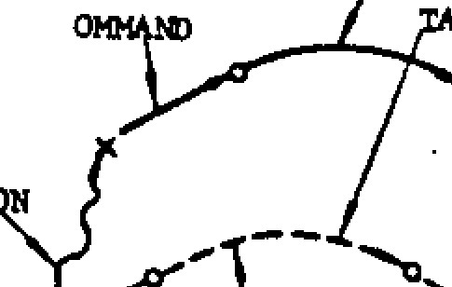

**CIRCULAR**

**e4M:PORARY INTERPOLATION**

**STOP**



**MANUAL**

**OPERA TI TRAVEL TO TARGET COME INATE SPECIFIED**

**BY PROGRAM COMM**

**GOO OR GOl COMMAND**

**(FEED HOLD)**

Fig . 6 .14

- 161

• When MANUAL ABSOLUTE switch is off.

After the automatic operation is interrupted by m a n u a l o p e r a t io n , **the coordinate** sy st e m is sh ifted , an d the too l performs the rest of the travel co mma nds **in parallel with programmed moves.**

**Fig. 6.15 Tool Movement** w i t h

**REST OF ACTUAL MOVEMENT TAPE COMMAND**

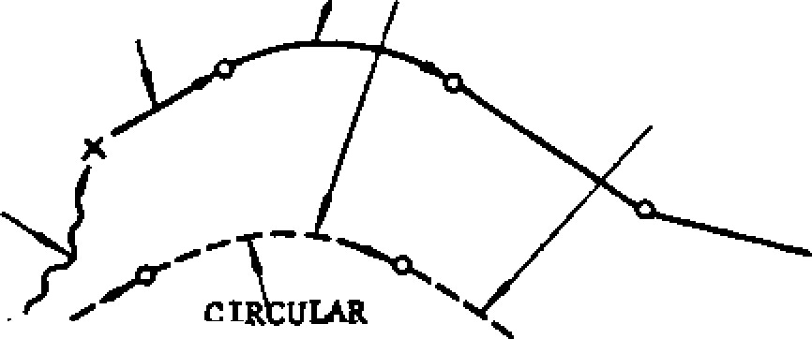**TRAVEL COMMAND**

**GOO OR COI COMMAND**

**MANUAL**

**OPERATION**

**MANUAL**

**ABSOLUTE**

**INTERPOLATION**

**TEMPORARY STOP** No.

**(FFED HOLD) OFF**

MANUAL ABSOLUTE Switch Off

The parallel shift is reset by executing Refer e n ce Ze ro Re tu rn ma nu ally , a u to ma tica lly b y G 2 8 , o r o p e r a t in g th e R E S E T k e y . T h e c o m m a n d v a lu e is **forced to change to the current position. Thus the shift value** i s r e s e t .

**6. 1. 25 M I RR OR IM A GE AXI S SEL EC T OR SW I TC H**

**MIRROR IMAGE AXIS switch** s e le c t s t h e a x i s whose motion is reversed for programmed opera tions.

To select the mirror image axis with this switch a s we ll a s se tting fu nc tio n , se t th e d ata o f se t ting # " 6000DO-D3" to 0.

Turn on the MIRROR IMAGE AXIS switch of the axis to which Mirror Image function is assigned. The mo tion of the selec ted mirror image axis is set up at M95 command is given until M94 is c o m ma n d e d . F o r d e ta i ls, se e 2 .8 .5 .

**NOTE: During the M95 (Mirror Image ON) mode, never operate the MIRROR IMAGE AXIS** switc h .

MIRROR IMAGE **AXIS1** **X**

**OFF OFF**

**Fig. 6. 16**

-

|  |
| --- |
| **6.1.26 TOOL LENGTH MEASUREMENT PUSH BUTTON 6 . 1 . 2 8 E D I T L O C K S W I T C H +**  **AND LAMP' .**  Turning on the EDIT LOCK switch prevents the  Use the WRITE button to automatically store the amount fun ction of ERS , INS , ALT, and EOB k eys, and of Z-axis move manually made between "home-position" storing from NC tape. When editing is made with and "base-position" directly in `,he tool offset EDIT LOC K switc h tu rn ed on . "E DIT LO CK" memory. For operating procedure, flickers on the CRT displ.ty.  r e f e r t o 6 . 2 . 3 Au t o m a t i c T o o l L e n g t h M e a s u r e m e n t ' • |

TOOL LENGTH MEASUREMENT'

MEASURE- WRITE & MENT

0 RETRACT

Fig . 6.17

6.1 .27 **S T A R T L O C K I N P U T ( O R S W I T C H ) t**



When the START LOCK is

on, CYCLE START p u sh b u t to n d o e s n o t f u n c t io n . Us e th e S T A RT L OC K i n p u t t o p re v e n t o p e r a t i n g t h e m a c h i n e i n a b no rm al co nd itio n

d u ring au to ma tic op era tio n . The input may be use d as on /off switch on c on trol station for machine.

EDIT

LOCK

STLK **I _________ I**START

T LOCK

YASNAC OFF

START

LOCK

Fig. 6.18

**6 . 1 . 2 9 A X I S I N T E R L O C K I N P U T**

The control is provided with AXIS INTERLOCK input for each axis to prevent axis motion.

In terlo cking an axis in feed mo tion causes the axis to slow down to a stop. When the intErlock is released, the axis motion finishes the inter ru p te d b lo c k a n d p ro c e e d s to th e n e x t.

Interlocking one of the two or three axes being simultaneously interpolated disables the ir. ter polation.

YASNAC

**6.1.30 EXTERNAL DECELERATION INPUT**

**SIGNALS**

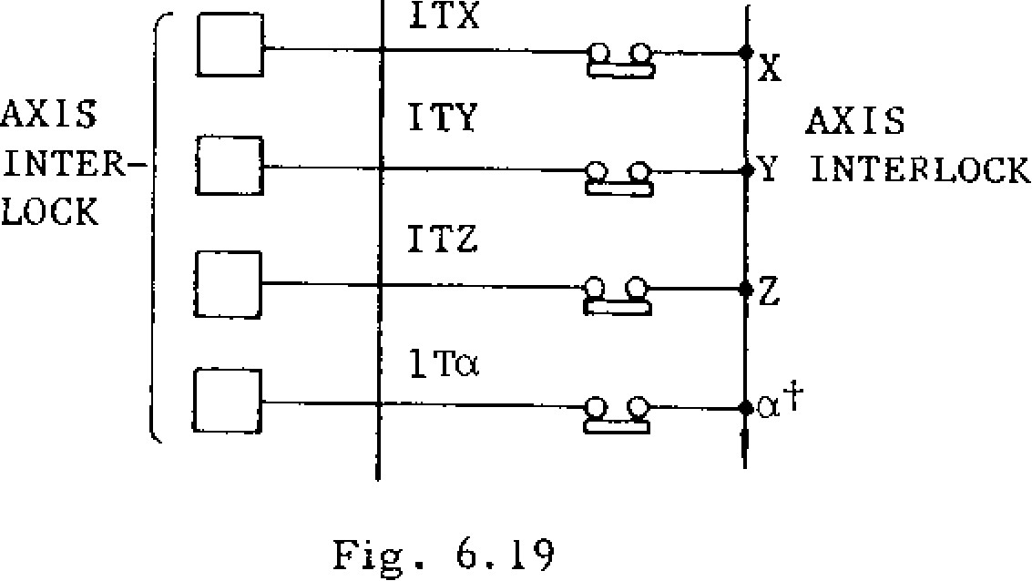

AXIS

Y INTERLOCK

AXIS

INTER

-

LOCK

ITX

Fig. 6.19

In orde r to eliminate the dange r of high speed contact at speed end caused by erroneous motion commands, limit switches for originating external d e c e l e ra t i o n i n p u t s i g n a l s m a y b e in sta lle d a t selected points.

1. During rapid traverse (GOO) and manual operation

When the limit switch is tripped by t1 -,e tool m o v e me n t, th e tra v e rse sp e e d is d e c e le ra te d i n t h e t r i p p i n g d i r e c t io n t o a l e v e l s e ': b y

th e p a ra me te r # 6 3 4 0 . In th e d ire c t io n o p p o s i t e t o t h e t r i p p in g d i r e c t i o n , t h e o r i g in a l spe ed re ma ins un changed.

1. D u r i n g m o t i o n a t f e e d r a t e ( G 9 4 )

While the limit switch is be ing tripped , the to ol move s at a speed set b y the para me ter # 6 34 1. If the fe ed ra te set b y the F co mma nd i s l o we r th a n th e ra te s e t b y th e p a ra me te r, the original feedrate remains unchanged.

V GOO

S. S. SPEED SET BY PARAMETER

#6340

F COMMAND I SPEED SET BY PARAMETER

#6341

_______________________________ t(x) gTRAVERSE RATE CLAMP LIMIT SWITCH

RELEASED OPERATED

Fig. 6.20

Notes:

1. The external deceleration function is ineffec tive on feedrate specified in mm per revolu tion o f th e sp indle (mmirev).
2. It is also ineffective on the HANDLE feed.

**6.2 OPERATION PROCEDURE**

**6.2.1 MANUAL RETURN TO REFERENCE POINT**

With h t his function, t he tool is returned to the reference point manually. The procedure is as follows.

1. Set the mode select switch to RAPID or JOG.
2. Manually move the tool to a position some d is ta n c e a w a y f ro m t h e re fe re n c e p o in t . When the tool is within the range A shown below, it can be brought back to the refer ence point in the normal way, as described below.
3. Turn on the REFERENCE POINT RETURN switch.
4. Keep the . JOG button for the return direction depressed. The tool starts to move as in the normal manual control, but the speed is de celerated at the deceleration point, and the motion stops automatically at the reference point.
5. Then, the REFERENCE POINT lamp for the relevant axis lights.

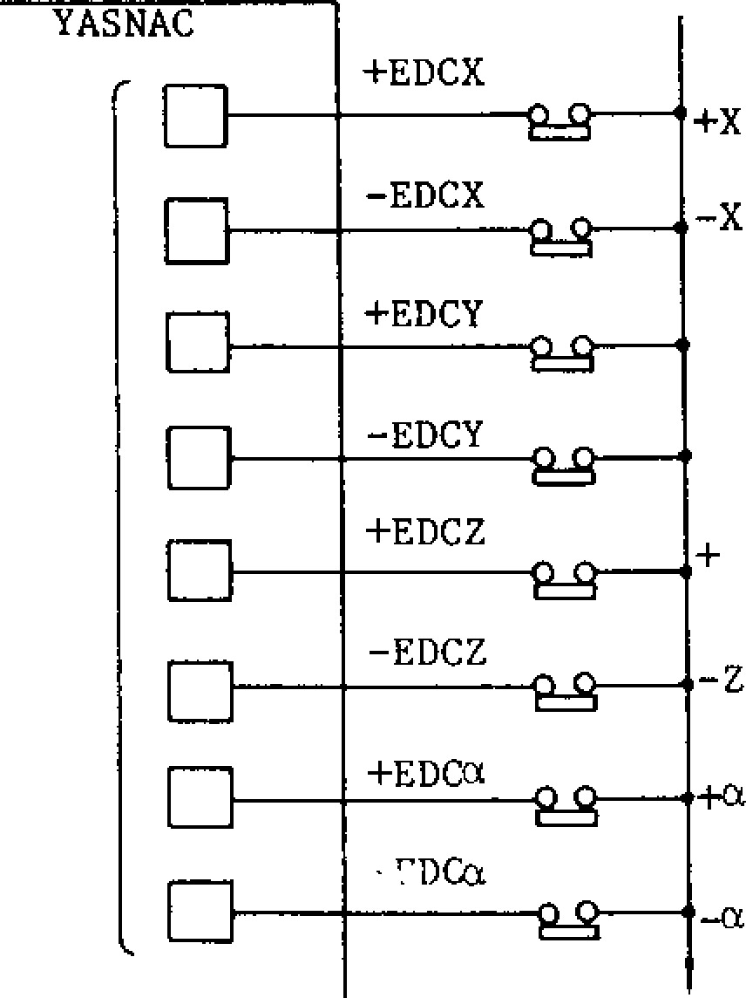

Fig. 6.21

DECELERATION POINT

AREA A

AREA B

Fig. 6.22

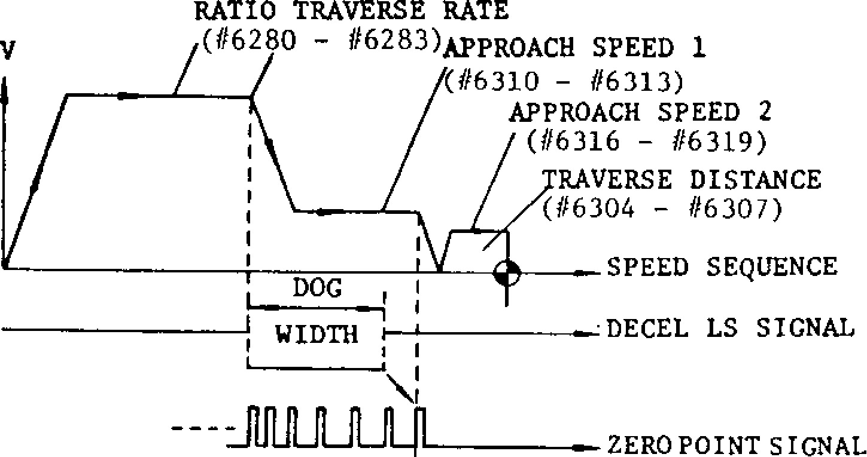

.DECEL LS SIGNAL

______________

WIDTH

_

ZERO POINT SIGNAL

RATIO TRAVERSE RATE

(#6280

#

62133

)

APPROACH

SPEED 1

(

#6310

-

#6313)

APPROACH SPEED 2

(

#6316

-

#6319)

RAVERSE DISTANCE

(

#6304

-

#6307)

SPEED SEQUENCE

V

+

Y

TRAVERSE

-

Y RATE

CLAMP

LIMIT

SWITCH

TRAVERSE

RATE

CLAMP

LIMIT

SWITCH

NOTES:

1. . A s l o n g a s t h e p o w e r s u p p l y i s t u r n e d o n , either the manual or the automatic return to r e f e r e n c e p o in t c a n b e in i t ia te d , r e g a rd le ss of the tool position, but the tool will not re tu rn to the re fe re n ce p o in t ac cu ra tely if th e tool is started from a point in the area B. Be sure to bring the tool int o the area A before initiating a manual or automatic return motion.
2. . O n c e t h e t o o l i s r e t u r n e d t o t h e r e f e r e n c e po int, the poin t C is stored , and if the refer ence return motion is initiated from a point in th e are a B, this is rega rded as an error. Start the reference return motion from a position in the area A.

**6 . 2 . 1 M A N U A L R E T U R N T O R E F E R E N C E P O I N T**

**( C O N T ' D )**

1. Once the tool is returned to the reference point,

it can not be further moved in the same direction unless the REFERENCE POINT RE TURN switch is turned off.

1. While the MACHINE LOCK switch is on, the re fe ren ce poin t retu rn funct ion i s in effective .
2. Do no t ret u rn th e t oo l to th e re fe ren c e po in t by the manual re fe renc e point retu rn func tion, while the buffer is loaded with blocks read in advance of execution, beca use the stored motion data will be erased by the reference point return motion.

-4

II

-

X

**6 . 2 . 2 A U T O M A T I C C O O R D I N A T E S Y S T E M**

**SETTINGt**

W i t h t h i s f u n c t i o n , a n e w c o o r d i n a t e s y s t e m i s s e t u p a u t o m a t i c a l l y u p o n t h e r e t u r n o f t h e t o o l t o t h e r e f e r e n c e p o i n t b y t h e m a n u a l r e f e r e n c e p o i n t r e t u r n f u n c t i o n . T h e c o o r d i n a t e s o f t h e n e w o ri g i n a re p r e s e t wi t h t h e fo l l o w i n g p a ra m e t e r s . T h e c o o r d i n a t e s y s t e m s e t u p b y t h i s

f u n c t i o n i s e q u i v a l e n t t o t h e o n e s s e t u p b y G9 2 .

1. . P a r a m e t e r s f o r m e t r i c s y s t e m

|  |  |
| --- | --- |
| Pa ra mete r | Meaning |
| #6636 | X coo rdin ate |
| #6637 | Y coo rdin ate |
| #6638 | Z coo rdina te |
| #6639 | 4th coo rdinat e |

1. . P a r a m e t e r s f o r i n c h s y s t e m

|  |  |
| --- | --- |
| Pa ra mete r | Meaning |
| #6630 | X coo rdin ate |
| #6631 | Y coo rdin ate |
| #6632 | Z coo rdina te |
| #6633 | 4th coo rdinat e |

1. . Axi s ca n b e s e le c te d by p a ra me t e r # 601 5 fo r

-

164

-

b o t h m e t r i c a n d i n c h s y s t e m s .

1. . U p o n t h e r e t u r n o f t h e t o o l t o t h e r e f e r e n c e p o i n t b y t h e m a n u a l r e f e r e n c e p o i n t r e t u r n f u n c t i o n ( G 2 8 ) . w h e n t h e c o n t r o l l e d a x i s i s

t h e 4 t h o r 5 t h a x i s o f t h e r o t a r y a x i s ( A , B , or C) , a new coordinate system is set 7.1p automatically in the same way as mentioned above.

|  |  |  |  |
| --- | --- | --- | --- |
| Upon Tool  Return to  Reference Point | Basic  Axis  X, Y, Z | 4th, 5th  Axis  U, V, W | 4th, 5th  Axis  A, B, C |
| Manual | Q | 0 | 0 |
| Automatic | x | x | 0 |

0 : Wh e n p a r a m e t e r # 6 0 1 5 D n = 1 , t h e a u t o m a t i c coordinate system setting is effective.

JOG

+

X

+

Y

Z

+

+4

II

II

Fig

.

6.2.1.2

1

-

REFERENCE POINT

X

Y

Z

4

0

0

0

0

IJ

1

REFERENCE POINT

RETURN

OFF

I]

Even if #6015 setting is 0 or 1 the automatic X coordinate system setting will not be performed.

5. Restrictions for automatic coordinate system setting by G28

When automa tic coordinate system setting G28 i s ex e cu t ed o n ro ta ry a xi s, t he too l i s re tu rn ed to the nearest reference point 1 360° x n( n: i n t e g e r ) , i f f i r s t r e f e r e n c e p o i n t i s 0 0 1 . A t t h i s

t i m e , t h e d i s p l a y s h o ws t he c u r re n t v a l u e o f

3 6 0 ° x n . Op e ra t i o n s h o u ld n o t b e c o n t i n u e d a t

t h i s v a l u e . Fo r o p e ra t i o n , c u r r e n t v alue d ispl ay s hould be s et up autom atical ly to the desired value.

NOTE:

If G28 command (automatic coordinate system setting) is used during operation on the work coordinate system (G54 to G59 commands), basic c o o r d i n a t e s y s t e m s h i f t s . A s a r e s u l t , w o k coordinate system, which is commanded by G54 to G59 and set on the basic coordinate system, a, s h i fts al so. Re fe r to 2.9 .25, Wo rk Coo rd inate System Setting (G52 to G59).

6.2.3 **A U T OM A T IC T OOL L EN GT H M EA SU R E -**

**MENTI-**

When a tool mounted on the spindle is manually brought to a position where the tool tip makes c o ntac t with the re ferenc e su rfa ce fo r Z -ax is, and the WRIT E & RETRACT button is push ed, the following operations are performed by the control.

1. The distance between the set Z-axis home position and the reference surface is stored automatically in the memory having the currently specified correction number.

The difference between tool touch po sition and base position can be set by parameter.

1. Increase the correction number by 1, in pre paration for the next writin g.

c . Re tu rn th e to o l to th e Z -a x is h o me p o sitio n .

1 . Me a su rin g me th o d

1. Mount a tool o n the sp indle , and move it to a Z-axis position which is to be se t as the h o me p osition . Any po sitio n ma y b e set as the home position, but for facilitating tool changing process, the tool changing position may be set up as the home position.
2. Select the manual operation mode (RAPID, JOG, HANDLE or STEP) using MODE SELECT switch.
3. P u s h t h e f u n c t i o n k e y [OFS1.

The offset number specified previously and re lated data are disp layed.

1. The page covering tool offset values speci fied the tool offset number keyed in will be shown. The specified number is shown by

cursor

1. Push the MEASUREMENT button when the motion stops. MEASUREMENT lamp lights and the current position of Z- axis will be set as home position.

(The button is effective only in the manual operation mode and while the 10FS _1 key is selected.

TOOL LENGTH MEASUREMENT?

fl

n

Fig. 6.24

MEASURE

WRITE&

MENT

RETRACT

Fig. 6.25

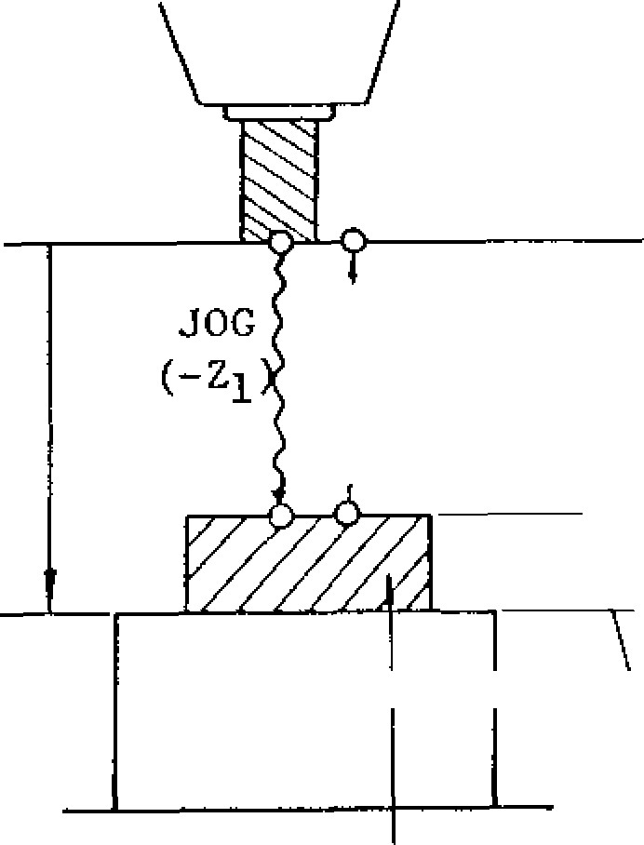

+

Z

HOME POSITION

'

RETRACTION

1

TOOL TOUCH

SITION

PO

BASE POSITION (B)

TOOL

LENGTH

MEASUREMENT

SETTING #6507

MOVE

MEAS

-

URE

-

MENT

MO

(

WORKPIECE

BLOCKGAGE

Home position is the p o in t wh e re me a su re ment starts. Measurement is made with the po int te mpora rily de termin ed a s coo rdina te

0

Note: To display the home position as coor d i n a t e 0 , r e se t t h e p o s i t io n r e f e r r i n g t o 4 . 3 . 4 . 1 . M e a s u r e m e n t a f t e r r e s e t t i n g w i l l be made in the offset mode.

f. S e t th e to o l

to th e to o l to u c h p o sit ion b y controlling Zaxis manually. Tool touch po sitio n is th e p o sitio n sp e c ifie d a rb itra rily b ased on th e b a se po sitio n (ma ch in e wo rk -piece surface). The difference between tool touch position

and base position is set in advance in setting

#6507 ("1" in put u nit).

T he diffe ren ce is re ga rd ed as thick ne ss o f block gage . Write it in p lus value .

|  |
| --- |
| **OFFSET. • 01234 148818 .**  **- ... .**  **POSiLIN 1 *1.0)* ..' •**  **-1.1'ito) es ,.... . .**  **k: H CD301 .• "488. GOO ..X .. ' .1: MS**  **: H CD)22 .•- , , - 1. IMMO - •**  **41 CD)83 • .. e y 'i s . w e**  • **H 0)84**  **.Haos5 _ . ,• ; 95..446.,:k ,., 85.**  **- . H CD38I ' •'H CD3117: 2. Me •**  **!**  **HCD)68 .. ••.:3.. ODD** |

• **• • H 0)119**

**RDY •**

r."

WRITE & RETRACT WHERE TOOL LENGTH

PUSHBUTTON MEASUREMENT BIAS #6507=10.000 MM



Fig. 6.26

The figure above shows the value in the offset number 05.

-

165

-

6 . 2. 3 AU T OM AT I C T O OL L EN GT H M E ASU R E M EN T T (C ON T ID )

1. D e p re s s t h e WR IT E & R E T R AC T b u t t o n .

T h e c o n t ro l e x e c u t e s t h e fo l l o wi n g o p e ra t i o n ,

T h e c on t ro l st o re s t he di ffe re n ce be t wee n h o m e p o s i t i o n a n d b a s e p o s i t i o n , t h a t i s , m o v e m e a s u r e m e n t v a l u e ( M L ) a s t h e v a l u e s p e c i f i e d b y t h e o f fs e t n u m b e r .

M L = ( - Z 1 ) - ( B )

* 1. The tool automatically returns in the Z direction to the home position in rapid traverse.
  2. The tool offset number is increased by one in preparation for next writing of o ffs et va lue.

( Wh e n i t i s H9 9 , H0 1 i s d e s i g n a t e d . )

1. Exch ange th e tool with a next tool by manua l o p e r a t i o n o r b y M D I o p e r a t i o n . E v e n w h e n

the MDT mode is switched on, the MEASURE -

M E N T l a m p r e m a i n s l i g h t e d . R e t u r n t o t h e

M ANUAL mod e a ft e rward s.

i . R e p e a t t h e p r o c e s s e s f . t h r o u g h h . t o s t o r e a l l t h e r e q u i r e d *o ff s e t* v a l u e s .

Push the M E ASUR EME NT key .

T h e M E A SUR E M E NT t a m p g o e s o u t , a n d t h e a u t o m a t i c w r i t i n g f u n c t i o n i s t u r n e d o f f . T h e l en gt h me a su ri ng d at a a l so di s ap pe a rs f ro m t h e C R T .

NOTES:

In this automatic writing mode, the mea s u r e d v a l u e s a r e s t o r e d i n t h e a b s o l u t e values.

W h e n t h e h o m e p o s i t i o n i s d i f f e r e n t f r o m t h e t o o l c h a n g e p o s i t i o n , t h e n e w t o o l m a y

b e b r o u g h t t o t h e r e f e r e n c e s u r f a c e d i -

1. e c t l y wi t h o u t fi rs t re t u rn i n g t o t h e h o m e

p o s i t i o n . O n c e t h e h o m e p o s i t i o n h a s b e e n

1. e t u p b y t h e u s e o f t h e M E A S U R E M E N T

k e y , r e p o s i t i o n i n g t o t h e h o m e p o s i t i o n i s not necessary.

W h e n t h e W R IT E & R E T R A C T k e y i s p u s h ed with HOO de signat ed as the tool o ffset n u m b e r , t h e t o o l o f f s e t n u m b e r i s c h a n g e d t o H 0 1 b u t n o w r i t i n g n o r t o o l r e t u r n i s

p e r f o r m e d . W h e n t h e k e y i s p u s h e d a g a i n , t h e t o o l o f f s e t v a l u e is w r i t t e n u n d e r H 0 1 i n t h e n o rm a l m a n n e r.

2. Operation for measuring remaining dicta ice

(Parameter #6039D4 = "1")

The following three methods are possible in a d d i t i o n t o t h e m e t h o d d e s c r i b e d a b o v e .

a . Wh e r e a s t h e m o v e m e a s u re m e n t v a l u e M L ( F i g . 6 . 2 . 3 . 2 ) i s w r i t t e n a s a t o o l o f f s E t

value, the remaining distance RL is written wh e n t he p a ra m et e r # 60 39D4 i s se t t o "I. . "

T h e b o t t o m l e v e l wh i c h i s u s e d a s a b a s e o f c a l cu la t ing re m ai ni ng d i s ta n ce c an b e se t by s etting #6508 (botto m l evel se tting, 1 = input unit). Writing operation is the same aE d e s c r i b e d i n s t e p 1 .

3. The following method is possible with NC

R L = - ( A M L )

+Z

HOME POSITION

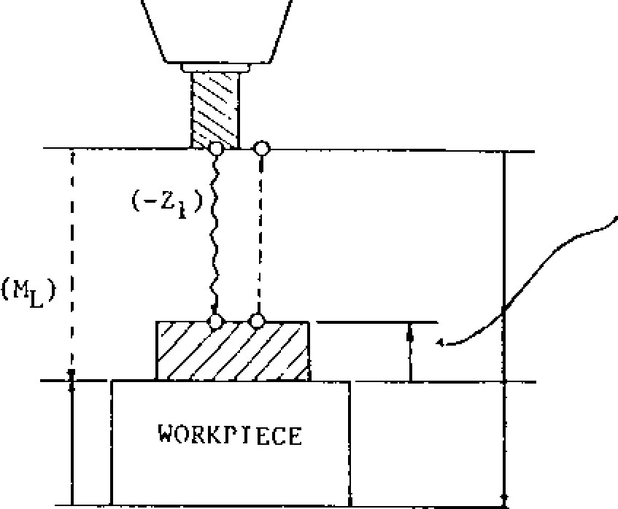

#5508

TOOL LENGTH

MEASUREMENT

BIAS (B) 116507

BASE POS T ICN

REMAINING 4-'BOTTOM LEVEL

DISTANCE SETTING (A)

BOTTOM LEVEL

Fig. 6.27

cont ro l s tation .

1. . In s tead o f th e ME ASUREME NT key, d epres s the PUS and PAGE key to select the page of POSITION [UNIVERSAL].
2. . R e s e t t he di s pl a y by d epre s s i ng Z and ORG k e y s . T h i s m e a n s t h a t h o m e p o s i t i o n i s s e t to "0 . "

ii i. Return the function mode to offset by de pressing OFS key.

1. . Instead of the WRITE & RETRACT key, de p re s s t h e N E X T , Z , WR k e y s i n t h a t o rd e r.

Th is execu tes auto mati c writing o f the s ame t o o l o f f s e t m e a s u re d a s wr i t t e n i n s t e p 1 . T h e Z -a xi s , h o wev e r, wi l l n ot re tu rn t o home position.

1. In this measurement operation, parame':er #6039D4 (move measurement valueiremzin i n g d i s t a n c e s w i t c h i n g ) i s e f f e c t i v e . St o ri ng e i th e r o ne o f th e v a lu e s i s d e te r m i n e d b y p a ra m e t e r.

6.2.4 PROGRAM RESTARTt

Machining may be restarted from the block that follows the one for which the sequence number was specified. This restart is use ful when re placing the broken tool or taking over the ma chining operation from the last work shift.

TOOL RETRACTED POSITION (OPERATION FOR PROGRAM

RESTART WILL BE MADE

HERE)

RETRAC-

TION

MANUAL

RESTART OPERATION

|  |
| --- |
| SEARCHING BLOCK  FOR PROGRAM  RESTART |

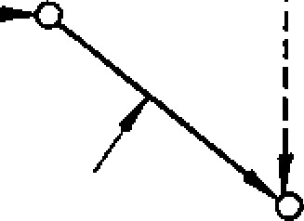MACHINING INTERRUPTED

POINT (FEED HOLD, etc)

Prog ra m re start is of either type P o r typ e Q, depen ding on wheth er the c hange o f th e coo r dinate system before or after the restart is per mitted.

6.2.4.1 PROGRAM RESTART OF TYPE P

In type P, the program is restarted assuming that the change of coordinate system before and after t h e r e s t a r t w i l l n o t o c c u r . T h e r e f o r e , t h i s t y p e is used after the replacement of the tool broken during operation, for example.

Operation Procedure

W h e n th e to o l i s b r o k e n d u r in g ma c h in in g

operation, the automatic operation may be restarted in the following procedure:

1. Press FEED HOLD button to stop the operation and make the tool escape.
2. Replace the broken tool and perform the associated chores. Change the tool offset, if req uired .
3. Turn on PROGRAM RESTART switch on the machine control station.
4. P r e s s P R O D f u n c t i o n k e y t o d i s p l a y t h e p a rt prog ra m b eing ex ec ute d . Ta ke no te of th e sequence number of the block immediately before the block on which the feed-hold operation was performed.

(5 ) S e t th e h e a d o f th e p a rt p ro g ra m a s fo llo ws :

1. . I n m e m o r y m o d e

Set memory mode, key-in the program number

(Oxxxx) to b e r e s t a r t e d , a n d p r e s s

|  |
| --- |
| CURSOR  4 |

key.

1. . In tape mode

Set tape mode and set the head of the tape to the tape reader.

|  |
| --- |
| CURSOR  4 |

(6) Key-in P, sequence number, and

in th is o rder. The sequence nu mber is the on e that was taken note of in step (4). While **making the setups for program restart, the** control searches **for** the block of the specified **sequence number. If the same sequence number appears repeatedly, the nth sequence** number may **be specified.**

P 0 0 4 0 1 2 3

**__________ It __________**

LLOW-ORDER 4 DIGITS: SEQUENCE NO.

HIGH-ORDER 4 DIGITS:

NO. OF TIMES

For example, the nth sequence number may be called in a subprogram for which L times of exe c u ti o n i s sp e c i f ie d . F o r t h e se q u e n c e n u mb e r th at ap pears first, the high -o rder 4 dig its may be omitted. In this case, the leading zero of the sequence number may also be omitted.

(7) When the search is completed, the CRT screen automatically displays the program restart information.

|  |
| --- |
| - 167- |

F ig . 6 .2 8 Di sp la y o f Pro g ra m

Restart Information

PROGRAM RETURN

00001

N0125

(

UNIVERSAL

)

M

03

33

10

06

45

X

100.000

63

*4

#4

44

,

*4

Y

-

200.000

2

300.000

A

45.000

(

INCREMENT)

X

-

258.77

4

Y

M COUNT (0006)

T 0015

0025

S 0500

s 0000

PRN

RDY

6. 2. 4. 1 PROGRAM RESTART OF TYPE P (CONT'D)

1. Position (UNIVERS AL) ind icates the position of machin ing re start. No rmally, this position is th e s ta rt p o in t o f th e b lo c k o n wh ic h th e fe e d hold operation was performed.

6,2.4.2 PROGRAM RESTART OF TYPE Q

If the coordinate system is changed by any of the fo llo wing op era tion s p erfo rmed after th e in te r r u p t i o n a u t o m a t i c o p e r a t i o n , u s e t h e p r o g r a m re start of type Q :

1. Position (INCREMENT ) indicates the distance from the curre nt tool position to the mach ining re start position.

c , T h e M c o d e s a n d th e n u mb e r o f M c o d e s

designated (M COUNT) from the head of the pro gram to the block of the specified sequence num b e r a r e d i sp l a y e d . H o w e v e r , i f t h e n u m b e r o f designated M codes exceeds 35, the 35 M codes as counted from the specified block are displayed.

1. The two last T codes specified up to the

designated blo ck are displa yed.

1. The last S code specified up to the designated

block is displayed.

1. The last B code specified up to the designated

block is displayed.

No te : Th e **M** co de s a nd T c od e s are d isp lay ed in t h e o r d e r i n w h i c h t h e y w e r e s p e c i f i e d . T h e c o d e d i s p l a y e d l a s t i s n e a r e s t t h e d e s i g n a t e d block.

1. Turn off PROGRAM RESTART switch on the machine control station.
2. Look at the displayed program restart infor m a t i o n a n d s p e c i f y t h e M , T , S , o r B c o d e

n e ce ssa ry fo r the re sta rt a s sh o wn be lo w:

1. . S e t M D 1 m o d e .
2. . P r e s s F R O G f u n c t i o n k e y .
3. . Key-in the necessary M, T, S, or B code and

depress WR key.

1. . P r e s s C Y C L E S T A R T b u t t o n .
2. . Press POS function key and check the dis -

play of program restart info rmation .

(10) Set the original operation mode (memory or tape mode).

(1 1 ) De p re ss C YC L E S T A RT b u t to n .

The tool moves to the machining restart position, a x i s b y a x i s ; t h a t i s , t h e 4 t h a x i s , X - a x i s , Y a x i s , a n d Z - a x i s , i n t h i s o r d e r . T h e n , t h e automatic operation restarts from the head of the block (on which the feed-hold operation was performed) that follows the block of the desig na ted se quence numb er.

1. The machine power was turned off.
2. G92 is specified by MDI operation.
3. The setting of work coordinate system is specified.
4. The automatic setting of work coordinate system was specified by reference -point return.
5. ORG key was pressed.

**Operational Procedure**

The automatic operation interrupted by any of the above operations may be resumed using the following procedure:

1. When the machine power is turned on after the interruption of machining, perform the nec essary ope ratio ns su ch as refe rence -poin t re turn.
2. Manually move the tool to the start paint (of machining) of the part program. Change the tool offset amount if necessary.
3. Turn on PROGRAM RESTART switch on the machine control station.
4. Press FROG function key to display :he part program (being executed). Record the sequence number of the block immediately before the block to be restarted.
5. Set the head of the part program as follows:

a. In memory mode

Set memory mode, key -in the program number CURSOR b. I n

(

Oxxxx) to be restarted, and depress

key.

t a p e

m o d e

Set tape mode and set the head of the tape to th e ta p e re a d e r.

( 6 ) K e y - i n Q , s e q u e n c e n u m b e r , a n d C U R S O R

4,

in th is o rd er. T he se qu enc e n u mbe r is th e on e th a t wa s tak en no te of in step (4 ). While making the setups for program restart, the machine searches the block of the specified seq u e n c e n u mb e r. If th e sa me se q u e n c e n u mb e r a p p e a r s r e p e a t e d l y , t h e n t h s e q u e n c e n u m b e r

may be specified.

**LOW-ORDER 4 DIGITS: SEQUENCE NO.**

**Q 0 0 0 4 0 1 2 3**

**1**

**HIGH-ORDER 4 DIGITS:**

**NUMBER OF TIMES**

**For example, the nth sequence number may be called in a subprogram for which L times of execution was specified. For the sequence number that appears first, the high -order 4 digits may be omitted. In this case, the leading zero of the sequence number may also be omitted.**

1. **When the search is completed, the CRT screen automatically displays the program restart information.**
2. **Turn off PROGRAM RESTART switch.**
3. **Look at the displayed program restart information and specify the M, T, S. or B code re quired for the restart in MDI mode.**
4. **Set the original operation mode (memory or tape mode).**
5. **Depress CYCLE START button.**

**The tool moves to the machining restart position, axis by axis; that is, the 4th axis, X -axis, Y-axis, and Z-axis, in this order. Then, the auto matic operation restarts from the head of the block (on which the feed-hold operation was performed) that follows the block of the designated sequence number.**

**CONSIDERATIONS AND REMARKS**

1. **Before depressing CYCLE START button to restart the program execution, check to see if the axis-by-axis tool movement (the 4th axis, X-axis, Y-axis, and 2-axis, in this order) interferes with the work or any part of the machine. If the tool is found interfering, correct the tool position manually.**
2. **In both types P and Q, the tool which is moving to the machining restart position axis -byaxis may be single-block-stopped after the completion of the movement for each axis. Even if the incremental shift amount is "0," the single-block stop is performed when SINGLE BLOCK switch is on. When the single-block stop is performed, however, the intervention of MDI operation is not allowed. Manual intervention is possible. But, if a manual intervention is performed on the axis which has already returned, it will not return to the machining restart position again.**

**4) When a feed -hold operation was performed during the search operation for program restart, or a reset operation was performed during or after**

-

**169**

**-**

**(3) During the search operation for program restart, set the switches on the machine control station to the state before commanding program restart. Otherwise, the former position cannot be reached.**

**the search operation, perform the operations all over again.**

1. **When PROGRAM RESTART switch is on, the operation of CYCLE START button is ignored.**
2. **Whether it is before or after machining, each manual operation should be performed with MANUAL ABSOLUTE switch on and MACHINE LOCK switch off.**
3. **In any of the following situations, the tool cannot return to the correct position:**
4. **A manual operation was performed with MANUAL ABSOLUTE switch off.**
5. **A manual operation was performed with MACHINE LOCK switch on.**
6. **The search operation for program restart was**

**performed with MACHINE LOCK switch on and then this switch was turned off.**

1. **A manual intervention was performed during**

**the axis shift to the return position.**

**(8) In type P, any of the following operations performed in the time between the discontinuation of machining and the search operation for pro gram restart will cause an error:**

1. **The setting of coordinate system was specified.**

**ERROR • • • 121 PRTN ERROR (G92)**

1. **The setting of work coordinate system was**

**specified.**

**ERROR • • • 122 PRTN ERROR (G54 - G59)**

1. **The coordinate system was modified by**

**operation ORG key.**

**ERROR - • • 123 PRTN ERROR (ORG)**

**In type P, the correct program restart is made possible only for the blocks that follow the one for which the coordinate-system setting was performed last before the discontinuation of machin ing.**

**(9) If the designated block is not found, an error will be caused.**

**ERROR • • • 120 PRTN ERROR (NOT FOUND)**

|  |
| --- |
| 6.2.5 PLAYBACK FUNCTIONS ( 5 ) Mo v e th e a x is t o th e p o s it io n w h i c h wi ll b e written as command . |

T h e c u rr e n t a x i s p o si t io n d u r in g mo v e me n t c a n be stored as command valu e in the part program. T h i s f u n c t io n i s p e r m i t te d i n t h e P L A Y B A C K mode whe n PLAYBACK switch is tu rned o n in manual operation mode.

To turn on PLAYBACK mode, activate the PLAY B A C K s witc h o n th e ma c h in e c o n tro l sta tio n o r se t # 6 0 0 0 D5 a t "1 ." P roc e d u re fo r s to rin g p ro gram in the PLAYBACK mode is as follows.

1. Set the control in the manual operation mode (RAPID, JOG, STEP, or HANDLE).
2. T u r n o n t h e P L A Y B A C K s w i t c h .
3. D e p r e s s t h e P R O G k e y o f f u n c t i o n k e y s . T he CRT sc re en sh o ws the co n te nts o f p a rt pro g r a m n u m b e r ❑ p l u s 4 d i g i t s a n d t h e c u r r e n t

value at the bottom.

1. R e g i s t e r t h e n e w p r o g r a m n u m b e r a f t e r a d d r e s s 0 . T o r e g i s t e r 0 1 2 3 4 , f o r e x a m p l e , k e y

- i n 0 , 1 , 2 , 3 , 4 a n d d e p r e s s t h e W R k e y . T he n u mbe rs a re d isp lay ed a s th ey a re ke ye d -in . See Fig.

|  |
| --- |
| PROG(PLAYBACK) 00001 N0010  00001;  N0001 G92 X140 Y100 Z30;  N0002 GOO 51200 T0202 M03;  N0003 G41;  N 0 0 0 4 X0 Z5 0 0 ;  N0005 G0 1 ZO F20 ;  N0006 X2000; ZN0007 2000; Y2000;  N0008 X3000 Y4000;  N0009 X1234, 567 Y2345,  POS 2-2345,789 678  (UNIV)  LSK RDY |

Fig . 6 ,29

PROG (PLAYBACK) 01234 N0010

01234;

G00X1234, 567 LSK RDY

EDIT BUFFER REGISTER

-

170

-

Fig. 6. 30

1. Depress the address key for the axis N./hose position is written .
2. D e p r e s s t h e W R k e y . T h e d i s p l a y e d c u r r e n t v a l u e i s t h e c o m m a n d . v a l u e o f t h e s e l e c t e d a d d r e s s . K e y - i n t h e n u m e r i c a l d a t a b e f o r e d e p r e s s i n g t h e W R k e y , and the tota l a moun t of keyed -in value plus curre n t v a lu e wil l b e th e n e w c o m ma n d v a lu e .

N OT E: T h e c u rre n t v a lu e in P OS IT ION (U N I VERS AL) is d isp la ye d b y d ep ressin g the PROG k e y i n t h e P L A Y B A C K m o d e . I t i s t h e s a m e

display as that shown in POSITION (UNIVERSAL) by depressing the POS key.

1. Wr ite -in th e v a lu e , e x c ep t fo r a x is, b y a block of data in the same way as writing in the E D IT mo d e . (S e e 4 .6 E DIT .)
2. D e p r e s s t h e E O B k e y .
3. D e p r e s s t h e W S R T k e y . A b lo c k

o f d a ta is sto re d in th e p a rt p ro g ra m.

1. R e p e a t s te p s ( 5 ) t h ro u g h (1 0 ) u n t il th e d e sire d d a ta is writte n .
2. Key-in MO2; or M30; at the end of the p a rt p ro g ra m.

NOTES:

1. The part program stored in the PLAYBACK operation can be edited in both PLAYBACK and E D IT m o d e s . P o s i t i o n d a t a s t o r e d i n t h e

PLAYBACK opera tion can be ed ited (dele tipn , in sertion, alteration).

1. The current value in POSITION (UNIVERSAL) c a n b e w r i t t e n - i n u s i n g th e W R k e y .
2. Part programs made by PLAYBACK operation and th e on es mad e by writing ope ration are the sa me . Ma ximu m capac ity of part progra m **is** the total of both programs.
3. When the parameter #6006 D5 (ten times the i n p u t ) i s " 1 , " d a t a wr it te n th ro u g h th e k e y b o a rd will be multiplied by ten .

E x . A t t h e c u r r e n t p o s i t i o n X 1 . 0 0 0 , k e y i n g - i n X , 1 , 0 , a n d d e p r e s s i n g t h e W R k e y w i l l s t o r e the value X1.1000.

5. MDI operation cannot be intervened daring compensation C in the PLAYBACK mode. If the C y c le S ta rt p u sh b u tto n is d e p re sse d in th e PLAYBACK mode, message "PLAYBACK LOCK," w i l l b e d i s p l a y e d . W i t h P L A Y B A C K s w i t c h

turned off, MDI operation can function.

|  |
| --- |
| Writing Operation C. Procedure f o r s t o r i n g c u r r e n t p o s i t i o n d a t a  u sin g GOO wh en mac hine wa s mov ed fro m p o in t |

*MOM*

D (700.1000,600)

E (1200,800,600)

(400*I*,200 A

**A**

qr B(700*p*  *r*,200/ (7*j*,60000,200,300) 1.0'N0002 C 6 : -

z

Fig. 6.31

Data of positioning at poin t A is stored in the p a rt p ro g ra m. T h e b lo c k a fte r p o in t A is stored in the PLAYBACK mode.

A . Pro c e d u re o f c h a n g in g c u rre n t p o s itio n data using G00 when machine was moved from p o int A to poin t B. Sequenc e No. fo r th is d ata block is N0001.

(1 ) Ke y -in N, 0 , 0 , 0, 1.

D o n o t d e p r e s s t h e W R k e y . If d e p re ss e d , "INP UT ERROR" will a p p e ar on th e scree n .

1. ) Key-in G, 0, 0.
2. ) Depress WR key after X.
3. ) Depress the EOB key.
4. ) Depress the INSRT key.

Then, block of N0001 G00 X0.700; will be stored in the pa rt p rogram.

1. . P r o c e d u r e fo r s to r in g c u rr e n t p o s i ti o n d a ta using G01, F02 when machine was moved from p o i n t B t o p o i n t C . S e q u e n c e No . f o r t h i s data block is NO002.

( 1 ) K e y - i n N , 0 , 0 , 0 , 2 .

Key-in G, 0, 1.



Depress the WR key after Z.

Ke y -in F , 2, 0.

Depress the EOB key.

-

171

-

Depress the INSRT key.

Then block of N0002 GO1Z 0.600F20; will be stored in the part program.

1. t o p o i n t D . S e q u e n c e N o . f o r t h i s d a t a b l o c k is N0003.

K e y - i n N , 0 , 0 , 0 , 3 .

Key-in G, 0, 0. Depress the WR key after Y D e p r e s s t h e E O B k e y .

1. e p r e s s t h e IN S R T k e y .

Then, block of N0003 G00 Y1.000; will be stored in the part program.

D. Procedure of storing current position data for three axes simultaneously when machine was moved from point A to point D with linear inter p o l a t i o n S e q u e n c e N o . f o r t h e d a t a b l o c k i s

N0004.

( 1 ) K e y - i n N , 0 , 0 , 0 , 4 .

( 2 ) K e y - i n G , 0 , 1 .

( 3 ) D e p r e s s t h e W R k e y a f t e r X .

( 4 ) D e p r e s s t h e W R k e y a f t e r Y .

( 5 ) D e p r e s s t h e W R k e y a f t e r Z .

( 6 ) K e y -in F , 1 , 0 , 0 .

( 7 ) D e p r e s s t h e E O B k e y .

( 8 ) D e p r e s s t h e I N S R T k e y .

Then block of N0004 GO1 X0.700 Y1.000 20.600 F 1 0 0 ; will b e sto re d in th e p a rt program.

E . W h e n t h e m a c h i n e c u r r e n t p o s i t i o n i s a t p o in t D (7 00 , 1000, 600) with sta rt at A, fo llo w th e proc edure to store the c urren t position data u si n g t h e p o si t io n d a t a o f p o i n t D wh e n th e m a c h i n e i s m o v e d f r o m p o i n t A t o p o i n t E ( 1 2 0 0 , 800, 600).

Key-in the incremental value for each axis when m a c h i n e m o v e s f r o m p o i n t D t o p o i n t E .

S e qu en ce No. fo r th is da ta b lo ck is NO0 05 .

**6 . 2 . 5 P L A Y B A C K F U N C T I O N ( C O N T ' D )**

Fig. 6.32 BY DEPRESSING WR KEY,

PROG(PLAYBACK) 00010N0000

00010;

G91 G28 X0 Y0 ZO;

G92 X9 YO ZO;

G90 GOO X0.4 Y0.2 Z0.3;

N0001 GOO X0.700;

N0002 GO1 20.600 F20;

N0003 GOO Y1.000;

N0004 GO1 X0.700 Y1.000 20.600 F100;

POS X .700 Y1.000

(UNIV) Z .600

N0005 GO1X0.5

RDY

POSITION X IS ADDED TO THE KEYED-IN VALUE.

Fig. 6.33

PROG(PLAYBACK)

00010N0000

00010

;

G91 G28 X0 YO ZO;

G92 X0 YO ZO;

G90 GOO X0.4 Y0.2

N0001 GOO X0.700;

Z0.3;

N0002 GO1 20.600

F20;

N0003 GOO Y1.000;

N0004 GO1 X0.700

Y1.000

20.600 F100

;

POS

X

.700

Y1.000

)

(

UNIV

Z

.600

N0005 GO1 X1.200

RDY

( 1) K e y - i n N , 0 , 0 , 0 , 5 .

( 2 ) K e y - i n G , 0 , 1 .

( 3 ) D e p r e s s t h e W R k e y a f t e r k e y i n g - i n X 0 . 5 .

( 4 ) D e p r e s s t h e W R k e y a f t e r k e y i n g - i n Y - 0 . 2

( 5 ) D e p r e s s t h e W R k e y a f t e r k e y i n g - i n Z .

( 6 ) K e y - i n F , 1 , 0 , 0 .

( 7 ) D e p r e s s t h e E O B k e y .

( 8 ) D e p r e s s t h e I N S R T k e y .

Then, block of N0005 GO1 X1.200 Y0.800 Z0.600 F0 . 60 0 F10 0; wi ll b e st o red in th e p a rt p ro g ra m.

1. **OPERATION PROCEDURE** 
   1. **INSPECTION BEFORE TURNING ON POWER**

Ma k e su re th a t th e fro n t a n d re a r d o o rs o f th e control are firmly closed. The control employs a totally-enclosed, dustproof enclosure to shut out s u r ro u n d in g a i r. If th e d o o r i s o p e n , lo c k i t

by turning two door lockers with a large screw d riv e r. In a d ditio n , in spe c t th e mac h in e re fe r ring to the machine tool builder's manual.

* 1. **TURNING ON POWER**

*chr•cp fr,* **r0174*.*** that Go! main power is supplied for the control.

1. Depress the POWER ON pushbutton on the operator's panel, and the control power is sup plied and then the cooling fans will start run n i n g . M a k e s u r e t h a t a i r b l o w s o u t f r o m th e e x h a u st p o rt s o f th e u p p e r sid e o f th e control.
2. Depress the POWER ON pushbutton again to turn on the servo power supply. When the machine is ready to operate, READY lamp lights.
3. If READY la mp do es no t light, de tect and eliminate the cause according to the alarm c o de d isp lay ed . Refer to 4 .3 .1 2 DISPL A Y ING ALARM CODE.

**7.3 MANUAL OPERATION**

When the MODE SELECT switch on the machine c o ntro l sta tio n is set to R APID, J OG, ST E P or HANDLE position, the machine can be oper ated manually.

Operation in RAPID Mode

I. Se t MODE S ELECT switch to RAPID.

2. Sele ct the speed u sing R APID TR AVER SE RATE OVERRIDE switch.

Speed setting range: 100% - 50% - 25% -FO

1. . S e t M O D E S E L E C T s w i t c h t o J O G .
2. . A d j u s t t h e f e e d r a t e t o t h e d e s i r e d s e t t i n g with JOG FEEDRATE switch (Up to 32 steps).
3. . Push JOG button to select the axis and direction of movement. The machine moves at the specified speed while the JOG button depressed.

Operation in STEP Mode

Set MODE SELECT switch to STEP.

1. Select the move amount per step using MANUAL PULSE MULTIPLY switch.

(Move amount setting range)

M e t r i c : 0 . 0 0 1 -0 . 0 1 -0 . 1 -1 . 0 -1 0 . 0 - 1 0 0 . 0 mm /step

Inch: 0 .00 01 - 0 .0 01 - 0 .0 1 - 0 .1 - 1 .0-10 .0 in ch/step

1. Depress JOG button to select the axis and direction of movement. The machine moves by: the move amount per step each time the b u tto n i s d e p re sse d .

Operation in HANDLE Model

The control with HANDLE dial± can permit the ope ra tion de scribe d below.

1. . S e t M O D E S E L E C T s w i t c h t o H A N D L E .
2. . S e l e c t t h e a x i s w i t h H A N D L E A X I S s w i t c h .
3. . Select the move amount of the machine cor responding to one scale of HANDLE dial using MANUAL PULSE MULTIPLY switch.

M e t r i c : . 0 . 0 0 1 - 0 . 0 1 - 0 . 1

(mm per graduation)

Inch: 0.0001 - 0.001 - 0.01

(inch pe r graduation)

NOTE: "X1000" or "X10000" is regarded as

"X100."

|  |  |  |
| --- | --- | --- |
| |  |  | | --- | --- | | tion of mo vement. The machine move s a t the specified speed while the JOG button depressed.  # Manu al op eration is de fin ed as the opera tion in R A PID , J OG, ST E P, o r HA N DL E . | Turning the dial clockwise:  The machine moves in the positive direction.  Turn ing the d ial counte rclock wi se :  The machine moves in :1 -_e d:rect - on. |   3 . - P u s h J O G b u t t o n t o s e l e c t t h e a x i s a n d d i r e c -  Operation in JOG Mode  - 173 - |

1. . R o t a t e H A N D L E d i a l .

**7.4 PREPARATION FOR STORED LEADSCRE ERROR**

**COMPENSATION AND STORED STROKE LIMIT -I-**

R e t u rn t o R e f e re n c e Po i n t

W i t h a n N C e q u i p p e d w i t h t h e s t o r e d l e a d s c r e w

e rro r c o mp en s a ti on o r th e s t o red s t rok e l i mi t fu nc t i o n s , e i t h e r o f t h e fo l l o w i n g t wo r e fe r e n c e p o i n t r e t u r n m o t i o n s m u s t b e p e r f o r m e d a f t e r s w i t c h i n g o n t he p o we r su pp ly and be fo re s ta rt in g a ut o ma ti c ope ra tion.

1. . M a n u a l r e t u r n t o r e f e r e n c e p o i n t ( S e e 6 . 2 . 1 )
2. . E x e cu te G91 G28 XO YO Z O ; in th e M DI mode.

T h i s p r o c e d u r e i s t o t e a c h t h e r e f e r e n c e p o i n t

t o t h e c o n t r o l , s i n c e d o i n g s o i s n e c e s s a r y b e -

1. a u s e b o t h p i t c h e r ro r c o m p e n s a t i o n a n d s t o re d
2. t r o k e c h e c k a r e p e r f o r m e d w i t h r e f e r e n c e t o
3. h e r e f e r e n c e p o i n t .

Che cking Pa ra met er #6006D1

Wh e n th e c on t rol i s eq ui pp e d wi th t h e pi t ch e rro r c o m p e n s a t i o n fu n c t i o n o r t h e s t o r e d s t r o k e l i m i t

f u n c t i o n , s e t t h i s p a r a m e t e r t o ' I " W i t h t h e

p a r a m e t e r # 6 0 0 6 D 1 s e t t o " 1 , " a r e t u r n t o t h e

r e f e r e n c e p o i n t i s r e q u i r e d b e fo r e s t a r t i n g c y c l e s ,

a l a r m c o d e s ( 0 0 1 - 0 0 4 " r e f e r e n c e p o i n t r e t u r n

inco mple te ") a re disp layed, i f th e C YCL E ST AR T

k e y i s p u s h e d w i t h o u t m a k i n g a r e f e r e n c e p o i n t

retu rn i mm ediat ely a fte r tu rning on the po we r s u p p l y . B e s u r e t o p e r fo r m t h e o p e r a t i o n fo r r e t u r n t o r e f e r e n c e p o i n t .

**7.5 PREPARATION FOR AUTOMATIC OPERATION**

T h e m a c h i n e m u s t b e p o s i t i o n e d p r o p e r l y a c c o r d i n g t o t h e p a rt p ro g ra m p ri o r t o t h e s t a rt o f a u t o m a t i c o p e r a t i o n . A f t e r p o s i t i o n i n g t h e a b s o l u t e c o o r d i n a t e s y s t e m f o r t h e m a c h i n i n g m u s t b e s e t

p r o p e r l y b y m a n u a l o p e r a t i o n o r p r o g r a m m i n g .

1. Wh en G92 i s not p rogram med in a tape o r memory.

R e tu rn t he m ac hi n e m an ual l y to th e re fe r en ce poin t.

(Re fe r to 6.2 .1 M ANUAL R ET UR N TO R EFERE NC E POINT . )

T h e G9 2 c o mm a nd a c co rdin g t o th e p a rt p ro g r a m s h o u l d b e e x e c u t e d b y M D I.

G9 2 X. . • Y. . . Z.- -

-

174

-

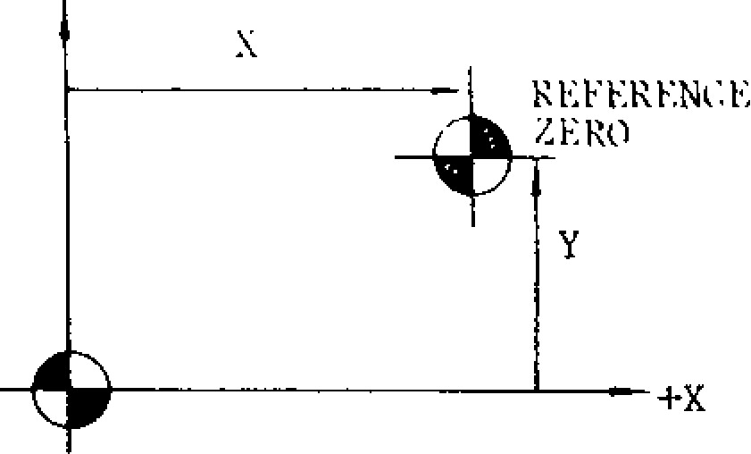

ABSOLUTE ZERO POINT (0, 0)

Fig. 7.1

I f " G 9 2 X 0 Y O Z O ; " s e t t i n g i s r e q u i r e d , t h e c o o r d i n a t e o f e a c h a x i s c a n b e s e t t o " 0 " e a s i l y u s i n g OR G k e y .

R e f e r t o 4 . 1 . 9 O R G K E Y .

EXAMPLE

EOR ;

N1 GOO X...

y.

z

--

.

Fig. 7.2

1. When G92 is programmed in a tape or ITIES11 -o ry .

W h e n t h e p r o g r a m r e q u i re s G 9 2 t o b e e x e c u t e d a t t h e r e f e r e n c e z e r o , r e t u r n t h e m a c h i n e t o t h e r e f e r e n c e p o i n t b y m a n u a l r e t u r n t o r e f e r e n c e p o i n t t o r e f e r e n c e z e r o .

EXAMPLE:

EOR

N I G 9 2 X . . . y . . . Z . . .

Fig. 7.3

1. W h e n G 2 8 a n d G 9 2 a r e p r o g r a m m e d .

Wh e n th e p ro g ram be g in s wi t h G2 8 a nd wi th G2 8 a nd G92 , m ov e t he ma c hi ne m an ua l ly i n t o t h e a r e a w h e r e r e t u r n t o r e f e r e n c e p a i n t

can be performed.

EXAMPLE:

FOR ;

N1 G28 X••• Z• • •;

N 2 G 9 2 X • • • Y . . . Z • • • ;

F ig . 7 .4

**7.6 OPERATION IN TAPE AND MEMORY MODE**

1. Make su re that NC ALARM la mp is not illu minated. If illuminated, detect and eliminate th e c a u se b y th e in d ic a tio n o f a la r m c o d e .

Refer to 4.3.12 DISPLAYING ALARM CODE.

**7.7 MANUAL OPERATION INTERRUPTING**

**AUTOMATIC OPERATION**

1. Stop the automatic operation temporarily by d e pressin g F EED HOLD p u sh bu tto n o r by setting SINGLE BLOCK switch to ON position.
2. Record the current positions of each ax is on a paper using the curre nt posit ion display operation.
3. Set MODE SELECT switch to manual operation mode (HANDLE, JOG or RAPID), and the machine can be manually operated.
4. Return the machine manually to the recorded positions.
5. Set MODE SELECT switch to the interrupted automatic-mode (TAPE, MDI or MEM).

1. Check and c orrec t th e stored offset values, and then put the machine in the correct start point.
2. Set the switches on the control station of machine to the proper positions.

MODE SELECT switch

SINGLE BLOCK toggle switch

RAPID TRAVERSE RATE OVERRIDE

switch

− MANUAL ABS OLUT E togg le switch

* + OPT IONAL BLOCK S KIP toggle switch
  + OPTIONAL STOP (M01) toggle switch DRY RUN toggle switch
  + FEEDRATE OVERRIDE & JOG FEEDRATE switch

1. Se t the punched tape onto the tape reader. In MEM mode, this opration is not required.
2. Depress RESET key on the control station. Then LABEL SKIP lamp will be illuminated and the memory will be rewound.
3. Depress CYCLE START button to give a Cy cle Sta rt to the sy ste m.
4. When the Feed Hold is required for the machine during the system operation, depress FEED HOLD button.
5. If the unexpected event occurs in the system, immediately depress EMERGENCY STOP pushbutton.

6 . Dep ress CYCLE S T ART pu sh bu tto n , an d th e machine will resume the automatic operation.

3 . D e p r e s s C Y C L E S T A R T b u t t o n , a n d a u t o m a t - ic operation can be executed in MDI mode.

NOTES:

Where MODE SELECT switch is changed with o u t d e p r e s s i n g F E E D H O L D p u s h b u t t o n . '

* 1. When the automatic -mode (TAPE, MDI or MEM) is changed to the manual-mode (HANDLE, JOG or RAPID), the machine rapidly slows down and stops.
  2. When the automatic-modes are changed the machine is stopped a t the b lock end.

Where the mach ine is resta rted by dep ressing CYCL E S T ART b u tto n, th e to ol pa th sh ifte d du e to manual opera tion will be changed by ON - OFF operation of MANUAL ABSOLUTE switch. Refer to 6.1.24 MANUAL ABSOLUTE SWITCH.

In manual operation mode, when the CYCLE

S T A RT b u tto n is d e p re sse d a fte r wir in g F , M, S . T o r B t c o d e b y u s e o f t h e s a m e p r o c e d u r e a s t h a t o f M D I operation, the command becomes e ff e c ti v e a n d is e x e c u t e d a s so o n a s w ri tt e n . T h is proc ed ure is used to a dd ne w da ta to an active buffer. However, MOO, M01, MO2, M30 and M90 to M99 cannot be written.

**7.8 AUTOMATIC OPERATION IN MDI MODE**

1. Set MODE SELECT switch to MD1 position.
2. Write up to 10 blo cks o f da ta by MDI opera tion, and execute by pressing CYCLE START. Refer to 4.3.3 Writing in Blocks and Display ing Contents by MDI.

**7.9 MDI OPERATION INTERRUPTING AUTOMATIC**

**OPERATION**

To modify the block data after interrupting op eration in TAPE or MEM mode, the following op e ra tio n sh o u ld b e d o n e afte r in te rru p tin g th e operation.

1. Turn on SINGLE BLOCK switch, and the op e ra ti o n i s in te rr u p te d a fte r th e c o mp le t io n o f t h e b l o c k b e i n g e x e c u t e d . A t t h e s a m e time, the next blocks of data may be read in advance.
2. Display the data on CRT DISPLAY according to 4.3.2 DISPLAY OF COMMAND DATA, and check it.
3. S e t MODE S ELECT switch to MDI o p era tion .
4. W r i t e t h e d a t a r e fe r r i n g t o 4 . 3 . 3 W r i t i n g

in Blocks and Displaying Contents by MDI. Execute the data by depressing the CYCLE ST ART bu tton.

1. Set back MODE SELECT switch to the inter rupted automatic mode (TAPE or MEM).
2. Return SINGLE BLOCK switch to OFF position.
3. Depress CYCLE START b utton, and TAPE or MEM operation can be continued.

NOTES:

Writing data by MDI cannot be executed in tool radius compensation modes (G41, 042) because two — four block s are read ahead.

In ma n ua l o pe ration mode , whe n the CYCLE

ST ART bu tton is depressed afte r writing F, M, 5 , T o r B t c o d e b y u s e o f t h e s a m e p r o c e d u r e as that of MDI operation, the command becomes e f f e c t i v e a n d i s e x e c u t e d a s s o o n a s w r i t t e n . This procedure is used to add a new data to an ac tive buffe r. Ho weve r, MOO, MOl, MO2 , M30 and M90 to M99 cannot be written.

Writing data by MDI should not be per:ormed in canned cycle modes (073, G74, G76, G77, G 8 1 to 0 8 9 ). T h e ma c h in e ma y n o t o p e ra te pro perly .

Excepting in tool radius compensation and can - ned cycle modes, MDI operation is possible.

**7.10 PREPARATION FOR TURNING OFF POWER**

1. Make sure that the machine is at standby and CYCLE START lamp is extinguished.
2. Check to see that NC ALARM is not indicated on CRT . If alarm is displayed , de te: -.t th e causes of displayed alarm code and eliminate them. Refer to 4.3.12 DISPLAYING ALARM CODE.
3. Inspect the machine referring to the machine tool builder's manual.

**7.11 TURNING OFF POWER**

1. Depress EMERGENCY STOP pushbutton to tu rn o ff th e se rv o p o we r su p p ly .
2. D ep res s PO W E R O FF pushbu tton on t h e op erator's panel to turn off the controi power supply.
3. Cut off the main power supply from the con trol.

- 176 -

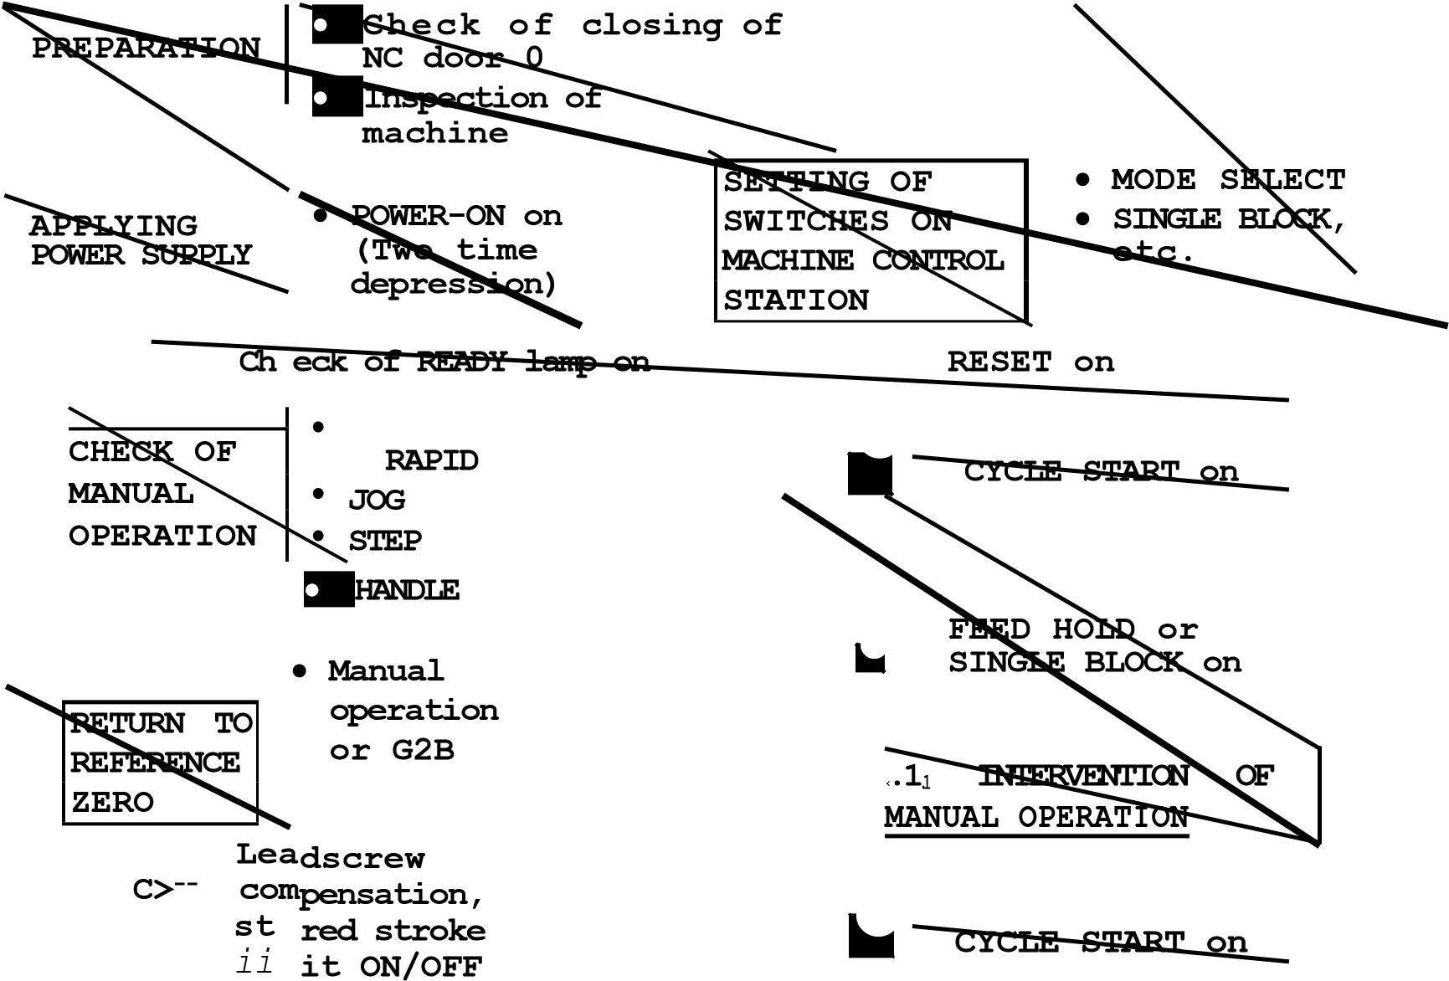

**SINGLE BLOCK on**

**PREPARATION • Positioning to**

|  |
| --- |
| **INTERVENTION OF MDI** |

**FOR AUTOMATIC starting position** •

**OPERATION**

**NC tape setting**

**STORING AND (1)-- CYCLE START on**

**EDITING NC TAPE,**

**PROGRAM NO.** SEARCH

**CMO2/M30 :) Completion of**

|  |  |
| --- | --- |
|  |  |
| **PREPARATION FOR POWER SUPPLY OFF** | |
|  |  |
| **POWER SUPPLY OFF** | |
|  | |

**machining Check if NC ALARM is indicated.**

**CHECK OF**

**TOOL POSI**

**-**

**TION OFFSET**



* **EMERGENCY STOP on and then**
* **POWER OFF on**

**Check if**

* **CYCLE START off**
* **NC alarm off**

F ig . 7 .4 Op e ra t in g Pro c ed u re

**8. MAINTENANCE**

**8.1 ROUTINE INSPECTION SCHEDULE** time in orde r to keep the equ ipment in op ti mum The following table shows the minimum require - condition for extended period. ments to be observed for maintenance according to ex ternal cle anline ss for vib ration and for noise, OFF button on the NC oper ator's panel is not b e s u r e t o t u rn o f f t h e p o w e r s u p p l y t o t h e sufficient, because after this b u tto n is p u sh e d , N C b e f o r e starting to undertake routine main - sti ll se v e ra l a re a s in th e h o u s in g a re e n e rg ize d , tainance service. a n d a re p o te n tia lly d a n g e ro u s.

Table 8. 1. 0 Inspection Schedule

a)

a)

Tape

reader

Gleaning of tape

tumble box

Weekly

Lubricating of tension

arm shaft end

Tight closing the

doors

Checking for loose fit

and gaps of side plates

and worn door gaskets

Vibration and noise

Motor contamination

and breakage

Clearance of ventila

-

tion openings

Burned spots, cracks,

wear, and pressure

of brushes

Roughened commuta

-

tor surface

Dirt in interior of

motor

Battery

Except for those checks which can be and

made with the NG energized, such as checks for

See

if ala

rm for BATTERY

is

displayed on CRT screen.

For this, turning off the

power

supply by

pushing the POWER



Items

Frequency

Remarks

Cleaning of reading

head

Including light source part.

Daily

0

0

As required

0

Daily

O

Feel by hand, and do the

audible inspection.

Inspect visually.

Inspect mainly spindle DC

motor.

Check the length of

brushes.

Control

panel

Servomotor

and DC

motor

for spindle

Monthly

Daily

0

0

0

0

Every

three months

Daily

0

0

Daily or

as required

Check dark bar, threading

and grooving of commutator.

Clean with compressed air.

**8.1.1 TAPE READER**

1. **Cleaning head of tape reader** 
   1. **Remove tape rubbish and dust on the glass with a blower brush. If the glass is stained with oil or oily dust, wipe it using a gauze or soft clo th wit h abso lute alcoh ol. A lso clean the tape guide and the tape retainer.**
   2. **Remove the dust, if any, on LED (light source) with a blower brush.**
2. **Cleaning of tape tumble box B. Whe n in spect ing the contr ol wi th the door open, upon completion of inspection,lock the door by turning two door locks with** th e key **attached to the control panel. Turning direction of door locks is as follows.**

OPEN POSITION

CLOSED

CLOSED POSITION

OPEN

POSITION

1. **Clean the polyester leading tape with a clean, soft cloth.**
2. **Remove the tape outlet cover (See Fig.**

**5.1.3) by loosening two mounting screws and clean the bottom of the tape tumble box with cloth or brush.**

**3. Lubricating of tension arm shaftt** CLOSED

POSITION **For the control with 6 inch. or 8 inch diameter reels, lubricate the shaft end of tension arm, when the tension arm does not move smoothly.**

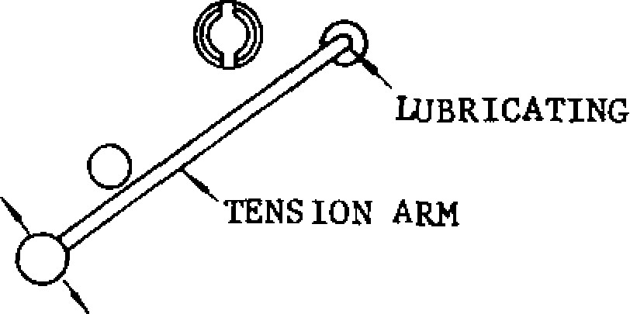

**(In the case of 8 inches diameter reel)**

Fig. 8.1

**NOTE: When trouble occurs in feeding or w i n d in g t ap e w i t h 8 in ch d ia m et er re e ls , open the front door and brush away dust around the photo-coupler by using a blower brush.**

**8.1. 2 CONTROL PANEL**

**The control panel is a dustproof, sheet -steel enclosure with gasketed doors.**

**A. Front and rear doors of the control should be** s h u t **tightly, even if the control is not operating .**

|  |  |
| --- | --- |
| With the door | With the door |
| lock on right | lock on l eft |
| side of the | side of the |
| **door.** | door. |

**Fig . 8. 2**

NOTE: **If the optional door interlocking switch i s p r o v i d e d , o p e n i n g t h e d o o r s h u t s o f f t h e main power supply and stops all** operations.

1. Check gaskets **on the rims of front and rear doors.**
2. **See if the inside of** enclosure **is dusty. Clean it, if necessary.**
3. **Check for any opening in the door base with the doors shut tightly.**

**8.1. 3 SERVOMOTOR AND DCMOTOR FOR**

**SPI ND LE**

1. **Vibra tion a nd** noi se.

**V i b r a t i o n c a n b e** c h e c k e d **b y r e s t i n g t h e**

**ha nd o n the m o tor s , a nd fo r noi s e , usi ng a listening stick is recommended. If** a n y **abnormality is found,** contact **maintenance** p e r sonnel **immediately.**

1. **Motor contamination and impairment.**

**Check the motor exterior visually. If dirt or damage should be observed,** i n s p e c t **the motor by removing the machine** cover. **Refer to the machine tool builder's manual.**

**8.1. 3 SERVOMOTOR AND DC MOTOR FOR**

**SPINDLE (CONT'D)**

3 . C l e a r a n c e o f v e n t i l a t i o n w i n d o w b l o c k a g e

Check the ventilation window of DC spindle m oto r. If it i s c logged with du st o r di rt. in spect DC spindle motor removing the machine cover. Refer to the machine tool builder's manual.

Inspection of commutators and brushes is essen tial for maintaining the excellent performance of t h e co nt ro l. In s p ec t ion wo rk t o be e xe c ut ed i s described in the following three items.

Q u art erl y In sp ect io n o f Commu t at o rs an d B ru shes

T h e c a r b o n d u s t f r o m b r u s h e s , a c c u m u l a t e d a ro un d th e co m mu t at o r, ins i d e t he mo to r, m ay cause motor troubles such as the layer short of a r m a t u r e a n d t h e f l a s h o v e r o f c o m m u t a t o r . I n

the worst case, it may lead to fatal damage. To avoid this, be sure to have an inspection on the c o m m u t a t o r s a n d b ru s h e s a t l e a s t e v e ry t h r e e months.

Be su re to turn o ff the powe r supply to the N C b e f o r e s t a r t i n g t o c h e c k t h e b r u s h e s a n d motor interior_

F o r t h i s , t u rn i n g t h e c i r c u i t b r e a k e r o n t h e power supply unit (DCP UNIT) for the servo con t rol unit (C PCR -MR -K ) o ff i s no t su ffi cient . To p r e v e n t e l e c t r i c s h o c k s a n d s h o r t i n g , b e s u r e t o sh ut o ff t he s upp l y o f po we r to th e NC .

1. . C a r b o n b r u s h e s
   1. . U n d e r n o r m a l o p e ra t i n g c o n d i t i o n s , b ru s h wears by 2 to 4 mm per 1000 operating hours. If wear is excessive, check to see if oil has contaminated commutator surface, or if ab n o r m a l o v e r c u r r e n t f l o w t h r o u g h m o t o r

circuit.

* 1. . When brush length becomes shorter t han those shown below, replace the brush with a new one.

Minertia motor junior series: 6 mm or below D C moto r fo r spindl e: 17 m m o r belo w

* 1. . I f e i t h e r o f b r u s h , o r p i g t a i l i s b r o k e n , brush assembly must be replaced as a whole unit.

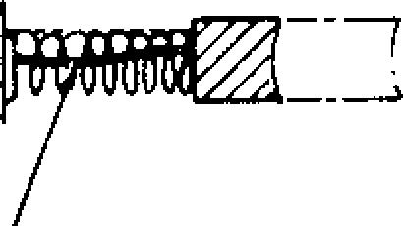

PIGTAIL

F i g . 8 . 3

NOTE: When replacing the brush assembly, consult the company.

1. . C o m m u t a t o r s u r f a c e
2. Visually check surface roughness of the commutator through inspection window.

After 100 to 200 operating hours, the com - m u t a t o r s h o u l d t a k e o n a p o l i s h e d l i g h t

b ro wn o r c h o c o l a t e c o l o r . T h e m o t o r h a s developed an ideal commutator film and needs no attent ion othe r than to be kept clean .

1. See i f a black ened ba r, th re ading (o r g ro o v i n g ) i s o n t h e c o m m u t a t o r . I f a n y o f t h e above is observed, investigate the cause of trouble.

Th reading o r g rooving on th e co mmut ato r surface may be due to too small moto r load. Blackened bar is a result of carbon dust in commutator slots, or accidentally produced s p a r k i n g s . I f t h e c a r b o n d u s t i s a c a u s e o f bl ackened ba r, wipe the com muta tor with a clean dry cloth to smooth the surface. If s pa rking occu rs, contac t the ma intenan ce rep re sent ative .

1. . M o t o r i n s i d e (d i rt y )

A. Visually check the motor interior through inspection window.

The d rie d c a rbo n du s t wi l l n ot a ffe ct m ot o r

r u n n i n g , b ut it i s r e c o m m e n d e d t h a t t h e

i n n e r p a r t s s u c h a s c o m m u t a t o r , b r u s h -

holde rs and b rush es be c lean ed with a d: .y

c o m p re s s e d a i r ( a i r p r e s s u r e : 2 - 4 k g / c m 2 ) .

B. Where oily carbon dust exists inside the mo tor due to poor oil seal or defective enclo s ure, contac t Ya ska wa.

1. . Se rv o m o t o r wi t h o i l s e a l

As t h e l i fe e xp ec t an cy o f o i l s e al an d b ru sh is 5000 hours (about five years) , the inspec tion and maintenance by the company should b e d o n e e v e ry 5 y e a rs . If p o s s i b l e , y e a rl y

inspection taking less than 8 hours is recom mended.

**8.1.4 BATTERY**

Make sure that "BAT" or "A /B" on the right -low po sition o f CR T s creen is not di splayed . If i t is d i s p l a y e d , i n fo r m m a i n t e n a n c e p e r s o n n e l . T h e battery must be replaced with a new one within a month.

|  |
| --- |
| - 180 - |

The control with a bubble memory board (optional) d o e s n o t re q u i r e a b a t t e ry .

**8.2 BATTERY REPLACEMENT**

The ba ttery is u sed as po wer source for me mory in order to prevent programming data stored in memory, such as parameter, tool offset and part pro gra m from erasing.

When the battery is discharged after a long period of use, "BAT" or "A /B" is blinked on CRT screen to g iv e wa rn in g fo r re p la c e me n t. On su c h o c c a s i o n s , t h e b a t t e r y m u s t b e r e p l a c e d w i t h i n 3 0 d a y s . W h e n r e p l a c i n g , n e v e r r e m o v e t h e o l d b a tte ry with p o we r o ff , o th e r wise th e d a ta sto re d in memory may be cleared.

Replacing Procedure

1. Depress POWER OFF pushbutton on the oper a to r 's sta tio n .
2. Open the fron t doo r of the control. The bat Where the control is provided with a door in terloc k switc h , pu sh it b a ck in p lac e since power cannot be turned on with the door open.
3. . T i g h t l y c l o s e t h e f r o n t d o o r .
4. . D e p r e s s P O W E R O N p u s h b u t t o n .

1 0 . Make sure that "BAT" or "A/B" on CRT sc reen go es o ff.

MEMORY BOARD, TYPE JANCD-MM01C

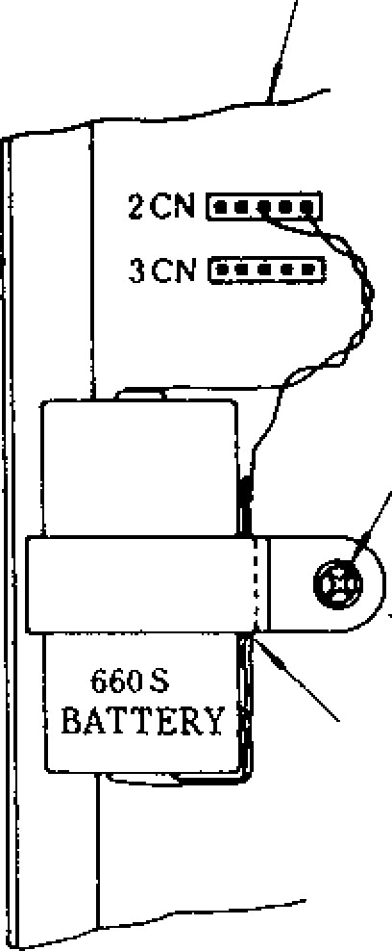f **BATALM1**

|  |
| --- |
| tery of the memory(printed circuit) board can be seen on the CPU module which is mounted  on rear of the front door. MOUNTING SCREWS FOR BATTERY   1. Depress POWER ON pushbutton. Where the control is equipped with a door interlock switch, pull it ou t by hand. The p owe r can b e tu rn e d o n , wi th th e d o o r o p e n .   **THREAD THE LEAD**  THROUGH THE GAP   1. Check to see if 1LED on memory board is illu-OF BATTERY CLAMP.m i n a t e d . F i g . 8 . 2 . 1 sh o w s t h e a r r a n g e m e n t o f LED a nd th e b attery . If illu mina ted , re place the battery "660S" with new one.   F ig . 8 . 4 A r ra n g e me n t o f L E D a n d Ba tt e r y  660S • • • Type: JZNC-GBAOZ NOTES: |

1**LED**

5 . W i t h t h e c o n t r o l p o w e r tu r n e d o n , c o n n e c t 1. th e rec eptac les o f the new ba ttery in to the plugs (1CN or 2CN) on memory circuit board, a n d L E D w i l l b e t u r n e d o f f . S e e Fig. 8 . 2 . 1 . If LED is still illuminated, it is due to the 2.

improper insertion of battery connectors, or defective battery.

**I M P O R T A N T : T w o p l u g s t a t i o n s ,** 1 C N **a n d 2CN** (o r 2 CN an d 3 CN) are co nn ec ted to ge the r3.

with common leads. When an old battery is rep laced with a ne w one, conne ct the ne w

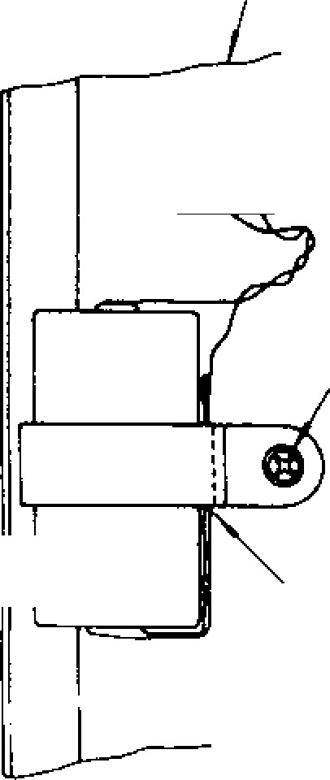

Fig. 8.5

**New Battery Mounted**

FATAT:T;(1

I

**LED**

**2**

**CN**

**3**

**CN**

MOUNTING SCREWS

FOR BATTERY



**THREAD THE LEAD**

THROUGH THE GAP

OF BATTERY CLAM.

**BATTERY**

While battery is being replaced, exercise ut most care to prevent contaminants from en te ring the con trol, and acco mp lish the work as quickly as possible.

Use sp ec ial ca re to p re ven t wa te r, o il, or dust, to adhere to the devices (printed cir cuit board, connectors, cables, etc.) inside the control.

Never leave any screws or washers in the control.

|  |
| --- |
| ba ttery first to the p lug sta tion not occupi - ed, then remove the receptacles of the old b a tte ry .   1. . D e p r e s s P O W E R O F F p u s h b u t t o n . 2. . Remove the mounting screw of old battery, and then replace the battery with new one. In this case, pass the battery lead through gap s between the battery and the battery clamp, and use care not to contact the lead with memory circuit board.   - 181 - |

**MEMORY BOARD, TYPE JANCD-MMO** 1C

**8.3 POWER CIRCUIT BREAKER AND FUSES**

T h e p o w e r c i r c u i t b r e a k e r a n d f u s e s a r e p r o v i d e d f o r t h e s a f e t y o f t h e c o n t r o l : a p o w e r c i r c u i t b r e a k e r a n d f o u r f u s e s a r e i n t h e c o m p o s i t e c o n t r o l p o w e r s u p p l y u n i t ; t w o f u s e s i n t h e p o w e r i n p u t u n i t ; a f u s e a n d c i r c u i t b r e a k e r i n t h e s e r v o c o n t r o l p o w e r u n i t . I f t h e b r e a k e r

t r i p s o r t h e f u s e s a r e b l o w n o f f , c o n s u l t t h e

maintenance personnel.

**8.3.1 CIRCUIT BREAKER OF COMPOSITE CO N TROL POWER SUPPLY UNIT**

The breaker trips due to overload of composite c o n tro l p o we r su p p ly u n it. Re se t th e c o n tro l

according to the following procedure. See Fig. 8.3.2 Breaker and Fuse s of Compo site Con trol Power Supply Unit.

8.3.2 **FUSES OF COMPOSITE CONTROL POWER SUPPLY UNIT**

If any of the fuses are blown, all power supplies a rc tu r n e d o f f. R e se t t h e c o n tr o l a c c o rd in g to the following procedure.

I. Remove the blown fuse that i s i n d i c , i t e d with white mark coming on the fuse casing window.

1. Inspect for the cause of failure in the control po wer supp ly, I/O in terface and servo un it, and re move, if any.

1. R e p l a c e t h e b l o w n f u s e w i t h n e w o n e .
2. Depress POWER OFF pushbutton on the op -

erator's station to reset the control and then tu rn o n th e p o we r.

1. If th e fu se is blo wn ag a in , co ntac t Yaska wa .
2. Inspect for the cause of overload, and remove, if any.
3. When the breaker trips, ON-OFF lever of the b rea ke r is in OF F po sitio n . Pu t th e lev er in ON position.
4. D e p r e s s VOLTAGE INPUT P REAKER FUSEWHITE MARK

P O W E R TERMINALS WHEN BLOWN O F F p u s h b u t OFF0 IT)1,5 t o n o n pip ® TD irT)

t h e o p - O F F e r a t o r ' s 7.5A

s ta t io n . R e s e t t h e c o n t ro l a n d th e n tu rn o n th e p o we r.

1. I f t h e b r e a k e r t r i p s a g a i n , c o n t a c t Y a s k a w a .

F ig . 8 . 6 B re a k e r a n d F u se s o f Co m p o si te

Control Power Sup ply Unit

- 182 -

**8. 3. 3 FUSES OF POWER INPUT UNIT**

**If any of the glass-tube fuses are blown, all power supplies are turned off and 1LED of the power closing unit goes off. To reset the control, use the following procedure.**

1. **Turn off all power** supplies by putting molde d - c a s e c ir c u i t b r e a k e r in O F F p o s i t i o n . N e v e r to u c h t h e u n i t u n ti l t h e b re a k e r is turned off.
2. Inspect for the cause of trouble, and remove, if any.
3. R e p l a c e t h e b l o w n f u s e w i t h n e w o n e .
4. Make sure that ILED goes on when the break e r is tu rn e d o n .

5 , T u r n **on the power.**

**6. If the fuse is blown again, contact Yaskawa.**

2FU 0

' Erin

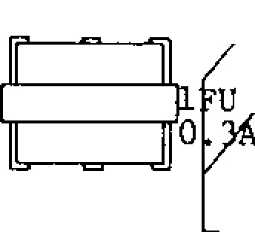

0

3

0

0

ILED GLASS-TUBE

FUSES

F i g . 8 . 7 F u se s o f P o w e r C l o s i n g U n i t

**8. 3. 11 FUSE FOR SERVO CONTROL POWER**

**UNIT**

**When the servo control power unit (called DCP unit hereinafter) is overloaded due to short-circuiting of** c o n t r o l u n i t p o w e r l i n e , e t c . , t h e f u s e fo r D C P i s b lo w n - o u t . **The "POWER" Led will be extinguished to indicate that the fuse is blown. Take the following measure for** t h e blown -out fuse .

( 1 ) D e p r e s s t h e P O W E R O F F b u t t o n t o t u rn **off the power supply, and then, depress it again to turn off the power to NC.**

**(.?..) Find the cause of** the **fuse blowing, and eliminate it.**

1. **Replace the blown fuse with the new one of the same rating.**
2. **Depress the POWER ON button to turn on** t h e p o w e r f o r NC anti Licpress it again t o **turn on the servo power. Check to be sure that "POWER" Led lights up.**

**--**

**183**

**-**

1. **If the** fuse is blown off **again, contact our service personnel.**

**NOTE DCP unit size will** d i f f e r w i t h t h e c a p a c i t y o f 1 0 A, 15 A, 30 A, 60 A.

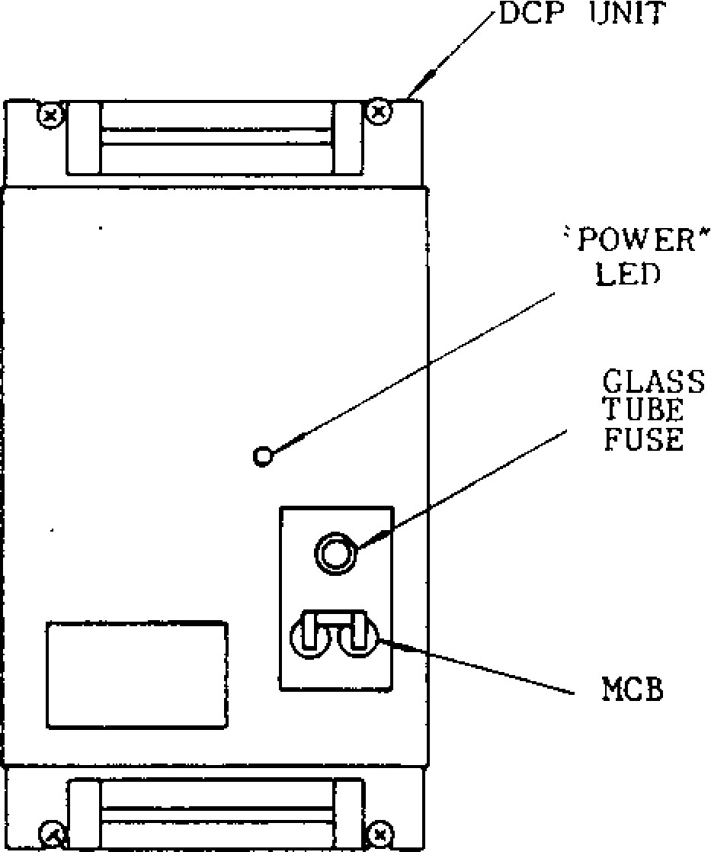

GLASS

TUBE

FUSE

**8 . 3 . 5 C I R C U I T B R EA K ER F OR S ER V O C O N T R OL**

**When the DCP unit is overloaded through the shorting of the output circuit, faults of the DCP unit itself, etc., this circuit breaker trips to disconnect** the ma in c ircu it.

In th is c a se , a n a la rm "3 5 0 :0 L" is d isp la y e d o n t h e C R T . ( 3 5 0 : 0 L m a y **be displayed also by other causes.) When this** c i r c u i t b r e a k e r i s t r i p ped to the OFF state, take the following measure.

1. Push the POWER OFF button to turn off the power supply, and then, stop the supply of power to NC.
2. F in d the cause o f th e tripping of the circuit bre aker, and elimin ate it.
3. Push up the breaker lever to the ON posi tion.
4. Supply power to NC, and then, push the POWER ON button twice.

The servo circuit is energized, and is ready for operation.

1. **If the circuit breaker is** tripped again, no tify **our service** de partment.

NOT E: Wh en th e c irc uit b rea ke r is man ua lly tu rn • e d o ff u n d e r p o we r, n o t tu rn in g o ff a u to ma tic a l ly by overloading, the alarm "310:SERVO OFF" is displayed on the CRT. The DCP unit can be **brought to the operating conditions by the same measures as above, also in this case.**

**8.4 THERMAL OVERLOAD RELAY OF SERVO UNIT** The servo control unit has the function of de tecting the following alarm states.

|  |  |
| --- | --- |
|  | Alarm No. |
| . Fuse (main circuit) | 331(X) 332(Y) 333(Z) |
| blown | 334(4) |
| . Overload | 351(X) 352(Y) 353(Z)  354(4) |
| . T G e rror | 391(X) 392(Y) 393(Z)  394(4) |

**8. 4.1 FUSE BLOWING (Alar m No. 331, 332)**

When the main circuit of the servo control unit is shorted or when the servo control unit itself be co mes fau lty , the fuse in the unit will be blo wn , and the following alarm Nos. will be displayed on th e CRT.

3 3 1 : F U S E ( X ) • — f o r X - a x i s 3 3 2 : FUSE(Y) for Y-ax is

3 3 3 : FUSE(Z) for Z-axis .

3 3 4 : FUSE (4) fo r 4Th axis

When a fuse is blown, and the alarm No. 331 or 332 is displayed, do not attempt to take mea s u r e s , b u t th e u se r sh o u ld i m me d ia te ly n o t if y

our serv ice departmen t.

**8 . 4 . 2 O V E R L O A D ( A L A R M N O. 3 5 1 , 3 5 2 )**

The servo control unit is provided with electronic thermal relays respectively and independently for the X and Z axes, and they trip under the follow ing conditions.

Programs involving excessively heavy cuts are execu ted.

Programs involving excessively frequent speed chang es a re exec uted.

Frictions in the machine system become abnor mally large.

When the e lectro nic thermal rela y trips, the servo power supply is turned off, and the follow in g ala rm Nos. are disp layed on the CRT.

3 5 1 : O L ( X ) • • • X - a x i s o v e r l o a d

3 5 2 : O L ( Y ) . . . Y - a x i s o v e r l o a d

**3 5 3 : OL (Z ) . . .** Z - a x i s o v e r l o a d

3 5 4 : O L ( 4 ) . . . 4 T h a x i s o v e r l o a d

When this is the case, take the following measures.

( 1 ) P u sh th e P O W E R O F F b u t t o n to tu rn o f f th e po wer supply, a nd th en, stop th e sup ply of power to NC.

( 2 ) F i n d t h e c a u s e o f t h e o v e r l o a d i n g . F o r example, the cause may be eliminated through m o d i f i c a t i o n s o f t h e p a r t p r o g r a m , o r b y

the elimination of abnormally large load on the machine.

( 3 ) S u p p l y p o w e r t o t h e N C , a n d p u s h t h e POWER ON button to turn on the power supp ly an d make the syste m ready for operation. However, since the servo motor requires approximately 30 minutes to zool down after being overloaded to the extent o f tripp in g th e e le ctron ic th erma l rela y, wait at least 30 minutes before starting to operate NC.

( 4 ) If the electronic thermal relay trips, notify our serv ice departmen t.

**8 . 4 . 3 T G ER R O R (A L A R M N O. 3 9 1 , 3 9 2 )**

The servo control unit can detect the following alarm states.

Wire breaking in the tachometer generator (TG) or overspeeding

* M a i n c i r c u i t o v e r c u r r e n t
* M a i n c i r c u i t o v e r v o l t a g e

When any of these faults occurs, the follow ing alarm Nos. will be displayed on the CRT.

391: TG ERROR (X)

392: TG ERROR (Z)

393: T G ERROR (Z)

394: T G ERROR (4 )

When this is the case, take the following measures.

1. Push the POWER OFF button to turn off the power supply, and then,stop the supply of power to NC.
2. Find the cause of the alarms, and eliminate it. In this case, if the fault conditions are reported to our service department, we will be able to give advice on troubleshooting.
3. Resupply power to NC, and then, push the POWER ON button to make the unit ready for operation.
4. If TG ERROR is displayed again, notify our se rvice departme nt.
   1. **OTHERS**

**Those special housing type controls, with which all the power sequence control circuits are con verted to the NC area, are sometimes provided with MCBs which can be turned on and off externally.**

**Generally, when these MCBs are turned off, the power supply to the NC is stopped. For details, refer to the manual of the machine tool builders.**

* 1. **TROUBLE CAUSES AND REMEDIES**

**8.6.1 ON—LINE DI AGNOST ICS**

**On-line diagnostics are implemented to locate a trouble quickly and protect the machine against malfunctions. Shown below** a r e **t di c - )** y i n g **furictions executed by the control being on-line and machining.**

* Display of three-digit alarm code including a cod e sho wing an axis in erro r.
* Display of four-digit status code including a function code showing M, S, T, V, DWL.
* I n p u t / o u t p u t s i g n a l d i s p l a y

Th es e di splay s c an be made at any ti me, while the machine is in automatic operation, or at stand by.

YASNAC MXI YASNAC MX1

**8. 6. 2 ALARM CODES AND REMEDIES**

**Where "ALM" or "A/B" on CRT screen is** blinking **and the machine stops, depress the** A L M k e y . Then alarm code and message will be displayedon CRT screen. Alarm codes "800," "810," "820," "830 " and "840" a re disp layed as soon a s **the** co r re s p o n d i n g e r ro r o c c u rs .

F o r t h e r e m e d i e s f o r t r o u b l e c a u s e s r e p r e s e n t e d by alarm codes, see APPENDIX **5 LIST OF ALARM** CODES on the last part of this manual.

**8.6.3 INPUT /OUTPUT SIGNALS**

**To clear up the causes indicated by alarm codes, check** t h e i n p u t / o u t p u t s i g n a l s o n

**the CRT screen.**

I n p u t / o u t p u t **signals are divided** i n t o s t a n d a r d and cus tom -buil t **ones, and displayed by specifying the corresponding diagnostic number with keys on the operator's station.** **Standard signals are included in every type of YASNAC MX1. Custom-built signals are provided for optional machine interface equipped with** som e type o f **YASNAC** con tro ls .

|  |
| --- |
| **Basic**  **Logic**    **Processing**  **Part**        **OPTION**    **Basic**  **Logic**    **Processing**  **Part**      **Optional**  **Ha chine**  **Interface**      !  Relay    1  Panel    on    'Machine  'Side      **Fig. 8.8** |

**8 . 6 . 3 I N PU T / OU T PU T SI G N A L S ( C ON T ' O )**

To display input/output signals, proceed as fol lows.

1. . D e p r e s s t h e D G N k e y .

A page containing the diagnostic number spec i f ie d p re v i o u s ly o c c u rs o n th e C R T sc re e n . • T he in pu t/o u tp u t sig na ls a re sho wn in "I," "0" and hexadecimal digit. 11I contact close

It 0 11contact open

1. . Key-in the diagnostic number to be displayed.
2. . D e p r e s s t h e c u r s o r

'or 4 ,1 key to page the

keyed-in diagnostic number on the screen. 8 . 6 . 4 **B E F OR E M A I N T EN A N C E C A L L**

CURSOR

B y d e p re ssin g th e c u rso r key,

4,

a c u r so r o n th e sc re e n mo v e s to t h e n e x t d i a g n o s t i c n u m b e r ( l i n e ) . W h e n d o w n t o th e la s t lo we r lin e , th e n e x t p a g e is d is played on the scree n.

B y d e p r e s s i n g t h e c u r s o r C U R S O R k e y , t h e c u r s o r m o v e s t o t h e p r e v i o u s l i n e . When up to the mo st upper line , the pre vious page is displayed.

|  |
| --- |
| fi  PAGE |

B y d e p r e s s i n g t h e p a g e P A G E k e y , t h e n e x t p a g e a p p e a rs o n th e sc re e n . By depressing the page key, the

previous page appears.

-

186

-

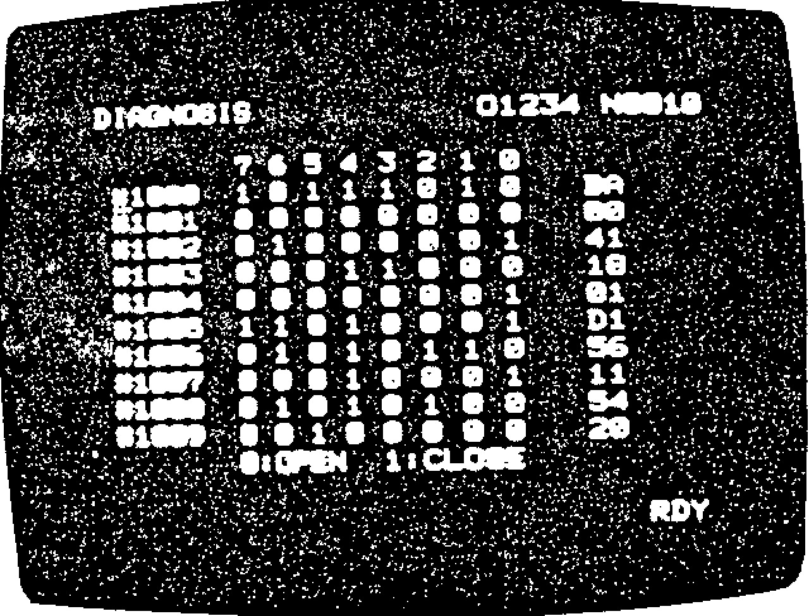

Fig. 8.9 Example of Input /Output

Signal Display

If the cause of trouble cannot be found by using alarm codes or I/O signals (described in 8.6.1to 8 .6 .3 ), o r c o r re c t a c ti o n f o r th e t ro u b l e c a n n o t

be taken. record the following items, and notify the company as soon as possible.

Alarm codes and the accompanying data with them.

T he ty pe s a nd ch ara cteristics of th e trou ble s.

The opera tional proc edures just be fore the trouble occured and number of applied tape.

Whethe r the troub le recurs e ach time, the o p eration is repeated after depressing the RESET key.

Date and time when the trouble occureCt.

Name of the discoverer of the trouble and the operator.

If trouble occurs, ke ep the contro l in th e sa me condition until it can be checked by your Yaskawa re p re se n ta tiv e . If th e s itu a tio n p e r mits, a v o id tu rning off control p owe r, or depressing POWER OFF button.

**APPENDIX -1 LIST OF SETTING NUMBERS**

**Setting numbers are classified in the following three groups:**

**Table 1.1**

|  |  |
| --- | --- |
| **Setting number** | **Group** |
| **No. 6000 to 6004** | **Setting by bit** |
| **No. 6200 to 6219** | **Setting by word** |
| **No. 6500 to 6599** | **Setting by double words** |

**Appendix table 1-2 lists setting numbers and their functions.**

SET Table 1.2 List of Setting Numbers

|  |  |  |  |  |  |  |  |  |  |
| --- | --- | --- | --- | --- | --- | --- | --- | --- | --- |
| SET NO. | D7 | D6 D5 | | 04 | D3 D2 | | 01 | DO |  |
|  |  |  | |  | I |  |  |  |  |
| #6000 | "1":I50  "0":EIA TAPE CODE | 1 :ON  "0":OFF  TV CHECK |  | ------------ | " ' :INV 1  4 | ":INY "0" :NORM  7. | " ":INV  "0":NORM Y | "1":INV  "0" :NORM |
|  | MIRROR | IMAGE |  |
|  |  |  |  |  |  |  |  |  | Refer to D2 3,4'  ,0603. |
| #6001 „ | " ":0N_  0" :OFF  BUZZER  ON/OFF | "1":0N  "0" :OFF  EIA/ISO  AUTO- RECOGNITIO | "1":0N  "0" :OFF  STORED  STROKE  AT MLK | "1":0N  "0" :OFF Z-AXIS  ,g1ELU_---„ INTERNAL | "1":0N  "0" :OFF  ABS | " "•0N  "0" :OFF  EDT  LocK, | "1":ON  "0":OFF  SECOND  STORED STROKE | # 6 0  "1":INCH  "0":MM INPUT |
| SWITCH |
|  |  |  |  |  |  |  |  |  | Refer to 116006D3. |
| #6002 | "1":0N  "0" :OFF  AFL | "1":0N  "0":OFF  MLK | "1":0N  "O":OFF  OPT | "1":0N  "O" .OFF  DRN | "1":0N  "O" :OFF BDT | " ":0N  "0" .OFF  DLK  ________ | "1":0N "O' :OFF  imotr | "1":0N  "0" .OFF  SBK  , |
|  |  |  |  | INTERNAL SWITCHES |
|  |  |  |  |  |  |  |  |  |  |
| 116003 | 08 | 04 | 02 | 01 | Ig | 14 | 12 |  |
|  |  | "0000": "0001": | FACIT  5I0-1 |  |  | "0000": "0001": | PTR 5I0-1 |  |
|  |  |  |  |  |  |  |  |  |  |
| 116004 |  |  |  |  |  |  |  | "1":0K  "0":ERROR  NO SKIP  SIGNALS AT  G31 |
|  |  |  |  |  |  |  |  |  |  |
|  |  |  |  |  |  |  |  |  |
|  |  |  |  |  |  |  |  |  |  |
|  |  |  |  |  |  |  |  |  |
|  |  |  |  |  |  |  |  |  |  |
|  |  |  |  |  |  |  |  |  |
|  |  |  |  |  |  |  |  |  |  |
|  |  |  |  |  |  |  |  |  |
|  |  |  |  |  |  |  |  |  |  |
|  | |  |  |  |  |  |  |  |
|  |  | | | | | | | | |

SET

|  |  |  |  |  |  |  |  |
| --- | --- | --- | --- | --- | --- | --- | --- |
| SET NO. | value | Functions | SET NO | Set |  |  | Functions |
| #6200 |  | BD-1 BREAK POINT |  |  |  |  |  |
| #6201 |  |  |  |  |  |  |  |
| #6202 |  | J |  |  |  |  |  |
| #6203 |  |  |  |  |  |  |  |
| #6204 |  |  |  |  |  |  |  |
| #6205 |  |  |  |  |  |  |  |
| #6206 |  |  |  |  |  |  |  |
| #6207 |  |  |  |  |  |  |  |
| #6208 |  |  |  |  |  |  |  |
| #6209 |  |  |  |  |  | • |  |
| #6210 |  | G76/77 DWELL TIME "1'1=1 msec |  |  |  |  |  |
| #6211 |  | G73(6)=0.001mm (0.001inch) |  |  |  |  |  |
| #6212 |  |  |  |  |  |  |  |
| #6213 |  | G83(6)=0.001mm (0.0001inch) |  |  |  |  |  |
| #6214 |  |  |  |  |  |  |  |
| #6215 |  |  |  |  |  |  |  |
| #6216 |  |  |  |  |  |  |  |
| #6217 |  |  |  |  |  |  |  |
| #6218 |  |  |  |  |  |  |  |
| #6219 |  |  |  |  |  |  |  |
|  |  |  |  |  |  |  |  |
|  |  |  |  |  |  |  |  |
|  |  |  |  |  | .t |  |  |
|  |  |  |  |  |  |  |  |
|  |  |  | 1 |  |  |  |  |
|  |  |  |  |  |  |  |  |
|  |  |  |  |  |  |  |  |
|  |  |  |  |  |  |  |  |
|  |  |  |  |  |  |  |  |
|  |  |  |  |  |  |  |  |
|  |  |  |  |  |  |  |  |
|  |  |  |  |  |  |  |  |
|  |  |  |  |  |  |  |  |
|  |  |  |  |  |  |  |  |
|  |  |  |  |  |  |  |  |
|  |  |  |  |  |  |  |  |
|  |  |  |  |  |  |  |  |
|  |  | • | I |  |  |  | . |
|  |  |  |  |  |  |  |  |
|  |  |  |  |  |  |  |  |

e

SET Table 1.2 List of Setting Numbers (Cont'd)

|  |  |  |  |  |  |  |  |
| --- | --- | --- | --- | --- | --- | --- | --- |
| __ SET NO__ 116500 | sir ! a,1.1, | Functions | | SET NO | Set  'value | Functions | |
| SCALLING MULTI numerator | | #6540 |  |  | |
| 16501 |  | SCALING MULTI denominator | | 46541 |  | 1 WORK COORDINATE ,zysTrm ', | |
| 1,6502 |  |  | | ::652 |  | Z G58 | |
| 116503 |  |  | | #6543 |  |  | |
| #6504 |  |  | | #6544 |  |  | |
| #6505 |  |  | | #6545 |  |  | |
| 716506 |  | G76/77 ANGLE  wiluNATION "1"=0.001deg | | 716546 |  |  | |
| #6507 |  | TLM BIAS VALUE | | 716547 |  | Y WORK COORDINATE SYSTEM 6 | |
| #6508 |  | TLM DISTANCE TO ZERO POINT | | 716548 |  | Z G59 | |
| #6509 |  |  | | #6549 |  |  | |
| #6510 |  | X STORED STROKE LIMIT 2 | | #6550 |  |  | |
| 116511 |  | Y G22 | | 716551 |  |  | |
| 716512 |  | Z (+) SIDE BOUNDARY VALUE | | #6552 |  | X | |
| 116513 |  | X | | #6553 |  | Y COORDINATE VALUES WHEN SKIP | |
| 716514 |  | YJG22 | | #6554 |  | Z SIGNAL IS ON | |
| #6515 |  | Z | (-) SIDE BOUNDARY VALUE | #6555 |  |  | |
| #6516 |  | X |  | #6556 |  |  | |
| #6517 |  | Y | WORK COORDINATE SYSTEM 1 | #6557 |  |  | |
| #6518 |  | Z | G54 | #6558 |  |  | |
| #6519 |  | 4 |  | #6559 |  |  | |
| #6520 |  |  |  | #6560 |  | 'FO FEED, |  |
| 716521 |  |  |  | 716561 |  | Fl FEED |  |
| #6522 |  | X |  | 716562 |  | F2 FEED |  |
| #6523 |  | Y | WORK COORDINATE SYSTEM 2 | #6563 |  | F3 FEED |  |
| 116524 |  | Z | C55 | #6564 |  | F4 FEED | Fl-DIGIT COMMAND |
| 116525 |  | 4 |  | 116565 |  | F5 FEED | "1" = 0.1 mm/min |
| #6526 |  |  |  | #6566 |  | F6 FEED |  |
| 116527 |  |  |  | 116567 |  | F7 FEED |  |
| 116528 |  | X |  | 116568 |  | F8 FEED |  |
| #6529 |  | Y | WORK COORDINATE SYSTEM 3 | #6569 |  | F9 FEED, | |
| #6530 |  | Z | G56 | 116570 |  |  | |
| 116531 |  | 4 |  | 116571 |  |  | |
| 116532 |  |  |  | #6572 |  |  | |
| #6533 |  |  |  | 116573 |  |  | |
| #6534 |  | X |  | #6574 |  |  | |
| #6535 |  | Y | WORK COORDINATE SYSTEM 4 | #6575 |  |  | |
| 1,6536 |  | Z | G57 | #6576 |  |  | |
| 1(6537 |  | 4 |  | 116577 |  |  | |
| #6538 |  |  |  | #6578 |  |  | |
| 116539 |  |  |  |  |  |  | |

716579

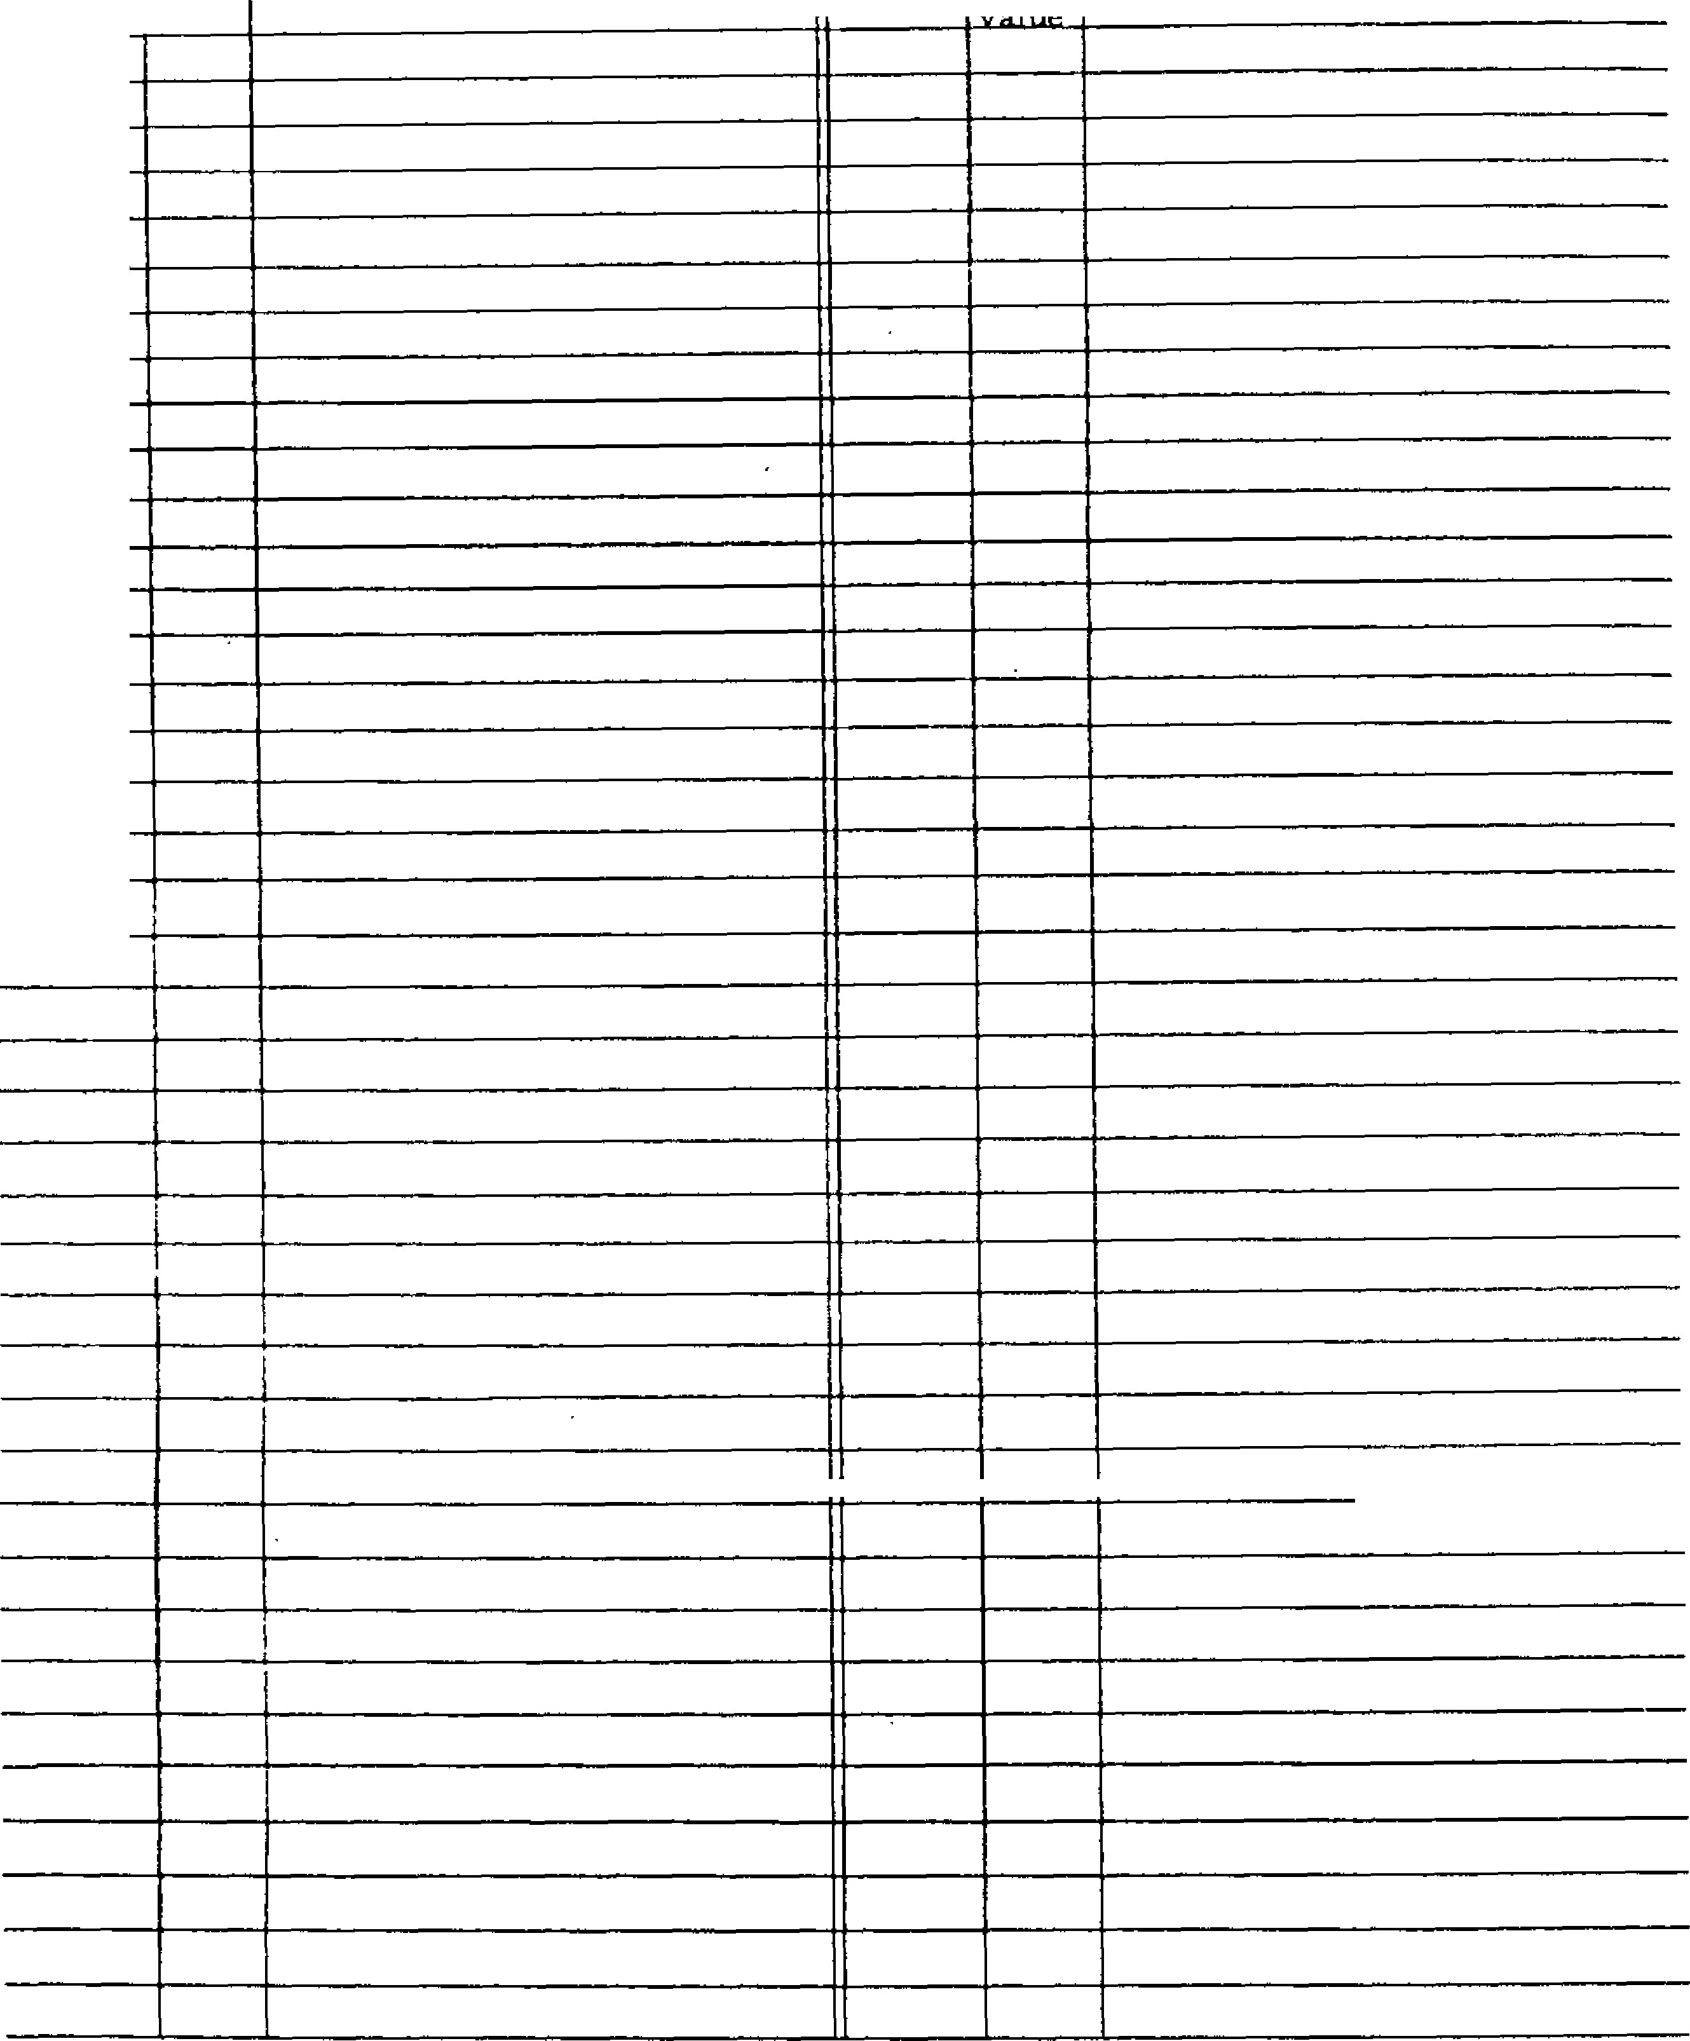

SET

SET NO.

#6580

#6581

#6582

#6583

#6584

#6585

#6586

#6587

#6588

#6589

#6590

#6591

#6592

#6593

#6594

#6595

#6596

#6597

#6598

#6599

**Function s**

SET NO,

**Set**



Functions

Set

value

r

•

•

•

.

.

.

.

.

.

.

■

■

■

■

■

•

■

**APPENDIX - 2 LIST OF PARAMETER NUMBERS**

Parameter numbers are classified in the following f i v e g ro u p s :

T able 2 .1

|  |  |
| --- | --- |
| Parame ter number | Group |
| #6005 to #6049 | Se tting by b it |
| #6050 to #6199 | S e ttin g b y b y te |
| #6220 to #6399 | Se tting by word |
| #6600 to #6699 | Se tting by do uble wo rds |
| #7000 to #7095 | S e ttin g b y b y te fo r se q u e n c e r |

Optimum data of parameters have been set accord ing to machine performance and applications. For any modification of parameter data, consult the ma chine tool builde r.

Data pertaining to parameters #6033 to #6049 must n o t b e mo difie d , for they ha ve be en in co rpo ra ted a s p a r t o f t h e s y s t e m .

**PARAMETER NUMBERS AND THEIR CONTENTS**

|  |
| --- |
|  |
| #6005 |
|  |

|  |
| --- |
|  |
| #6006 |

D7 D6 D5 D4 D3 D2 D1 D7 D6 D5 D4 D3 D2 Do

D 7 1 : S t o r e s t h e H c o d e f o r r e s e t , G 9 2 a n d G 2 8 . D 7 , D 6 S i g n s o f 5 4 - d i g i t a n a l o g ( S D A ) o u t p u t

0: Sets the H code to 1-100 for reset, G92 and G28.

D 6 1 : S to re s th e G c o d e in th e 0 1 g ro u p fo r reset.

0: Sets the G code in the 01 group to GOO for reset.

D s 1 : Al lo ws th e c u rre n t v a lu e d isp la y (u n i versal) to be preset by the coordinate system seeeing command G92.

At this time, the ORG key is capable of Zero Setup.

0: Keeps the current value display (uni versal) from being preset by the coor dinate system setting command G92.

At this time, the FORG I key is incapable of Zero Setup.

D 4 , D 3 : Sta tus of G codes a t po we r on.

|  |  |  |
| --- | --- | --- |
| D4 | D3 | Initial status |
| 1 | 0 | Sets the G code in the 08 group to G44 on power application. |
| 0 | 1 | Sets the G code in the 08 group to G43 on power application. |
| 0 | 0 | Sets the G code in the 08 group to G49 on power application. |

D 2 1 : S e t s t h e G c o d e i n t h e 0 1 g r o u p t o G O l on power application.

0: Sets the G code in the 01 group to GOO on power application.

D1 1: Sets the G code in'the 05 group to G95 on power application.

0: Sets the G code in the 05 group to G94 on power application.

D o 1 : S e ts th e G c o d e i n t h e 0 5 g ro u p to G9 1 on power application.

0: Sets the G code in the 05 group to G90 on power application.

|  |  |  |  |
| --- | --- | --- | --- |
| D7 | D6 | Sign | |
| 1 | 1 | Minus | Plus |
| 1 | 0 | Plus | Minus |
| 0 | 1 | Minus | Minus |
| 0 | 0 | Plus | Plus |
|  | | SINV signal off | SINV signal on |

D5 1: Sets the least input increment to 0.01 mm (o r 0 .0 0 1 in ., 0 .0 1 d e g .) .

0 : S e ts th e le a st in p u t in c re me n t to 0 .0 0 1

mm (o r 0.0 001 in , 0.001 deg .).

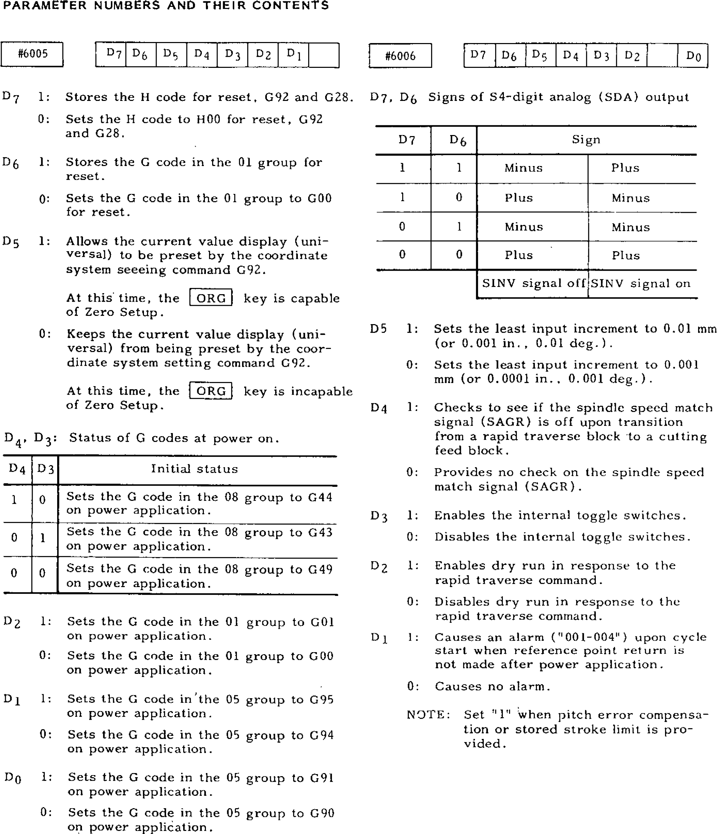D4 1 : Ch ec k s to see if the sp ind le sp e ed match s i g n a l ( S A G R ) i s o f f u p o n t r a n s i t i o n from a rapid traverse block to a cutting feed block.

0: Provides no check on the spindle speed match signal (SAGR).

D3 1 : En a b le s th e in te rn a l to g g le s witc h e s. 0: Disables the internal toggle switches.

D2 1: Enable s dry run in response to the rapid traverse command.

0: Disab les dry run in re sponse to the rapid t rave rse c ommand .

D1 1 : C a u s e s a n a l a r m ("0 0 1 -0 0 4 " ) u p o n c y c l e s t a r t w h e n r e f e r e n c e p o i n t r e t u r n i s

not made after power application.

0: Causes no alarm.

NOTE: Set "1" when pitch error compensa tion o r stored strok e limit is pro vided.

**PARAMETER NUMBERS AND THEIR CONTENTS**

**(** **C ONT'D)**

|  |  |  |
| --- | --- | --- |
| |  | | --- | | #6007 | | D6    04  D3  02    Do |

D6 1 : Employ s th e ne wly e n te re d too l c o mpe n sation value in place of the old value.

0 : A d d s t h e n e w l y e n t e r e d t o o l c o m p e n s a tion value to the soterd value to establish another offset.

0 4 1 : P r o v i d e s o u t p u t d u r i n g r e w i n d i n g .

03 1 : S e ts th e le a st in c re me n t to 0 .0 0 0 1 in . 0 : S e ts th e le a st in c re me n t to 0 .0 0 1 m m.



D2 1 : Ma ke s the sp ind le o v errid e 10 0 % d u ring tapping.

0: Does not make the spindle override 100$ . d u rin g ta p p in g .

D o 1 : E s t a b l i s h e s t h e 2 n d p r o h i b i t e d a r e a o f th e stored strok e limit outside the b o u n d a ry .

0 : E s t a b l i s h e s t h e 2 n d p ro h i b i t e d a r e a o f the sto red stroke limit inside the b o u n d a ry .

#6008

external de

celeration signal effective.

DI

D3

Do

D2 Dl

#6013

|  |  |  |
| --- | --- | --- |
| |  | | --- | | #6010 | | D3    D2 |

0 : Pr o v id e s n o o u tp u t d u r in g re w in d i n g . D3,

D2, Di, D0

Spec ify the d irec tion of refe rence point re - t u r n o n t h e 4 t h - , 2 - , Y - a n d X - a x e s , re spect ively. 1 : M i n u s d i r e c t i o n

0: Plus direction

NOTE: The specification is effective for an axis with #6016 at "1."

#6012 D3 02 Di Do

-

194

-

D3, D2, Di, D0

Spec ify whether or not th e p lus -d irection external deceleration signal is effective on th e 4 th - , 2 -, Y- a n d X-a x e s, re sp e c tiv e ly .

1 : Ma k e s th e p lu s -d i re c tio n e x te rn a l deceleration signal effective.

|  |
| --- |
| 1: Makes the minus direction |

0 : M a k e s t h e p l u s - d i r e c t i o n e x t e r n a l

de cele ra tion signal ine ffectiv e.

D1 1: Does not c lear the co mmon v ariab les of #100 through #149.

0: Clears the common variables of #100 through #149.

Note: Some controls are not provided with the parameter #6008.

#6009 D 3 D 2 O l Do

03 • 02 , Di, Do

Specify the start direction of backlash comp e n sa t io n o n th e 4 th -, Z - , Y - a n d X -a x e s, r e s p e c t i v e l y , u p o n p o we r a p p l i c a t i o n .

1 : M in u s d ire c t io n

0 : P l u s d i r e c t i o n

D3, 02, D 1, D0

Specify whether or not the minus-direction external deceleration signal is effective on th e 4th -, 2-, Y- and X-axes, re spectively . 0: Makes the minus direction external deceleration signal ineffective.

#6014 D 3 D 2 D 1 Do

D 3, D2, Di, Do

Specify the direction of the G60 uridirection a p p ro a c h u p p e r li mit o n th e 4 th - , Z-, Y - a n X a x e s , r e s p e c t i v e l y .

1 : M in u s d i rec t ion

0 : P l u s d i r e c t i o n

NOTE : Th e app roa ch upper l imit i s set witl #6062 to #6065.

|  |  |  |  |  |  |
| --- | --- | --- | --- | --- | --- |
| |  | | --- | | #6015 | | |  |  |  | | --- | --- | --- | |  | D3 D | Do | |

D 3, D2, Di, Do

Specify whether or not the automatic coor - dinate system setting is effective on the 4 th-, Z-, Y- an d X-a xe s, re sp ec tiv e ly .

1: Effec tive

0: Ineffective

NOTE: The automatic coordinate system is established with the following parameters:

Metric system; #6636 -#6639

Do

D3

D2

#6016

In c h sy ste m; # 6 6 3 0 - # 6 6 3 3

D3, D2, Di, Do

S p ec ify whe th e r or no t refe re nc e p o in t re turn is effective on the 4th -, Z-, Y- and Xa x e s , r e s p e c t i v e l y . •

1:

Makes

referen

ce

D3

04

D2

**T**

DI

D6

D7

DO

D5

#6017

p o i n t r e t u r n e f f e c t i v e . 0: Ma ke s re fe re nc e p o in t re tu rn ine ffec tiv e .

D7 - DO

Specify whether or not a hole is to be made on channels 8-1, respec tive ly, in a code corresponding to symbol "#" (used with user macro) in the EIA code.

1: Hole

0: No hole

Example:

D7 - Do = 01001001

T he c od e with ho le s on ch a nn els 7, 4 an d 1 is considered equivalent to symbol "#" in the E IA c o d e . No c o d e fo r u s e b y th e u n i t c a n be set.

|  |
| --- |
| #6018 |

D7 D6 D5 D4 D2 DO

-

195

-

D 7 1 : Pr o v id e s d we ll a t h o l e b o tto m in t h e c a n ned cycles of G76 and G77.

0: Does not p rovide d well at hole bottom in the canned cycles of 076 and G77.

NOTE: The dwell time is set with #6210.

D 6 1 : Esta b lish e s M0 3 fo r G7 4 a n d M0 4 fo r G8 4 a s th e M co de fo r o u tp ut a t ho le bo tto m in the canned cycles of G74 and G84.

0: Reverses the M code in effect before the c a nn ed c yc le s for o utpu t a t ho le b o tto m

**M04**

**M03**

**M04**

**M03**

**Before**

**canned cycle**

**Hole bottom**

in the canned cycle of G74 and G84.

NOT E : Th is spe cific a tio n is e ffe ct iv e wh en = 0 in #6018.

D 5 1 : R o t a t e s t h e s p i n d l e f o r w a r d a n d i n reverse, outputting M05 at hole bottom in the canned cycles of 074 and G84.

0 : R o t a t e s t h e sp in d le fo r wa rd a n d i n reverse, not outputting M05 at hole bottom in the canned cycles of G74 and 084.

N O T E : T h i s s p e c i fi c a t i o n i s e f fe c t i v e wh e n

04 = 0 in #60 I8.

D4 1 : O u t p u t s a r e a d - o n l y s i g n a l ( S S P , S R V , a s s ) i n t h e c a n n e d c y c l e s .

0 : Ou tp u ts th e M c o d e in th e c a n n e d c y c le s.

D 2 1 : C a u s e s t h e X a n d Y m o v e m e n t i n t h e canned cycles to follow the U code in g r o u p 0 1 ( G 0 2 a n d G 0 3 r e g a r d e d a s

G01).

1. : C a u s e s t h e X a n d Y m o v e m e n t i n t h e c a nn ed c yc les to sta y in ra pid t ra ve rs e .
2. 1 : Ou tp u ts th e F MF sig n a l twic e in a c a n - ned cycle.

0: Outputs **the FMF** signal once in a canned cycle.

NOTE: The **specification of D7 - Do =00000000**

assumes that symbol "#" is not used Do 1 : Ou tp u ts th e e x t e rn a l o p e r a t io n sig n a l

in the EIA code. E F a t th e **en d of** p o sitio n in g b y G8 1

(081 being external operation function).

0: Does not output the external operation signal EF at the end of positioning by G81 (G81 being canned cycle).

**PARAMETER NUMBERS AND THEIR CONTENTS** m i n u t e i n t h e m e t ri c s y s t e m .

(CONTID)0 : S e t s F 3 1 ( m m / m i n . ) f o r t h e f e e d p e r #6019   Dot m i n u t e i n t h e i n c h s y s t e m .

41

-

D

Di

D5

D0 Set s P51 (to m/ rain . ) fo r the feed p et•

m i n u t e i n t h e m e t ri c s y s t e m .

D5 1 : E n a b l e s d r y r u n a t t h r e a d - c u t t i n g ( G 3 3 ) . 0 : S e t s F 5 0 ( m m / m i n . ) f o r t h e f e e d p e r m i n u t e i n t h e m e t ri c s y s t e m . 0 : D i s a b l e s d r y r u n a t t h r e a d - c u t t i n g ( G 3 3 ) .

D4 1 : E m p l o y s t h e f e e d r a t e s e t i n p a r a m e t e r

#6232 for the skip function command (G31).

0 : E m p l o y s t h e F c o d e c o m m a n d a s t h e feedrate for the skip function command (G31).

D2, Di

Speci fy the tool shi ft d ire ction in th e can ned cycles of G76 and G77 (effective when #6019 = 0).

|  |  |  |
| --- | --- | --- |
| D2 | D l | Shi ft d irection |
| I | 1 | -Y |
| I | 0 | +y |
| 0 | 1 | -x |
| 0 | 0 | +x |

Allows the tool shift direction in the canned cycles of G76 and G77 to he specified in setting #6506 (specifiable in the +X direction in increments of 0 . 0 0 1 ; t h e s h i ft b e i n g c u t t i n g fe e d ).

-

196

-

0

1:

0: Allows the tool shift direction in the canned cycles of G76 and G77 to be specified in D2 and D1 of parameter #6019 (specifiable only axially).

1 1 : S e t s F 3 2 ( m m i m i n . ) f o r t h e f e e d p e r

#6021 D0

DI 1 : E m p l o y s t h e v a l u e f o l l o w i n g a d d r e s s 0 o r N a s th e p ro g ra m nu m be r (s p e c fab le in one blo ck).

0 : E m p l o y s t h e v a l u e f o l l o w i n g a d d r e s s 0 a s t h e p r o g r a m n u m b e r .

D0 1 : C on s id e rs M O2 , M3 0 a nd M99 a s t he p ro g ram en d wh en m ac hi nin g d at a i s s to red in to memo ry .

0 : D o e s n o t c o n s i d e r MO2, M30 and M99 a s th e p ro g ra m end wh e n m a ch in in g d a t a i s s t o re d i n t o m e m o ry .

#6023

D6 1 : E n a b l e s t h e a d d i t i o n a l a x i s t o i g n o r e

s

i g nal 4NG.

D6

D4

D3

D

*2*

D1

D

o

0 : Di sa bl e s t h e ad di t ion a l a x i s t o ig no re signal 4NG.

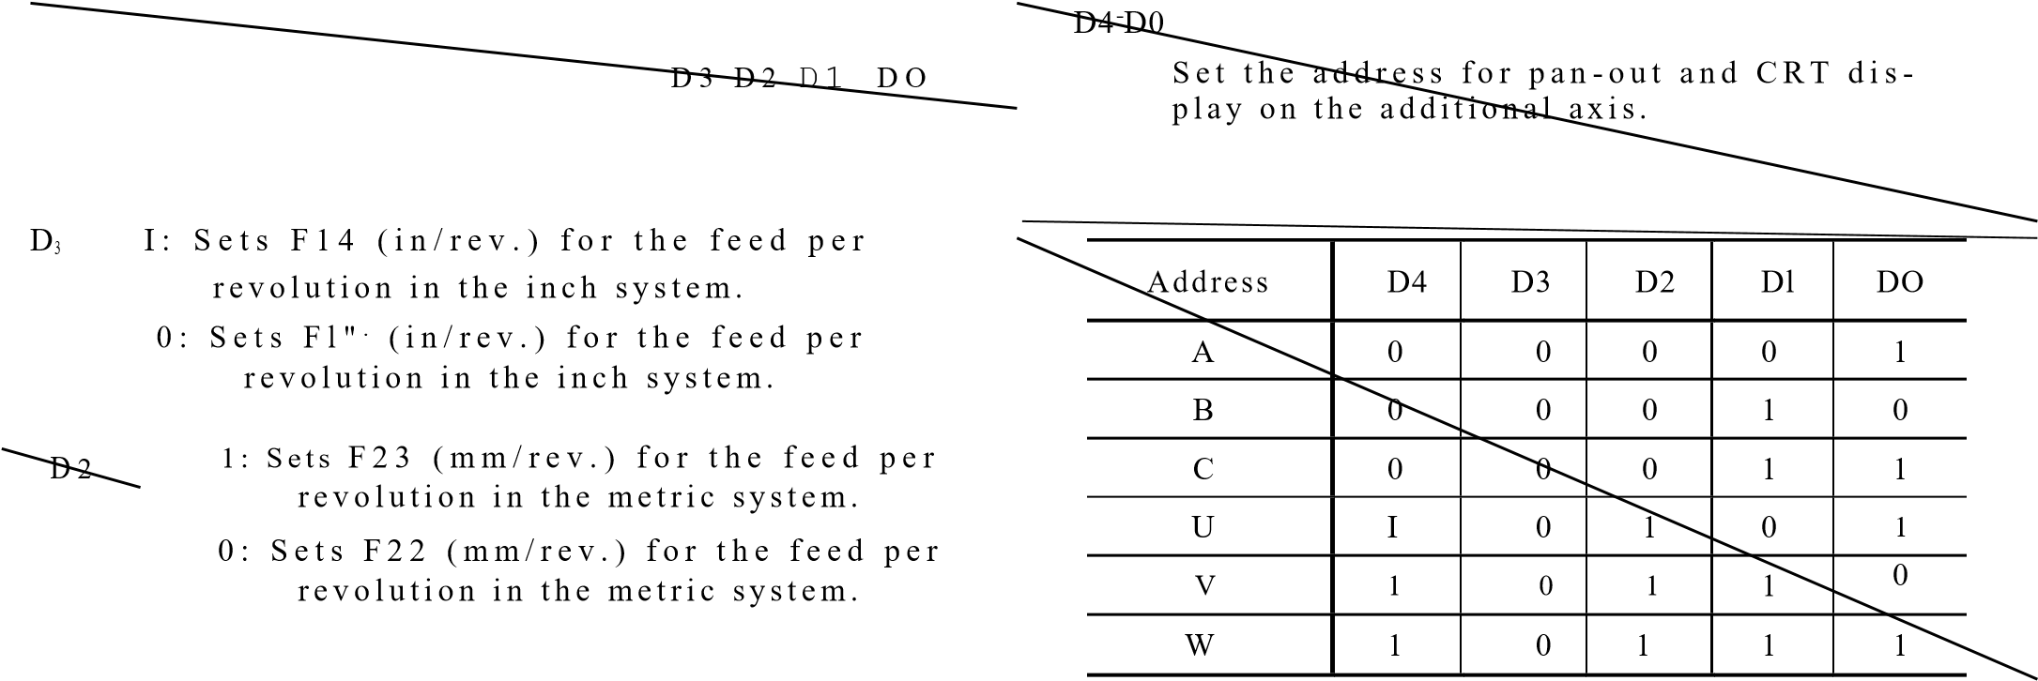

|  |  |  |  |  |  |
| --- | --- | --- | --- | --- | --- |
|  |  | D5 | D4 | D3 | D2 D1 |
|  | | | | |
|  | 135 | 134 | D3 | D2 Di |

D4 1: Enables the axis interlock function.

#6026 Do

0: Disables the axis interlock function.

#6027 D0 Do 1: Enables data output with DIAGNOSE.

0: Disables data output with DIAGNOSE.

**#6026, #6027:**

D5 1 : Does not allow the con trol code (DC1 - #6031 D2 D1 DO

|  |  |
| --- | --- |
| 0: Allows the control code (DC1 - DC4) to be used on th e I/O devic e.  **D4 1:** E m p l o y s 2 s t o p b i t s o n **the I/O device.**  **0:** Emp lo ys 1 sto p b it o n th e I/O de vice . **D3 - DO**  **Baud rate setting** | **02,.01, Do**  **Specify whether or not** the d irec t -in sign a ls **1N2, IN1 and INO are effective,** respectively.  **1: Effective with signal "0"** |

DC4) to be used on the I/O dev ice.

|  |  |  |  |  |  |
| --- | --- | --- | --- | --- | --- |
| Baud rate | D3 | D2 |  | DI | DO |
| 50 | 0 | 0 |  | 0 | 0 |
| 100 | 0 | 0 |  | 0 | 1 |
| 110 | 0 | 0 | . | 1 | 0 |
| 150 | 0 | 0 |  | 1 | 1 |
| 200 | 0 | 1 |  | 0 | 0 |
| 300 | 0 | 1 |  | 0 | 1 |
| 600 | 0 | 1 |  | 1 | 0 |
| 1200 | 0 | 1 |  | 1 | 1. |
| 2400 | 1 | 0 |  | 0 | 0 |
| 4800 | 1 | 0 |  | 0 | 1 |
| 9600 | 1 | 0 |  | **1** | **0** |

**0:** E ffe c tiv e wi th sig n a l "1 "

1)2

Di

DO

#6032

D2, D1, Do

Specify whether or not the direct -in signals

1N2, IN1 and INO are effective, respectively.

1 : In e ffe c tiv e

0: Effective

#6050 (X-axis)

#6051 (Y-axis)

|  |
| --- |
| #6052 |

NOT E: # 60 26 prov ide s the se ttin g o n I/O d ev ice 1 (Z-axis)

(SIO-1) and #6027 on I/O device 2 (SIO -2).

For #6028, #6029, see YASNAC MX1 OPERATOR'S

|  |
| --- |
| #6053 |

MANUAL ADDENDUM section **6.3.**

(4

th

-

axis)

0: Does not provide an additional axis control module.

D 6 1 : Ca u se s th e sy st e m t o fi lt e r th e s p i n d le PG reference point signal before read ing it.

0 : Allo ws th e sy ste m to re a d th e sp in d le PG reference point signal as it is.

#6030 1D7 D6 D4 Do #6050 to #6053:

Spec ify the b acklash co mpen sation , respec- t i v e l y , o n t h e X - , Y - , Z -a n d 4 t h - a x e s

D7 1 : Provides an a dditiona l axis con trol (setting range: 0-255; "1" = least output module. increment).

**P A R A M E T E R NUMBERS AND THEIR CONTENTS**

**(C ONT'D)**

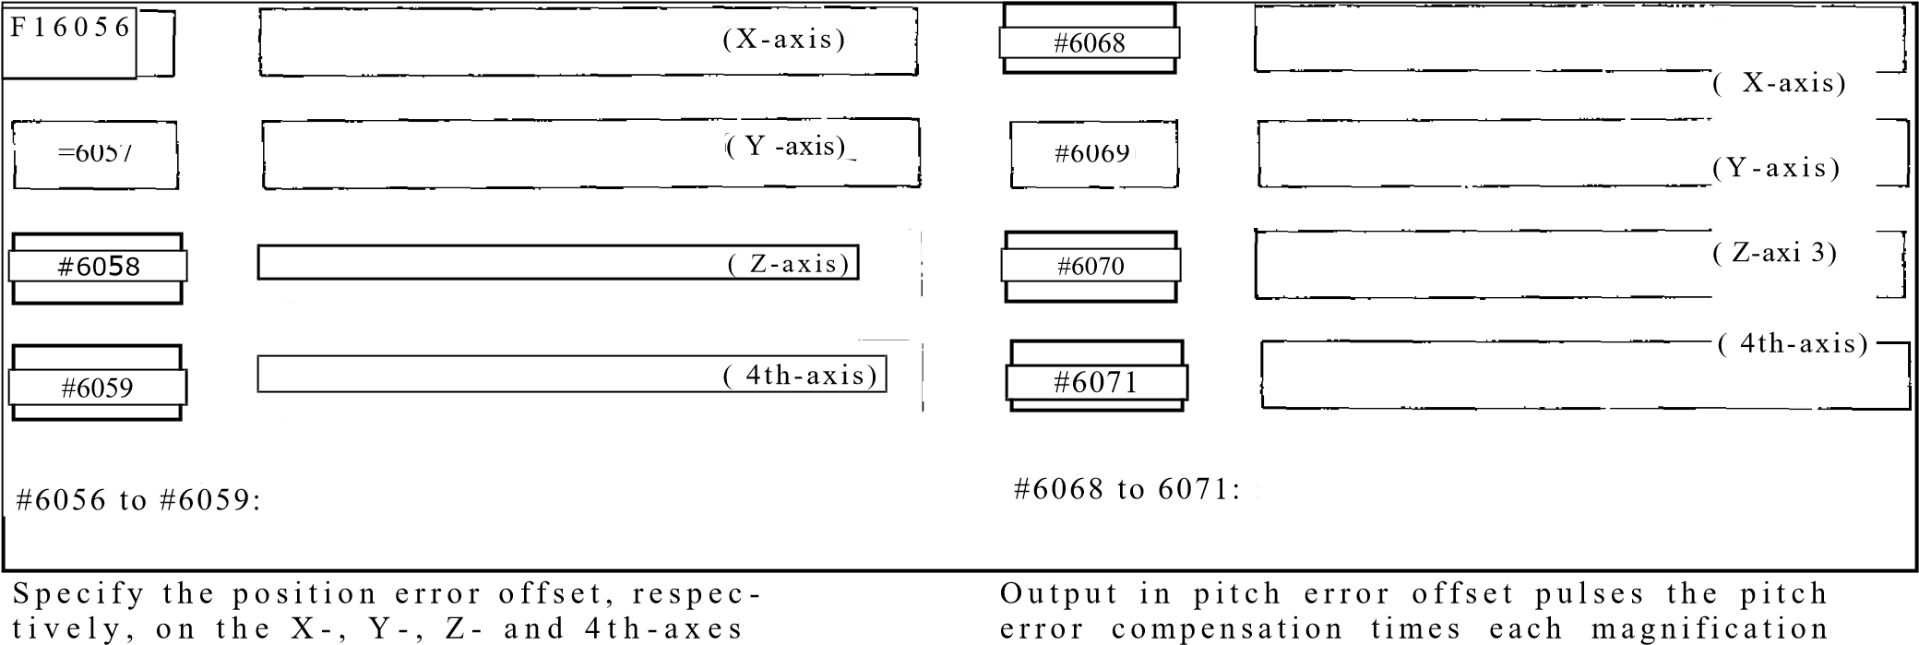

( s e t t i n g r a n g e : 0 - 2 5 5 ; " 1 " l e a s t ou tp ut i n c r e m e n t ) . T h e s t a n d a r d s e t t i n g i s 3 2 .

|  |  |  |  |  |  |  |  |  |  |  |  |  |  |  |  |  |  |  |  |  |  |  |  |  |  |  |  |  |  |  |  |  |  |  |
| --- | --- | --- | --- | --- | --- | --- | --- | --- | --- | --- | --- | --- | --- | --- | --- | --- | --- | --- | --- | --- | --- | --- | --- | --- | --- | --- | --- | --- | --- | --- | --- | --- | --- | --- |
| |  |  |  |  |  | | --- | --- | --- | --- | --- | | #6062 | (X-axis) |  | #6074 | (X-axis) | |  |  |  | |  | | #6063 | ( Y-axis) |  | #6075 | ( Y-axis) | |  |  |  |  | | #606,1 | Z - axis) |  | #6076 | ( Z-axis) | |  |  |  | |  | | of,(1f,t; | (4th-axis) | #6077 | | ( 4th-.axis) |   I |

s p e c i f i c a t i o n , r e s p e c t i v e l y , f o r t h e X - , Y - , Z - a n d 4 t h a x e s . T h e s e t t i n g r a n g e i s I t o 3 , a n d "1 " re p re s e n t s a m a g n i f i c a t i o n o f 1 .

#6062 to #6065:

S p e c i f y t h e o v e r t r a v e l . r e s p e c t i v e l y , o n t h e X-, Y-, a n d 4 t h -a x e s i n u n i d i re c t i o n a l

-

198

-

a p p r o a c h ( G i i 0 ; s e t t i n g r a n g e : 0 - 2 5 5 ; " 1" le:is1 input increment).

#6074 to #6077:

C a u se s an a la rm "3 4 *" wh e n a po s it io n d ev i a t i o n e x c e e d i n g t h e c ri t i c a l s e rv o e r ro r v a l u e i s d e t e c t e d r e s p e c t i v e l y , o n t h e X - , Y - , Z.and 4th axe s.

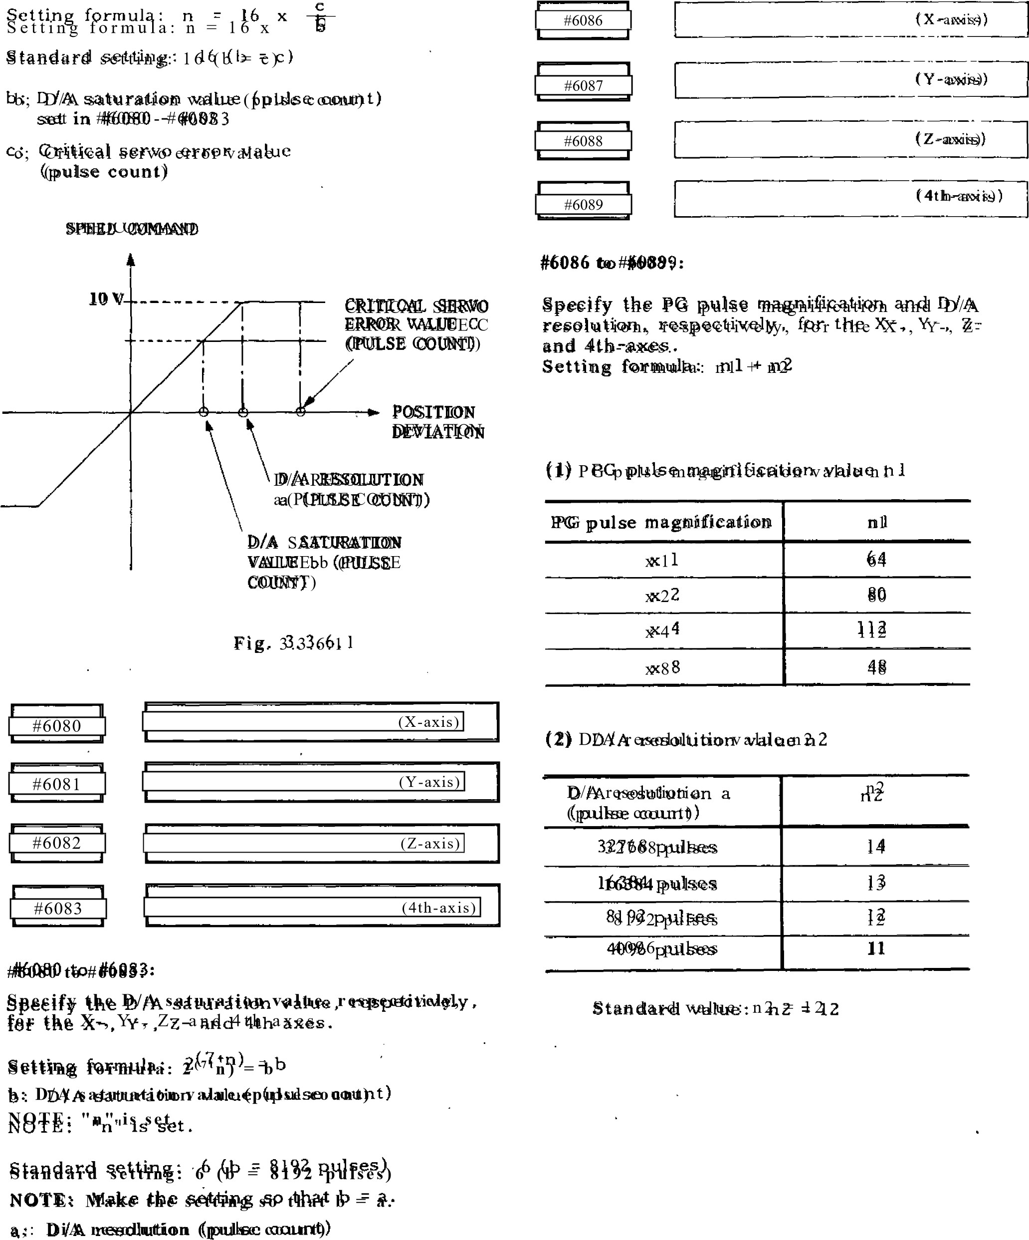

#6092

Specifies the exponential function acceler ation/deceleration time constant for cutting feed (common to all axes).

T h e se t tin g fo r mu la i s: "n " = t 1

4

where, t: time constant(ms), specifiable in units of 4 ms

|  |
| --- |
| #6093 |



S p e c i fi e s t h e " r a p i d t ra v e r s e se c ti o n ' fo r a "returning semicircle" by the proportionite semicircle radius in circle cutting (G12, G [3).

S e t t i n g r a n g e : 0 - 1 0 ( x 1 0 % ) Examples:

1. A setting of 0 creates a rapid traverse section automatically computed by the program command values.
2. 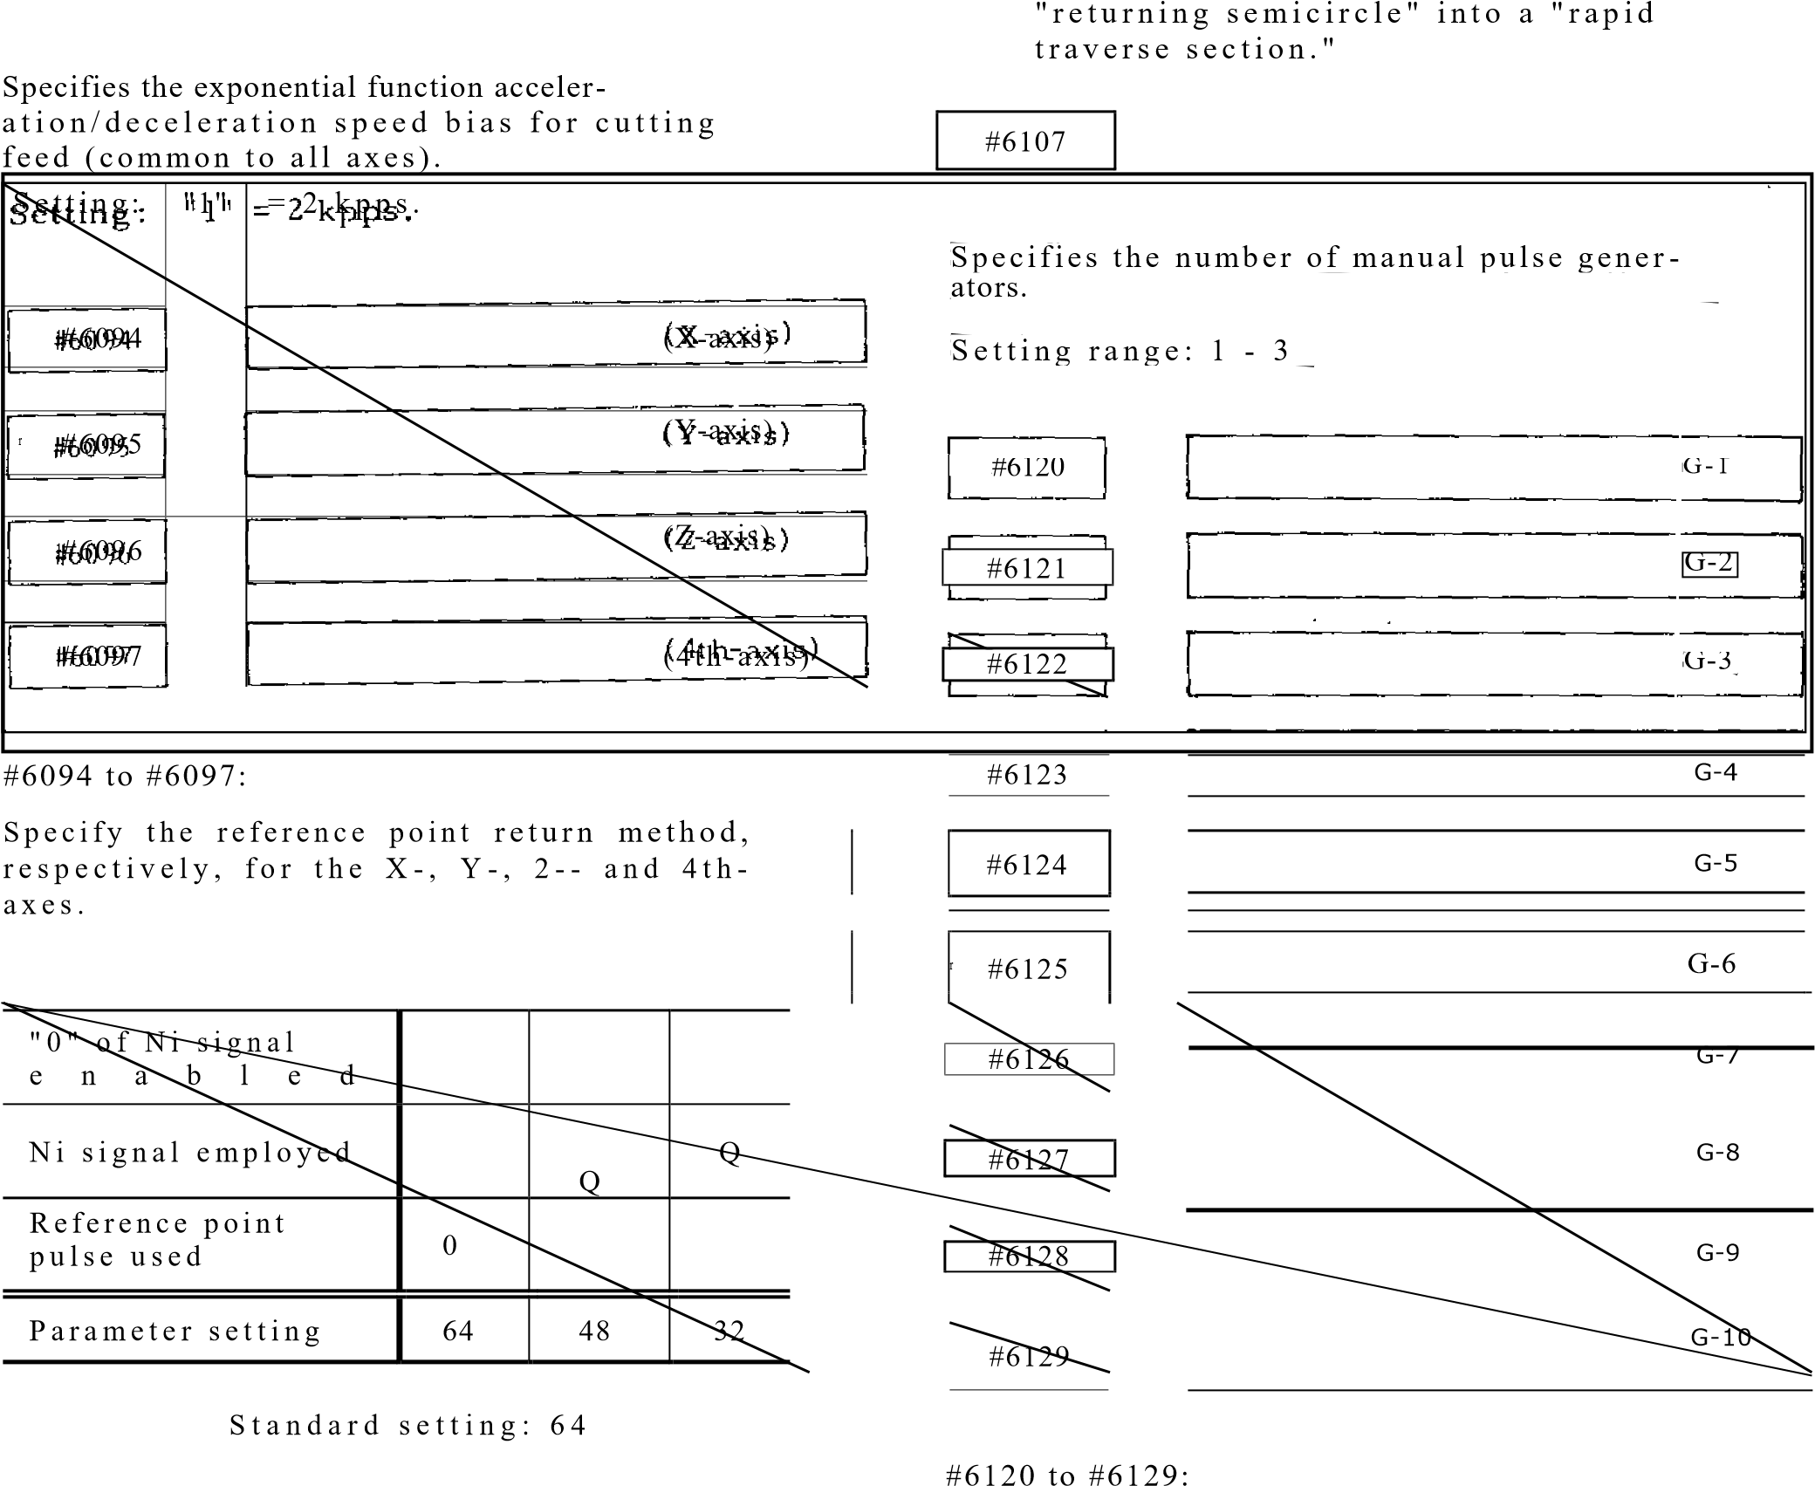A setting of 10 (= 100%) makes the entire

-

200

-

Specify up to id G codes for calling user macros.

#6130

M

-

1

#6220

|  |  |
| --- | --- |
| #6131 | M-2 |
|  |  |
| #6132 | M 3 |
|  |  |
| #6133 | M-4 |

Specifies the interval from the time, N4, S, T an d B c od es are tran smitted un til th e time MF, S F, TF and BF are transmitted.

Setting: "1" = 1 ms

It-6130 to #6133: #6221

|  |  |
| --- | --- |
| Specify up to 4 M codes for calling user |  |
| macros.  S e ttin g ra n g e : 0 3 - 2 9 , 3 1 - 8 9  NOTE: MOO, M01, MO2, M30 and M90 - M99 cannot be called by user macros . | S p e c if ie s th e in te rv a l f ro m g e a r o u t p u t (GRH, GRL) unit SF transmission when an S5-digit designation is added.  S e ttin g : "1 " = 1 ms |

|  |  |  |  |
| --- | --- | --- | --- |
| |  | | --- | | #6134 | |  |  |

|  |
| --- |
| Specify the |

|  |  |  |
| --- | --- | --- |
| #6223 |  |  |

|  |  |  |
| --- | --- | --- |
| #6224 |  |  |

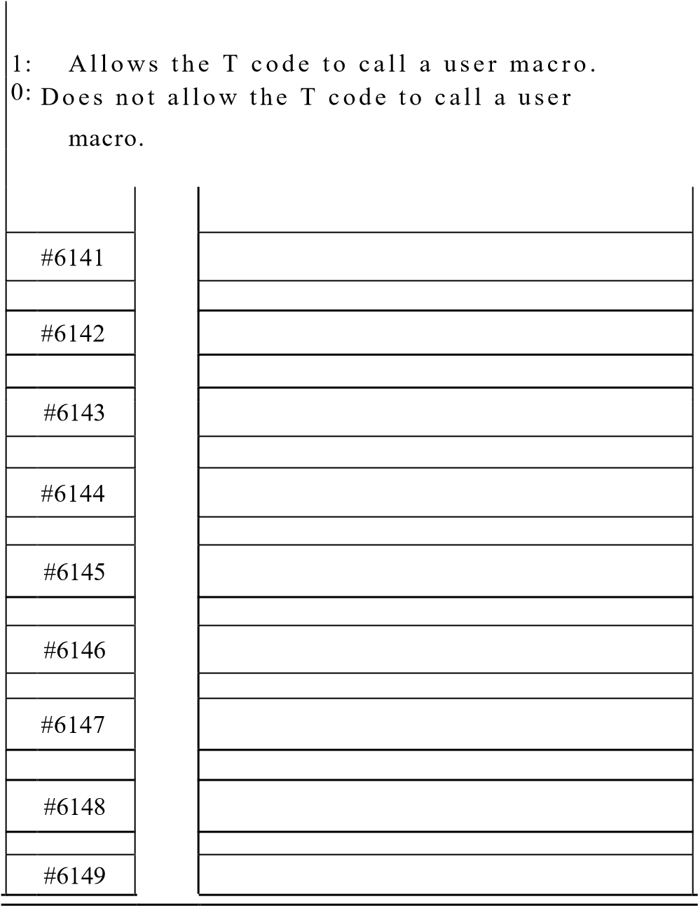is common to the linear axes (X, Y , Z, U, V, w).

maximum

handle feedrate, which

Setting: "1" = 7.5 mm/min.

-

201

-

NOTE: The settings for the rotary axes (A, B, C) are made with #6348 .

Specifies the tool shift speed for canned cycles of G76 and G77.

Setting: "1" 1 ram/min.

NOTE: This specification is effective when

#601 9 D0 -1 .

I f # 6 0 1 9 0 0 = 0 , r a p i d t r a v e r s e i s

is effective regardless of this pa -

rameter specification.

Specifies the delay time for checking the

sp indle speed reach ing signa l (S AGR).

#6141 to #6149: S e ttin g : "1 " = 1 ms

Spec ify the feedra te cha nge for one incre ment on a manual pulse generator, for Fl to F9 , re spectively , of Fl -d igit de signa tion. Setting: "1" = 0..1 mm/min.

**PARAMETER NUMBERS AND THEIR CONTENTS (CONT'D)**

Setting: "1" -= 0.001 mm (metric system) 0 . 0 0 0 1 i n . (i n c h s y s t e m )

*#6225*

AX

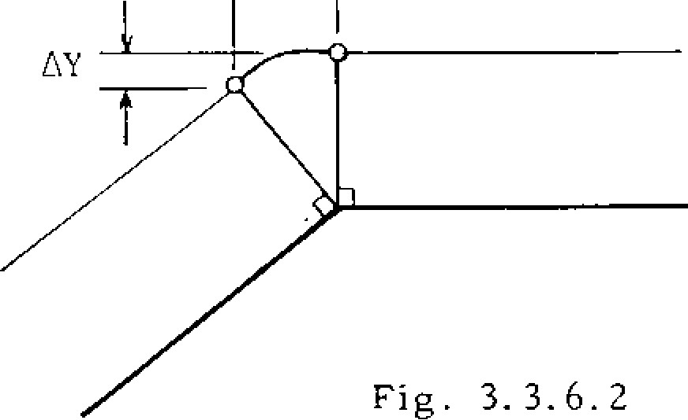Sp e c i fi e s t h e fe e d ra t e fo r t h e ra p i d t ra v e r s e s e c t i o n i n c i r c l e c u t t i n g ( G 1 2 , G1 3 ) .

S e t t i n g : " I" = **1** m m / m i n ,

#6226

#6227 T h e c o r n e r a r c s e t t i n g i s i g n o r e d w h e n :

|  |  |
| --- | --- |
| #6226, #6227  Sp e c i fy th e m ax i mu m fe edra t e fo r Fl -d ig it d e s i g n a t i o n .  S e t t i n g : "1 " = 1 mm/min.  N O T E : T h e m a x i m u m f e e d r a t e f o r F I - F 4 | AX #6230  AY #6230  S t a n d a r d s e t t i n g = 5 |

|  |
| --- |
| #6231 |

c o m m a n d s i s s e t i n # 6 2 2 6 a n d t h a t f o r F 5 - F 9 c o m m a n d s i n # 6 2 2 7 . A n y

1. e e d r a t e s i n c re a s e d o n m a n u a l p u l s e
2. e n e r a t o r s a r e b u n c h e d i n t o t h e s e Sp e c i fi e s t h e F0 s p e e d fo r ra p i d t ra v e r s e

s e t t i n g s . override.

S e t t i n g : " 1 " = 7 . 5 m m / m i n .

#6228

-

202

-

|  |
| --- |
| #6232 |

|  |  |
| --- | --- |
| t h e l i n e a r a x e s ( X , Y , Z , U , V , W ) . |  |
| Setting: "I" 1 mm/min.  *#6229 j*    Speci fies the maxi mu m cutting feed rat e fo r t h e r o t a r y a x e s ( A , B , C ) . | Specifies the feedrate in the skip function (G31).  S e t t i n g : " 1 " = 1 m m / m i n .  N O T E : T h i s s e t t i n g i s e f f e c t i v e w h e n parameter #6019D4 = 1. |

Speci fies the maxi mu m cutting feed rat e fo r

S e t t i n g : **' I " =** 1 m m i m i n .

|  |  |
| --- | --- |
| #62 33 |  |
|  |

N O T E : A n y c u t t i n g f e e d r a t e s g r e a t e r t h a n

t h o s e s e t i n # 6 2 2 8 a n d #6229 a r e b u n c h e d

i n t o t h o s e s e t t i n g s .

F1;62301

When a circular path is drawn in tool radius c o m p e n s a t i o n o u t s i d e a c o r n e r a p p ro a c h i n g

180 0, the movement follows on a very small c i r c u l a r a r c . In t h i s . a r c m o v e m e n t i s c o n s i d e r e d t o a f f e c t t h e w o r k p i e c e s u r f a c e m a c h i n i n g , t h i s p a r a m e t e r i s u s e d t o s e t

t h e c ri t i c a l a rc v a l u e .

#6264

#6233 to #6264

S p e c i f y t h e f e e d r a t e f o r t h e r e s p e c t i v e po sition s on the jog feed rate s elec t switch.

Setting: = 1 mrramin.

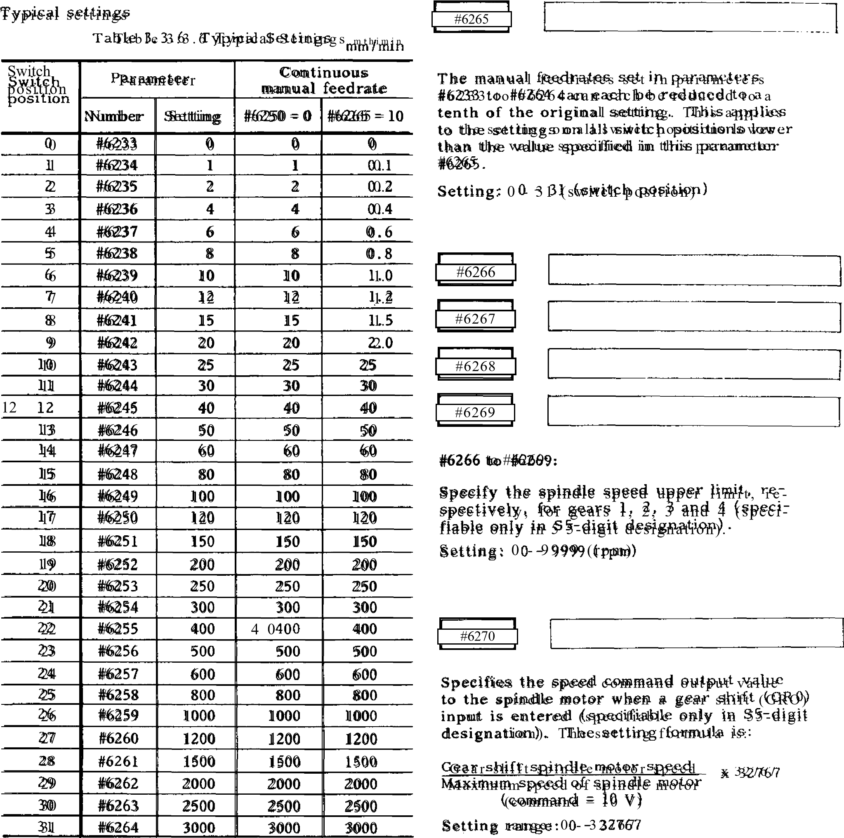

**PARAMETER NUMBERS AND THEIR CONTENTS**

**CONT'D**

**(**

**)**

#6273

#6274

#6271 to

#6274:

Specify the maximum speed of the spindle,

respectively, for gears 1, 2, 3 and 4 each

selected by an input signal (specifiable in

55

-

digit designation). Set the spindle speed

applicable when the speed command voltage

is 10 V.

Setting, range: 0

-

)

rpm

99999 (

r

#6271

#6276

#6272

#6277

#6278

#6279

r

#6276 to #6279:

Specify the minimum speed of the spindle,

respectively, for gears 1, 2, 3 and 4 each

selected by an input signal (specifiable in

S 5

-

digit designation).

Setting range: 0

-

99999 (

rpm

)

|  |  |  |  |
| --- | --- | --- | --- |
| #6280 | (X-axis; | | |
|  |
| #6281 | (Y-axis:•    (Z-axis) | | |
|  |
| #6282 |
| #6283 |  |  | (4th-axis) |

.1.1 •voi MOT 1,11E ti LA, 4...(11•SMAN11

j.

|  |  |  |  |  |
| --- | --- | --- | --- | --- |
|  |  | | | S P I NDLE. |
|  | *• . 2 7 2*  Fig. | 3.3.6.3 | *p 6 2 ,*  *. h 2 6 ] i*  **I** | SPI.F.17 rRrtii  r (12 7 |

#6280 to #6283

Spec ify the rapid trav erse rate , re spectively , o n t h e X - , Y - , Z - a n d 4 t h - a x e s . Setting: "1" = 7.5 mm/min.

~~1~~ . #6275

S p e c i f i e s t h e s p i n d l e m o t o r s p e e d i n e f f e c t w h e n s p i n d l e o r i e n t a t i o n ( S O R ) i n p u t i s ent e red (speci fi able in 55 -digi t de signat ion).

S e l l i n g r a n g e : 0 - 9 9 9 9 9 ( r p m )

|  |  |  |  |
| --- | --- | --- | --- |
| #6286    #6287    #6288    #6289 | |  | | --- | | (X-axis) | | Y  (  -  axis)    Z  (  -  axis)    (4  th  -  axis)    #6298    #6299    #6 300    #6301 |
| |  | | --- | | (Y-axis) (z-axis) | |
| |  | | --- | | (4th-axis) | |

(X-axis)

|  |  |
| --- | --- |
| #6286 to #6289:  Specify the first-stage time constant in linear  a c c e le ra tio n /d e c e le ra t io n, re sp e c tiv e ly , o n t h e X - , Y - , Z - a n d 4 t h - a x e s . Se tting : "1" = 125/8 (mm/sec 2) | #6298 to #6301:  Specify the second -stage time constant in linear acceleration/deceleration, respective l y , o n t h e X - , Y - , Z - a n d 4 t h - a x e s . Se tting : "1" = 125/8 (mm/sec 2) |

FEEDEtATE

RAPID TRAV

(

-

ERSE RATE)

#6280

#6283

#6304

#6305

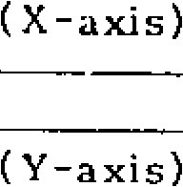

06292

**4**

**--**

**#**

2 9 5

6

SWITCROVER

(

SPEED)

#6298

#6301

#6286

#6289

#6306

#6307

Z

(

-

axis)

(4

th

-

axis)

TIME

#6304 to #6307:

Fig. 3.3.6.4 Specify the traverse distance for reference

-

205

-

p o i n t r e t u r n , r e s p e c t i v e l y , o n t h e X - , Y - , Z -and 4th -axes.

Setting: "1" = 0.001 mm

|  |  |  |  |
| --- | --- | --- | --- |
| #6292 |  |  | (X-axis) |
|  |  |  |  | #6310 | (X-axis) |
| #6293 |  |  | (Y - axis) |
|  |  |
|  |  |  |  |
| #631 1 | (Y-axis) |
| #6294 |  |  | (Z-axis) |

|  |  |  |  |  |  |  |
| --- | --- | --- | --- | --- | --- | --- |
|  |  |  |  |  | #6312 | (Z-axis) |
| r | #6295 |  |  | (4th-axis) |
|  |  |

|  |  |
| --- | --- |
| #6292 to #6295: |  |
| Specify the second -stage time constant switchover speed in linear acceleration/ dece lera tion, respectively, on the X -, Y-, Z- and 4 th-axe s.  Setting : "1" = 7.5 mm/min. | Specify the approach speed 1 for reference p o i n t re t u r n , re s p e c t iv e ly , o n th e X - , Y - , Z--and 4 th-axes.  Setting: "1" = 7.5 mm /min |

#6313

(4

th

-

axis)

#6310 to #6313:

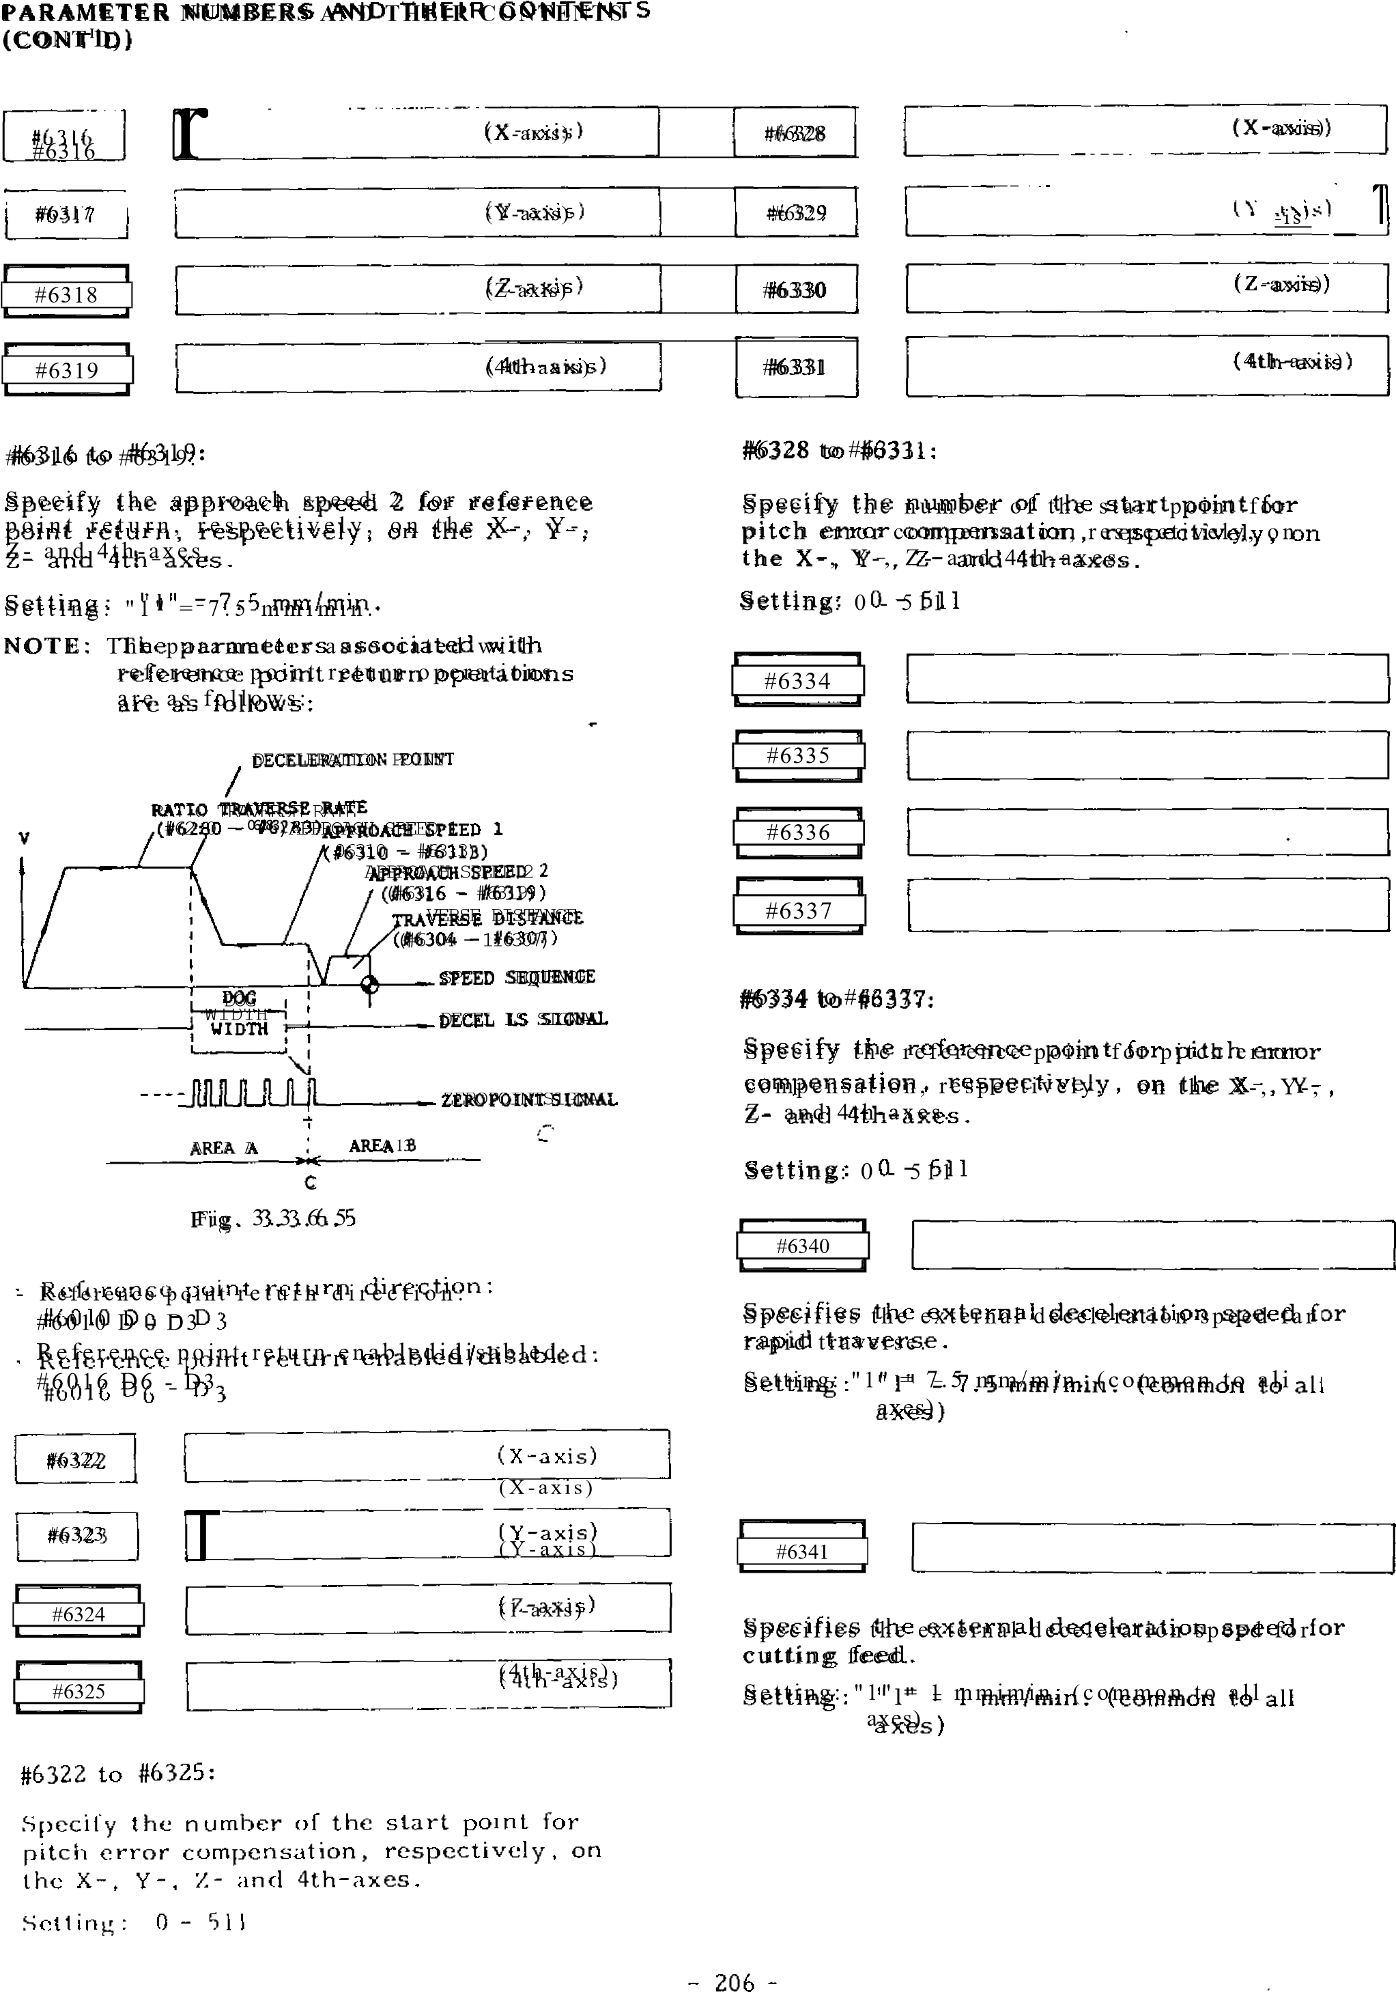

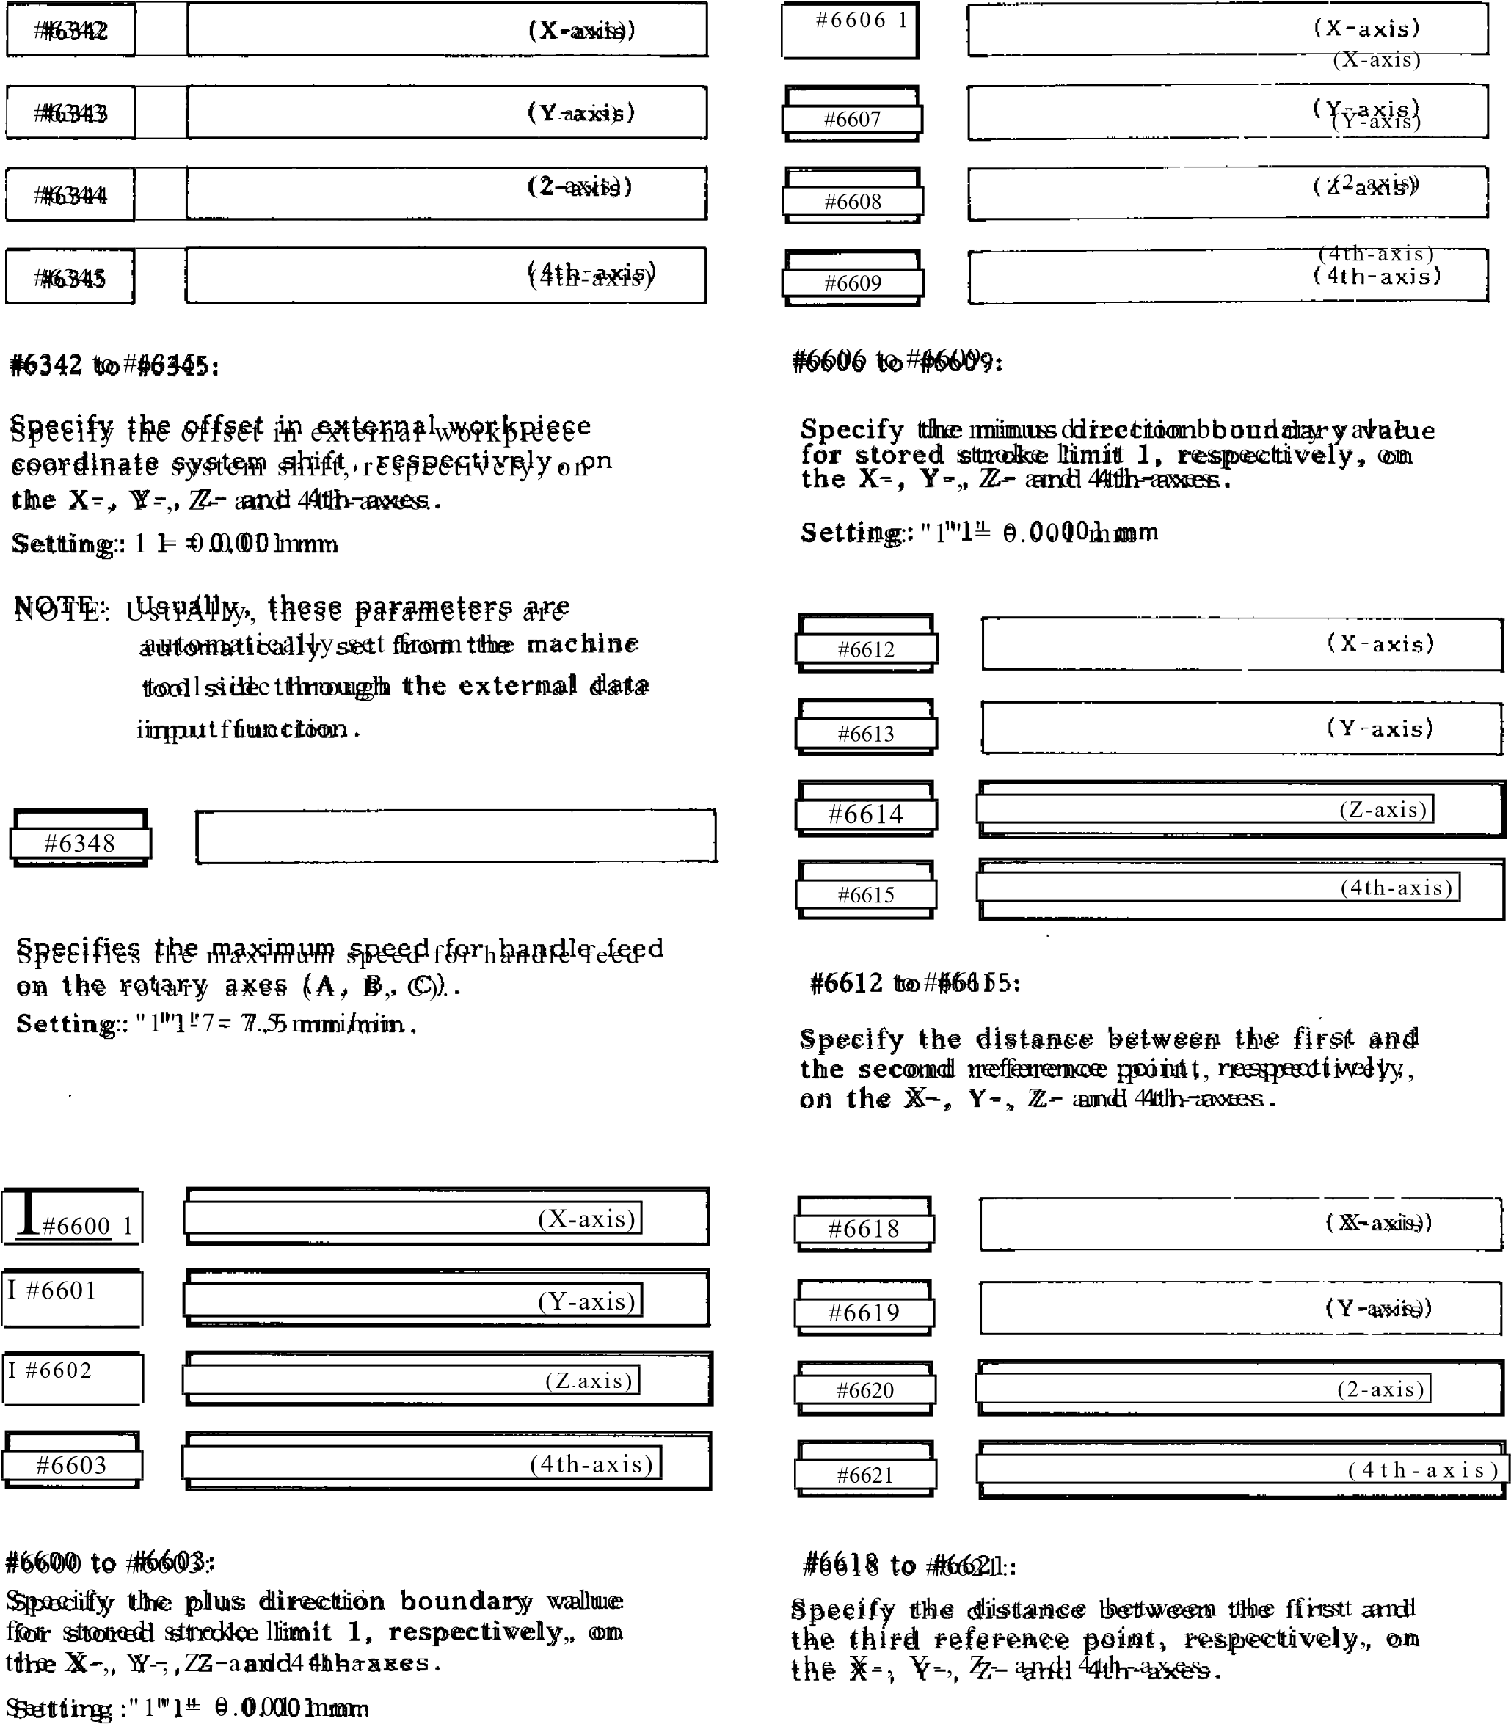

**PARAMETER NUMBERS AND THEIR CONTENTS**

**(CONT'D)**

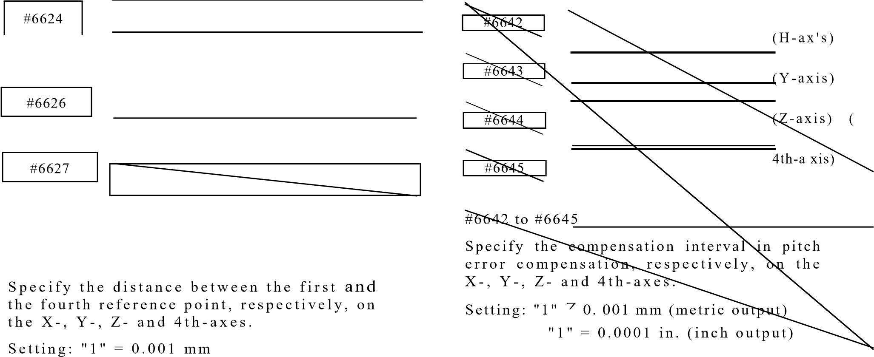#6625_j

#6624 to #6627

|  |  |  |  |
| --- | --- | --- | --- |
| |  | | --- | | #6630 | | |  | | --- | | (X-axis) | |
| |  | | --- | | #6631 | | |  | | --- | | (Y-axis) | |

|  |  |  |  |
| --- | --- | --- | --- |
| |  | | --- | | #6632 | | |  | | --- | | (Z-axis) | |

#8000 (number 0)

#6633. (4th-axis)

#6630 to If6633

Specify the value for automatic coordinate sy ste m se tting a t the time o f inch input, r e s p e c t i v e l y , o n t h e X- , Y - , Z -, a n d 4 t h a x e s . A d e s i r e d v a l u e s h o u l d b e s e t i n in ches for the d istan ce between the first re ference poin t and the refe rence point of th e coordinate syste m to be estab lish ed.

-

208

-

S e t t i n g : ' 1 " = 0 . 0 0 0 1 i n .

|  |  |  |
| --- | --- | --- |
| #6636 |  | (X-axis) |

|  |
| --- |
| (Y-axis) |

I #66 37

|  |  |  |  |
| --- | --- | --- | --- |
| |  | | --- | | #6638 | | | (  Z  -  axis) |
| |  | | --- | | #6639 | | |  | | --- | | (4th-axis) | | | |

#6636 to #6639

Specify the value for automatic coordinate system setting at the time of metric input, re sp e c tiv e ly , o n th e X -, Y -, Z- a n d 4 th a x e s . A d e s i r e d v a l u e s h o u l d b e s e t in millimeters for the distance between the first referen ce po int an d th e refe re nc e p oin t of the coordinate system to be established.

S e ttin g : " I" 7 0 .0 0 1 mm

NOTE: Each setting is effective only for an axis with parameter #6015 at ''1."

L

#8511 (numl-er 511)

#8000 to #8511

Specify the respective values of pitch error compensation.

S e ttin g : 0 - ±1 5 (o u tp u t in c re me n t)

NOTE: Parameters #6322 to #6339 determ.ne specific combinations of settings and axes.

|  |
| --- |
| **APPENDIX 3 STORED LEADSCREW ERROR COMPENSATION** |

This function automatically compensates for leadscrew error on each axis according to the compensation data set by parameter and is effective after completion of reference point return. The compensation data are made on the distances between the reference point on each axis and specified points.

Compensation axes: X, Y, Z and 4th axes

(including rotary axis) No. of correction points: 512 Max.

Compensation base point: Reference point

Compensation interval: 6000 Pulses or more

Data setting system: Absolute /incremental

(Set by Parameter #603902)

Compensation value:

Minimum compensation unit: 1 pulse (least out- put increment) Compensation multiplication: X13 max. Onetime-compensation value: 15 pulses max. (Compensation multiplication)

Note 1:

Regardless of absolute/incremental setting, the difference between neighboring compensation values should be (15 pulses x compensation multiplication) and below.

Note 2:

Maximum set value in case of absolute setting is ±127 pulses. Compensation multiplication is taken on this value.

Note 3:

No. of correction points on each axis can be arbitrary as far as the total compensation points are within 512.

Note 4:

Where the 4th axis is a rotary axis, operation is possible within ±200 revolutions maximum.

Table 3.1

|  |  |  |  |
| --- | --- | --- | --- |
|  | Axis | Parameter # | Functions |
| Compensation interval | X to a | #6642 to #6645 | 6000 OR MORE  "1" = 1 pulse |
| Absolute/incremental setting switchable | _________ | #6039D2 | "0" = Incremental setting  "1" = Absolute setting |
| Compensation reference no. | X to o. | #6334 to #6337 | Value of parameter # of co mp en s at i o n on each point minus 8000 will be written |
| Compensation max point | X to a | #6322 to #6325 |
| Compensation min point | X to a | #6328 to #6331 |
| Compensation value on each point | X to a | #8000 to #8511 | -15 to +15 (Incremental setting)  "I" = 1 pulse |
| Compensation multiplica- tion | X to a | #6068 to #6071 | 0 to 3  "1" = lx |

T h e figu re be lo w s ho ws the e xa m pl e o f wri ti ng t h e d a t a fo r X a x i s .

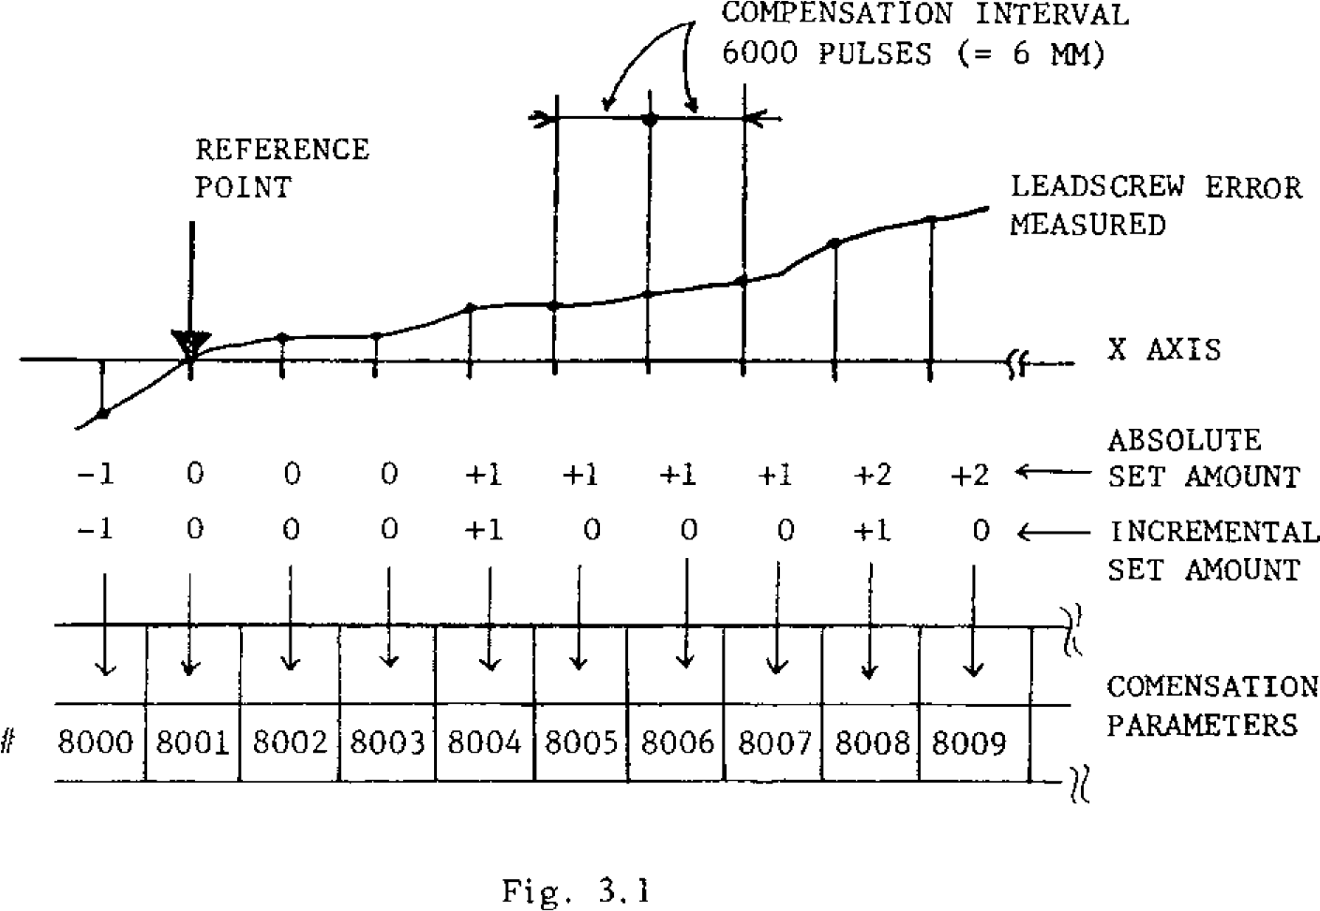

REFERENCE

POINT

LEADSCREW ERROR

MEASURED

COMPENSATION INTERVAL

d/

el 6000 PULSES (= 6 MM)

-

1

0

0

0

+1

+1

I

+

+1

+2

+2

-

1

0

0

0

+1

0

0

0

+1

_

0

ABSOLUTE

SET AMOUNT

4

-

INCREMENTAL

SET AMOUNT

1111111111111111111111111111

8009

*if*

8000

8008

COMENSATION

PARAMETERS

Fig. 3.1

8005

8004

8002

8001

8003

8006

8007

In the above figure,

Compensation interval: 6000 pulses Absolute /incremental : Incremental Compensation multiplication: x 1 Compensation point on X axis: 100 points

Each parameter is set as follows:

100

POINTS ON X

-

AXIS

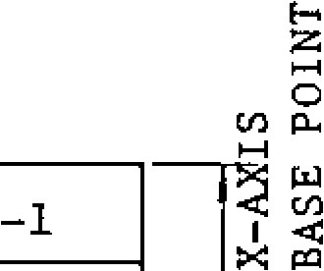

COMPENSATION BASE NUMBER

#8002

COMPENSATION MINIMUM POINT

#6328

0

#8004

COMPENSATION MAXIMUM POINT

#8100

**0**

#8001

I

PARAMETER OF

COMPENSATION AMOUNT

ON EACH POINT

#8000

#6334

1

**0**

#8003

**0**

+1

#8005

0

X AXIS

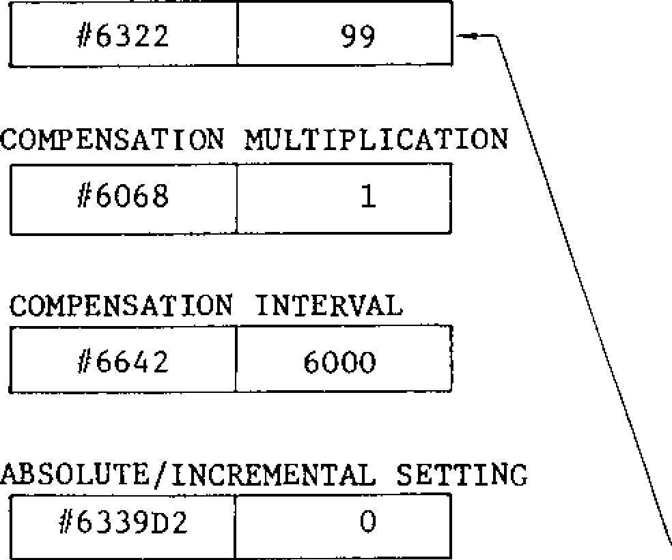

99

#6322

6000

#6642

0

#633902

COMPENSATION MULTIPLICATION

#6068

1

COMPENSATION INTERVAL

ABSOLUTE/INCREMENTAL SETTING

#8006

#8008

#8009

#8007

#8010

**+1**

**0**

0

0

#8098

#8099

Fig. 3.2

To use the 4th axis as the rotary axis, follow the r u l e s s h o wn b e l o w in a d d i tio n to th e r u l e s f o r s e t t i n g X - , Y - , a n d Z - a x e s .

( 1 ) C o m p e n s a t i o n I n t e r v a l

The compensation interval should be more than 6000 pulses and the quotient obtained by divid ing 360000 by the compensation interval become a positive integer.

( 2 ) C o m p e n s a t i o n A m o u n t a t R e f e r e n c e P o i n t

The compensation amount to be set to the refer ence point should be as follows:

1. . A b s o l u t e s e t t i n g • • • " 0 "
2. . I n c r e m e n t a l s e t t i n g • - • " 0 "

In the case of incremental setting, set such a value for the compensation amount at compen sation maximum point, that the sum of the compensation amount of each point becomes "0."

( 3) Sa mple Writing

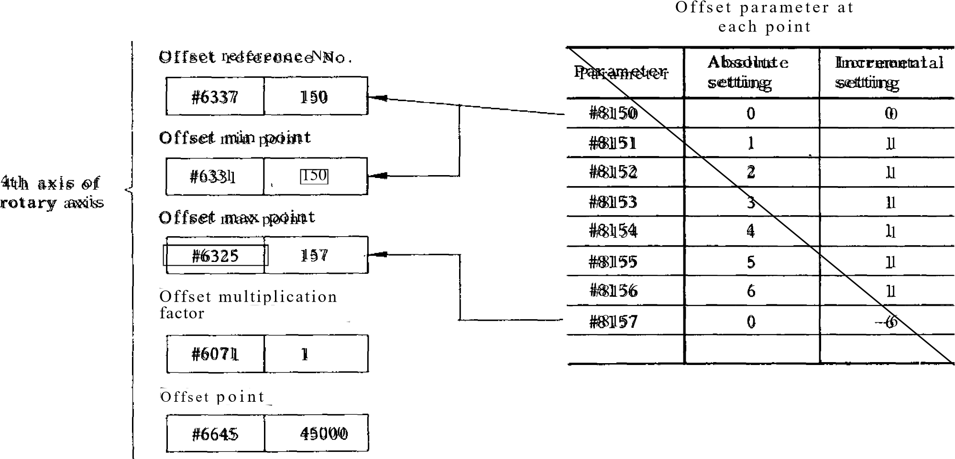If the compensation interval is 45000 pulses (one ro tation divided by 8) as sho wn belo w, se t th e parameters as follows.

|  |  |
| --- | --- |
| MAX CORRECTING 118 L50  POINT 0, ( 1) | REFERENCE  CORRECTION NO. AND MIN CORPORATION POINT |

# 8 1 5 6 , 0 4 i i i t 8 , 1 5 ( - 7 6 ) 1 1 4

#815.1

I, (1)

#8152 PULES

45000

6, (1) 2, (1)

#8154

4 , ( 1 )

OFFSET AMOUNT

FOR INCREMENTAL

SETTING OFFSET AMOUNT

FOR ABSOLUTE

**APPENDIX - 4 LIST OF STANDARD INPUT/OUTPUT SIGNALS**

Table 4.1 shows standard input/output signals. For custom-built signals depending on the sys tem, refer to the list of I/O signals provided on the system.

DISPLAY

D 7 D 6 D 5 D 4 D 3 D 2 D l . D O

0 • 0 0 0 1 1 1 1

Contact open Contact closed

Table 4-1 List of Standard Input Signals

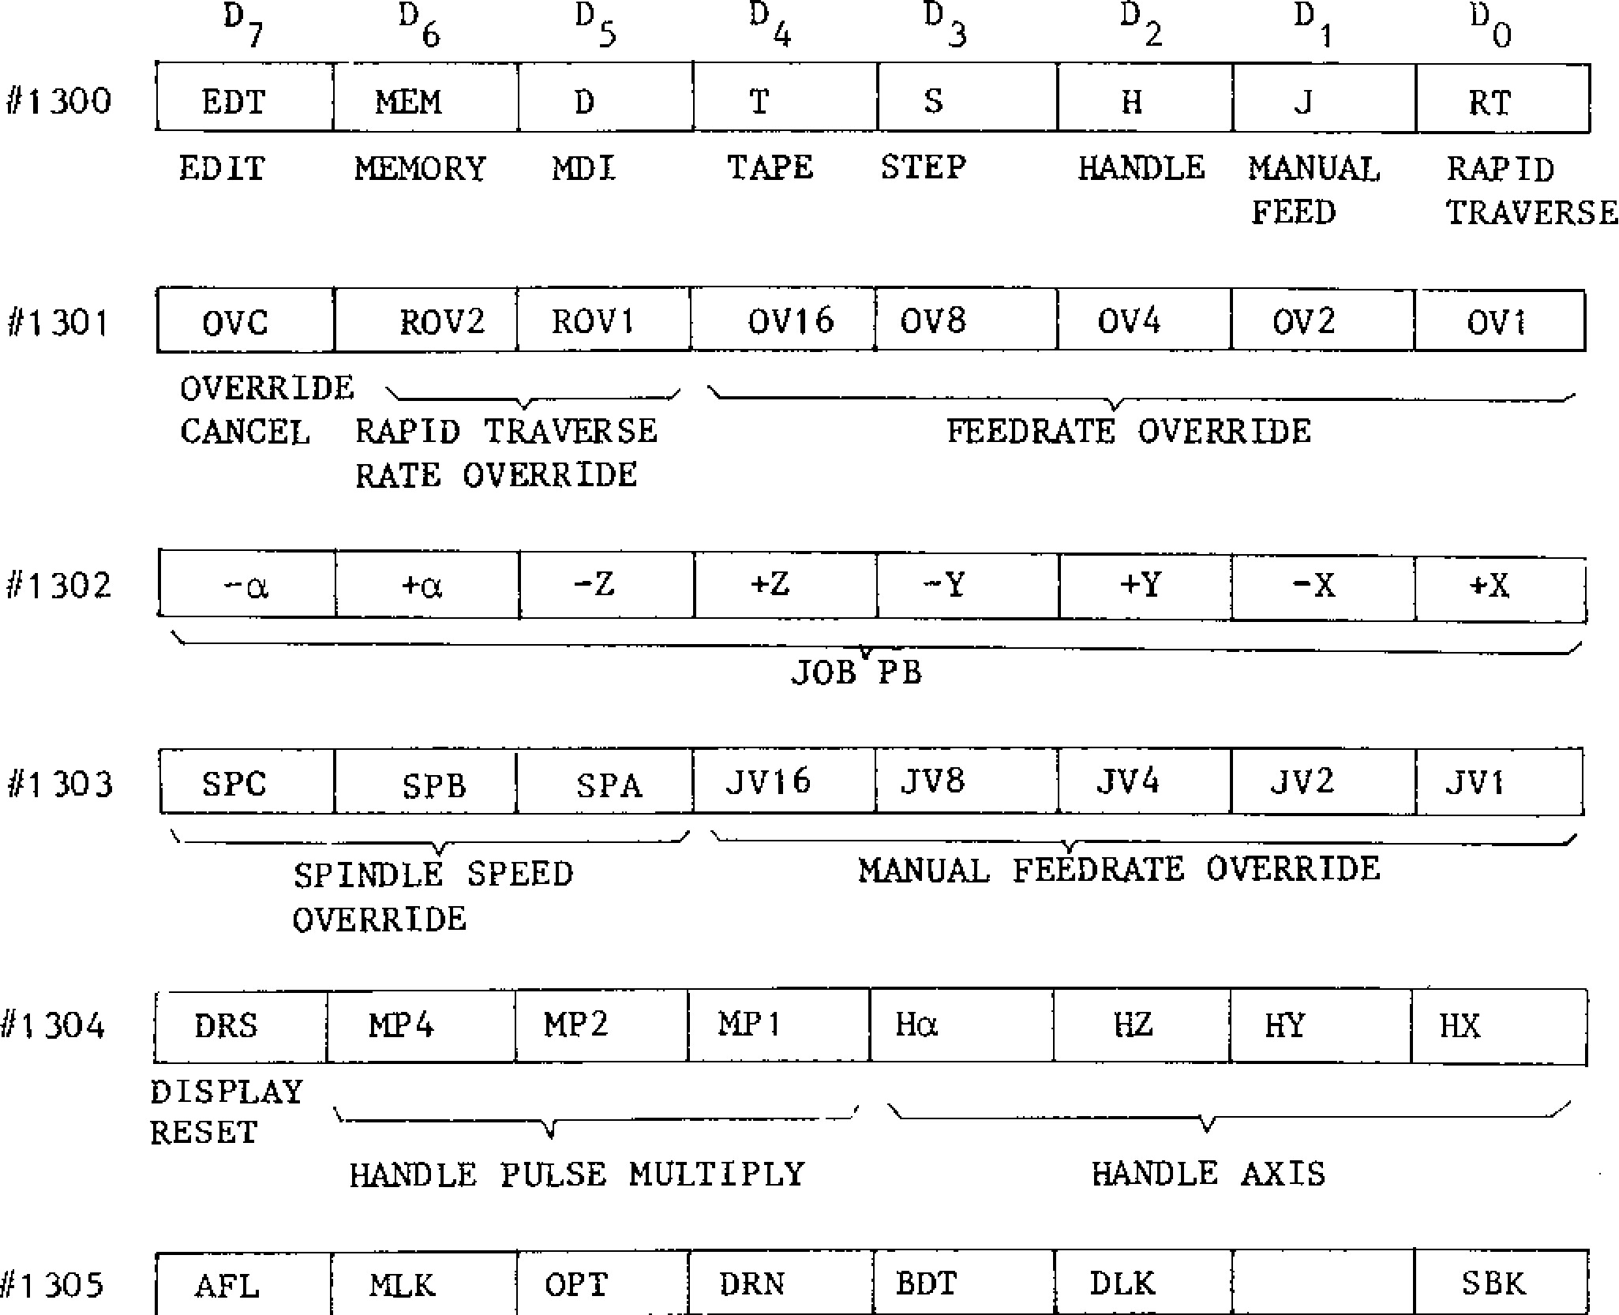

BDT

DLK

SBK

OPT

DAN

AFL

#1 305

MILK

FEEDRATE OVERRIDE

OVERRIDE

CANCEL RAPID TRAVERSE

RATE OVERRIDE

#1302

-

a

+

a

+

Z

-

Y

Y

+

-

x

x

+

0

VC

ROV2

ROV1

OV1 6

OV8

V

0

4

OV2

OV1

D

6

D

5

D

3

D

2

D

5

D

1

D

0

H

J

HANDLE MANUAL

FEED

D

7

EDT

EDIT

RT

RAPID

TRAVERSE

HEM

MEMORY

MDI

S

STEP

T

TAPE

#1300

#1301

JOB'PB

#1 30

3

SPC

SPB

SPA

JV1 6

„TVS

JV4

JV2

JV1

SPINDLE SPEED

OVERRIDE

MANUAL FEEDRATE OVERRIDE

#

1

304

DRS

KP 4

MP2

MP 1

Ha

HZ

HY

HX

DISPLAY

RESET

HANDLE PULSE MULTIPLY

___________________

V

______________________

HANDLE AXIS

M- MACHINE OPTIONAL DRY BLOCK DISPLAY SINGLE

FUNCTION LOCK

STOP

RUN

DELETE LOCK

BLOCK

LOCK

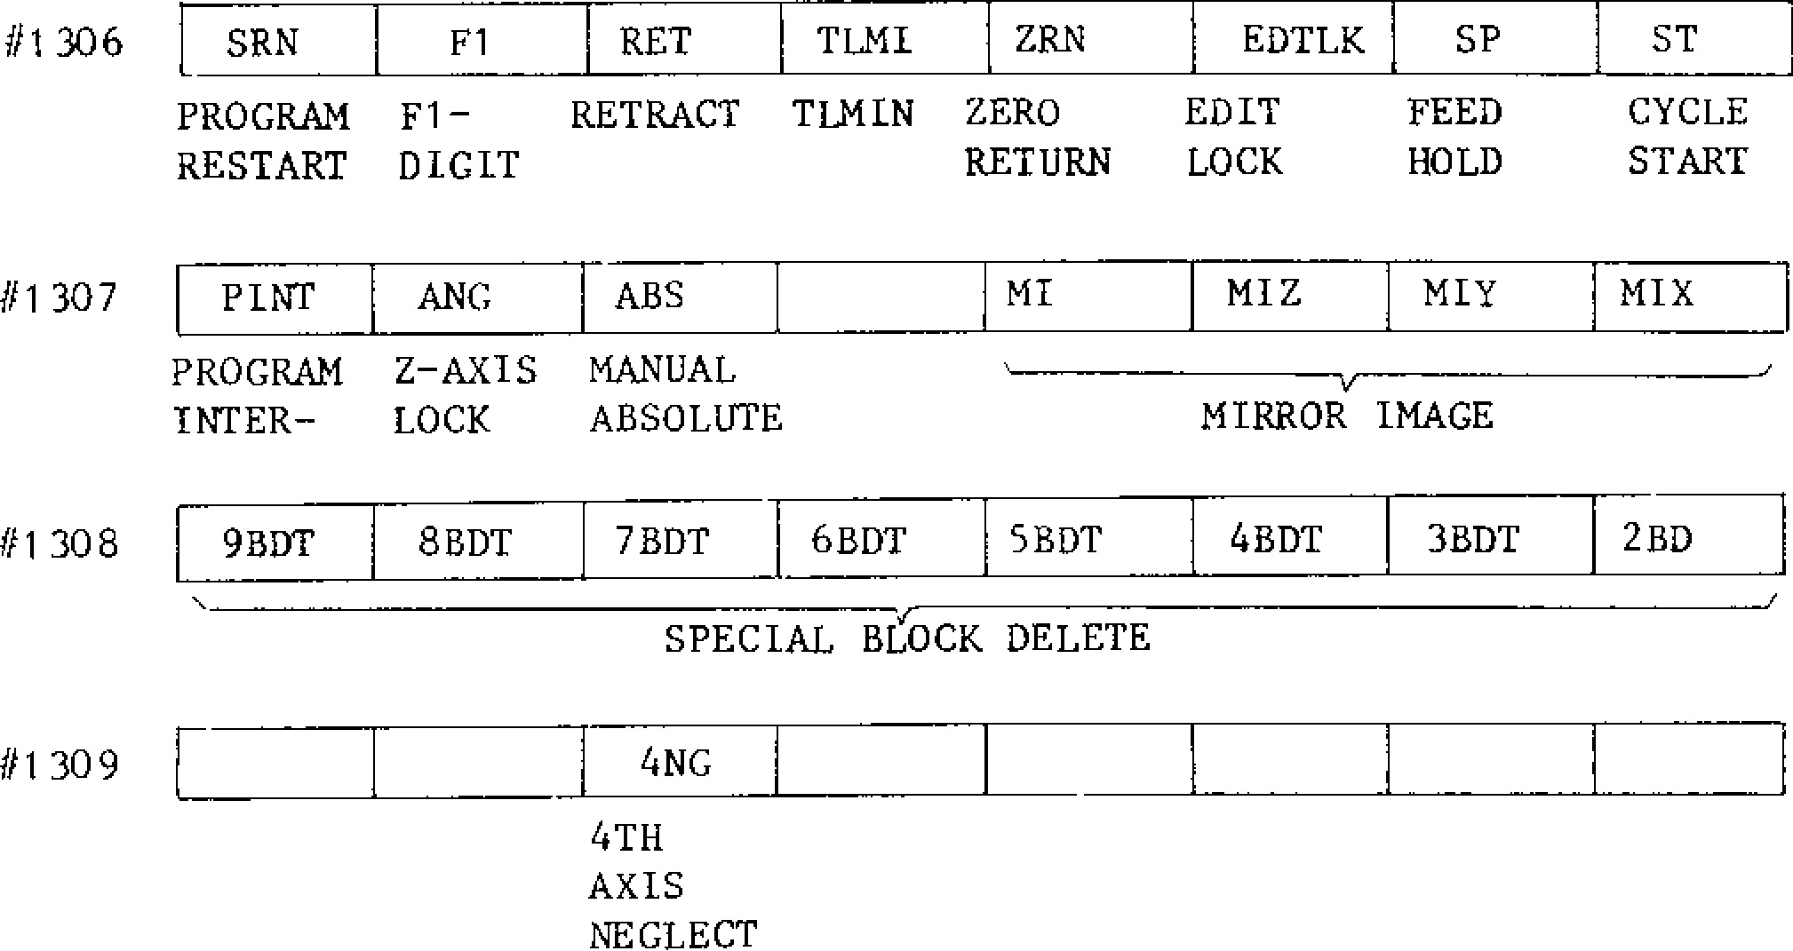

ZRN

EDTLK

TLMI

RET

F1

SRN

MI

MIZ

ABS

PINT

ANC

PROGRAM Z

-

AXIS MANUAL

INTER

-

LOCK

ABSOLUTE

____________

V

_______________

MIRROR IMAGE

#1 308

BDT

9

BDT

8

7

BDT

BDT

6

5

BDT

BDT

4

BDT

3

2

BD

#1

309

I

4

NG

4

TH

AXIS

NEGLECT

SPECIAL BLOCK DELETE

SP

ST

FEED

CYCLE

HOLD

START

MI?

MIX

#1 306

#1

307

PROGRAM Fl

-

RETRACT TLMIN ZERO

EDIT

RESTART DIGIT

RETURN LOCK

D6 D 5 D4 D3 D2 D1 D0

#1 310 2Ha 12HZ 2HY 2HX

SECOND HANDLE AXIS SELECT

#1312 PLYBK EXC1 ESCO

PLAYBACK EXT STROKE CHECK SELECTION

#1313

#1314

I

#1315

#1316

EFIN

FIN

RWD

EOP

ERS

EXTC

STLK

MRD

COMMAND MST

EXTERNAL END

EXTERNAL EXTERNAL CYCLE FUNCTION

|  |  |  |  |  |
| --- | --- | --- | --- | --- |
| TION | GRAM |  | COUNT | COMPLETED |
| #1317 S- INV S -FIN | *S-STP pAGR | SOR | GRB GRA | GST |

CYCLE COMPLE- REWIND PRO RESET TIME START PREP

|  |  |
| --- | --- |
|  | SPINDLE S FIN SPINDLE SPINDLE GEAR  REVERSE COINCI- INDEXING GEAR SHIFT DENCE SELECTION |
| #1318 | ERR2 ERR] ERRO IEXOUT EXVER EXLN  DEC TO IMMEDI- SINGLE EXTERNAL EXTERNAL EXTERNAL  STOP ATE BLOCK OUTPUT COLLATION INPUT  STOP STOP |

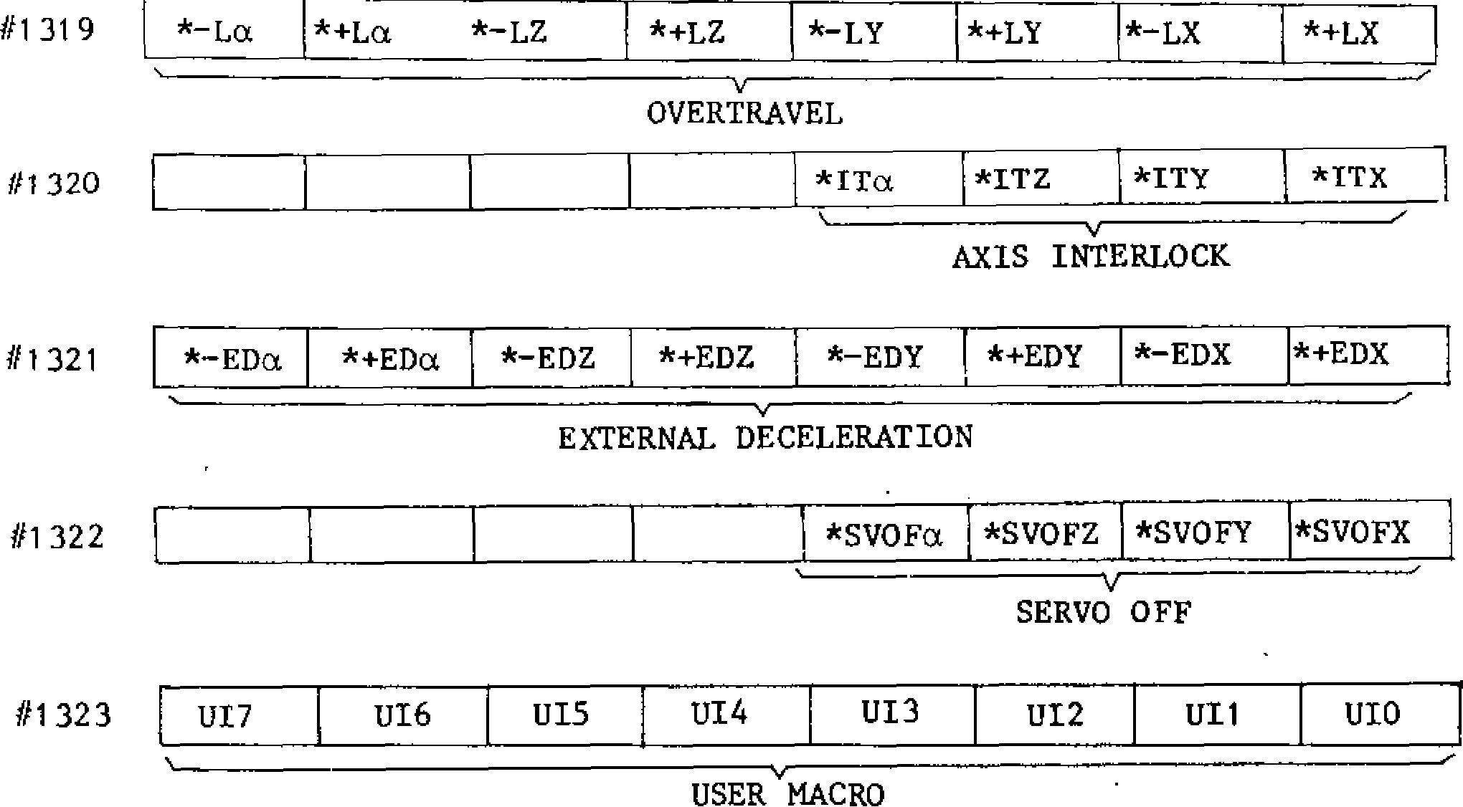

#1 31 9

*

-

La

*+

La

*

-

LZ

*+

LZ

*

-

LY

*+

LY

*

-

LX

*+

LX

r

*ITZ

*ITa

#1

32

0

*ITY

1

*IT'

*

-

EDZ

EDa

*+

*

-

EDa

EDZ

*+

*

-

EDY

j

*+

EDY *

-

EDX *+EDX

#1 322

*SV0Fa *SVOFZ

*SVOFY

*SVOFX

v

------

SERVO OFF

#1323

U17

U16

UI5

UI4

U13

U12

UI1

UI0

#1321

USER MACRO

EXTERNAL DECELERATION

________________________________

___________________

V

________________________________

____________________________

F

OVERTRAVEL

V

_________________________

AXIS INTERLOCK

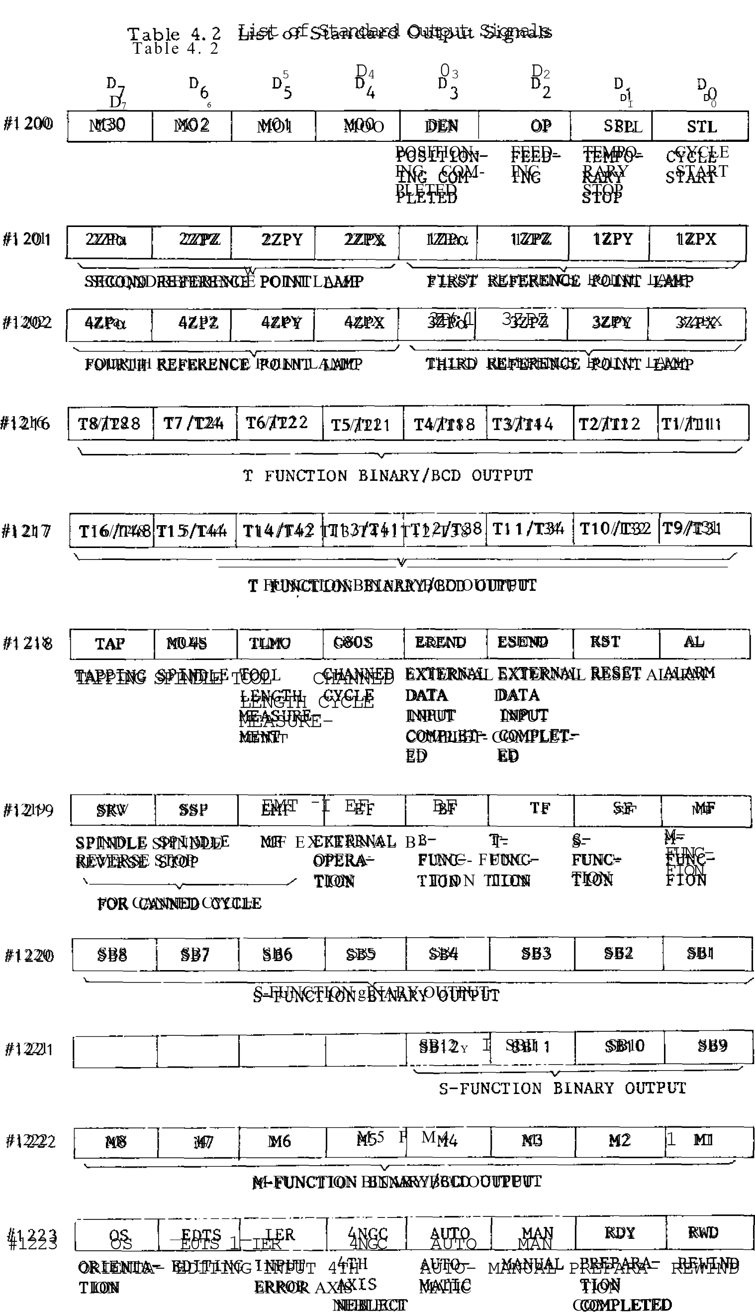

**D7 D6 D5 D4 D3 D2 Do**

|  |  |  |  |  |
| --- | --- | --- | --- | --- |
| **SDA8 SDA7 SDA6 SDA5 SDA4 SDA3** | | | **SDA2** | **SDA1** |
| **V**  **SPINDLE OPERATION COMMAND** | | |  |  |
| **SDA16 SDA1 5 SDA1 4 SDA13 SDA1 2 SDA1 1** | | | **SDA10** | **SDA9** |
|  | | |  |  |
| **SPINDLE OPERATION COMMAND** | | |  |  |
| **B8/B28 B7/B24 B6/B22 B5/B21 B4/13.18 B3/B14** | | | **B2/B12** | **B1 /B1 1** |
|  | | |  |  |
| - s r  **B FUNCTION BINARY/BCD OUTPUT** | | |  |  |
| **L1316/B48B15 /B44 )314/B42 B1 3/B41 ,B1 2/B38 B1 1 /B34** | | | **B10/B32** | **B9/B31** |
| **B FUNCTION BINARY/BCD OUTPU** | | **T** |  |  |
| **S28** |  |  | **S12/GRH** | **811/GRL** |
|  | **S24** i **522 S21** | **818** |  |  |
|  | S **FUNCTION BCD OUTPUT** |  | **LOW- SPEED**  **GEAR** | -  **HIGH**  **SPEED**  **GEAR** |
| **S48** | **S44 842 S41 S38** | **S34** | **832** | **831** |
|  | v**BCD OUTPUT**  **S FUNCTION** |  |  |  |
| **U7** | **U6 U5 U4** U3 | U2 | U1 | U0 |

**#1224**

**#1 225**

**#1232**

**#1233**

**#1234**

**#1235**

**#1236**

#1237

1

z

**USER MACRO**

**U15**

**Ul 4**

**Ul 3**

**U12**

**U11**

**U10**

**U9**

**U8**

**USER MACRO**

Table 4. 2

List of Standard Output Signals (Cont' d)

D

D7 D6 D5 D4D3 D2 D1

#1 280

0

0

0

R

F

SN3

SN2

SN1

|  |  |  |  |  |  |  |  |
| --- | --- | --- | --- | --- | --- | --- | --- |
|  |  |  |  | TAPE FEED SWITCH |  | SYSTEM NO. S | WITCH |
| #1281 |  |  |  | ON-PB OLD | SVALM | ESP | OHT |
|  |  |  |  | POWER OVERLOAD | SERVO | EMER- | OVERHEAT |
|  |  |  |  | ON | ALARM | GENCY |  |
|  |  |  |  | SWITCH | STOP |  |  |
| #1282 | 1 HP7 | 1 HP6 | 1 HP5 | 1 HP4 1 HP3 | 1 HP 2 | 1 HP1 | 1 HP0 |

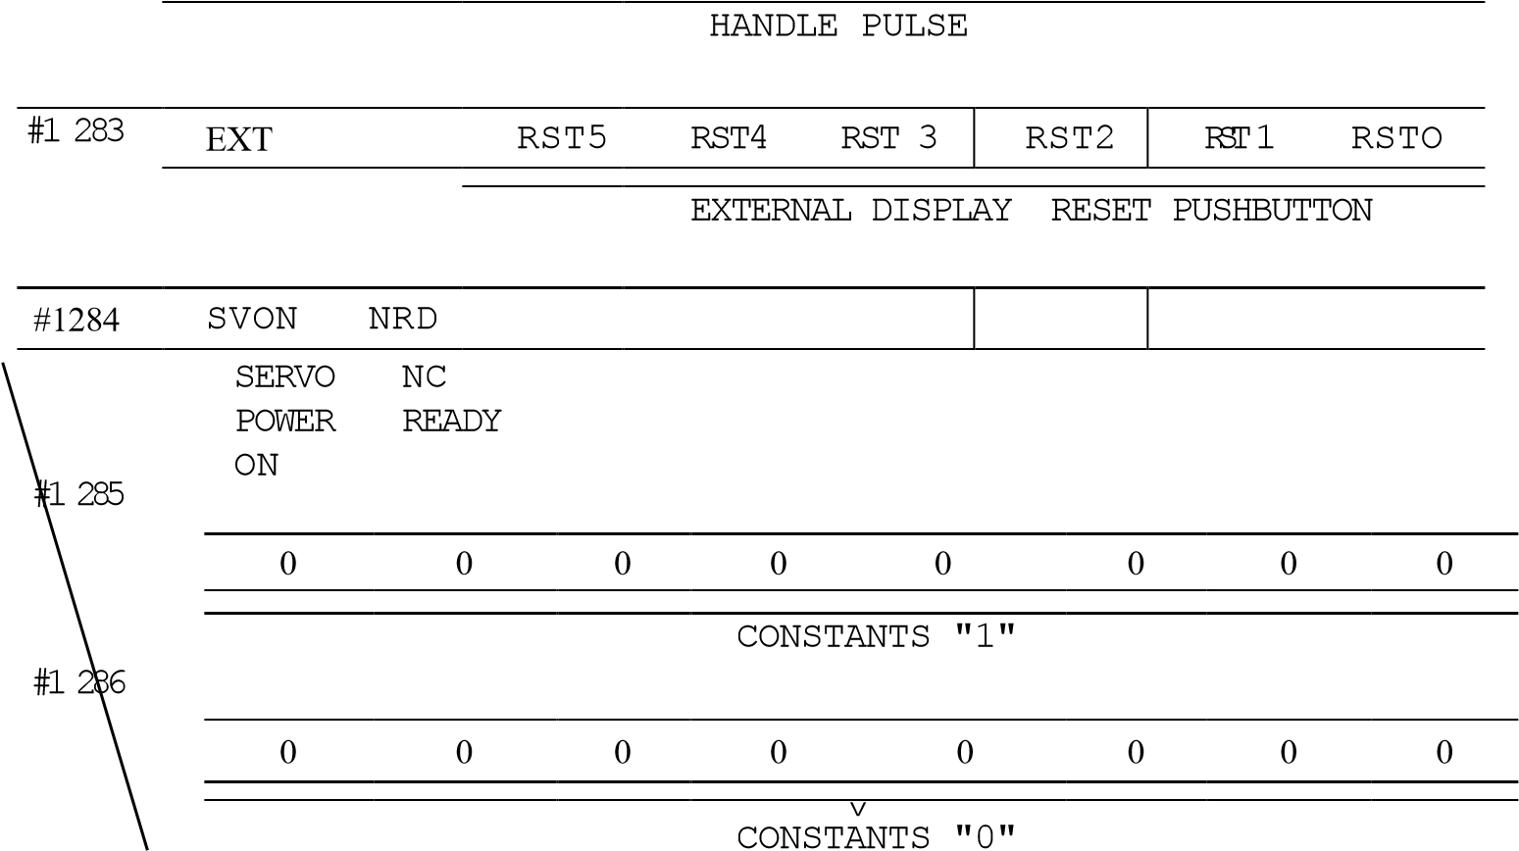

#1 287 0 0 0 0 SRDec SRTZ SRDY SRDX

SERVO READY

#1 288 ALMX PGALX SMCALX TGALX SDALX OLX FUX SRDYX

X-AXIS PG DIS- SERVO TG ALARM OVER- FUSE SERVO

ALARM CONNEC- ERROR SIGNAL LOAD BLOWN REACY

TION N ______________________________________________________________________ /

X-AXIS SERVO UNIT MONITOR

#1 289 ALMY PGALY SMCALY 1 TGALY SDALY OLY FUY jSRDYY I

Y-AXIS PG DIS- SERVO TG ALARM OVER- FUSE SERVO

ALARM CONNEC- ERROR SIGNAL LOAD BLOWN READY

TION V ______________ _/

|  |  |
| --- | --- |
| #1 290 ALMZ LPGALZ SMCALZ TGALZ SDALZ  Z-AXIS PG DIS- SERVO TG ALARM  ALARM CONNEC- ERROR SIGNAL TION | OLZ FUZ SPDYZ  OVER- FUSE SERVO  LOAD BLOWN READY |

Y-AXIS SERVO UNIT MONITOR

Z-AXIS SERVO UNIT MONITOR

D

7

D

D

5

4

D

3

D

2

D

1

D

ALMa

PGALa

SMCALa

TGALa

SDALa

OLa

Flla

SRDYa

4

TH

AXIS

ALARM

PG DIS

-

CONNEC

-

TION

SERVO

ERROR

TG

SIGNAL

ALARM

OVER

-

LOAD

FUSE

BLOWN

SERVO

READY

-

/

a

-

AXIS SERVO UNIT MONITOR

#1 293

ZNGC I ABSC

EDTLKC

Z

-

AXIS MANUAL EDIT

NEG

-

ABSOLUTE LOCK

#1 291

#1

2

92

LECT

AFLC

r

MLKC

OPTC

DRNC

BTDC

DLKC

STLKC

SBKC

#1294

#1295

|  |  |  |  |
| --- | --- | --- | --- |
| AUX FUNC- MACHINE OPTION- DRY  TION LOCK LOCK NAL RUN STOP | OPTIONAL  BLOCK  SKIP | DISPLAY START  LOCK LOCK | SINGLE BLOCK |
| PLBKC | MIaC | MIZC MIYC | MIXC |

PLAYBACK a Y X

MIRROR IMAGE AXIS

**APPENDIX --5 LIST OF ALARM CODES**

T a b l e 5 . 1

|  |  |  |
| --- | --- | --- |
| Alarm No, | Spindle Operation | Type of Alarm |
| 000 to 099 | Stop at blo ck end | Tape format error alarm |
| 100 to 199 | Stop at block end | Macro, operation, external input/ o u t p u t e r ro r, s e q u e n c e e r ro r (1 ) |
| 200 to 299 | Decelerate to stop | Overtravel, reference point return, positioning, machine ready |
| 300 to 399 | Decelerate to stop | Servo, emergency stop, overload FG, RPG |
| 400 to 499 | Decelerate to stop | Sequen ce e rro r (2 ) |
| 500 to 599 | immediate stop | Sequen ce e rro r (3 ) |
| 600 to 699 |  | Sequen ce r mes sag e |
| 700 to 799 |  |  |
| 800 to 899 | NC system stop | C PU e rro r, R AM e rro r, R OM e rro r |
| 900 to 999 |  | Off-line error |
|  |

Table 5-2 List of Alarm Codes (Cant 'd)

|  |  |  |  |
| --- | --- | --- | --- |
| Code | Causes | Code | Causes |
| 000 | POWER OFF  SETTING THE PARAMETER  REQUIRING TURNING OFF POWER | 014 | PROG ERROR ("-," "0")  , ------------------------------------------------------------  SIGN "-," "0" NOT CORRECTLY USED |
| 001 | ZR UNREADY (X)  REFERENCE POINT RETURN NOT  COMPLETED X | 015 | PROG ERROR (UNUSABLE CH)  UNUSABLE CHARACTER PROGRAMMED IN  INSIGNIFICANT DATA AREA |
| 002 | ZR UNREADY (Y)  REFERENCE POINT RETURN NOT  COMPLETED Y | 016 | PROG ERROR (UNUSABLE AXIS)  DEFINED AS ADDITIONAL AXIS OR  B-FUNCTION |
| 003 | ZR UNREADY (Z)  REFERENCE POINT RETURN NOT  COMPLETED Z | 017 | PROG ERROR (8 DIGITS)  INPUT DATA OVERFLOW (MODE THAN 8  CHARACTERS) |
| 004 | ZR UNREADY (4)  REFERENCE POINT RETURN NOT COMPLETED. | 020 | PROG ERROR (G)  UNUSABLE G CODE OR G CODE NOT  INCLUDED IN OPTIONS PROGRAMMED |
| 005 | ZR UNREADY (5)  REFERENCE POINT RETURN NOT COMPLETED. | 021 | PROG ERROR (G)  G CODE IN 1, 4, * GROUP PROGRAMMED  SIMULTANEOUSLY IN A BLOCK |
| 010 | TH ERROR  TAPE HORIZONTAL PARTY  ERROR | 022 ,-1 | FROG ERROR (G02/03, G43/44)  G43, G44 COMMANDED IN CIRCULAR  INTERPOLATION MODE (G02, G030 |
| 011 | TV ERROR  TAPE VERTICAL PARITY ERROR | 023 | PROG ERROR (G)  UNUSABLE G CODE COMMANDED IN  CANNED CYCLE |
| 012 | OVERFLOW (128CH)  BUFFER CAPACITY OVERFLOW IN A  BLOCK (128 CHARACTERS) | 024 | PROG ERROR (G, G41/42)  UNUSABLE CODE COMMANDED DURING  COMPENSATION MODE |
| 013 | PROG ERROR (NO ADDRESS)  ADDRESS PLUS NO DATA AND T■rfxr  ADDRESS COMMANDED. OR NO ADDRESS PLUS DATA | 025. PROG ERROR (G70171/72)  G 7 0 T O G 7 2 C O M M A N D E D E X C E P T I N CANNED CYCLES | |
| N O T E S :   1. No move command in three'blocks in series at G41 (G42) command. 2. M O O c o m m a n d e d w h e n r i s e . 3. R i s e a t c i r c u l a r i n t e rp o la t i o n b l o c k . | |  | |

Table 5-2 List of Alarm Codes (Cont td) Code

Code

Causes

Causes

038

026 PROG ERROR (G41/42) FROG ERROR (P, G10)

RISE ERROR AT COMPENSATION C (-COMMAND

WHICH CANNOT BE ACCOMODATED COR- TOOL LARGE P WHEN WORK COORDINATE

RECTLY IN COMPENSATION *C* MODE) SEE NOTES SYSTEM IS PROGRAM-INPUT

027 FROG ERROR (G41/42)

ERROR AT COMPENSATION C (ERROR IN CIRCULAR INTERPOLATION MODE)

030

FROG ERROR (F)

NO F-COMMAND IN FEED COMMAND

031 FROG ERROR (R = 0)

CIRCLE WITH RADIUS 0 COMMANDED IN CIRCULAR ARC COMMAND

032 PROG ERROR (G02/03)

COMMANDS ON THREE AXES IN CIRULAR ARC COMMAND WITHOUT HELICAL OPTION

COMMANDS ON MORE THAN FOUR AXES IN

cm

-

CULAR ARC PLANE WHOSE ARC CANNOT BE

SELECTED FROM THE COMMAND

IN CIRCLE CUTTING, PROGRAMMED RADI

-

US R IS SMALLER THAN COMPENSATION D.

PROG ERROR (G

02/03)

034

045

CAL ERROR (G

41/42)

CIRCULAR ARC R DESIGNATION ERROR

TOO LARGE NO. OF H OR D CODE FOR

TOOL RADIUS COMPENSATION AND TOOL

LENGTH COMPENSATION

IN COMPENSATION C MODE, CIRCU

~~LAR~~

ARC OUTSIDE OF COMPENSATION PLANE

PROGRAMMED.

TOO LARGE P (NUMBER DESIGNA

-

TION) WHEN OFFSET IS PROGRAM

-

INPUT

COMPENSATION PLANE CHANGED

.

DURING

COMPENSATION C MODE

FROG ERROR (G02/03)

033

12/13)

PROG ERROR (G

044

41/42)

PROG ERROR (G

046

035

FROG ERROR (D, H)

PROG ERROR (P, G10)

036

PROG ERROR

(G41142)

047

040 PROG ERROR (M98, G65/66)

* P NOT PROGRAMMED IN M98, G65, G66, G2f,.
* P DIFFERENT FROM Q IN NO. IN G25MODE.
* G25 AND M98/M99 PROGRAMMED SIMULTANEOUSLY.

041 PROG ERROR (M08/09, G65/66)

PROGRAM NO. (SEQUENCE NO.) NOT

FOUND WHEN PROGRAM IS CALLED BY

M98, G65, G66, G25, G, M, T

042 FROG ERROR (M98, NEST)

SUBPROGRAM (G25) OR MACRO CA.LL FIVE-NESTED.

043 PROG ERROR (G75)

UNUSABLE ADDRESS COMMANDED IN

G75.

037 1 FROG ERROR (P, G10) 048 FROG ERROR (G41/42)

TOOL LARGE R WHEN WORK COORDINATE INTERSECTION POINT NOT OBTAINED BY

SYSTEM IS PROGRAM-INPUT INTERSECTION COMPUTATION

Table 5-2 List of Alarm Codes (Cont 'd)

REVERSE OR ALMOST REVERSE COM

-

MANDED IN M97 MODE

MEMORY OPERATION FINISH COMMAND

NOT GIVEN

SCALING ERROR

050

UNUSABLE G CODE

TOT

U2I3

-

MT

G36 TO G38, G70 TO G72) IN SCALING

MODE.

I RS232C

075

RS232C INTERFACE DISAGREEMENT OF

NO. OF BITS AND NO. OF BAUD RATES

ERROR IN G51 AND G50 BLOCK

FORMAT. SCALING FACTOR ZERO.

DATA TRANSMISSION FAILURE

THROUGH RS232C INTERFACE

055

FROG ERROR (M, S, T, B

)

M, S, T, B COMMANDS IN THE BLOCK

IN WHICH M, 5, T, B CODE CANNOT

BE COMMANDED

077

I RS232C

CHARACTERA MORE HAVE BEEN READ

10

IN AFTER STOP CODE HAS BEEN TRANS

-

MITTED THROUGH RS232C INTERFACE

AXIS COMMAND IN G04, G20, AND

G21 BLOCKS

G10, G22, AND G23 COMMANDED WITH

AXIS DATA

G28 COMMANDED DURING MIRROR

IMAGE

MIRROR IMAGE IS ON WITH G36 TO

G 38

G28 NOT COMPLETED ON THE AXIS WHICH HAS

G29 COMMAND OR REFERENCE POINT

RETURN NOT COMPLETED ON THE AXIS

COMMAND OF I (J) ON MORE THAN ONE

AXIS AT G36 (G37)

066

RESET UN READY (AFTER EDITING

)

(G38)

086 1

FROG ERROR

COMMAND OTHER THAN K AT

G38

37/38)

087

I PROG ERROR (G31/36/

POWER TURNED OFF DURING WRITING

MEMORY

TOUCH SWITCH NOT ON WHEN MOTION

REACHES AT END POINT BY G31, G36

TO G38 COMMANDS

Code

Causes

Causes

Code

049

(G41142)

PROG ERROR

070

I FROG ERROR (MO2/

30/99)

051

SCALING ERROR

076

I RS232C

056

. FROG ERROR (AXIS

)

22/23)

t PROG ERROR (G10, G

080

(G28)

MIRROR IMAGE

058

37/38)

MIRROR IMAGE (G36/

084

085 1

PROG ERROR (G

36/37)

ZR UNREADY

059

067

088 I FROG ERROR (G36/37/38)

EDITING BEING EXECUTED IN THE

EDIT INHIBIT AREA

TOUCH SWITCH CALCULATION ERROR AT G36 TO G38 COMMANDS

068

Table 5-2 List of Alarm Codes (Cont `d)

|  |  |  |  |  |
| --- | --- | --- | --- | --- |
| Code | Causes |  | Code | Causes |
| 100 | CAL ERROR (FIXED POINT)  MAGNITUDE OF FIXED POINT DATA  EXCEEDING UPPER LIMIT |  | 111 | MACRO ERROR (MOVE G66-M99)  MOVE COMMAND IN M99 FINISHING COMMAND OF MACRO CALLED BY G66. |
| 101 | CAL ERROR (FLOATING)  ---------------------------------------------------- ..  EXPONENT OF FLOATING POINT DATA  EXCEEDING ALLOWABLE RANGE | - | 114 | MACRO ERROR (DO-FORMAT)  __ ----------------------------------------------  NO. OF DOs AND ENDs NOT THE SAME. |
| 102 | CAL ERROR (DIVISION)  CALCULATION DIVISOR ZERO OR OVERFLOW ERROR. |  | 115 | MACRO ERROR ([ I UNMACH)  NO. OF LEFT BRACKETS AND RIGHT BRACKETS NOT THE SAME. |
| 103 | CAL ERROR (SQUARE ROOT)  ROOT VALUE 15 A NEGATIVE  (—) |  | 116 | MACRO ERROR (DO-END NO.)  CONDITION 1 n= 3  NOT ESTABLISHED IN DOn. |
| 104 | PROG ERROR (DOUBLE ADD) SAME ADDRESS REPEATED IN •A BLOCK. |  | 117 |  |
| 105 | MACRO ERROR (CONSTANT)  CONSTANTS USABLE IN USER MACRO EXCEEDING THE LIMIT. |  | 118 | MACRO ERROR (GOTO N)  CONDITION 0 <n< 9999 NOT ESTABLISHED OR NO SEQUENCE NO. IN GO TO n. |
| 107 | MACRO ERROR (FORMAT)  ERROR IN THE FORMAT AND EQUATION. |  | 120 | PRTN ERROR (NOT FOUND)  SEQUENCE NO. NOT FOUND IN PART PROGRAM. |
| 108 | MACRO ERROR (UNDEFIN # NO)  UNDEFINED VARIABLE NO.  DESIGNATED. |  | 121 | PRTN ERROR (G92)  G92 COMMANDED THROUGH MDI OPERATION DURING PROGRAM RESTART. |
| 109 | MACRO ERROR (#1\10 NOT LEFT)  COMMANDED PROHIBITED VARIABLE AS SUBSTITUTION IN LEFT-HAND SIDE OF THE EQUATION. |  | 122 | PRTN ERROR (G54 -G59)  G54 TO G59 COMMANDED THROUGH MDI  OPERATION DURING PROGRAM RESTART. |
| 110 | MACRO ERROR ([ i5 LIMIT)  MULTIPLE LAYERS OF PARENTHESES EXCEEDING THE UPPER LIMIT (5). |  | 123 | PRTN ERROR (ORG)  COORDINATE SYSTEM CHANGED BY DEPRESSING THE ORG BUTTON DURING PROGRAM RESTART. |
|  | |  |  | |

Table 5 - 2 **List of Alarm Codes (Cant 'd)**

|  |  |  |  |
| --- | --- | --- | --- |
| Code | Causes | Code | Causes |
| 124 | PRTN ERROR (MDI MOVE)  AXIS OPERATED BY MDI AFTER  PROGRAM RESTART | 145 |  |
| 130 | EXT DATA  **DATA** ERROR IN A GROUP DATA | 146 | PROG ERROR (G100)  HIGH-SPEED CUTTING COMMAND G101 OR G102 NOT CANCELLED BY G100. |
| 131 | EXT MESSAGE  NO ALARM NUMBER CORRESPONDING TO EXTERNAL ALARM MESSAGE TO BE CLEARED. | 147 | PROG ERROR (PARAMETER ON)  PARAMETER #6008 (D7) SET TO 1 AT HIGH-SPEED CUTTING COMMAND. |
| 132 | EXT MESSAGE  NO CORRESPONDING ALARM NO. WHEN  EXTERNAL ALARM MESSAGE IS CLEARED. | 170 | MEM ERROR (OFS)  TOOL OFFSET TOATAL CHECK ERROR |
| 133 | EXT MESSAGE  NO CORRESPONDING ALARM NO. WHEN  EXTERNAL ALARM MESSAGE IS CLEARED. | 172 | MEM ERROR (SET)  SETTING AREA TOTAL CHECK ERROR |
| 140 | FROG ERRROR (P NG)  NO AXIS COMMAND IN HIGH-SPEED CUTTING PROGRAM AT HIGH-SPEED CUTTING COMMAND. | 173 | MEM ERROR (PRM)  PARAMETER AREA TOTAL CHECK ERROR |
| 141 | FROG ERROR (FILE OVER)  NO. OF BLOCKS IN REGISTERED  PROGRAM EXCEEDING THE SPECIFIED VALUE IN HIGH-SPEED CUTTING. | 179 | OVER TEMP  PANEL INSIDE TEMPERATURE TOO HIGH |
| 142 | FROG ERROR (G00/G01/G02)  G CODE OTHER THAN GM G01,002AND G03 OR M, S, T CODE COMMANDED IN REGISTERED PRO GRAM AT HIGH- SPEED CUTTING COMMAND. | 180 | SEQ ERROR  SEQUENCE ERROR (1) |
| 143 |  | 181 | S E Q E R R O R  SEQUENCE ERROR (1) |
| 144 | PROG ERROR (G101/G100)  ADDRESS OTHER THAN P COMMANDED IN G100, G101, G102 BLOCK. | 182 | SEQ ERROR  SEQUENCE ERROR (1) |
|  |  |  | |

T ab le 5 - 2 List **of Alarm Codes (Cant 'd)**

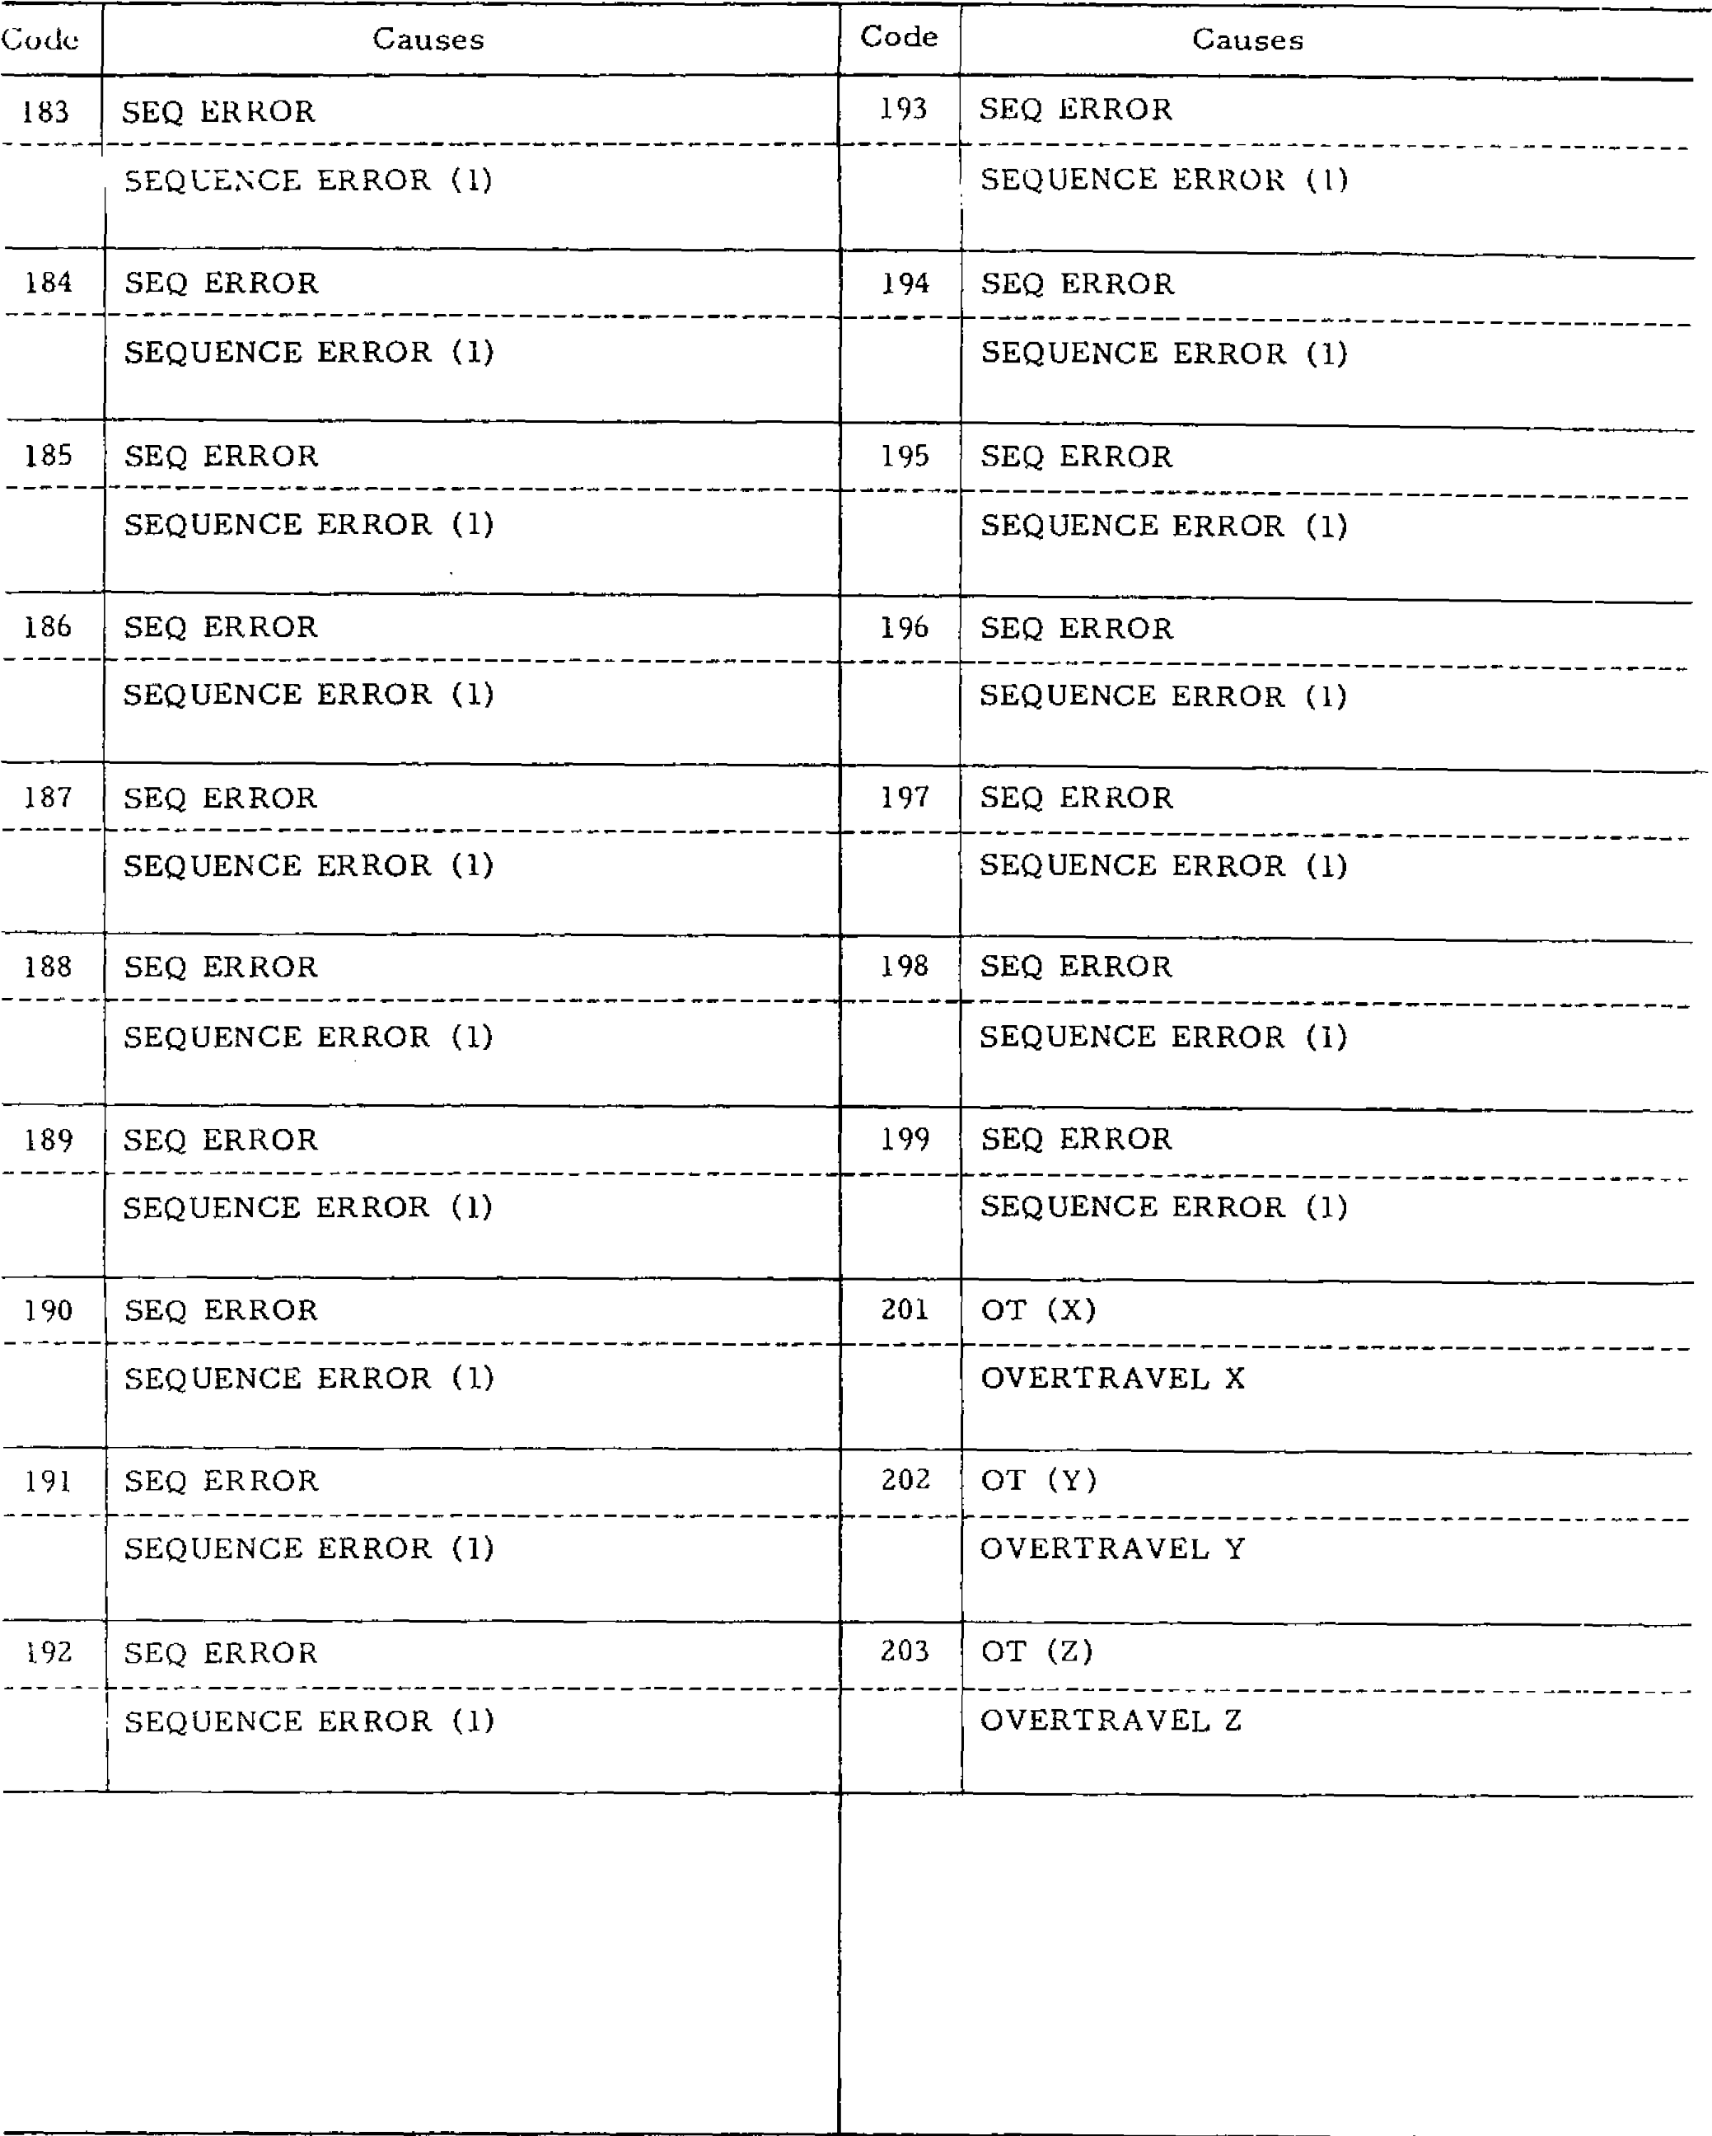

SEQUENCE ERROR (1)

198

SEQ ERROR

199

SEQ ERROR

189

SEQ ERROR

SEQ ERROR

186

191

SEQ ERROR

202

OT (Y)

OVERTRAVEL Y

SEQUENCE ERROR

**(1)**

203

192

SEQ

ERROR

OT (Z)

Code

Causes

SEQ ERROR

193

SEQ ERROR

183

SEQUENCE ERROR (1)

SEQ ERROR

SEQUENCE ERROR (1)

SEQ ERROR

SEQUENCE ERROR (1)

SEQ ERROR

196

SEQUENCE ERROR (1)

197

SEQUENCE ERROR (1)

SEQUENCE ERROR (1)

190

SEQ ERROR

SEQUENCE ERROR (1)

SEQUENCE ERROR (1)

)

201

OT (X

OVERTRAVEL X

SEQUENCE ERROR (1)

184

SEQ ERROR

SEQUENCE ERROR (1)

SEQ ERROR

185

SEQUENCE ERROR (1)

SEQUENCE ERROR (1)

187

SEQ ERROR

SEQ ERROR

SEQUENCE ERROR (1)

SEQ ERROR

188

SEQUENCE ERROR (1)

194

195

SEQUENCE ERROR (1)

OVERTRAVEL Z

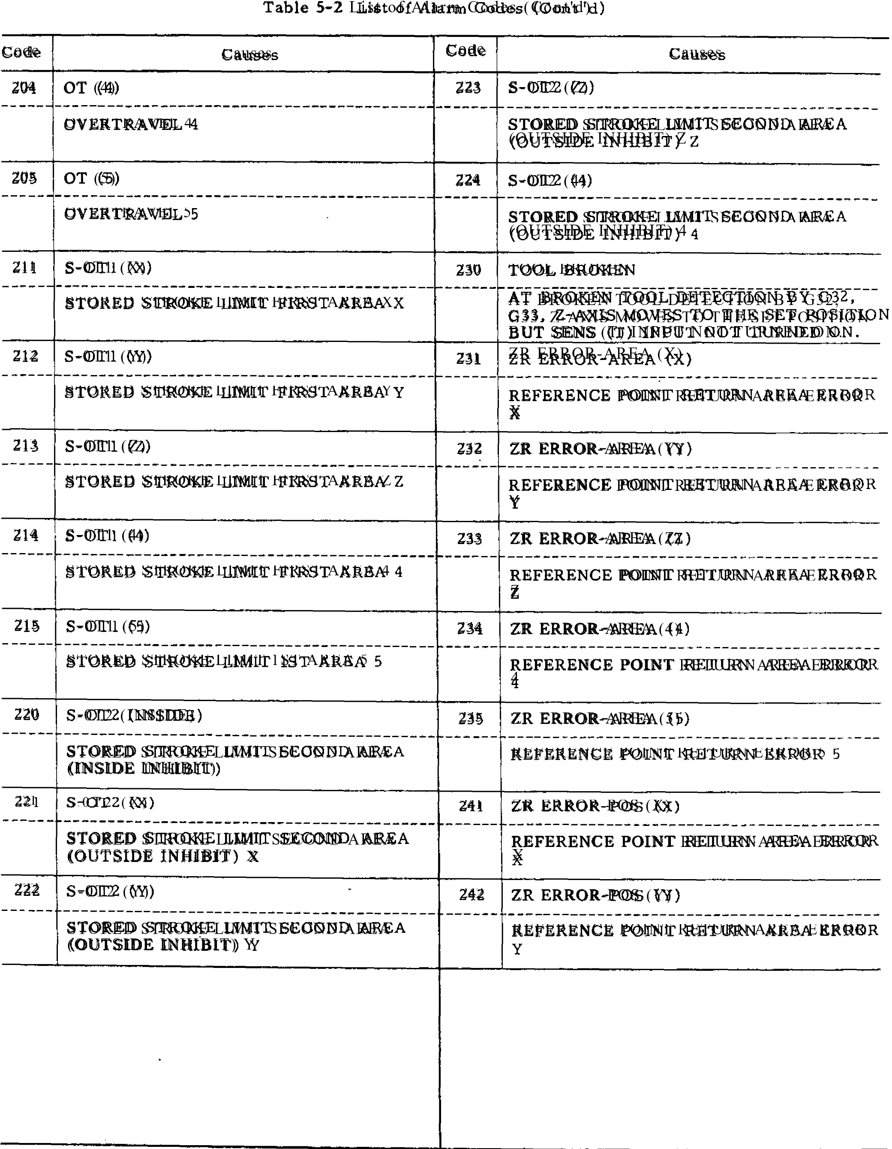

Table 5-2 List of Alarm Codes (Cont rd)

|  |  |  |  |
| --- | --- | --- | --- |
| Code | Causes | Code | Causes |
| 243 | ZR ERROR-POS (Z)  REFERENCE .POINT RETURN AREA  ERROR Z  --------------------------------------------------------------- | 274 | P--SET ERROR (4)  P SET ERROR 4 |
| 244 | ZR ERROR-POS (4)  REFERENCE POINT RETURN AREA ERROR 4 | 275 | P-SET ERROR (5)  PROGRAM SET ERROR 5 |
| 245 | ZR ERROR-POS (5)  REFERENCE POINT RETURN POSITION ERROR 5. | 280 | MACH UNREADY  MACH RDY OFF |
| 250 | S-0T3 -5 (INSIDE)  STORED STROKE LIMIT 3RD, 4TH, 5TH AREA INSIDE PROHIBITED. | 310 | SERVO POWER NOT SUPPLIED  SERVO POWER NOT SUPPLIED |
| 251 | S -0 T 3 -5 ( X)  STORED STROKE LIMIT 3RD, 4TH,  5TH AREA OUTSIDE PROHIBITED X. | 320 | NC UNREADY  NC UNREADY P SET UNREADY |
| 252 | S -0 T 3 -5 ( Y)  STORED STROKE LIMIT 3RD, 4TH,  5TH AREA OUTSIDE PROHIBITED Y. | 330 | EMERGENCY STOP  EMERGENCY STOP |
| 253 | S -0 T 3 -5 ( Z)  STORED STROKE LIMIT 3RD, 4TH,  5TH AREA OUTSIDE PROHIBITED Z. | 331 | FUSE (X)  FUSE BLOWN X |
| 271 | P-SET ERROR (X)  P SET ERROR X | 332 | FUSE (Y)  FUSE BLOWN Y |
| *272* | P-SET ERROR (Y)  P SET ERROR Y | 333 | FUSE (Z)  FUSE BLOWN Z |
| 273  -- 7 | P-SET ERROR (Z)  P SET ERROR Z | 334 | FUSE (4)  FUSE BLOWN 4 |
|  | |  | |

Table 5

-

)

List of Alarm Codes (Cant 'd

2

Code

Causes

Code

Causes

335

FUSE (5)

355

OL (5)

FUSE BLOWN 5

OVERLOAD (1) 5

|  |  |
| --- | --- |
| 342 SERVO ERROR (Y) | 361 PG ERROR (X) |
| SERVO ERROR Y | PG ERROR X |

341 SERVO ERROR (X) 357 OL (OTHERS) SERVO ERROR X OVERLOAD (2)

)

SERVO ERROR (Z

343

**362**

PG ERROR (Y)

SERVO ERROR Z

PG ERROR Y

SERVO ERROR

344

(4)

363

PG ERROR (Z

)

SERVO ERROR 4

PG ERROR Z

(5)

345

SERVO ERROR

364

PG ERROR

(4)

SERVO ERROR 5

PG ERROR 4

|  |  |
| --- | --- |
|  |  |
| 351 OL (X) | 365 PG ERROR (5) |

352

OL (Y

)

OVERLOAD (1) Y

)

OL (Z

353

371

)

FG ERROR (X

FG ERROR X

)

FG ERROR (Y

372

OVERLOAD (1) X

PG ERROR 5

OVERLOAD (1) Z

FG ERROR Y

373

FG ERROR (Z

)

354

OL

(4)

FG ERROR Z

OVERLOAD (1) 4

Table 5-2 List of Alarm Codes (Copt `d)

|  |  |  |  |
| --- | --- | --- | --- |
| Gode | Causes | Code | Causes |
| 374 | •  FG ERROR (4)  FG ERROR 4 | 394 | TG ERROR (4)  TG LEAD DISCONNECTION |
| 375 | FG ERROR (5)  FG ERROR 5 | 395 | TG ERROR (5)  TG LEAD DISCONNECTION |
| 381 | RPG ERROR (X)  RPG ERROR X | 400 | SEQ ERROR  SEQUENCE ERROR (2) |
| 382 | RPG ERROR (Y)  RPG ERROR Y | 419 | SEQ ERROR  SEQUENCE ERROR (2) |
| 383 | ----- --------------------------------------------  RPG ERROR (Z)  RPG ERROR Z | 300 | SEQ ERROR  SEQUENCE ERROR (3) |
| 384 | RPG ERROR (4)  RPG ERROR 4 | 519 | SEQ ERROR  SEQUENCE ERROR (3) |
| 385 | RPG ERROR 5  PROGRAM ERROR 5 | 800 | MEM ERROR  BUBBLE FAILURE  INPUT/OUTPUT FAILURE |
| 391 | TG ERROR (X)  TG LEAD DISCONNECTION | 801 | MEM ERROR  BUBBLE FAILURE  INITIAL ERROR |
| 392 | TG ERROR (Y)  TG LEAD DISCONNECTION | 802 | MEM ERROR  BUBBLE FAILURE  UNDEFINED COMMAND |
| 393 | TG ERROR (Z)  TG LEAD DISCONNECTION | 803 | MEM ERROR  BUBBLE FAILURE  TRANSFER MISSING |
|  | |  | |

Table 5-2 List of Alarm Codes (Cont 'cl)

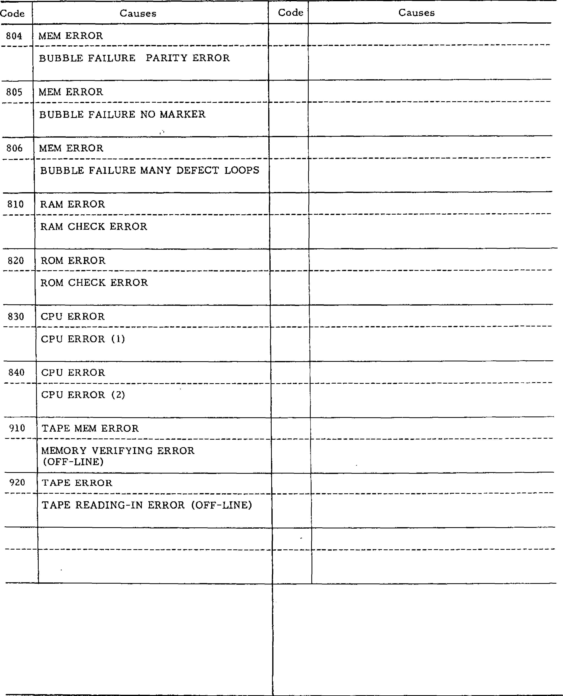

Code

Causes

Code

Causes

804

MEM ERROR

805

MEM ERROR

806

MEM ERROR

810

RAM ERROR

820

ROM ERROR

830

CPU ERROR

CPU ERROR (1)

840

CPU ERROR

910

TAPE MEM ERROR

MEMORY VERIFYING ERROR

OFF

(

-

LINE)

920

TAPE ERROR

■

_

BUBBLE FAILURE PARITY ERROR

BUBBLE FAILURE NO MARKER

BUBBLE FAILURE MANY DEFECT LOOPS

RAM CHECK ERROR

ROM CHECK ERROR

CPU ERROR (2)

TAPE READING

-

IN ERROR (OFF

-

LINE)

**APPENDIX 6 LIST OF ADDRESS CHARACTERS**

T a b l e 6 . 1 L i s t of Address C h a r a c t e r s

|  |  |  |  |  |  |  |  |  |
| --- | --- | --- | --- | --- | --- | --- | --- | --- |
| Address  C h a ra c t e rs | Meanings |  |  |  |  | B. 0: | Basic Optional | _ |
| A | Ad d i t i o n a l ro t a ry a x i s p a ra l l e l t o X -a x i s |  |  |  |  |  | 0 |  |
| B | Ad d i t i o n a l ro t a ry a x i s p a ra l l e l t o Y -a x i s |  |  |  |  |  | 0 | _ |
| C | Ad d i t i o n a l ro t a ry a x i s p a ra l l e l t o Z -a x i s |  |  |  |  |  | 0 |  |
| D | T o o l ra d i u s o ff s e t n u m b e r |  |  |  |  |  | B , 0 |  |
| E | U s e r m a c ro c h a ra c t e r |  |  |  |  |  | 0 |  |
| F | Feed ra te |  |  |  |  |  | B |  |
| G | P r e p a r a t o r y f u n c t i o n |  |  |  |  | 13, | 0 |  |
| H | T o o l l e n g t h o f f s e t n u m b e r |  |  |  |  |  | B |  |
| I | X-coordinate of arc center R a d i u s fo r c i rc l e c u t t i n g |  |  |  |  |  | B 0 |  |
| J | Y -c o o rd i n a t e o f a rc c e n t e r  C u t t i n g d e p t h f o r c i r c l e c u t t i n g |  |  |  | , |  | B 0 |  |
| K | Z -c o o rd i n a t e a rc c e n t e r |  |  |  |  |  | B |  |
| L | Nu m b e r o f re p e t i t i o n s |  |  |  |  |  | 13, 0 |  |
| M | Miscellaneous functions |  |  |  |  |  | B |  |
| N | Sequence number |  |  |  |  |  | B |  |
| 0 | Program number |  |  |  |  |  | B |  |
| P | Dwell time, Program No. and sequence No.  d e s i g n a t i o n i n s u b p ro g ra m |  |  |  |  |  | B 0 |  |
| Q | D e p t h o f cut, s h i ft o f c a n n e d c y c l e s |  |  |  |  |  | 0 |  |
| R | Po i n t R fo r c a n n e d c y c l e s  R a d i u s d e s i g n a t i o n o f a c i r c u l a r a r c  0 , |  |  | B |  |  |  |  |
| S | Sp i n d l e -s p e e d fu n c t i o n |  |  |  |  |  | B |  |
| T | Tool function |  |  |  |  |  | 13 |  |
| U | Ad d it io na l l in e a r a xi s pa ra l l el to X -ax i s |  |  |  |  |  | 0 |  |
| V | Ad d it io na l l in e a r a xi s pa ra l l el to Y -ax i s |  |  |  |  |  | 0 |  |
| W | Ad d it io na l l in e a r a xi s pa ra l l el to Z -a x i s |  |  |  |  |  | 0 |  |
| X | X-coo rdinat e |  |  |  |  |  | B |  |
| Y | Y-coo rdinat e |  |  |  |  |  | B |  |
| Z | Z -coord inate |  |  |  |  |  | B |  |

T a b l e 6.2 F u n c t i o n C h a r a c t e r s

|  |  |  |  |
| --- | --- | --- | --- |
| EIA Code | ISO Code | Meanings | Remarks |
| Blank | Nut | Error in significant data area in ETA Disregarded in ISO |  |
| BS | BS | Disregarded |  |
| Tab | HT | Disregarde d |  |
| CR | LF /NL | End of Block (EOB) |  |
|  | CR | Disregarded |  |
| SP | SP | Space |  |
| ER | % | Rewind stop |  |
| UC |  | Upper shift |  |
| LC |  | Lower shift |  |
| 2-4-5 bits |  | Control out (Comment start) | EIA: |
|  |  |  |
| 2-4-7 bits | ) | Control in (Comment end) | Special code |
| + | + | Disregarde d, Use r macro ope rator |
| - | - | Minus sig n, Use r macro operator |  |
| 0 to 9 | 0 to 9 | Numerals |  |
| a to z | A to 2 | A d d re ss c h a ra c te rs, Use r ma c ro o p e ra to r |  |
| / | / | Optional block skip |  |
| Del | DEL | Disregarded (Including All Mark) |  |
| . | . | Decimal point |  |
| Parameter setting | # | Sharp (Variable) | EIA: Special code |
| * | * | • As trisk (Multipli cation ope ra tor) |
| = |  | Equal mark |
| [ | I | Left bracket |
| i | [ | Righ t b racket |
| . | . | User macro comment |
| $ | $ | User macro comment |
| @ | @  7 | User macro comment |
| Us e r m ac ro co mm ent |

Notes:

I. C h a r a c t e r s o t h e r t h a n t h e a b o v e c a u se e r r o r i n s i g n i f i c a n t d a t a a r e a .

1. . In fo rma tion be twee n Co ntro l Ou t a nd Con tro l In is ign ored as in sig n ifica nt d ata .
2. . Tape code ( 4.11A or ISO) call be su i tk• hod by setting.

- 235 -

Table 6

rat)e

)

0

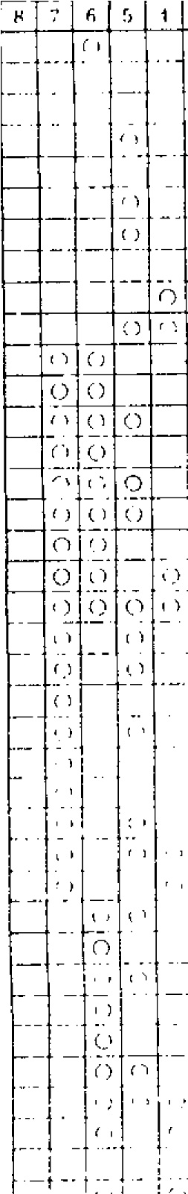

1

C')

0

)

)

r

-

1

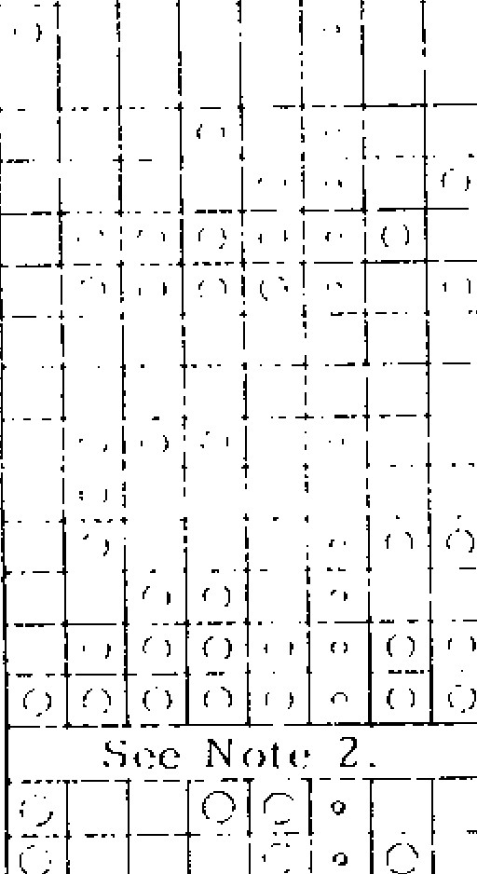

EIA CODE

*C*

)

0

(

•

•

c 0 0

0

(

-

)

0

0

C)

C

-

)

C7

ti

•

ISO CODE

*r •*

*C*

)

(

,

0

n

rr

CHARACTERS

Ella

nk

S

13

I

**—**

CR

1.1

-

1

N

1.

CR

V

NUE,

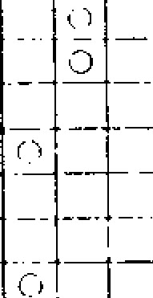

1.0

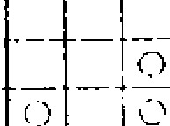

0

0

0

■

0

0

0

■

0

0

■

0

0

0

0

Notes:

1.

For characters from # to ?,

ETA codes have not been

agreed upon. In the

present system, for the time

being, the above provisional

codes are used.

2.

EIA code of character # can

be designated by the param

-

eter #6017.

-

236

-

*1*

1. *M°MMEMEM11*

*______ ■■""■■■1111 "li*

*1*

*fl*

*_________*

**. 9 _ A Norm**

C

___ **MMEMEM**IMPEIM0.0

**h B a**

**f __ F  p i . . . . o .**

**E MMIUMM° h H**

**EarI ir ..0. g** G

11111

DEEMMEM

E MEMS EMMENEMU

P ■

M■ 0

IC ■ELIE

**■III**

**ME**■

**. o**

**"PI**

0 Del I DEL

A l l M a r k I **milimmm**

**HEIM**

**/**

**# ■o■.**

**Table 6.4 Tape Format**

|  |  |  |  |  |  |  |  |  |
| --- | --- | --- | --- | --- | --- | --- | --- | --- |
| No. | Address | | Metric output | | Inch input  B : B a s i c | |  | 0: Optional |
|  |  |  |  |
|  |  | | Metric input | Inch input | Metric input | Inch input |  |  |
| **1.** | Program No. | | 04 | | 04 | |  | B |
| 2 | Sequence No. | | N4 | | N4 | |  | B |
| 3 | G function | | G3 | | G3 | |  | B |
| 4 | Cordinate Word | Linear axis | a + 43 | a + 34 | a + 53 | a + 34 |  | B |
| Rotary aids | b + 43 | b + 43 | b + 43 | b + 43 |  | 0 |
| 5 | Feed /min | | F40 | F31 | F50 | F31 |  | B |
| 6 | Feed /min 1/10 | | F41 | F32 | F51 | F32 |  | B |
| 7 | Feed/rev | | F22 | F13 | F22 | F13 |  | 0 |
| 8 | Feed/rev 1/10 " | | F23 | F14 | F23 | F14 |  | 0 |
| 9 | S- function |  | 52 | | 52 | |  | B |
|  | 55 | | S5 | |  | 0 |
| 10 | T-function |  | T2 | | T2 | |  | B |
|  | T4 | | T4 | |  | 0 |
| 11 | M-function | | M3 | | M3 | |  | B |
| 12 | Tool Offset No. | | H2 or D2 | | H2 or D2 | |  | B |
| 13 | B-function | | B3 | | 133 | |  | 0 |
| 14 | Dwell | | P53 | | P53 | |  | B |
| 15 | Program No. designation | | Pi | | P4 | |  | B |
| 16 | Sequence No. designation | | P4 | | P4 | | 7 | B |
| 17 | No . o f re p i t i t i o n s | | L8 |  | L8 | |  | B |

Table 6.5 Range of Progra m Co mmands

|  |  |  |  |  |  |  |
| --- | --- | --- | --- | --- | --- | --- |
| No. | Acid ress |  | Metric U u t p i i i  _ . _ .  Met vie loon' | to. **Ii lupt 41** | int Ii O  **M e I.. I r i p l i l** | **1 ilk•11 li4Al41** |
| **1**  2 | P•ow•am Numbi.r | 0 | 1 to 9999 • | 1 to 9999 | 1 to 9999 | 1 to 9999 |
| Sequence Number | N | 1 to 9999 | 1 to 9999 | 1 to 9999 | 1 to 9999 |
| 3 | G-function | G | 0 to 199 | 0 to 199 | 0 to 199 | 0 to 199 |
| 4 | Coordinate address  Linear axis  Rotary axis  Max cumulative value |  | ± 8388.607 mm  ± 8388.607 deg  ± 99999.999 mm | -± 330.2601 in. ± 8388.607 deg ± 9999.99999 in. | ± 21307.061 mm ± 8388.607 deg  ± 99999.999 mm | ± 838.8607 in.  ± 8388.607 deg ± 9999.99999 in. |
| 5 | Feed per minute | F | 1 to 8100 mm /min | 0.1 to 313.0 in | 1 to 20574.0 mm /min | 0.1 to 810.0 in |
| 6 | Feed per minute  1/10 |  | 0.1 to 8100.0 mm /min | 0.01 to 313.00 in. /min | 0.1 to 20574.0 mm /min | 0.01 to E10.00 i n |
| 7 | F eed per revolution |  | 0.01 to 99.99 mm/rev | 0.0001 to 3.936 in. /rev | 0.01 to 99.99 mm/rev | 0.0001 to 3.936 in. /rev |
| 8 | Feed per revolution  1/10 |  | 0.01 to 99.999 mm/rev | 0.001 to 3.9366 in. /rev | 0.001 to 99.999 mm/rev | 0.0001 to 3.9366 in. /rev |
| 9 | S-function | 52 | 0 to 99 | 0 to 99 | 0 to 99 | 0 to 99 |
| 55 | 0 to 99999 | 0 to 99999 | 0 to 99999 | 0 to 99919 |
| 10 | T- function | T2 | 0 to 99 | 0 to 99 | 0 to 99 | 0 to 99 |
| T4 | 0 to 9999 | 0 to 9999 | 0 to 9999 | 0 to 9999 |
| 11 | M-function | M | 0 to 199 | 0 to 199 | 0 to 199 | 0 to 199 |
| 12 | Tool offset No. | H | 0 to 99 | 0 to 99 | 0 to 99 | 0 to 99 |
| D | 0 to 99 | 0 to 99 | 0 to 99 | 0 to 99 |
| 13 | B-function | B | 0 to 999 | 0 to 999 | 0 to 999 | 0 to 999 |
| 14 | Dwell | P | 0 to 99999.999 sec | 0 to 99999.999 sec | 0 to 99999.999 sec | 0 to 99999.999 sec |
| 15 | Program No. designation | P | 1 to 9999 | 1 to 9999 | 1 to 9999 | 1 to 9999 |
| 1 6 | Sequence No.  designation | P | 1 to 9999 | 1 to 9999 | 1 to 9999 | 1 t o 9 9 9 9 |
| 17 | No. of repetitions | L | 99999999 | 99999999 | 99999999 | 99999999 |

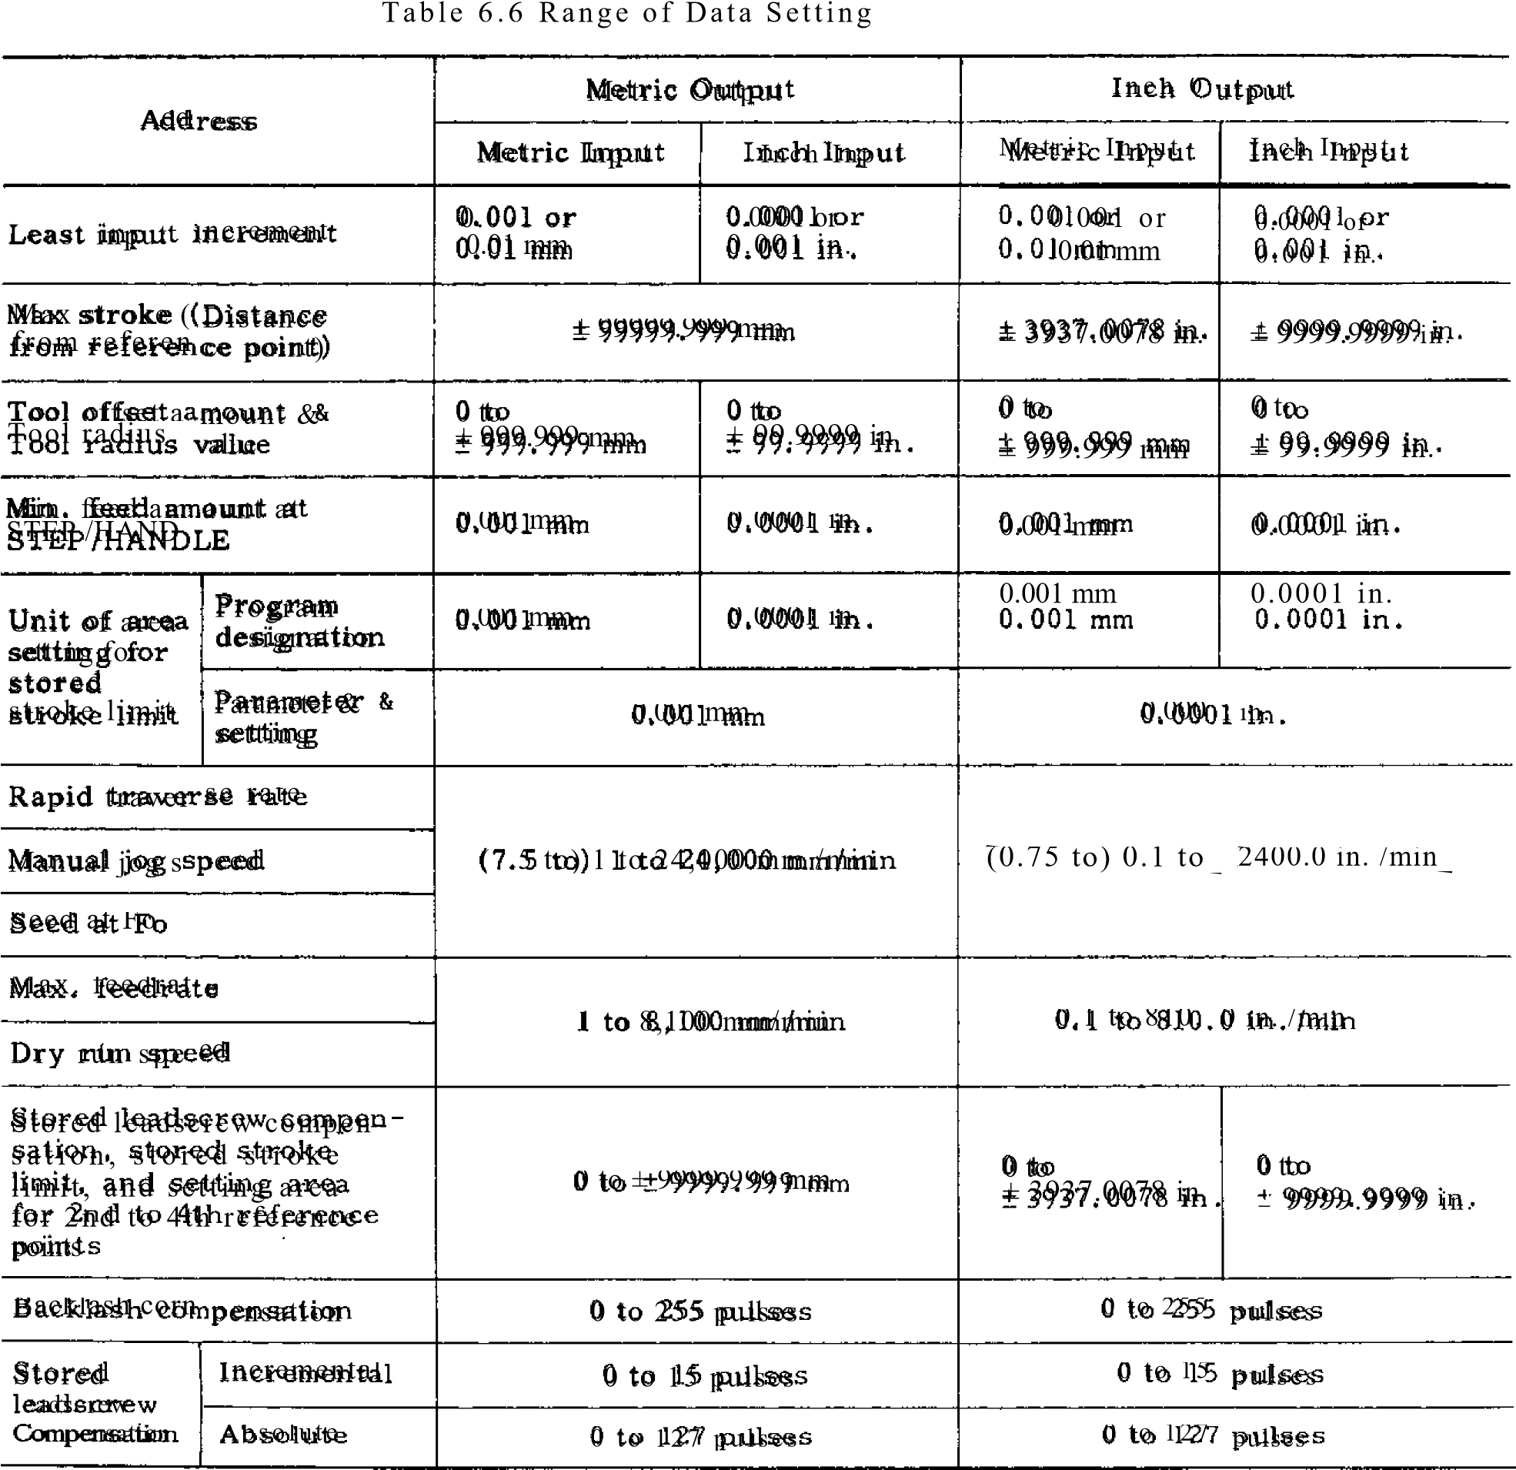

Note: 1 pulse = least output increment

T a b le 6 .7 List o f G Co d e s

|  |  |  |  |  |
| --- | --- | --- | --- | --- |
| G code | Group | 113: Basic  Funct ion  .0: Optional | | |
| G00.1 | 0 l | Positioning B | | |
| a-FIN,  G02 | Linear interpolation_ .  Circular interpolation CW, Helical interpola- tion CW | _____13 _  13, 0 |  |
| G03 | Circular interpolation CCW, Helical interpola- tion CCW | 8, 0 |  |
| G04 |  | Dwell | B |  |
| 006 | Positioning in error detect off mode | B |  |
| G09 | E x a ct s t o p | B |  |
| 010 | Toot o ffs et val ue and work coordinate, Shift - value modification | B, 0 | I |
| G12 | Circle cutting CW | 0 |  |
| G13 | Circle cutting CCW | 0 |  |
| G 17Nr | 02 | XY plane designation | B |  |
| G18 | ZX plan e desi gnat ion | B |  |
| G19 | Y Z plan e desi gnat ion | B | . |
| G 20 | 06 | In ch i n p u t d es i g n at i o n | 0 |  |
| 021 | Metric input designation | ❑ |  |
| 0 2 2 1 | 04 | Stored stroke limit ON | 0 |  |
| G23 | Sto red st roke li mit OFF | 0 |  |
| 027 |  | R ef er en ce p o i n t ch e ck | ❑ |  |
| G28 | Automatic return to r ef er en ce p o i n t | 0 |  |
| G29 | Retu rn from reference  point | 0 |  |
| G 30 | R e t u r n t o 2 n d , 3 r d , 4 t h re fer en c e p o i n t | 0 |  |
| G31 | Skip fun ction | 0 |  |
| G33 | 01 | T h r e a d c u t t i n g | 0 |  |
| G36 |  | Auto matic cent ering | 0 |  |
| G 37  0 38 | Auto matic cent ering | 0 |  |
| Z-ax is reference sur face offset | 0 |  |
| **1**  040 | 07 | Tool radius compensa tion cancel | 0 |  |
| 041  — G42  - -  (143  — | Tool radius compensa tion, left | 0 | , |
|  | Tool radius compensa-  tion, ri _ Yht  , | 0 |  |
|  | Tool length compensa - tion, lus direction | B |  |
| C,14  **-- NI**  C,49 | 08 tion, | Tool l ength co mpen sa - minus direction | B |  |
|  | Tool length compensa tion, cancel | B |  |
| Cir, ' - -- | | Tool position offset, extension | B |  |
| C;46 | | -1'ool position offset, ret ract ion | B |  |
| -1 Cl? | 4 | Tool position offset, double extension | 13 |  |
| G48 |  | Tool position offset, doub le ret raction | B |  |
| G50N |  | Scaling OFF | 0 |  |
| Gam- | 15 | Scaling ON j 0 | | |
| G 52 | 12 | R et u rn t o b as e co o rd i -  0  n at e s y s t e m | | |
| 053 | t | T e mp o ra ry s h i ft t o m a - 0  chin e coord inate syst em | | |

|  |  |  |  |
| --- | --- | --- | --- |
| code | Group | Funnelion | 13: Basic  0 : O p t i o n al |
| 654 | 12 | Shut to work coordinate st er;) ,_ | 0 |
| G55 | Shift to work coordinate sys tem 2 | 0 |
| C56 | Shift to work coordinate sys tem 3 | 0 |
| 057 | Shift to work coordinate sys tem 4 | 0 |
| G58 | Shift to work coordinate system 5 | 0 |
| G59 | Shift to work coordinate system 6 | 0 |
| 'G60 | 01 | Unidirectional approach | 0 |
| 11 | 13 | Ex act stop mo de |  |
| G64 | Ex act stop mo de cance | B |
| 1065 |  | Non-modal call of user macro | 0 |
| G66  G67 | 14 | Modal call of user macro |  |
| Modal call of user macro cancel | C. |
| 1070 |  | Bolt hole circle | C |
| ;071 | Arc Cu | |
| 1072 | Lin e -at -angle | |
| 073 | 09 | Cann ed cy cle 10 0 | |
| !G74 | Canned cycle 11 0 | |
| 076 | Cann ed cy cle 12 0 | |
| :077 | Cann ed cy cle 13 0 | |
|  | Cann ed cy cle can cel 0 | |
| 081 | Canned cycle 1, Output  for external motion C) | |
| G82 | Cann ed cy cle 2 C) | |
| 083 | Cann ed cy cle 3 C) | |
| G84 | 09 | Cann ed cy cle 4 0 | |
| G85 | Cann ed cy cle 5 0 | |
| t086  LG87 | Cann ed cy cle 6 0 | |
| Cann ed cy cle 7 0 | |
| G88 | Cann ed cy cle 8 0 | |
| G89 | Cann ed cy cle 9 0 | |
| G90 | 03 | Absolute command  designation | |
| G91 | Incremental command  designation 3 | |
| G92 |  | Programming of absolute  zero point B | |
| 'G94 | 05 | Feed p er minut e  (mm /min) designation 0 | |
| G95 | Feed p er revo lution  (mm/rev.) designation 0 | |
| -41  G 98 | 10 | Return to initial point  for cann ed cy cles 0 | |
| .099 | Return to point R for  cann ed cy cles 0 | |
| G1001- | 16 | High-speed cutting cancel ,9 | |
| :0101 | High-speed cutting in sequential processing ',7). mode ON | |
| I G102 | High-speed cutting in  processing mode ON C | |

Notes:

* + 1. . T h e G co d es i n t h e * g rou p are n o n -mo d a l , an d t h e ef fect i v e o n l y fo r t h e b l o ck i n w h i ch t h e y a r e c o m m a n d e d . T h e y c a n n o t b e p r o g r a mm e d t w i c e o r m o r e i n a b l o ck . T h ey mu s t

be programmed only once in a block of its own.

* + 1. . T h e co d es m ark ed w i t h is automatically s el ect ed at power on o r reset .

- 2 4 0 -

***YASNACIWEW* OPERATOR'S MANUAL**

**.1.1.111 111111601111101111.11M11.11.1111.1111111.11110111.1111.1411111liiiffi ili111.111.11111.111.10101111110 E11,1 111111.111101■111u 11111, 1,11,,,M1.111.1.114** I 111111 ,I,1111. i,111.1,1.■■■24,1111..1111.1.1114 **1111** 111.i I

r■ 11111 ~Illliii11111~~111.111111.111111

***A Barter* Tomorrow *for Industry through Automation* YASKAWA Electric Mfg. Co., Ltd.**

**TOKYO 0/01C1 Ohtemachi Bldg Chsyona kw, *Tokyo* 100 Japan**

**Phone (03) 284-9111 Telex YASKAWA 133530 Fax (031 284 9034**

**TAVIHOPPICIE TECO ELC & MACH Bldg 8F, 156 2 Sung Chiang Road. Taipei**

**Phone (21531-7732, 551-7065 Telex (785123591 TA1AN FaX (21 396 2397 314 7818**

**YASKAWA ELECTRIC SUSS/DIARY**

**CItlegie 0/11•6 1 *YASNAC* Affwmica**

**305 Era Drive, Northbrook. Illinois 60062. U S A**

**Phone (31215640770 Telex (2301 270197 YSKW YSNC *IsTBRK* Fax (312/ 564 3276**

**1.04 Ampolips Offlo•**

**14811 Mylord Road. Tuasin. Calilornia 92680 U S A**

**Phone (714) 731-6841 Telex (230) 678396 YASKAWAUS TSTN Fax (7141 730 8294**

**YAS S AINA E MT = MO M O ffeb i l :DIARY**

**Honachauerstrase. 1. 4000 Dusseldc;k2. West Germany**

**Phone (0211) 501127 Telex (4118 73 YASD D Fax (02111507737**

**Printed in Japan September 1984 83-6 1. 7 TA 0.**